**مازن عبدالتواب سعد**

**Lab 4**

1. Create a folder called myteam in your home directory and change its permissions to read only for the owner.

mkdir ~/myteam

chmod u=r,g=,o= ~/myteam

ls -ld ~/myteam

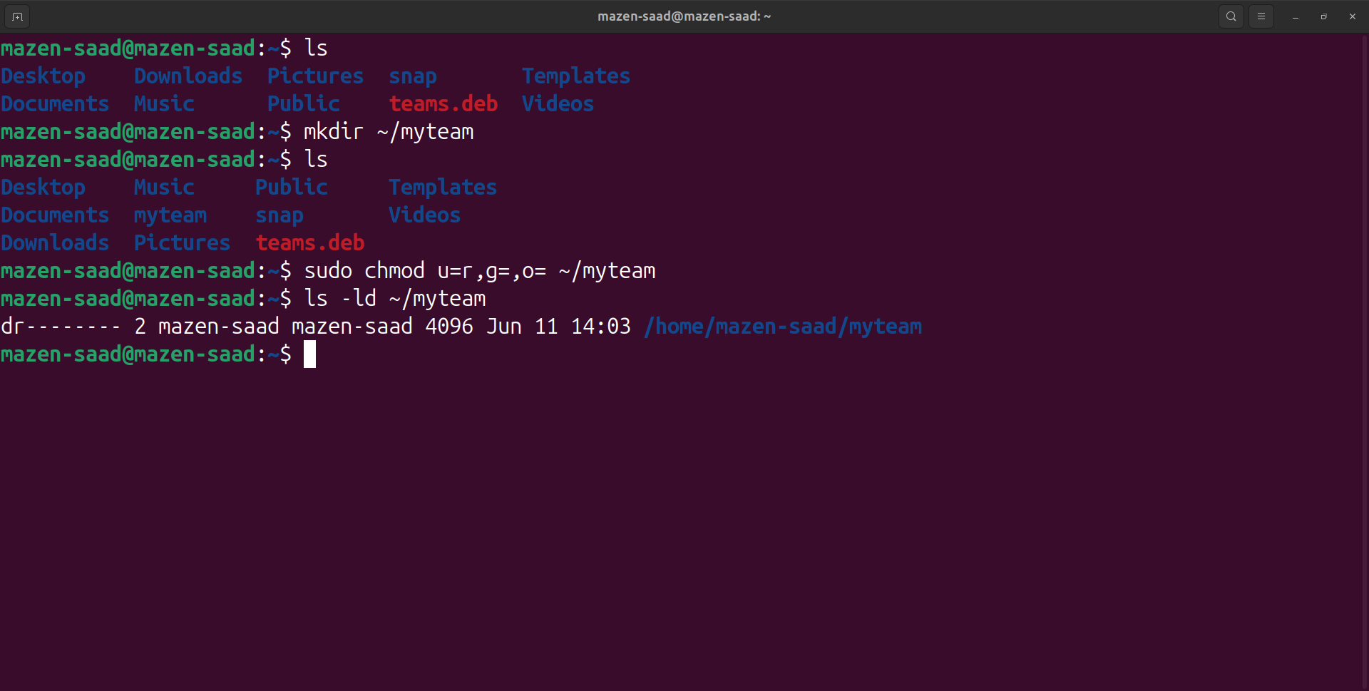

2. Log out and log in by another user

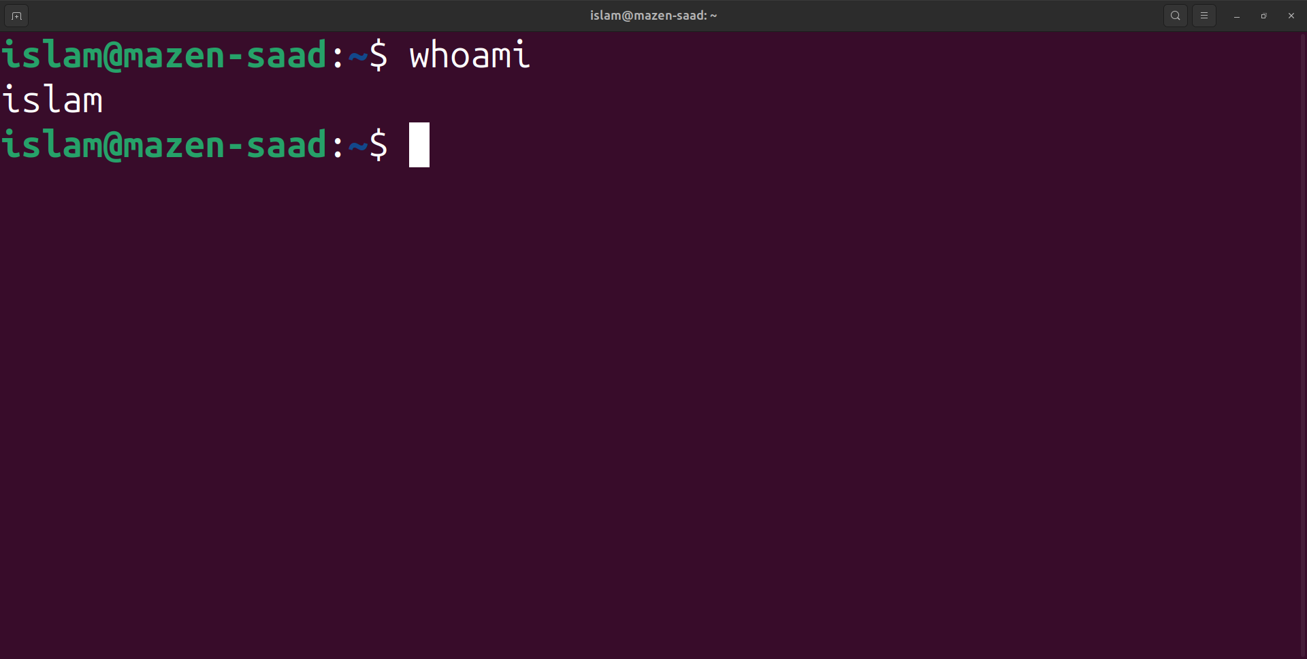

3. Try to access (by cd command) the folder (myteam).

cd ./../mazen-saad/myteam

or

cd /home/mazen-saad/myteam

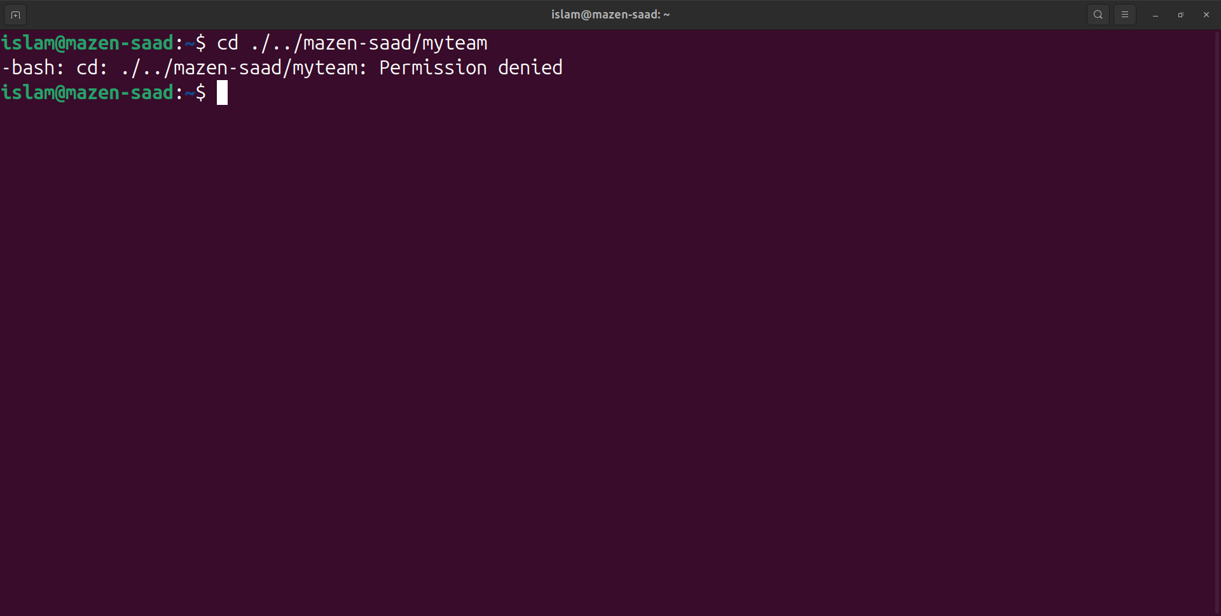

4. Change the permissions of mycv file to give owner read and write permissions and for group write and execute and execute only for the others (using chmod in 2 different ways )

vi mycv

ls -ld mycv

sudo chmod u=rw,g=wx,o=x mycv

chmod 631 mycv

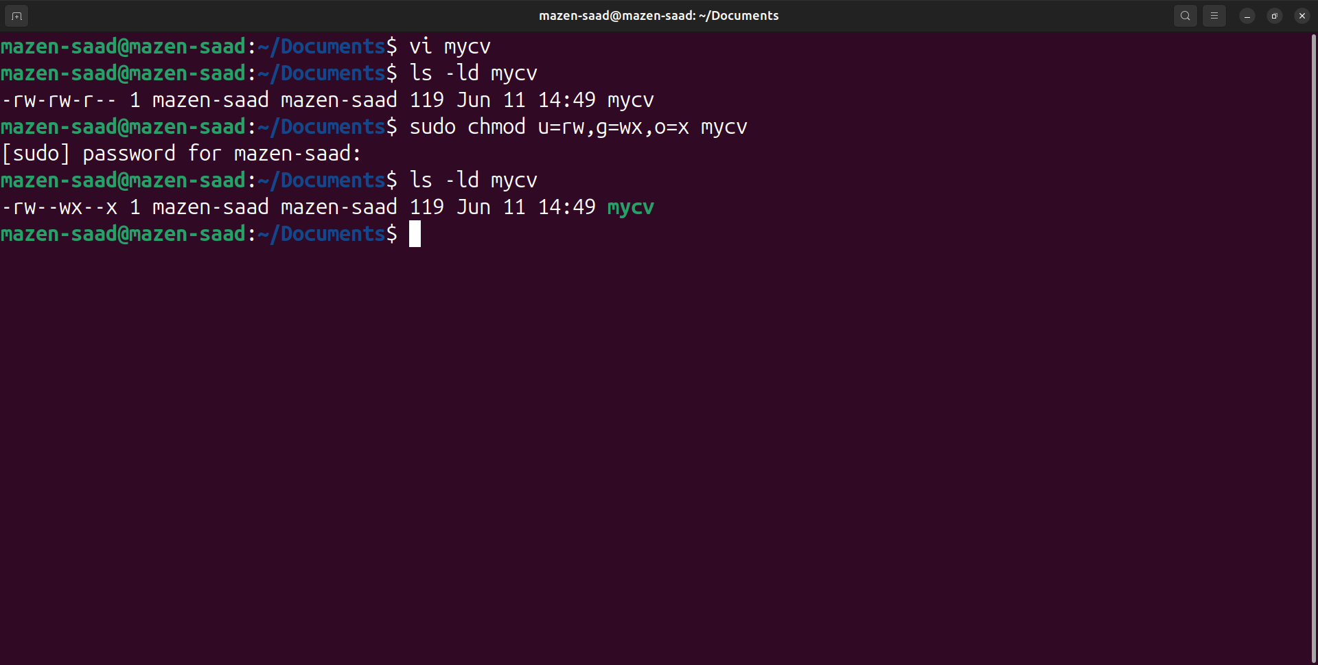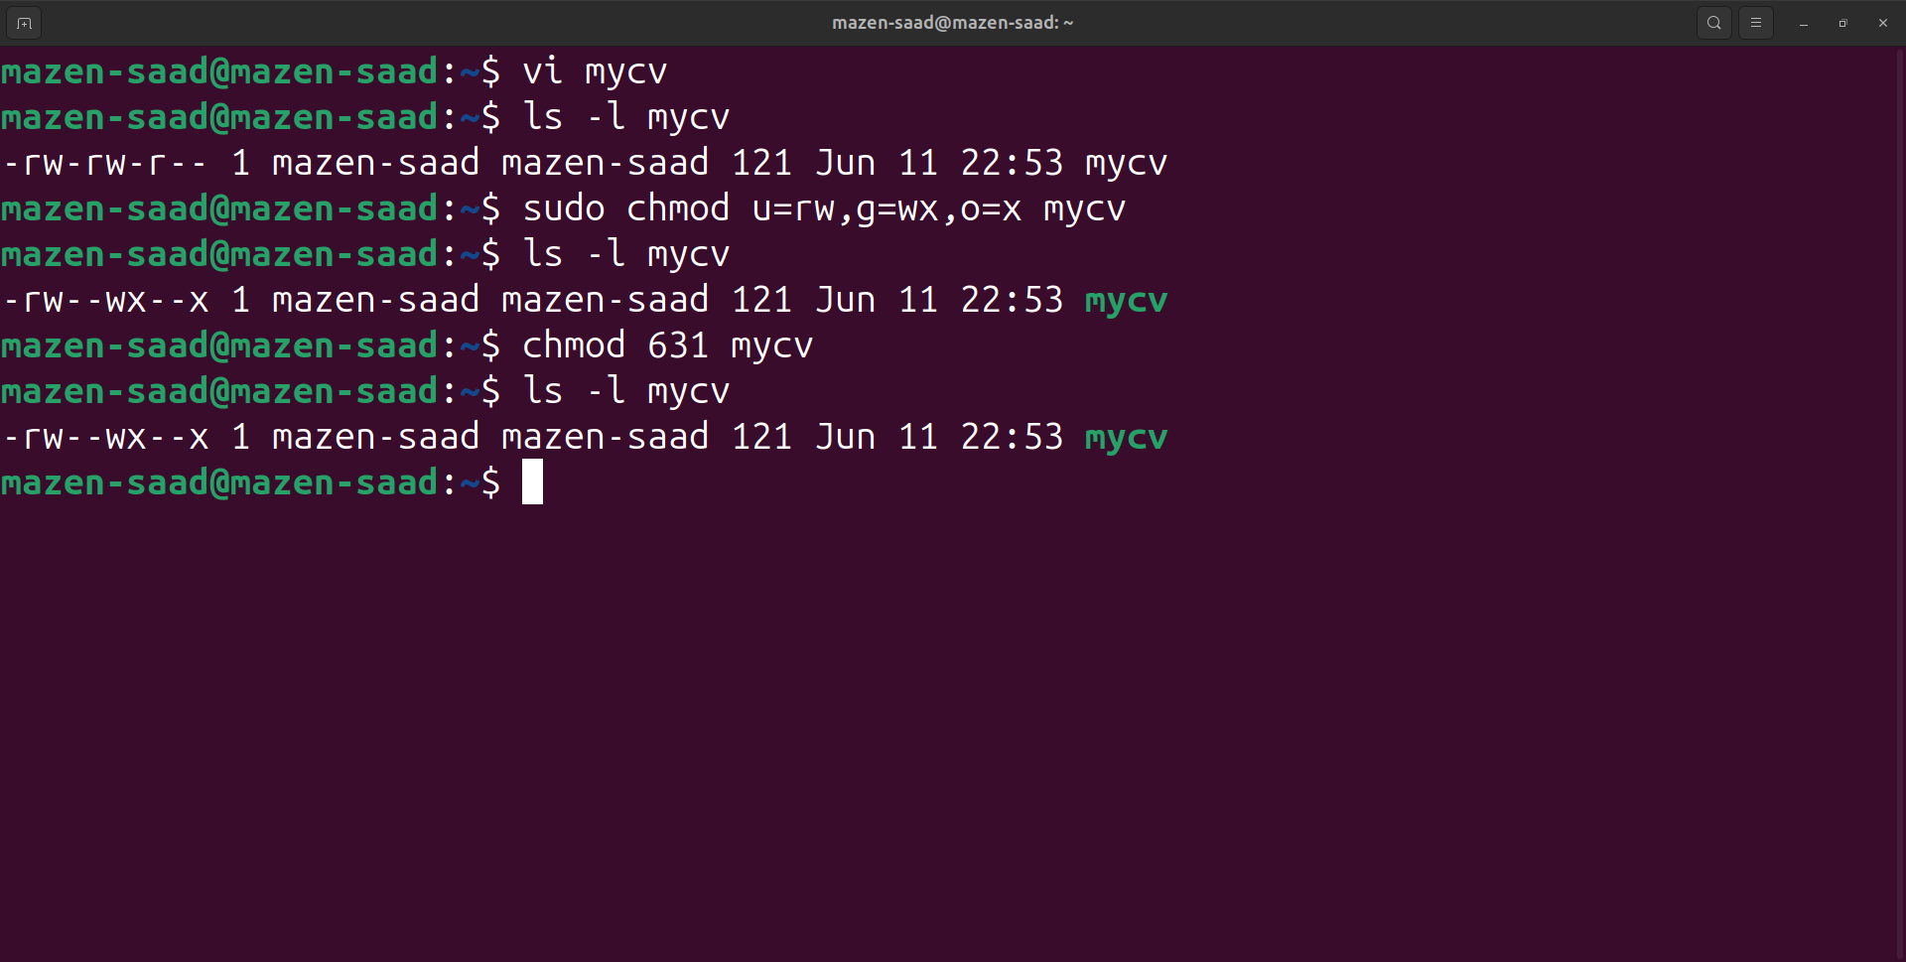

5. Change your default permissions to be as above (Q.4).

ls -ld mycv

-rw-rw-r-- 1 mazen-saad mazen-saad 119 Jun 11 14:49 mycv

sudo chmod u=rw,g=rw,o=r mycv

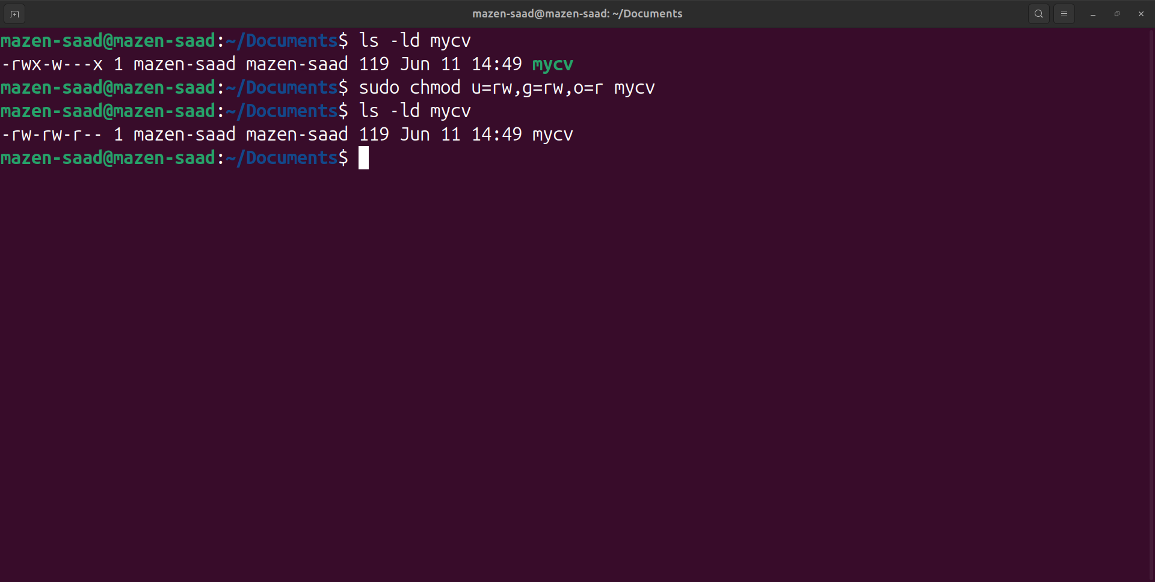

6. What is the maximum permission a file can have, by default when it is just created? And what is that for directory.

-> By Default Max Permission File 666

-> By Default Max Permission Folder or Directory 777

7. Change your default permissions to be no permission to everyone then create a directory and a file to verify.

umask -S u=,g=,o=

umask -S a=

mkdir ~/testdir

ls -ld testdir

touch ~/testfile

ls -ld testfile

sudo chmod u=rw,g=rw,o=r testdir

sudo chmod u=rw,g=rw,o=r testfile

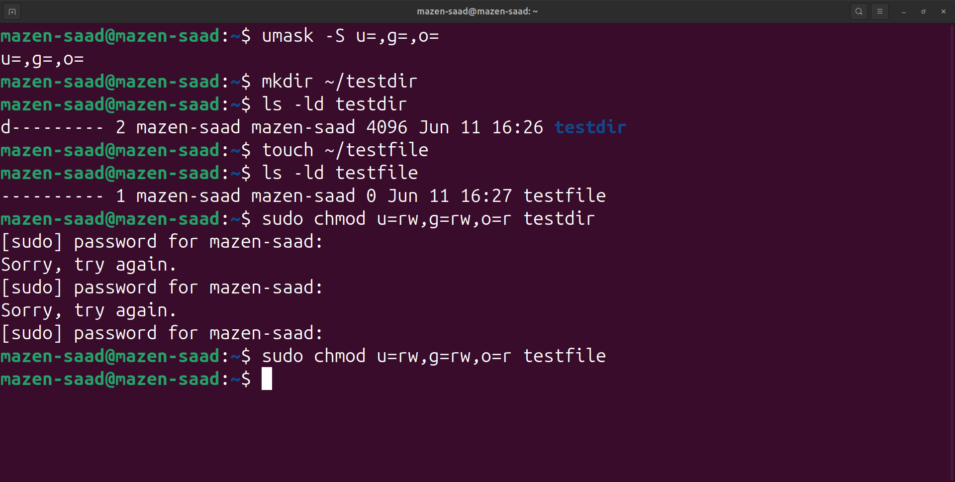

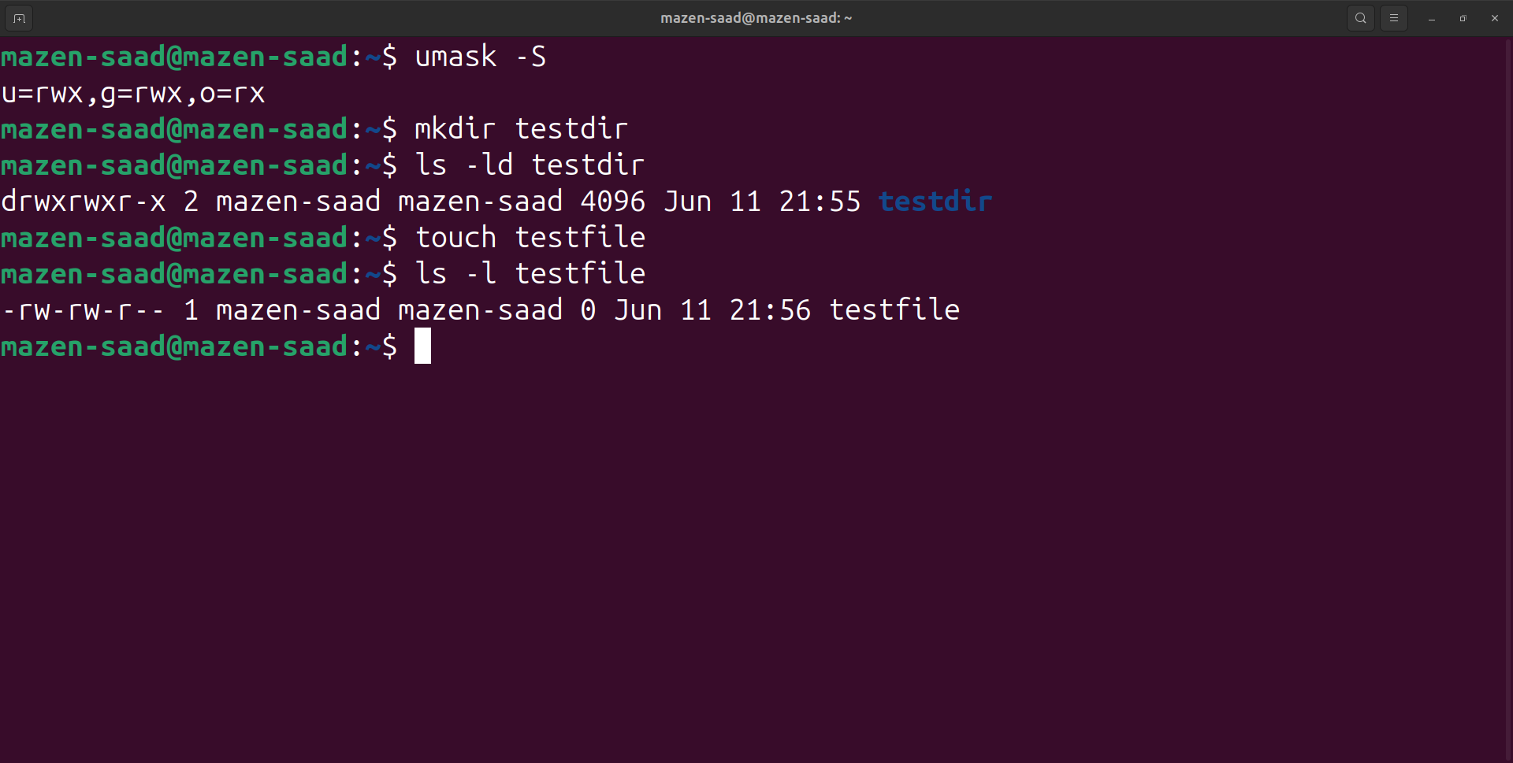

8. What are the minimum permission needed for :

a. Copy a file (permission for source file and and permission for target parent directory)

-> file (r--)

-> Source Folder(--x)

-> Target Folder(-wx)

b. Delete a file

-> (---)

c. Change to a directory

-> (--x)

d. List a directory content (ls command)

-> (r-x)

e. View a file content (more/cat command)

-> (r--)

f. Modify a file content

-> (-w-)

9. Create a file with permission 444. Try to edit in it and to remove it? Note what happened.

touch ~/myfile

ls

chmod 444 myfile

vi myfile

rm myfile

enter y

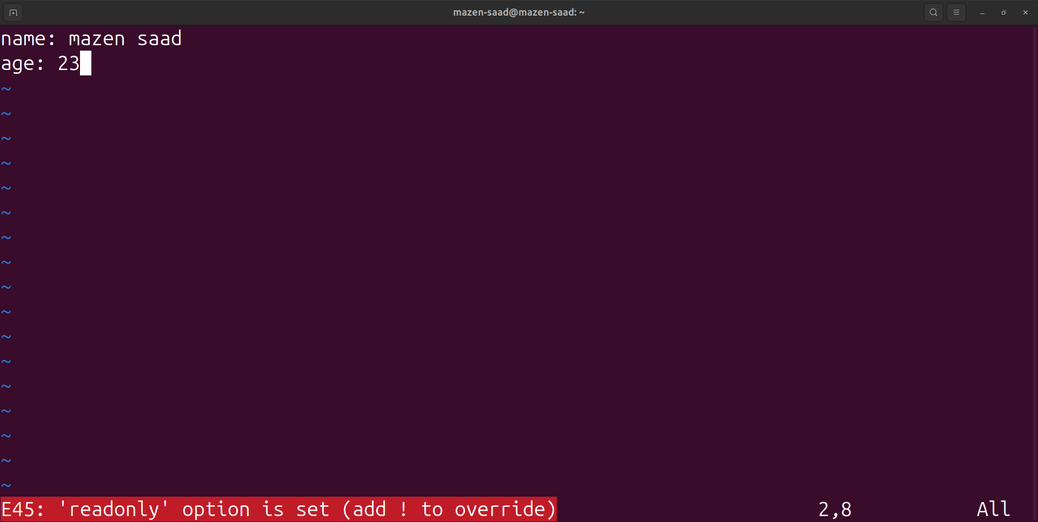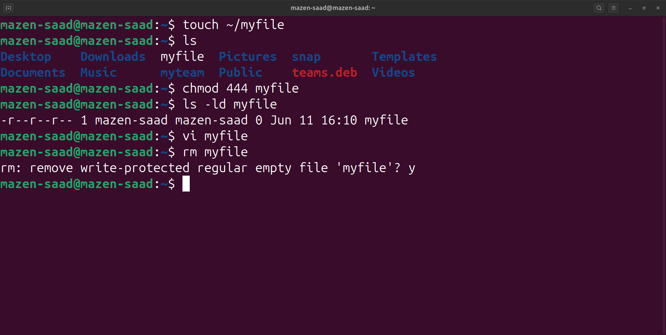

10. What is the difference between the “x” permission for a file and for a directory.

For a file: The (x) permission allows the file to be executed as a program.

For a directory: The (x) permission allows you to enter the directory and access its contents (using cd).

11. List the available shells in your system.

cat /etc/shells

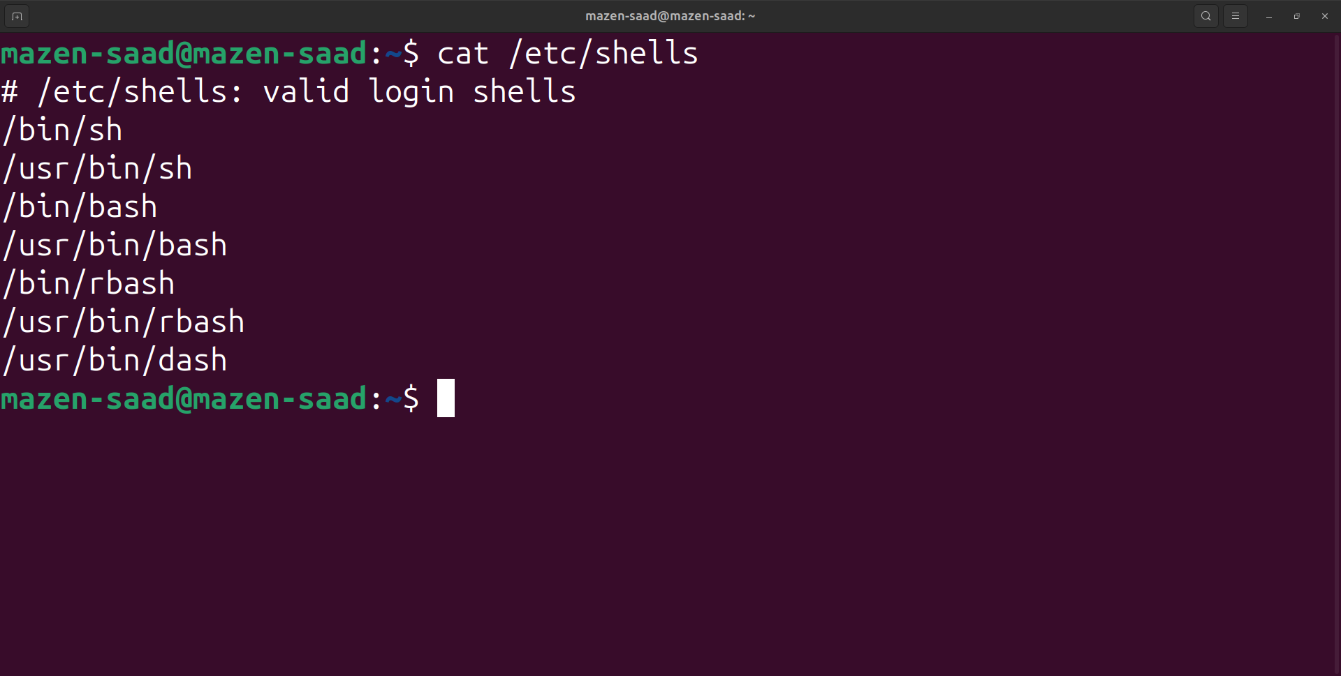

12. List the environment variables in your current shell.

env

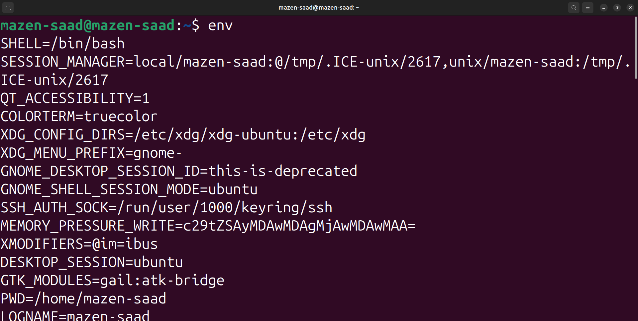

13. List all of the environment variables for the bash shell.

man bash

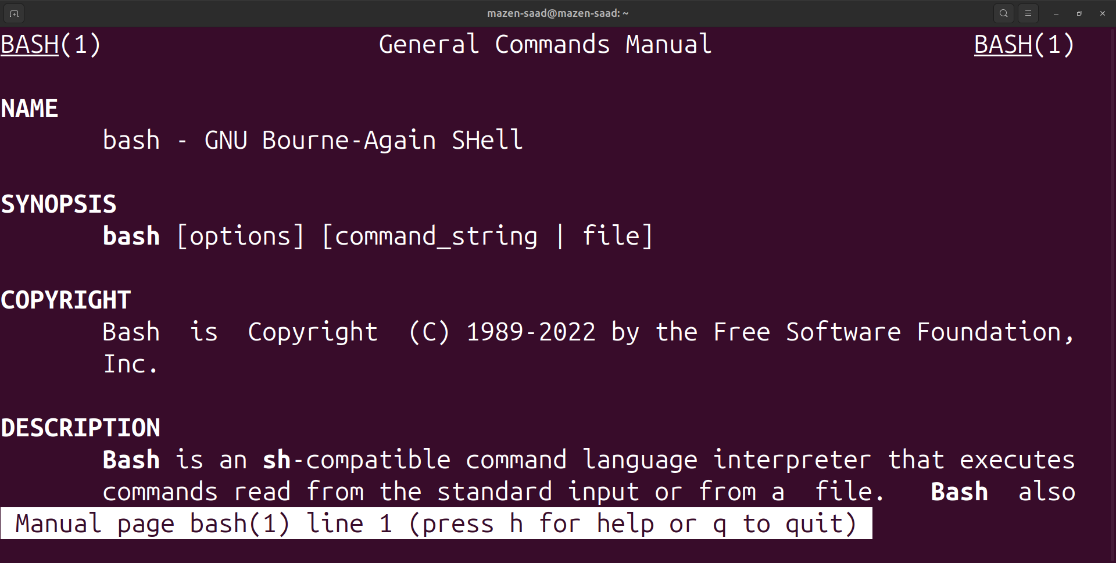

14. What are the commands that list the values of all the variables?

env

printenv

15. What are the commands that list the value of a specific variable?

echo $varName

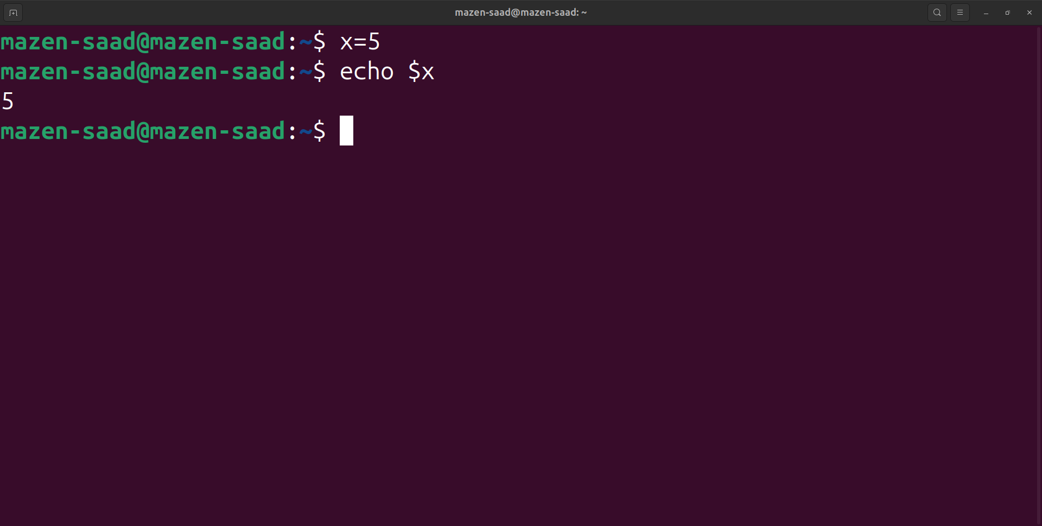

16. Display your current shell.

echo $SHELL

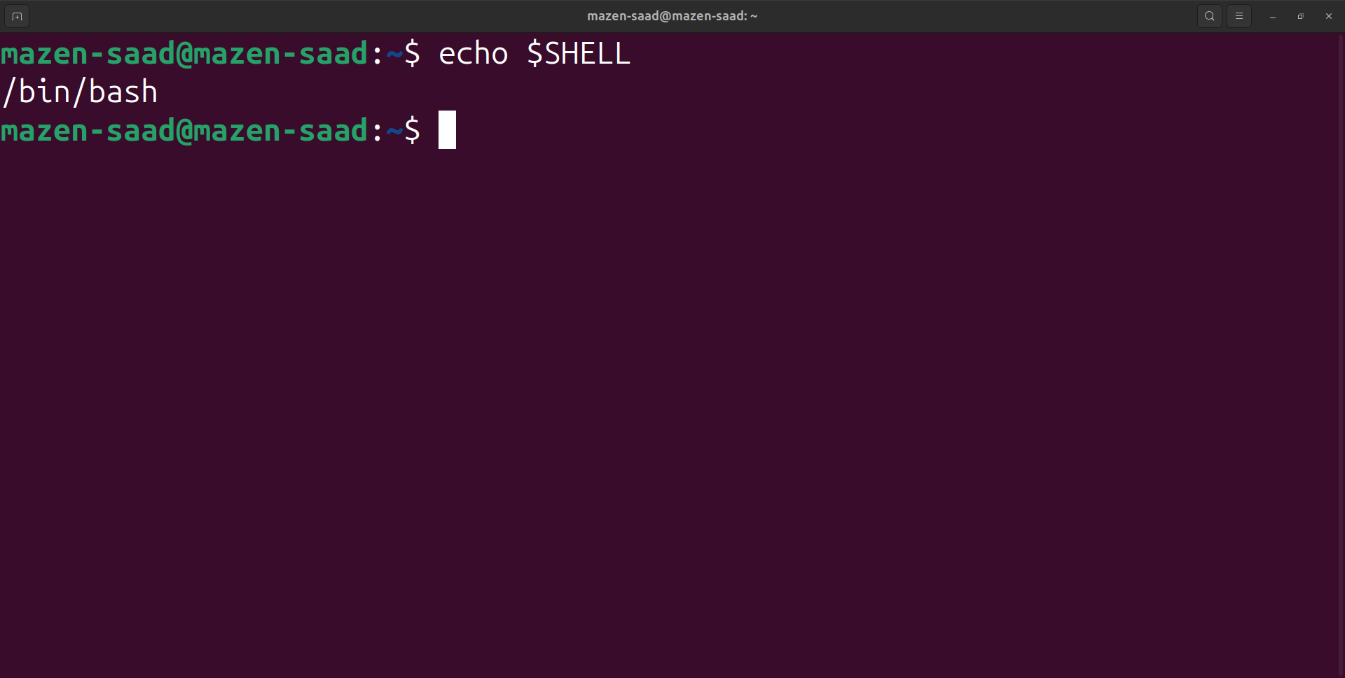

17. State the initialization files of: sh, ksh, csh, bash.

sudo apt-get install ksh

sudo apt-get install csh

sudo apt-get install sh

man bash

man csh

man ksh

man sh

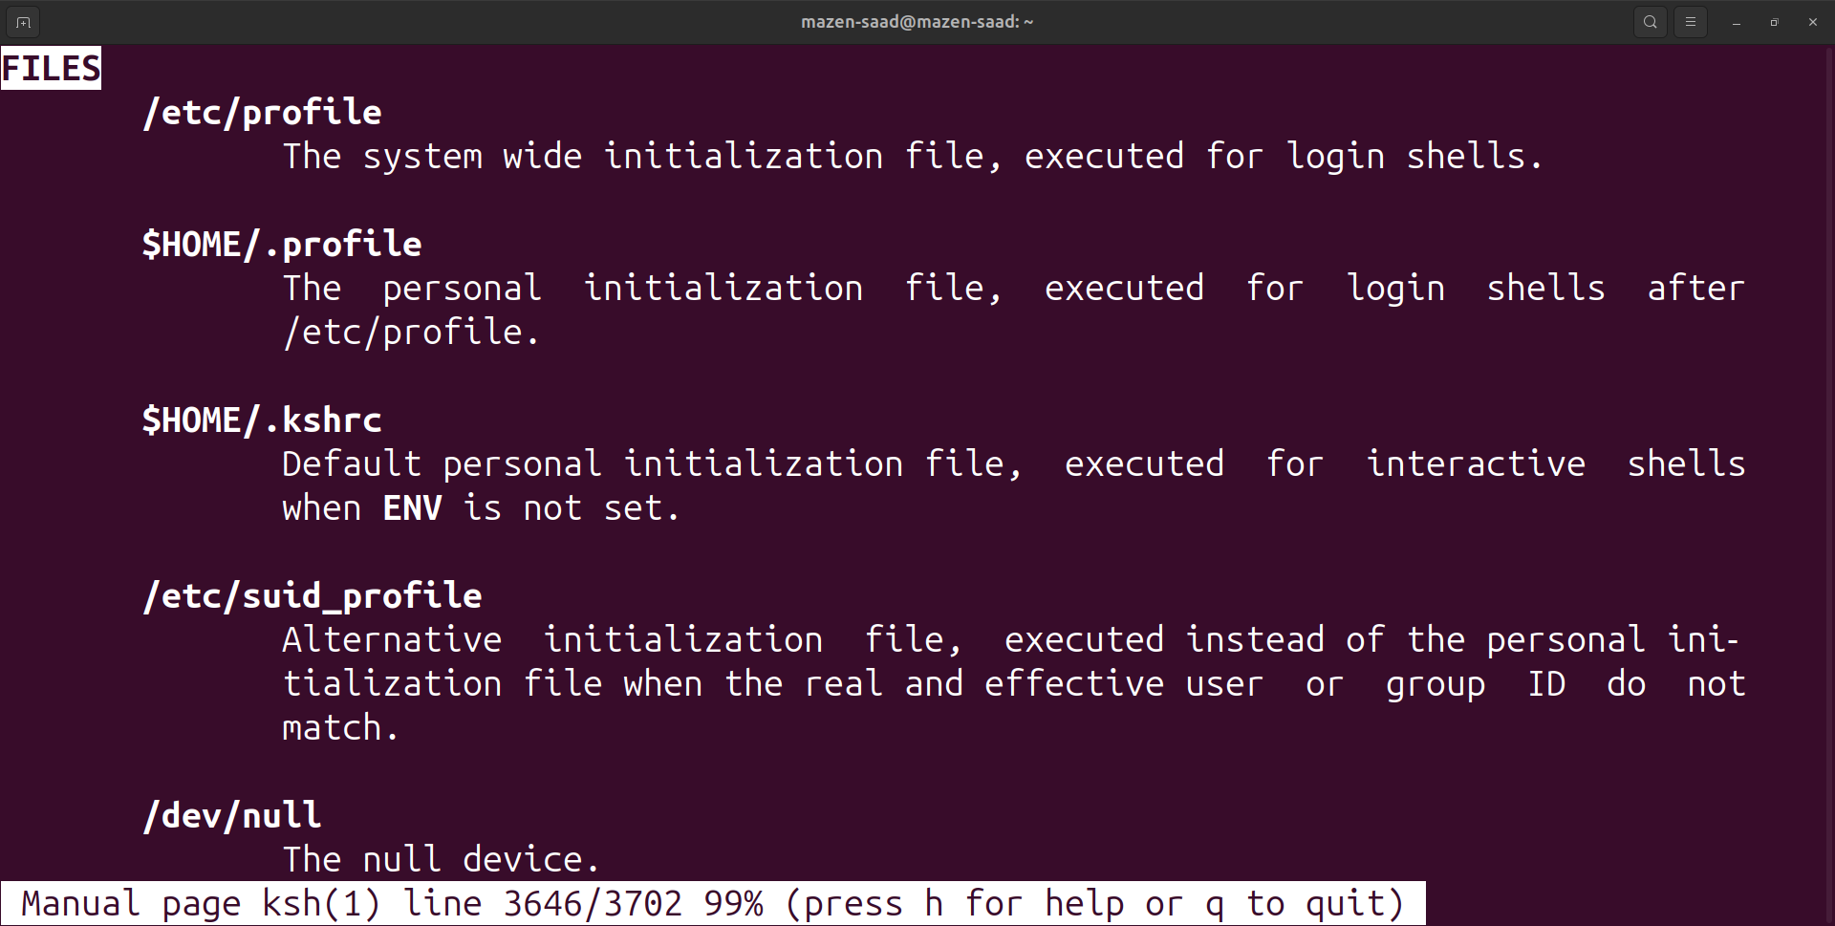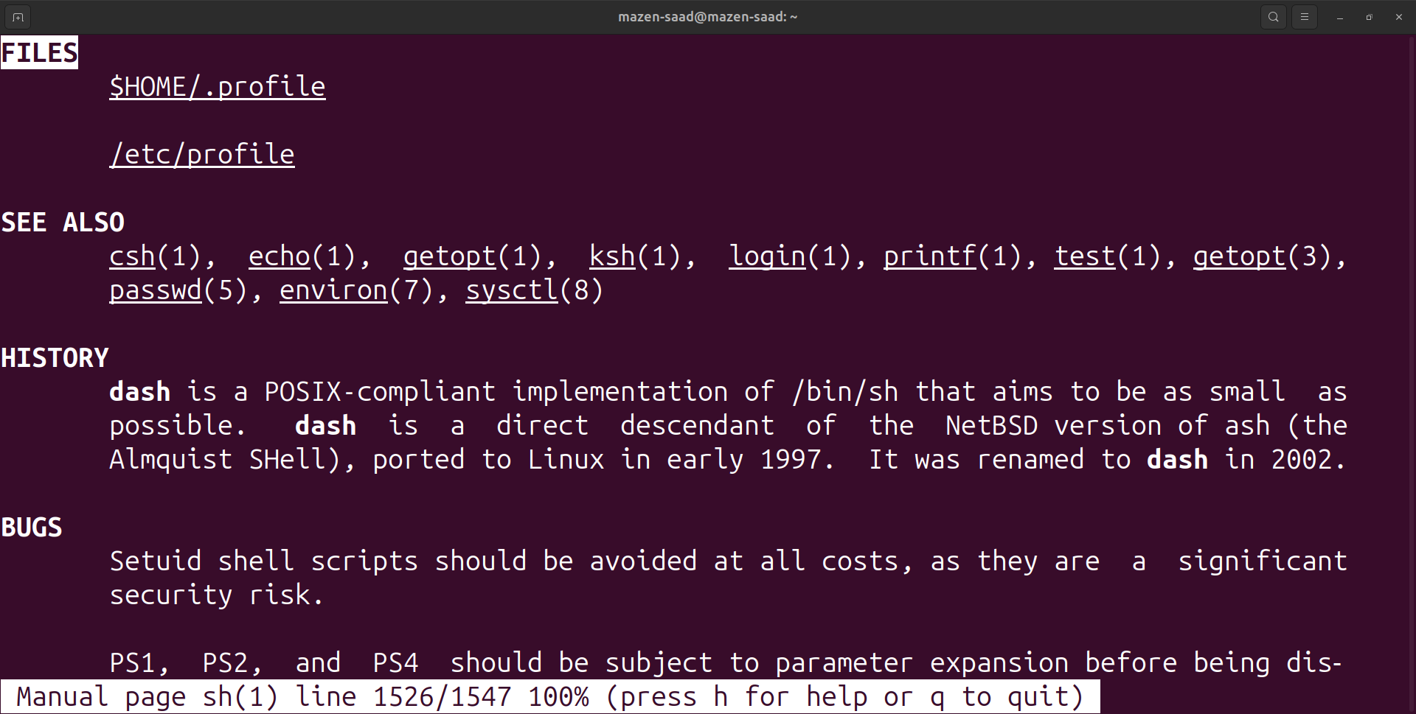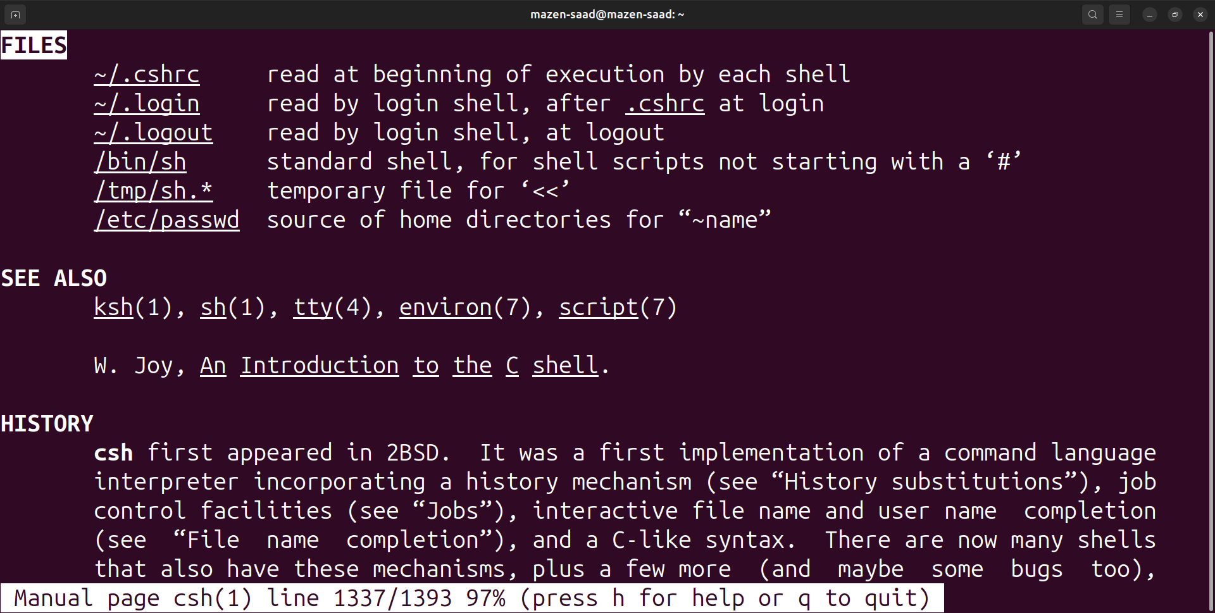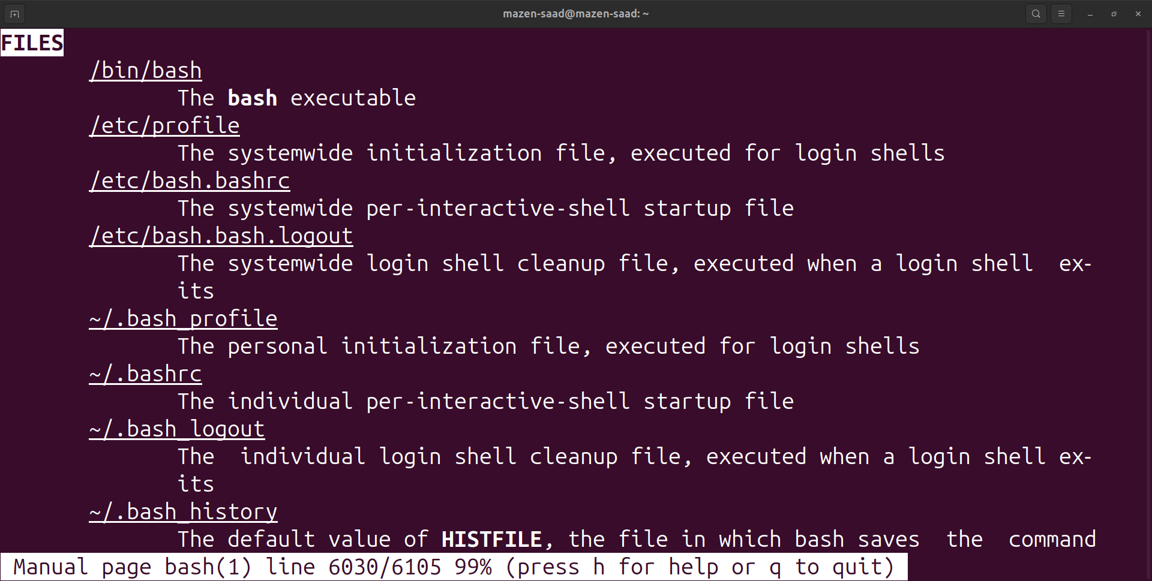

18. Edit in your profile to display date at login and change your prompt permanently.

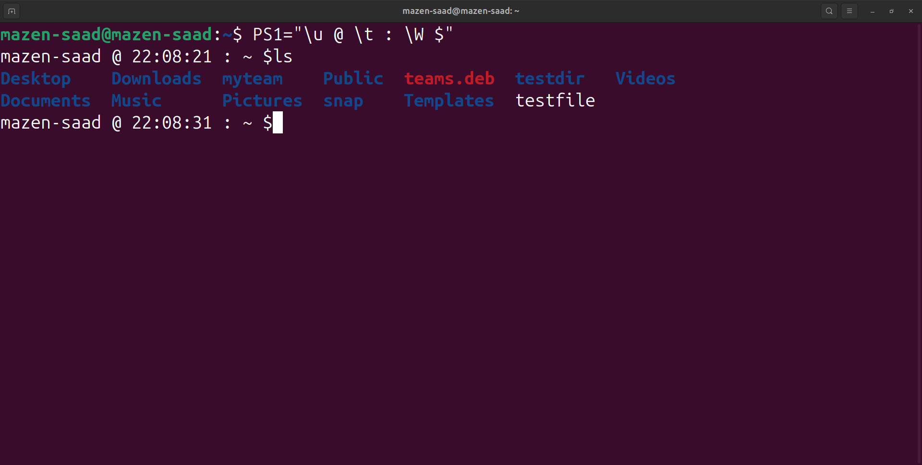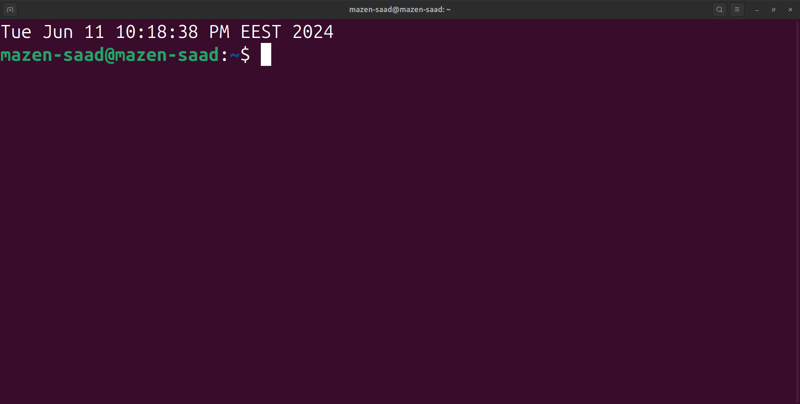

19. Execute the following command :

echo \ then press enter

Notice the prompt what is that and how can you change it.

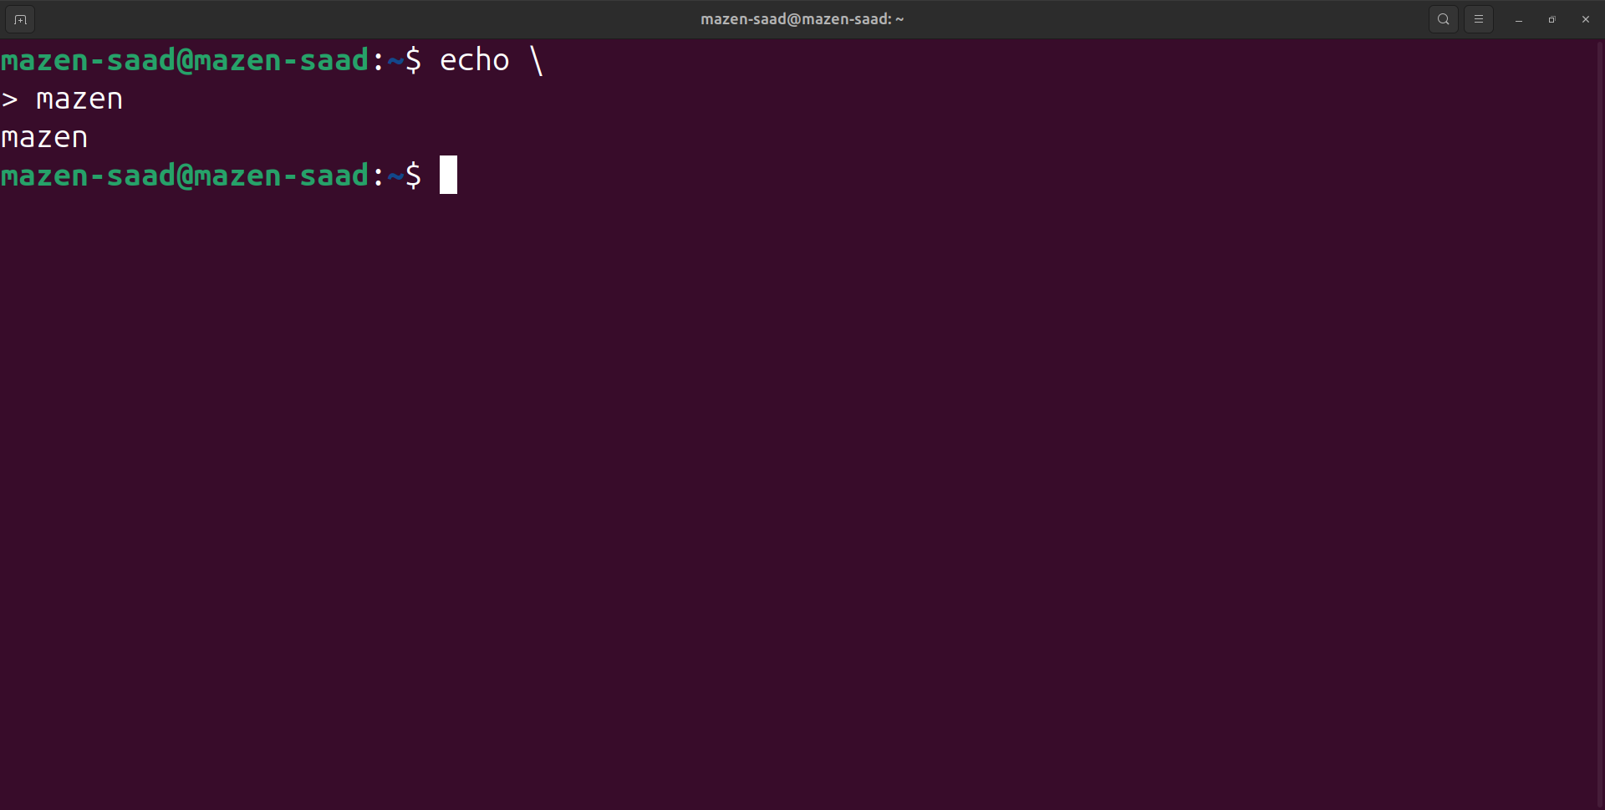

20. Create a Bash shell alias named ls for the “ls –l” command

alias ls='ls -l'

