مازن عبدالتواب سعد

Lab 5

1. List the user commands and redirect the output to /tmp/commands.list

ls -R /bin > /tmp/commands.list

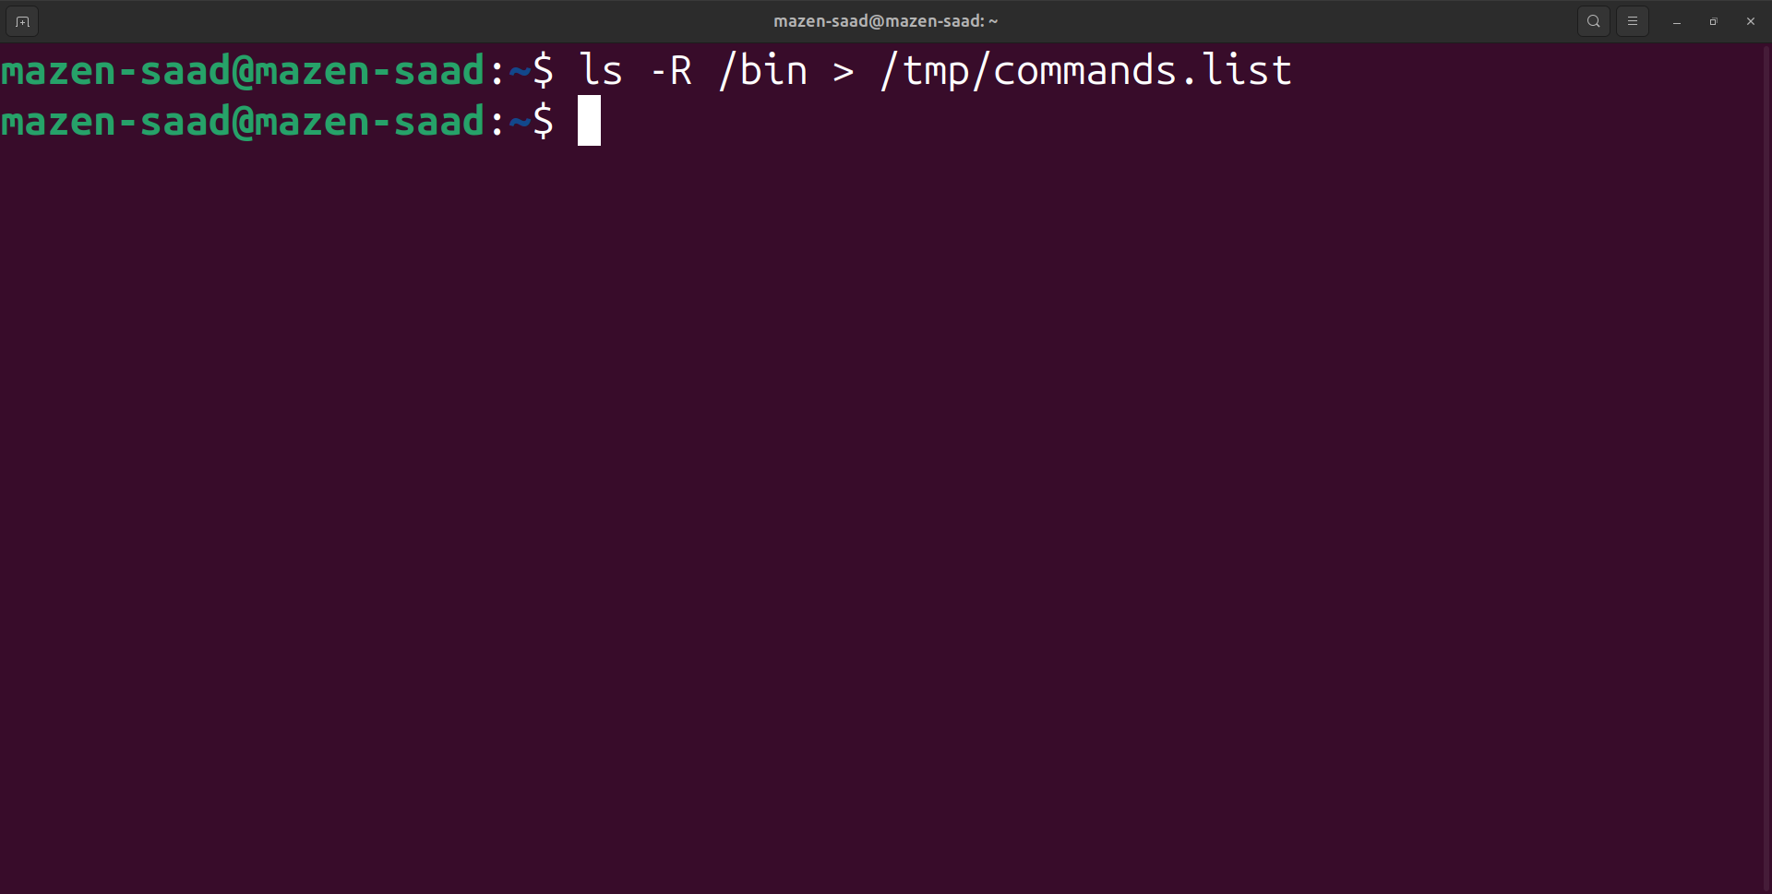

2. Count the number of user commands

wc -l /tmp/commands.list

wc -w /tmp/commands.list

wc -c /tmp/commands.list

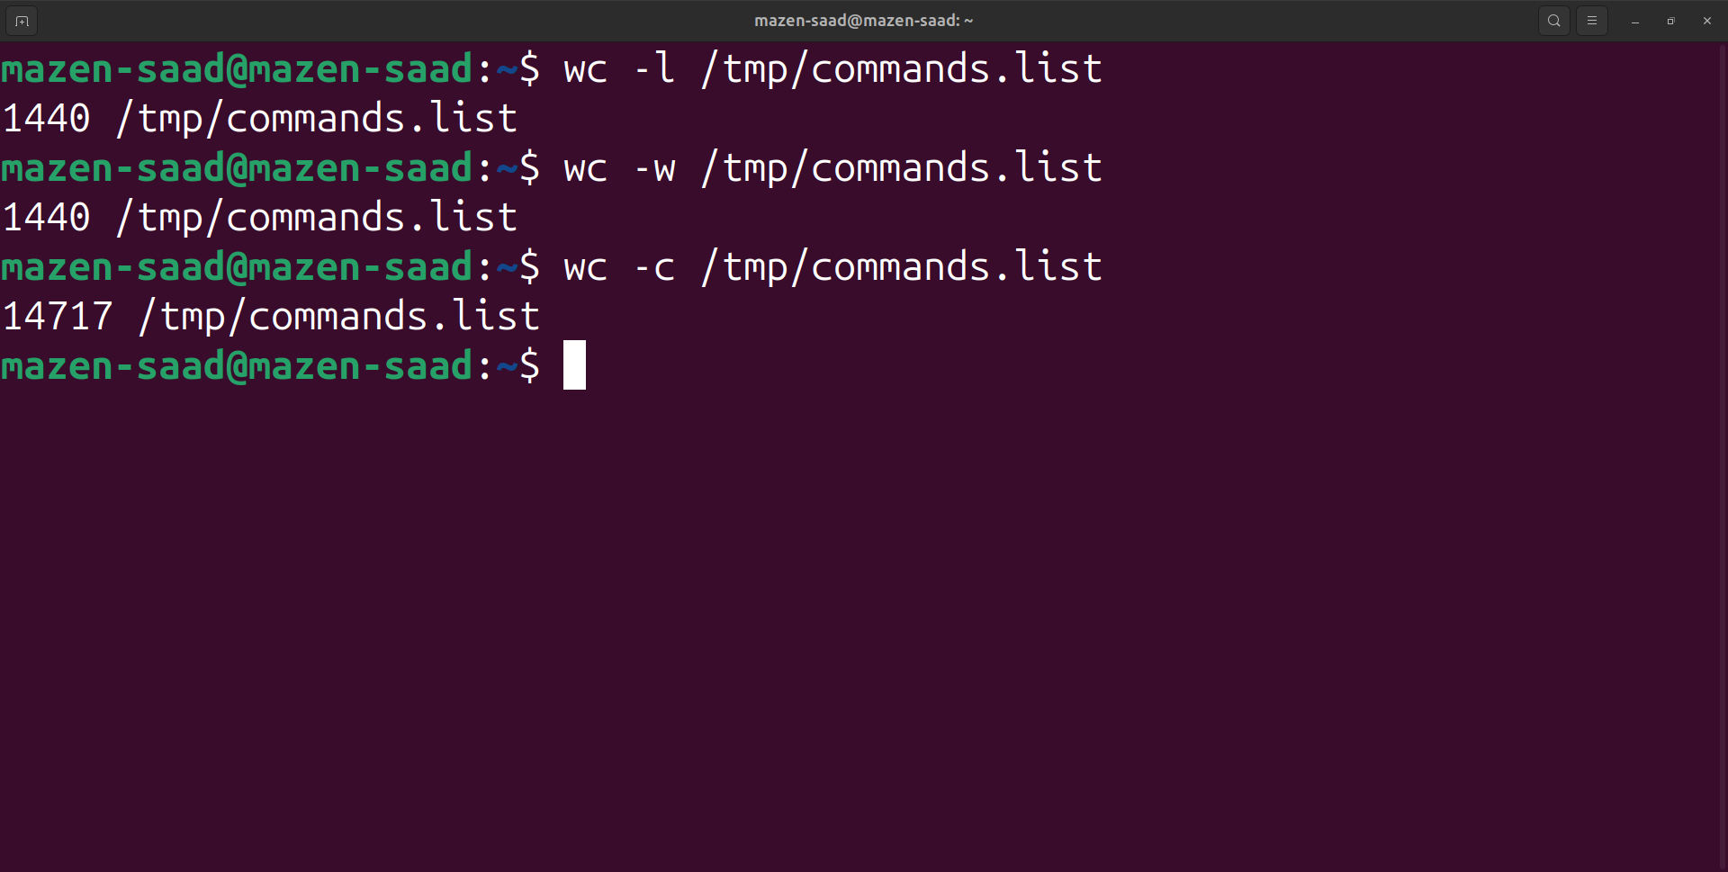

3. Get all the users names whose first character in their login is ‘g’.

grep '^g' /etc/passwd

or

cut -d: -f1 /etc/passwd | grep '^g'

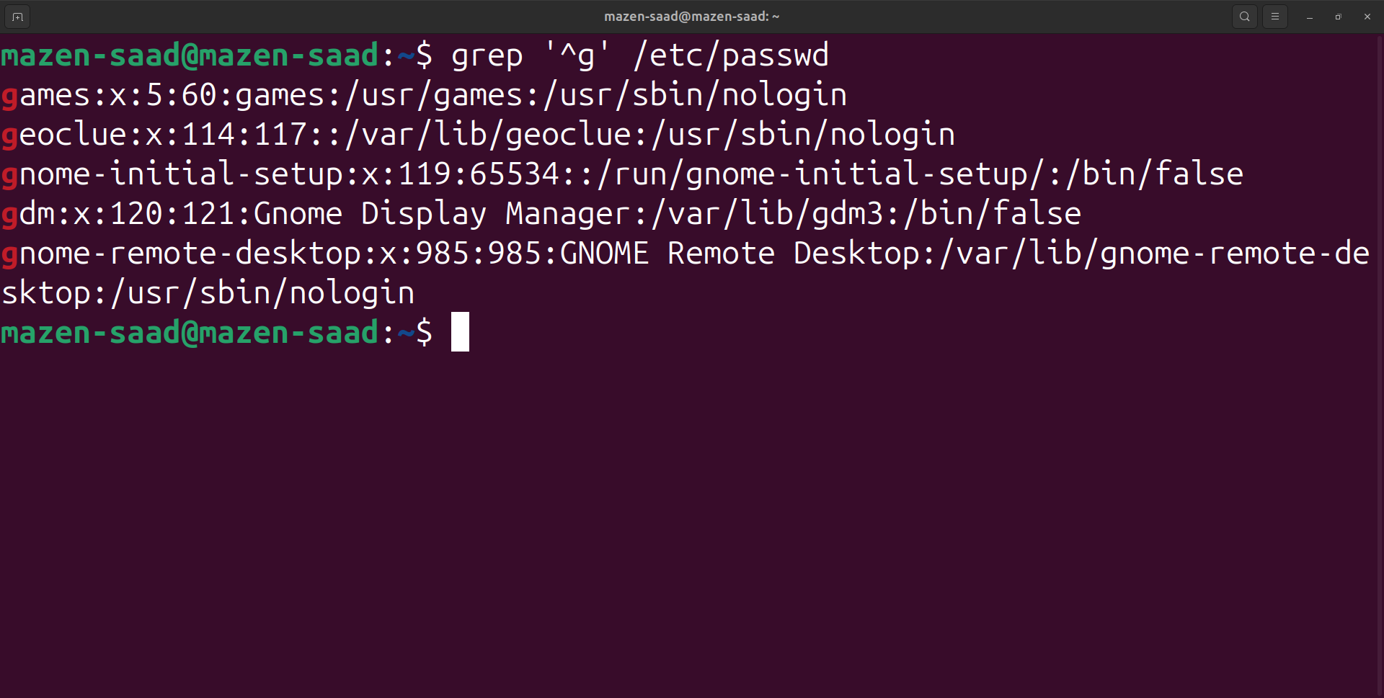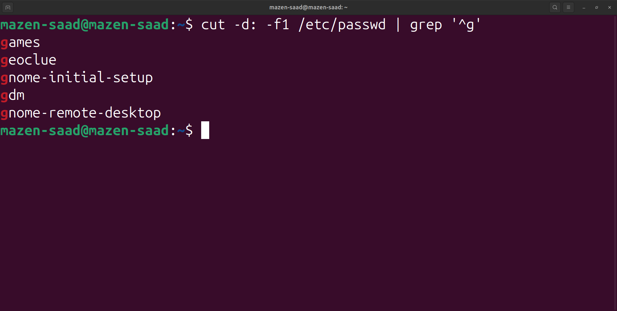

4. Get the logins name and full names (comment) of logins starts with “g”.

grep '^g' /etc/passwd | cut -d: -f1,5

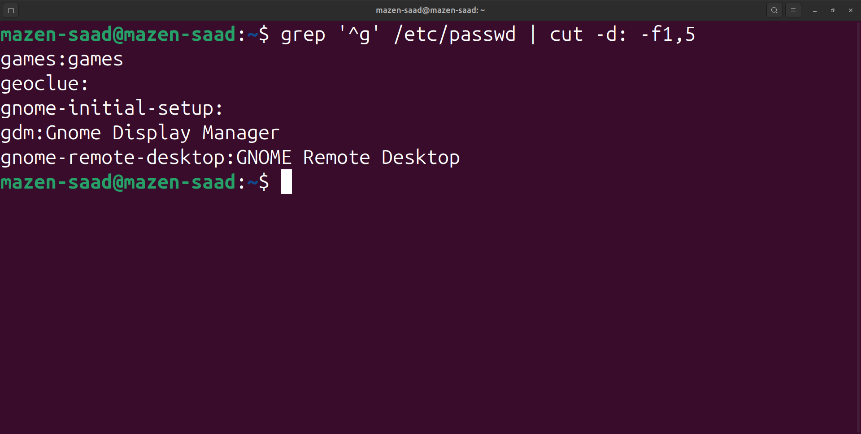

5. Save the output of the last command sorted by their full names in a file.

grep '^g' /etc/passwd | cut -d: -f1,5 | sort -t: -k2 > ~/Documents/sorted_g_users.list

or

!! | sort -t: -k2 > ~/Documents/sorted_g_users2.list

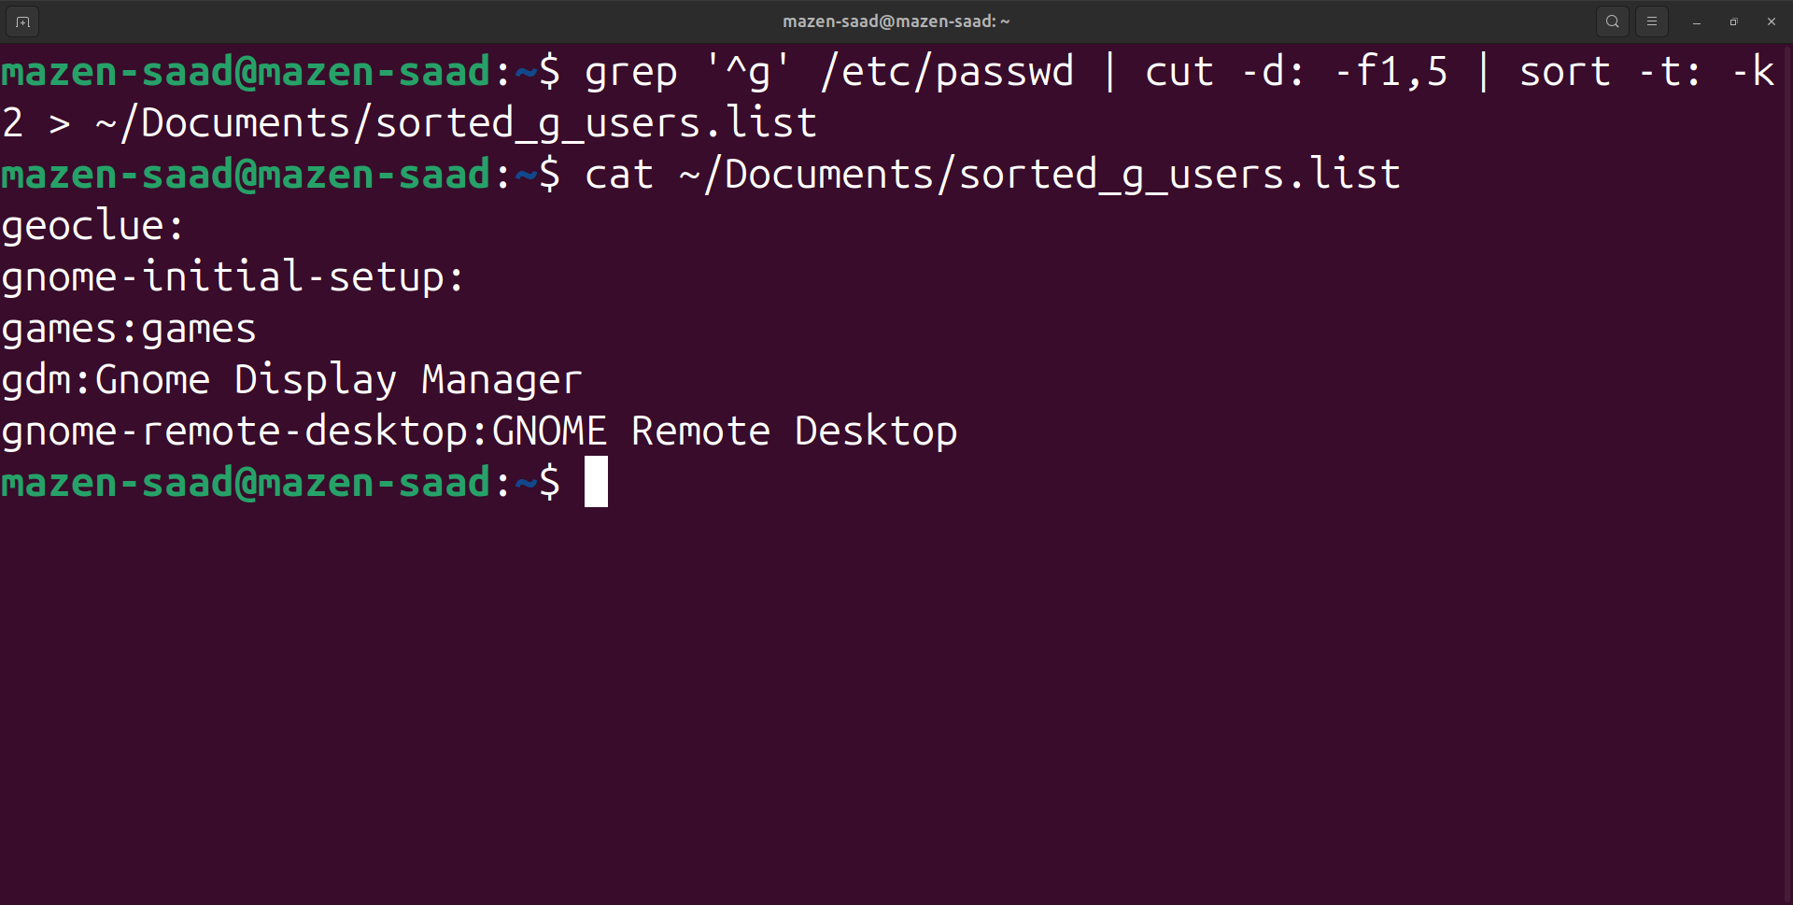

6. Write two commands:

first: to search for all files on the system that named .bash_profile.

Second: sorts the output of ls command on / recursively, Saving their output and error in 2 different files and sending them to the background.

1-

find / -name .bash_profile

find / -name .bash_profile -type f

find / -name .bash_profile 2>/dev/null

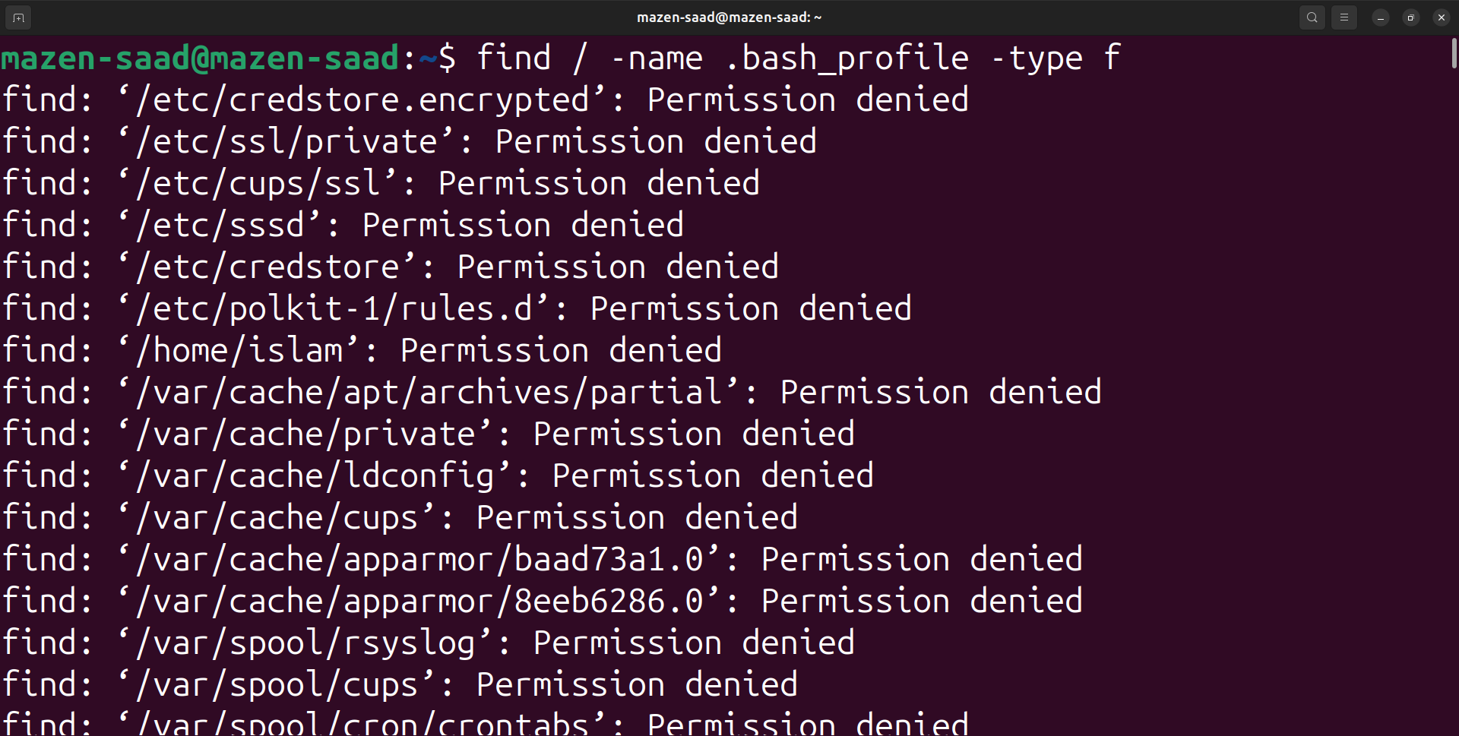

2-

ls -R / > ~/Documents/ls_output.log 2> ~/Documents/ls_error.log &

jobs

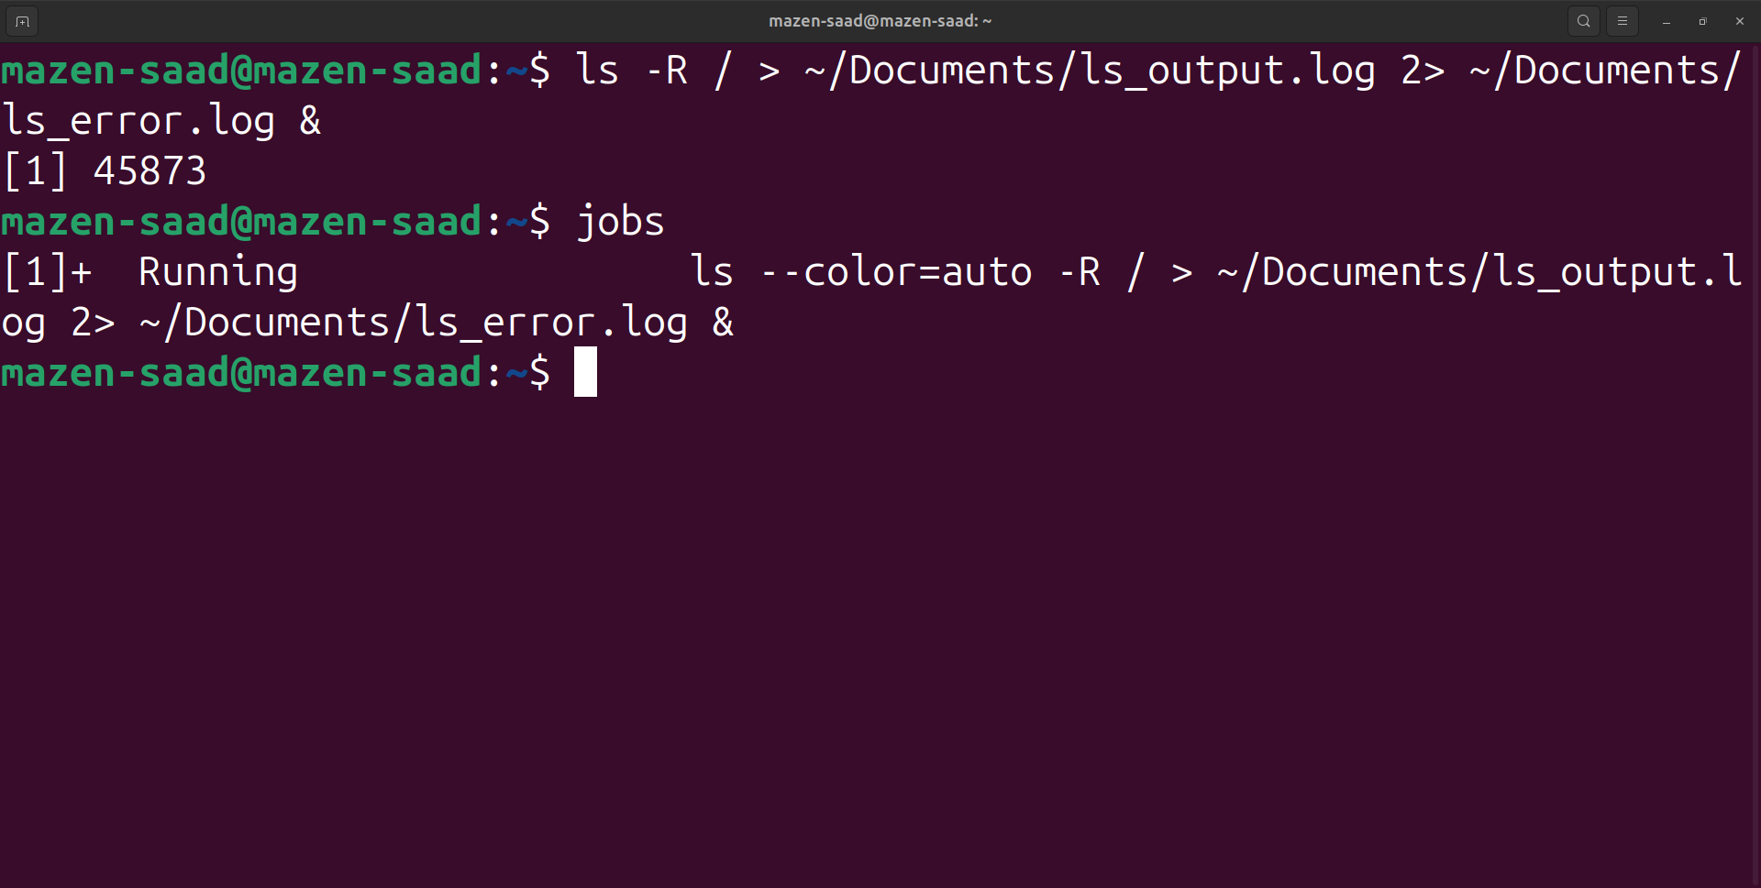

7. Display the number of users who is logged now to the system.

who | wc -l

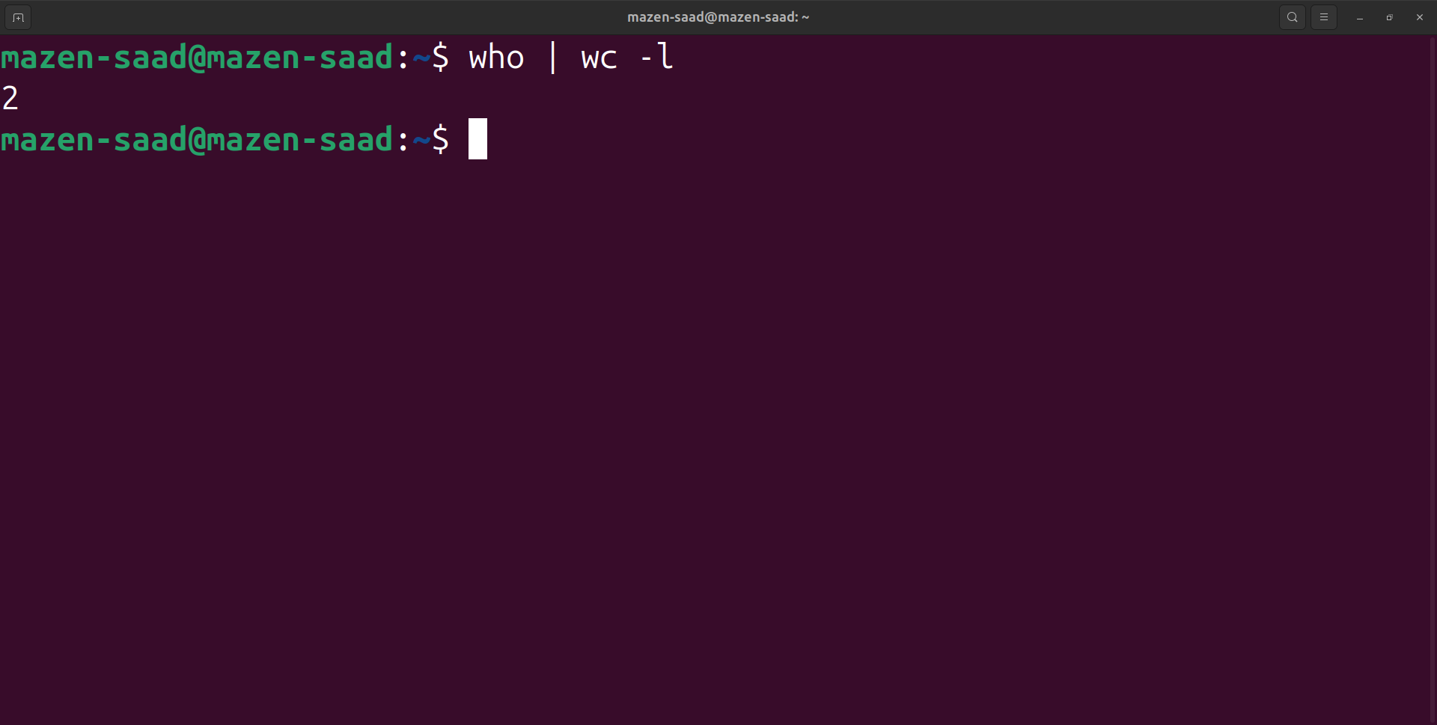

8. Display lines 7 to line 10 of /etc/passwd file

head -10 /etc/passwd | tail -4

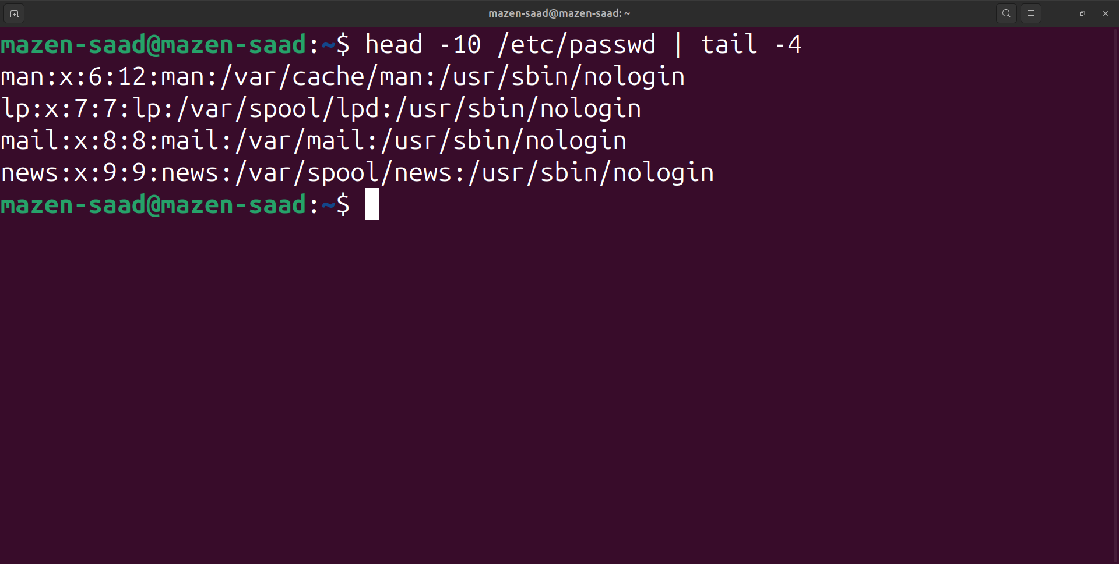

9. Issue the command sleep 100.

sleep 100

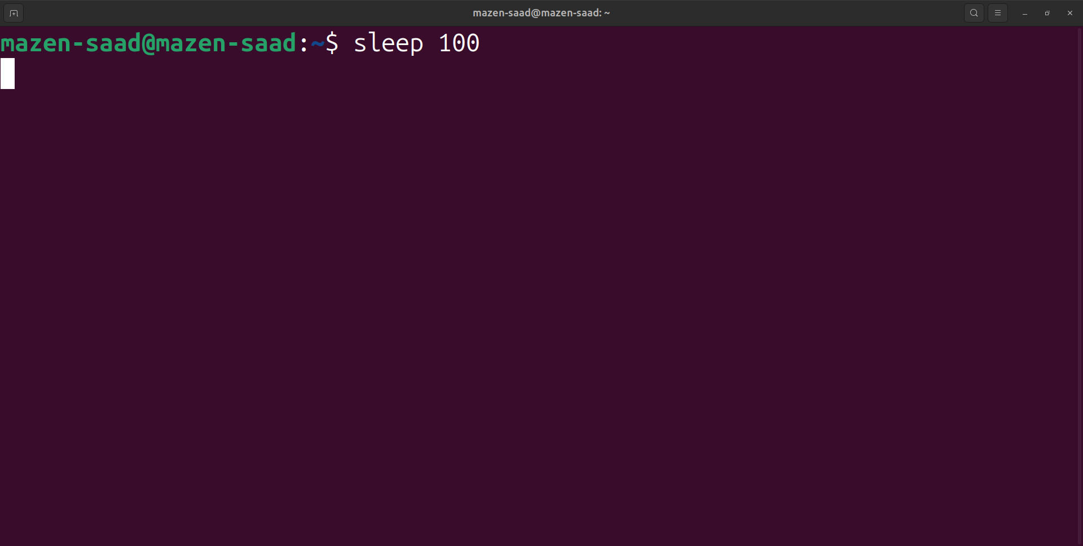

10. Stop the last command.

cntrl+z(Stopped)

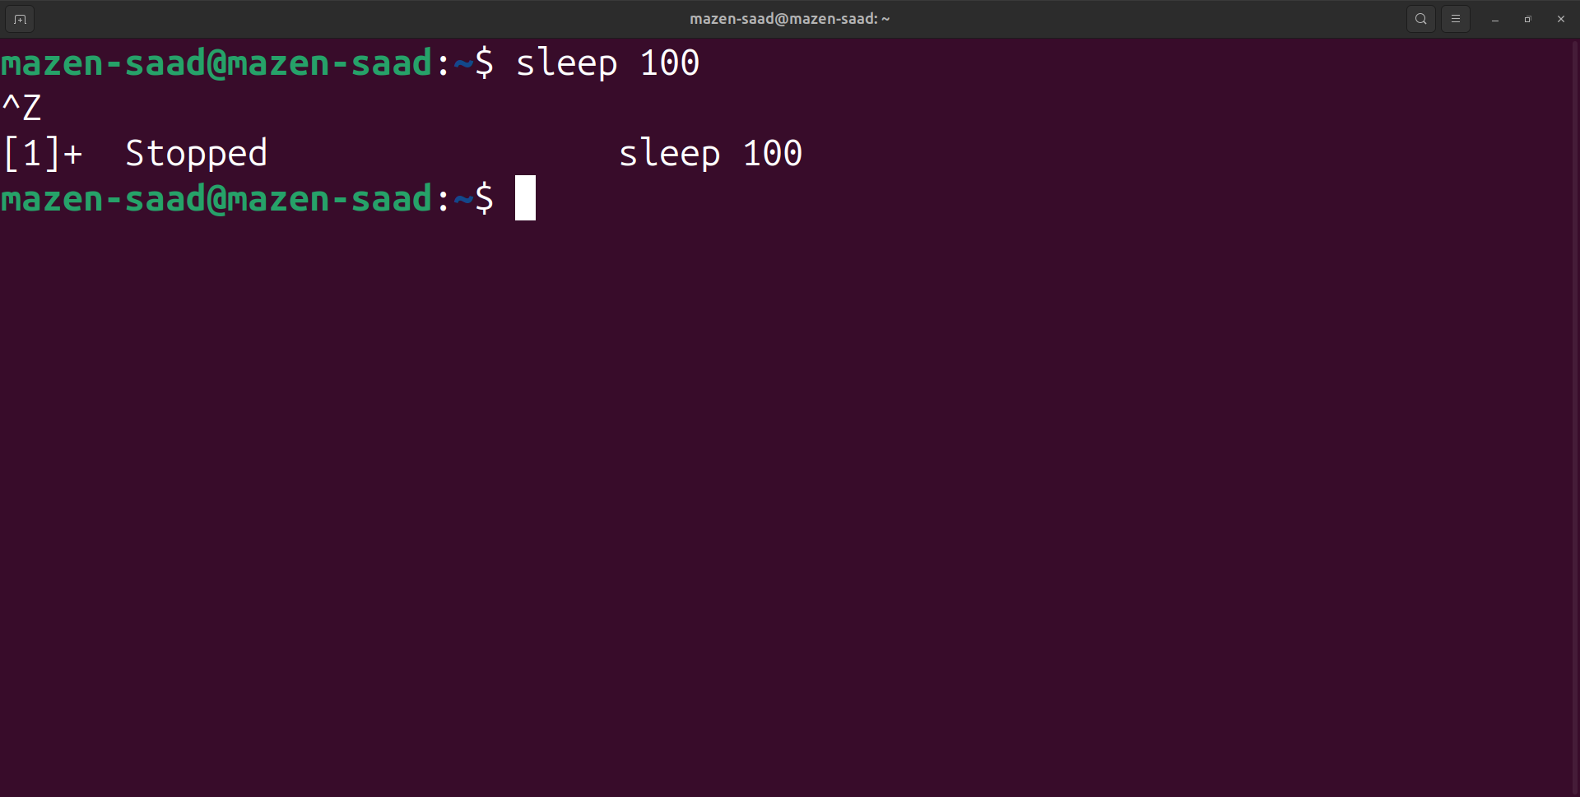

11. Resume the last command in the background

bg %1

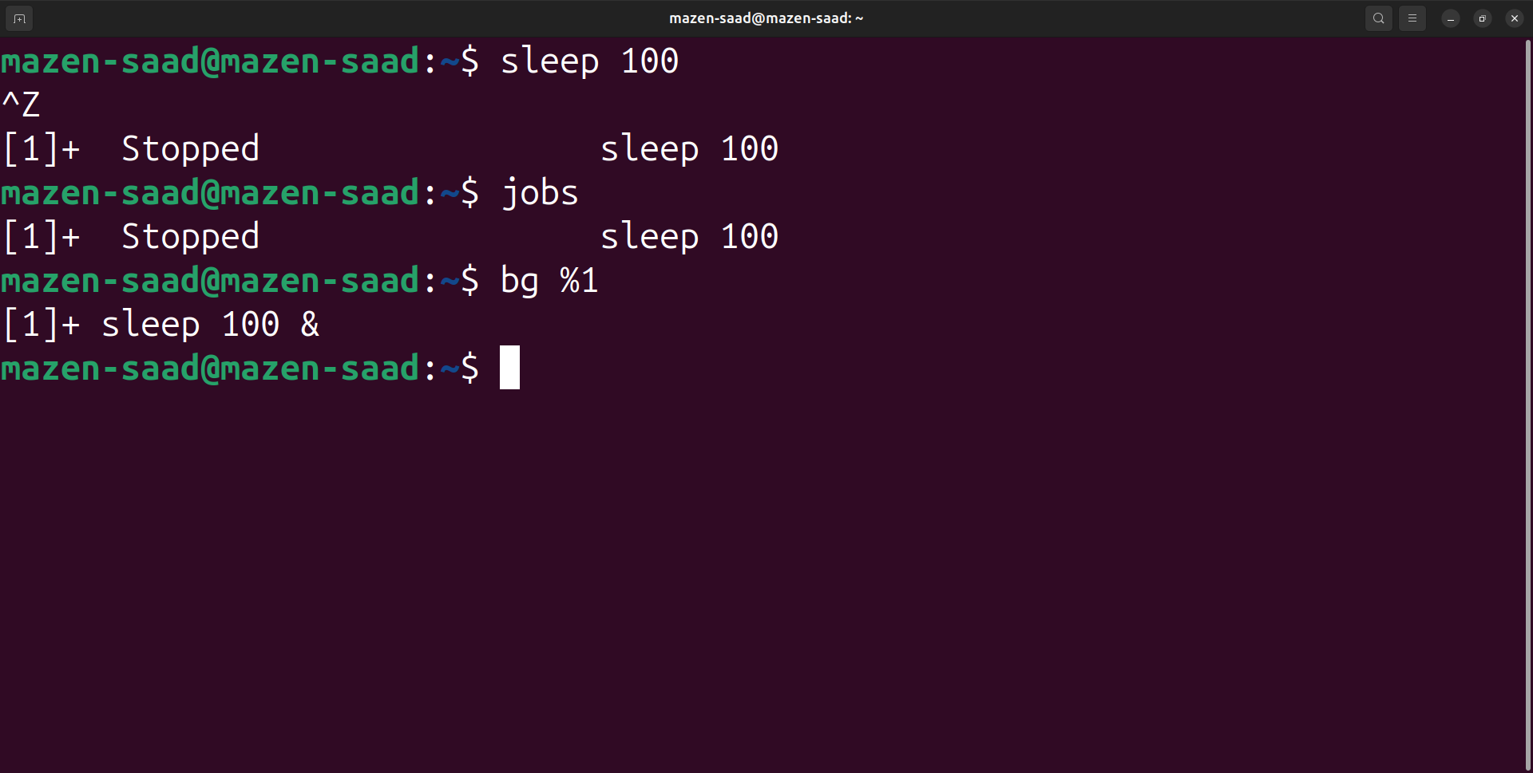

12. Issue the jobs command and see its output.

jobs

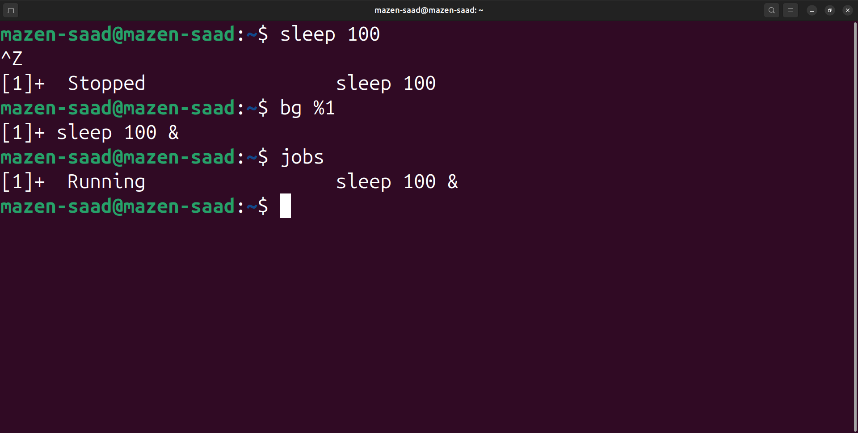

13. Send the sleep command to the foreground and send it again to the background.

fg %1

ctrl+z => ^Z

bg %1

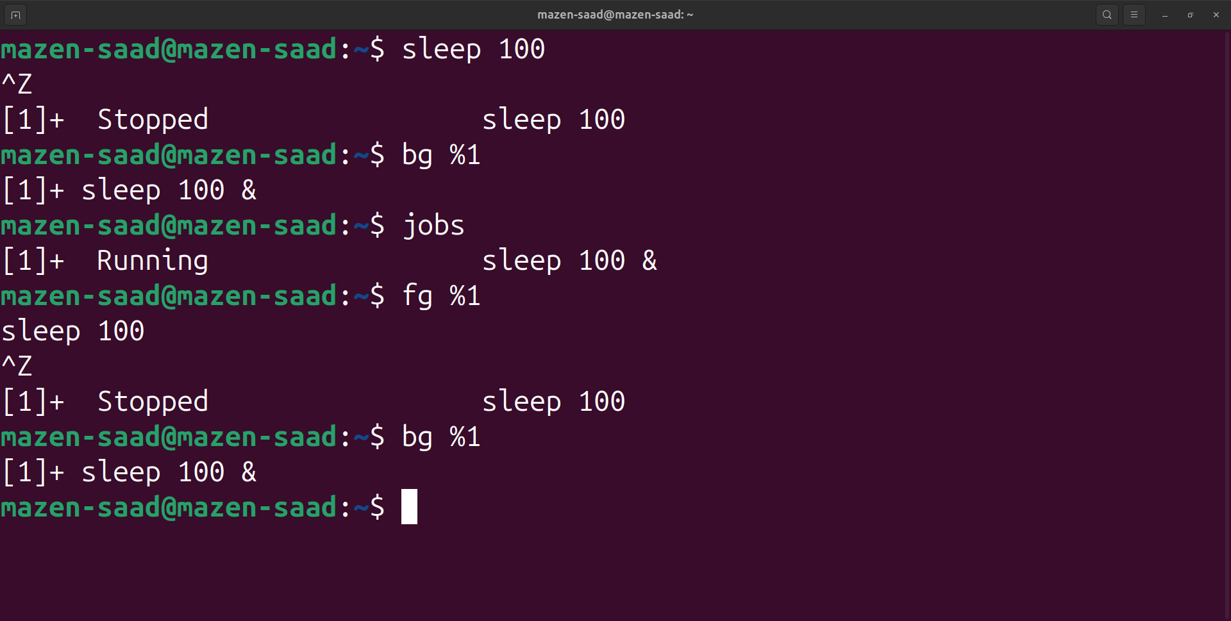

14. Kill the sleep command.

kill -9 %1

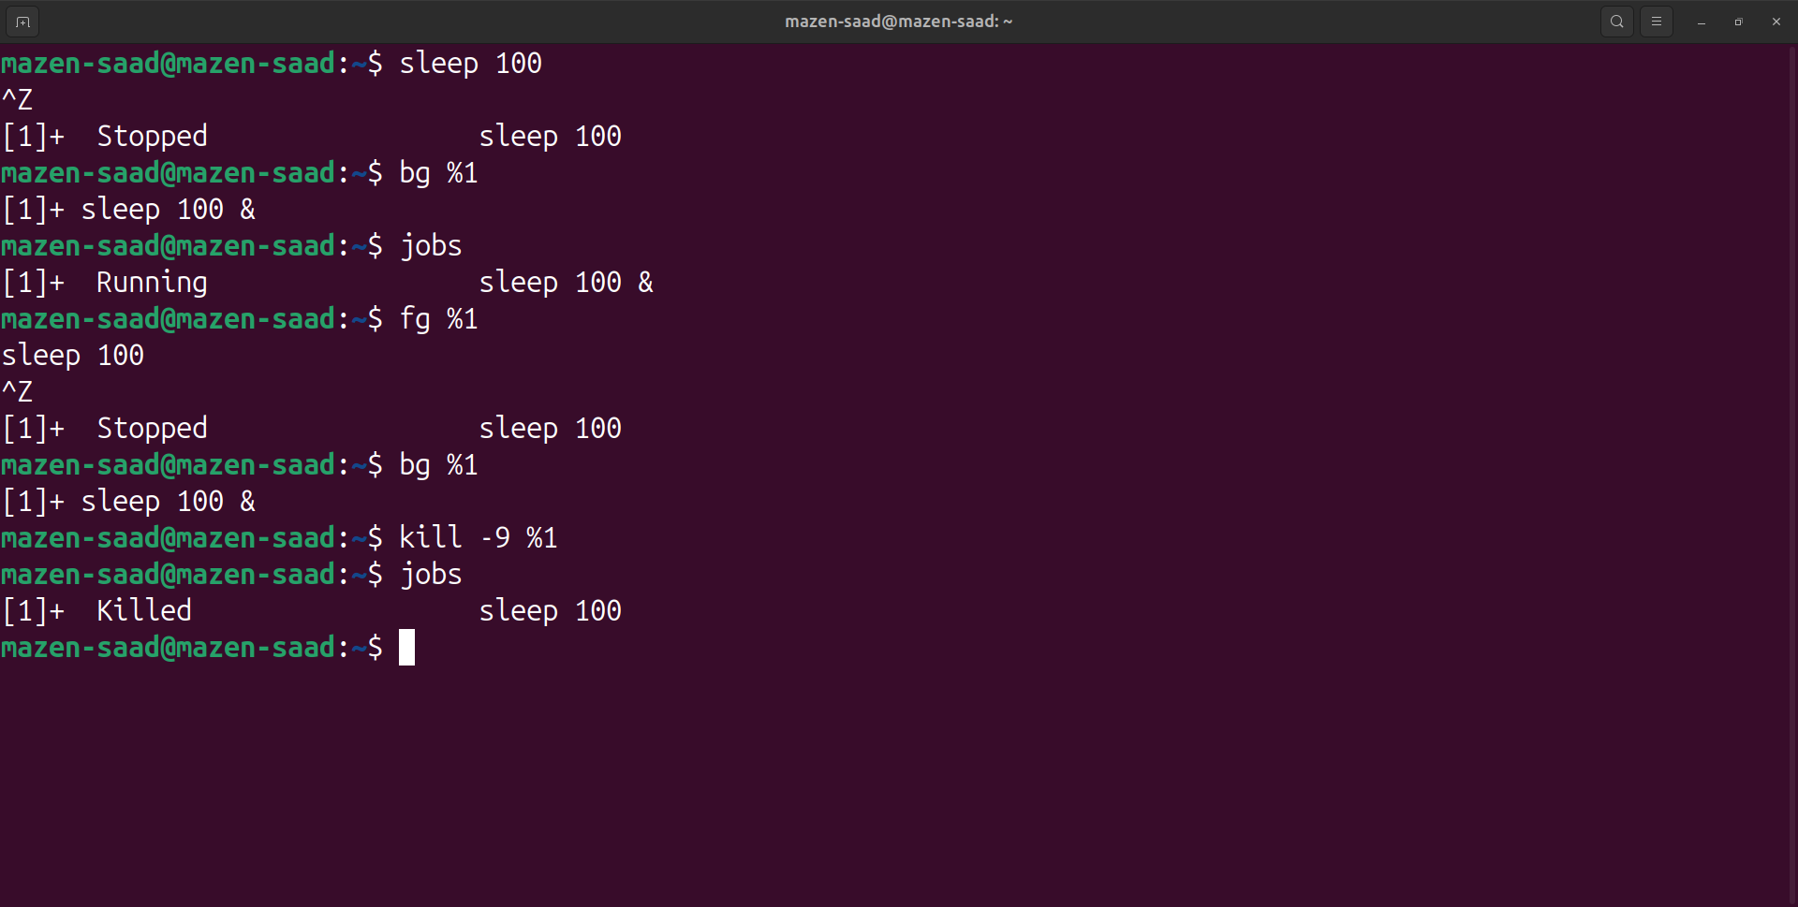

15. Display your processes only

ps -u $(whoami)

or

ps -u mazen-saad

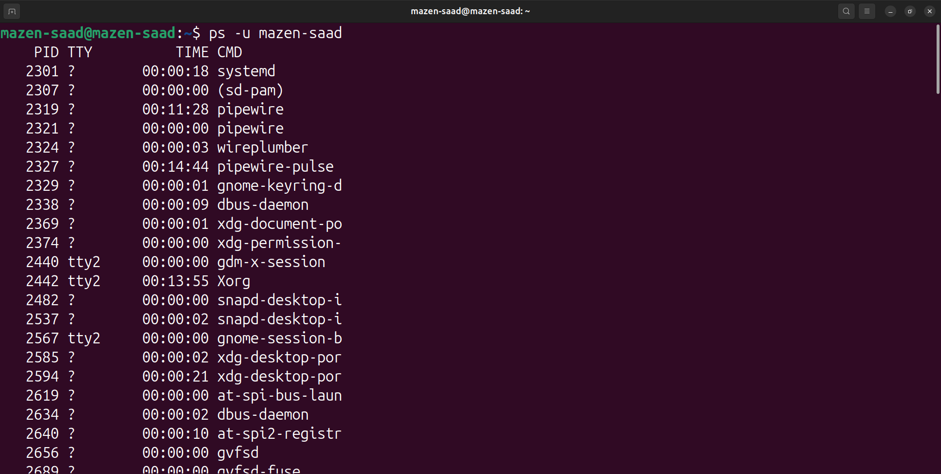

16. Display all processes except yours

ps -u $(whoami) -N

or

ps -u mazen-saad -N

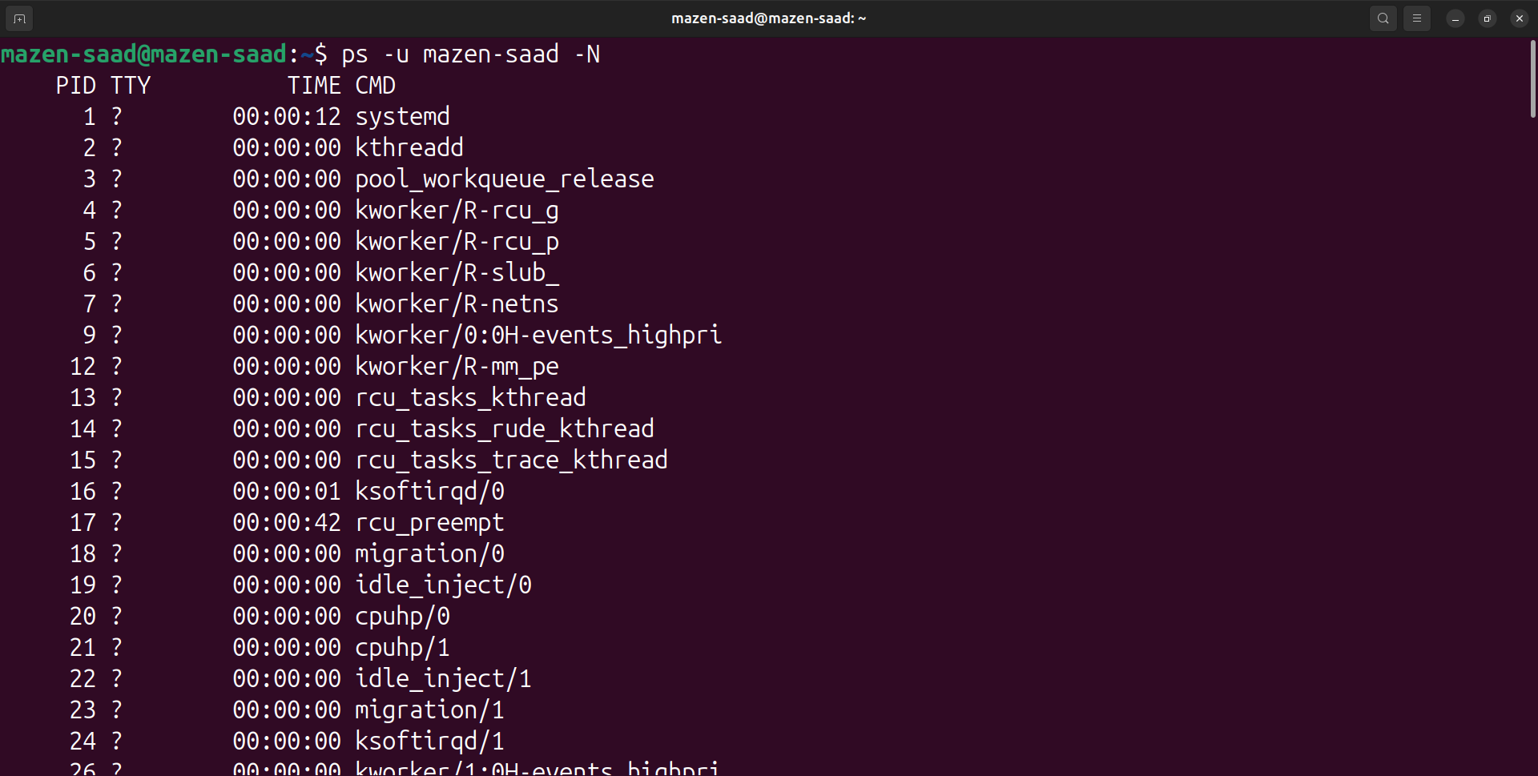

17. Use the pgrep command to list your processes only

pgrep -u $(whoami) -l

or

pgrep -u mazen-saad -l

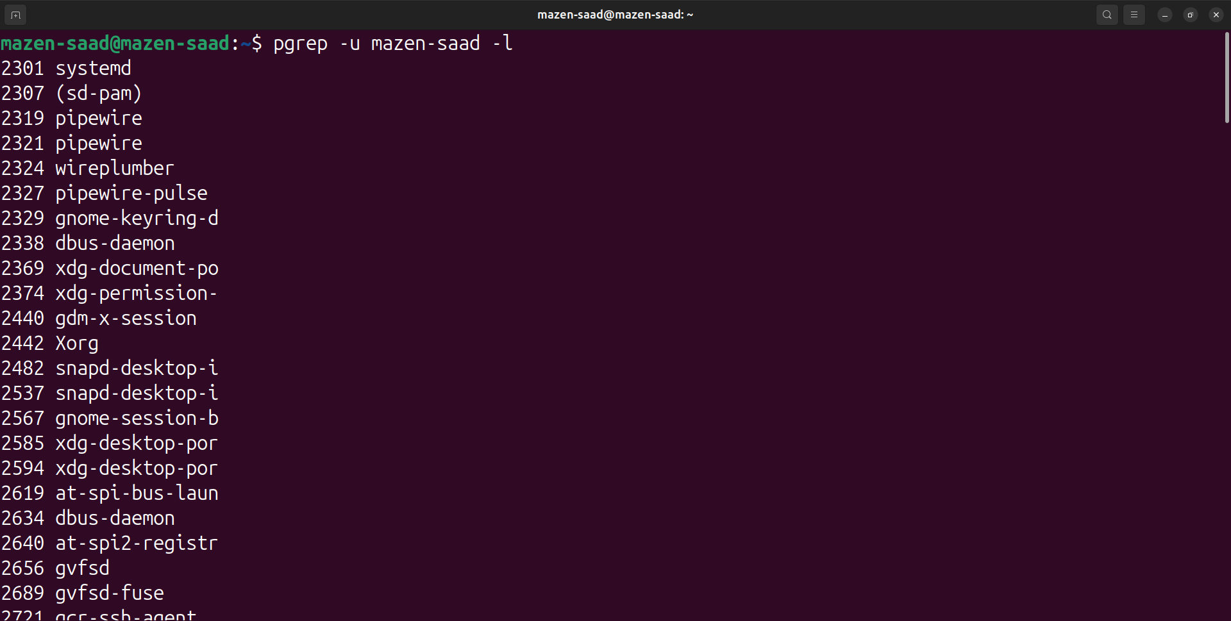

18. Copy /etc/passwd to your home directory, use the commands diff and Edit in the

cp /etc/passwd ~/newpasswd

diff /etc/passwd ~/newpasswd

vi ~/newpasswd

diff /etc/passwd ~/newpasswd

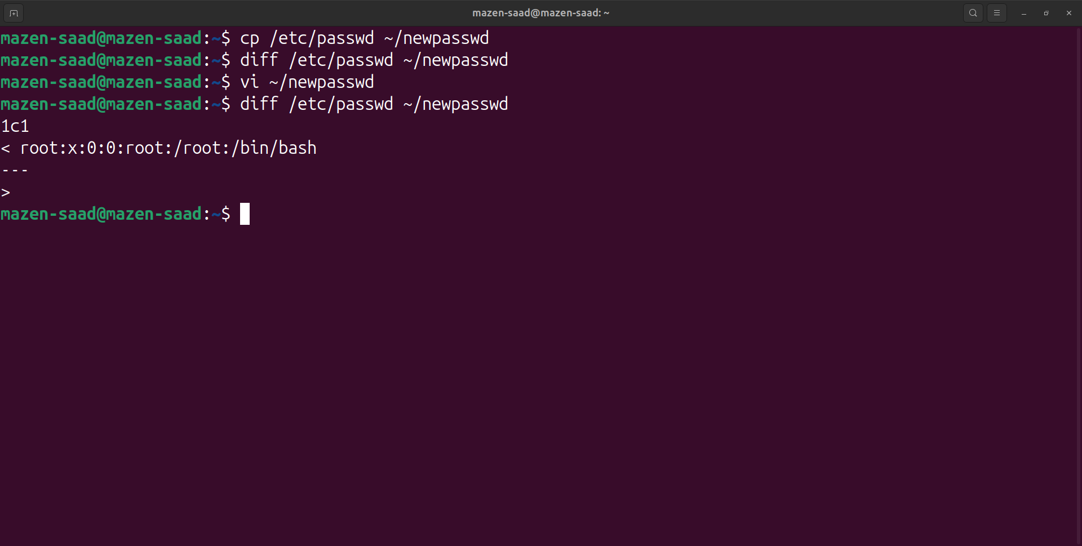

19. file you copied, and then use these command again, and check the output.

cp /etc/passwd ~/newpasswd

diff /etc/passwd ~/newpasswd

vi ~/newpasswd

diff /etc/passwd ~/newpasswd

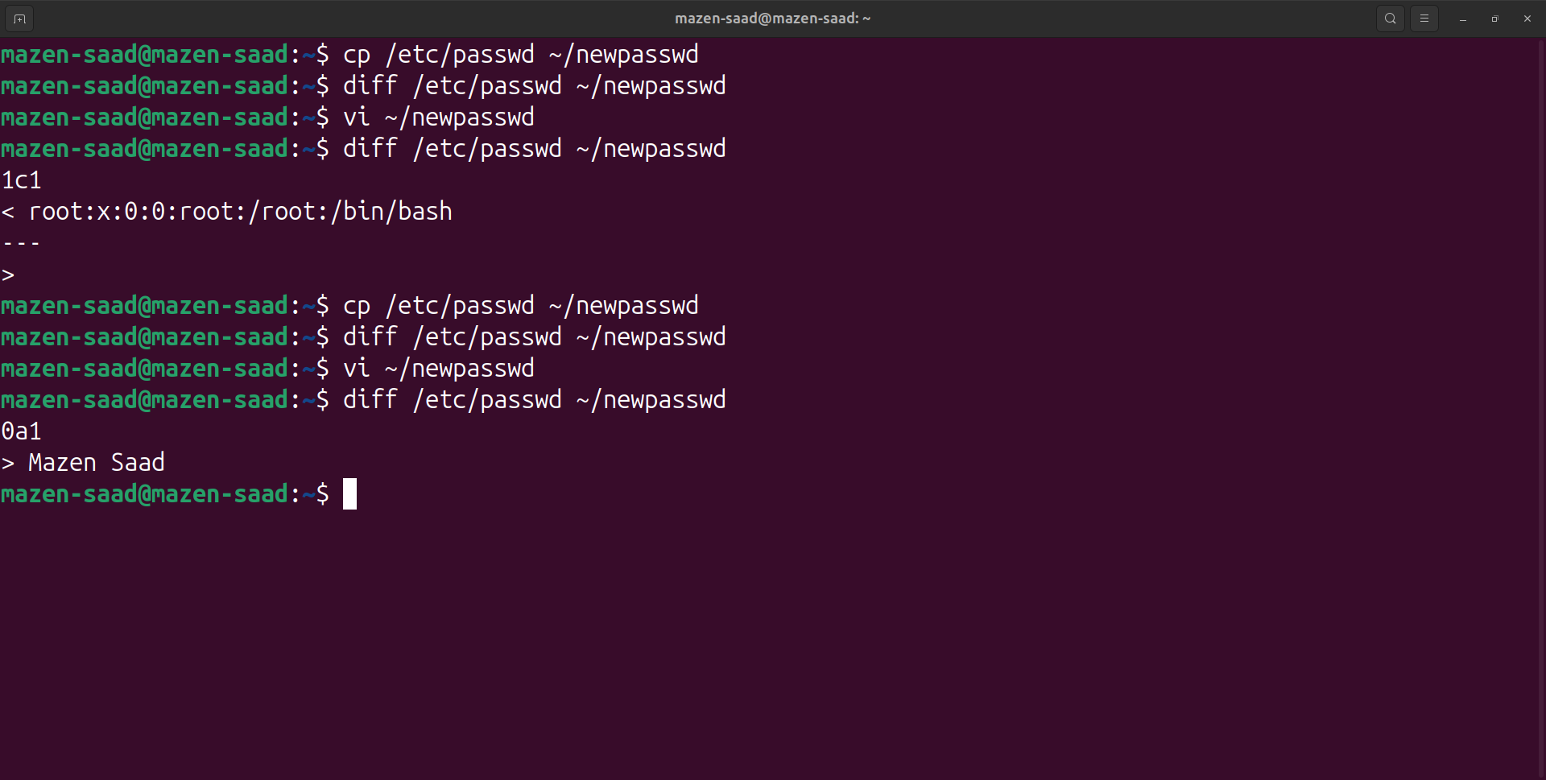

20. List the inode numbers of /, /etc, /etc/hosts.

ls -i /

ls -i /etc

ls -i /etc/hosts

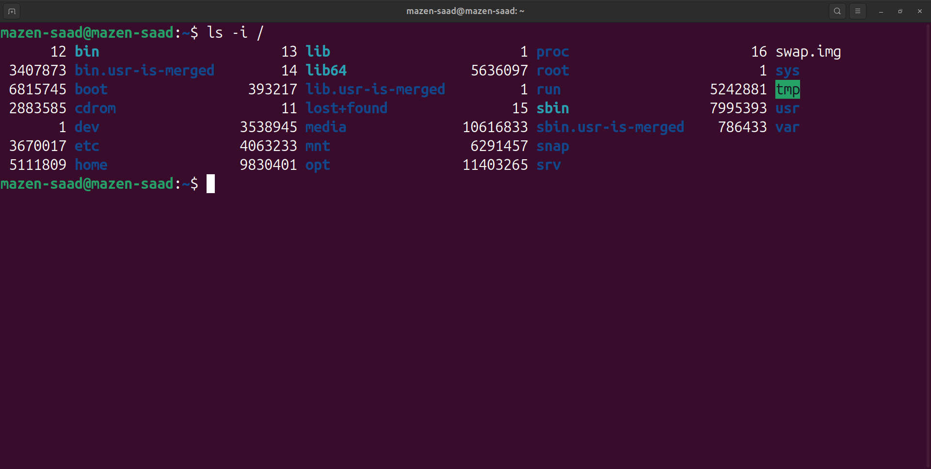

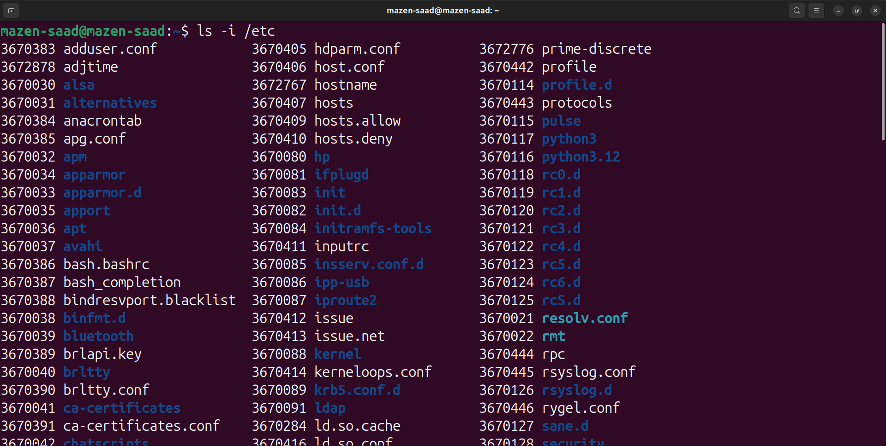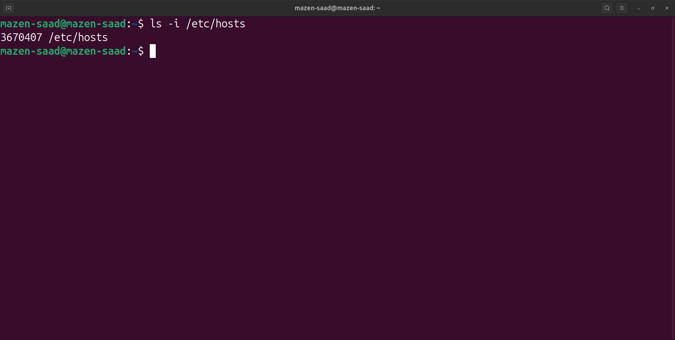

21. Find all the files whose permissions are 777.

find / -perm 777

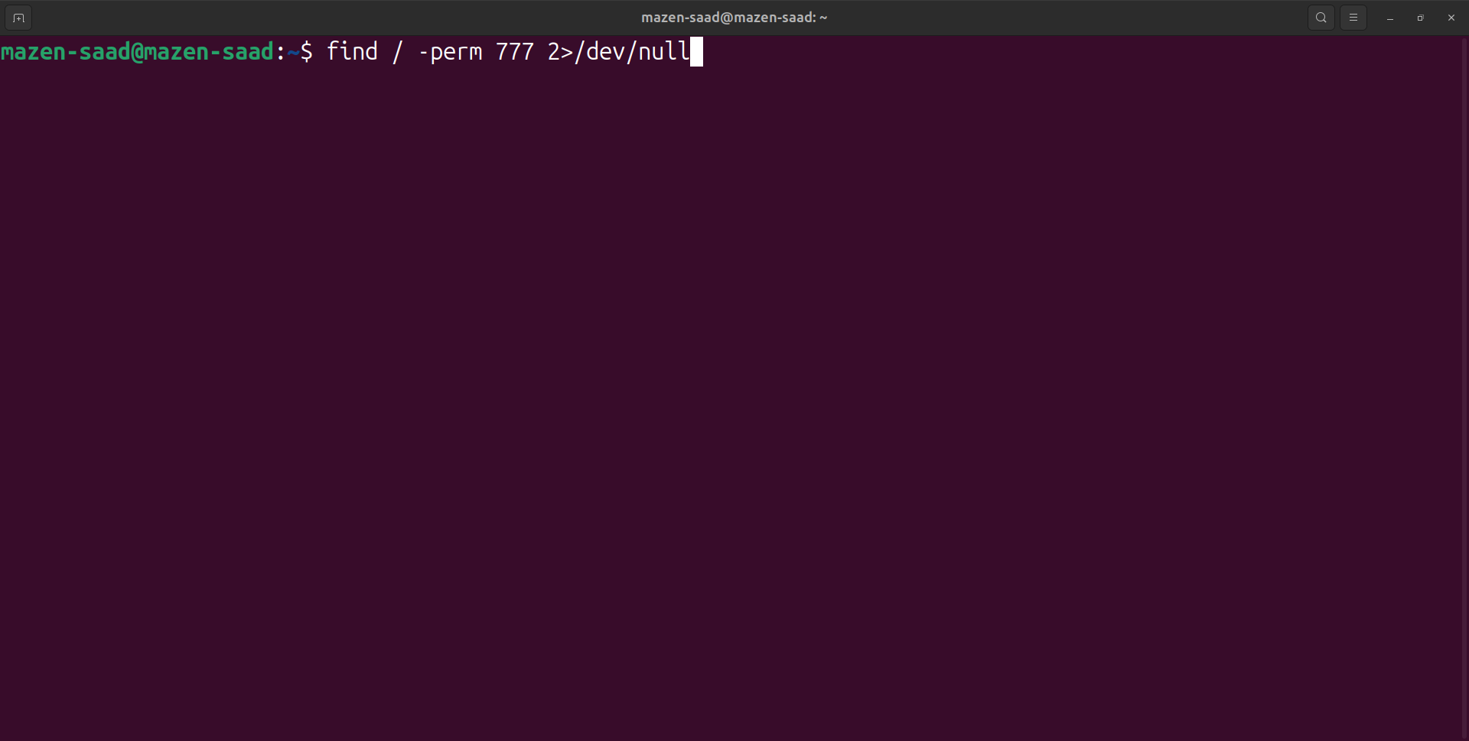

22. Find all 777 permission directories.

find / -type d -perm 777

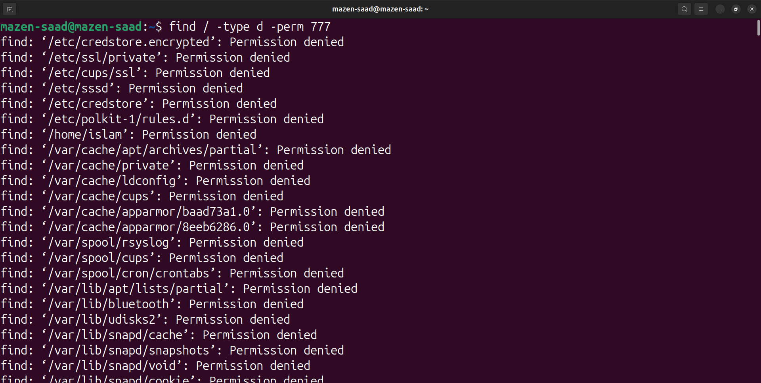

23. find all the files which are greater than 50MB and less than 100MB.

find / -size +50M -size -100M

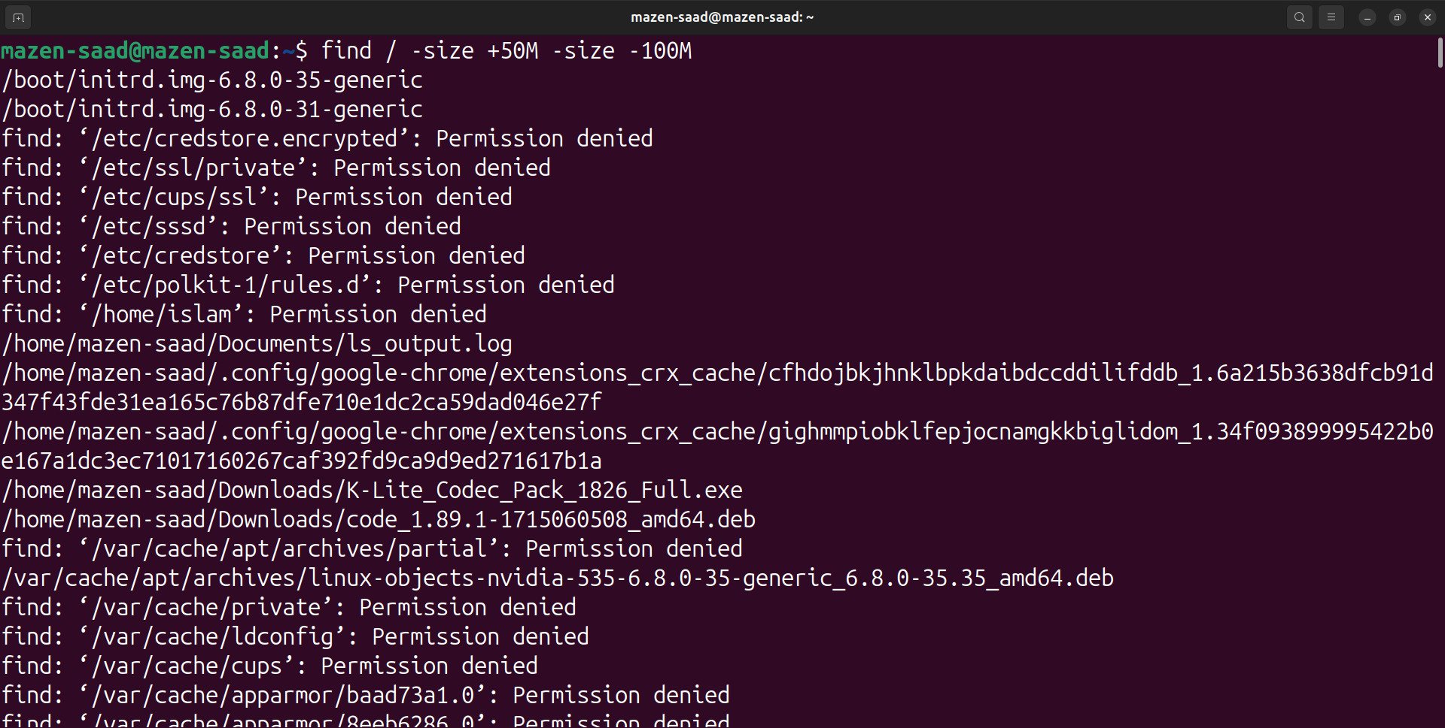

24. find all the files which are modified in the last 1 hour.

find / -mmin -60

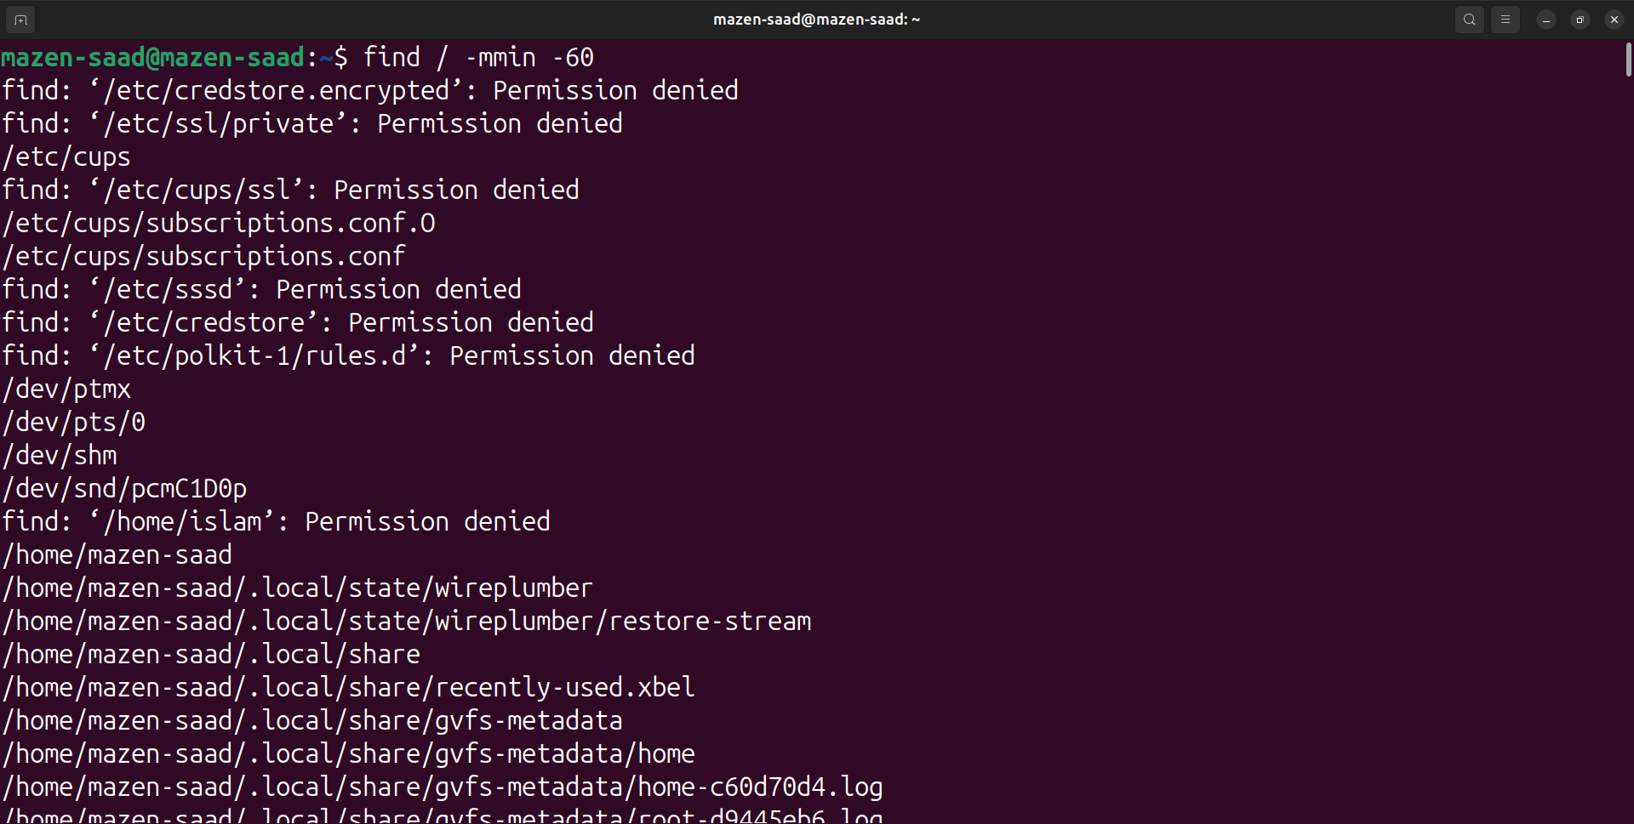

25. Compress a file by compress, gzip, bzip2 commands and decompress it again. State the differences between compress, gzip, bzip2 commands.

ls -R / > ~/Documents/file25.txt 2> /dev/null

du -sh ~/Documents/file25.txt

compress ~/Documents/file25.txt

du -sh ~/Documents/file25.txt.Z

uncompress ~/Documents/file25.txt.Z

gzip ~/Documents/file25.txt

du -sh ~/Documents/file25.txt.gz

gunzip ~/Documents/file25.txt.gz

bzip2 ~/Documents/file25.txt

du -sh ~/Documents/file25.txt.bz2

bunzip2 ~/Documents/file25.txt.bz2

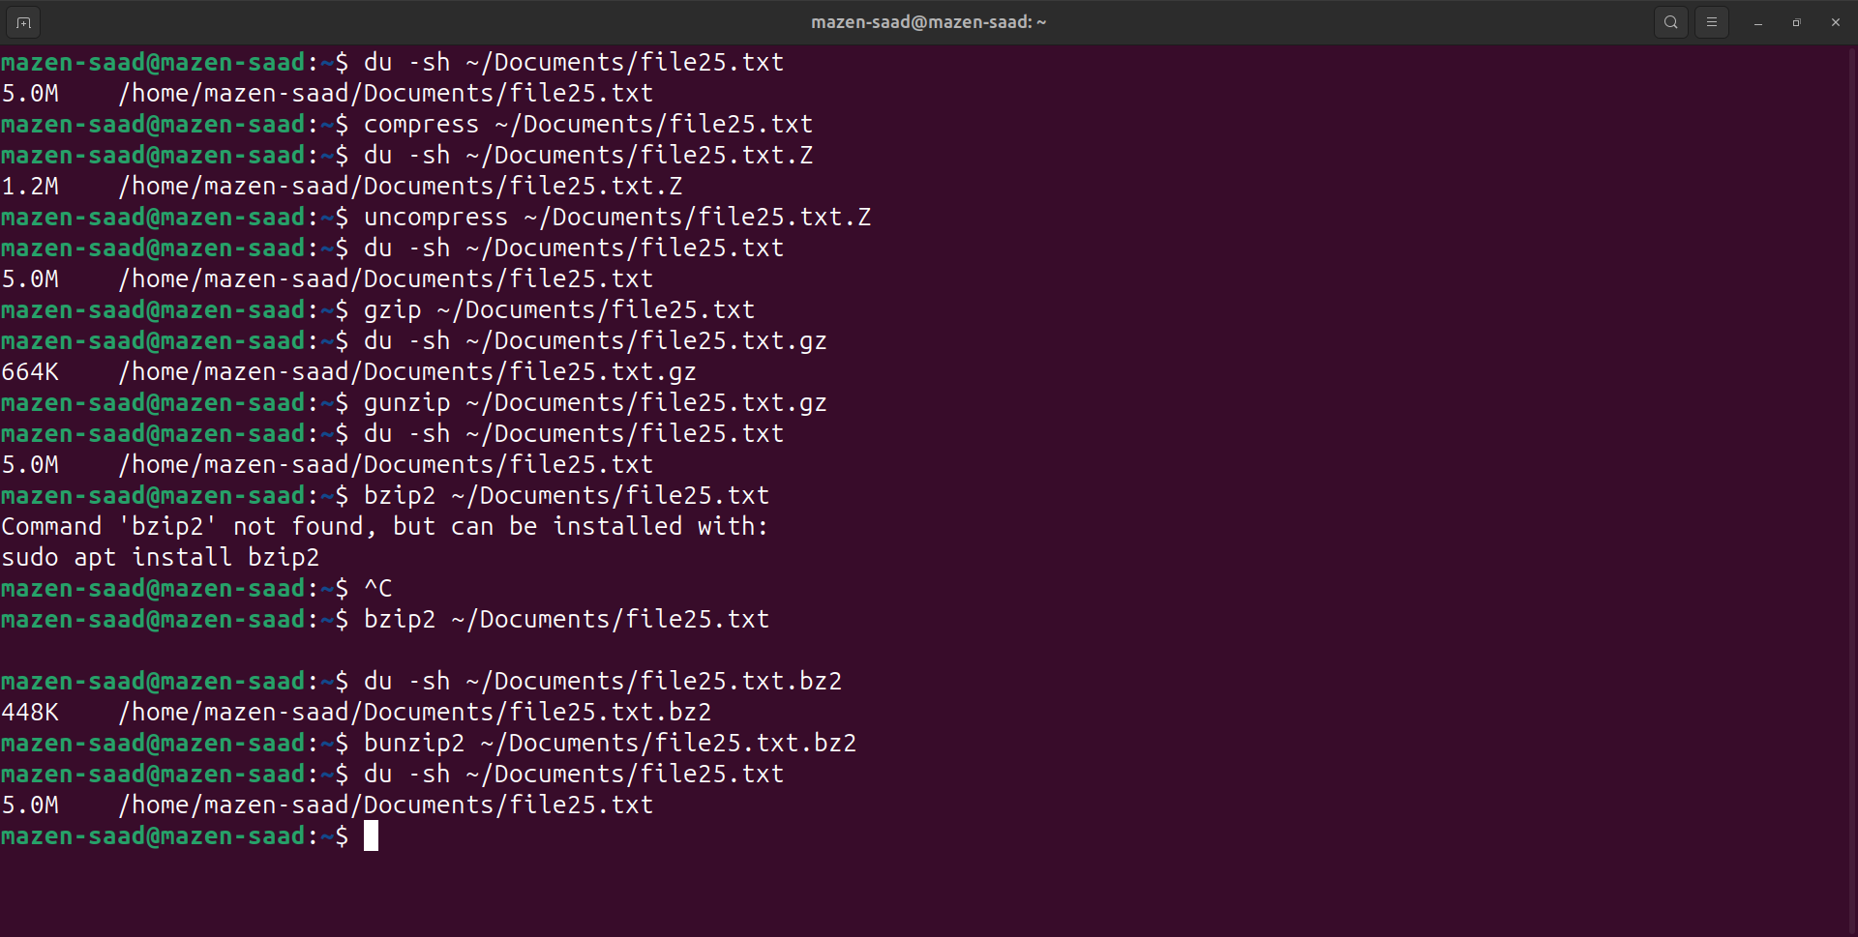

26. Backup /etc directory using tar utility.

tar -cvf ~/Documents/etc_backup.tar /etc

or

sudo tar -cvf ~/Documents/etc_backup.tar /etc

