**Apache Lab1**

**Team 4**

- Mazen AbdelTawab Saad

- Ahmed Mohammed Ahmed

- Shrouk Ahmed Hassan

- Rehab Ezat Nady

1. Install Apache HTTP server

sudo apt update

sudo apt install apache2

2. Create two simple html pages named “page1.html, page2.html” then use the suitable directive to automatically redirect from localhost/page1.html to localhost/page2.html.

(solution)

# start server

sudo service apache2 start

# restart server

sudo service apache2 restart

cd /var/www/html

sudo mkdir -p lab1/q{2..6}

cd lab1/q2

sudo touch page1.html page2.html .htaccess

# Inside the file .htaccess

RewriteEngine On

RewriteRule ^page1\.html$ /lab1/q2/page2.html [R=301,L]

# Inside the file apache2.conf

<Directory /var/www/html/lab1/q2>

AllowOverride All

</Directory>

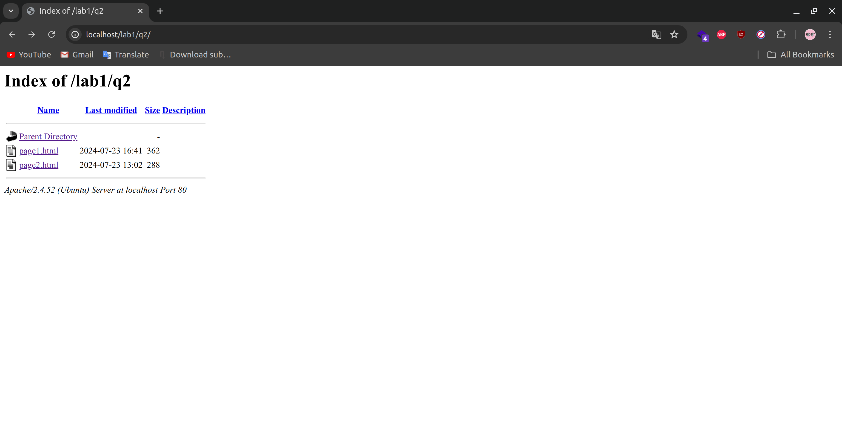

3. Ask for user name and password when accessing a directory

(solution)

# Inside the file apache2.conf

# lab1 q3

<Directory /var/www/html/lab1/q3>

AuthType Basic

AuthName "Please enter your creds"

AuthUserFile /var/www/html/.htpasswd

Require valid-user

</Directory>

# In the terminal

sudo htpasswd -c /var/www/html/.htpasswd admin

new password

123123

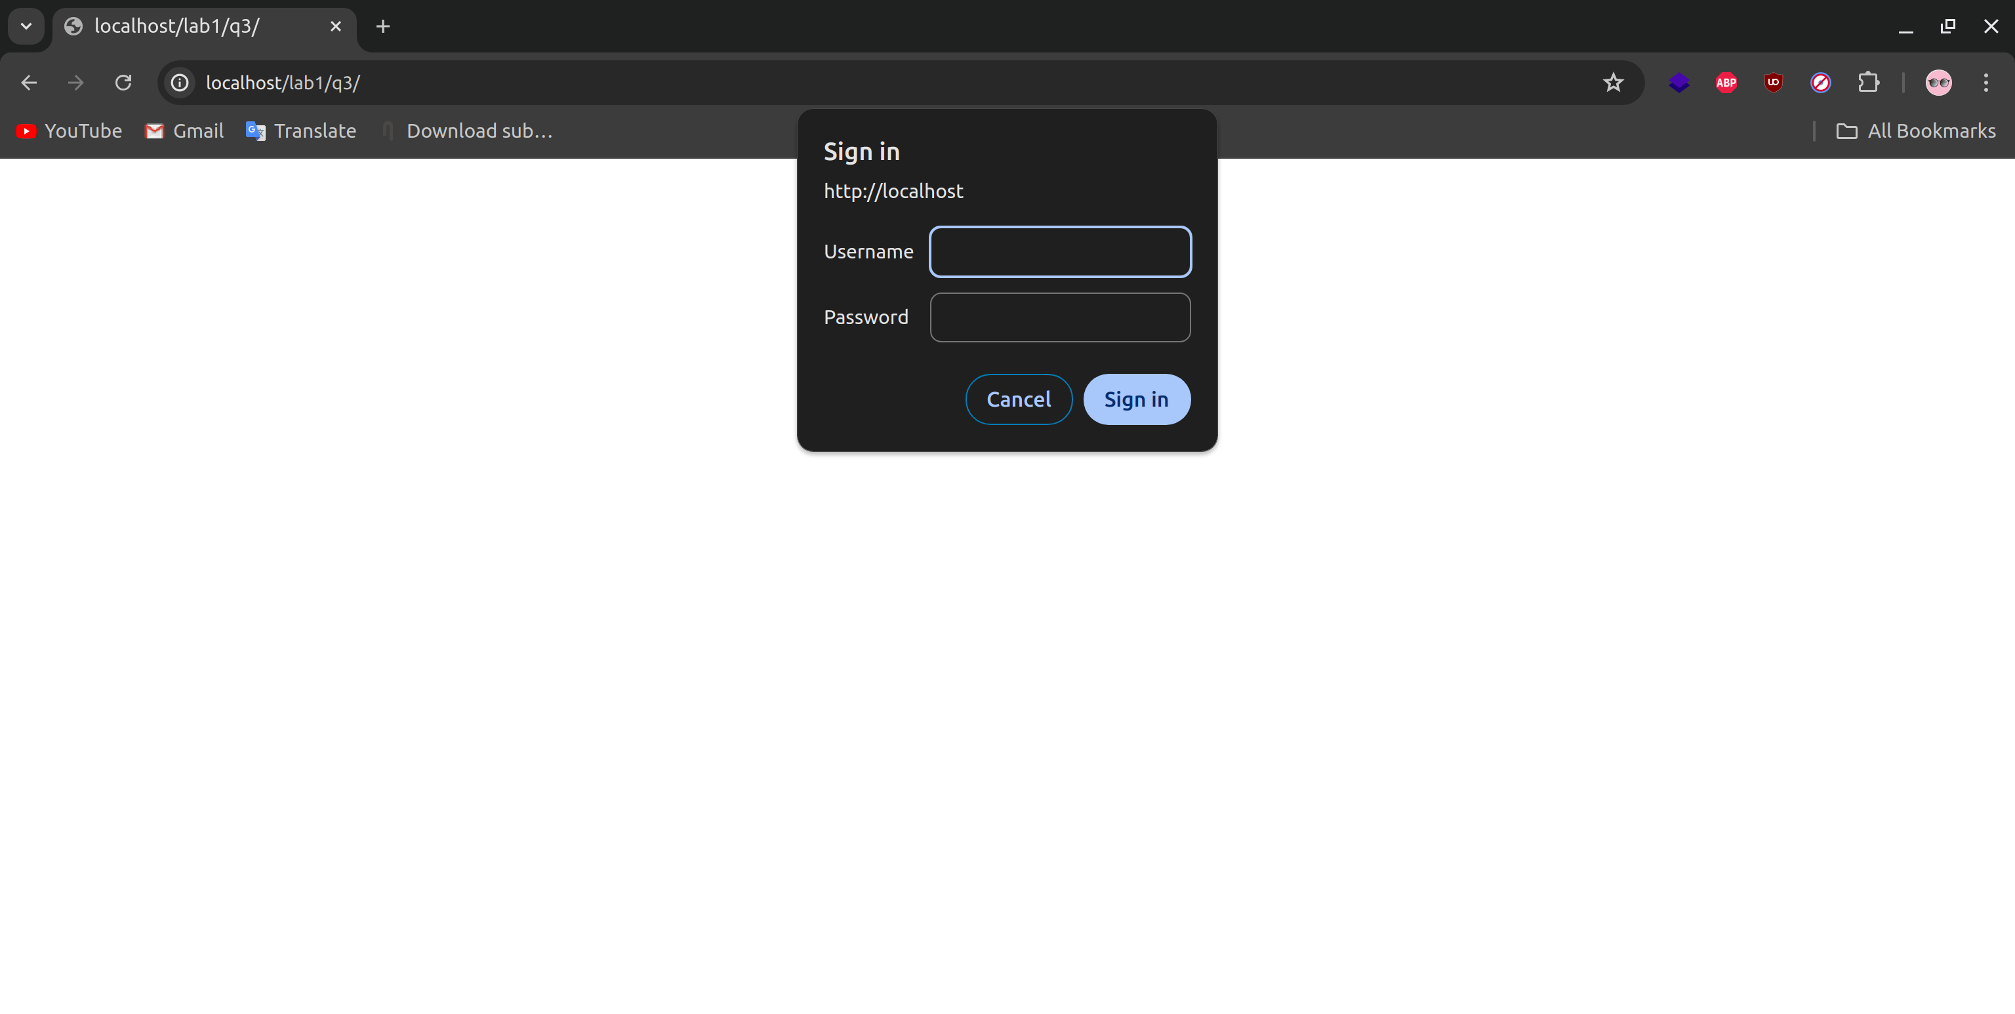

4. Apply authentication before downloading PDF files.

(solution)

# Inside the file apache2.conf

# lab1 q4

<FilesMatch "\.pdf$">

AuthType Basic

AuthName "Restricted Content"

AuthUserFile /var/www/html/.htpasswd

Require valid-user

</FilesMatch>

5. Create a directory then allow access to one of your classmates only.

(solution)

# Inside the file apache2.conf

# lab1 q5

<Directory /var/www/html/lab1/q5>

Deny from all

Allow from 154.178.254.39

Allow from 154.178.253.220

Allow from 41.68.71.101

Allow from 154.178.232.64

Order Deny,Allow

</Directory>

6. Disable listing the directory content (hint use indexs)

(solution)

cd q6

sudo touch .htaccess

# Inside the file .htaccess

Options -Indexes

# Inside the file apache2.conf

# lab1 q6

<Directory /var/www/html/lab1/q6>

AllowOverride All

</Directory>

