**Apache Lab2**

**Team 4**

- Mazen AbdelTawab Saad

- Ahmed Mohammed Ahmed

- Shrouk Ahmed Hassan

- Rehab Ezat Nady

1. Change the default index page to default.html instead of index.html (use DirectoryIndex)

cd /etc/apache2

sudo vim apache2.conf

# Add the following code in the file

DirectoryIndex default.html index.html

sudo service apache2 restart

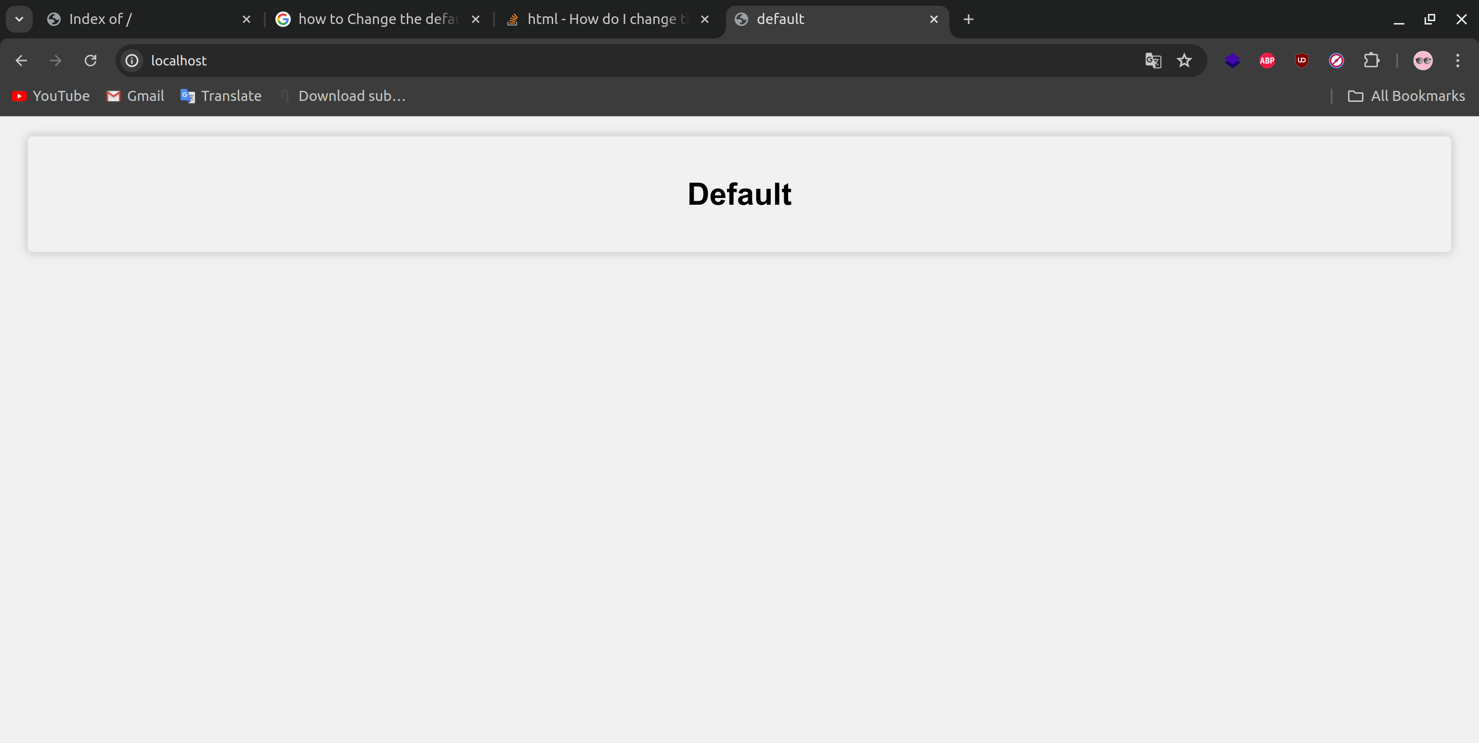

2. Change the default port to be 8000 instead of 80

cd /etc/apache2

sudo vim ports.conf

# edit listen

8000

sudo service apache2 restart

# open

localhost:8000

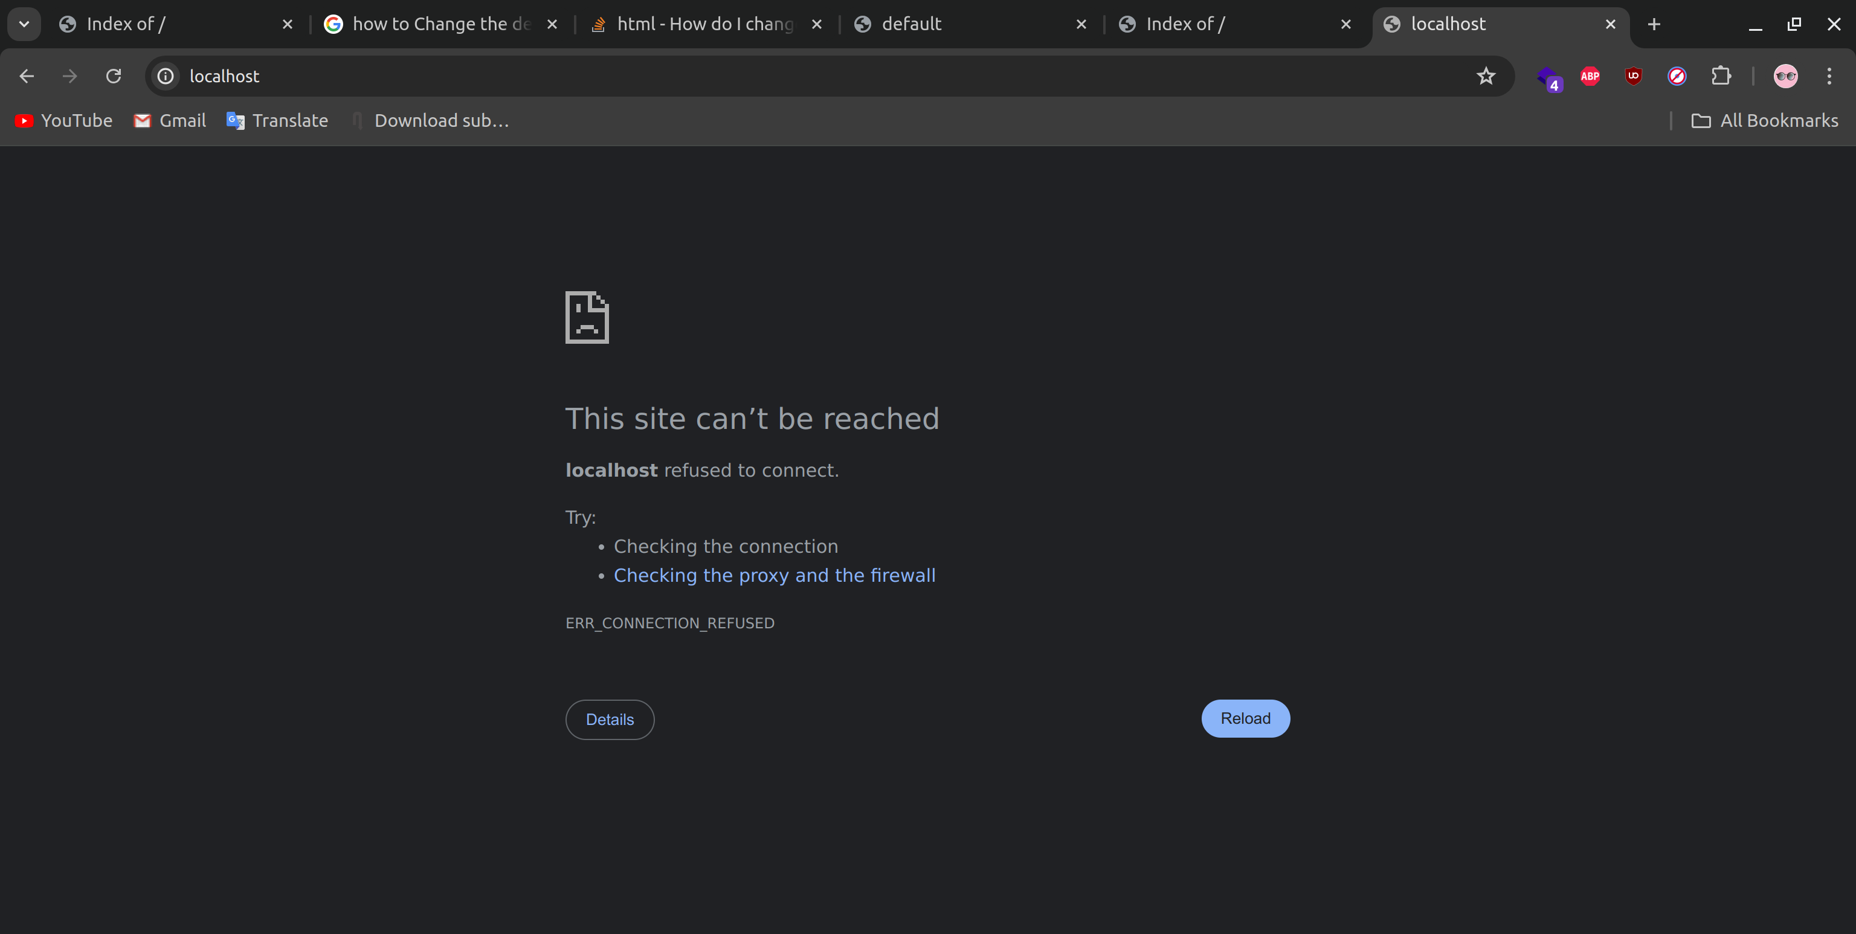

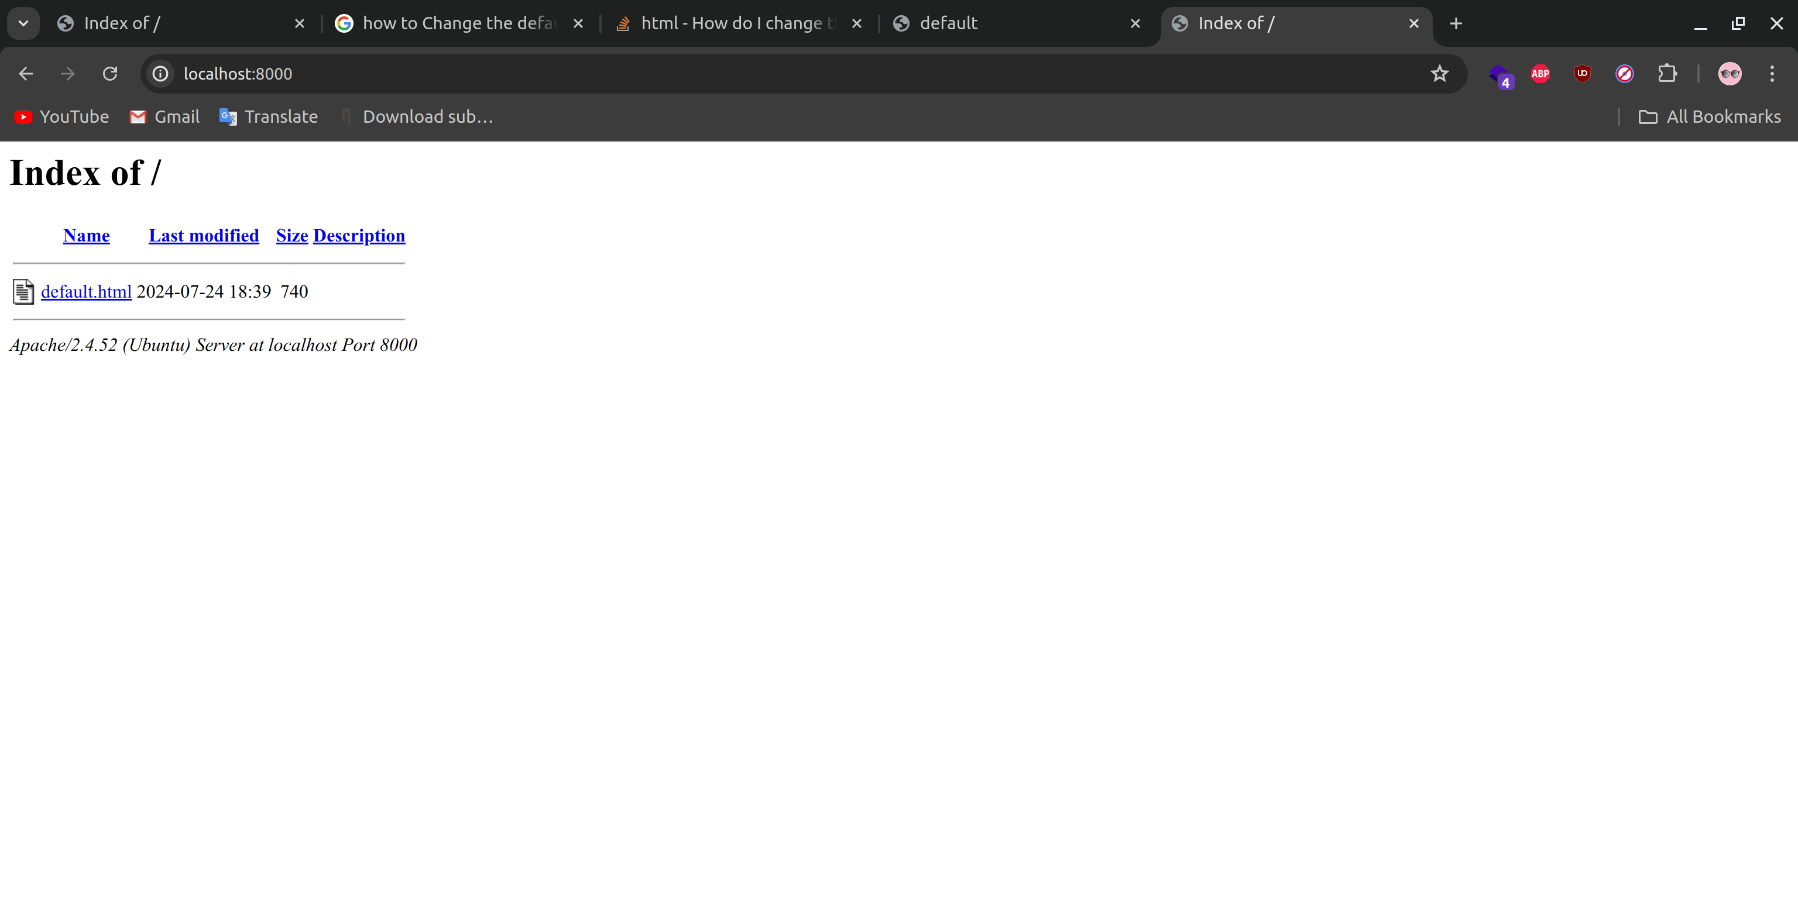

3. What is the importance of rewrite module?

The mod_rewrite module is an Apache module that allows you to rewrite URLs.

It can be used to optimize your URL structure, to apply access restrictions, or to create search engine friendly links.

It is a very powerful and flexible tool for directing and controlling traffic to your site.

4. Configure apache to use Worker MPM

sudo a2enmod mpm_worker

cd /etc/apache2

# edit file apache2.conf

sudo vim apache2.conf

<IfModule mpm_worker_module>

StartServers 2

MinSpareThreads 25

MaxSpareThreads 75

ThreadsPerChild 25

MaxRequestWorkers 150

</IfModule>

5. Check the status of rewrite_mod and enable it if it is enabled.

apache2ctl -M | grep rewrite

sudo a2enmod rewrite

sudo service apache2 restart

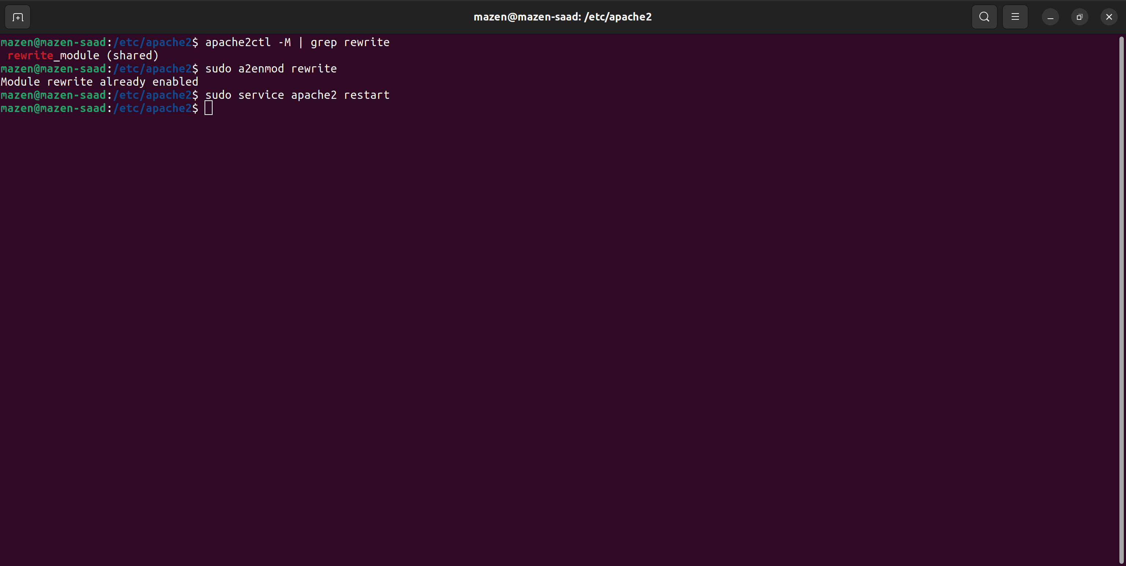

Bonus:

1- Write RewriteCond and RewiteRules for:

cd /etc/apache2/sites-enabled

sudo vim 000-default.conf

sudo service apache2 restart

A. Deny access to http://localhost/page?queryString if queryString contains the string forbidden.

RewiteEngine on

RewriteCond "%{QUERY_STRING}" "^queryString=forbidden$"

RewriteRule ^/page - [F]

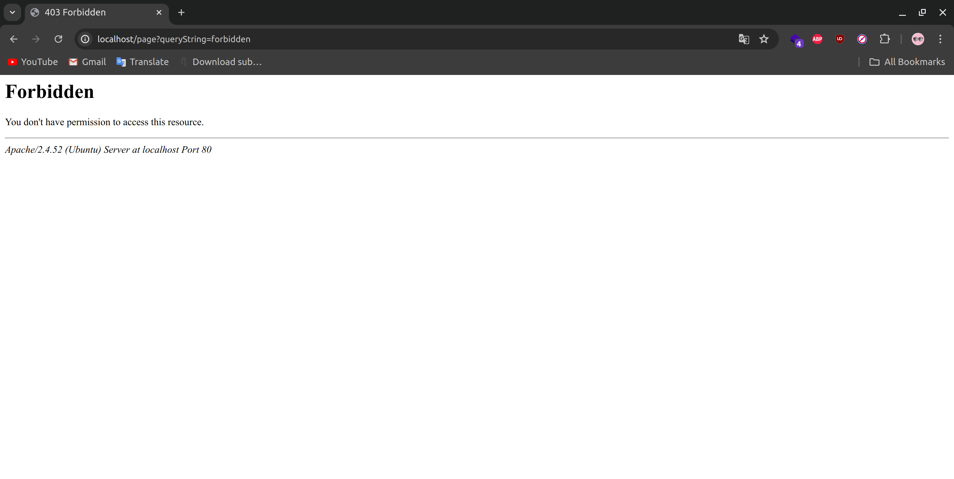

B. Remove the Query String

RewiteEngine on

RewriteCond "%{QUERY_STRING}" "^queryString=forbidden$"

RewriteRule ^/page /page? [R]



C. Rewrite URLs like http://localhost/page1?var=val to

http://localhost/page2?var=val

but do not rewrite if val isn't present.

RewiteEngine on

RewriteCond "%{QUERY_STRING}" "(var)=(val)"

RewriteRule ^/page1$ /page2 [R]



D. Take a URL of the form http://localhost/path?var=val and transform it

into http://localhost/path/var/val.

RewiteEngine on

RewriteCond "%{QUERY_STRING}" "^(var)=(val)$"

RewriteRule ^/path$ /path/var/val? [R]



E. Map http://localhost/example/one/two to

http://localhost/something.cgi?arg=one&other=two

RewiteEngine on

RewriteRule ^/example/(one)/(two)$ /something.cgi?arg=$1&other=$2 [R]



2- Create virtualhost for os.iti.gov.eg website

cd /etc/apache2/sites-available

sudo vim os.iti.gov.eg.conf

<VirtualHost *:80>

ServerAdmin "webmaster@os.iti.gov.eg"

ServerName os.iti.gov.eg

ServerAlias "os.iti.gov.eg"

DocumentRoot "var/www/html/os.iti.gov.eg

</VirtualHost>

sudo mkdir -p /var/www/html/os.iti.gov.eg

sudo a2ensite os.iti.gov.eg

sudo service apache2 restart