**Mazen AbdelTawab Saad**

**BSS - Lab1**

1- Display the lines that contain the word “lp” in /etc/passwd file.

sed -n '/lp/p' /etc/passwd

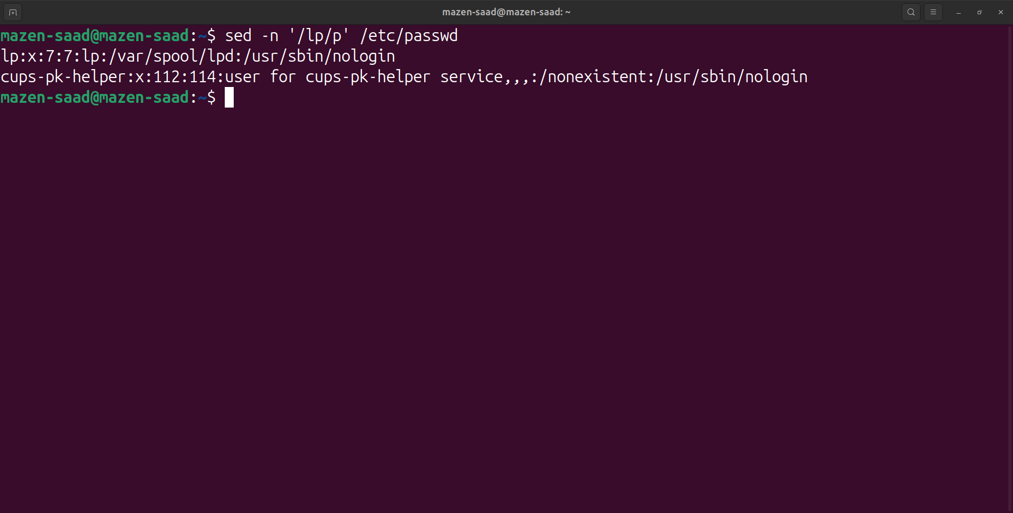

2- Display /etc/passwd file except the third line.

sed -n '3!p' /etc/passwd

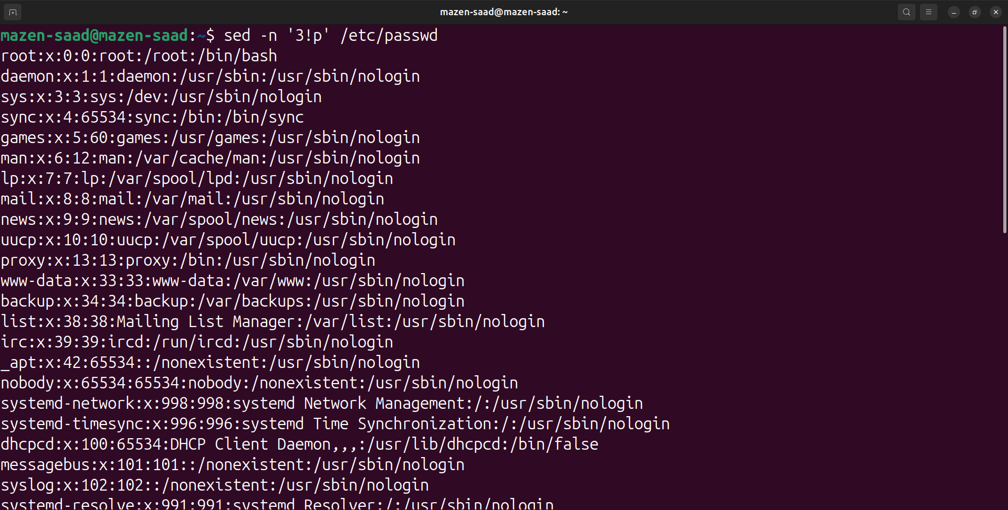

3- Display /etc/passwd file except the last line.

sed -n '$!p' /etc/passwd

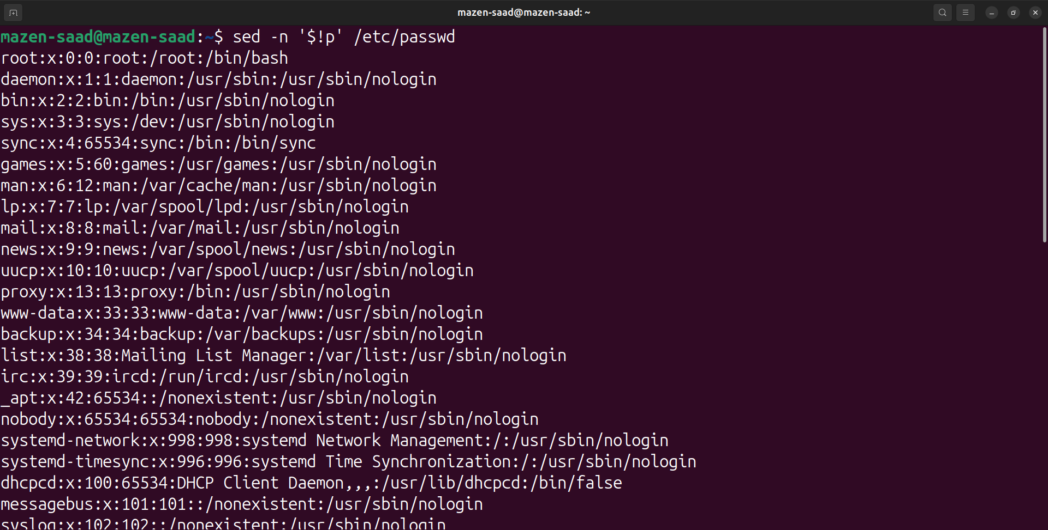

4- Display /etc/passwd file except the lines that contain the word “lp”.

sed -n '/lp/!p' /etc/passwd

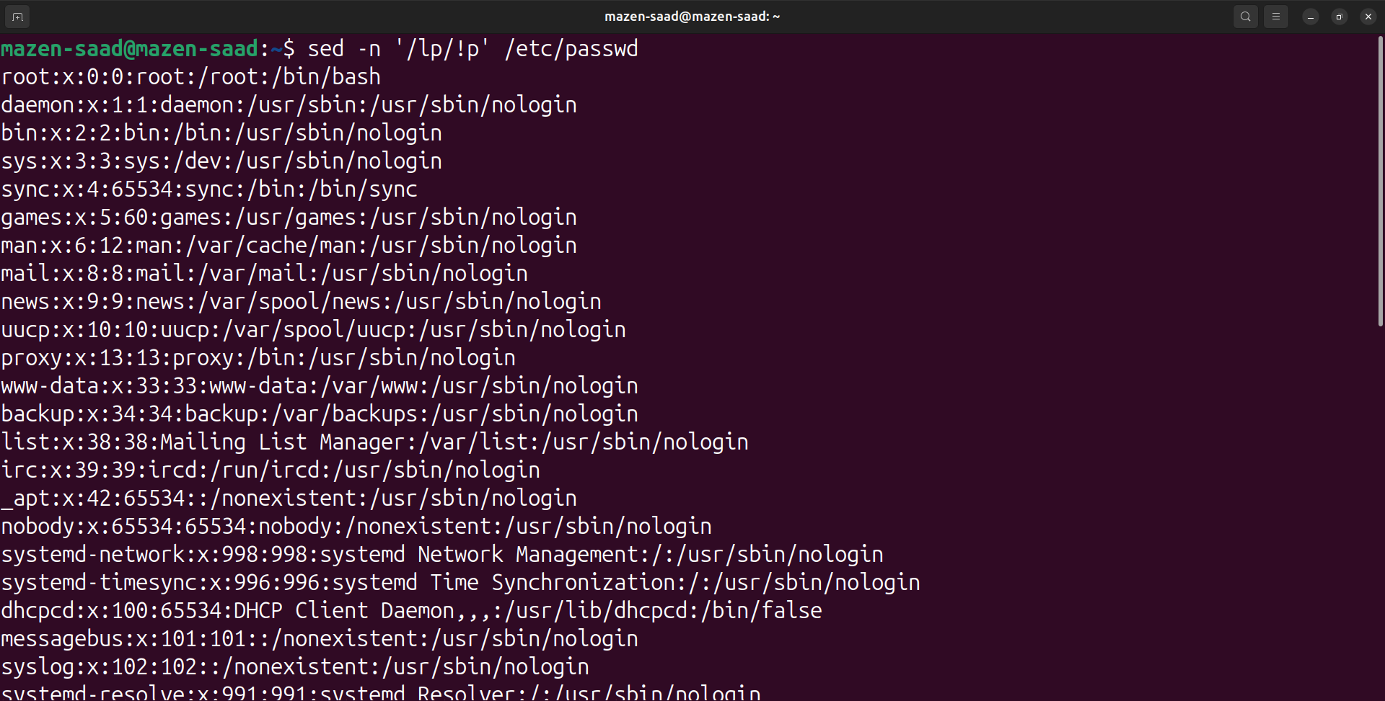

5- Substitute all the words that contain “lp” with “mylp” in /etc/passwd file.

sed -n 's/lp/mylp/gp' /etc/passwd

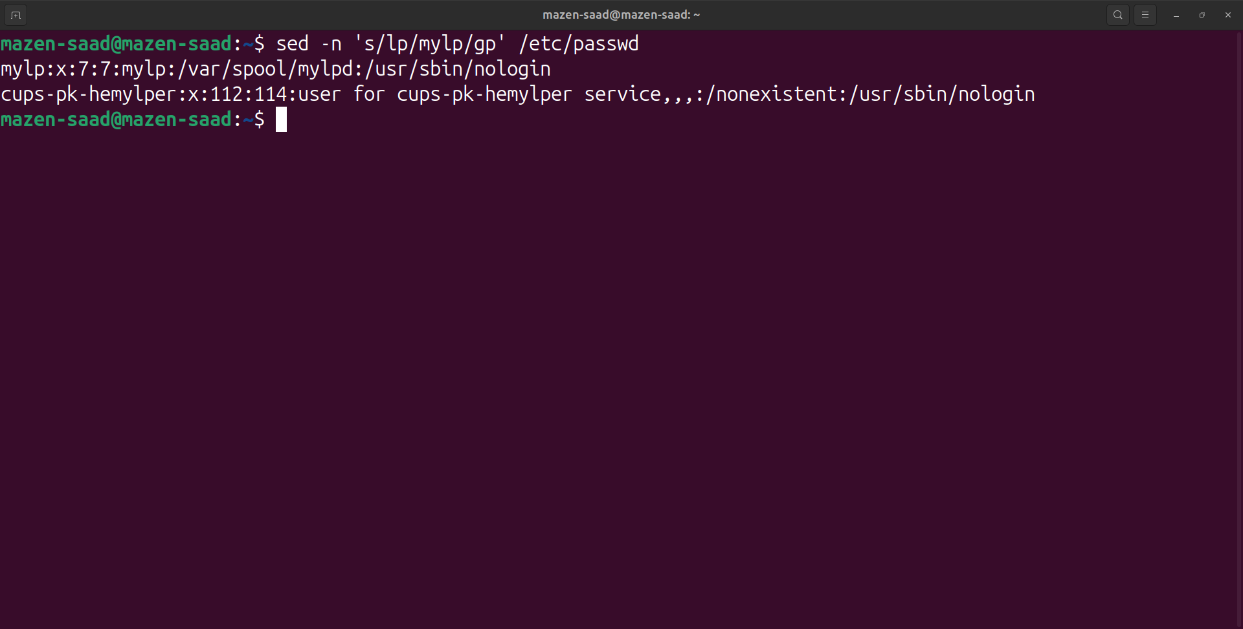

1- Print full name (comment) of all users in the system.

# Q1

awk -F: '

{

print NR" - "$5

}

' /etc/passwd

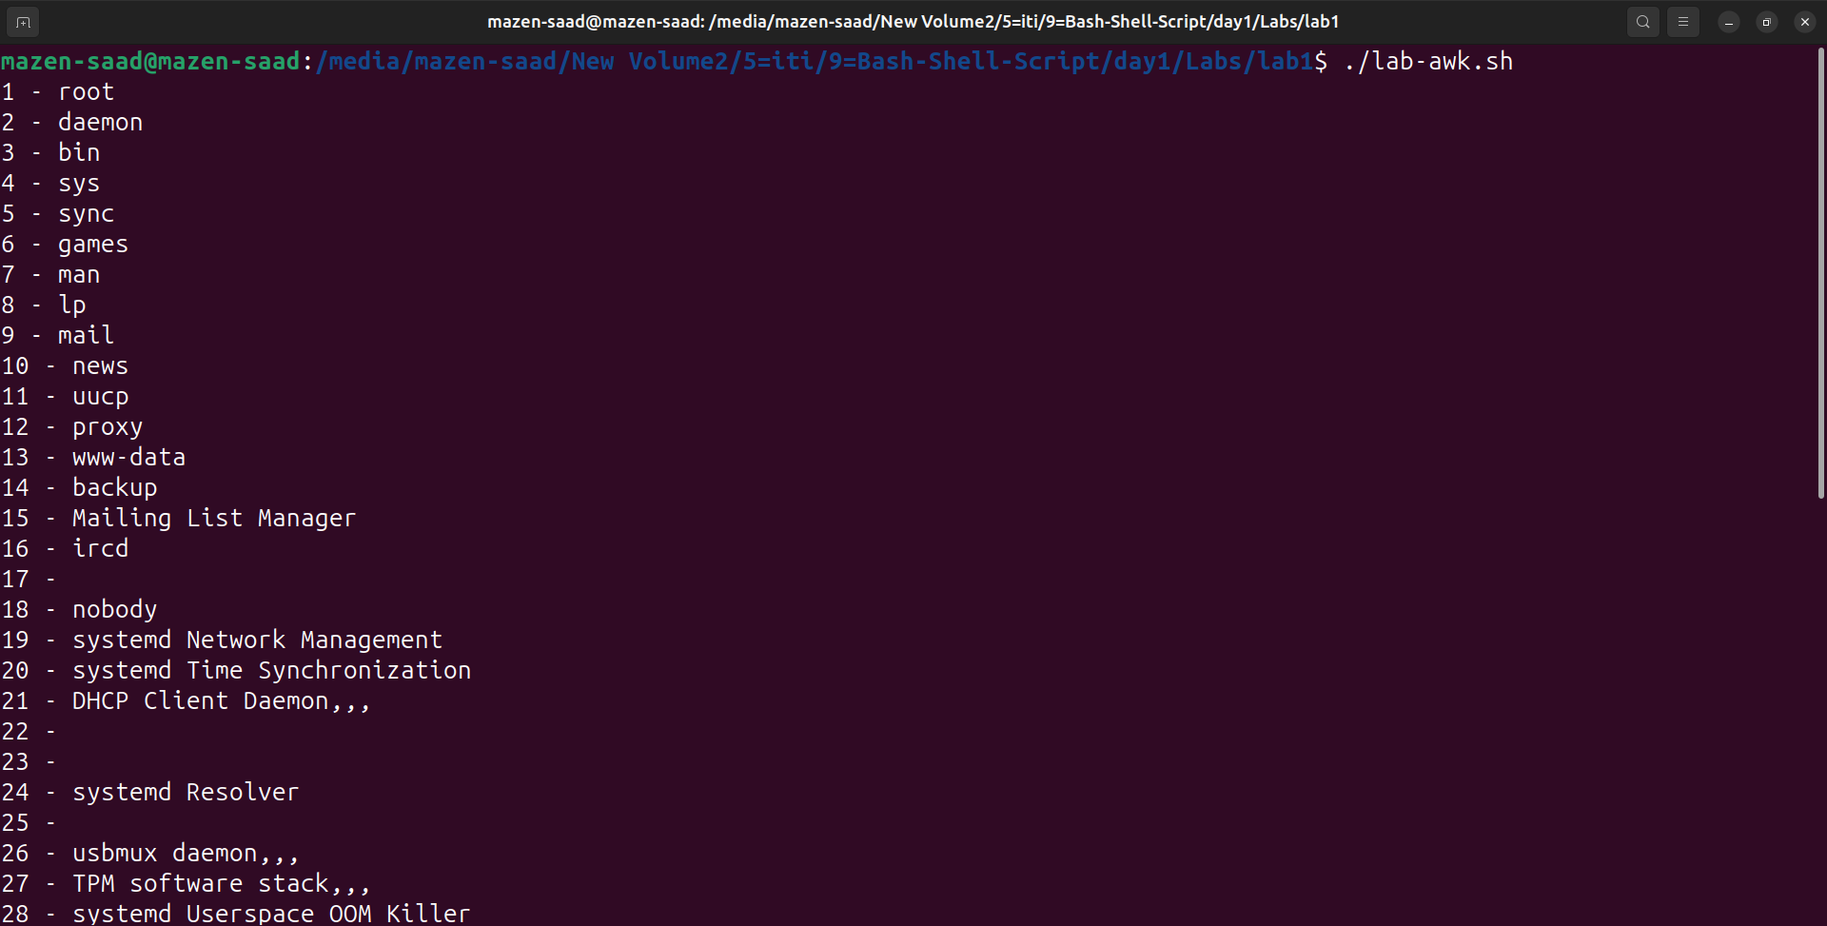

2- Print login, full name (comment) and home directory of all users.( Print each line preceded by a line number)

# Q2

# mazen-saad : x:1000:1000: Mazen Saad :/home/mazen-saad:/bin/bash

awk -F: '

BEGIN{

OFS=" - "

}

{

print NR, $1, $5, $6

}

' /etc/passwd

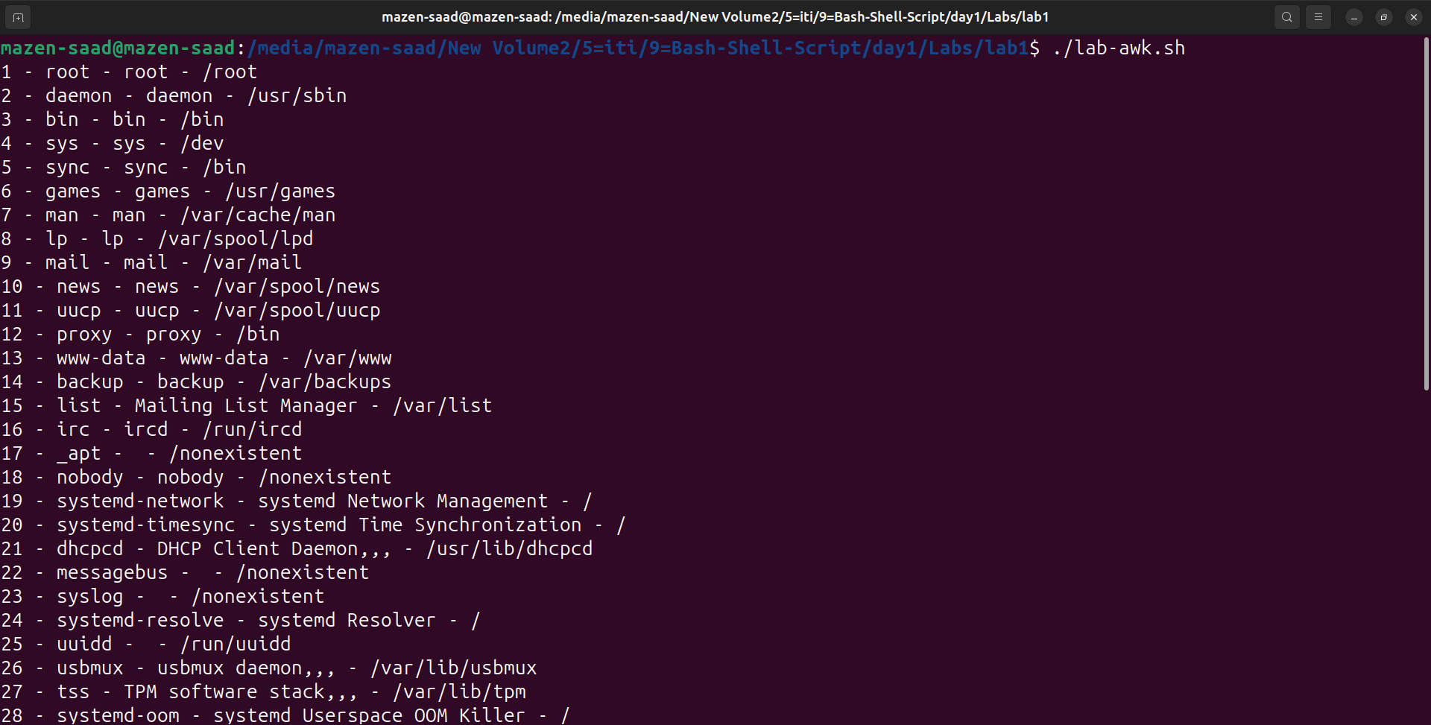

3- Print login, uid and full name (comment) of those uid is greater than 500

# Q3

# mazen-saad : x : 1000 : 1000 : Mazen Saad :/home/mazen-saad:/bin/bash

awk -F: '

BEGIN{

OFS=" - "

}

{

if ($3 > 500){

print NR, $1, $3, $5

}

}

' /etc/passwd

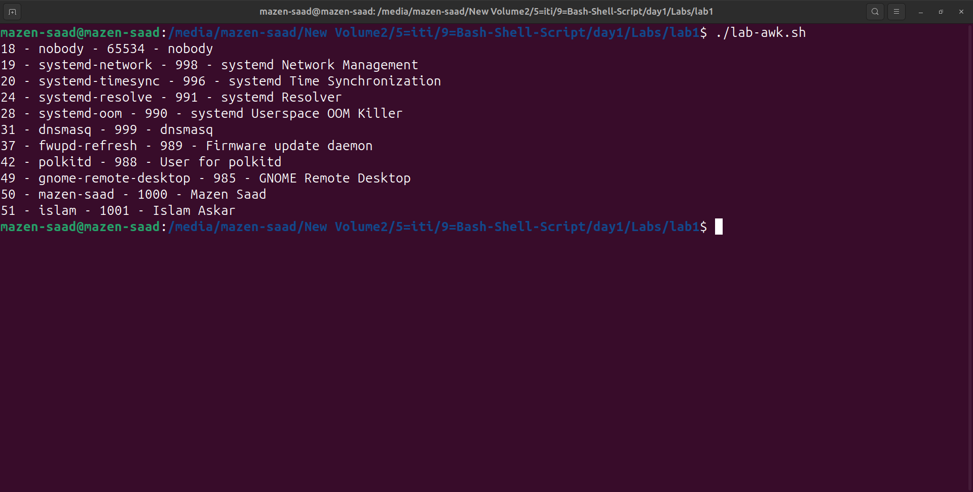

4- Print login, uid and full name (comment) of those uid is exactly 500

# Q4

# mazen-saad : x : 1000 : 1000 : Mazen Saad :/home/mazen-saad:/bin/bash

awk -F: '

BEGIN{

OFS=" - "

}

{

if ($3 == 500){

print NR, $1, $3, $5

}

}

' /etc/passwd

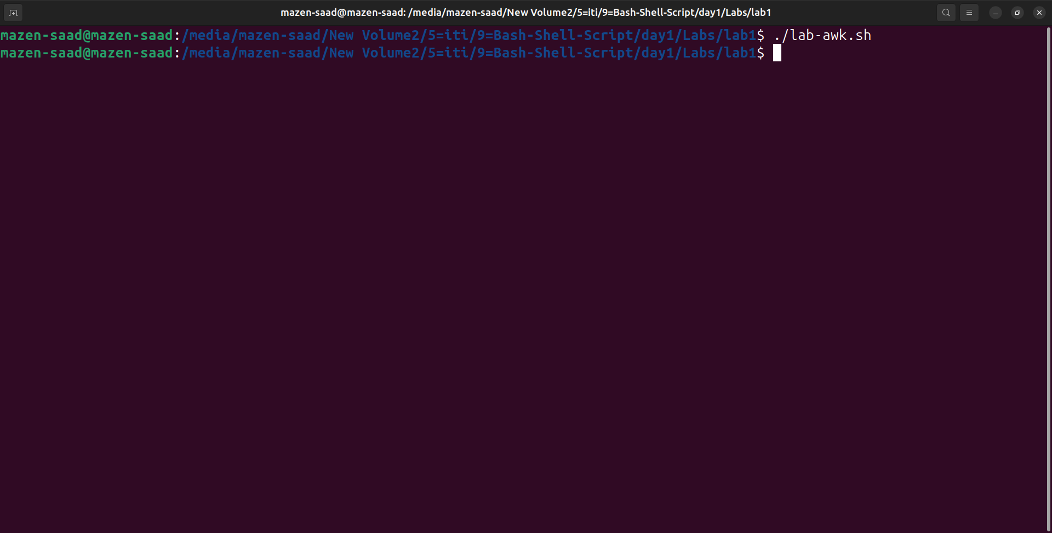

5- Print line from 5 to 15 from /etc/passwd

# Q5

awk -F: '

BEGIN{

OFS=" - "

}

{

if (NR>=5 && NR<=15){

print NR, $0

}

}

' /etc/passwd

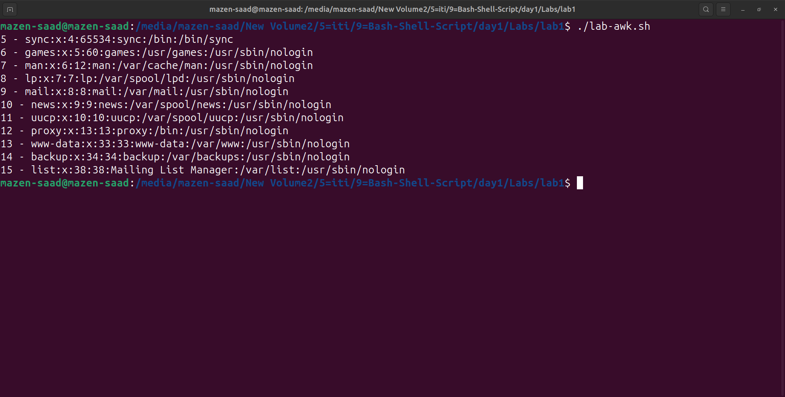

6- Change lp to mylp

awk -F: '

BEGIN{

OFS=" - "

}

{

i = 1

line = ""

while (i <= NF){

if($i == "lp"){

$i="mylp"

line=$0

}

i++;

}

if (line != "") {

print line

}

}

END{

}

' /etc/passwd

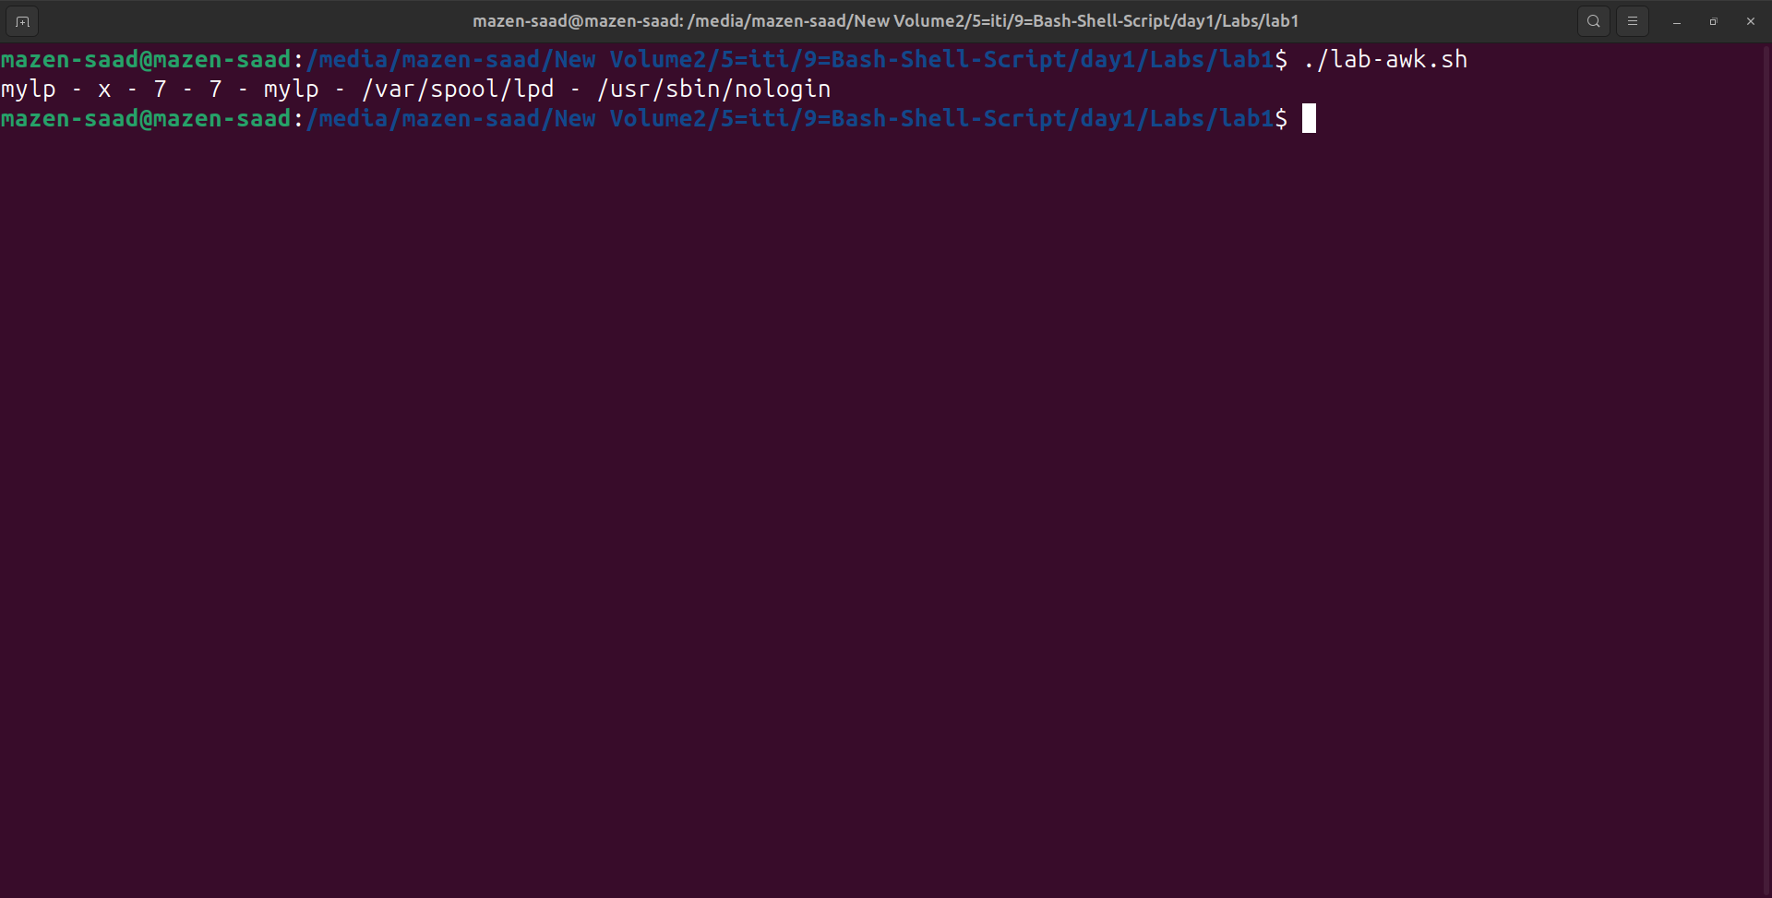

7- Print all information about greatest uid.

awk -F: '

BEGIN {

max = 0

contline = ""

}

{

if ($3>max) {

max=$3;

contline=$0

}

}

END {

print NR" - ", contline

}

' /etc/passwd

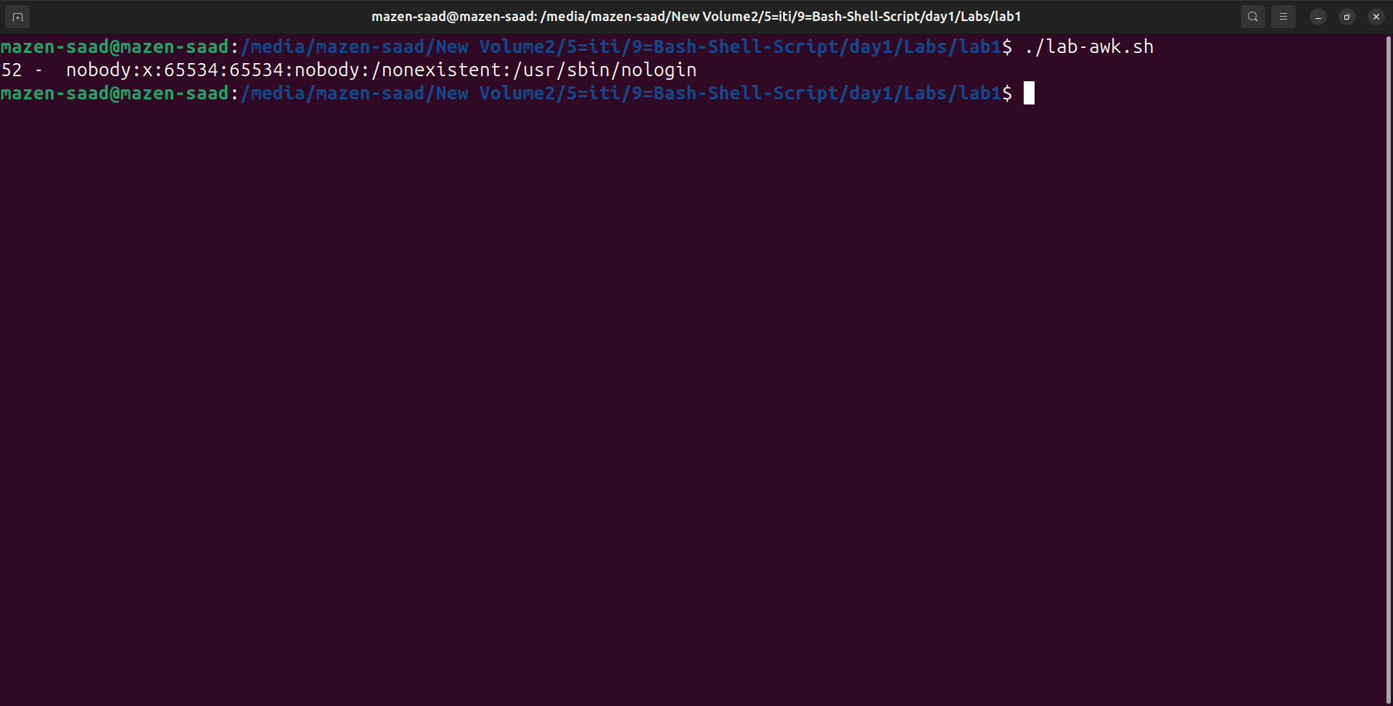

8- Get the sum of all accounts id’s.

awk -F: '

BEGIN {

sum=0;

}

{

sum += $3

}

END {

print "(", sum, ")"

}

' /etc/passwd

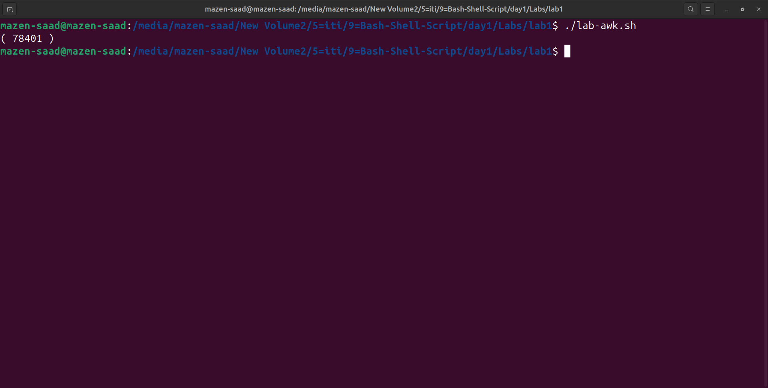

Bonus

1. Get the sum of accounts id’s that has the same group.

# Group| 7 # =>

# User| 7 |, Group| 7 |,

# User| 116 |, Group| 7 |,

# Group| 65534 # =>

# User| 4 |, Group| 65534 |,

# User| 42 |, Group| 65534 |,

# User| 65534 |, Group| 65534 |,

# User| 106 |, Group| 65534 |,

# User| 999 |, Group| 65534 |,

# User| 119 |, Group| 65534 |,

# Group| 114 # =>

# User| 112 |, Group| 114 |,

# User| 115 |, Group| 114 |,

# B1

awk -F: '

BEGIN{

OFS=" - "

print "------------------------"

}

{

group[$4] += $3

}

END {

for (grp in group) {

print "Group ID:", grp

print "Total Sum of IDs:", group[grp]

print "------------------------"

}

}' /etc/passwd

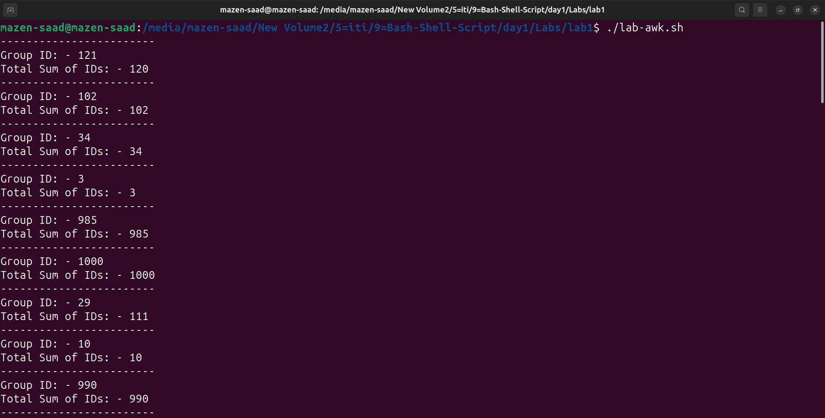

2. Make the following report:

# B2

awk -F: '

BEGIN{

print "User-Group Report"

}

{

group[$4] = group[$4] $1 "\n";

group_name[$4] = $1

}

END {

for (i in group) {

print "--------------------------"

print "Group Name:- ", i

print "- User:- ", group[i];

print "--------------------------"

}

}' /etc/passwd

