**Mazen Abdeltawab Saad**

**BSS – Lab 2**

1. Create a script that asks for user name then send a greeting to him.

# Q1

touch greet.sh

#! /usr/bin/bash

echo "Please enter your name:- "

read name

echo "Hello, $name"

Terminal =>

./greet.sh

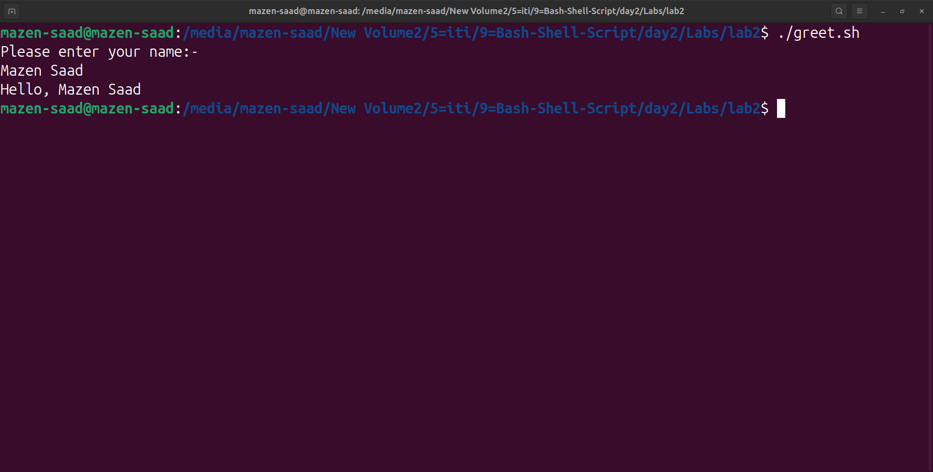

2. Create a script called s1

that calls another script s2 where:

a. In s1 there is a variable called x, it's value 5

b. Try to print the value of x in s2 by two different ways.

# Q2

touch s1.sh s2.sh

#=> file s1.sh

#! /usr/bin/bash

x=5

./s2.sh $x

export x

#=> file s2.sh

#! /usr/bin/bash

echo "1-> Value of x from environment variable: $x"

echo "2-> Value of x from argument: $1"

Terminal =>

. ./s1.sh

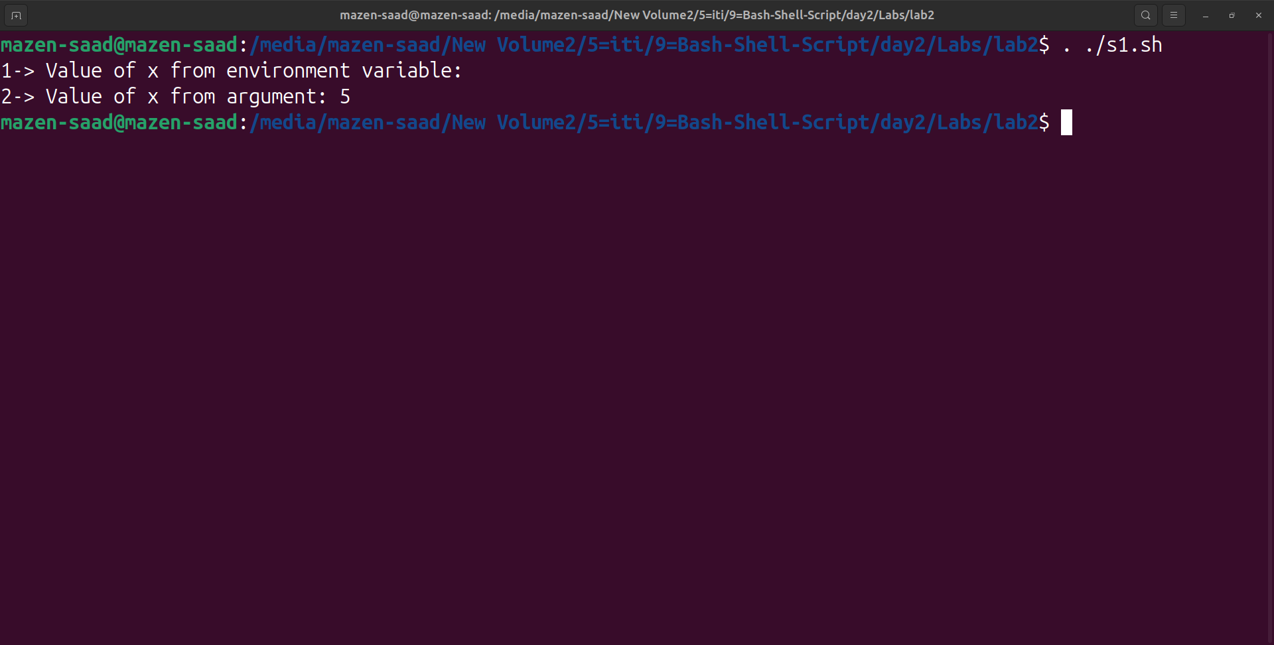

3. Create a script called mycp where:

a. It copies a file to another

b. It copies multiple files to a directory.

# Q3

touch mycp.sh

#-

#! /usr/bin/bash

if [ "$#" -lt 2 ]

then

echo "Usage: $0 source_file... destination"

exit 1

fi

#-

dest="${@: -1}"

#-

if [ -d "$dest" ]

then

#-

for src in "$@"

do

[ "$src" != "$dest" ] && cp -r "$src" "$dest/"

done

else

#-

cp "$1" "$dest"

fi

Terminal =>

# 1=> one file

touch file1.txt

./mycp.sh file1.txt file2.txt

# 2=> multiple files

mkdir target_directory

./mycp.sh file1.txt file2.txt target_directory/

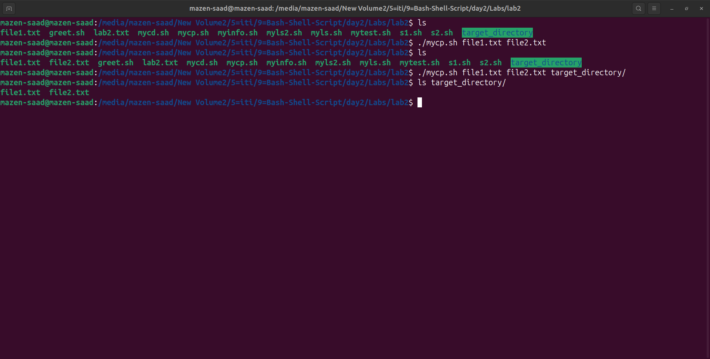

4. Create a script called mycd where:

a. It changed directory to the user home directory, if it is called without arguments.

b. Otherwise, it change directory to the given directory.

# Q4

touch mycd.sh

if [ $# -eq 0 ]

then

cd ~

else

cd "$1"

fi

Terminal =>

. ./mycd.sh

. ./mycd.sh ~/Documents

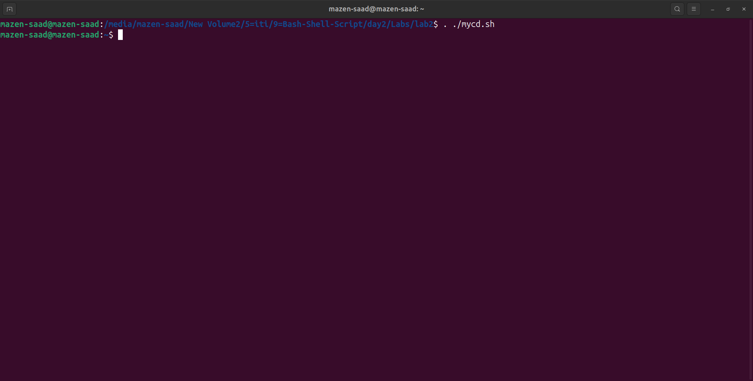

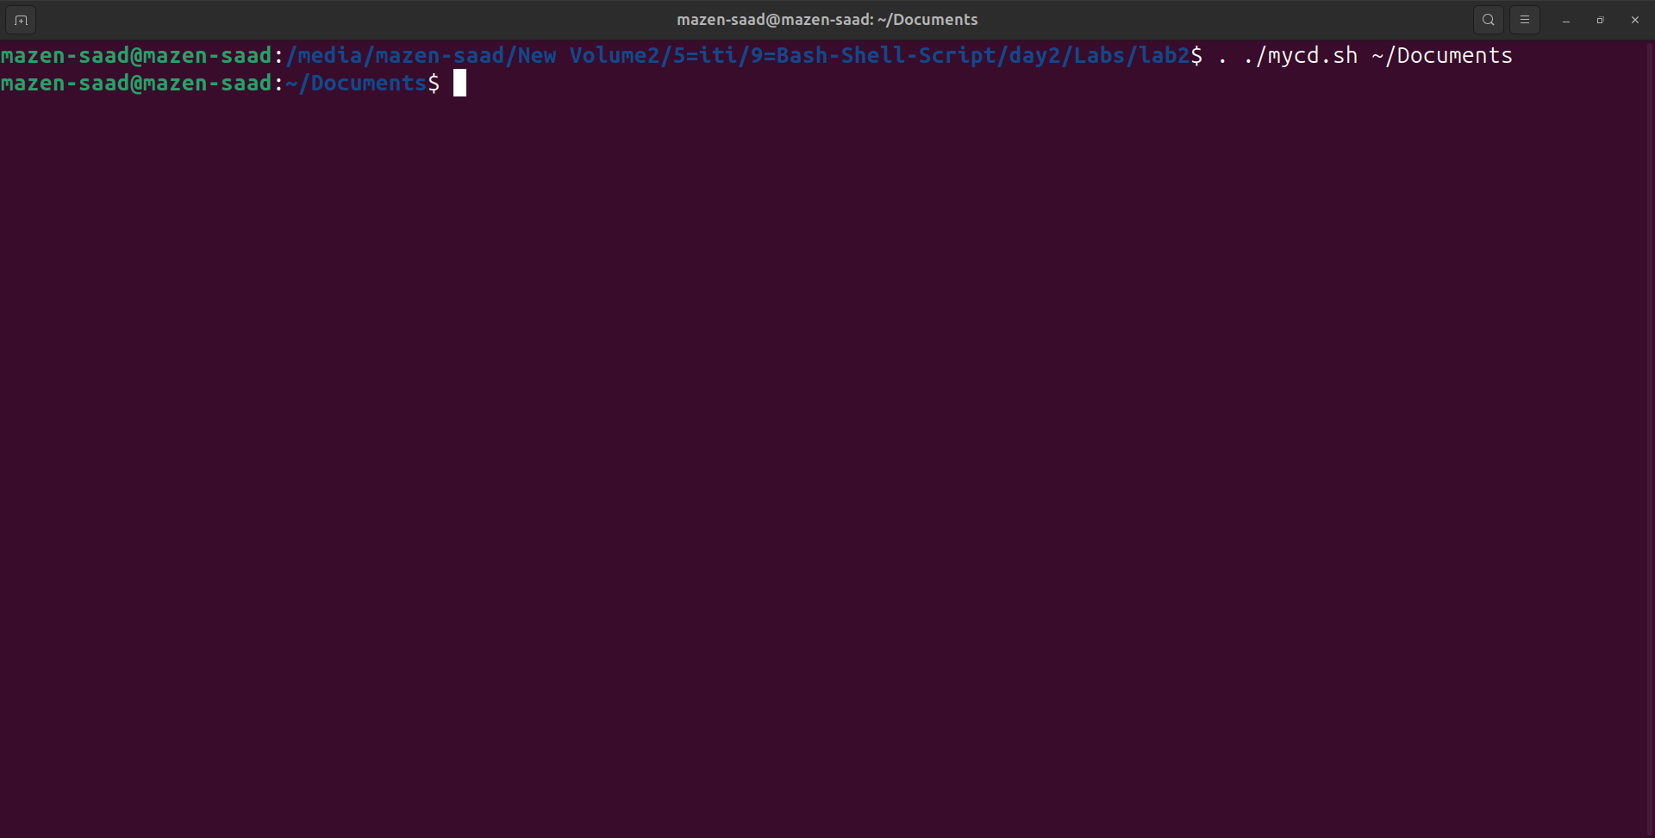

5. Create a script called myls where:

a. It lists the current directory, if it is called without arguments.

b. Otherwise, it lists the given directory.

# Q5

touch myls.sh

#! /usr/bin/bash

if [ $# -eq 0 ]

then

ls

else

ls "$1"

fi

Terminal =>

./myls.sh

./myls.sh ~/Documents

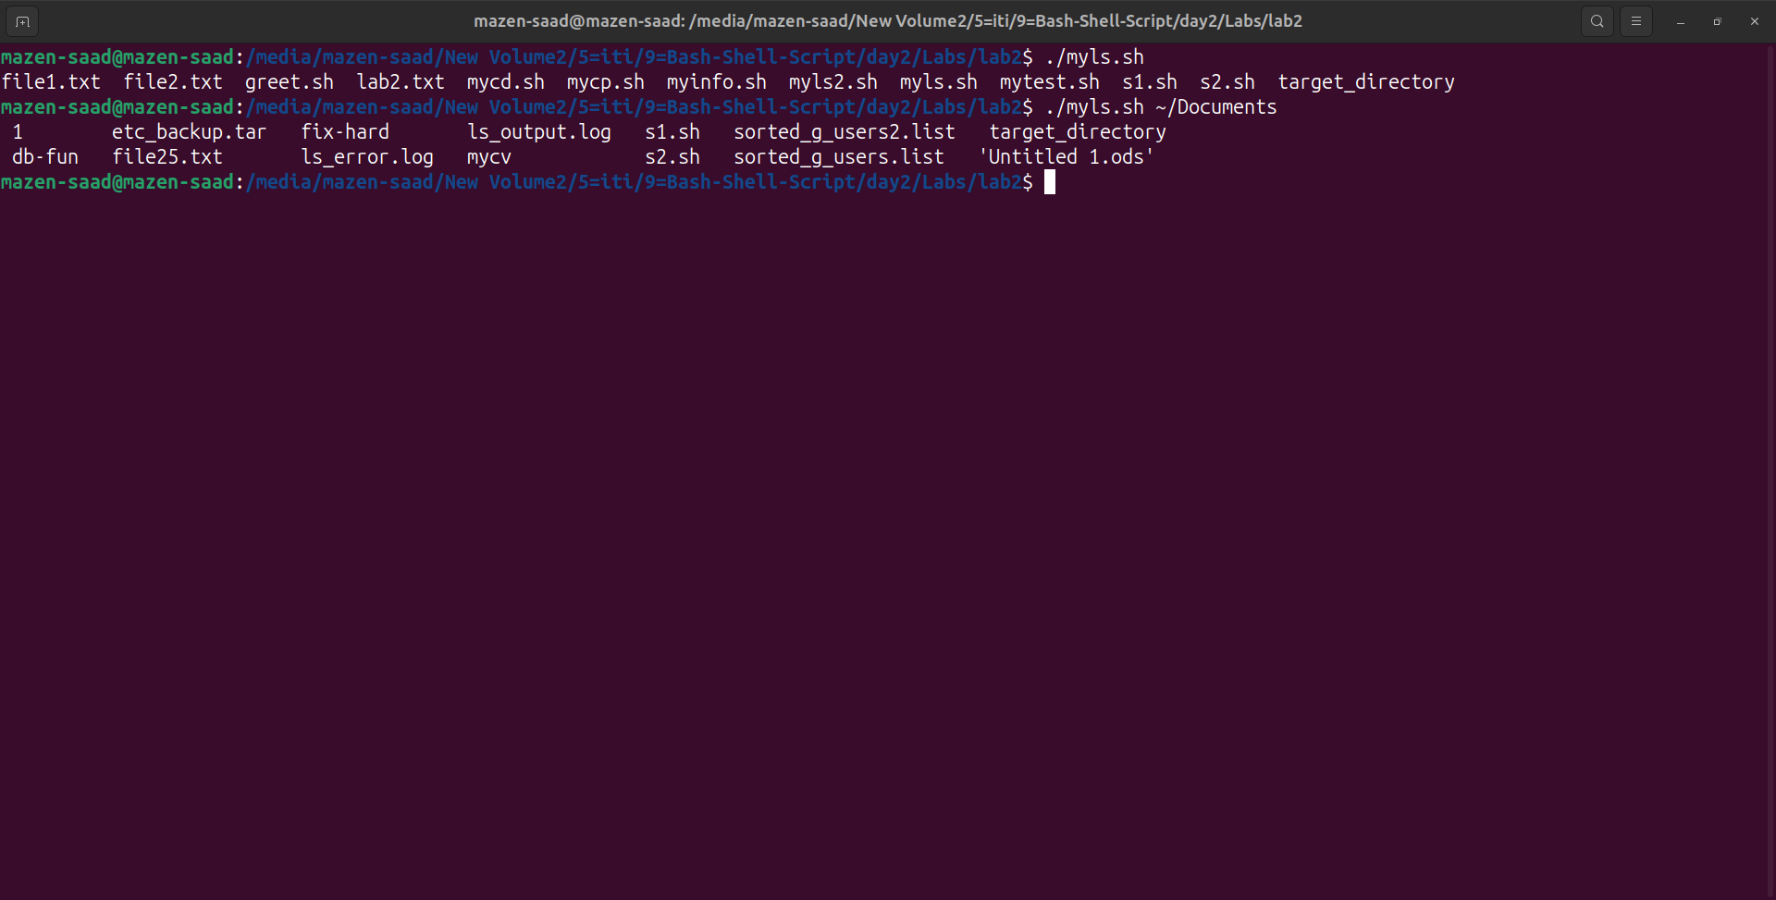

6. Enhance the above script to support the following options individually:

a. –l: list in long format

b. –a: list all entries including the hiding files.

c. –d: if an argument is a directory, list only its name

d. –i: print inode number

e. –R: recursively list subdirectories

Bonus: enhance the above script to support the following Synopsis:

myls -option1 –option2

myls –option2 –option1

myls –option1option2

myls –option2option1

# Q6

touch myls2.sh

#! /usr/bin/bash

options=""

directory=""

#-

while [[ "$1" =~ ^- ]]

do

options="$options $1"

shift

done

if [ -n "$1" ]

then

directory="$1"

fi

#-

if [ -n "$directory" ]

then

ls $options "$directory"

else

ls $options

fi

Terminal =>

# ./myls2.sh

# ./myls2.sh ~/Documents

# ./myls2.sh -l

# ./myls2.sh -a

# ./myls2.sh -i

# ./myls2.sh -R

# ./myls2.sh -la

# ./myls2.sh -al

# ./myls2.sh -l -a

# ./myls2.sh -l -a ~/Documents

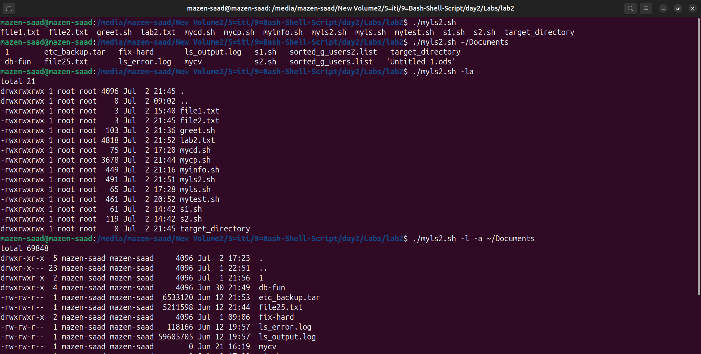

7. Create a script called mytest where:

a. It check the type of the given argument (file/directory)

b. It check the permissions of the given argument (read/write/execute)

# Q7

touch mytest.sh

#! /usr/bin/bash

if [ "$#" -ne 1 ]

then

echo "Usage: $0 type file or directory"

exit 1

fi

target="$1"

if [ -f "$target" ]

then

echo "($target) is a file."

elif [ -d "$target" ]

then

echo "($target) is a directory."

else

echo "($target) is not a regular file or directory."

exit 1

fi

echo "Permissions for ($target):"

[ -r "$target" ] && echo "Readable"

[ -w "$target" ] && echo "Writable"

[ -x "$target" ] && echo "Executable"

Terminal =>

./mytest.sh myls.sh

./mytest.sh target_directory

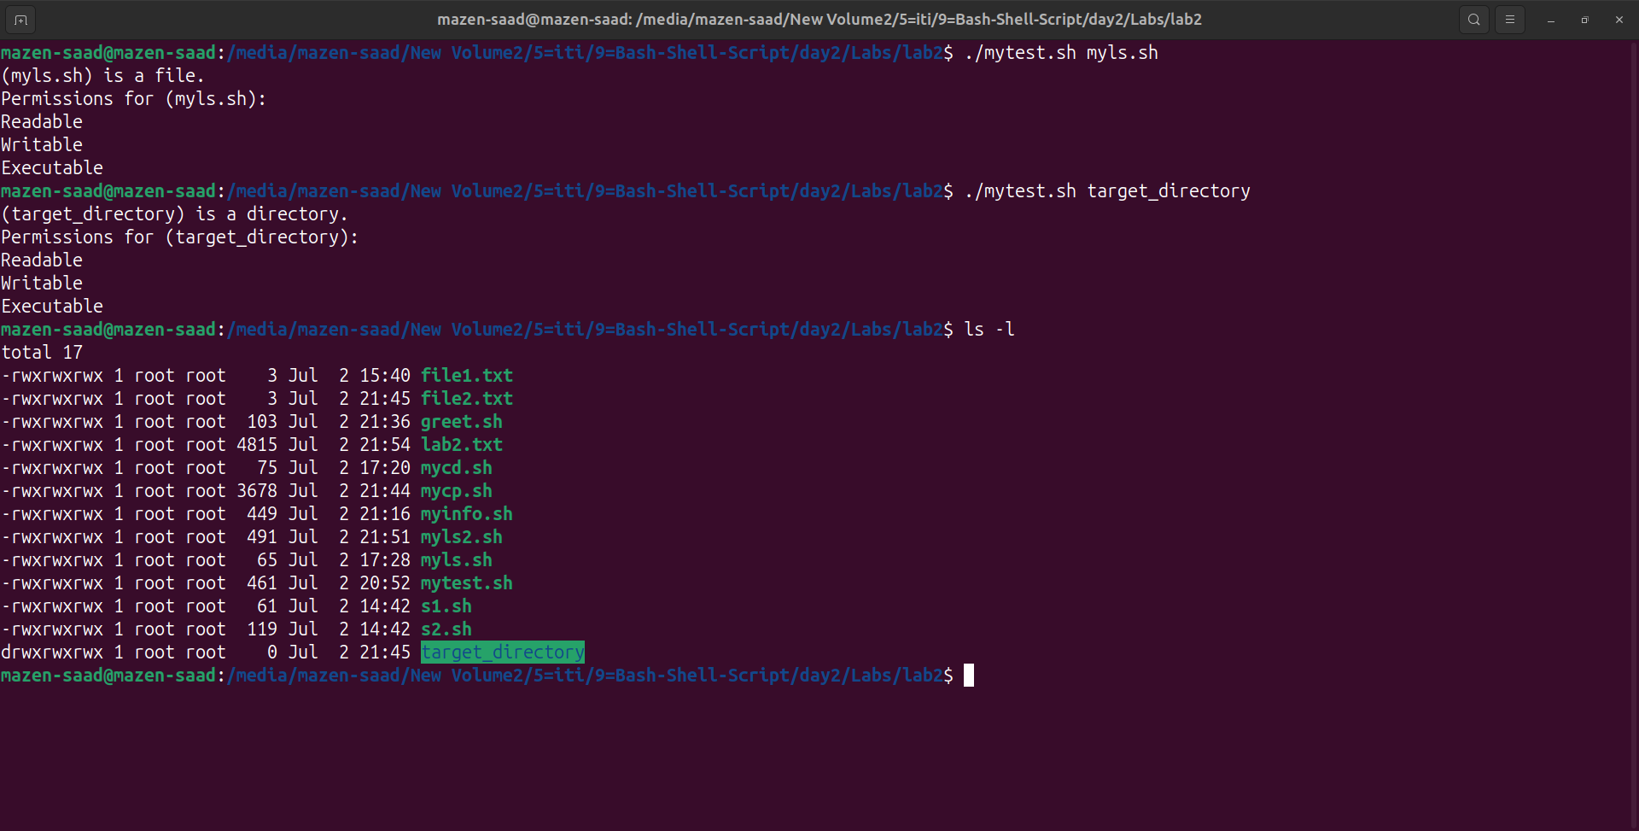

8. Create a script called myinfo where:

a. It asks the user about his/her logname.

b. It print full info about files and directories in his/her home directory

c. Copy his/her files and directories as much as you can in /tmp directory.

d. Gets his current processes status.

#Q8

touch myinfo.sh

#! /usr/bin/bash

echo "Please enter your logname:"

read logname

if [ "$logname" == "$(whoami)" ]

then

echo "Username is correct.🎉🎉"

echo "Full info about files and directories in home directory: "

ls -l /home/"$logname"

echo "Copying files and directories to /tmp: "

cp /home/"$logname"/* /tmp/

echo "Current processes status:"

ps -u "$logname"

else

echo "Incorrect username."

fi

Terminal =>

./myinfo.sh

