1. Write a script called mycase,

using the case utility to checks the type of character entered by a user:

a. Upper Case.

b. Lower Case.

c. Number.

d. Nothing.

touch mycase.sh

#! /usr/bin/bash

shopt -s extglob

echo "Enter a Character: "

read char

case $char in

[A-Z])

echo "Upper Case."

;;

[a-z])

echo "Lower Case."

;;

[0-9])

echo "Number."

;;

"")

echo "Nothing."

;;

*)

echo "Invalid input."

;;

esac

# Terminal =>

# ./mycase.sh

# M

# m

# 9

#

# -

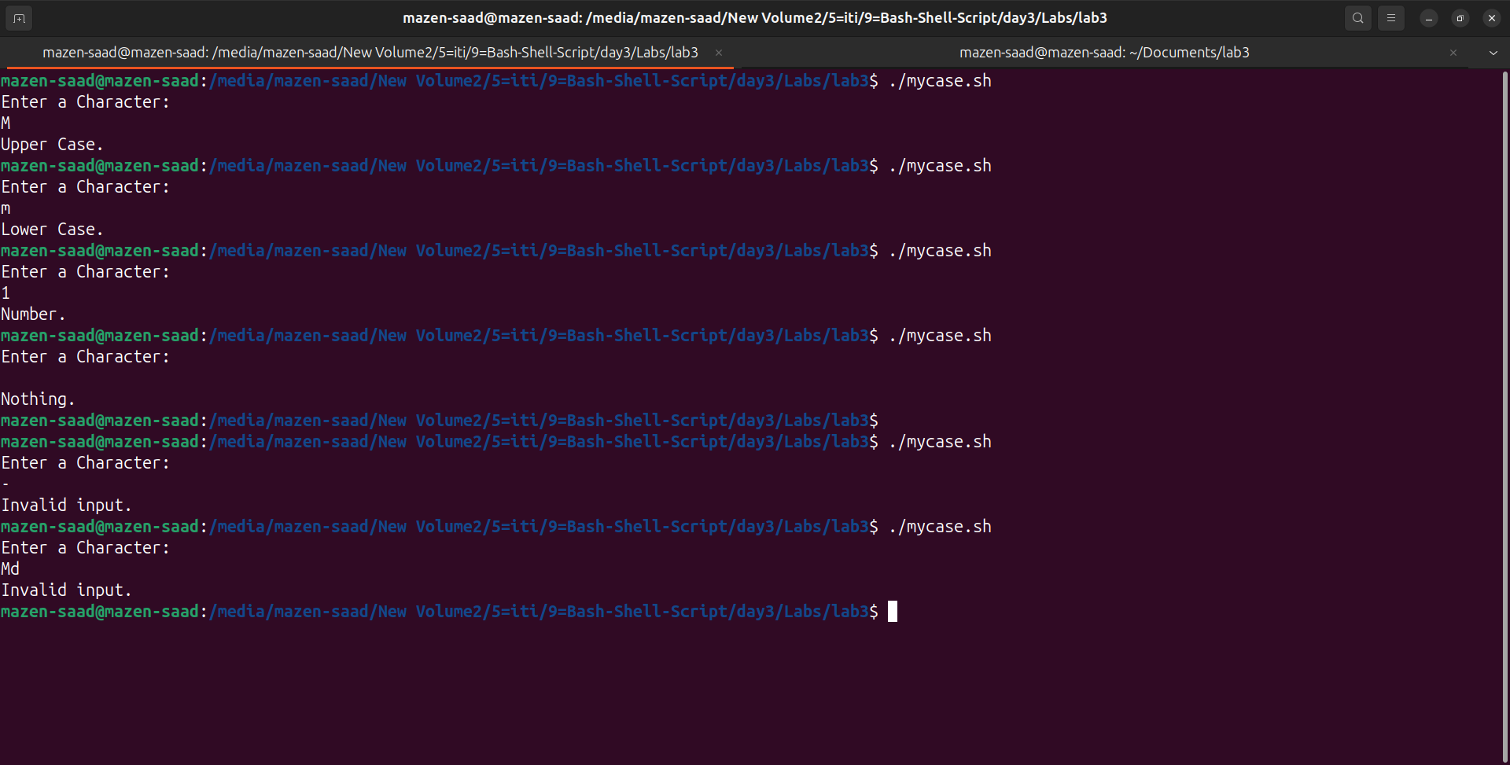

2. Enhanced the previous script,

by checking the type of string entered by a user:

a. Upper Cases.

b. Lower Cases.

c. Numbers.

d. Mix.

e. Nothing.

touch mycase2.sh

#! /usr/bin/bash

shopt -s extglob

echo "Enter a Character: "

read char

case $char in

"")

echo "Nothing."

;;

+([A-Z]||" "))

echo "Upper Case."

;;

+([a-z]||" "))

echo "Lower Case."

;;

+([0-9]||" "))

echo "Number."

;;

+([a-zA-Z0-9]||" "))

echo "Mix."

;;

*)

echo "Invalid input."

;;

esac

# Terminal =>

# ./mycase2.sh

# Mazen

# mazen

# 20

# Mazen Saad

# mAzEn20

#

# -

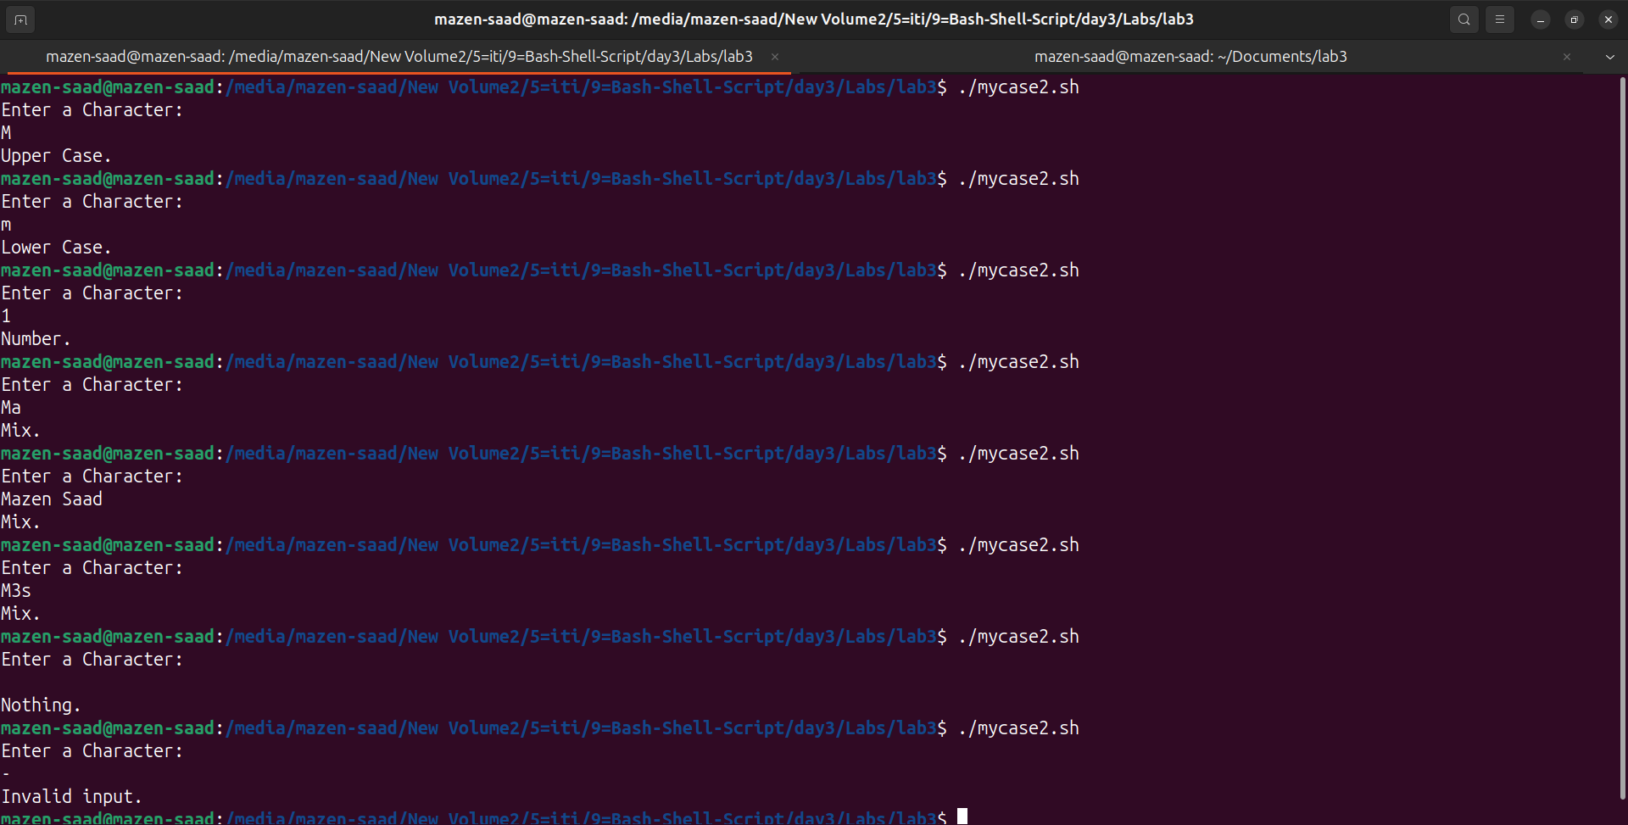

3. Write a script called mychmod using for utility to give execute permission to all files and directories in your home directory.

touch mychmod.sh

cd ~/Documents/lab3

mkdir ma mz me

touch file{0..9}.txt

#! /usr/bin/bash

shopt -s extglob

for item in $1/*

do

chmod u+x "$item"

done

# Terminal =>

# ./mychmod.sh ~/Documents/lab3/

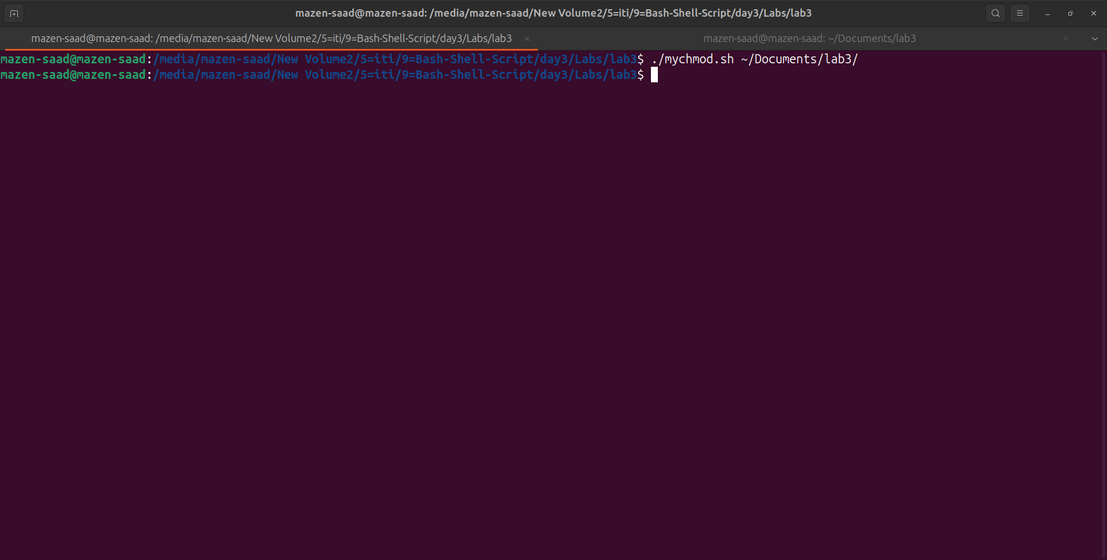

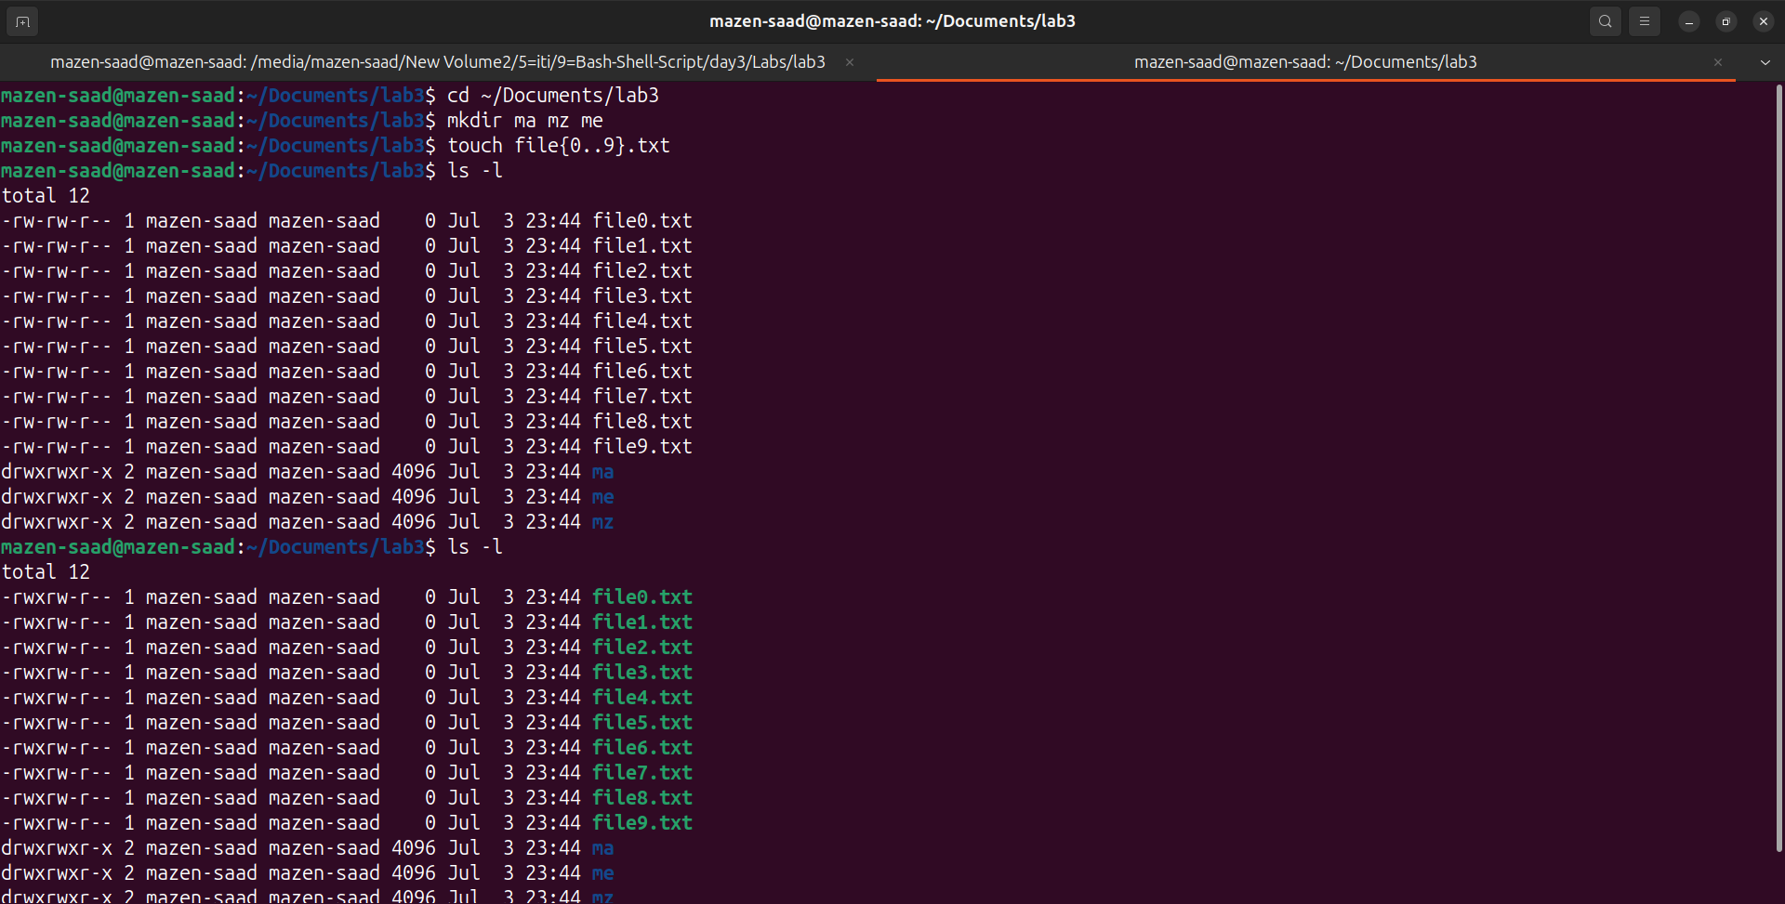

4. Write a script called mybackup

using for utility to create a backup of only files in your home directory.

touch mybackup.sh

cd ~/Documents/lab3

mkdir ma mz me

touch file{0..9}.txt

#! /usr/bin/bash

shopt -s extglob

backup_dir="$HOME/Documents/lab3/backup/"

mkdir -p $backup_dir

for file in ~/Documents/lab3/*

do

if [[ -f $file ]]

then

cp "$file" "$backup_dir"

fi

done

# Terminal =>

# ./mybackup.sh

# cd $HOME/Documents/lab3/backup/

# ls -l

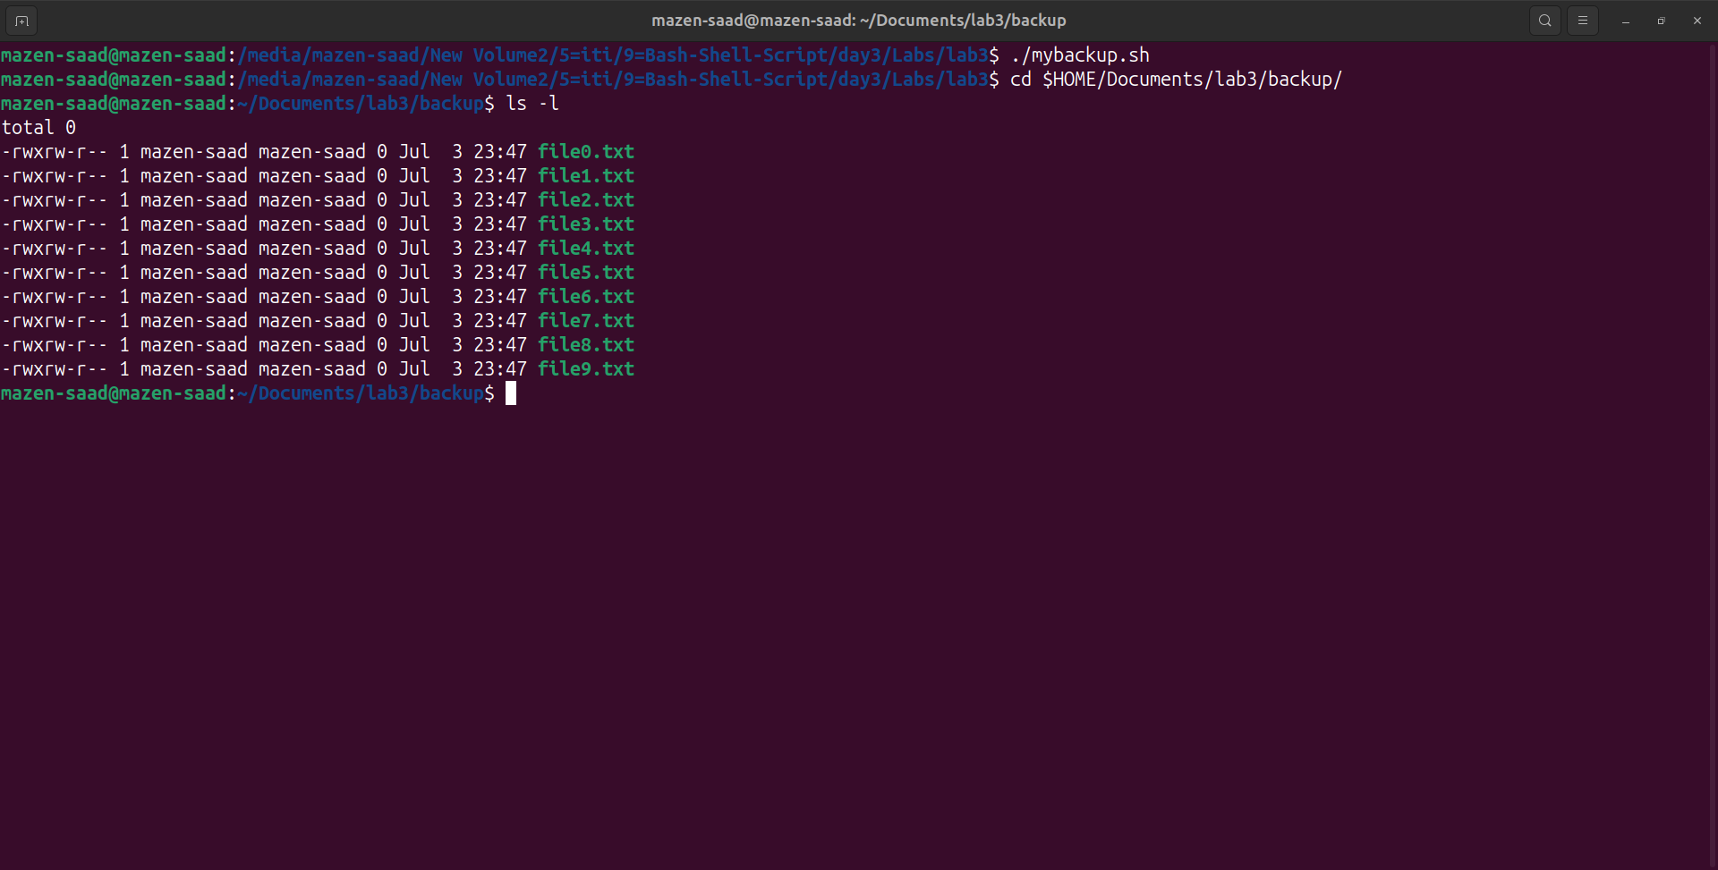

5. Write a script called mymail

using for utility to send a mail to all users in the system.

Note: write the mail body in a file called mtemplate.

sudo apt-get install mailutils

=> Local only

touch mymail.sh mtemplate.txt

#! /usr/bin/bash

shopt -s extglob

mtemplate=$1

if [ ! -f $mtemplate ]

then

echo "mtemplate file not found!"

exit 1

fi

email_body=$(cat $mtemplate)

user_list=$(cut -d: -f1 /etc/passwd)

for user in $user_list

do

mail -s "Subject of the email" "$user" <<< "$email_body"

done

echo "Email has been sent to all users."

# Terminal =>

# ./mymail.sh mtemplate.txt

# cd /var/mail

# ls -l

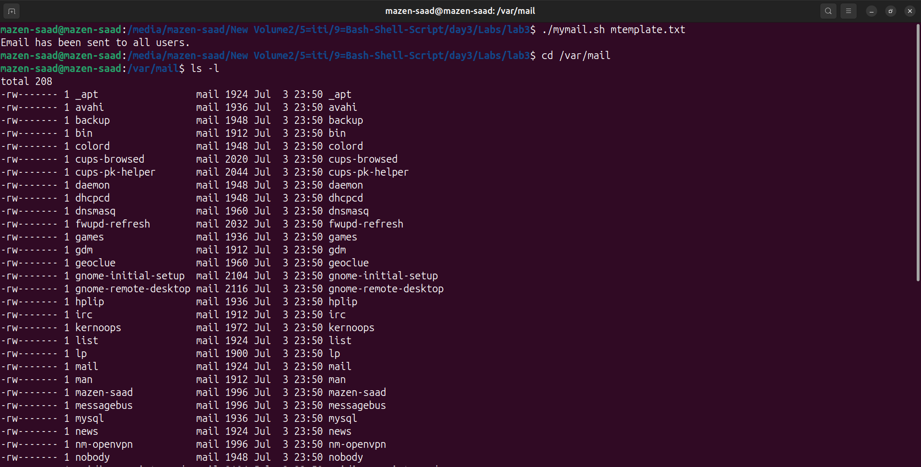

6. Write a script called chkmail to check for new mails every 10 seconds.

Note: mails are saved in /var/mail/username.

touch chkmail.sh

#! /usr/bin/bash

shopt -s extglob

username=$(whoami)

mail_file="/var/mail/$username"

while true

do

if [ -s "$mail_file" ]

then

echo "You have new mail."

else

echo "No new mail."

fi

sleep 10

done

# Terminal =>

# ./chkmail.sh

Bonus:

Open a talk session to a certain user when she/he logs into the system.

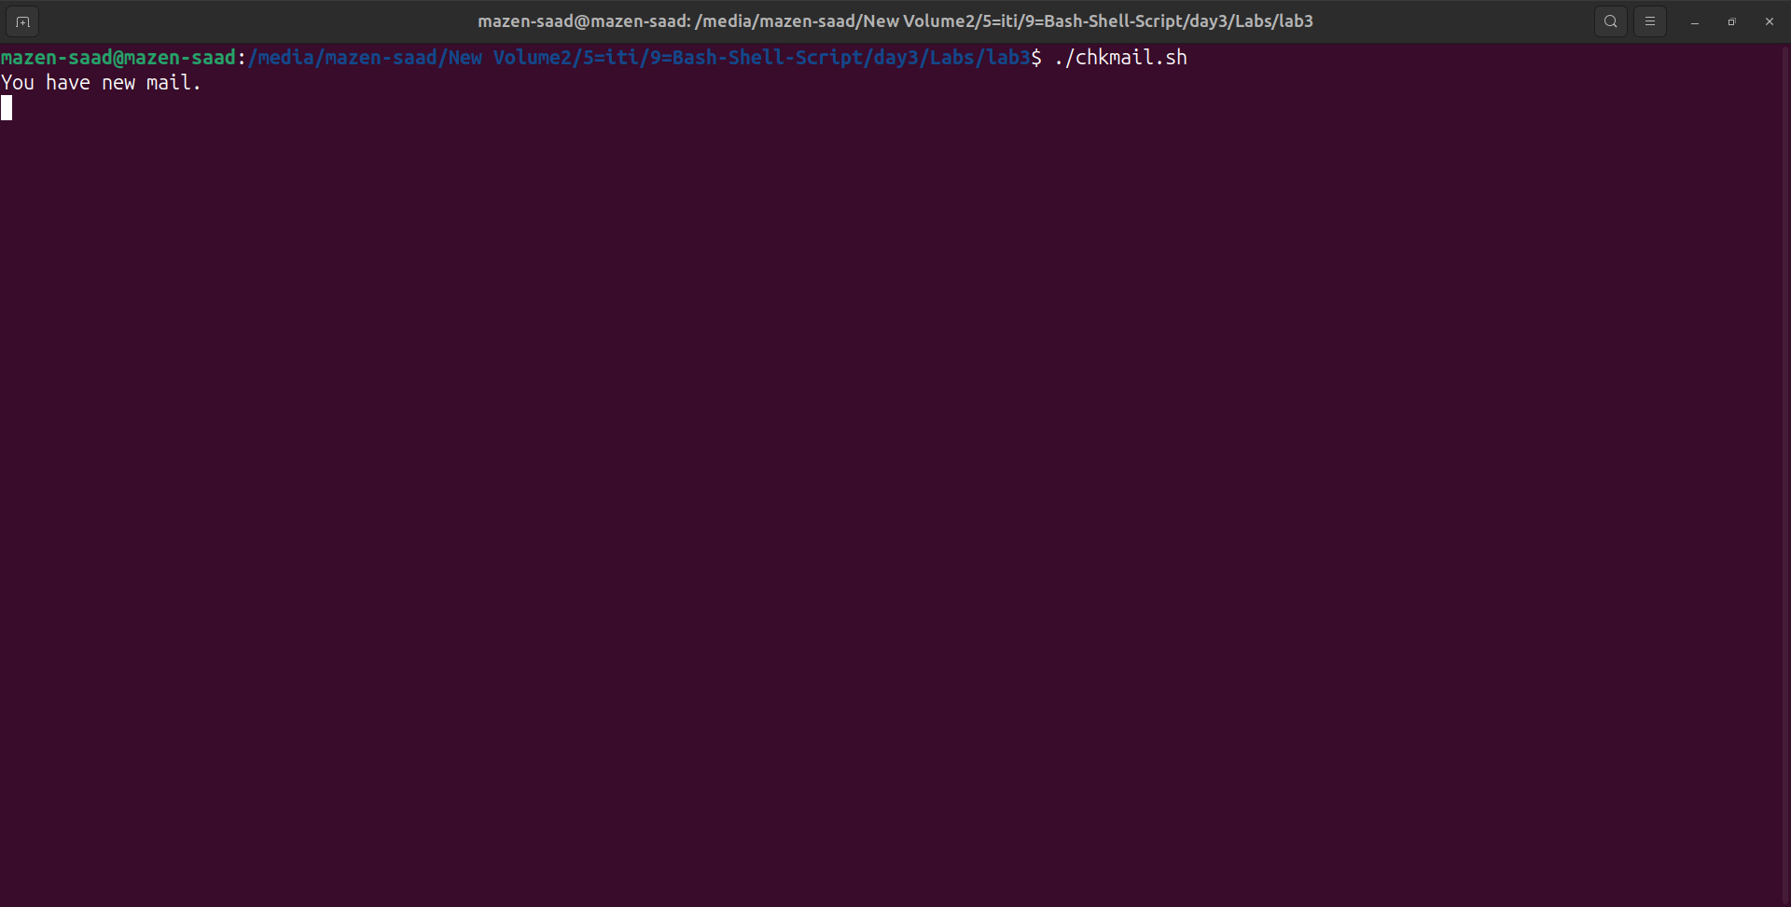

7. What is the output of the following script

typeset –i n1

typeset –i n2

n1=1

n2=1

while test $n1 –eq $n2

do

n2=$n2+1

print $n1

if [ $n1 –gt $n2 ]

then

break

else

continue

fi

n1=$n1+1

print $n2

done

touch output.sh

#! /usr/bin/bash

shopt -s extglob

typeset -i n1

typeset -i n2

n1=1

n2=1

while test $n1 -eq $n2

do

n2=$n2+1

echo $n1

if [ $n1 -gt $n2 ]

then

break

else

continue

fi

n1=$n1+1

echo $n2

done

# 1 => Error

# ./output: line 1: typeset: `–i': not a valid identifier

# ./output: line 2: typeset: `–i': not a valid identifier

# ./output: line 5: test: –eq: binary operator expected

# Fix =>

# Replace –i with -i

# 2 => Error

# ./output: line 9: print: command not found

# Fix =>

# Replace print with echo

# result => 1

# Terminal =>

# ./output.sh

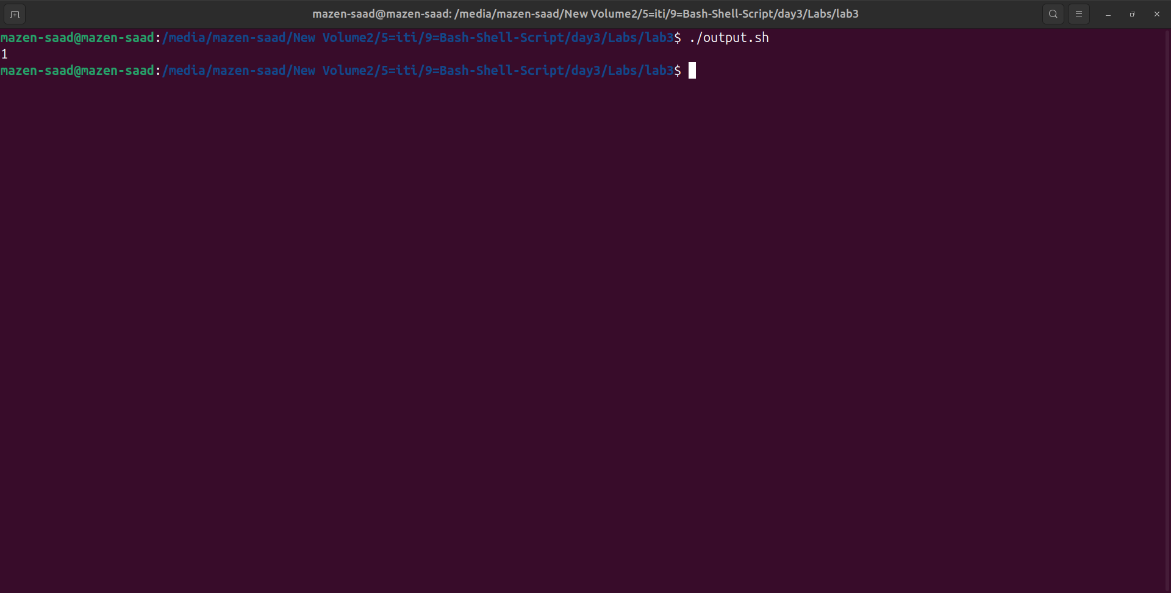

8. Create the following menu:

a. Press 1 to ls

b. Press 2 to ls –a

c. Press 3 to exit

Using select utility then while utility.

touch menu.sh

#! /usr/bin/bash

shopt -s extglob

PS3="Choose an option: "

select option in "ls" "ls -a" "Exit"

do

case $option in

"ls")

ls

;;

"ls -a")

ls -a

;;

"Exit")

break

;;

*)

echo "Invalid option."

;;

esac

done

# Terminal =>

# ./menu.sh

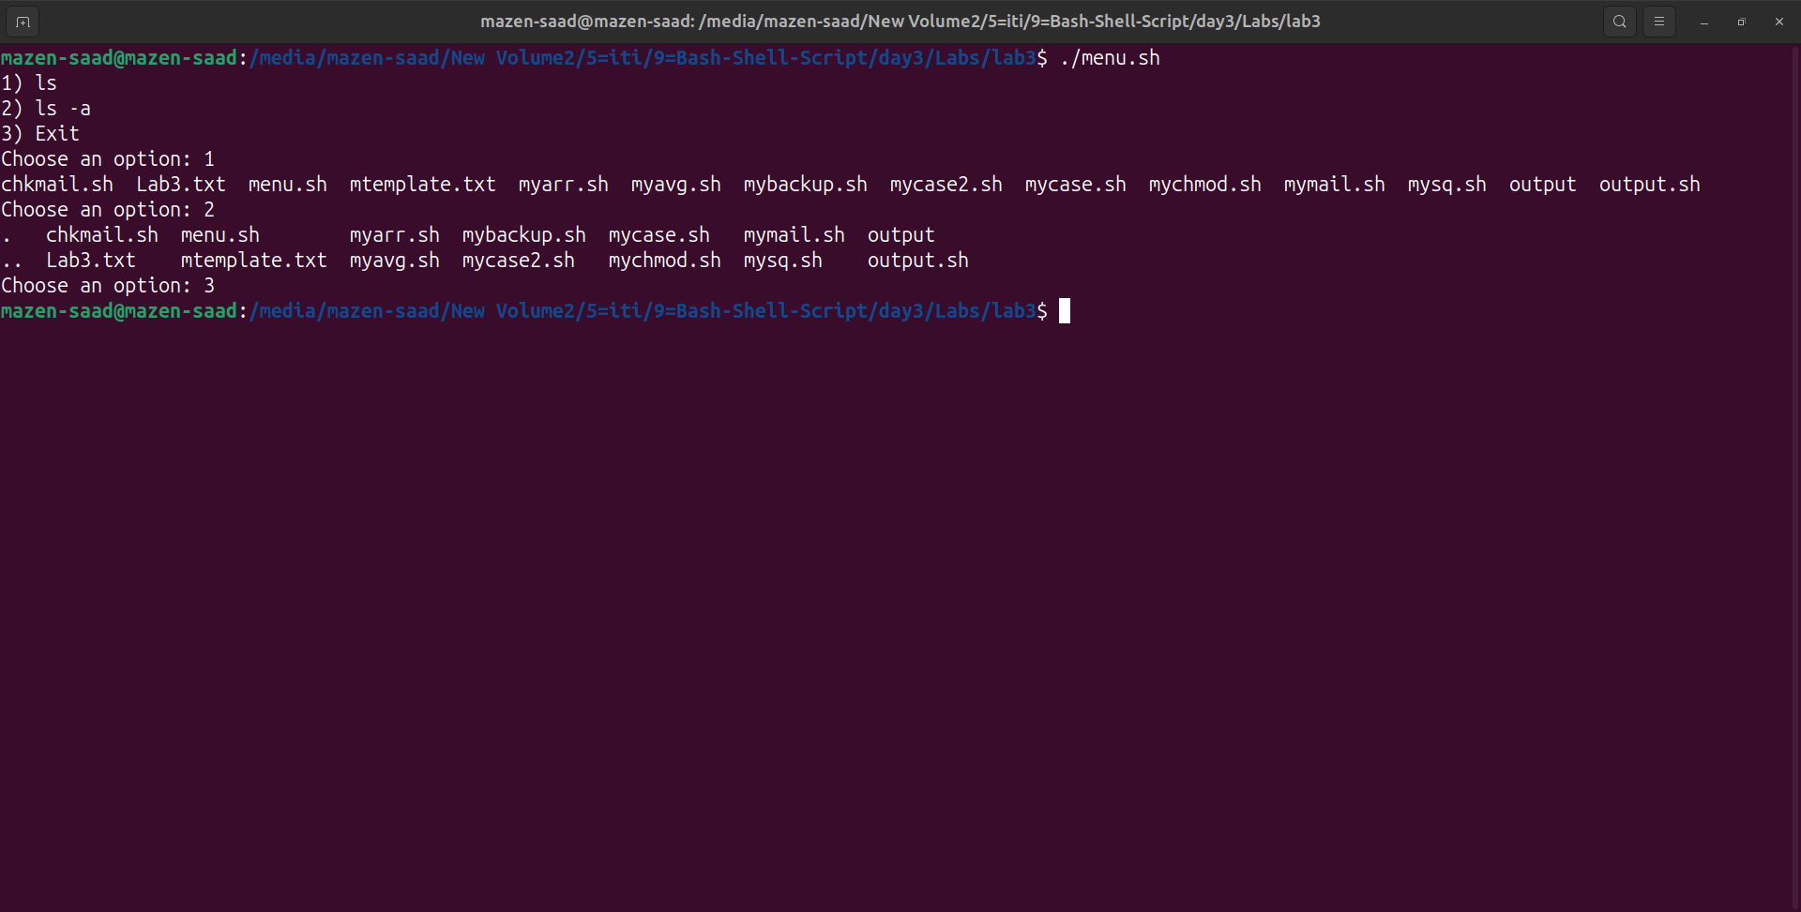

9. Write a script called myarr

that ask a user how many elements he wants to enter in an array,

fill the array and then print it.

touch myarr.sh

#! /usr/bin/bash

shopt -s extglob

#! /usr/bin/bash

shopt -s extglob

read -p "Please Enter Array Size: " size

for ((i=0;i<$size;i++))

do

read -p "Enter Array Element $(($i+1)): " arr[$i]

done

echo "The Array is: [${arr[@]}]"

# Terminal =>

# ./myarr.sh

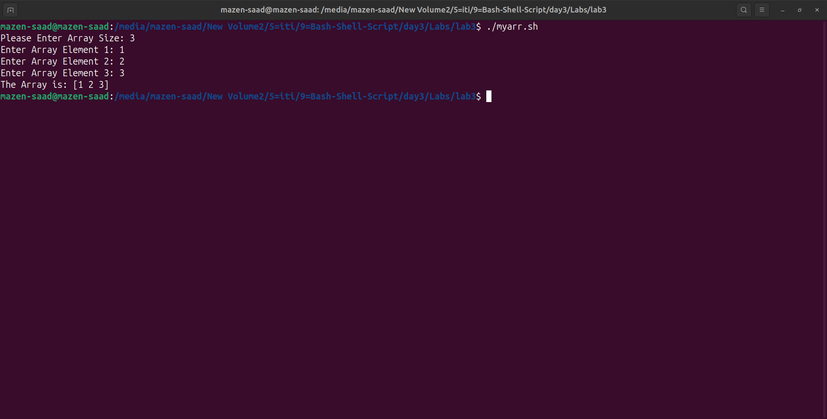

10.Write a script called myavg

that calculate average of all numbers entered by a user.

Note: use arrays

touch myavg.sh

#! /usr/bin/bash

shopt -s extglob

read -p "Please Enter Array Size: " size

declare -i sum=0

for ((i=0;i<$size;i++))

do

read -p "Enter Array Element $(($i+1)): " arr[$i]

sum+=${arr[$i]}

done

echo "The Array is: [${arr[@]}]"

avg=$(echo "$sum / $size" | bc -l)

echo The Average is: $avg

# Terminal =>

# ./myavg.sh

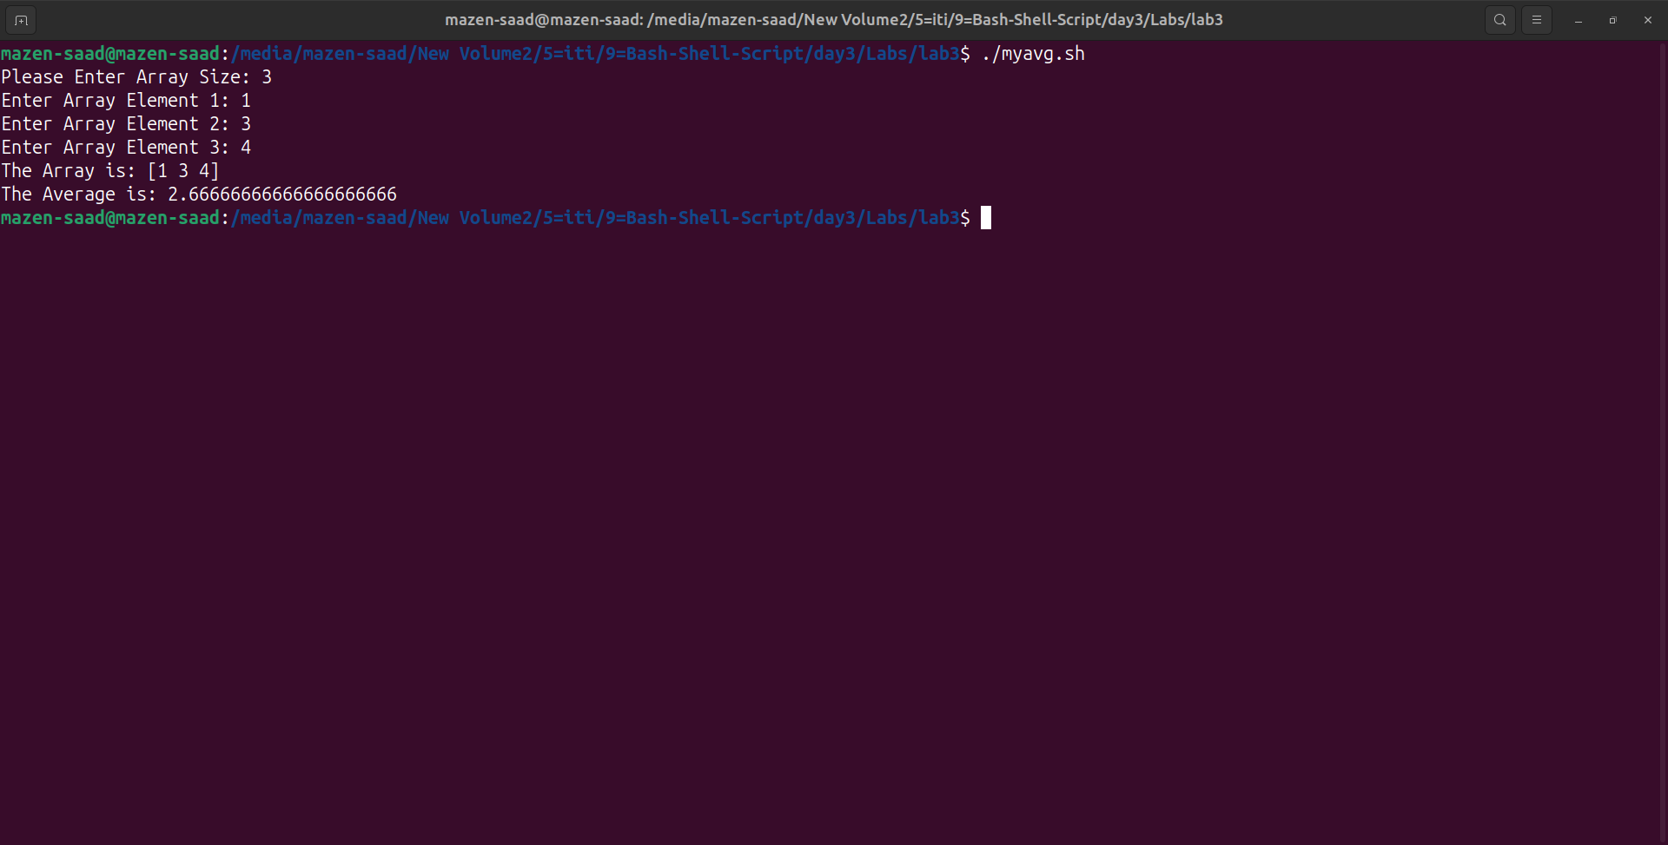

11.Write a function called mysq

that calculate square if its argument.

touch mysq.sh

#! /usr/bin/bash

shopt -s extglob

# =>1

function mysq(){

echo $(( $1 * $1 ))

}

echo "Square of 4 is: $(mysq 4)"

# =>2

read -p "Enter number: " number

function mysq(){

echo $(( $1 * $1 ))

}

echo "Square of ($number) is: $(mysq $number)"

# Terminal =>

# ./mysq.sh

