**Name: Mazen AbdelTawa Saad**

**DB - Fayoum - Lab Number 4**

1. Insert your personal data to the employee table

as a new employee in department number 30,

SSN=102672, Superssn=112233.

/*

Q1 =>

*/

insert into employee (SSN, Fname, Lname, Bdate, Address, Gender, Salary, SuperSSN, DNO)

values(102672, 'Mazen', 'Saad', '2001-04-20', 'Fayoum', 'M', 500, 30, 30);

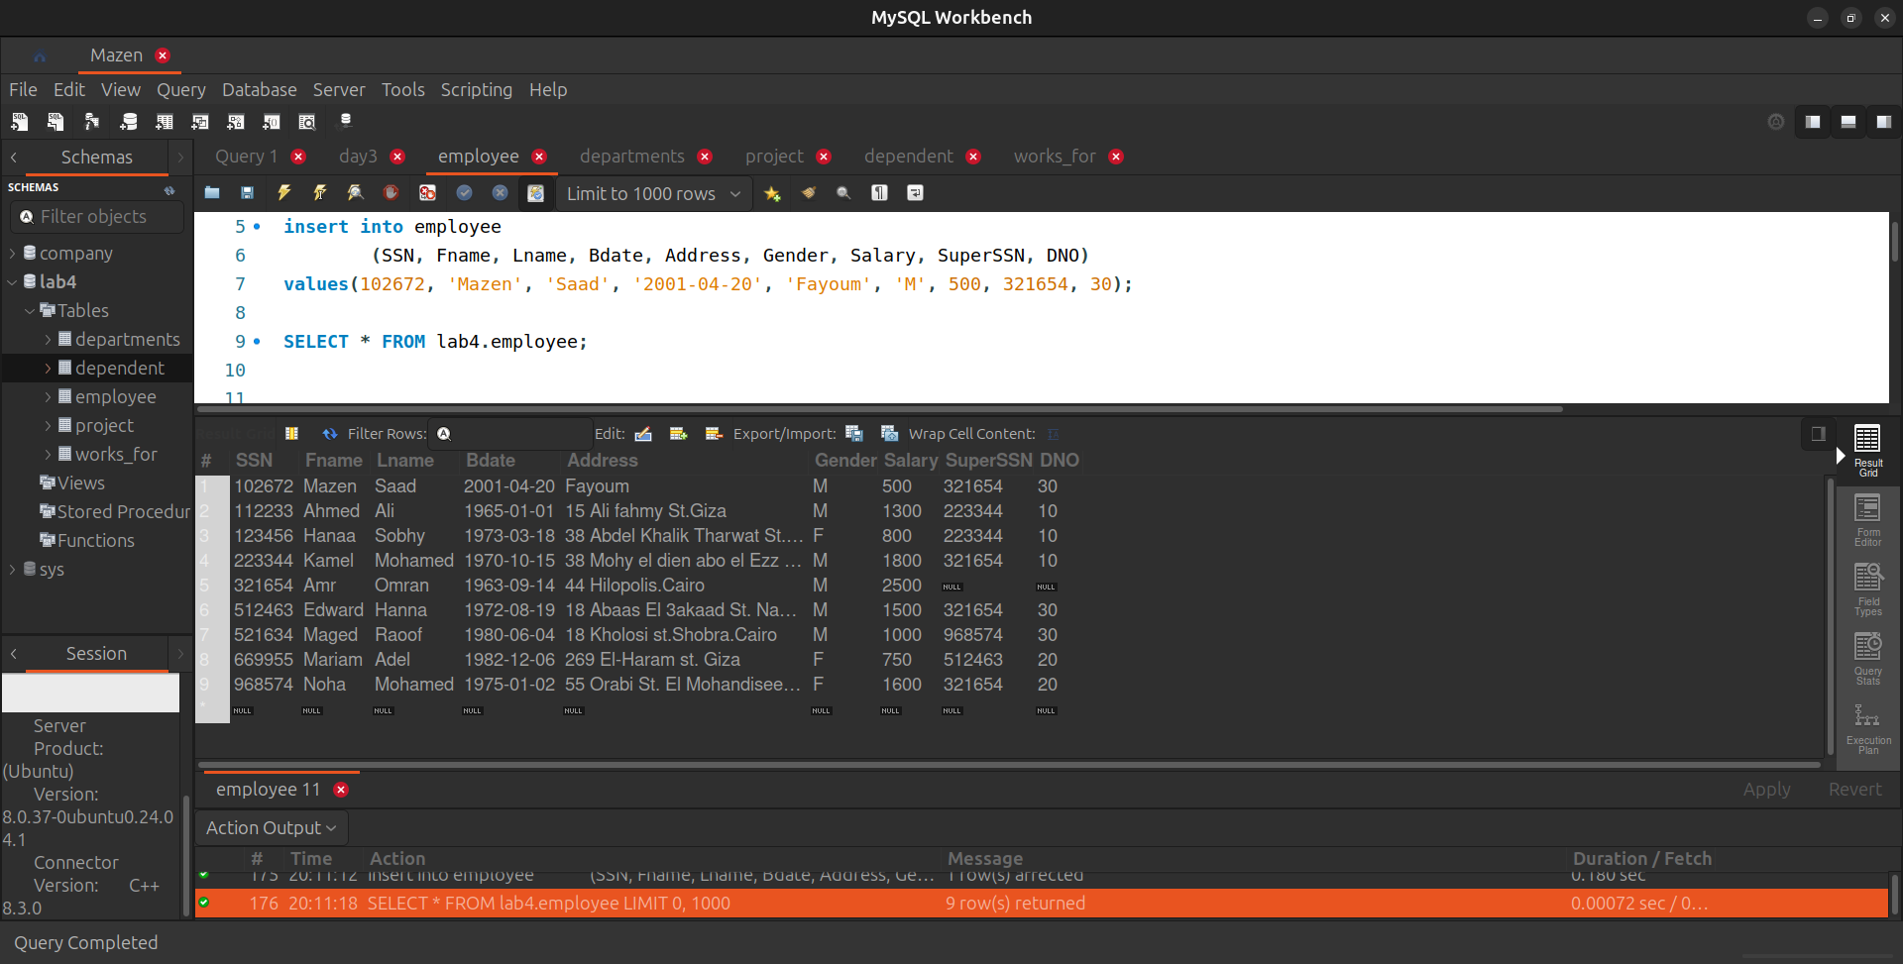

2. Insert another employee with,

personal data your friend as new employee in department number 30,

SSN = 102660,

but don’t enter any value for salary or supervisor number to him.

/*

Q2 =>

*/

insert into employee (SSN, Fname, Lname, Bdate, Address, Gender, Salary, SuperSSN, DNO)

values(102660, 'Ali', 'Ahmed', '2002-04-10', 'Fayoum', 'M', null, null, 30);

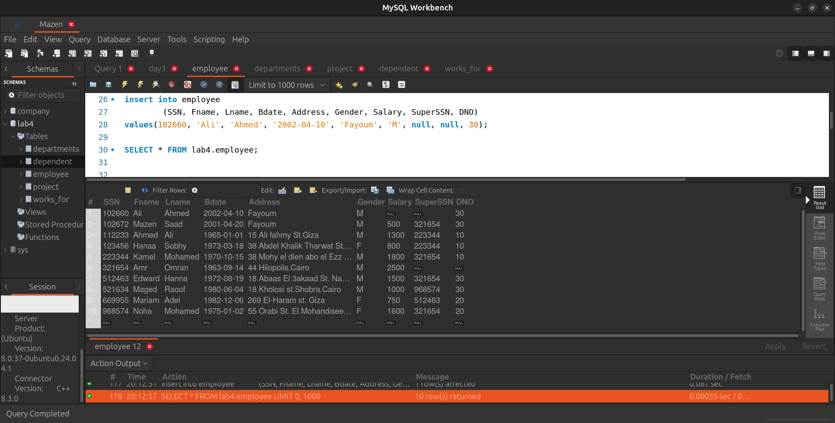

3. In the department table

insert new department called "DEPT IT",

with id 100, employee with SSN = 112233 as a manager for this department.

The start date for this manager is '1-11-2006'

/*

Q3

*/

insert into department (Dname, Dnum, MGRSSN, MGRSatrtDate)

values('DEPT IT', 100, 112233, '2006-11-01');

SELECT * FROM lab4.departments;

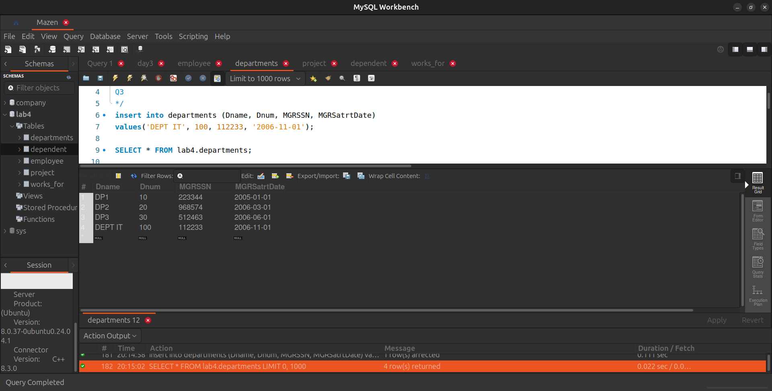

4. Increase salary by 20% for all employees.

/*

Q4 =>

*/

SET SQL_SAFE_UPDATES = 0;

update employee

set Salary = Salary * 1.20;

SET SQL_SAFE_UPDATES = 1;

SELECT * FROM lab4.employee;

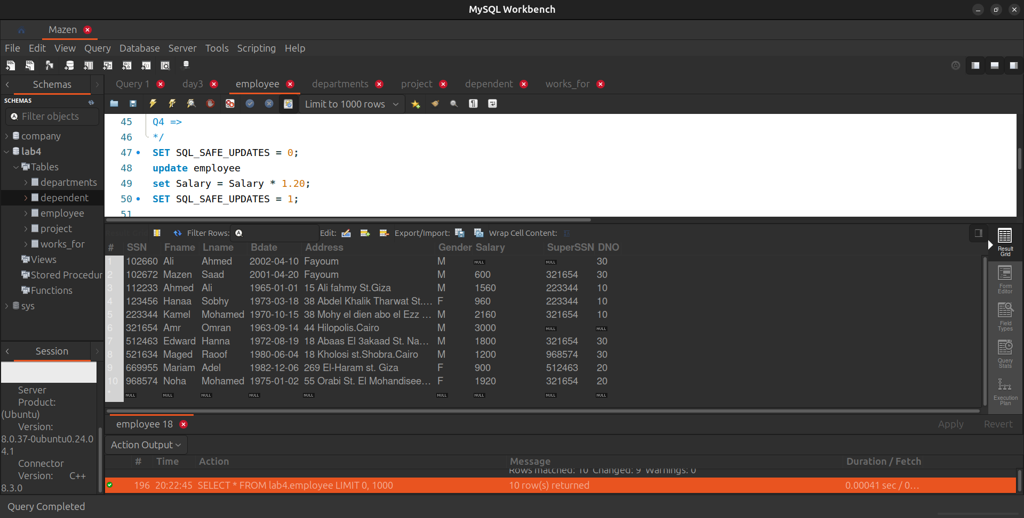

5. Display the employee

First name, last name, Salary and Department number.

/*

Q5 =>

*/

select Fname, Lname, Salary, DNO from employee;

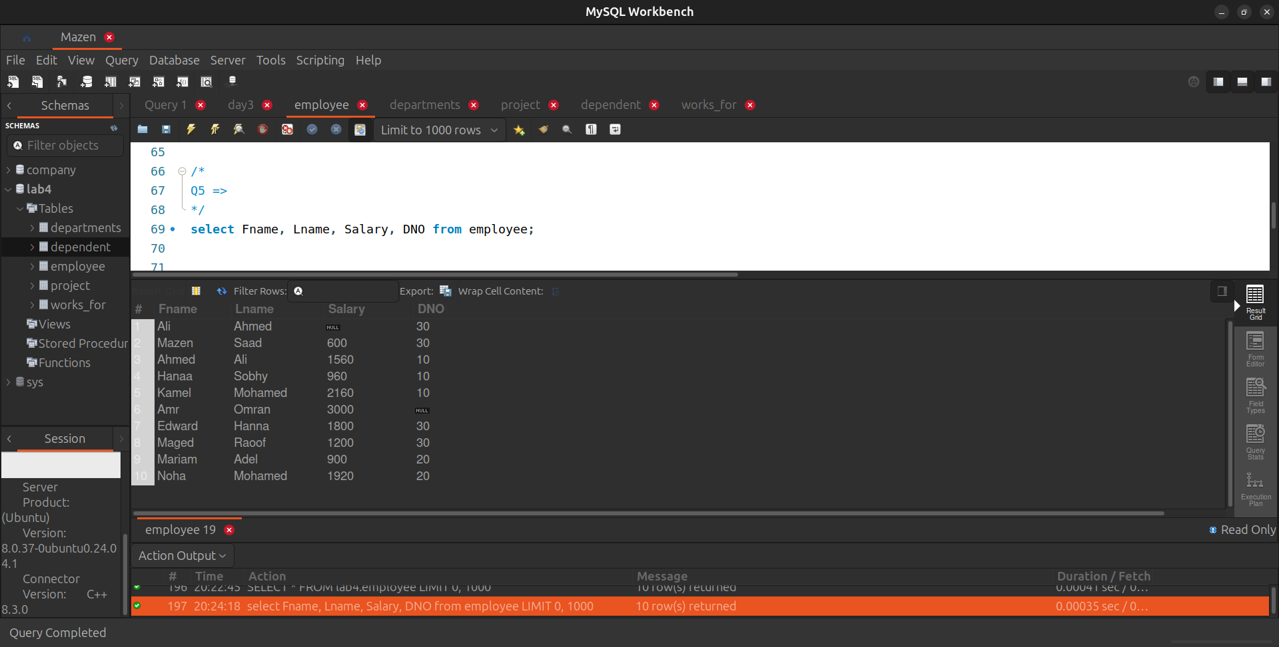

6. If you know that the company policy is to pay an annual commission for each employee with specific percent equals 10% of his/her annual salary.

Display each employee full name and his annual commission in an ANNUAL COMM column (alias).

/*

Q6 =>

*/

select concat(Fname, ' ', Lname) as Full_Name, (Salary * 12 * 0.10) as ANNUAL_COMM

from employee;

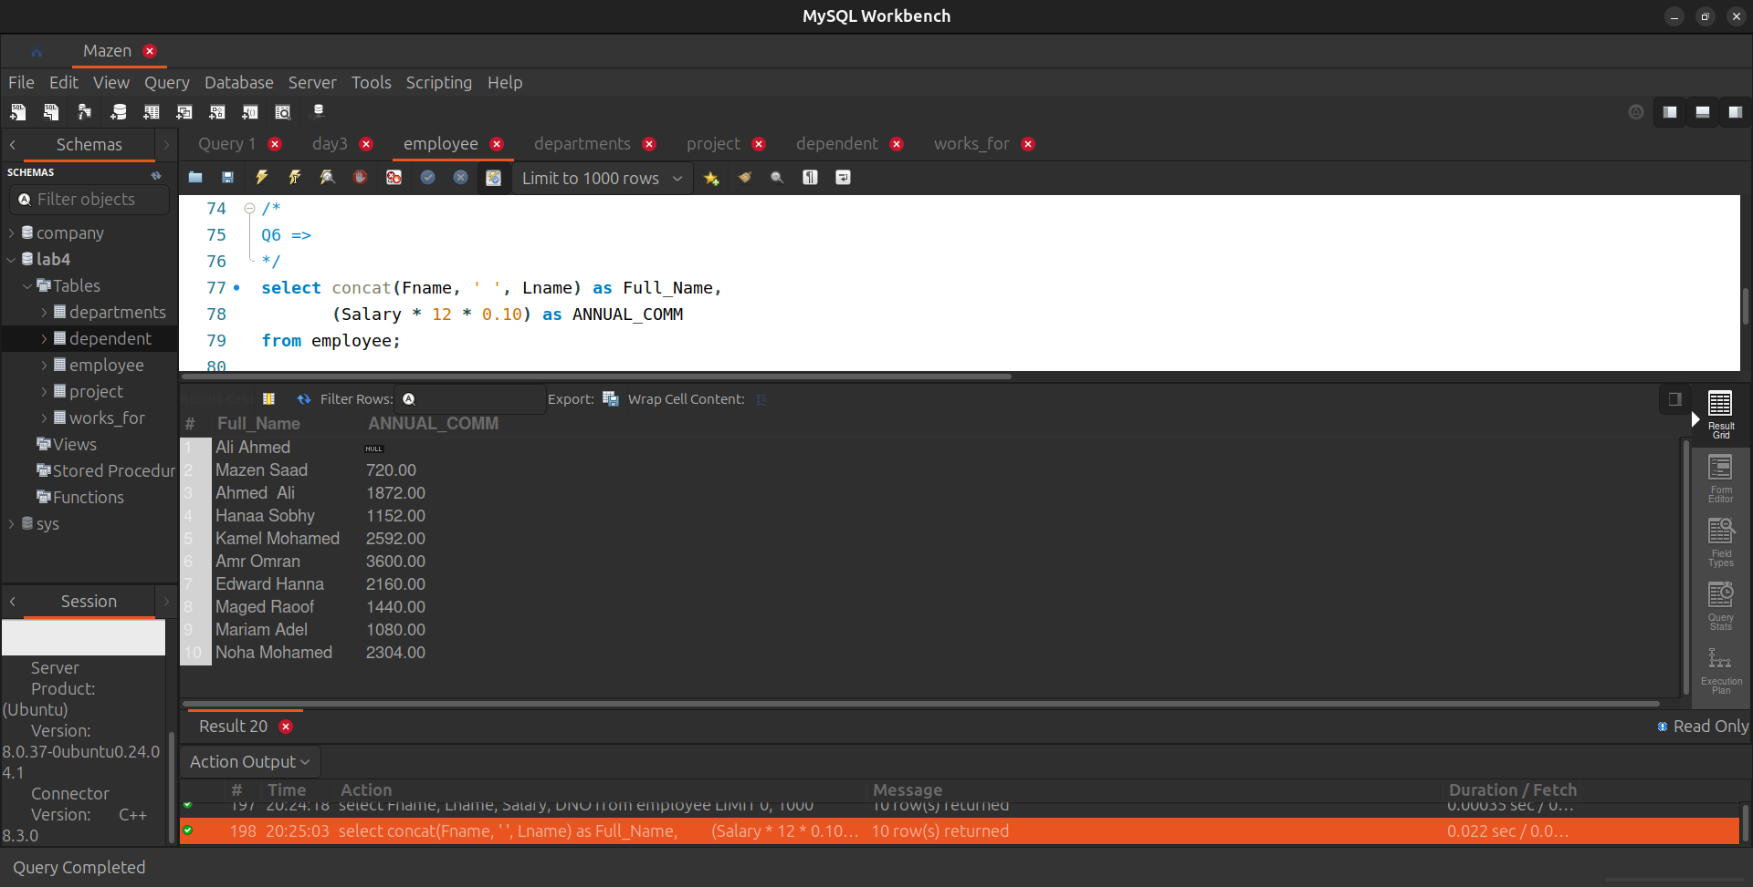

7. Display the

employees Id, name who earns more than 1000 LE monthly.

/*

Q7 =>

*/

select SSN, Fname, Lname

from employee

where Salary > 1000;

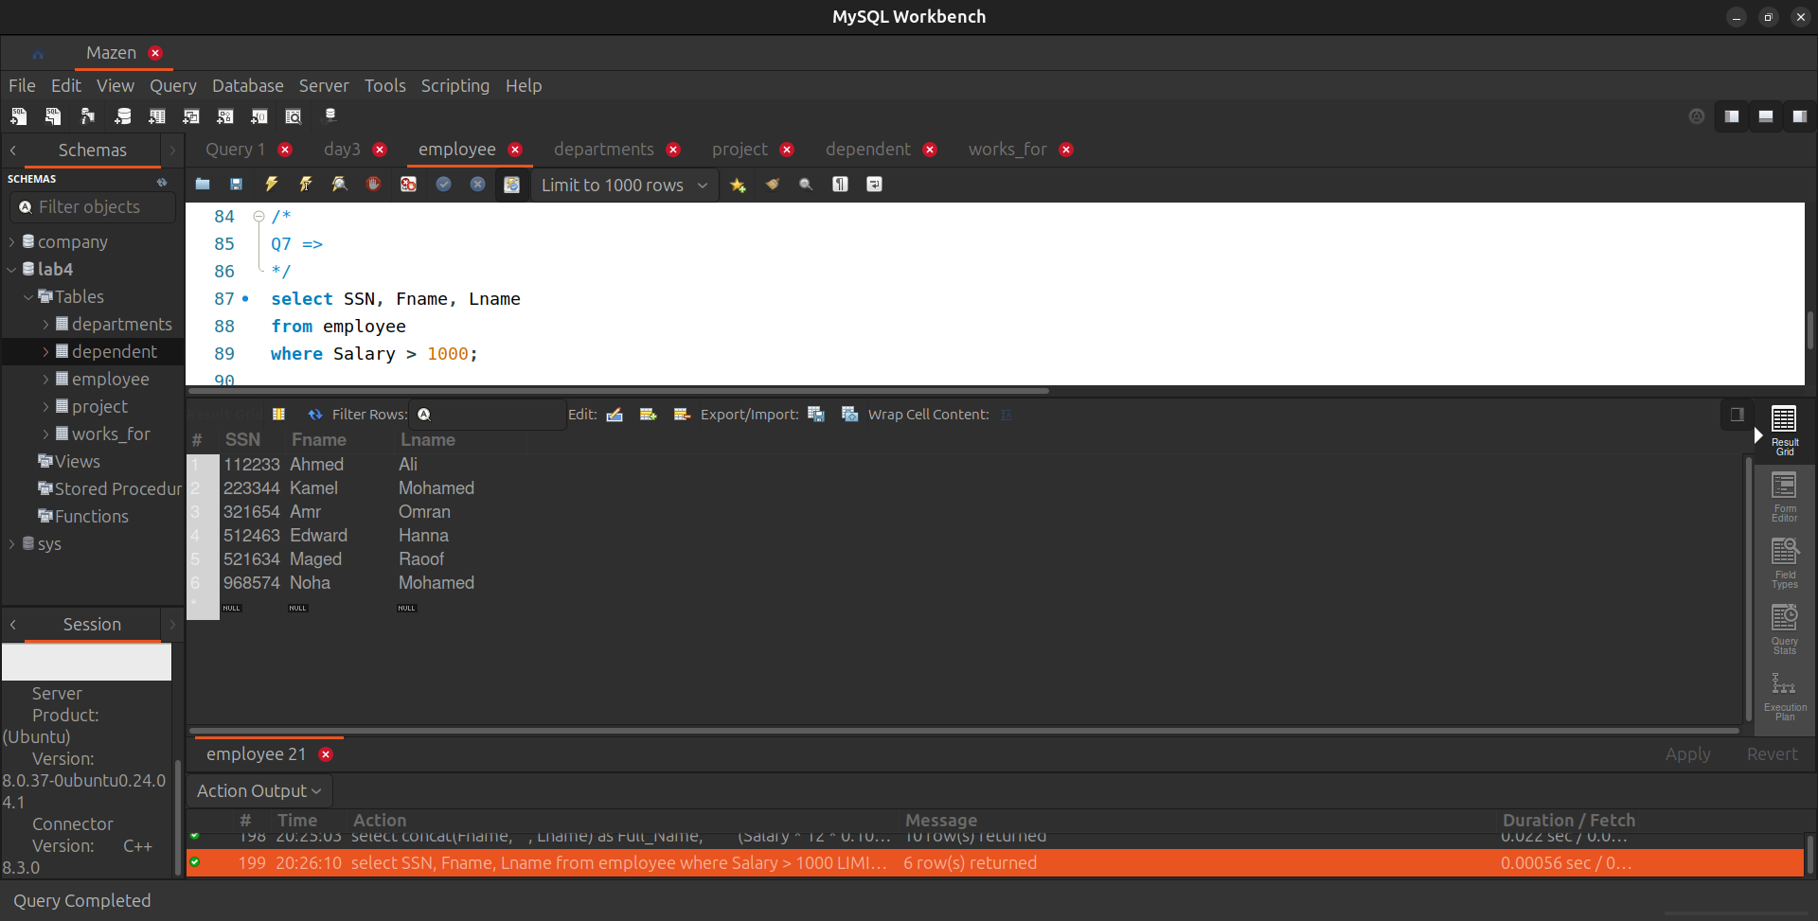

8. Display the

Department id, name and id and the name of its manager.

/*

Q8

*/

select d.Dnum, d.Dname, m.SSN as Manager_id,

concat(m.Fname, ' ', m.Lname) as Manager_Name

from departments d

join employee m on d.MGRSSN = m.SuperSSN;

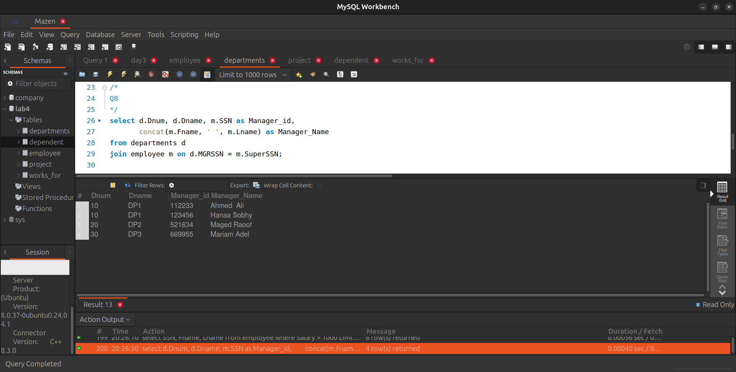

9. Display the

name of the departments and the name of the projects under its control.

/*

Q9

*/

select d.Dname as Name_Departments, p.Pname as Name_Projects

from departments d

join project p on d.Dnum = p.Dnum;

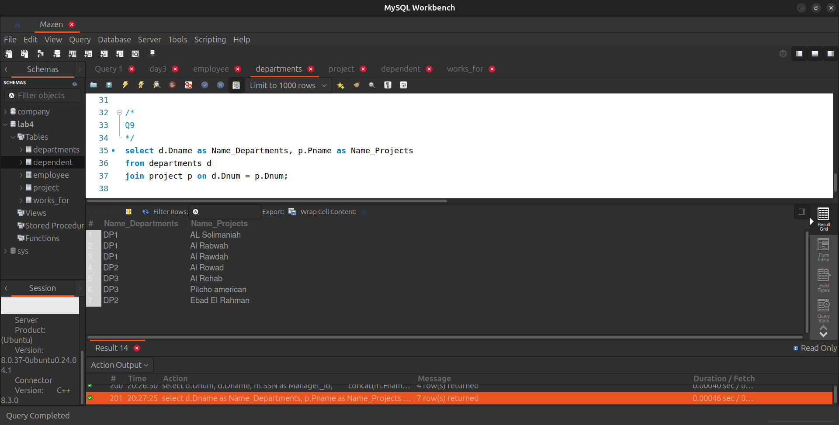

10. Find the

names of the employees who directly supervised with Kamel Mohamed.

-- 321654

/*

Q10

*/

select e.Fname, e.Lname

from employee e

join employee s on e.SuperSSN = s.SuperSSN

where s.Fname = 'Kamel' and s.Lname = 'Mohamed';

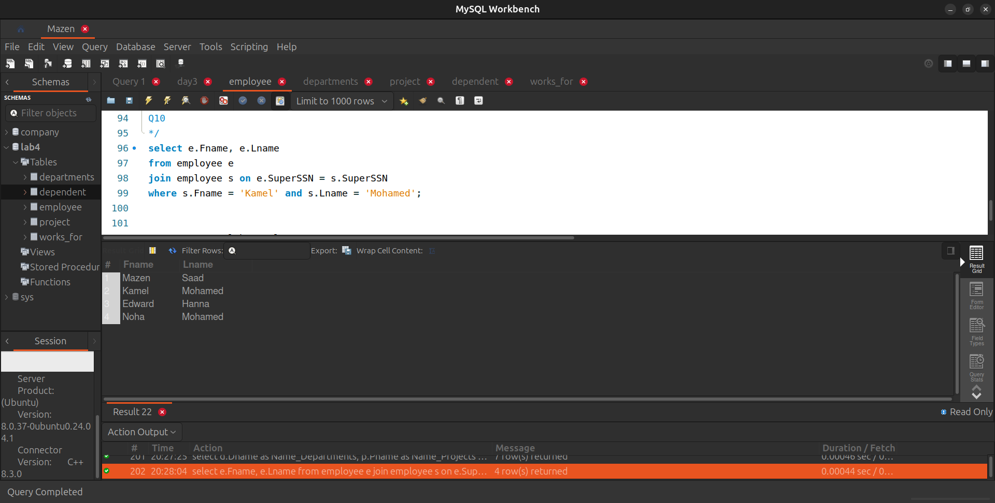

11. Retrieve the

names of all employees and the names of the projects they are working on, sorted by the project name.

/*

Q11

*/

select concat(e.Fname, ' ',e.Lname) as Names_Employees, p.Pname as Names_Projects

from employee e

join works_for w on e.SSN = w.Essn

join project p on w.Pno = p.Pnumber

order by p.Pname;

