**PostgreSQL Lab2**

**Mazen Abdeltawab Saad**

**Track Python Fayoum**

su - postgres

psql

create database postgres_lab2 TEMPLATE postgres_lab1;

\l

\c postgres_lab2

1. Add gender column for the student table[Enum]. It holds two value (male or female).

(solution 1)

create type gender_enum as enum ('male', 'female');

alter table student add gender gender_enum;

(solution 2)

alter table student add column gender enum('male', 'female');

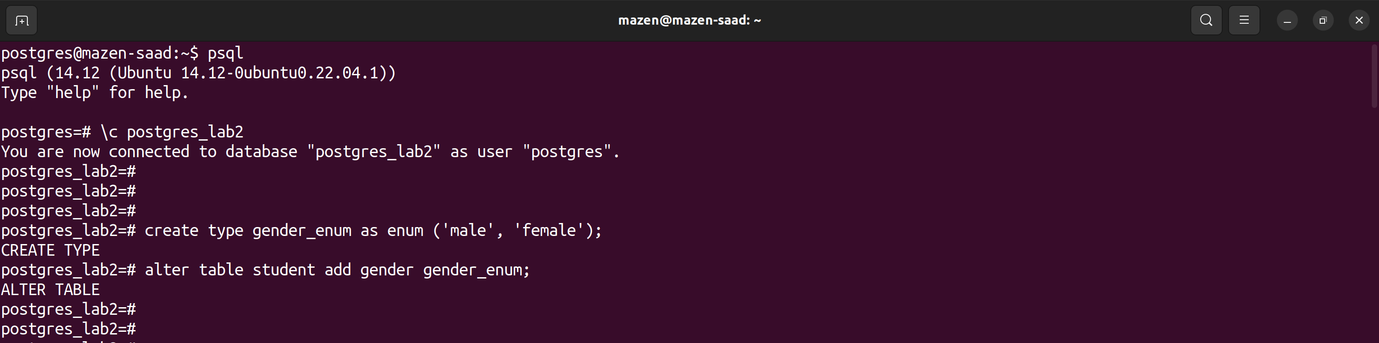

2. Add birth date column for the student table.

(solution)

alter table student add column birth_date date;

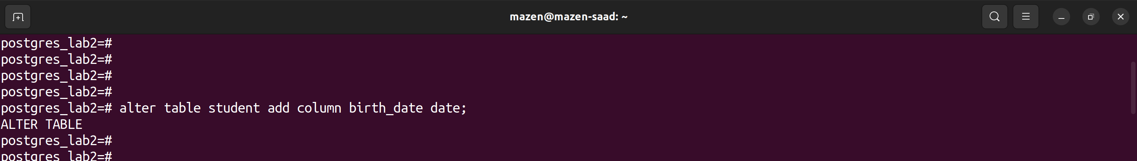

3. Delete the name column and replace it with two columns first name and last name.

(solution)

alter table student drop column name;

alter table student add column first_name text;

alter table student add column last_name text;

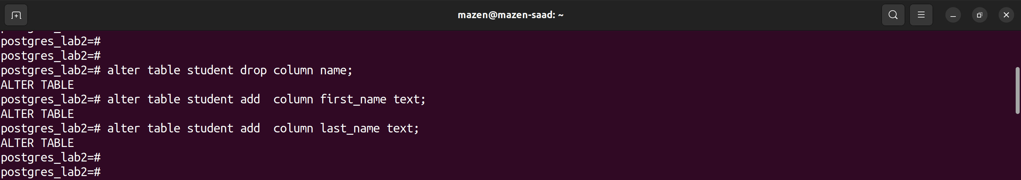

4. Delete the address and email column and replace it with contact info (Address, email) as object/Composite Data type.

(solution)

alter table student drop column address;

alter table student drop column email;

create type contact_info_obj as (email text, address text);

alter table student add column contact_info contact_info_obj;

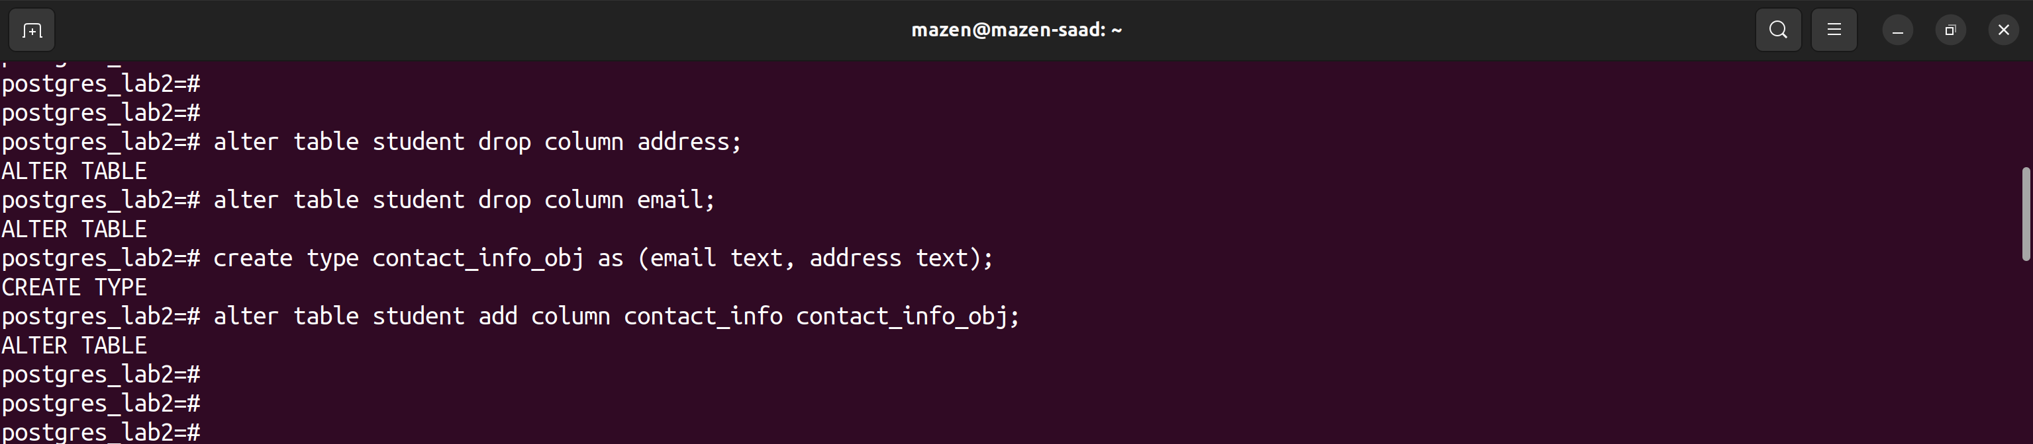

5. Change any Serial Datatype at your tables to smallInt

(solution)

alter table track alter track_id set data type smallInt;

alter table student alter student_id set data type smallInt;

alter table phone alter phone_id set data type smallInt;

alter table subject alter subject_id set data type smallInt;

alter table exam alter exam_id set data type smallInt;

alter table exam_results alter exam_result_id set data type smallInt;

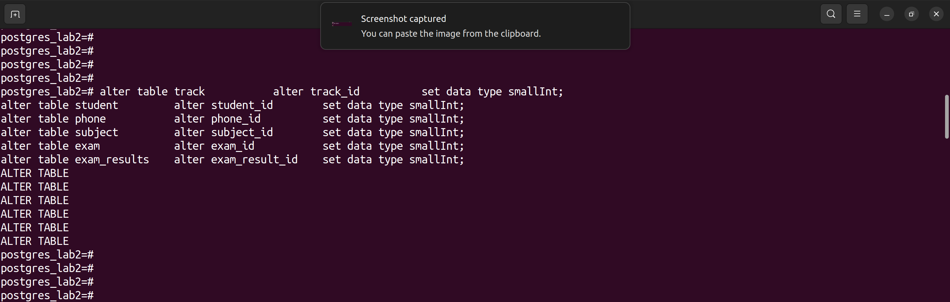

6. Add/Alter foreign key constrains in Your Tables.

(solution) s42

alter table student add constraint student_tr_fk FOREIGN KEY (track_id) references track(track_id);

alter table phone add constraint phone_st_fk FOREIGN KEY (student_id) references student(student_id);

alter table subject add constraint subject_tr_fk FOREIGN KEY (track_id) references track(track_id);

alter table exam add constraint exam_su_fk FOREIGN KEY (subject_id) references subject(subject_id);

alter table exam_results add constraint exam_results_st_fk FOREIGN KEY (student_id) references student(student_id);

alter table exam_results add constraint exam_results_ex_fk FOREIGN KEY (exam_id) references exam(exam_id);

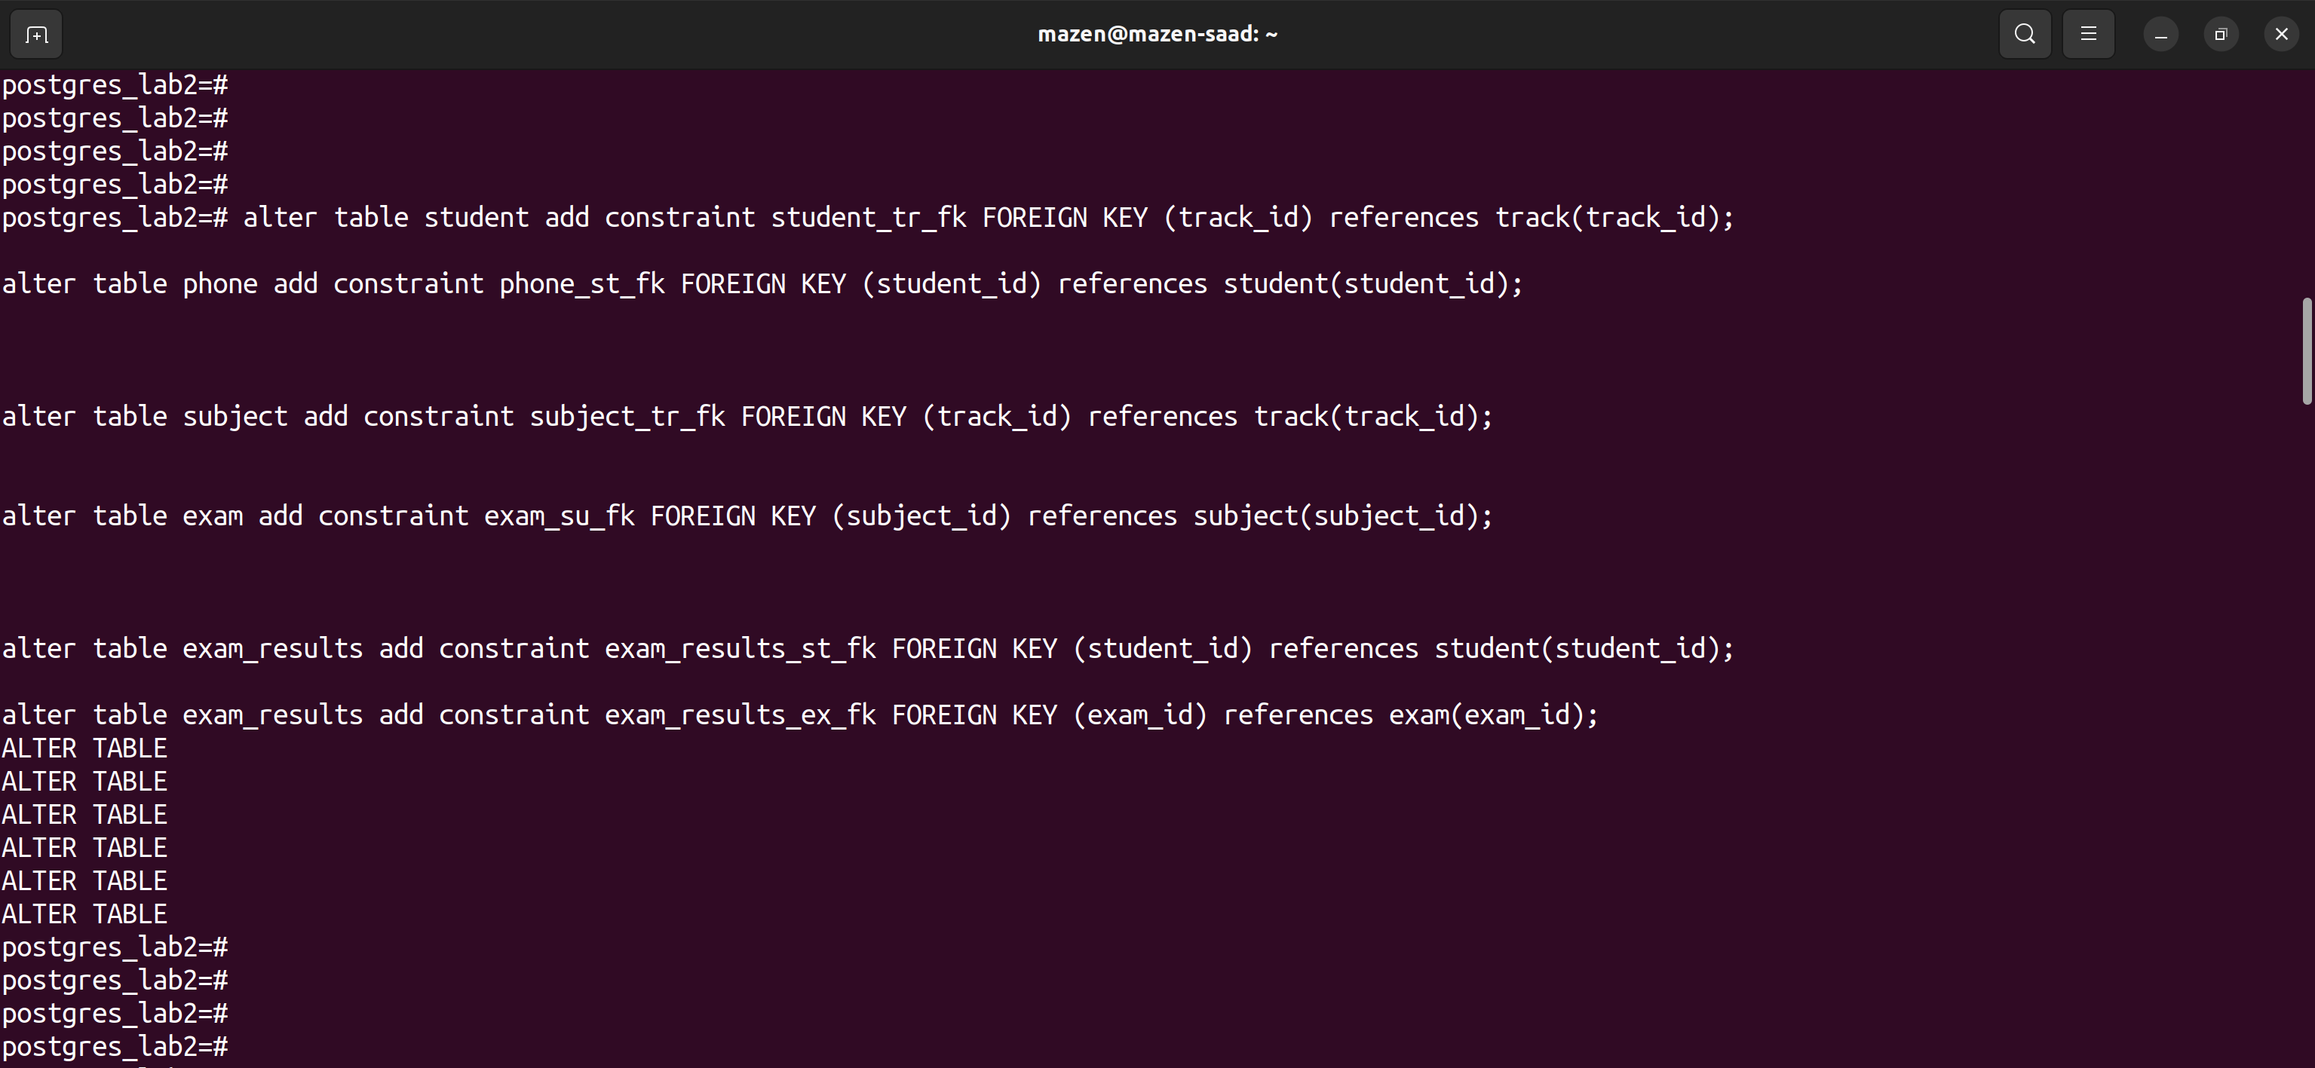

7. Insert new data in all Tables.

(solution)

insert into student

(track_id, first_name, last_name, gender, birth_date, contact_info)

values

(1, 'mazen', 'saad', 'male', '2001-04-20', ROW('mazen@gmail.com', 'fayoum')),

(2, 'Ali', 'sayed', 'male', '1992-08-01', ROW('asayed@gmail.com', 'cairo')),

(2, 'Mohammed', 'Mustafa', 'male', '1992-08-01', ROW('asayed@gmail.com', 'cairo')),

(5, 'Mustafa', 'sayed', 'male', '1991-09-01', ROW('asayed@gmail.com', 'fayoum')),

(3, 'sara', 'gamal', 'female', '1992-08-01', ROW('asayed@gmail.com', 'cairo')),

(4, 'shrouk', 'ahmed', 'female', '1992-08-01', ROW('asayed@gmail.com', 'fayoum'));

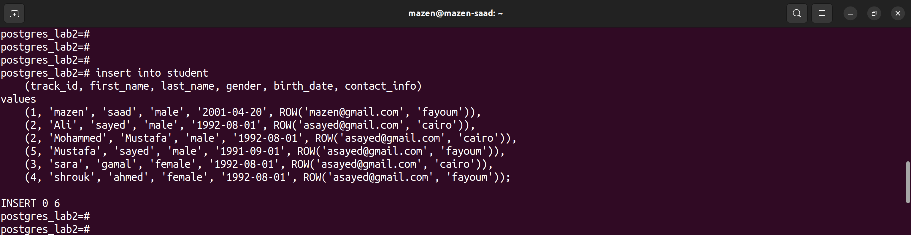

8. Display all students’ information.

(solution)

select * from student;

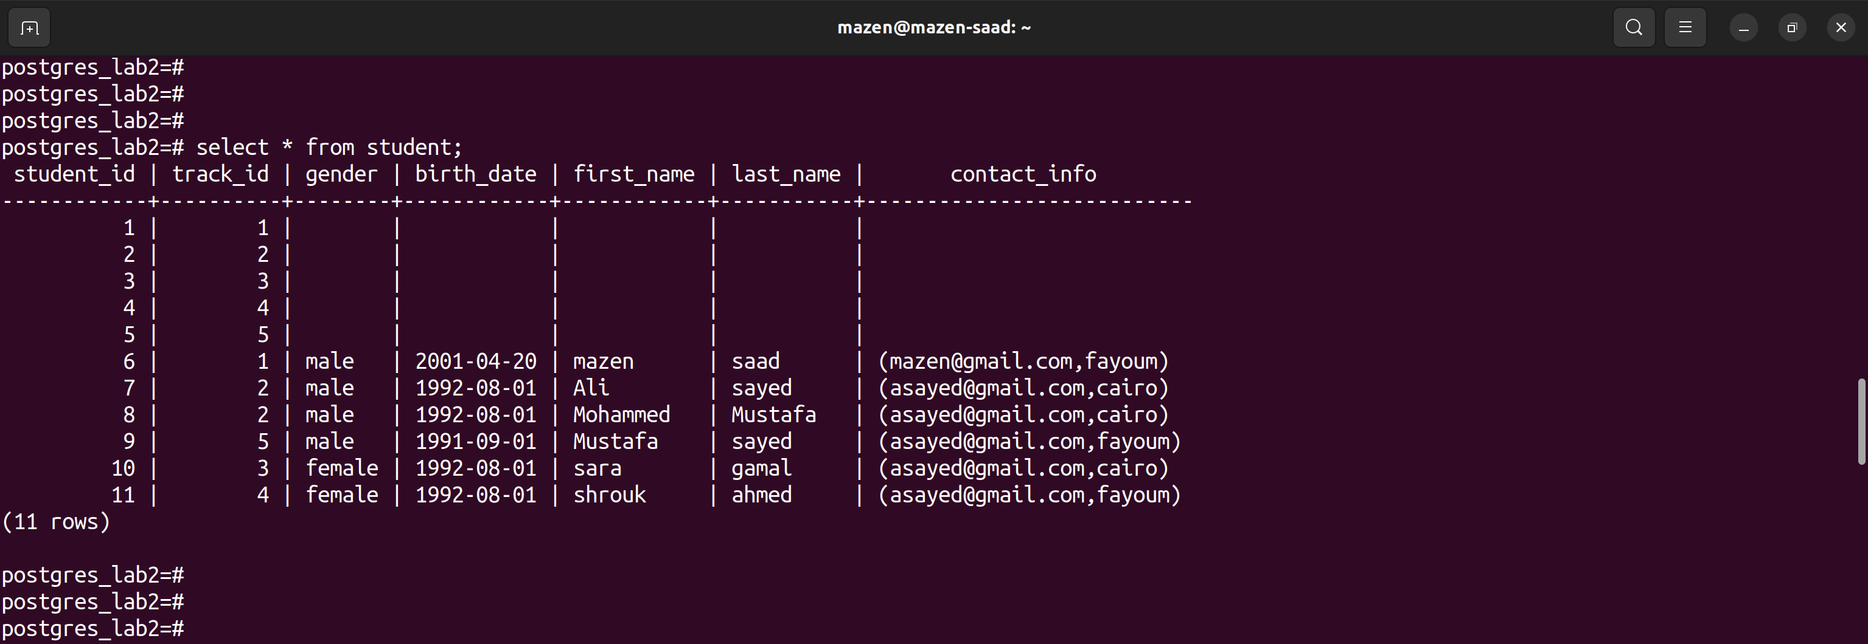

9. Display male students only.

(solution)

select * from student where gender = 'male';

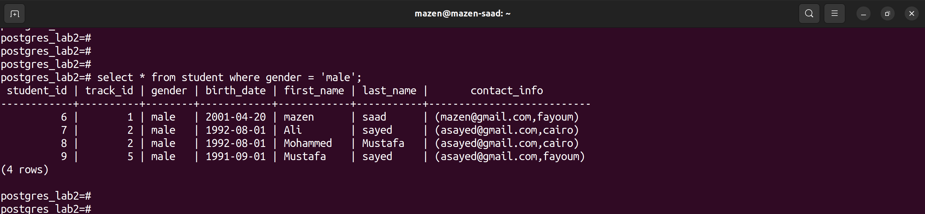

10. Display the number of female students.

(solution)

select count(*) from student where gender = 'female';

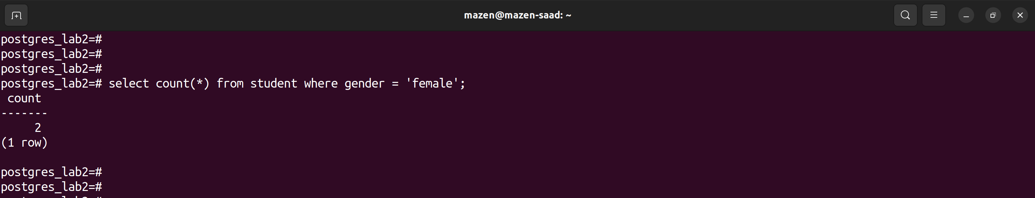

11. Display the students who are born before 1992-10-01.

(solution)

select * from student where birth_date < '1992-10-01';

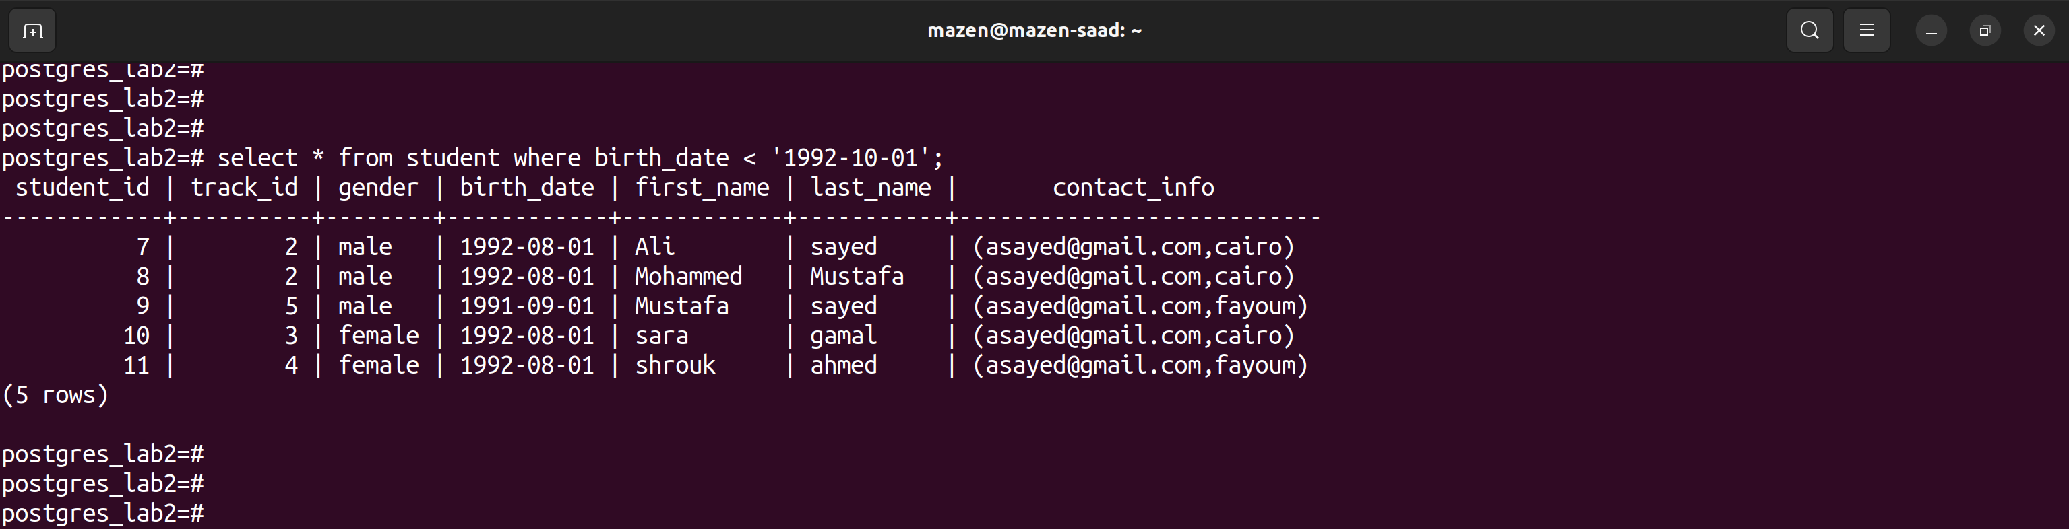

12. Display male students who are born before 1991-10-01.

(solution)

select * from student where gender = 'male' and birth_date < '1991-10-01';

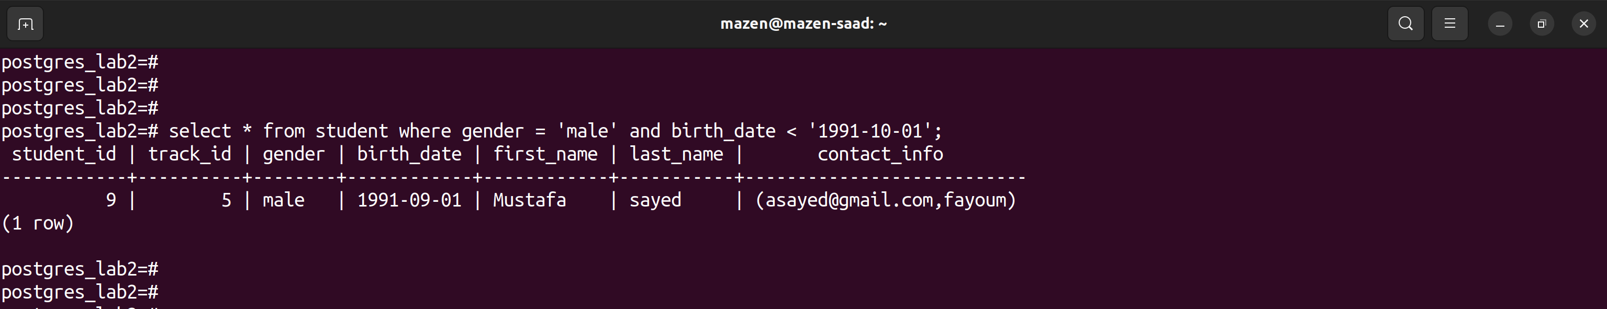

13. Display subjects and their max score sorted by max score.

(solution)

select * from subject order by max_score desc;

or

select subject_name, max_score from subject order by max_score desc;

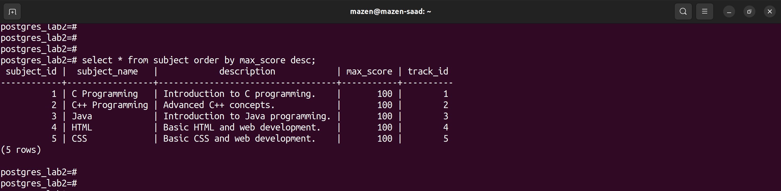

14. Display the subject with highest max score

(solution)

select * from subject order by max_score desc limit 1;

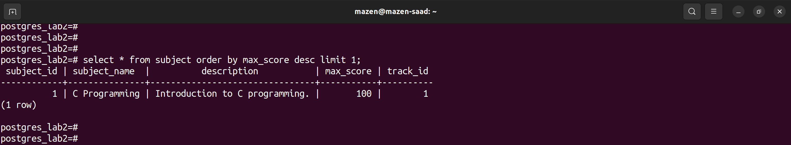

15. Display students’ names that begin with A.

(solution) s26

select * from student where first_name like 'A%';

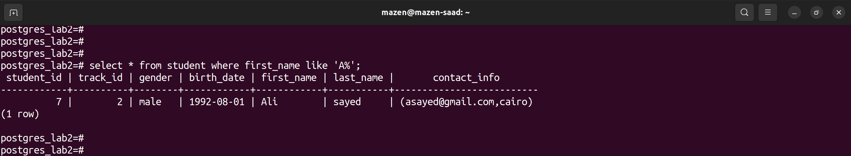

16. Display the number of students’ their name is “Mohammed”

(solution) s28

select count(*) from student where first_name like '%Mohammed';

or

select count(*) from student where first_name = 'Mohammed';

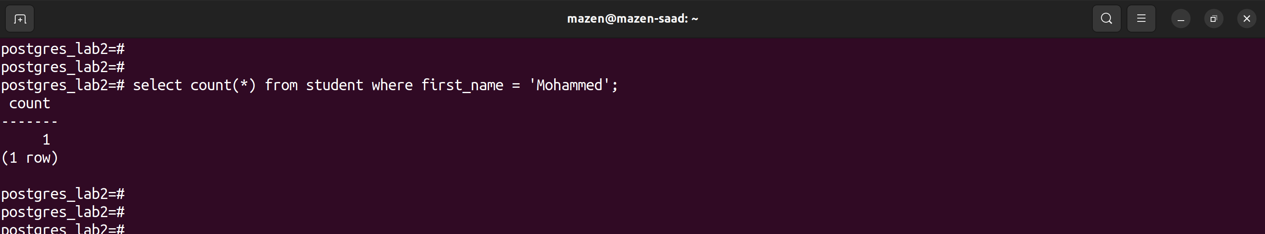

17. Display the number of males and females.

(solution) s28

select count(*) from student where gender = 'male' or gender = 'female';

or

select gender, count(gender) from student group by gender;

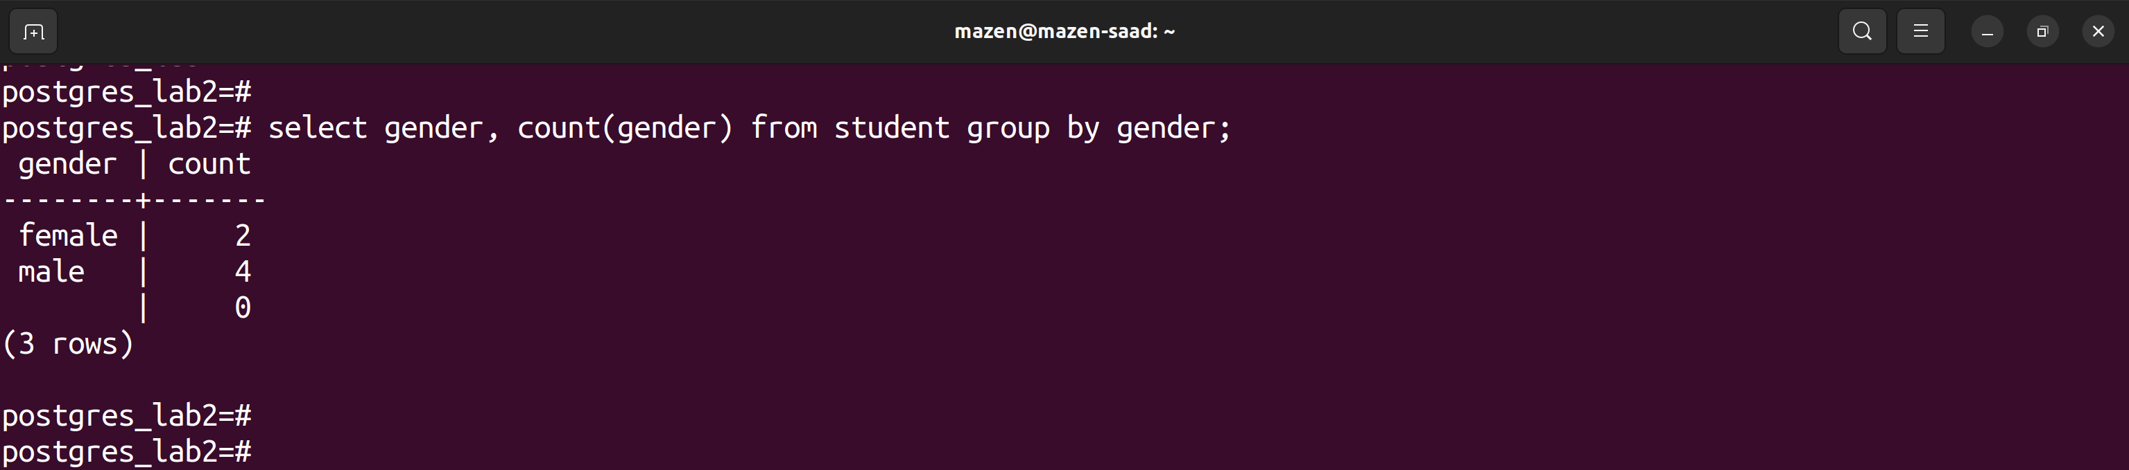

18. Display the repeated first names and their counts if higher than 2.

(solution) s29

select name from student group by name;

select count(name) from student group by name;

or

SELECT first_name, COUNT(*) FROM student GROUP BY first_name HAVING COUNT(*) > 2;

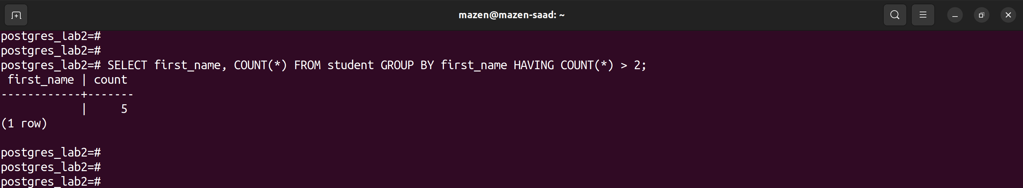

19. Display the all Students and track name that belong to it

(solution)

SELECT

student.first_name,

student.last_name,

track.track_name

FROM

student

JOIN

student_subjects ON student.student_id = student_subjects.student_id

JOIN

subject ON student_subjects.subject_id = subject.subject_id

JOIN

track ON subject.track_id = track.track_id;

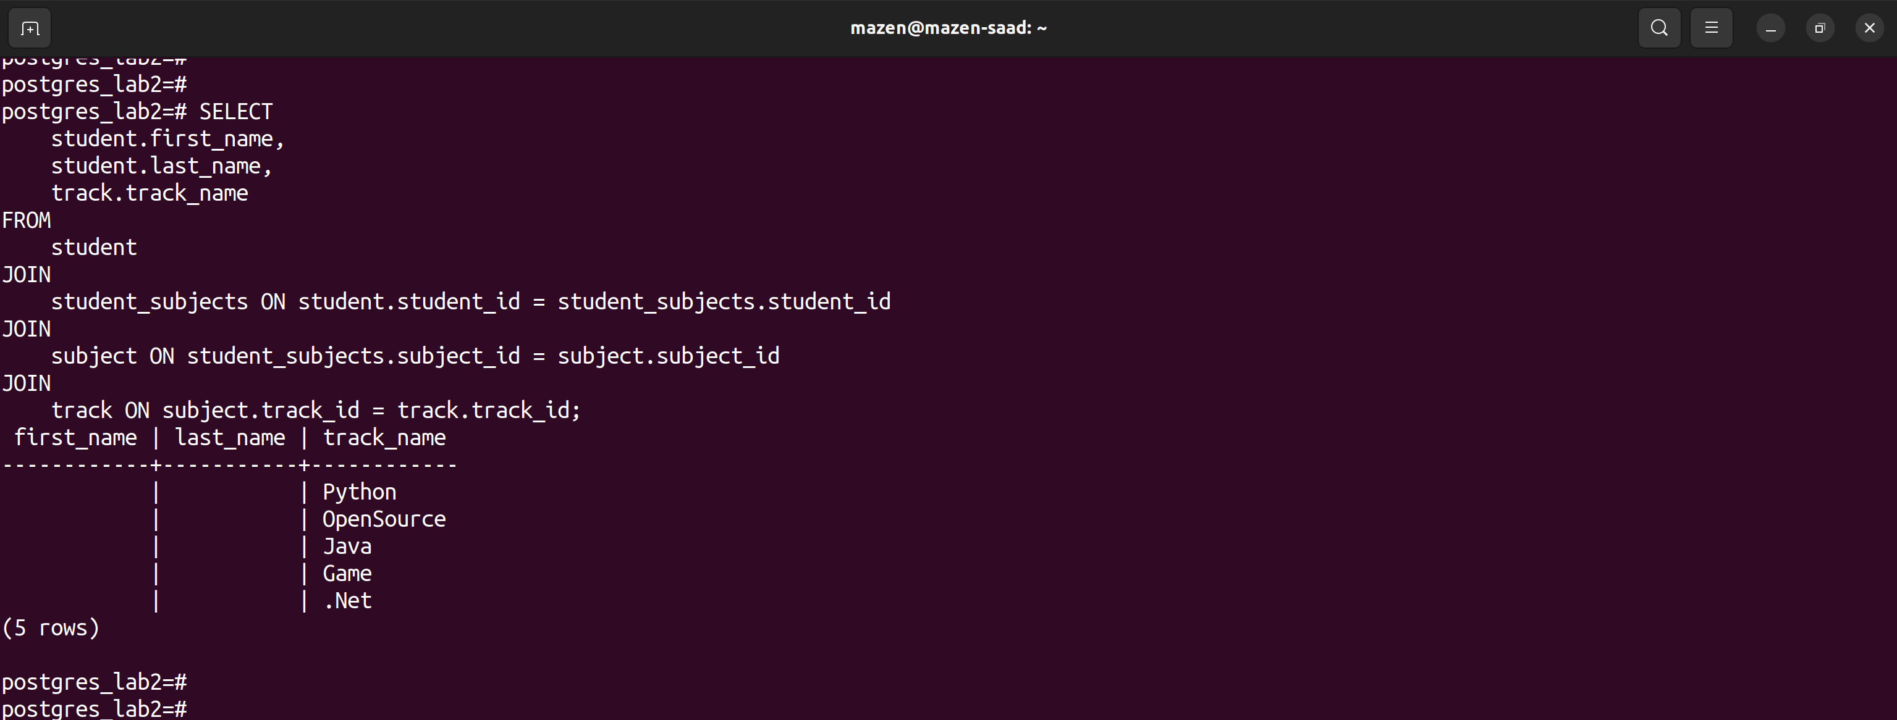

20. (Bouns) Display students’ names, their score and subject name.

(solution)

SELECT

student.first_name,

student.last_name,

subject.subject_name,

exam_results.score

FROM

student

JOIN

exam_results ON student.student_id = exam_results.student_id

JOIN

exam ON exam_results.exam_id = exam.exam_id

JOIN

subject ON exam.subject_id = subject.subject_id;

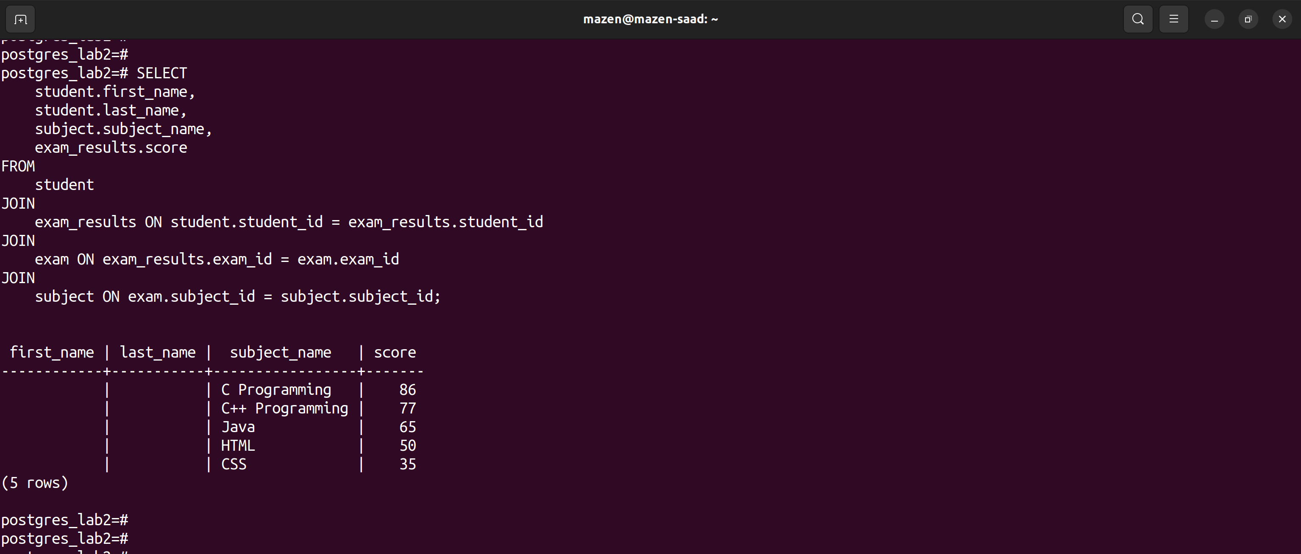

// lab3

su - postgres

psql

create database postgres_lab3 TEMPLATE postgres_lab2;

\l

\c postgres_lab3

1. Insert new student and his score in exam in different subjects as transaction and save it.

begin;

insert into student

(first_name, last_name, gender, birth_date, contact_info)

values

('mohammed', 'ali', 'male', '2002-04-20', ROW('mohali@gmail.com', 'fayoum'));

insert into exam_results

(student_id, exam_id, score)

values

(6, 5, 59);

commit;

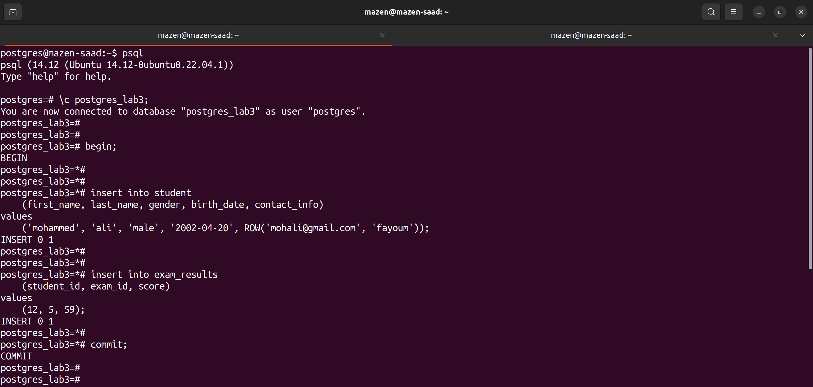

2. Insert new students and his score in exam in different subjects as transaction and undo it.

begin;

insert into student

(first_name, last_name, gender, birth_date, contact_info)

values

('jane', 'smith', 'male', '2003-04-20', ROW('jane@gmail.com', 'fayoum'));

insert into exam_results

(student_id, exam_id, score)

values

(7, 5, 99);

rollback;

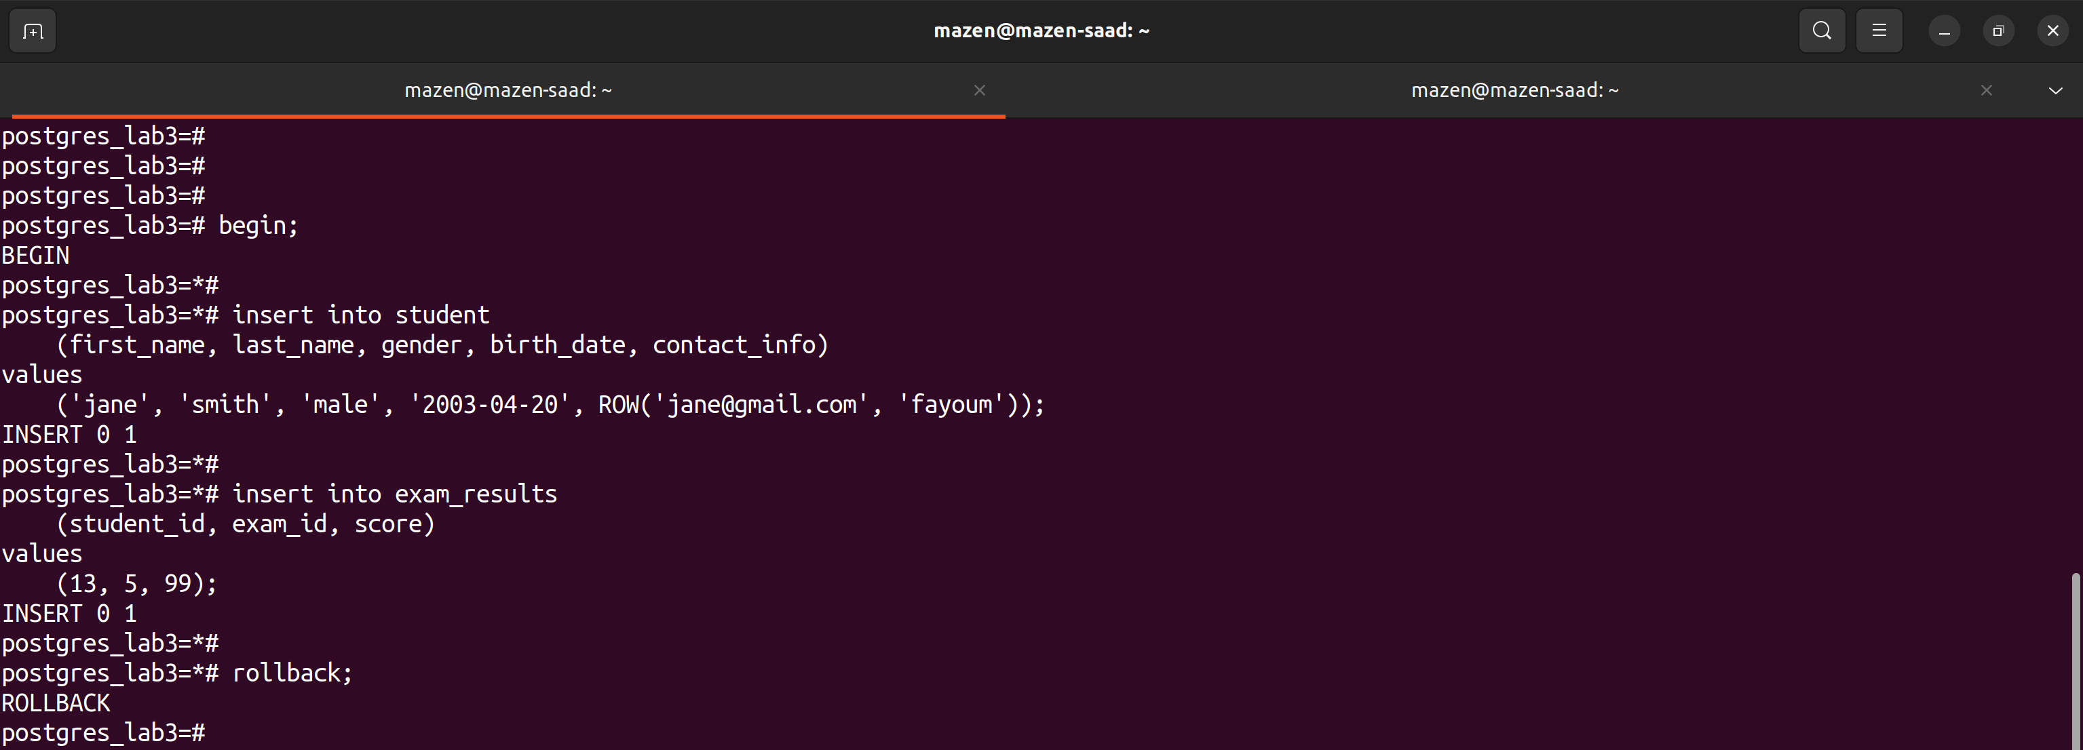

8. Create user and give him all privileges.

(solution)

sudo adduser newuser

sudo passwd newuser

su – postgres

psql

create user newuser with password 'mazen@@1';

GRANT CONNECT ON DATABASE postgres_lab2 TO newuser;

GRANT ALL PRIVILEGES ON DATABASE postgres_lab2 TO newuser;

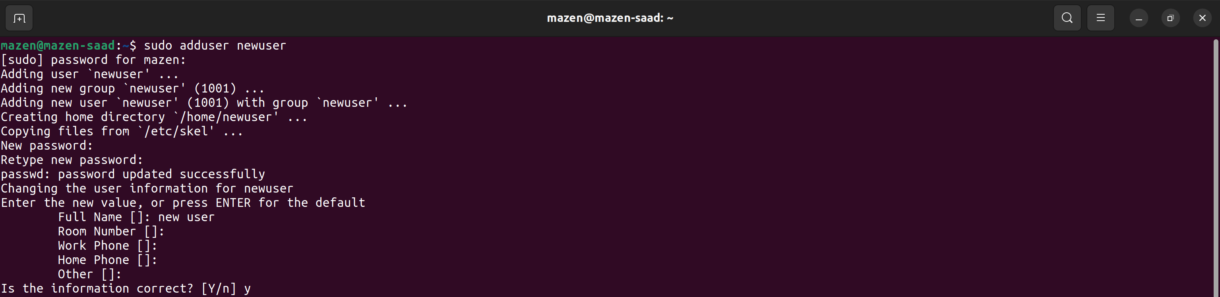

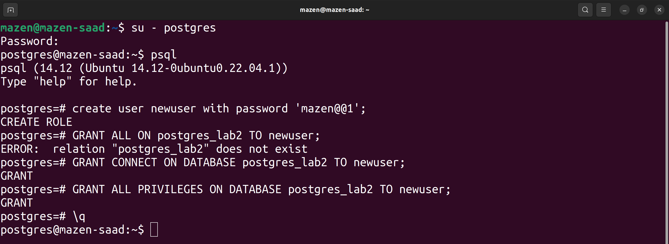

9. Create another new user and make the authentication method is “trust” and give him all privileges if he login from his “local” server.

(solution)

sudo adduser localuser

sudo passwd localuser

su – postgres

psql

CREATE USER localuser WITH PASSWORD 'mazen@@1';

# edit file pg_hba.conf

sudo vim /var/lib/pg_hba.conf

local all localuser trust

GRANT CONNECT ON DATABASE postgres_lab2 TO newuser;

GRANT ALL PRIVILEGES ON DATABASE postgres_lab2 TO newuser;

