**PostgreSQL Lab3**

**Mazen Abdeltawab Saad**

**Track Python Fayoum**

**Lab3**

su - postgres

mazen@@1

psql

create database postgres_lab3 TEMPLATE postgres_lab2;

\l

\c postgres_lab3

3. Create a view for student names with their Tracks names which is belong to it.

create view student_tracks_view

as select student.first_name, track.track_name

FROM

student

join

track on student.track_id = track.track_id;

select * from student_tracks_view;

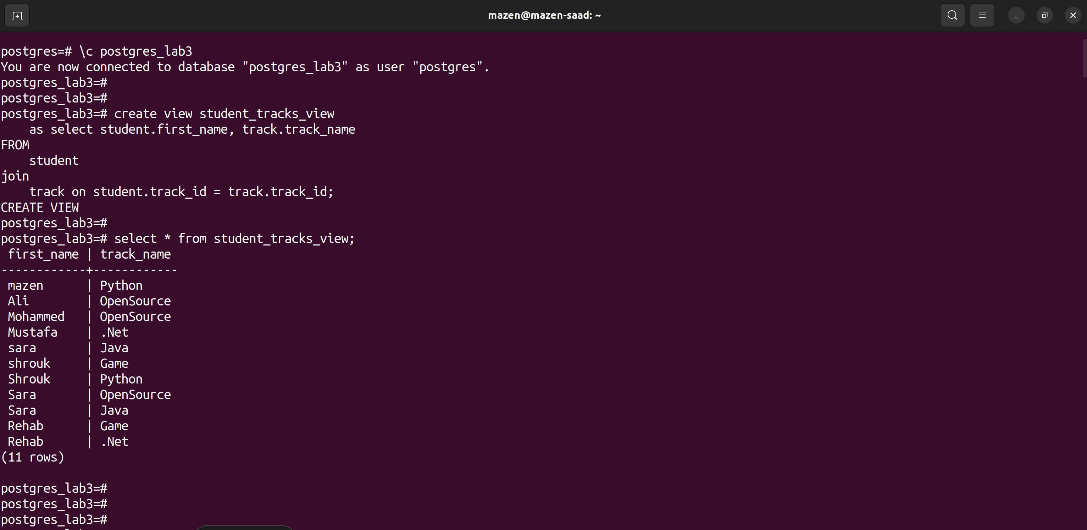

4. Create a view for Tracks names and the subjects which is belong/study to it.

create view track_subject_view

as select track.track_name, subject.subject_name

FROM

track

join

subject on subject.subject_id = track.track_id;

select * from track_subject_view;

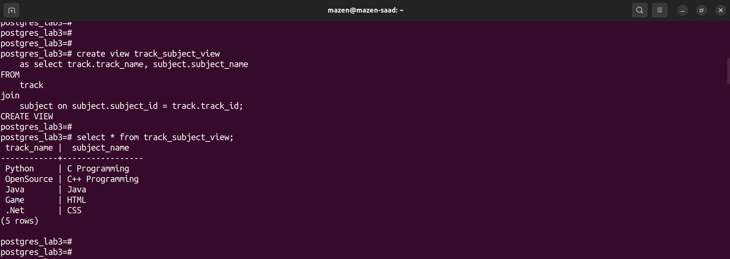

5. Create a view for student names with their subject's names which will study.

create view student_subject_view

as select student.first_name, subject.subject_name

FROM

student

join

subject on subject.subject_id = subject.subject_id;

select * from student_subject_view;

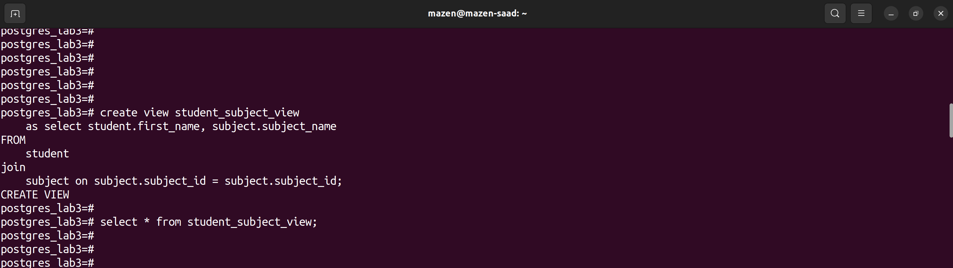

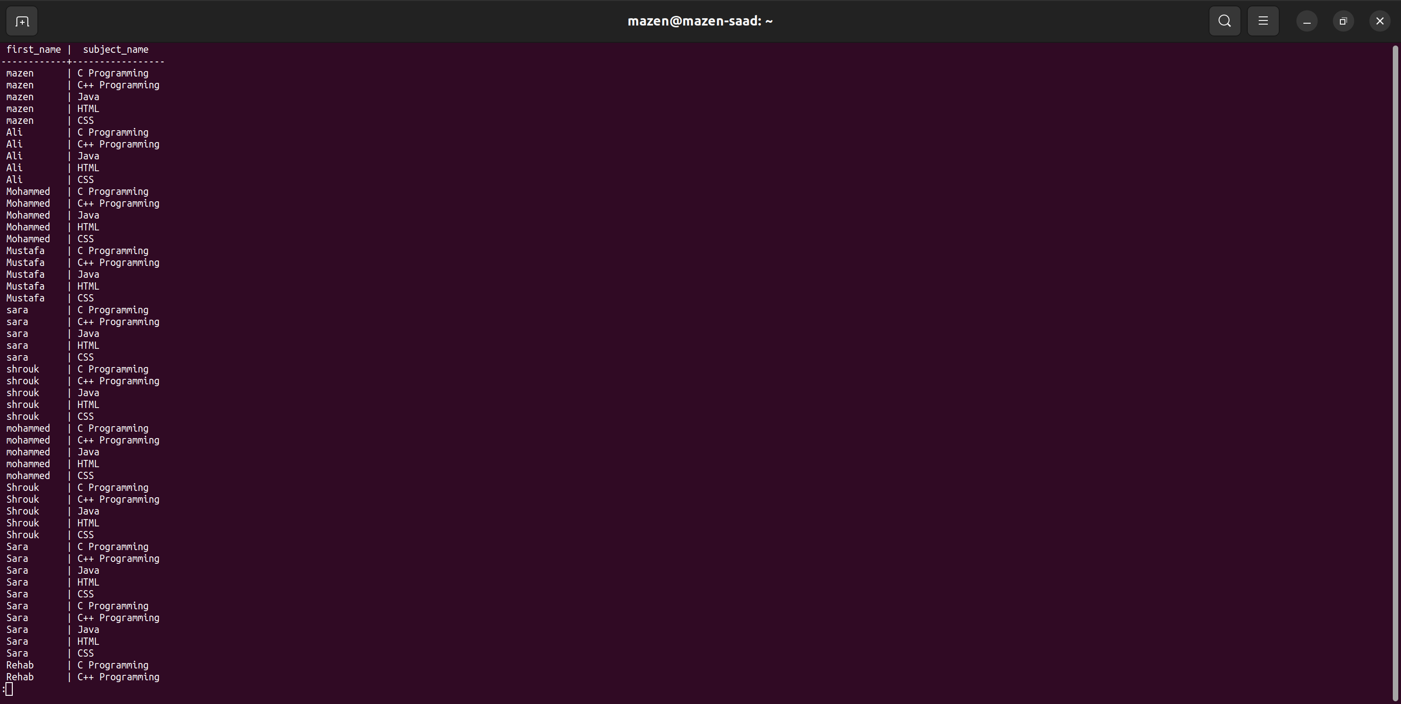

6. Create a view for all students name (Full Name) with their score in each subject and its date.

create view student_score_view

as select concat(student.first_name, ' ', student.last_name) as FullName , subject.subject_name, exam_results.score, exam.exam_date

FROM

student

join

subject on subject.subject_id = subject.subject_id

join

exam_results on exam_results.student_id = student.student_id

join

exam on exam.exam_id = subject.subject_id

;

select * from student_score_view;

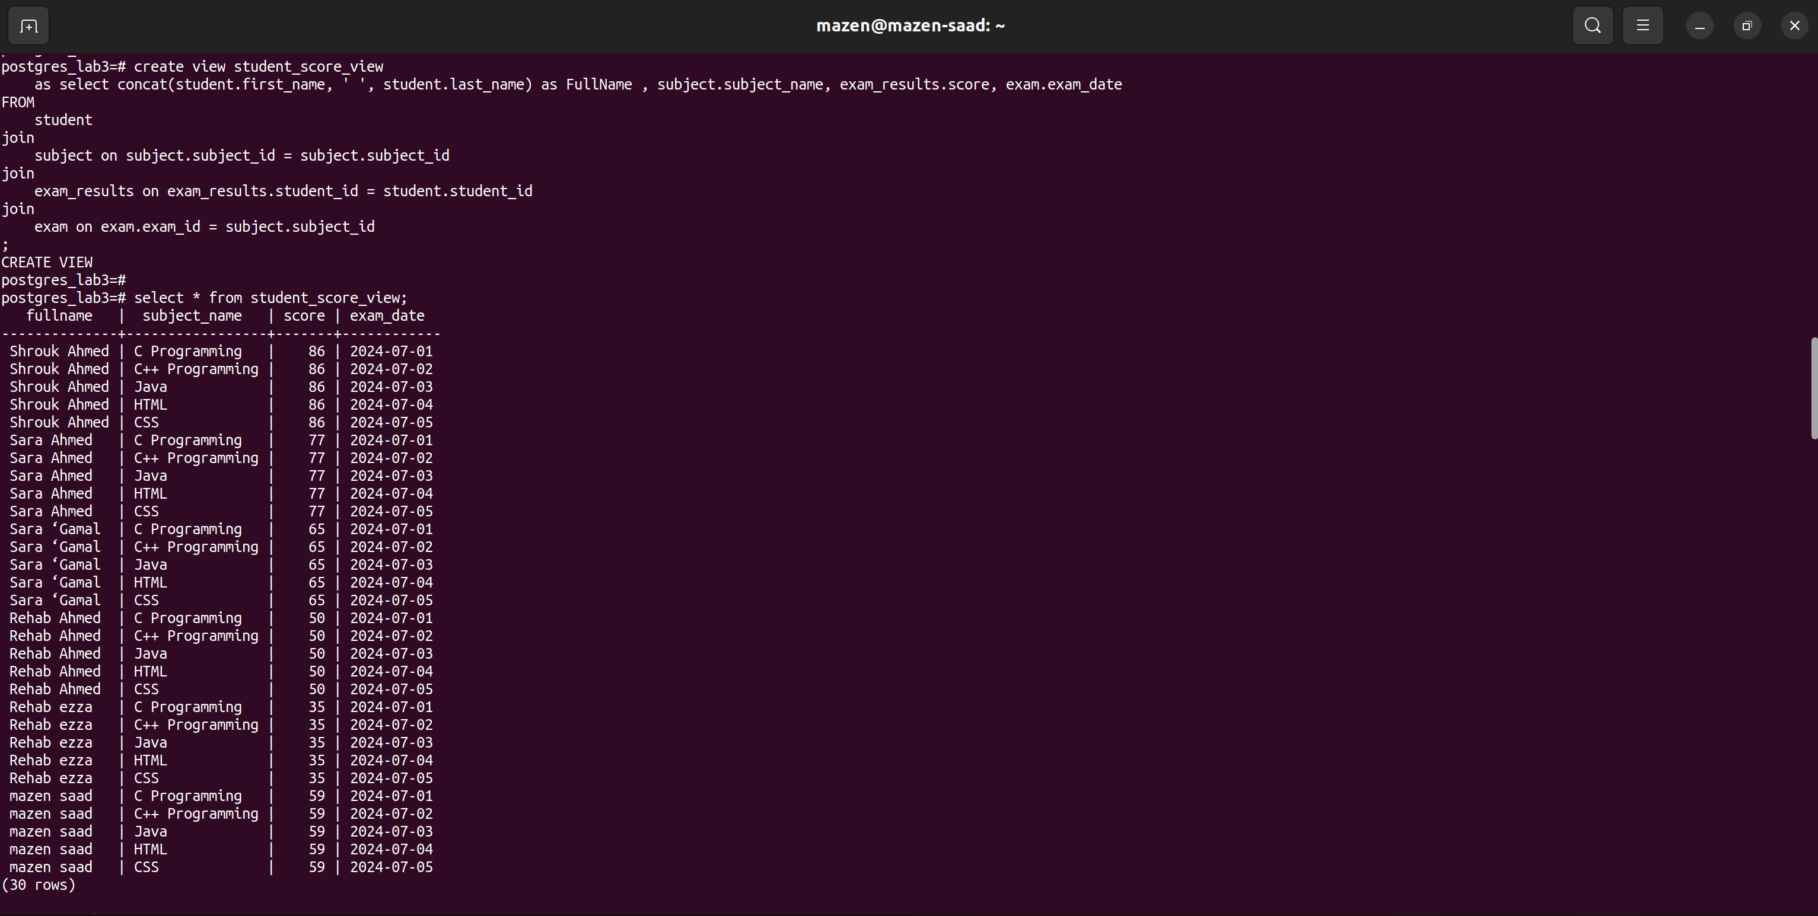

7. Create a temporary view for all subjects with their max_score.

CREATE TEMP VIEW temp_subject_max_score

AS SELECT subject.subject_name, MAX(exam_results.score) AS max_score

FROM

subject

JOIN

exam ON subject.subject_id = exam.subject_id

JOIN

exam_results ON exam.exam_id = exam_results.exam_id

GROUP BY

subject.subject_name;

select * from temp_subject_max_score;

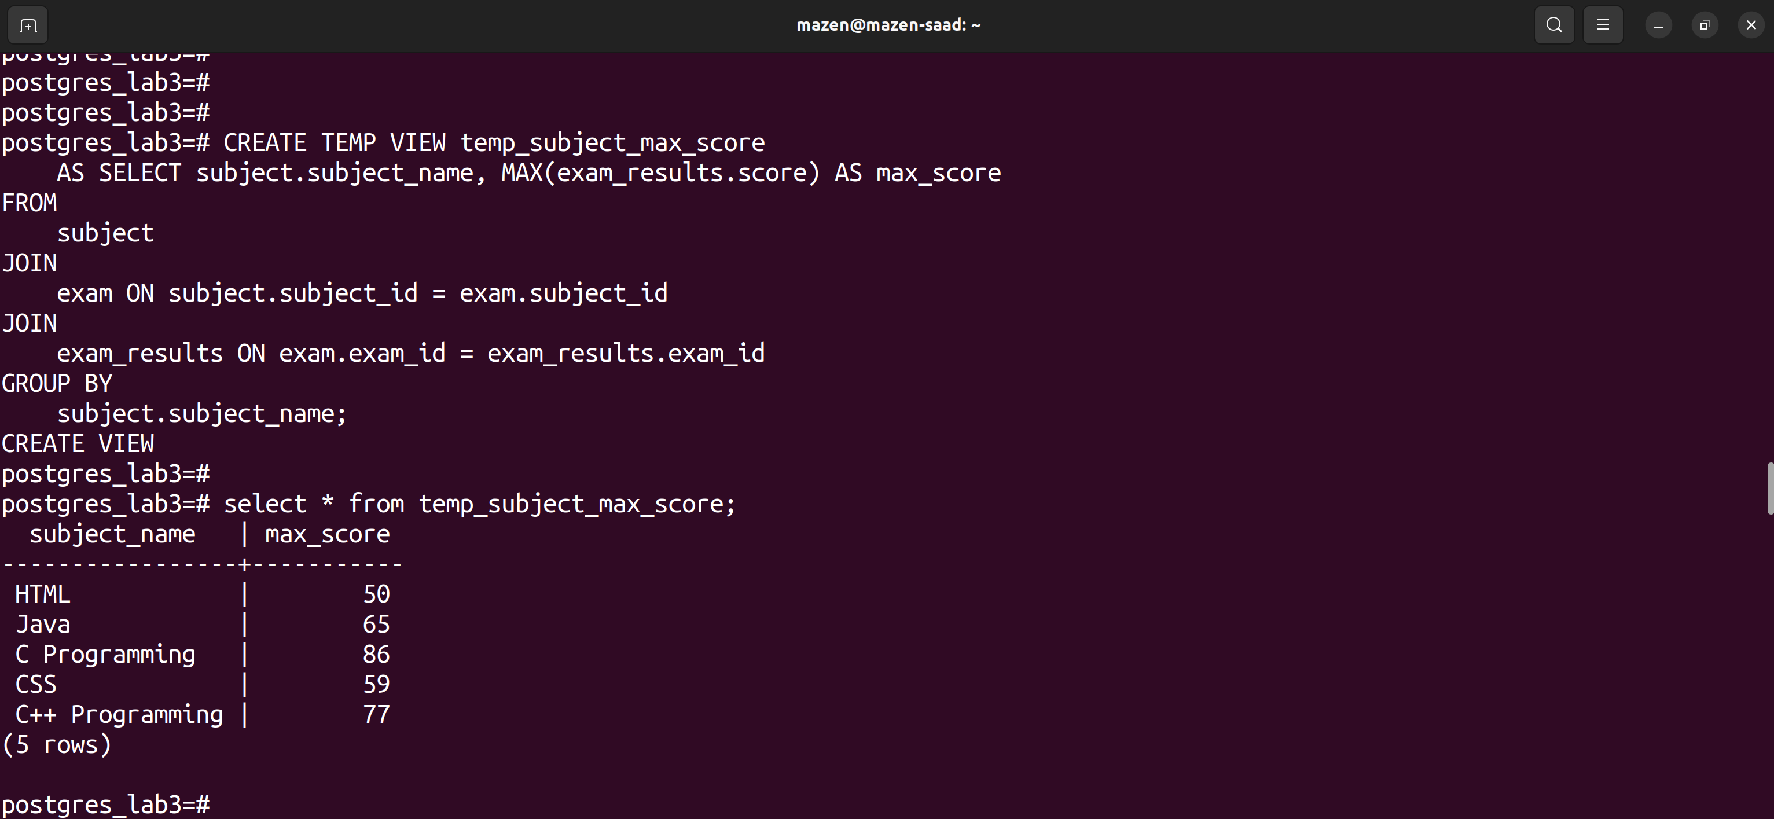

10. (from Q.6) Display the date of exam as the following: day 'month name' year.

SELECT

FullName, subject_name, score, TO_CHAR(exam_date, 'Day FMMonth YYYY') AS formatted_date

FROM

student_score_view;

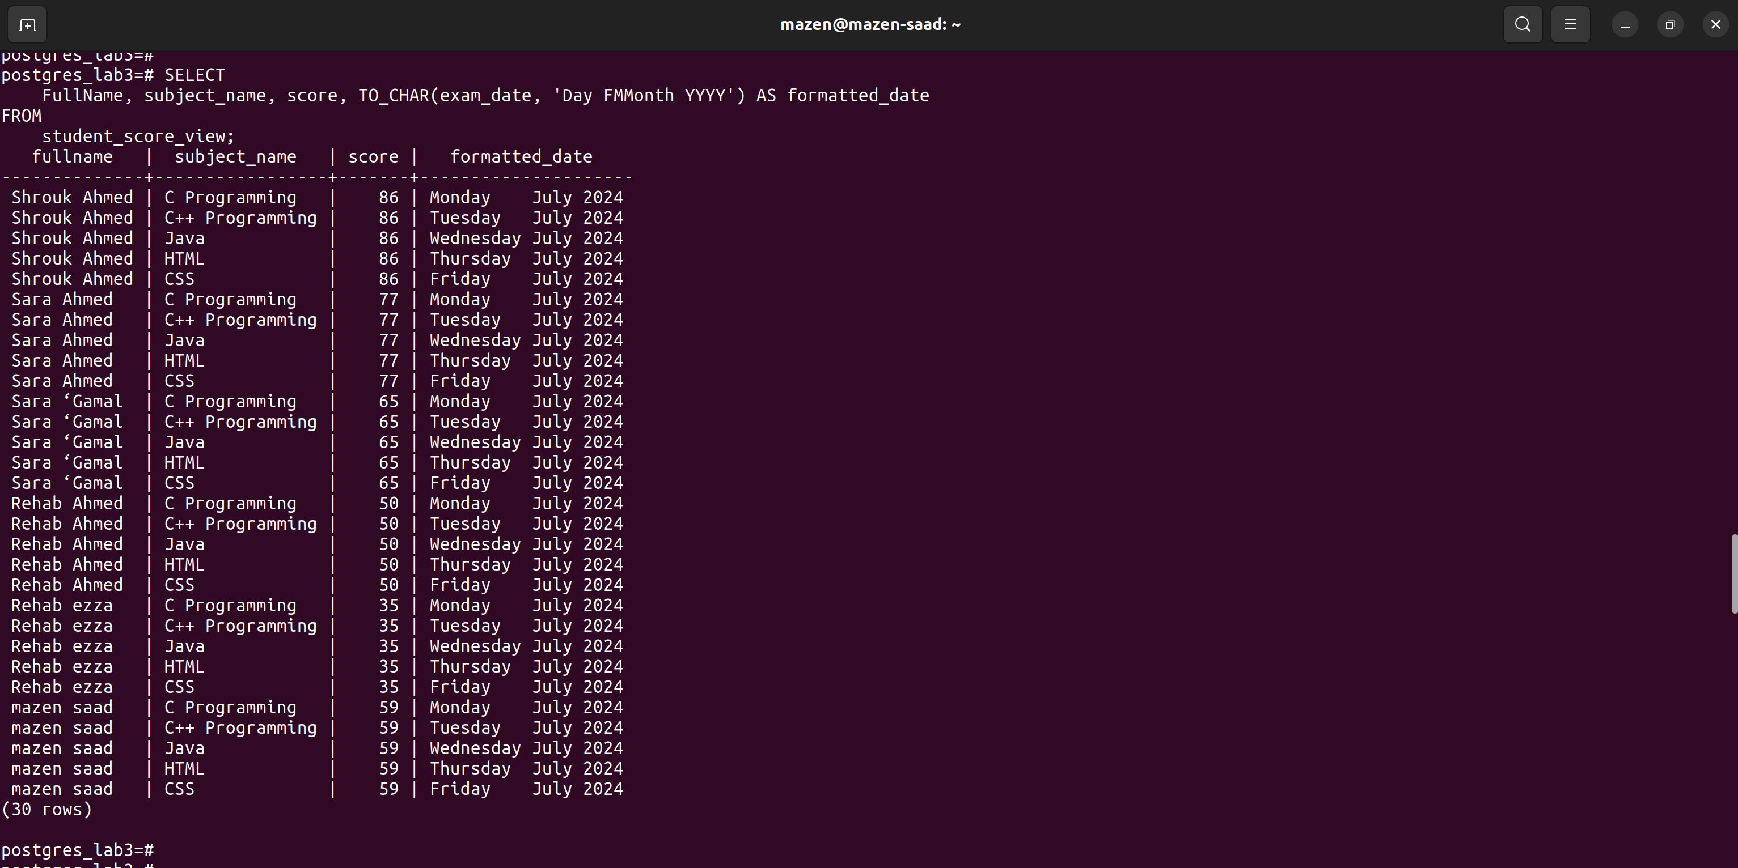

11. Display name and age of each students

SELECT

concat(student.first_name, ' ', student.last_name) as FullName, age(birth_date) AS Age

FROM

student;

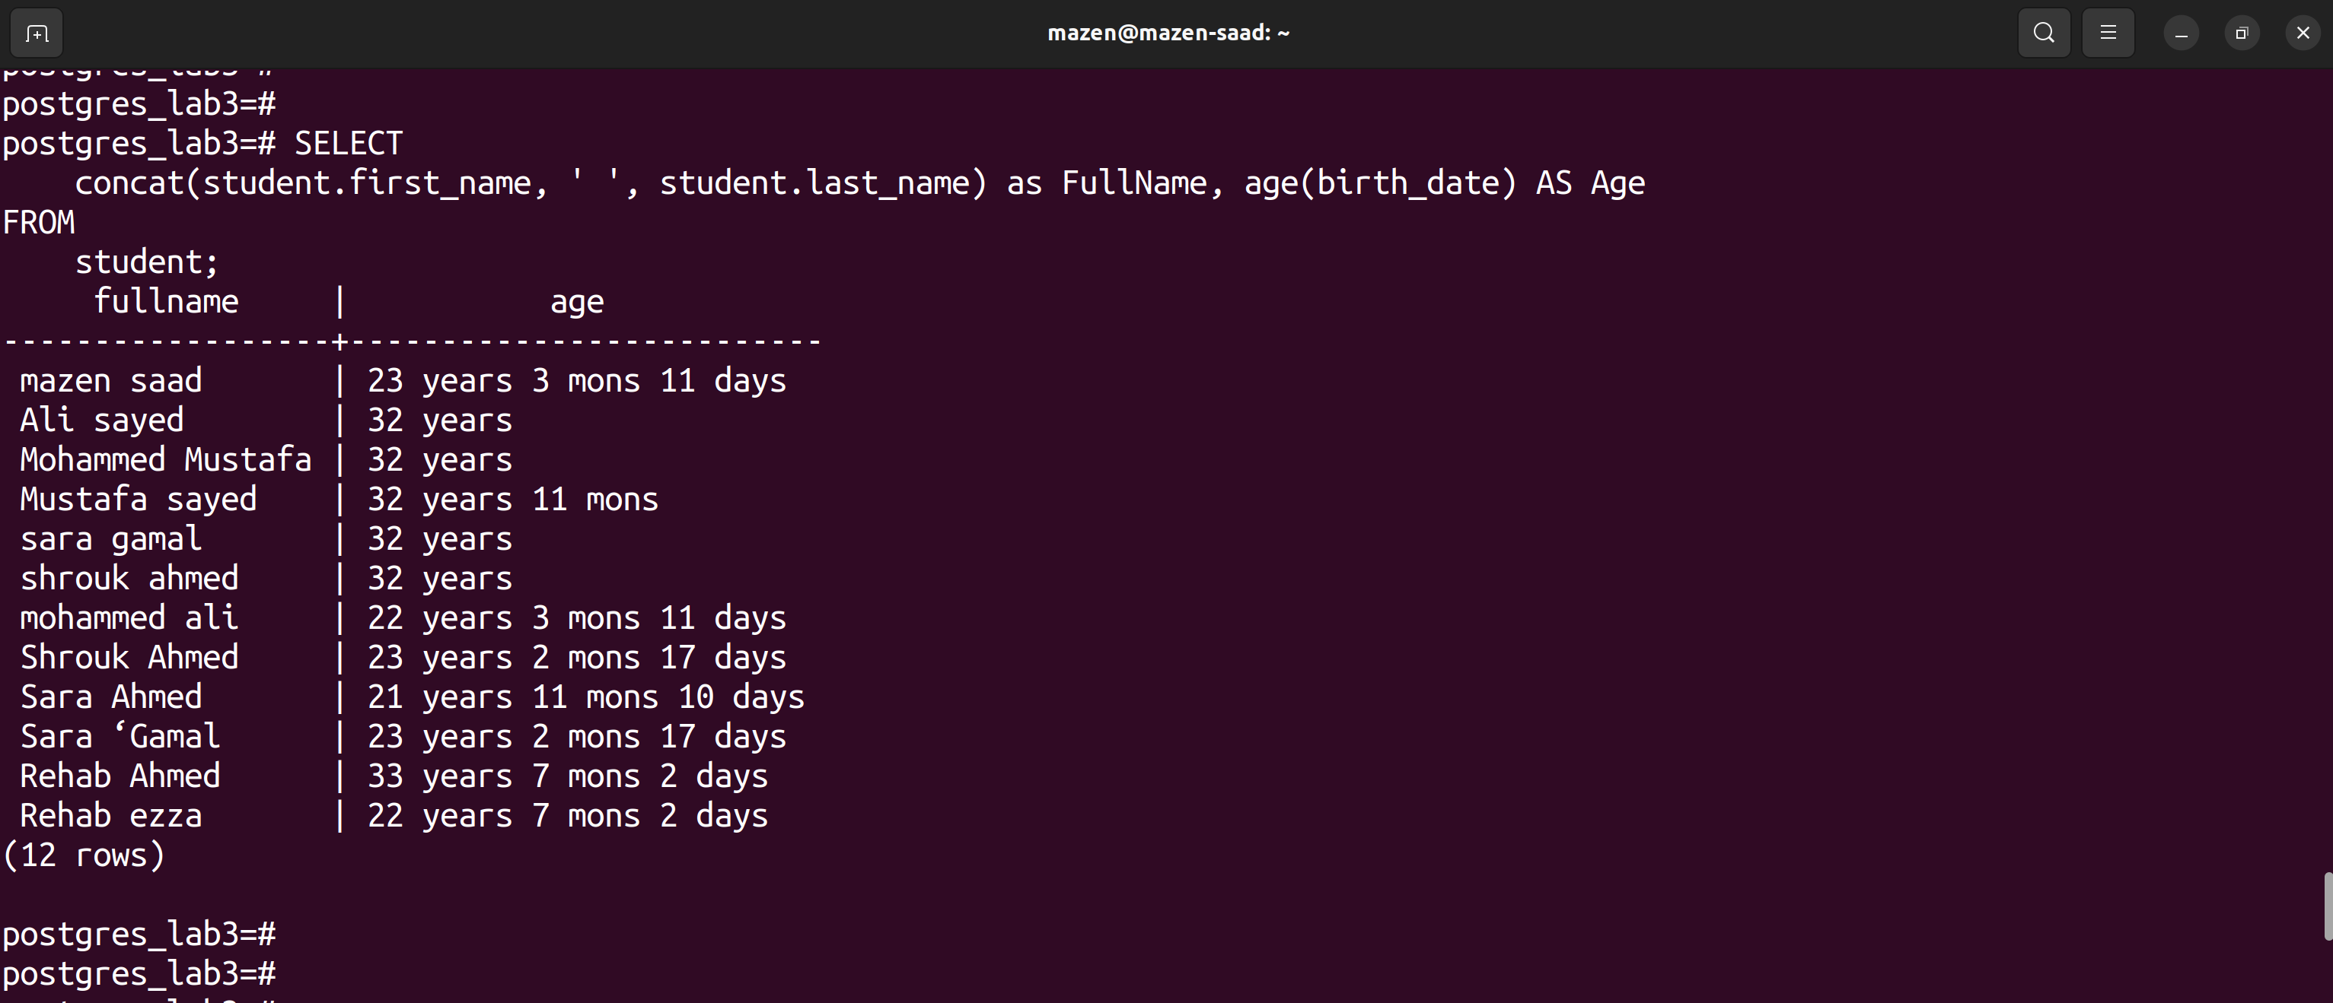

12. Display the name of students with their Rounded score in each subject

SELECT

CONCAT(student.first_name, ' ', student.last_name) AS FullName,

subject.subject_name,

ROUND(exam_results.score) AS rounded_score

FROM

student

JOIN

exam_results ON student.student_id = exam_results.student_id

JOIN

exam ON exam_results.exam_id = exam.exam_id

JOIN

subject ON exam.subject_id = subject.subject_id;

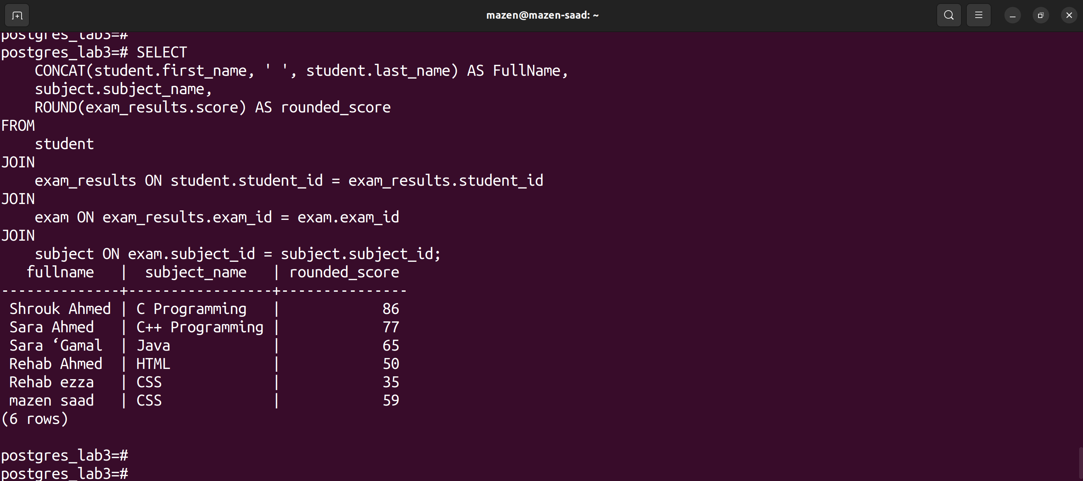

13. Display the name of students with the year of Birthdate

SELECT

concat(student.first_name, ' ', student.last_name) as full_name, date_part('year',birth_date) AS birth_year

FROM

student;

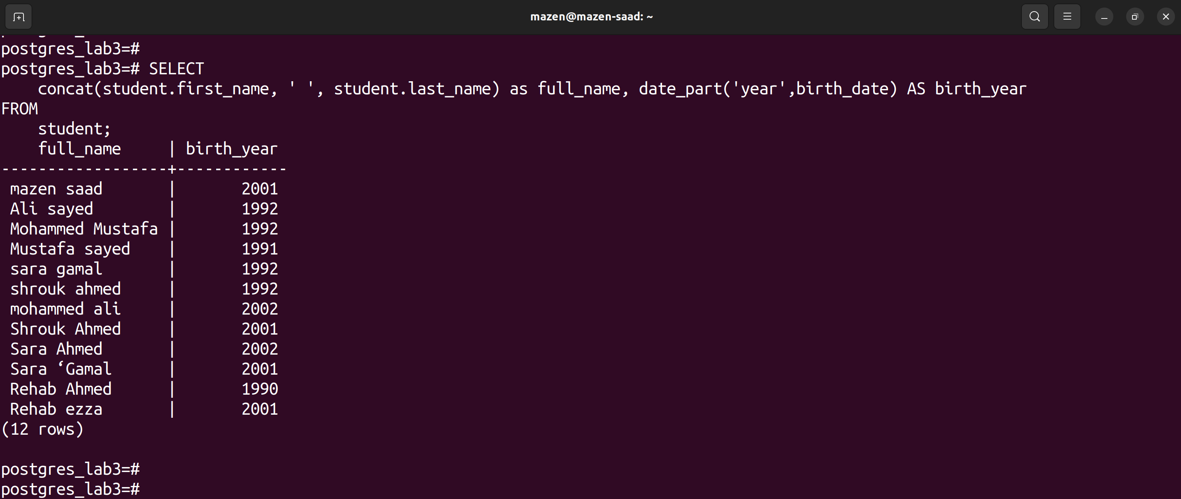

14. Add new exam result, in date column use NOW() function;

INSERT INTO

exam (exam_date, subject_id)

VALUES

(NOW(), 3);

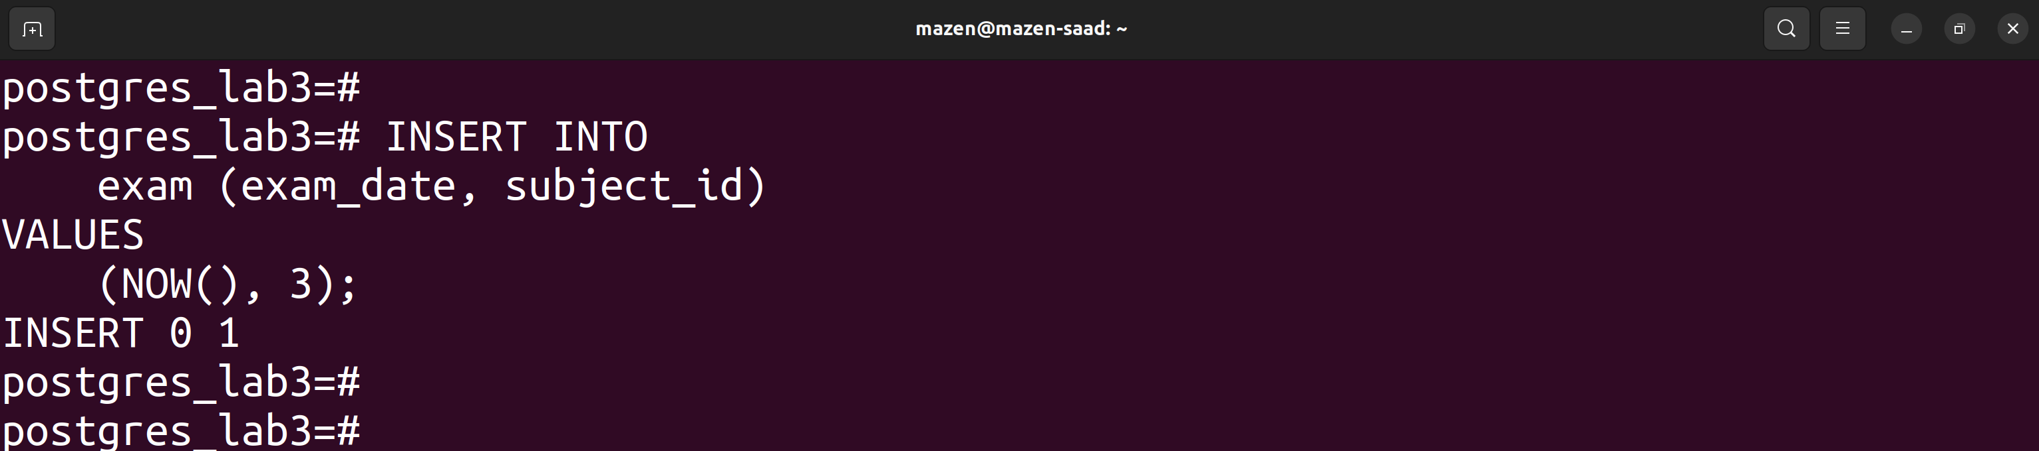

15. Create database called ITI, and create different schema and Tables inside this schema

create database iti;

\c iti

create schema iti_schema;

create table iti_schema.student (

student_id serial PRIMARY KEY,

name text,

birth_date date

);

create table iti_schema.exam_score (

student_id int REFERENCES iti_schema.student(student_id),

subject_name text,

score int,

exam_date date

);

SELECT * FROM iti_schema.student;

SELECT * FROM iti_schema.exam_score;

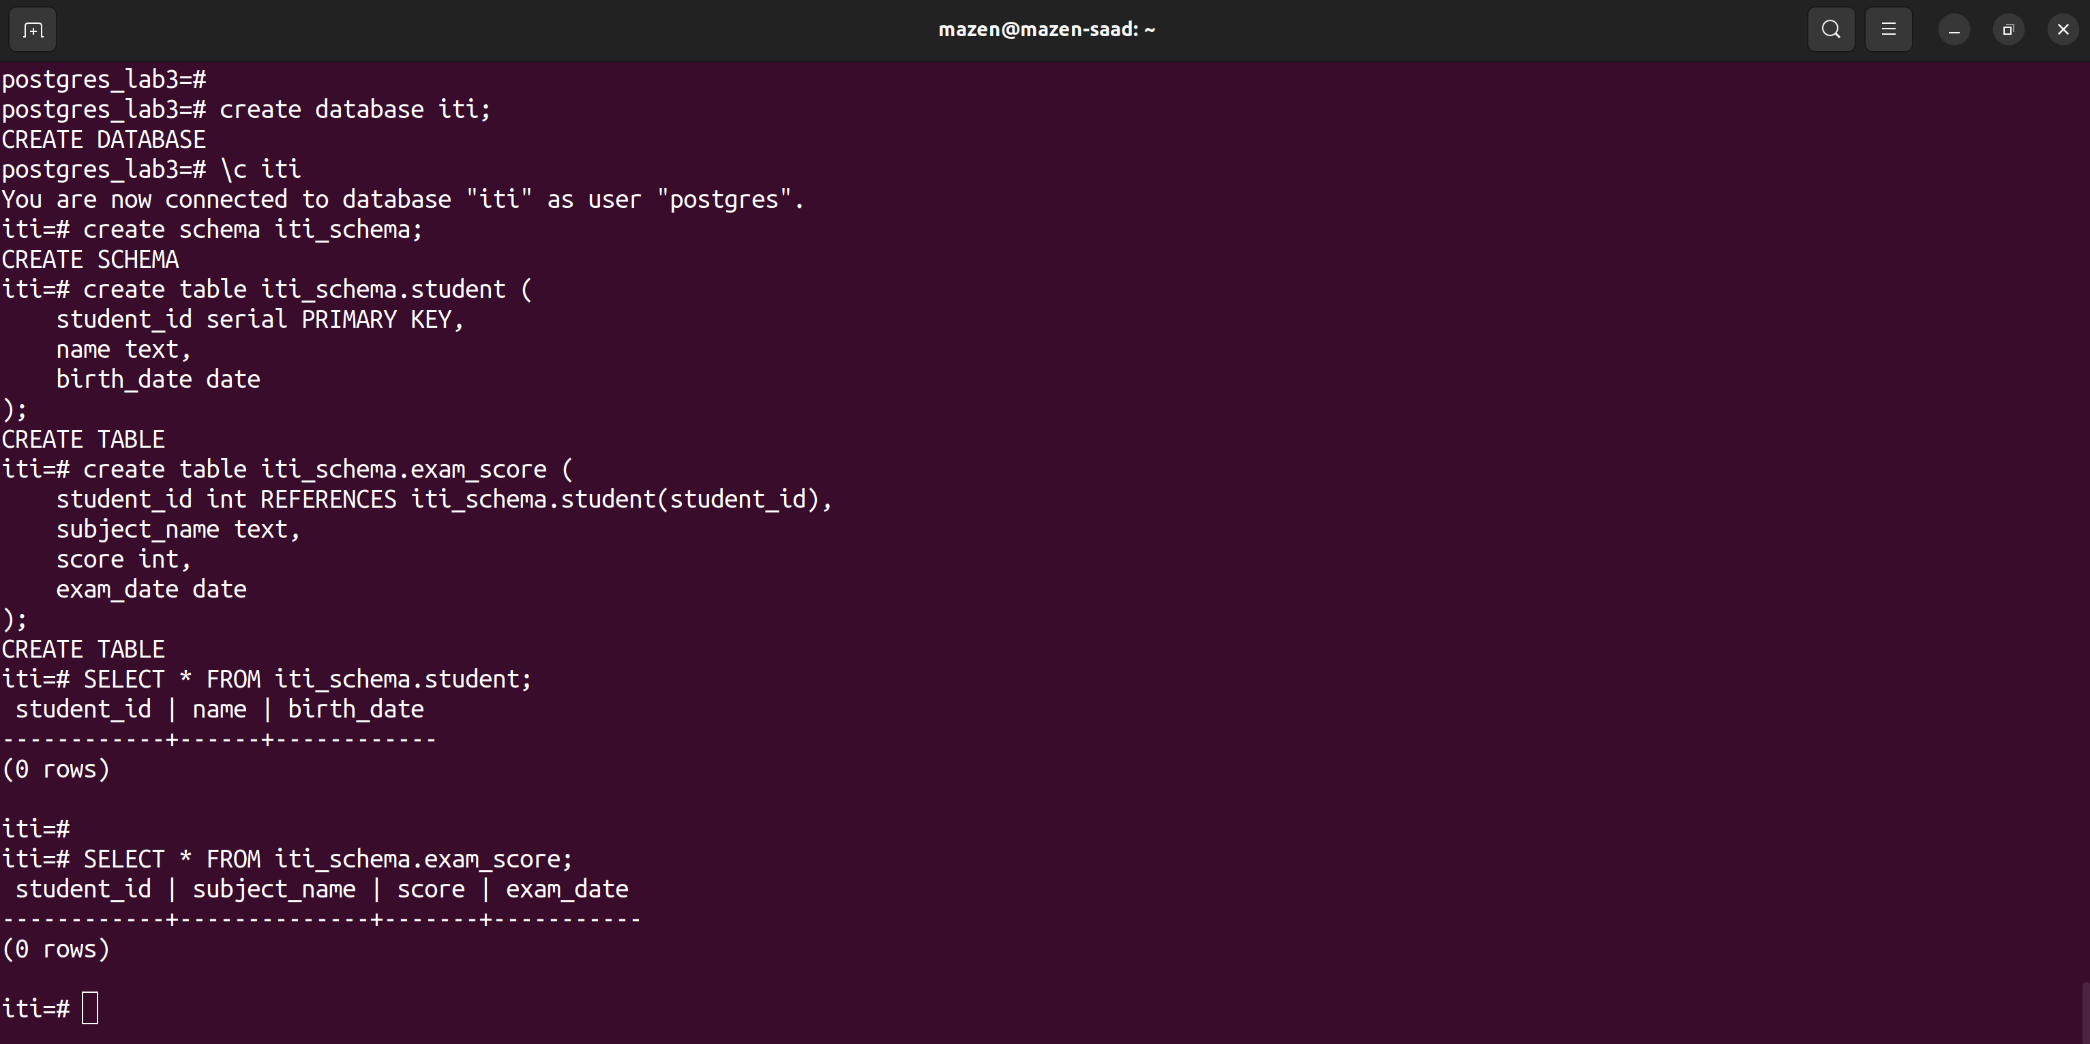

**lab simp**

1. Create trigger to prevent insert new Course with name length greater than 20 chars;

su - postgres

mazen@@1

psql

create database postgres_lab_simp;

\l

\c postgres_lab_simp

create table courses (

course_id serial primary key,

course_name text

);

insert into courses (course_name) values ('html');

insert into courses (course_name) values ('css');

insert into courses (course_name) values ('js');

\i /tmp/triggerone.sql

CREATE OR REPLACE FUNCTION check_course_name_length()

RETURNS TRIGGER AS $$

BEGIN

IF LENGTH(NEW.name) > 20 THEN

RAISE EXCEPTION 'Course name cannot exceed 20 characters';

END IF;

RETURN NEW;

END;

$$ LANGUAGE plpgsql;

CREATE TRIGGER course_name_length_trigger

BEFORE INSERT ON courses

FOR EACH ROW

EXECUTE FUNCTION check_course_name_length();

INSERT INTO

Courses (course_name)

VALUES

('ThisCourseNameIsWayTooLongForTheSystem');

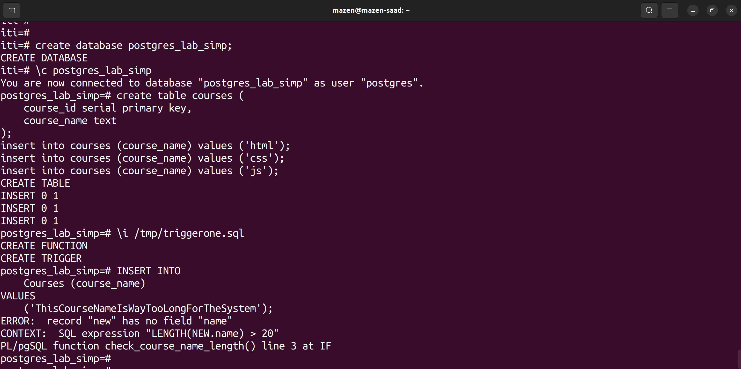

2. Create trigger to prevent user to insert or update Exam with Score greater than 100 or less than zero

\c postgres_lab3

\i /tmp/triggertwo.sql

CREATE OR REPLACE FUNCTION check_exam_score()

RETURNS TRIGGER AS $$

BEGIN

IF NEW.score < 0 OR NEW.score > 100 THEN

RAISE EXCEPTION 'Score must be between 0 and 100';

END IF;

RETURN NEW;

END;

$$ LANGUAGE plpgsql;

CREATE TRIGGER exam_score_trigger

BEFORE INSERT OR UPDATE ON exam_results

FOR EACH ROW

EXECUTE FUNCTION check_exam_score();

INSERT INTO exam_results (score) VALUES (-10);

INSERT INTO exam_results (score) VALUES (105);

INSERT INTO exam_results (score) VALUES (85);

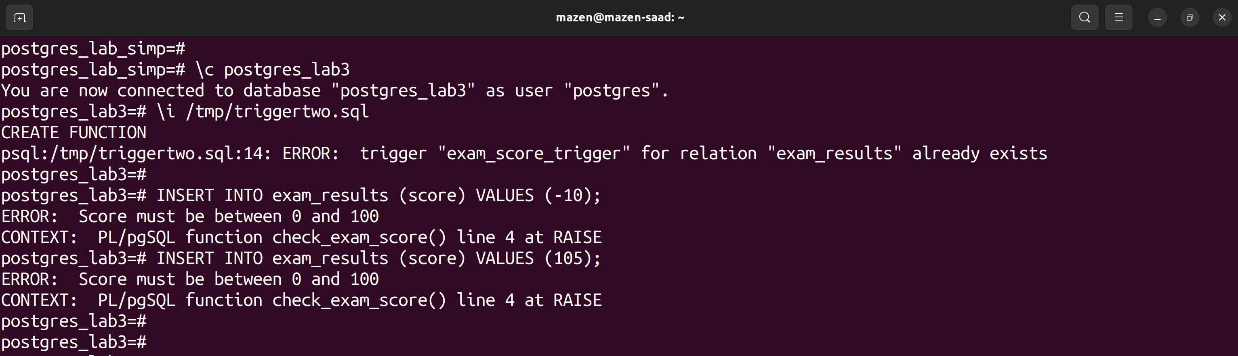

3. (bonus) Create trigger to prevent any user to update/insert/delete to all tables (Students, Exams, Tracks,..) after 7:00 PM

\i /tmp/triggerthree.sql

CREATE OR REPLACE FUNCTION restrict_after_7pm()

RETURNS TRIGGER AS $$

BEGIN

IF EXTRACT(HOUR FROM CURRENT_TIME) >= 19 THEN

RAISE EXCEPTION 'Updates, inserts, or deletes are not allowed after 7:00 PM';

END IF;

RETURN NEW;

END;

$$ LANGUAGE plpgsql;

CREATE TRIGGER restrict_time_trigger

BEFORE INSERT OR UPDATE OR DELETE ON student

FOR EACH ROW

EXECUTE FUNCTION restrict_after_7pm();

INSERT INTO

student (first_name)

VALUES

('Mazen');

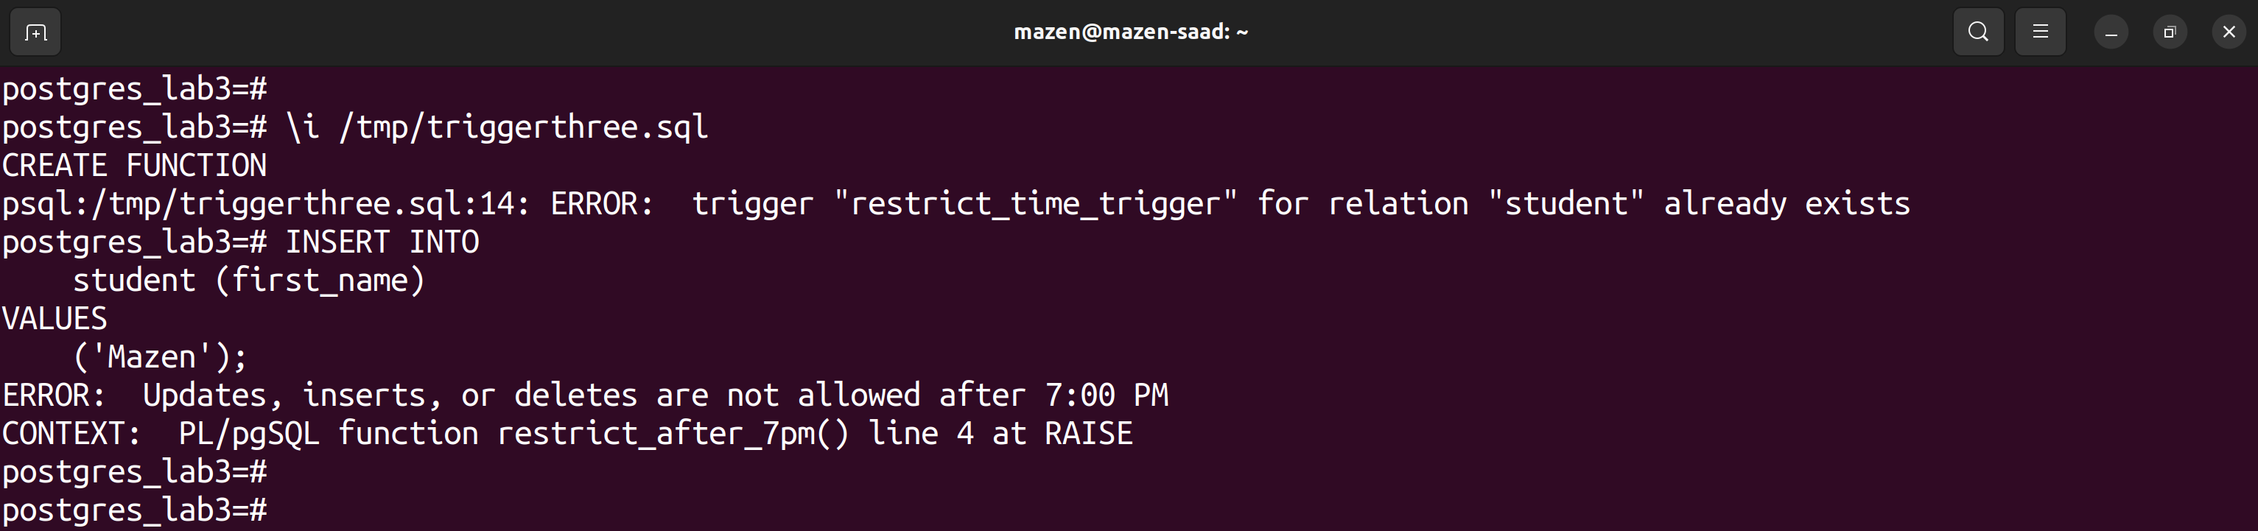

4. Backup your Database to external file

pg_dump postgres_lab3 > /tmp/postgres_lab3_db.txt

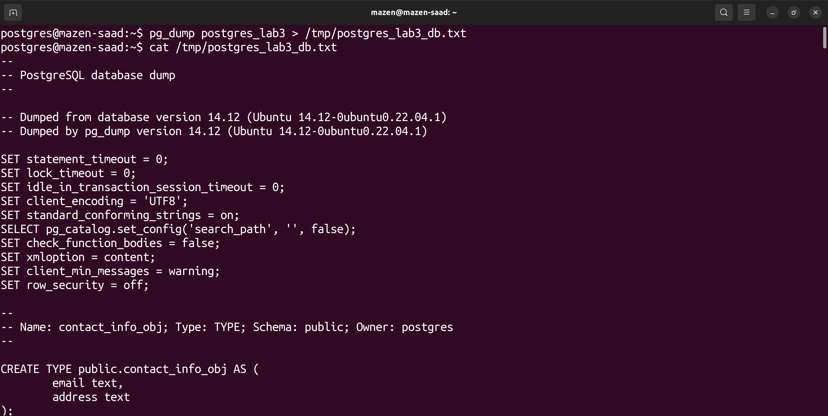

5. Backup your Student table to external file

su - postgres

mazen@@1

psql

\c postgres_lab3

copy student to '/tmp/student_table.txt';

