**Button Creation and Popup Display**

Doctype: Sales Order

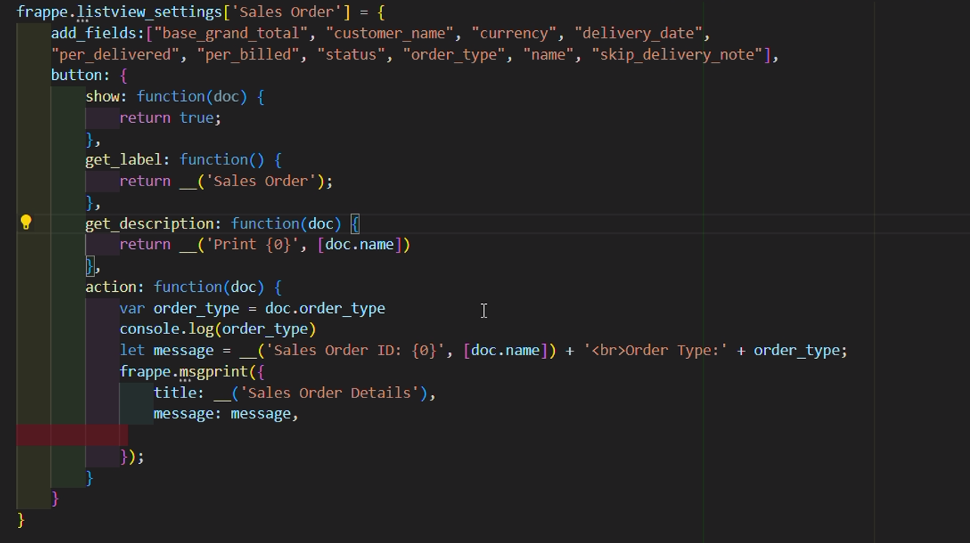

* The script will add a button to each row of the Sales Order list view. When this button is clicked, it will trigger an event that fetches and displays the Sales Order details in a popup.Sales Order Id and Order type shows in the popup.

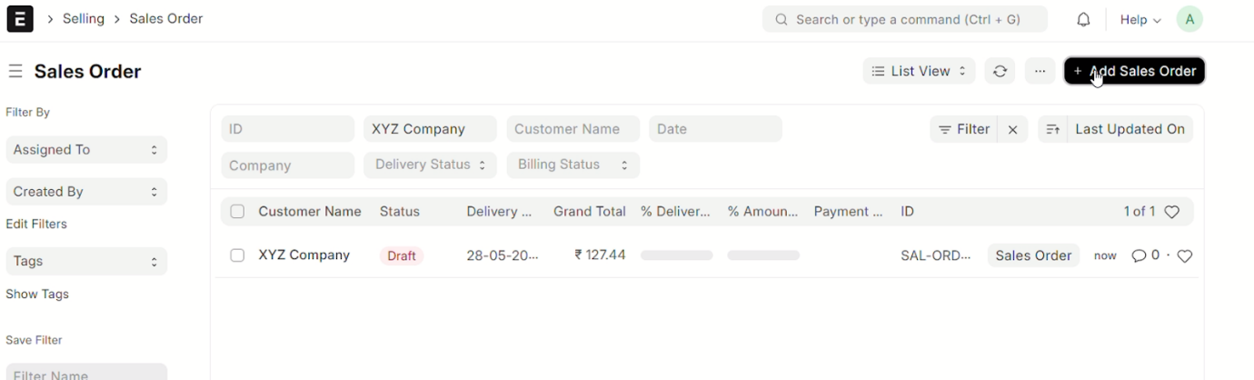

Button Click Event:

* Go to the Sales Order list view.
* Verify that each row has the new button.
* Click the button and ensure the popup appears with the correct Sales Order ID and Order Type.

