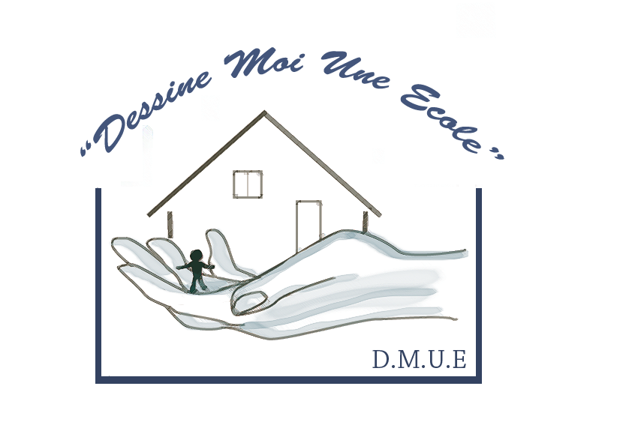
« « « Dessine Moi Une Ecole » /Draw Me A School
French humanitarian association, for schooling needy children, in development countries.

Membership form-2010

Name ………………………………………………………………………………….

Address ………………………………………………………………………………….

Country ……………………………………………….…………………………………..

Phone number …………………………………………………………………………….

Fax : …………………………………………..………………………………

E-mail ……………………..........................................

□ I wish to join Dessine Moi Une Ecole (Draw Me A School) for one year.

As such, I pay a premium of 30 Euros/year by:

□ Check (payable to « Dessine Moi Une Ecole »)
□ PayPal (on the website)
□ Transfer on bank account :

IBAN: FR76 1615 9053 4000 0204 7900 174
BIC (Bank Identifier Code) : CMCIFR2A

Date : Signature :

Form to print, and send by mail to :
- Head office:
78, Résidence IBIS/ Moudong Sud
97122 Baie Mahault / Guadeloupe
France

By joining us, you’ll help us to be more able to help needy children, in development countries.

Thank you for them…

