**Exploring Ecosim with Anchovy Bay**

Scientists have noticed a gradual decline in the seal population of about 50 kg a year. The resource managers of Anchovy Bay decide that new regulations should be put in place on the seal fishery to combat this population decline. Local trawlers are concerned that an increased seal population will negatively impact their business as their chief targets are prey for seals. Build an rsim scenario that shows the impact of the seal decline and one that shows the impact of reducing the seal fishery in half. Also test the impact if seals are a strong ‘top-down’ predator. Run the simulations for 25 years.

1. **SCENARIO INCREASING FISHING EFFORT ON SEALS**

**Increasing on fishing effort for seals, reduce the seals population and increase cod, an increase in the population of cod produces an increase in mortality due to predation exerted on whiting, reducing its biomass**

#plot results  
rsim.plot(AB.run1)

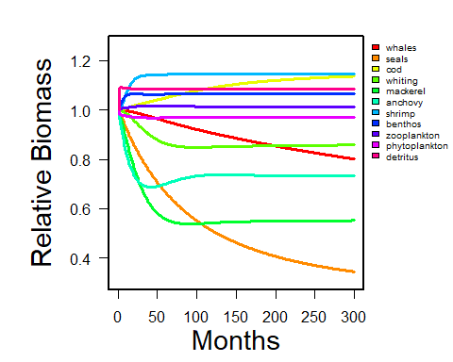

seals <- extract.node(AB.run1, 'seals')  
plot(seals$Biomass, xlab = 'Month', ylab = 'Biomass', main = "Seals")

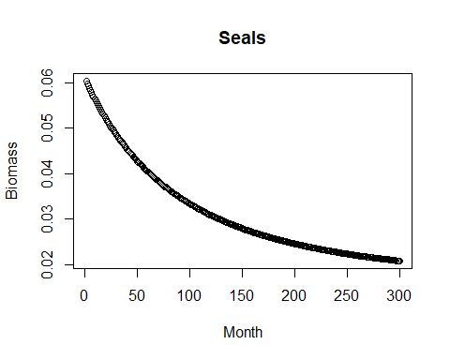

cod <- extract.node(AB.run1, 'cod')  
plot(cod$Biomass, xlab = 'Month', ylab = 'Biomass', main = "Cod")

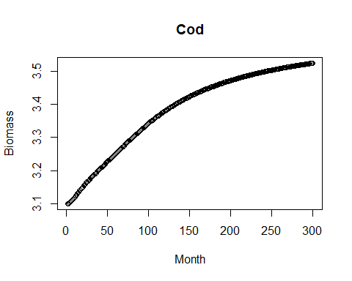

whiting <- extract.node(AB.run1, 'whiting')  
plot(whiting$Biomass, xlab = 'Month', ylab = 'Biomass', main = "Whiting")

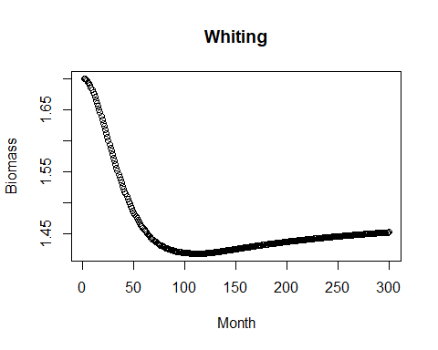

1. **SCENARIO DECREASING FISHING EFFORT ON SEALS**

**on the other hand, a decrease in fishing effort on seals will produce higher seals biomass due to less fishing pressure, producing an increase in cod biomass (we expected it to be the opposite) and a decrease in whiting biomass**

#plot results  
rsim.plot(AB.run2)

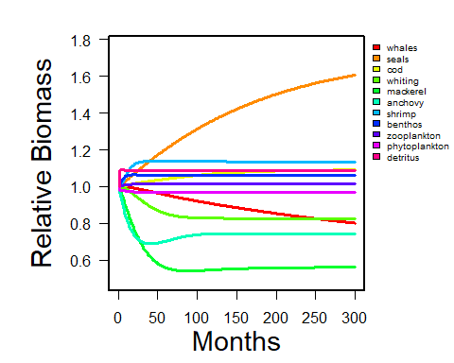

seals <- extract.node(AB.run2, 'seals')  
plot(seals$Biomass, xlab = 'Month', ylab = 'Biomass', main = "Seals")

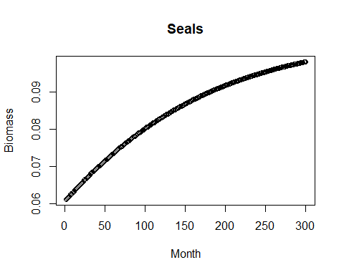

cod <- extract.node(AB.run2, 'cod')  
plot(cod$Biomass, xlab = 'Month', ylab = 'Biomass', main = "Cod")

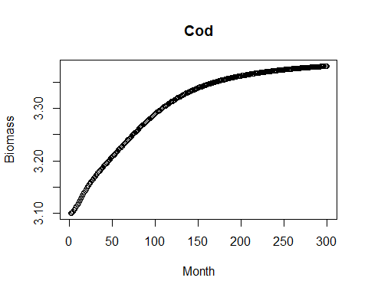

whiting <- extract.node(AB.run2, 'whiting')  
plot(whiting$Biomass, xlab = 'Month', ylab = 'Biomass', main = "Whiting")

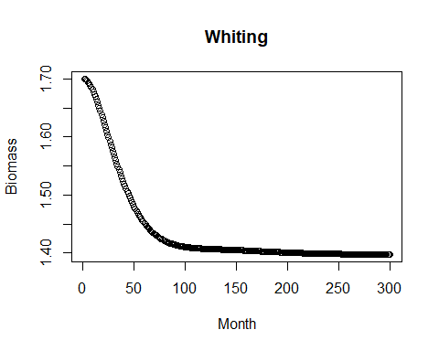

1. SCENARIO WITH SEALS AS TOP PREATOR

Then, seals were investigated to see what the impact would be if seals were a strong ‘top-down’ predator. To do this, we adjusted the first scenario to reflect a situation where seals had an increased effect on all of their prey.

#plot results  
rsim.plot(AB.run3)

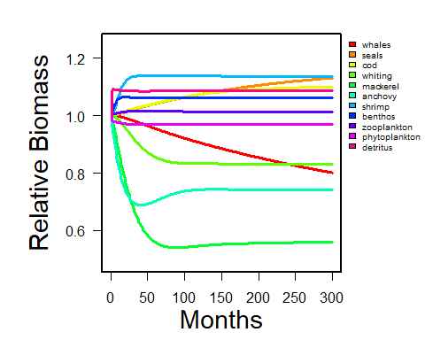

seals <- extract.node(AB.run3, 'seals')  
plot(seals$Biomass, xlab = 'Month', ylab = 'Biomass', main = "Seals")

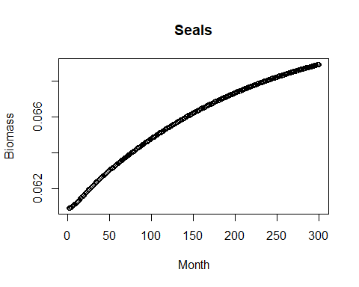

cod <- extract.node(AB.run3, 'cod')  
plot(cod$Biomass, xlab = 'Month', ylab = 'Biomass', main = "Cod")

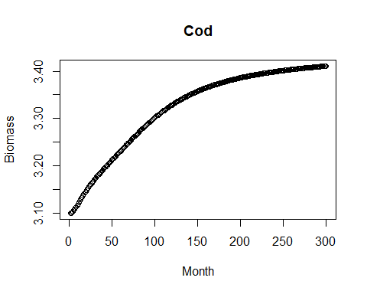

whiting <- extract.node(AB.run3, 'whiting')  
plot(whiting$Biomass, xlab = 'Month', ylab = 'Biomass', main = "Whiting")

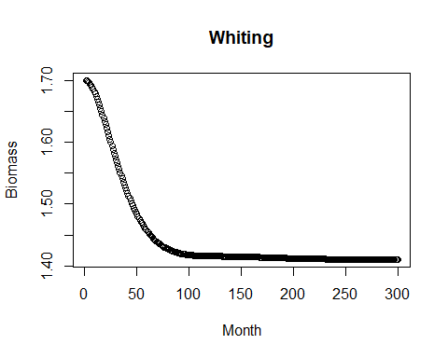

1. **SCENARIO WITH COD AS TOP PREDATOR**

**scenario with cod as top predator**

#plot results  
rsim.plot(AB.run5)

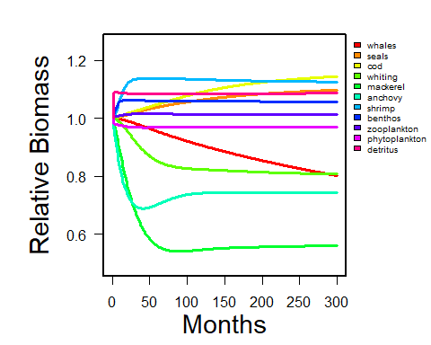

whales <- extract.node(AB.run5, 'whales')  
plot(seals$Biomass, xlab = 'Month', ylab = 'Biomass', main = "Seals")

WHALES

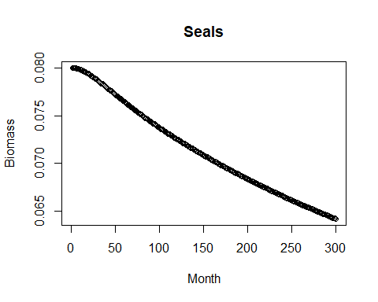

seals <- extract.node(AB.run5, 'seals')  
plot(seals$Biomass, xlab = 'Month', ylab = 'Biomass', main = "Seals")

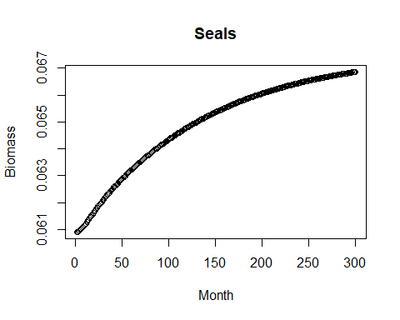

cod <- extract.node(AB.run5, 'cod')  
plot(cod$Biomass, xlab = 'Month', ylab = 'Biomass', main = "Cod")

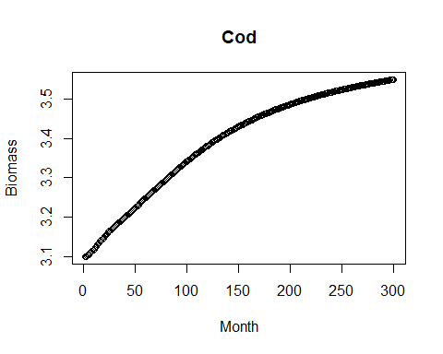

whiting <- extract.node(AB.run5, 'whiting')  
plot(whiting$Biomass, xlab = 'Month', ylab = 'Biomass', main = "Whiting")

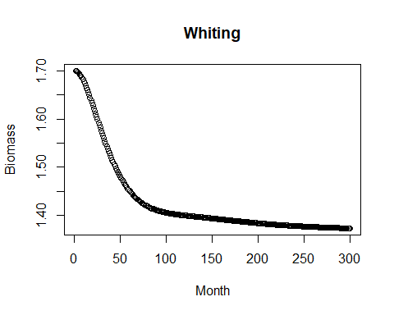

1. **scenario with trawlers fishing effort*2.5 times higher**

#plot results  
rsim.plot(AB.run6)

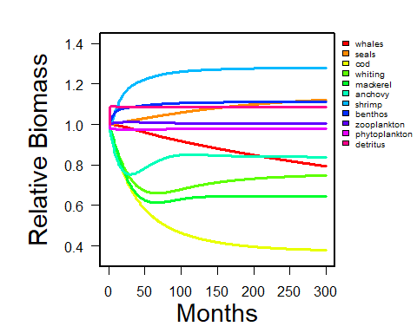

whales <- extract.node(AB.run6, 'whales')  
plot(seals$Biomass, xlab = 'Month', ylab = 'Biomass', main = "Seals")

WHALES

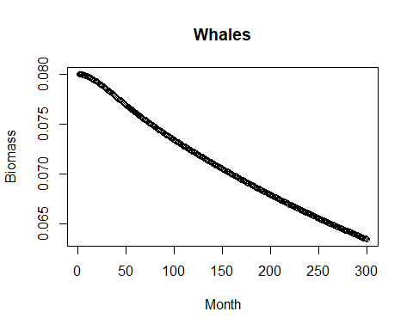

seals <- extract.node(AB.run6, 'seals')  
plot(seals$Biomass, xlab = 'Month', ylab = 'Biomass', main = "Seals")

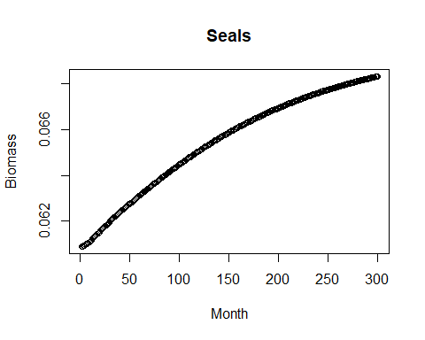

cod <- extract.node(AB.run6, 'cod')  
plot(cod$Biomass, xlab = 'Month', ylab = 'Biomass', main = "Cod")

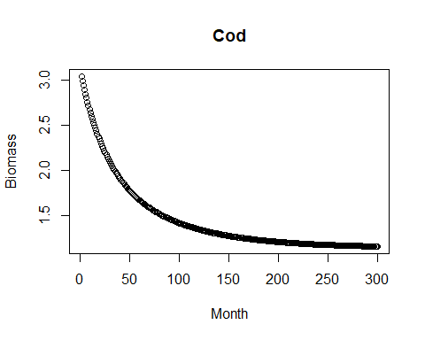

whiting <- extract.node(AB.run6, 'whiting')  
plot(whiting$Biomass, xlab = 'Month', ylab = 'Biomass', main = "Whiting")

