Hydra OM diagnostics
30 October, 2025

abundance indices

fits to survey indices of abundance

Survey # 1
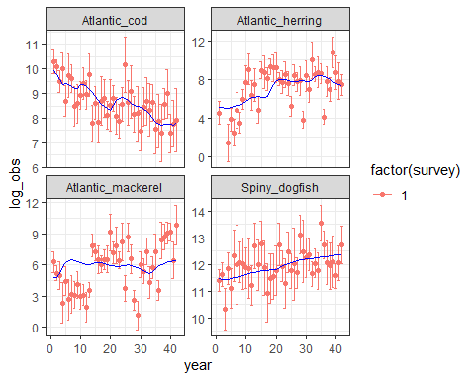

catch

fits to Catch time series

Fleet # 1
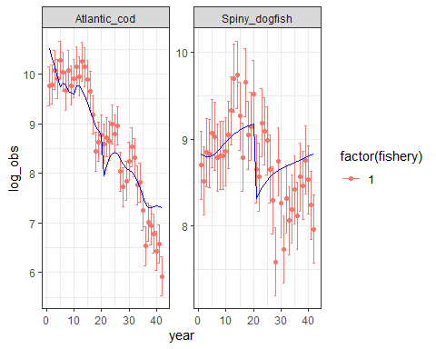

Fleet # 2
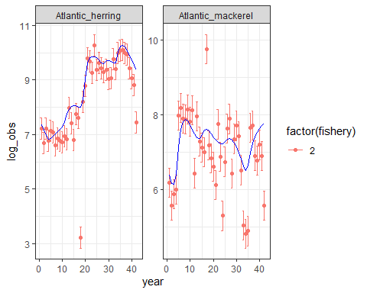

Estimated Recruitment time series
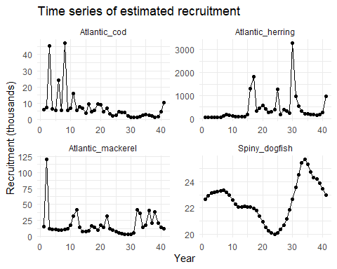

time series of log-recruitment
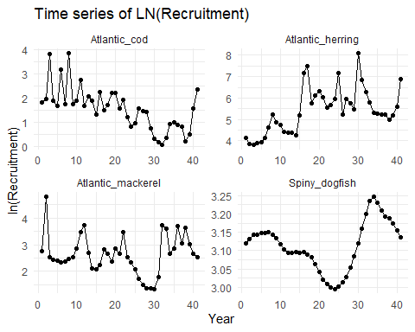

Biomass time series
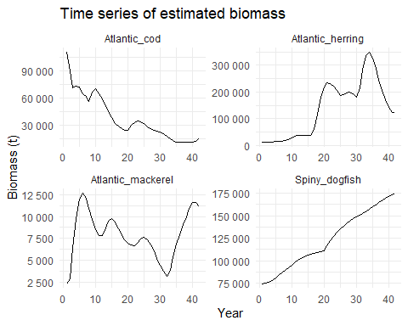

Biomass time series
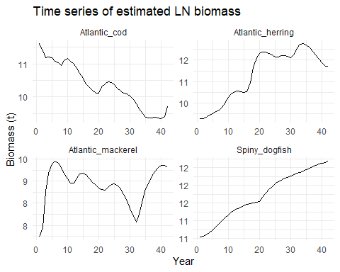

Fishing mortality time series
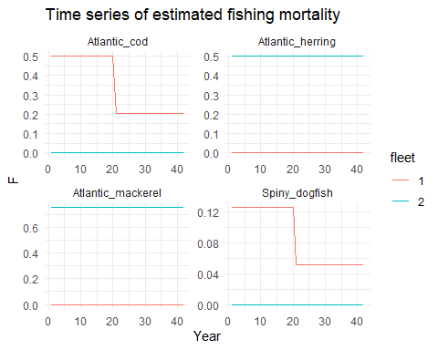

M2 Predation mortality
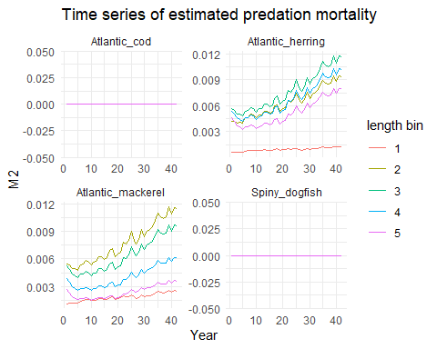

M total mortality
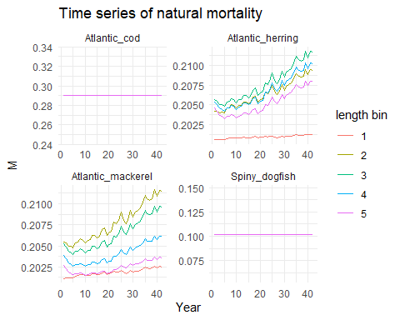

Survey selectivity
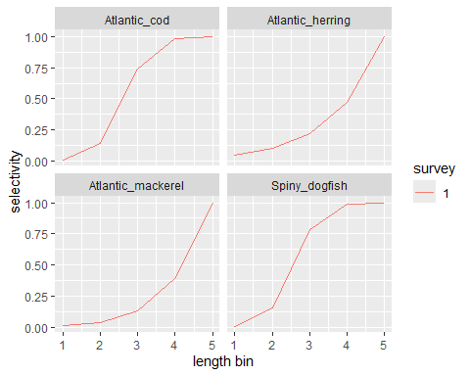

Fishery selectivity
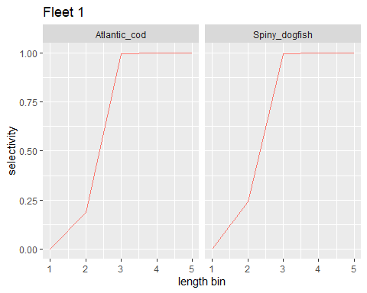
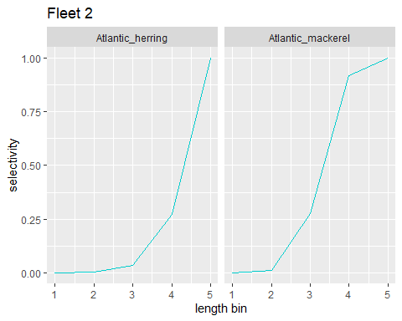

surveys

Size composition of survey 1 by species

Atlantic_cod
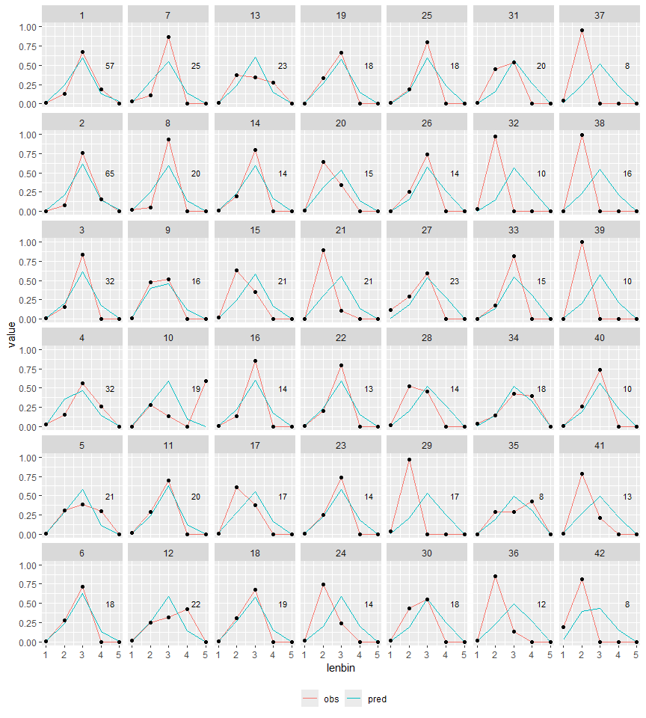

Atlantic_herring
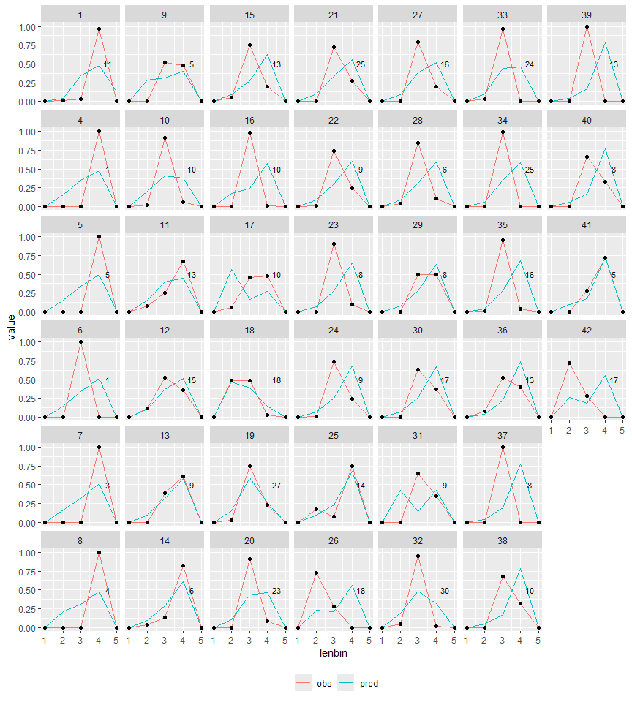

Atlantic_mackerel
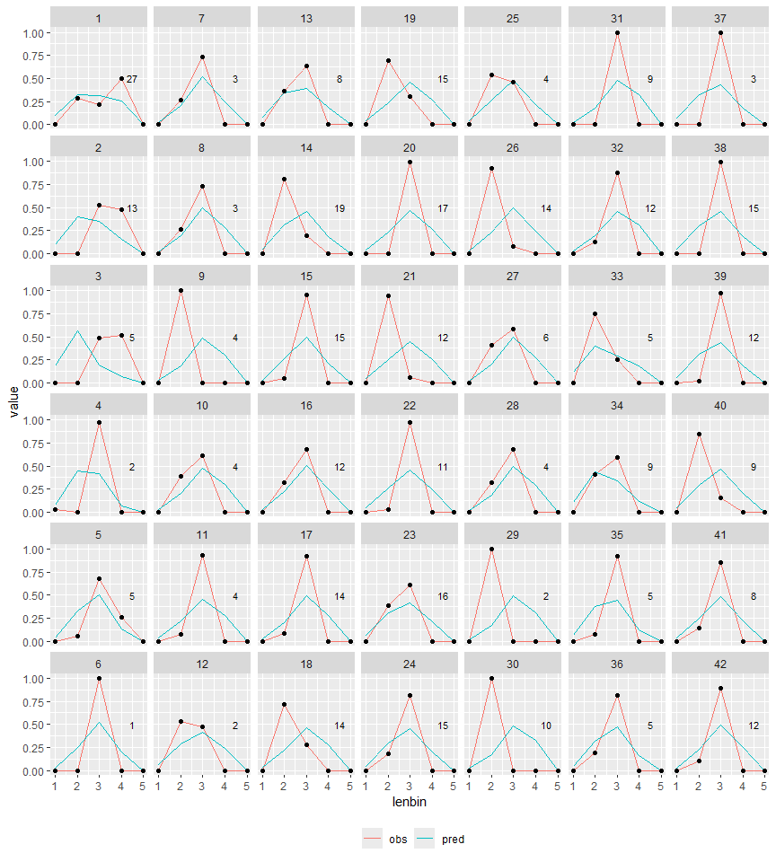

Spiny_dogfish
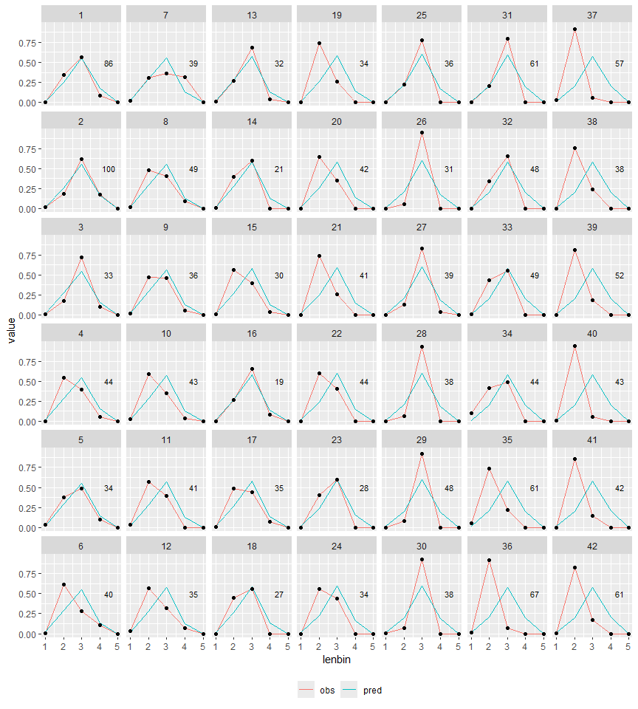

Size composition aggregated over time

Surveys (1)
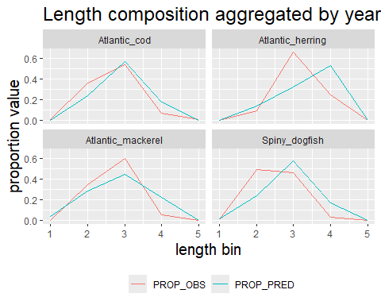

Size composition of catch by species

catch

Atlantic_cod
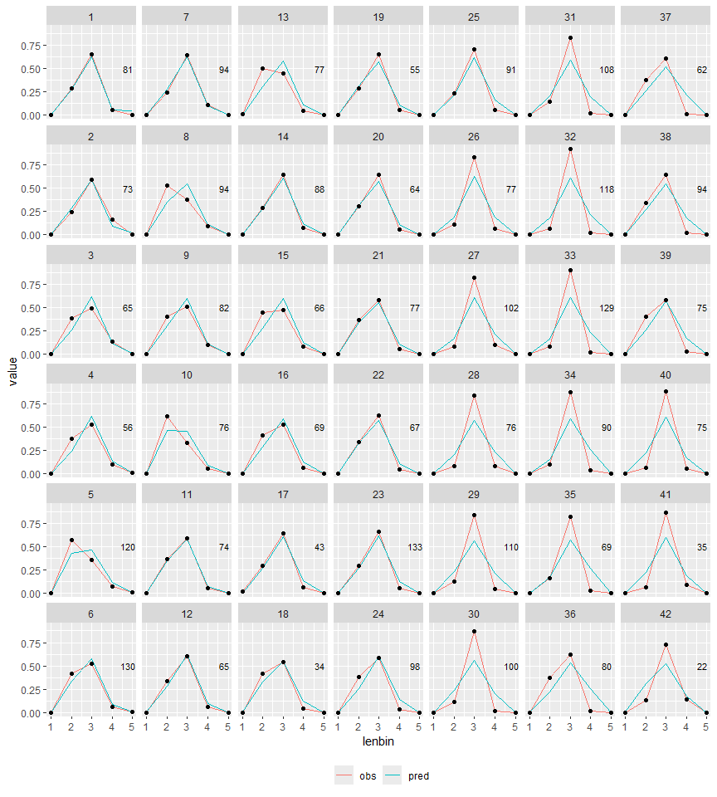

Spiny_dogfish
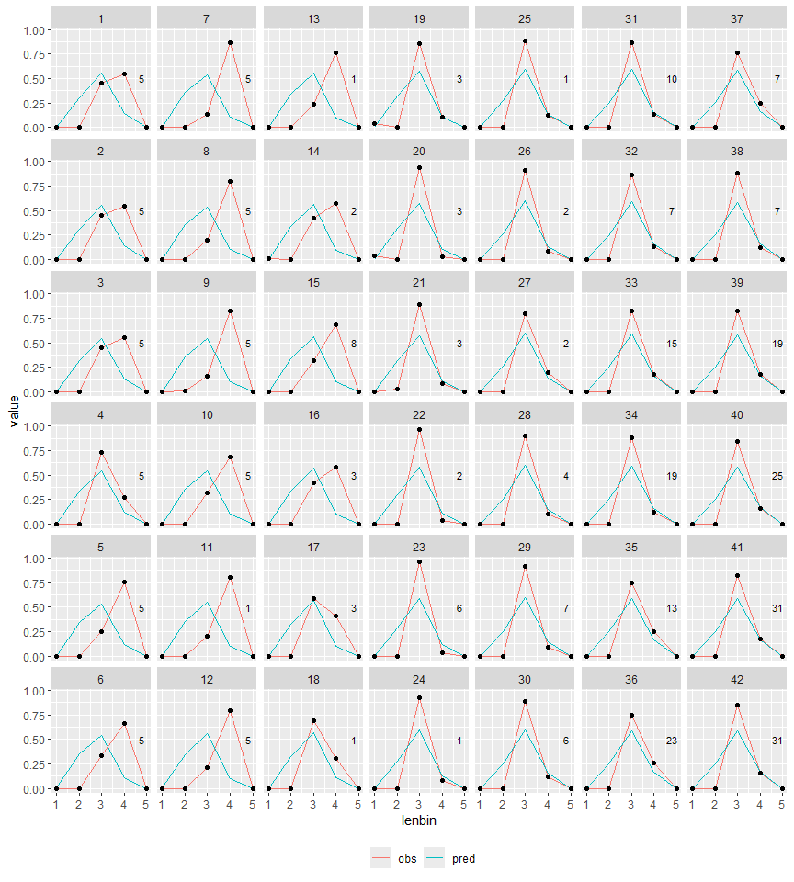

Atlantic_herring
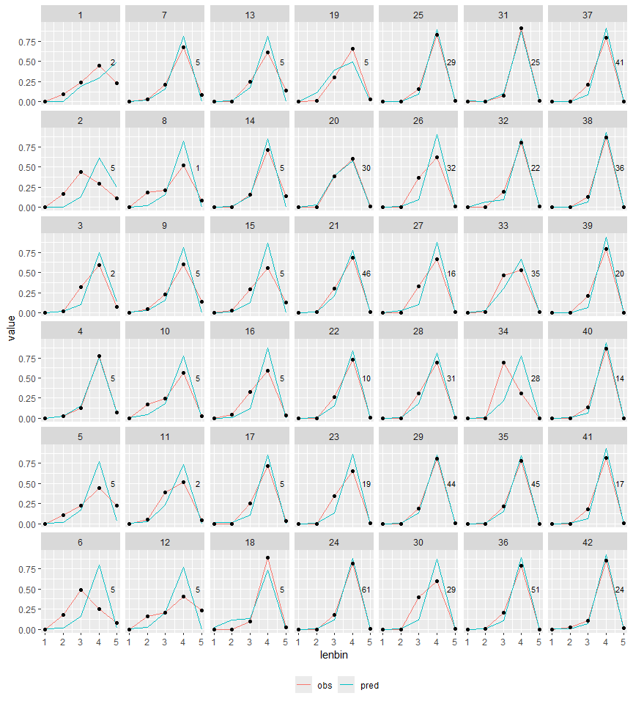

Atlantic_mackerel
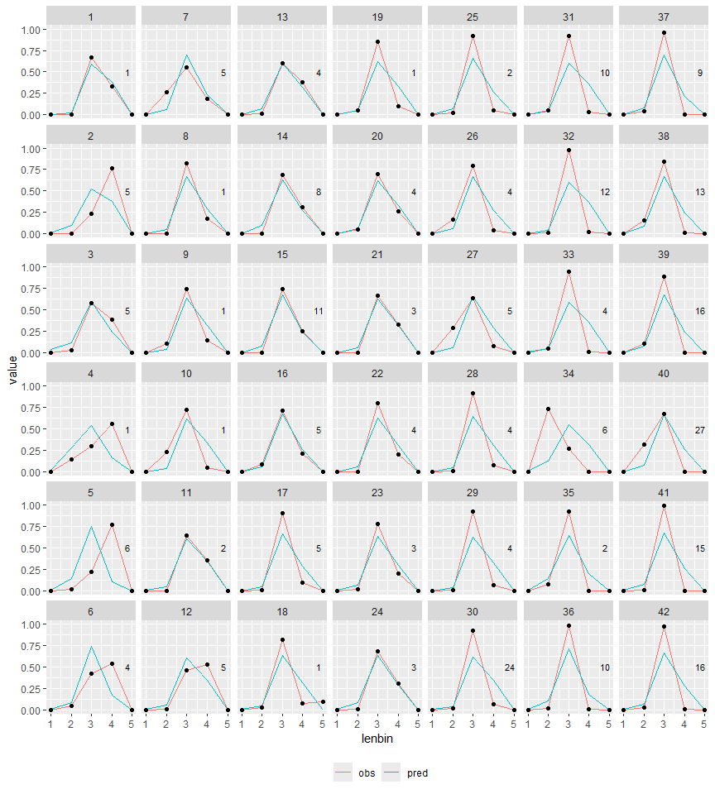

Size composition aggregated over time

Catches
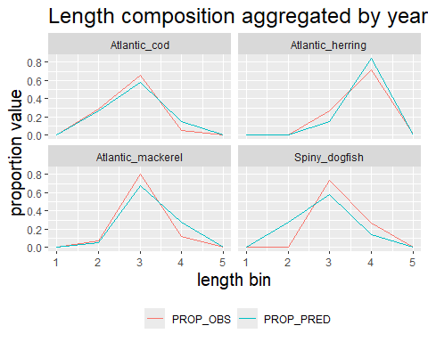

Survey size composition pearson residuals (survey 1)
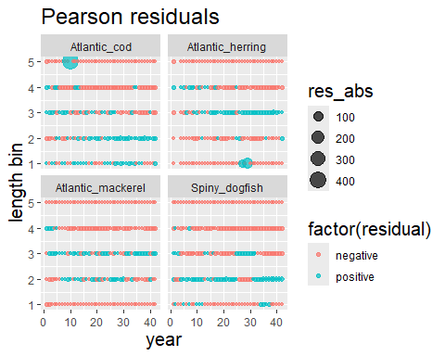

Survey OSA residuals

Survey 1 OSA residuals

Atlantic_cod
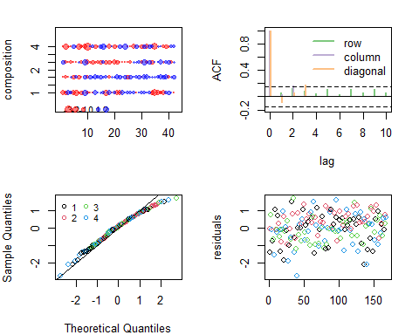

Atlantic_herring
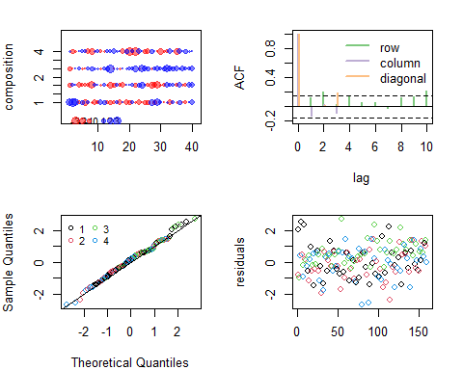

Atlantic_mackerel
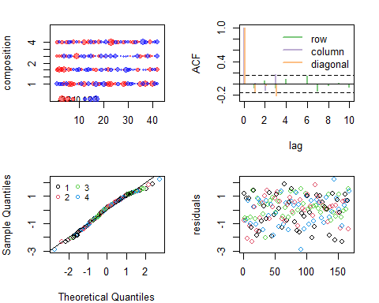

Spiny_dogfish
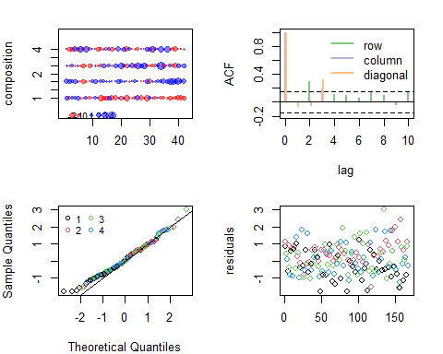 ##### {-}

Diet composition effective sample size

Survey # 1
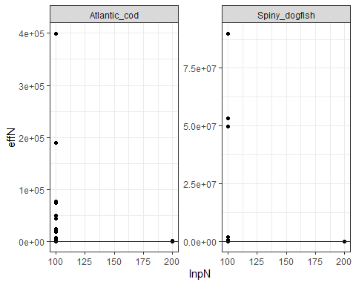

Catch size composition pearson residuals
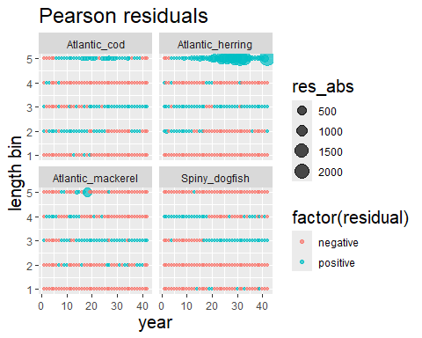

Fishery Size Comp OSA residuals

Fleet 1 Size composition OSA residuals
for (sp in especies) {
tmp <- plot_osa[[sp]]
cat("######", sp, " \n")
plot(tmp)
cat(" \n\n")
}

Atlantic_cod
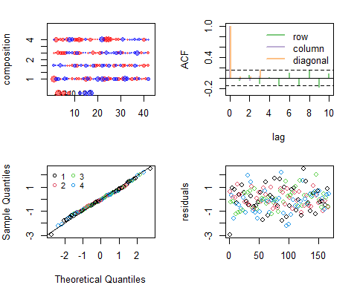

Spiny_dogfish
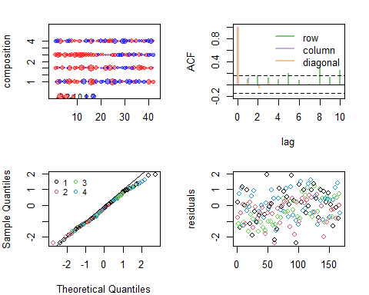

Fleet 2 Size composition OSA residuals

Atlantic_herring
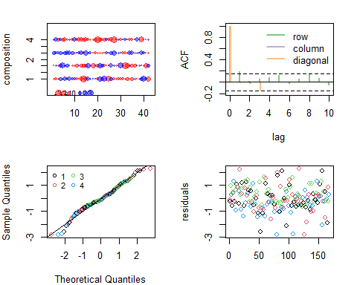

Atlantic_mackerel
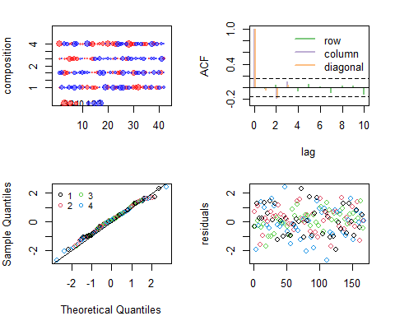

Fishery size comp Effective sample size

Fleet # 1
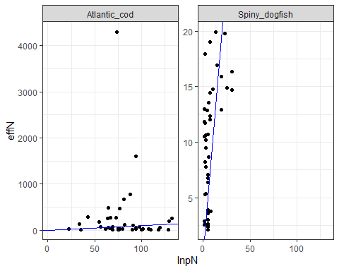

Fleet # 2
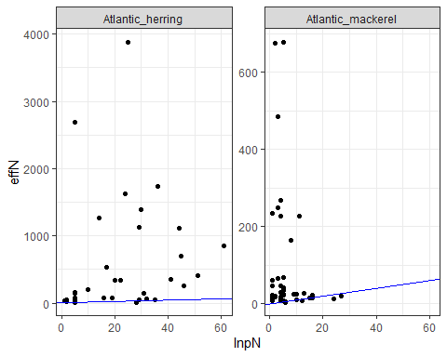 ##### {-}

Diet composition data

Proportions by weight for stomach by predator size bin survey 1

Atlantic_cod
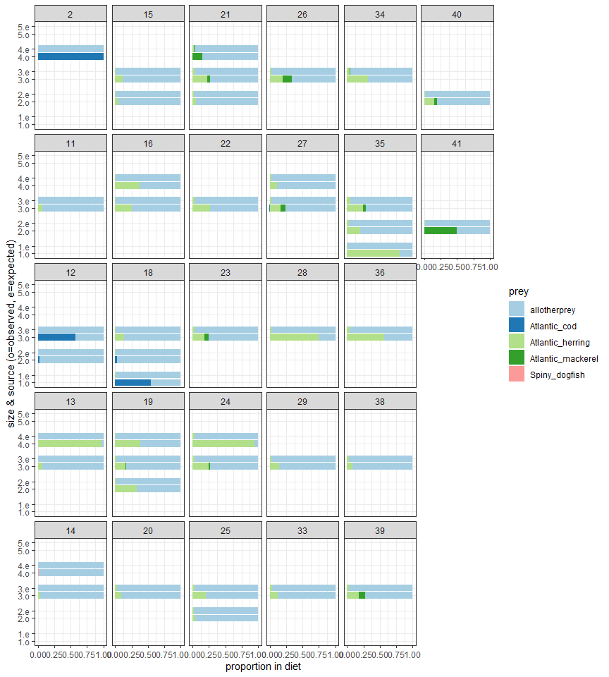

Spiny_dogfish
