Hydra OM diagnostics

05 September, 2024

#### abundance indices

#### fits to survey indices of abundance

##### Survey # 1

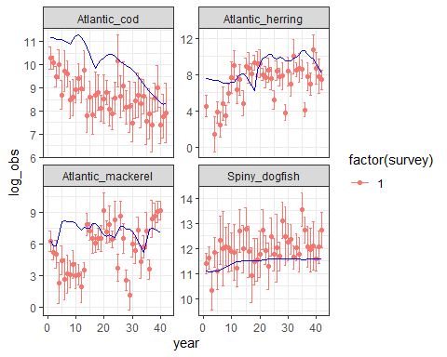

#### catch

#### fits to Catch time series

##### Fleet # 1

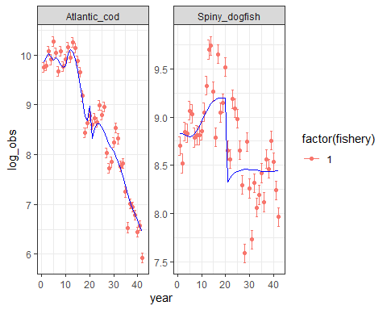

##### Fleet # 2

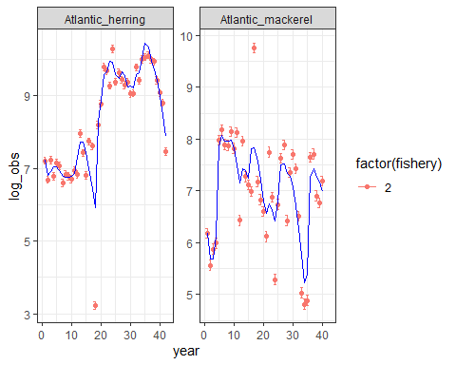

#### Estimated Recruitment time series

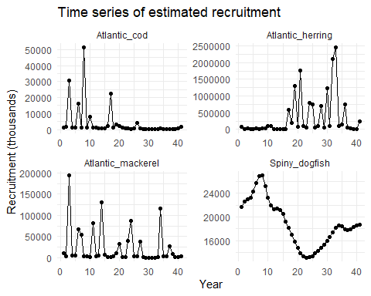

#### time series of log-recruitment

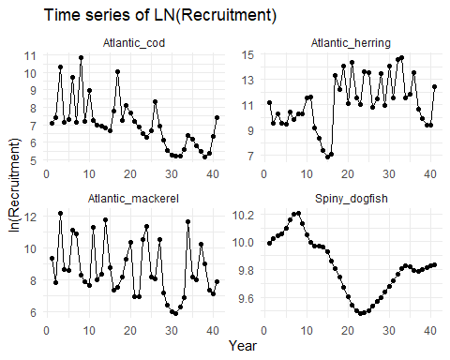

#### Biomass time series

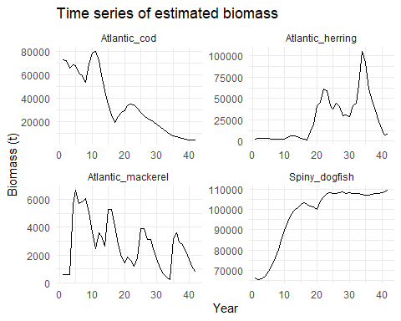

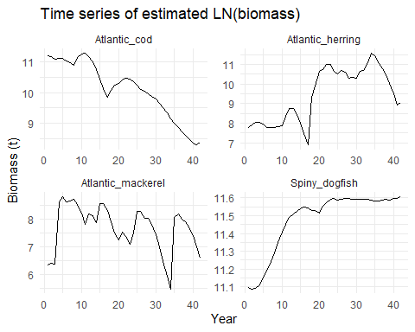

#### Fishing mortality time series

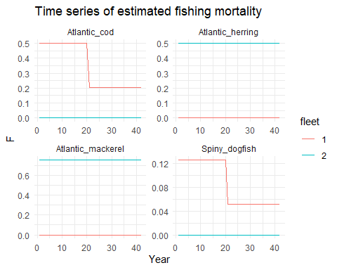

#### M2 Predation mortality

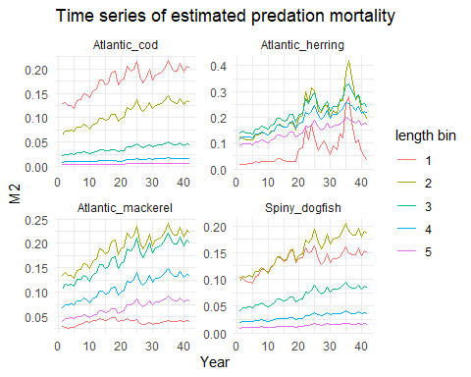

#### M Natural mortality

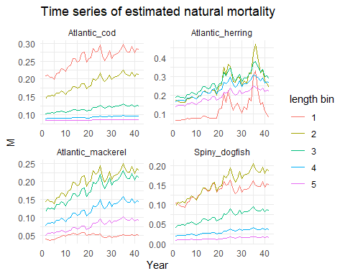

#### Survey selectivity

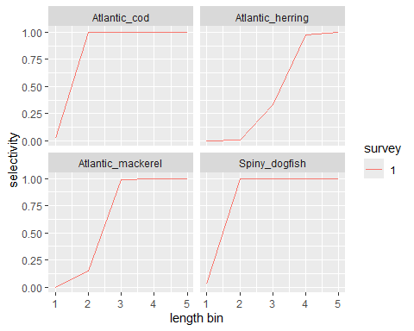

#### Fishery selectivity

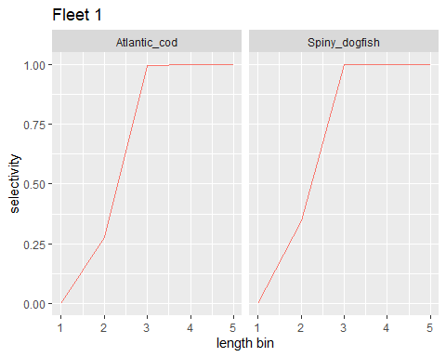

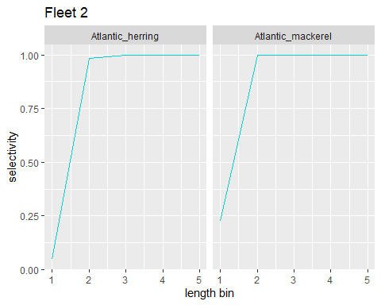

##### surveys

##### Size composition of survey 1 by species

###### Atlantic_cod

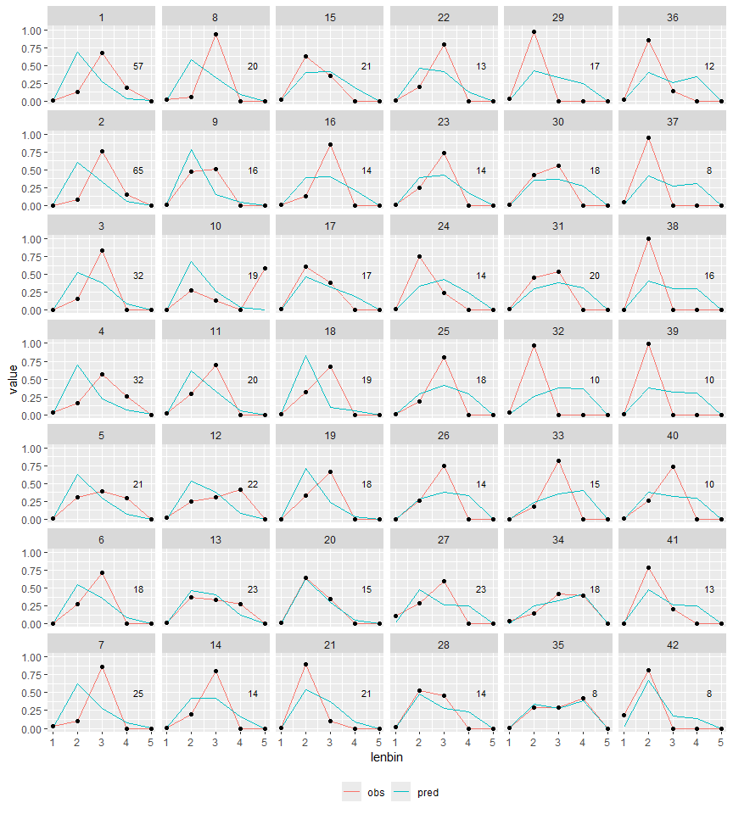

###### Atlantic_herring

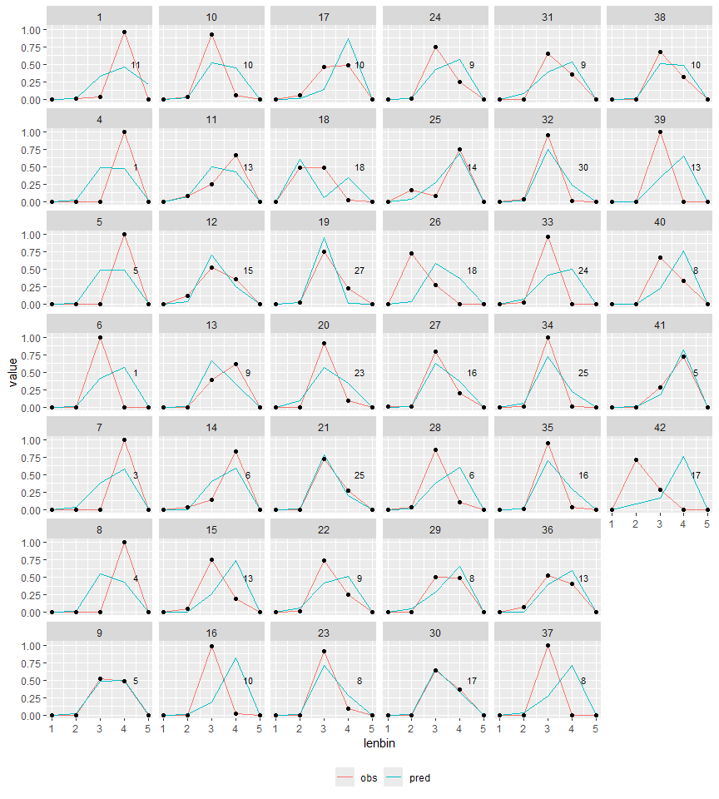

###### Atlantic_mackerel

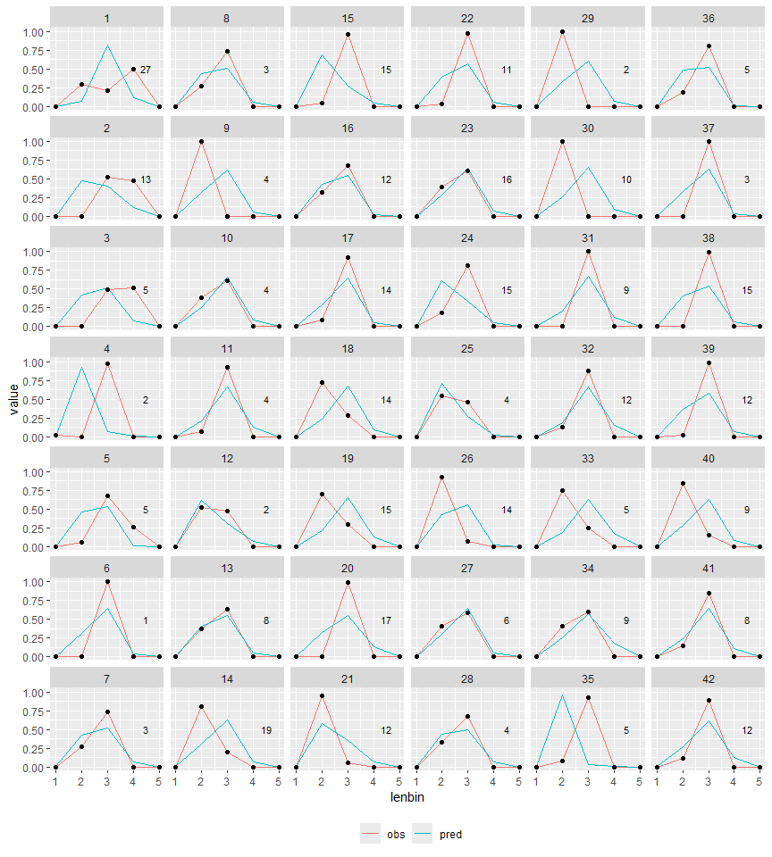

###### Spiny_dogfish

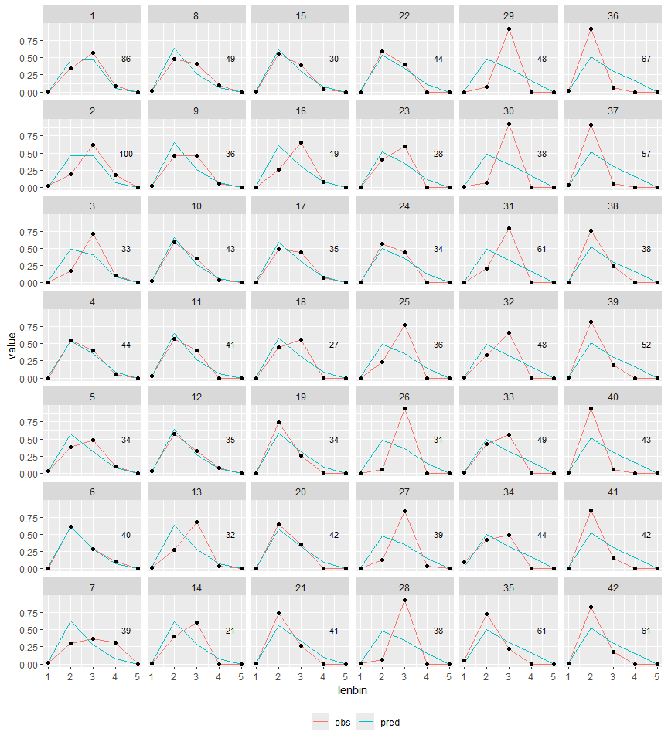

##### Size composition aggregated over time

###### Surveys (1)

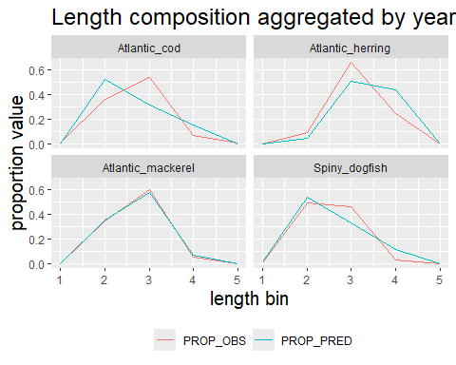

##### Size composition of catch by species

##### catch

###### Atlantic_cod

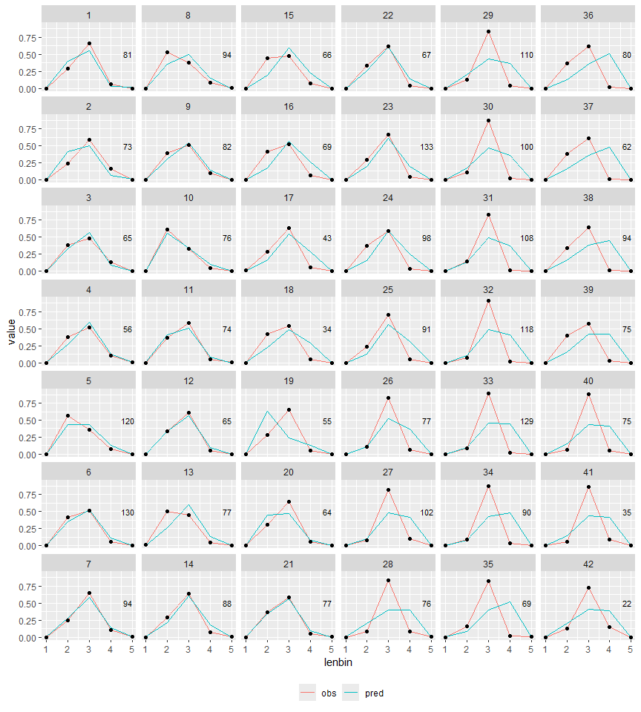

###### Spiny_dogfish

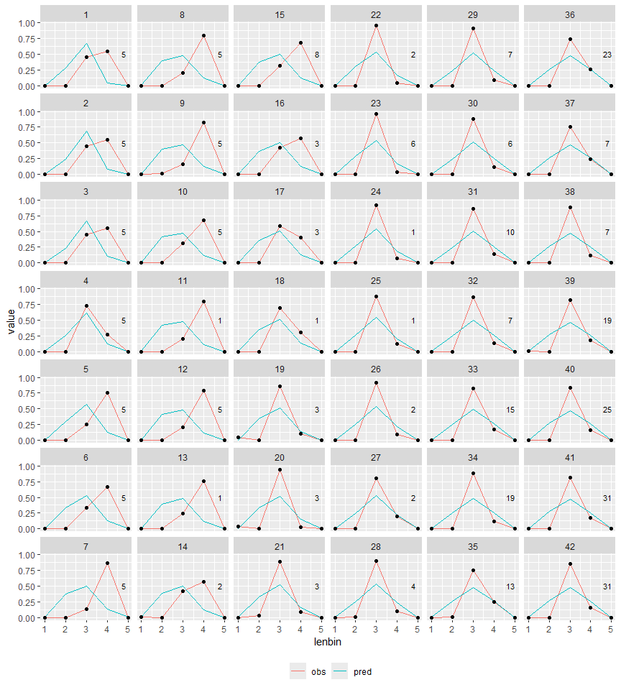

###### Atlantic_herring

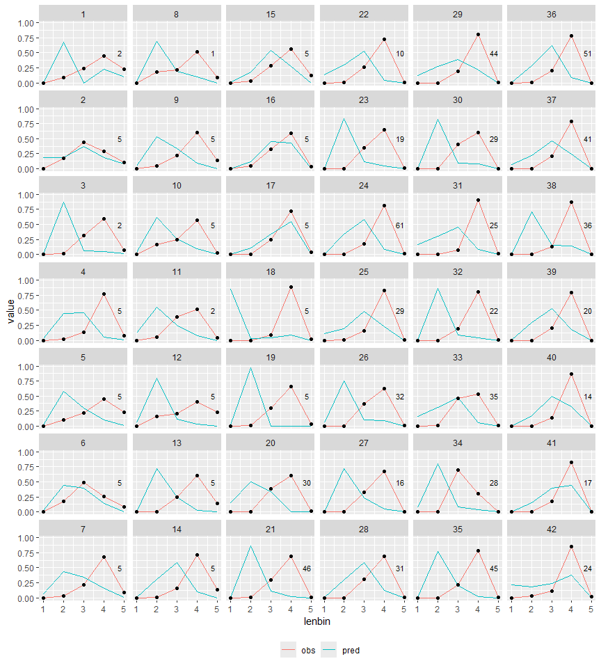

###### Atlantic_mackerel

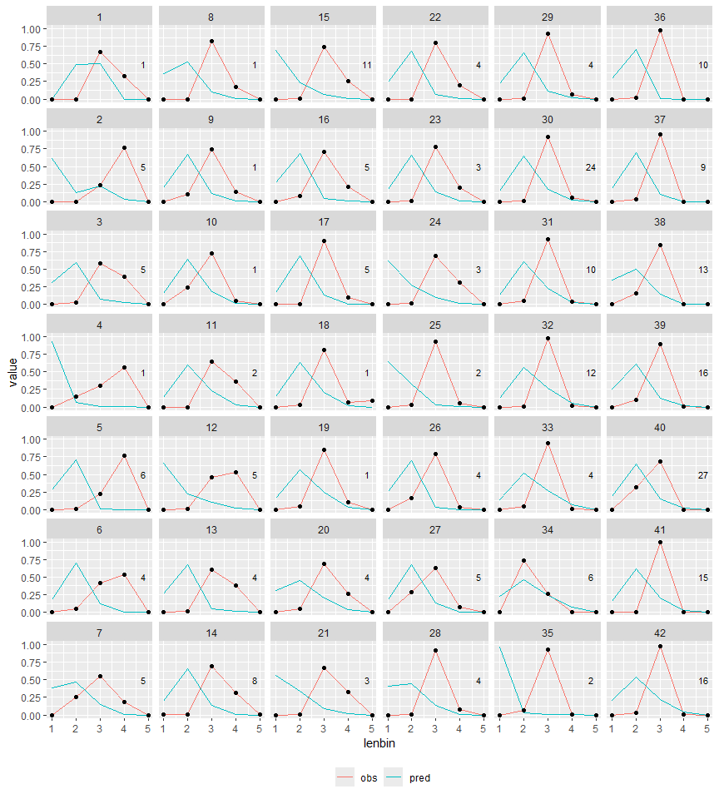

##### Size composition aggregated over time

###### Catches

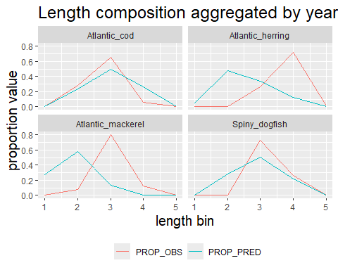

##### Survey size composition pearson residuals (survey 1)

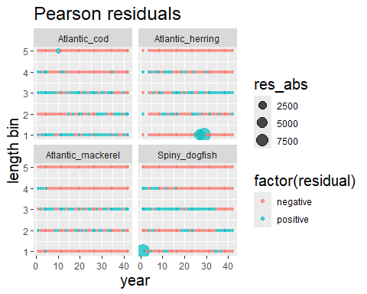

##### Survey OSA residuals

##### Survey 1 OSA residuals

###### Atlantic_cod

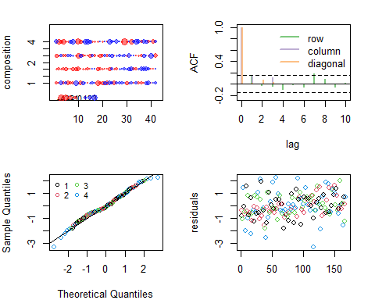

###### Atlantic_herring

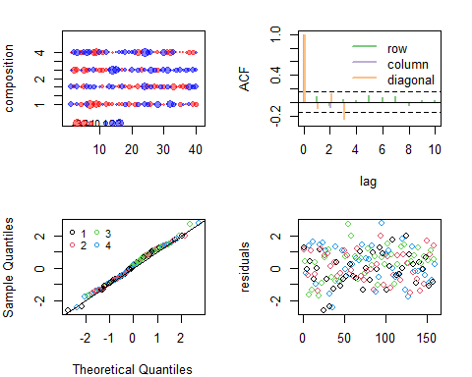

###### Atlantic_mackerel

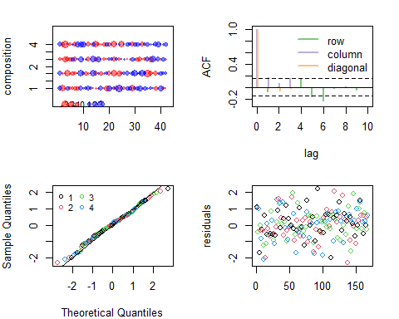

###### Spiny_dogfish

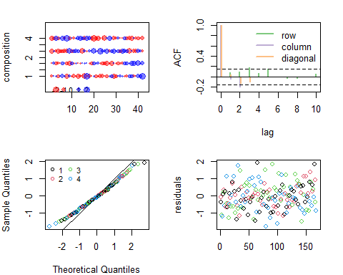 ##### {-}

##### Diet composition effective sample size

###### Survey # 1

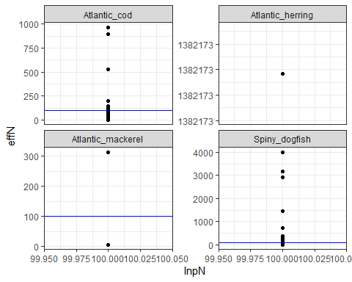

##### Catch size composition pearson residuals

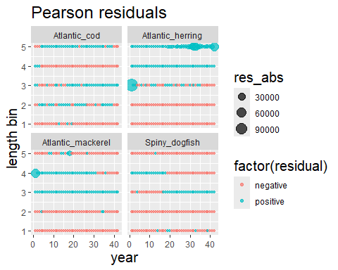

##### Fishery Size Comp OSA residuals

##### Fleet 1 Size composition OSA residuals

for (sp in especies) {  
 tmp <- plot_osa[[sp]]  
 cat("######", sp, " \n")  
 plot(tmp)  
 cat(" \n\n")  
 }

###### Atlantic_cod

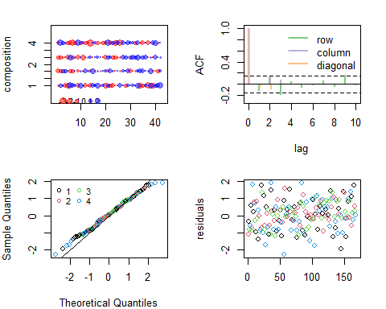

###### Spiny_dogfish

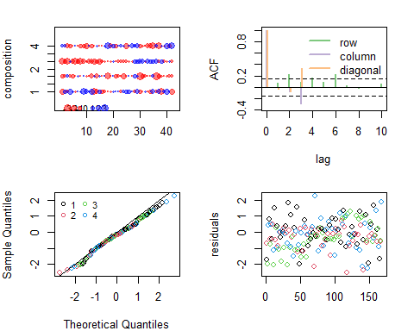

##### Fleet 2 Size composition OSA residuals

###### Atlantic_herring

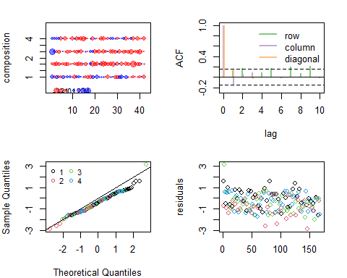

###### Atlantic_mackerel

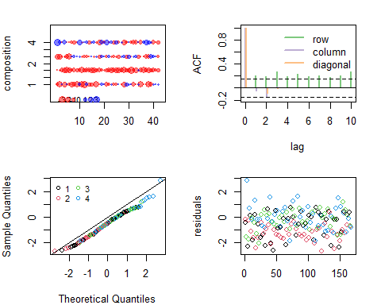

##### Fishery size comp Effective sample size

###### Fleet # 1

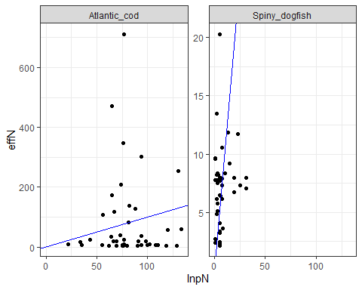

###### Fleet # 2

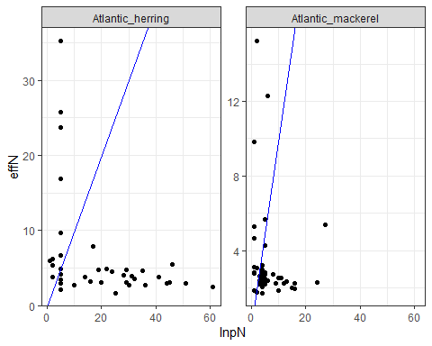 ##### {-}

#### Diet composition data

##### Proportions by weight for stomach by predator size bin survey 1

###### Atlantic_cod

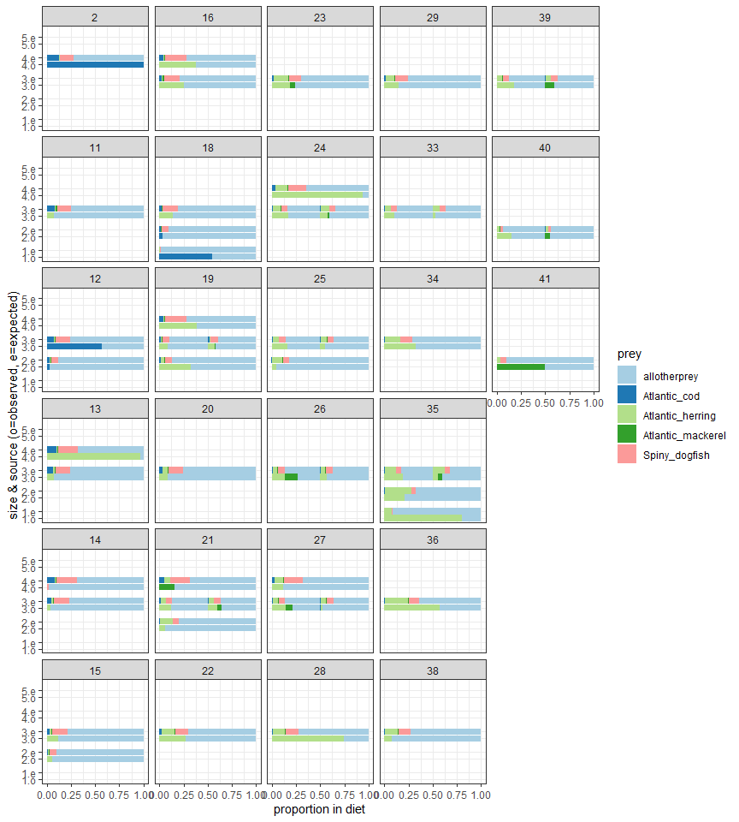

###### Atlantic_herring

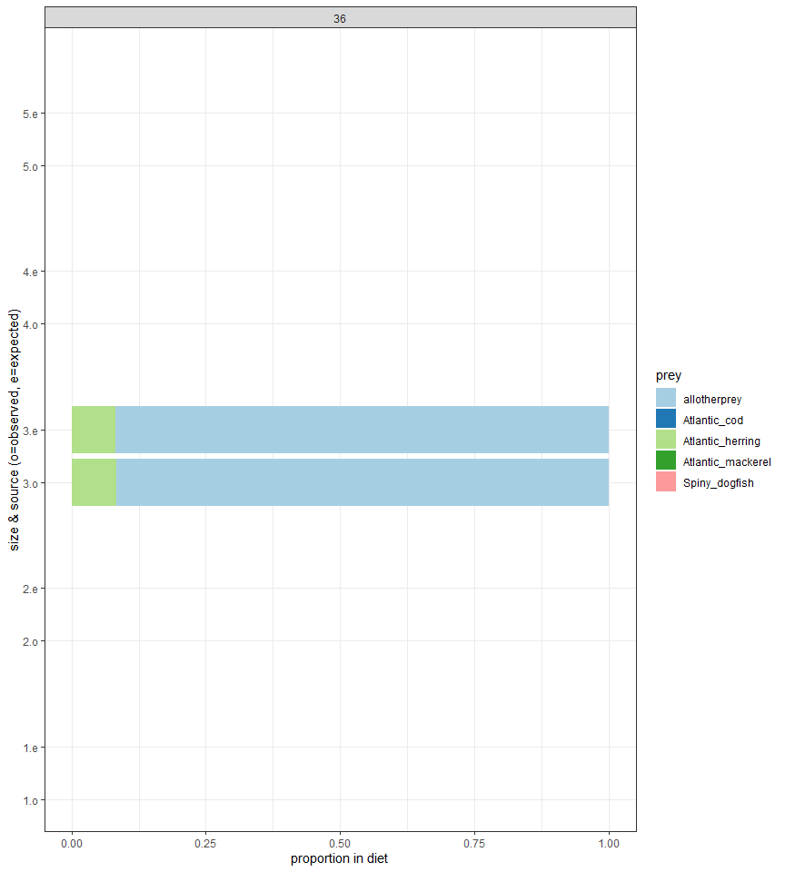

###### Atlantic_mackerel

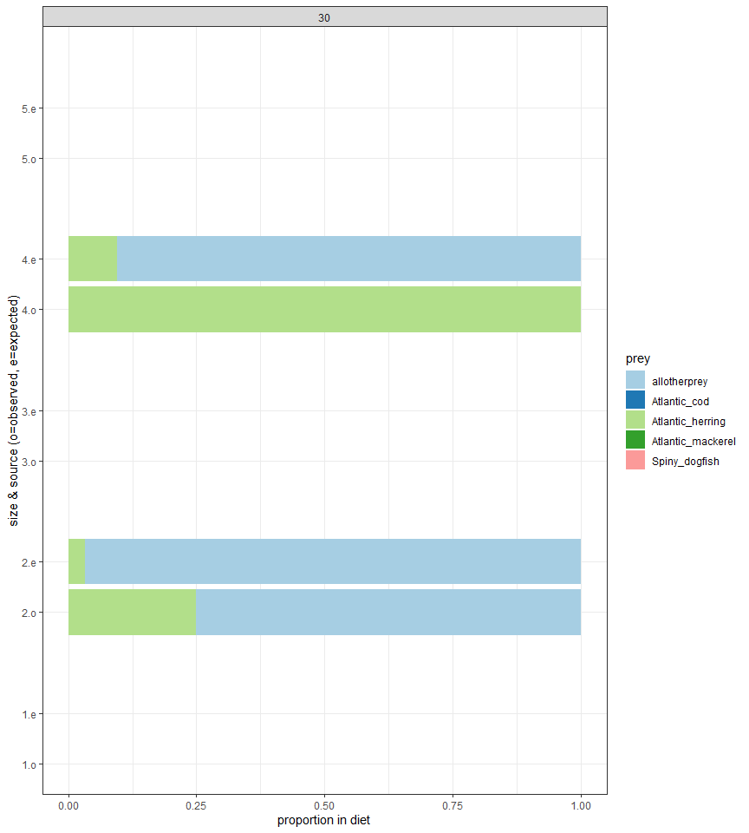

###### Spiny_dogfish

