**Estimation of growth**

Von Bertalanffy growth equation to estimate growth (length) at age

$$L_{t}=L_{∞}(1-e^{-k\left(t-t_{0}\right)})$$

L= length

*t*=age $L_{∞}$ = asymptotic length

K= growth coefficient

t0= theoretical age when length is 0

no todos los animals crecen von Bertalanffy hay otros con seasonal growth o por fases como los crustáceos multing, Gompertz

the first example was calculate length at age for yellow perch (chesapeak bay) estimating Loo K and t0

**Estimation of mortality**

Exponential mortality model, if you track the abundance in a cohort the amount of fish on each year will drecrase exponentially …. More individuals at younger ages. The basics of stock assessment.

$$N_{t}=N_{0}e^{-zt}$$

N= number of animals

Z= total mortality (F+M)

t= age

A= 1- ${ e}^{-z}$, A= annual catch rate

**Age based catch curves**

Way to estimate Z, we have catch at age. We need to specify the age at full recruitment to the gear and some assumptions:

Constant recruitment and mortality over time

Recruitment is knife-edged

Constant mortality across fully recruited ages

Population is in equilibrium

Survival of recruited fish described by a negative exponential function

Most of these assumptions are frequently not met.

$$N_{t}=N_{tc}e^{-z(t-tc)}$$

tc= age at full recruitment to the fishery.

The slope=Z

We calculate the yellow perch age-based catch curve to calculate Z

With Z=0.55

M=0.25

F= 0.30

A= 0.42

**Length based catch curves**

But what if we do not have age?, growth is not constant and it takes a fish longer to growth through the larger groups that means larger bins contain fish from more ages. The slope of the log of the catch is not longer linear like it is in length based catch curve because is a function of mortality but also growth (and all those animals that are in the largest length bins).

Assumptions

Asymptotic growth

Known constant K and Linf

No individual variability in growth

Recruitment is knife-edged

Constant mortality and recruitment over time

Constant mortality across lengths > lc

Population is in equilibrium

Lx= length at turning point in the curve

Lc= length at full recruitment to the fishery

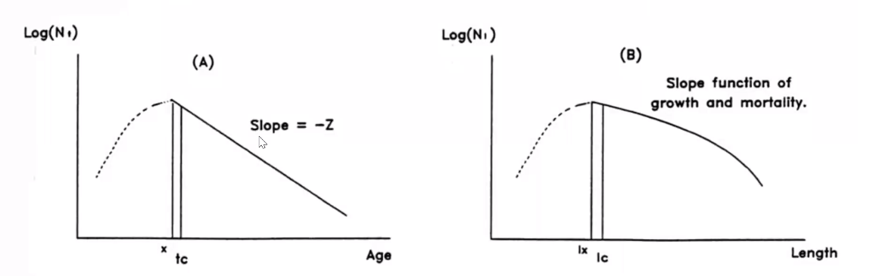

Catch curves in terms of age and length

Beverton & Holt

How to use length data to estimate mortality?

$$Z=K\left(\frac{L_{∞}-\overline{l}}{\overline{l}-lc}\right)$$

K= growth coefficient

$\overline{l}$ = mean length of fish in the sample

TropFishR example using catch at length and assumed values for Linf, K and Lc we calculate Z

Other methods: If we just have length data without growth parameters.

Regression methods (Powell-Wetherall), rearrange of vB equation and estimate Linf and Z/K by regressing $\overline{l}$-*l*c on *l*c.

$\frac{\hat{Z}}{K}=\frac{(1+\hat{β})}{\hat{β}}$

$$\hat{L∞}=\frac{\hat{a}}{\hat{β}}$$

**Length corrected- converted catch curves**: we already know growth is not constant, often takes animals longer to grow through the larger bins, but if the numbers in a length bin are divided by the time to grow through that bin this effect can be eliminated, converting lengths to “relative ages”, but we need some growth information (vB parameters) to calculate delta t. So, we can run a regression on ln(catch)>= fully selected animals like an age-based catch curve.

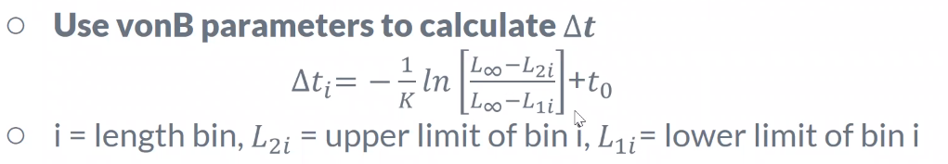

Cautions: it has steady state assumptions, tends to overestimate Z in simulation studies due to un-accounted for seasonal and individual growth variability.