**12/16/2022**

**Length Based Assessment Methods Report**

**Maria Cristina Perez**

The von Bertalanffy growth model is widely used to model age-length relationships and estimate growth parameters that are highly used in more complex models. The first part of this course was estimate growth and mortality using length at age data.

1. **Estimation of growth** usingthe von Bertalanffy growth equation:

$$L_{t}=L_{∞}(1-e^{-k\left(t-t_{0}\right)})$$

where L= length, *t*=age, $L_{∞}$ = asymptotic length, k= growth coefficient, t0= theoretical age when length is 0.

Not all animals grow von Bertalanffy type, there are other types of growth such as seasonal growth (small pelagic fish) or some cases where the molting process marks increments in the growth curve (crustaceans), or the Gompertz growth that assumes an exponential decrease of the growth rate with size.

The first example was calculated length at age for yellow perch (Chesapeake Bay) estimating , *k* and t0 for males and females. Generally, growth in females is bigger than in the males due to reproductive reasons and also growth in females is more often calculated because the spawning stock biomass is used in stock assessment models to estimate reproductive status of fish populations (**Figure 1**).

We estimate vonB parameters and lc given the yellow perch length and age data provided using excel and the function “growth” from fishmethods in R. Parameters estimated from both platforms were very similar for the three parameters (**Table 1**).

**Table 1** Estimated von Bertalanffy parameters using excel and fishmethods in R.

|  |  |  |
| --- | --- | --- |
| **von B parameter estimates** | **excel** | **R** |
| Linf | 316 | 315.895 |
| K | 0.27 | 0.268 |
| t0 | -1.54 | -1.512 |

* Excel file with the results can be found in folder examples/class 2 under the name Simple LB Catch Curves in Excel.xlsx, the section that was made in R can be found in LBAM.Rmd file.

**Figure 1** Length at ageyellow perch males and females. Blue dots observed values red line estimated values.

1. **Estimation of mortality**

Exponential mortality model: if we track the abundance in a cohort, the number of fish on each year will decrease exponentially with more individuals at younger ages. This is one of the basics models in stock assessment.

$$N_{t}=N_{0}e^{-zt}$$

where, N= number of animals, Z= total mortality (F+M), t= age. Also, A= 1- ${ e}^{-z}$, A= annual catch rate.

1. **Age based catch curves**:how toestimate Z using catch at age data. First, we need to specify the age at full recruitment to the gear and some assumptions: constant recruitment and mortality over time, recruitment is knife-edged, constant mortality across fully recruited ages, population is in equilibrium, survival of recruited fish described by a negative exponential function. In real life, most of these assumptions are not met.

$$N_{t}=N_{tc}e^{-z(t-tc)}$$

where tc= age at full recruitment to the fishery.

As an example, we calculated Z for yellow perch using the Beverton-Holt length-based catch curve, the growth info we generated in the previous step and the catch at length data provided (**Table 2**, **Figure 2**).

**Table 2** Total mortality, fishing mortality and annual catch rate.

|  |  |
| --- | --- |
| Parameter | value |
| Z | 0.55 |
| F | 0.3 |
| A | 0.42 |

**Figure 2** Log catch at age for yellow perch.

* Excel file with the results can be found in folder examples/class 2 under the name Simple LB Catch Curves in Excel.xlsx.

1. 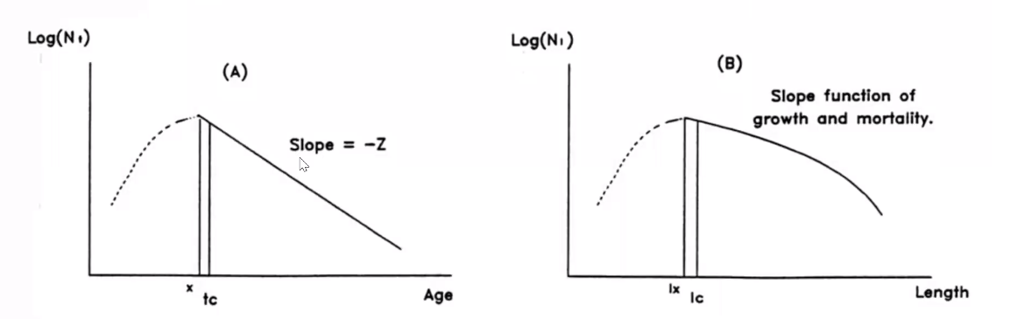**Length based catch curves:** what happens if we do not have age? Growth is not constant; it takes a fish longer to growth through the larger groups that means larger bins contain fish from more ages. The slope of the log catch is no longer linear, as in age-based catch curve (**Figure 3**), because is a function of mortality but also growth (and all those animals that are in the largest length bins). The assumptions for length-based catch curves are: asymptotic growth, known constant k and Linf, no individual variability in growth, recruitment is knife-edged, constant mortality and recruitment over time, constant mortality across lengths > lc an finally, population is in equilibrium.

**Figure 3** Catch curves in terms of age and length. Lx= length at turning point in the curve and Lc= length at full recruitment to the fishery.

Beverton & Holt equation: How to use length data to estimate mortality?

$$Z=k\left(\frac{L_{∞}-\overline{l}}{\overline{l}-lc}\right)$$

where Z is total mortality, k= growth coefficient, $\overline{l}$ = mean length of fish in the sample and Lc= length at full recruitment to the fishery.

Example: we used catch-at-length data and assumed values for Linf, K and Lc to calculate Z.

**Figure 4** Length at full recruitment to the fishery versus lmean-Lc for yellow perch. Z=0.3228.

* Excel file with the results can be found in folder examples/class 2 under the name Simple LB Catch Curves in Excel.xlsx.

There are other methods to estimate Z if we just have length data without growth parameters. The Powell-Wetherall regression method rearrange the von Bertalanffy’s equation to estimate Linf and Z/K by regressing $\overline{l}$-*l*c on *l*c. $\frac{\hat{Z}}{K}=\frac{(1+\hat{β})}{\hat{β}}$; $\hat{L∞}=\frac{\hat{a}}{\hat{β}}$ a and b can be estimated by a regression analysis. This method assumes the population is in a steady state with constant exponential mortality, there is no changes in selection pattern of the fishery and the recruitment is constant.

1. **Length corrected- converted catch curves:** we already know growth is not constant and often takes animals longer to grow through the larger bins, but if the numbers in a length bin are divided by the time to grow through that bin this effect can be eliminated, converting lengths to “relative ages”. To be able to do this, we need some growth information (vB parameters) to calculate delta t. So, we can run a regression on ln(catch)>= fully selected animals like an age-based catch curve. The method has steady state assumptions, tends to overestimate Z in simulation studies due to un-accounted for seasonal and individual growth variability.

$$∆t_{i}=-\frac{1}{k}ln\left[\frac{L_{∞}-L_{2i}}{L_{∞}-L_{1i}}\right]+t_{0}$$

where i= length bin, L2i =upper limit of bin I, L1i= lower limit of bin i.

1. **Length-frequency analysis**

If we imagine one annual class or one cohort and we plot the length frequency data, we should see distributions with different modes that represent our annual cohorts, these modes should help us to follow one cohort over time using the mean length, for example the mean length should decrease when there is a recruitment pulse, due to all the recruits entering in the cohort. Also, the mean length should increase throughout the years as fish grow and drop again when next year-class enters the fishery. In reality this process is difficult to observe because the recruitment process is more a seasonal event and recruitments doesn’t occur so abruptly.

The idea of length frequency analysis is to identify cohorts and estimate growth curve parameters assuming normal distributions, count with multiple samples could improve the results, connecting the peaks on each curve representing growth. This process is more commonly known as Modal Progression Analysis.

1. Electronic Length Frequency Analysis (ELEFAN): calculate moving average over multiple length bins and look for peaks where the length bin is greater than the average. Then, a score is assigned to each bin based on if is above or below the moving average.

The idea is identifying a von Bertalanffy curve that intersects as many positively scored bins as possible, the measure of goodness of fit (Rn) is the ratio of positive peaks relative to the total of possible peaks, this measure how close a growth curve is to the best possible fit. Different growth models can be used, including seasonal growth.

1. MULTIFAN: Statistical modelling approach, use maximum likelihood framework to estimate growth parameters resulting in best fit growth curve to the data and can account for size selectivity.

The major assumptions are: lengths are normally distributed around mean length, mean lengths at age lie on vB growth curve and standard deviation in mean length at age increases with mean length.

MULTIFAN Southern bluefin tuna example

We used a MULTIFAN model developed in ADMB with one of the southern bluefin tuna data sets presented in Fournier et al., 1990 to compare results from those presented in that paper. The ADMB model is configured in a similar way to Fournier’s model. Compare model estimates of growth to those obtained by Fournier et al. in Table 6 (note your log-likelihood and estimated number of parameters will differ because you are not estimating all the same components in the likelihood). k estimated by the model is bigger than the value reported by Fournier and L inf is smaller (**Table 3**), we also try different scenarios with different starting values for k, lambdas 1 and 2 and the number of ages. Finally, the model was not sensitive to initial k and Linf values but it was mostly sensitive to the number of ages.

**Table 3** Estimates parameters using the bluefin tuna MULTIFAN model and those reported by Fournier et al., 1990.

|  |  |  |  |  |
| --- | --- | --- | --- | --- |
| Param | model | Fournier et al., 1990 | sc2 | sc3 |
| vb k est | 0.17563 | 0.167 | 0.0067 | 0.1755 |
| Linf | 172.736 | 188.2 | 2797 | 172.76 |
| mL first | 66.6655 |  | 65.9 | 66.663 |
| mL last | 150.903 |  | 138.58 | 150.91 |

1. **Stage-based modeling, Catch Survey analysis (CSA)**

Consist in identify a stage or transition point in the life of the fish, in the case of age structured models it would be ages and in the case of length-based models it would be length bins, no matter what type of stage is considered, is more important that it is reliable measured. Any stage that we decide to use can allow us to track fish over time and divide the stock into discrete stages to monitor the relative number on each stage (before recruit and after). The stage with a number of fish plus a known or assumed natural mortality plus the total catch, we can estimate abundance on each stage and use that to calculate the exploitation rate. This analysis assumes knife-edged selectivity and indices are directly proportional to abundance, catchability of the data set is constant over time and natural mortality is known.

CSA works in a Maximum Likelihood estimation framework: consists of two models, first the population model that uses catch, indices and starting values for abundance at the first year, mean recruitment and annual deviations from mean recruitment to calculate abundance, exploitation rate and catchability and the observation model that uses catchability and abundance from population model to estimate indices

Example: Catch-Survey assessment model for the North Carolina stock of blue crab. The model assumes the individuals <70mm carapace length represent age 0 juveniles (or recruits) and >70mm represents age1+ adults.

Start plotting the time series of population model estimates of adult abundance, recruit abundance, and

annual recruitment deviations (from mean recruitment). What trends do you observe in abundance of adults vs recruits?

The abundance of adults has changed irregularly over time while changes in recruits are more regular.

High recruitment values for period 1993-1999 probably from the high abundance of adults in 1981-1985.

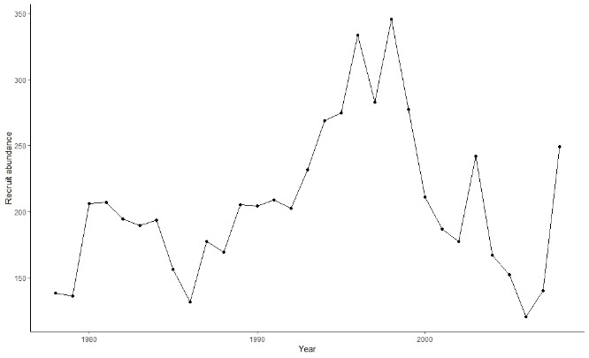

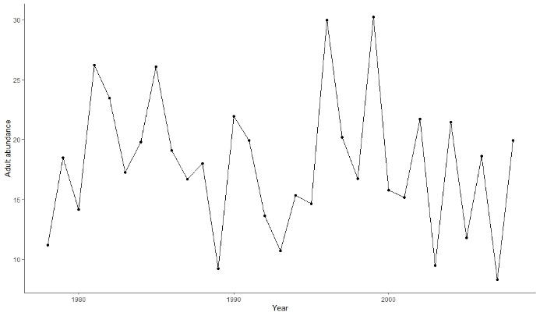

**Figure 5** Time series of abundance estimates for adults and recruits.

Compare the input time series of catch data with estimated fishery exploitation rate. How does estimated fishery exploitation rate (U) change over time relative to catch? Do the trends make sense? What appears to be going on with this stock? Hint: compare catch with recruit abundance.

Not much relationship between exploitation rate and catch but catch seems to follow the same recruitment pulses. This is typical in crustacean fisheries where the animals are immediately caught once they reach the size the gear can catch them.

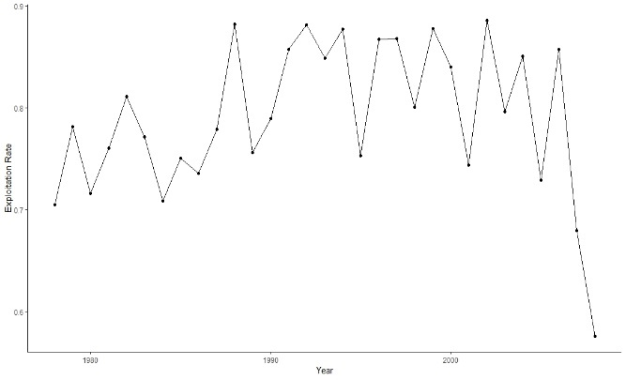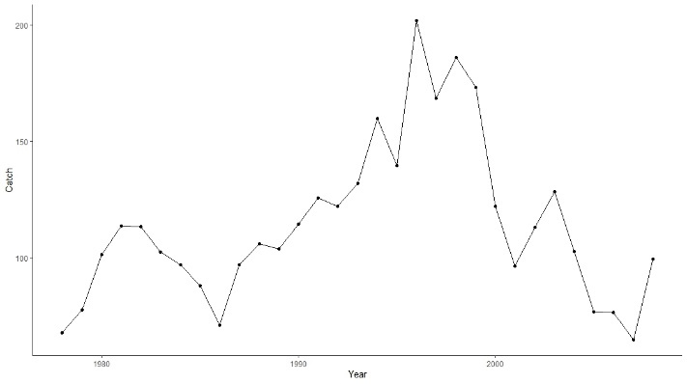

**Figure 6** Time series of abundance estimates for adults and recruits.

Compare model estimates of adult and recruit indices with observed indices by stage (recruits vs adults). How would you describe model fits to the survey data? What might be causing poor fit to some data sources?

The major assumption in the stage transition is recruitment size to the fishery once they reach 70 mm they are recruited to the fishery.

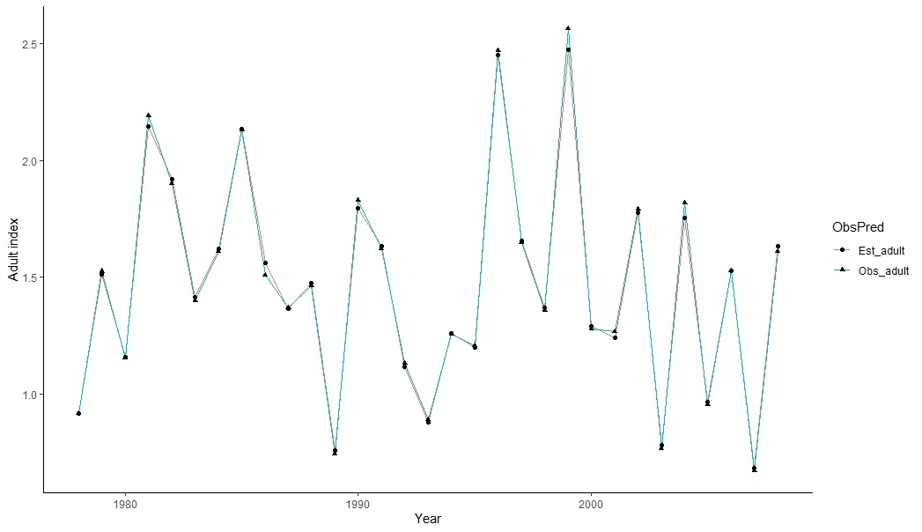

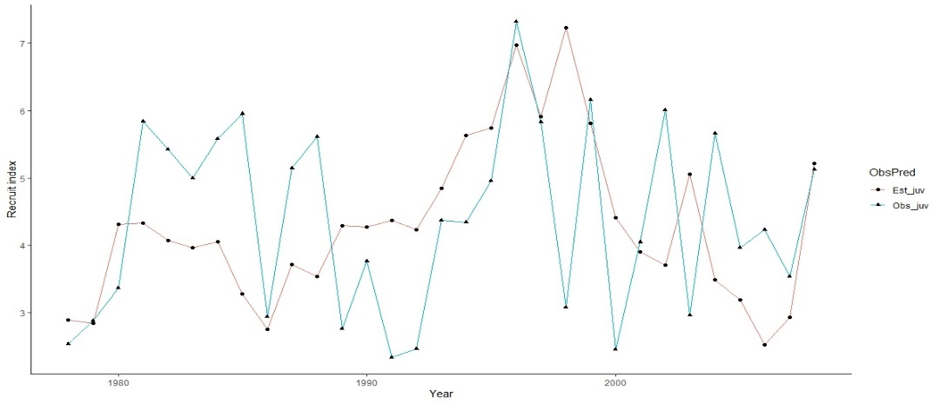

**Figure 7** Observed and predictedindextime series for adults and recruits.

1. **Catch at length models**: are used when no age data is available (or is unreliable), most of the fishery selectivity is given by length. Length data need to be reliable to be used in these methods. Catch at length models are stage models because they use length bins and it is necessary to define the number of bins and width which depends on each species and the available data. The length bins are the transition between stages, the mean size is estimate in each bin and the probability of transition between bins. The growth model parameters can be estimated inside the assessment model or outside the model

How to define the population model

* Set initial values for the estimated parameters (growth selectivity, initial abundance, R at length, q, etc).
* Calculate transition probabilities, selectivity and fishing mortality in each time step.
* Apply fishing and natural mortality.
* Apply transition probabilities to abundance at length in first time step to get the abundance at the next year.

The first thing to calculate is selectivity (gamma or logistic) to get fishing mortality and total mortality (Z=F+M). Then we can apply the estimated mortality to the abundance in the first time step. Then, recruitment for our initial time step would be the initial value. The abundance in the next time step would we calculated using the previous abundance, the recruitment and total mortality.

The observation model use population model values for abundance, fishing mortality and total mortality to calculate exploitation rate and catch at length with the Baranov catch equation.

The model includes minimized residual sum of squares between the observed and predicted catch at length.

Finally, the course included some guest lectures in which examples of the methods seen in class were presented, as well as the life experiences of the different researchers working in stock assessment in the country.

Catch Survey Analysis for northern shrimp assessment

Statistical catch at age for snow crab stock assessment in the Bering Sea.

Length based assessment model for American lobster stock assessment.

Stage structure model for oyster stock assessment in Chesapeake Bay.

Size structure model for blue crab stock assessment.