#### **TASK 1 (Business analytic question)**

Pricing strategies: How does pricing vary across different neighbourhoods, and how is it related to the number of reviews and the room type?

#### **TASK 2 (Data analysis)**

1. Data Loading and Exploration

2. Data Preprocessing

3. Exploratory Data Analysis and Data Visualisation

4. Statistical Analysis

**1. Data Loading and Exploration**

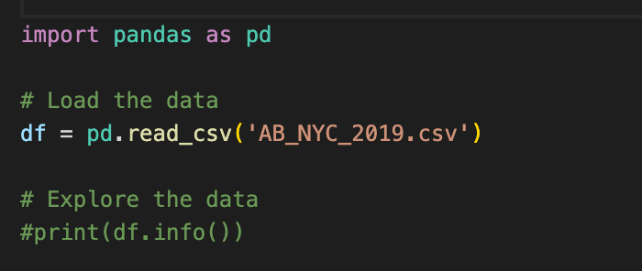

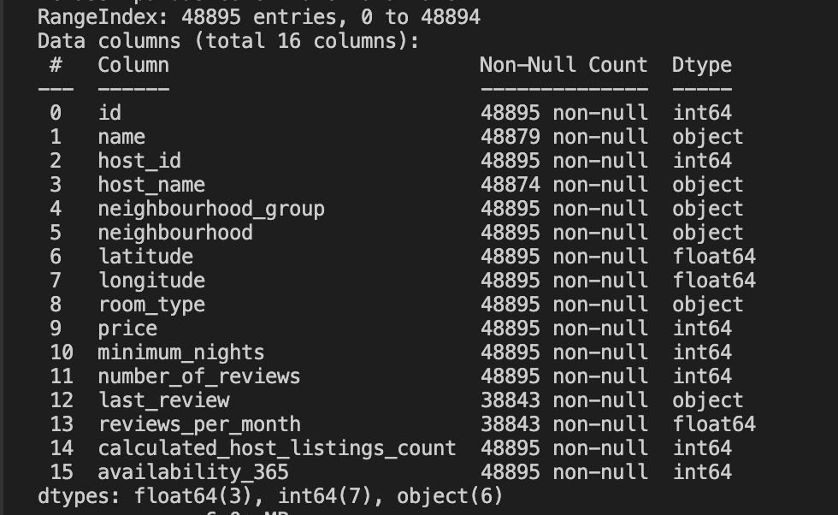

- According to our business analysis question, we will analyse based on these columns **price, neighbourhood, neighbourhood_group, number_of_reviews,** and **room_type**

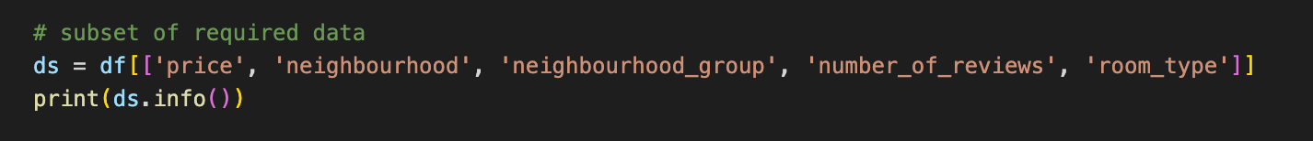

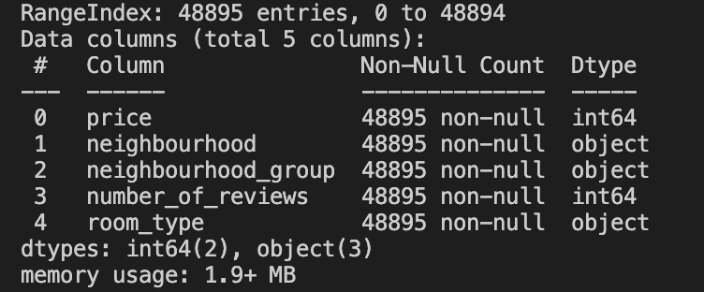

**2. Data Preprocessing**

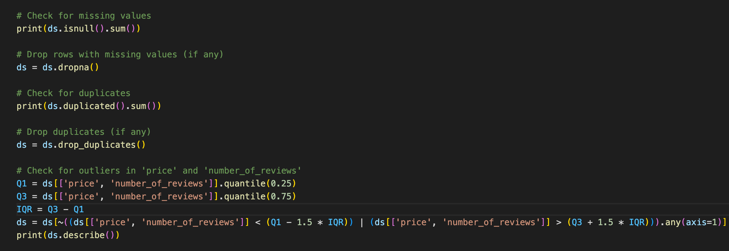

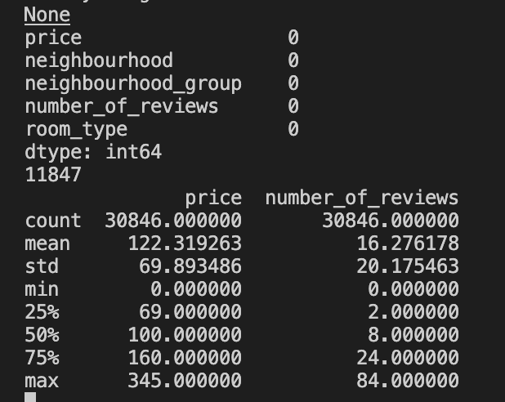

**3. Exploratory Data Analysis and Data Visualisation**

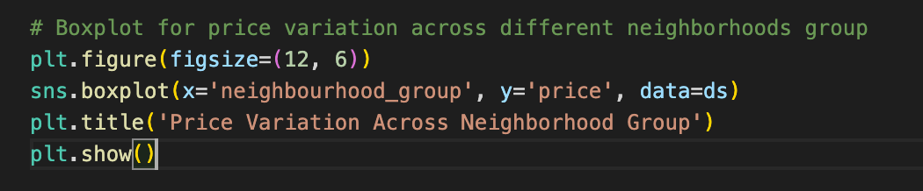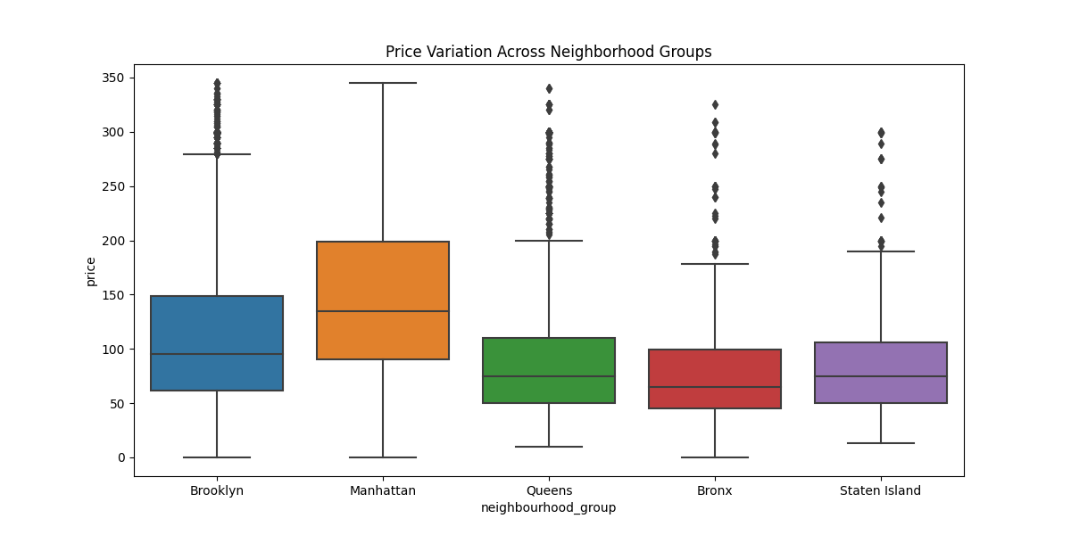

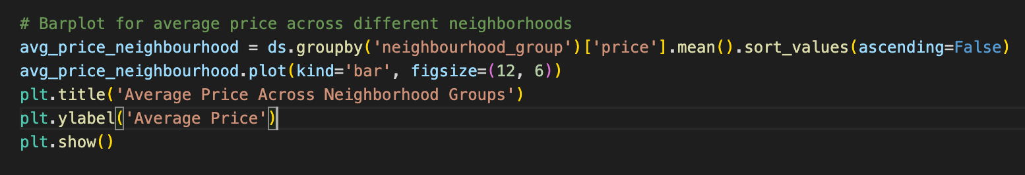

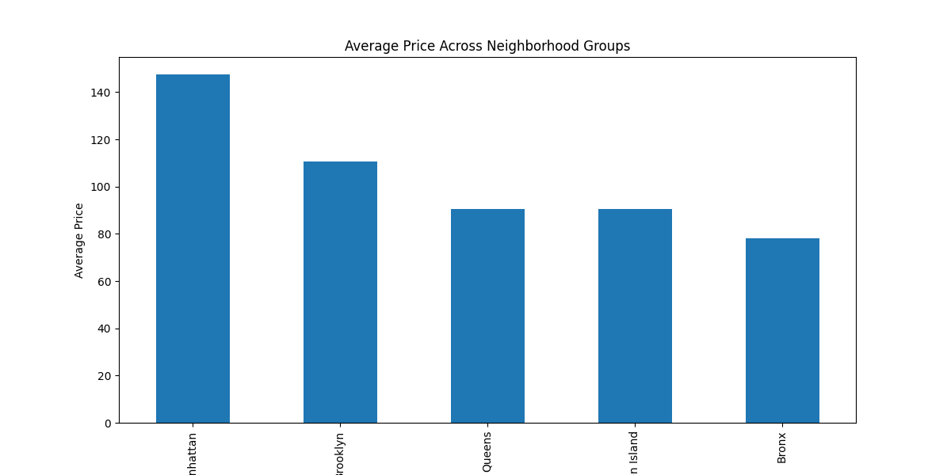

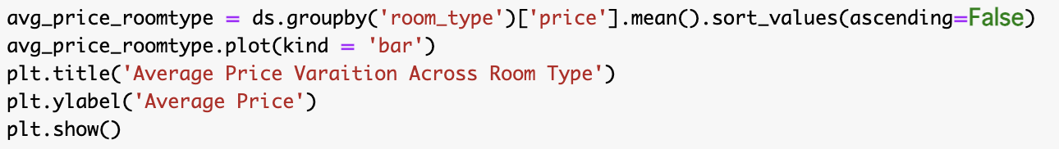

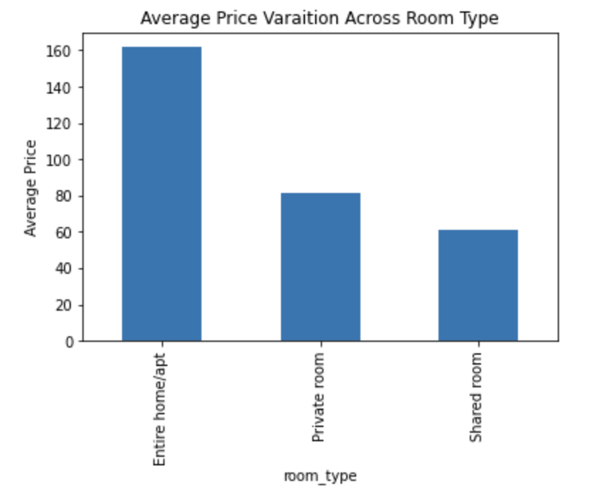

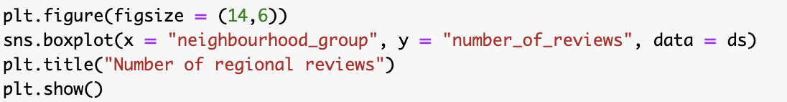

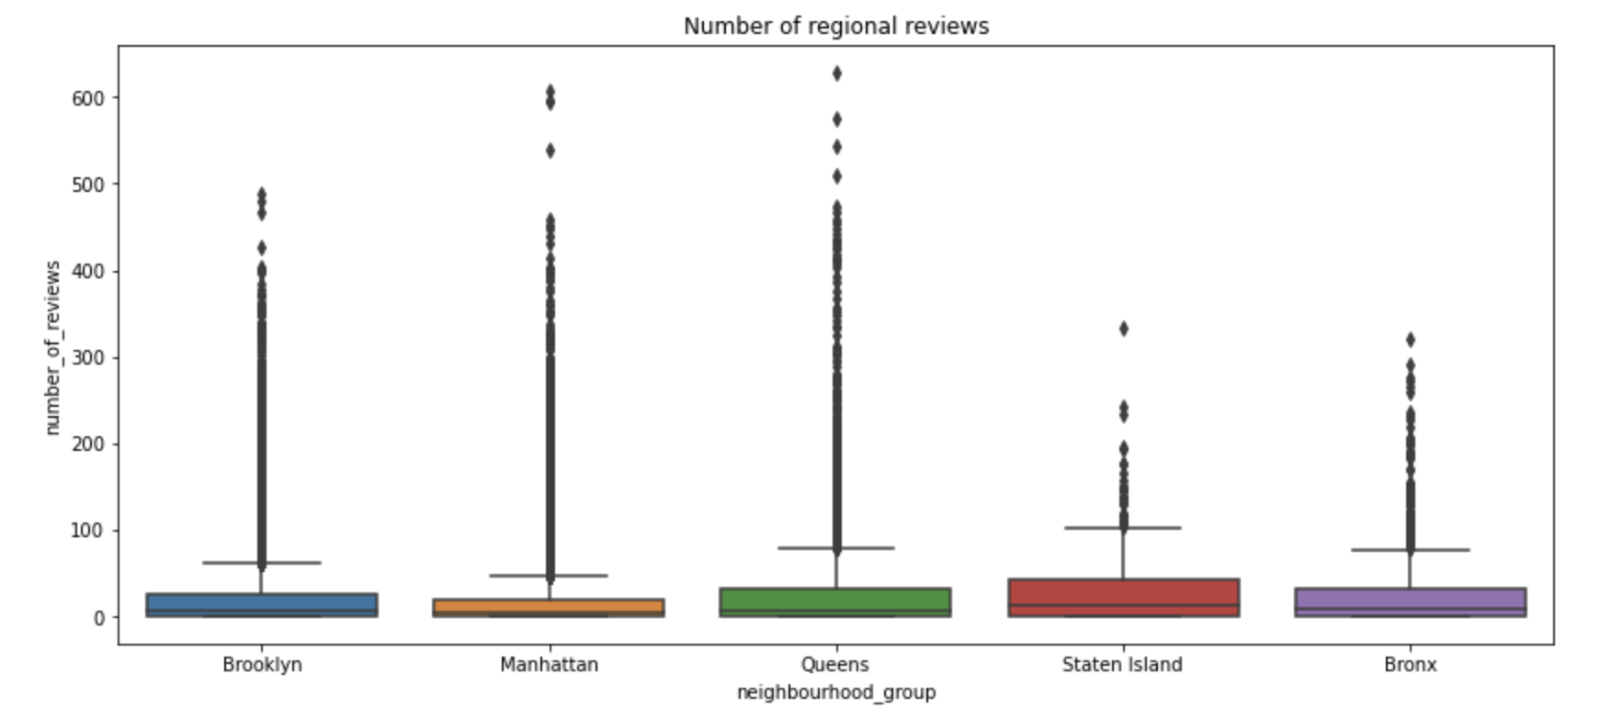

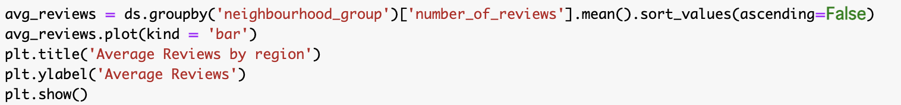

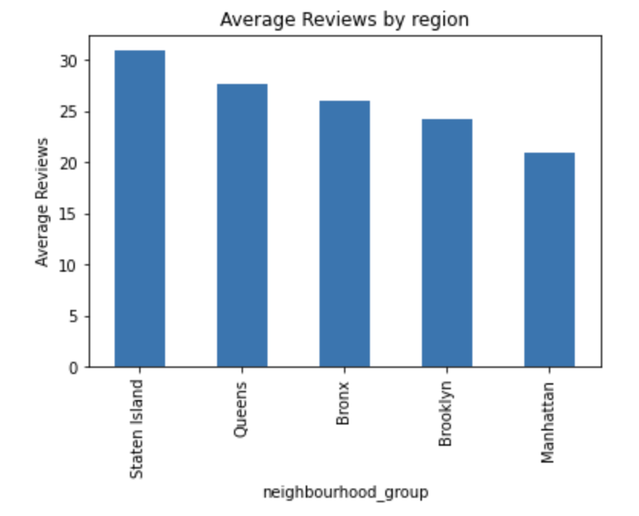

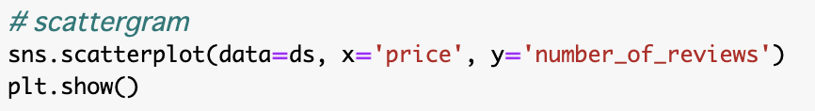

**4. Statistical Analysis**

**Transform categorical data into numeric form**

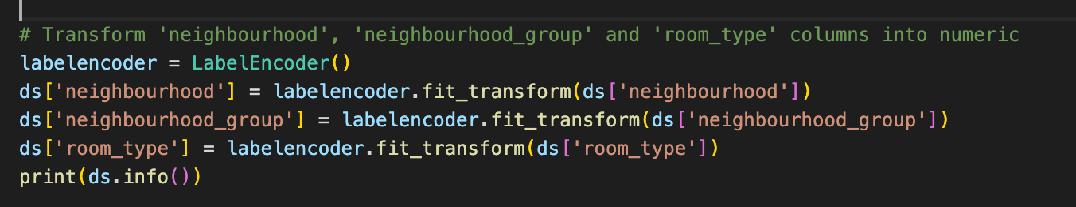

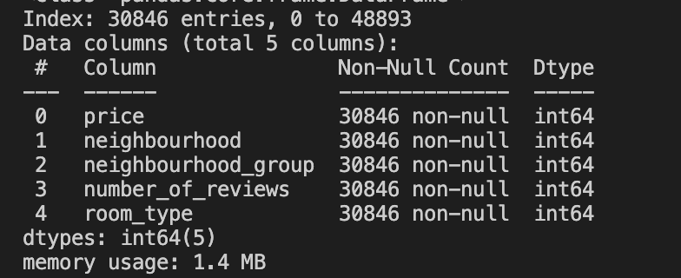

**Descriptive Statistic**

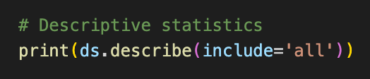

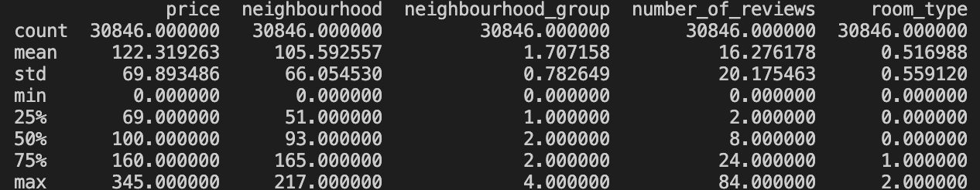

**Correlation Matrix**

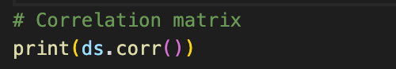

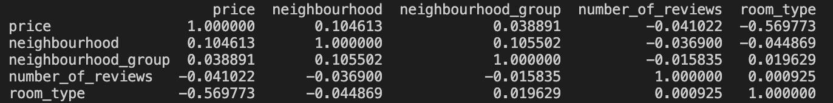

**Silhouette**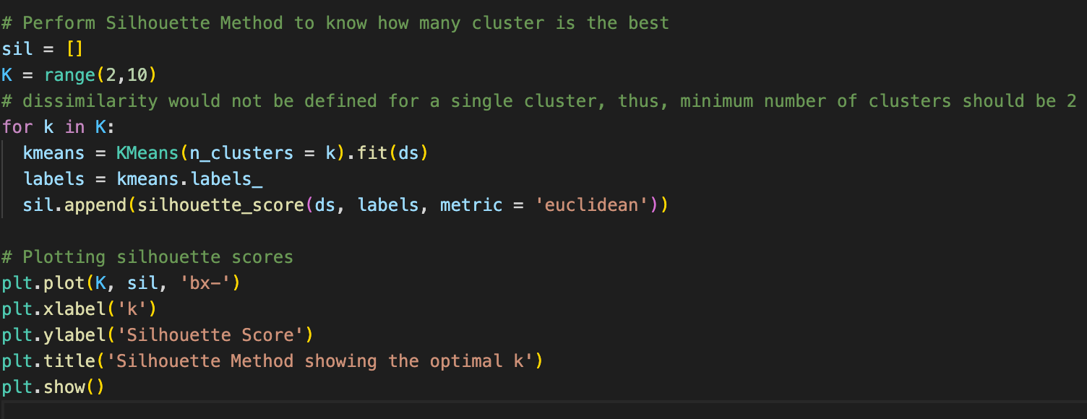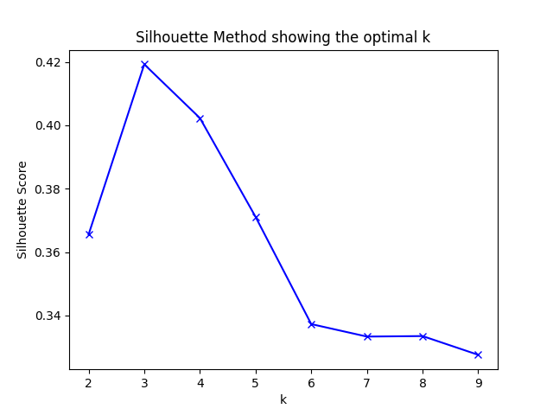

**K-mean Clustering**

- According to the result of the Sihouette method, n_cluster = 3 is the best.

