**Analytical Report on Airbnb Pricing Strategies**

**in New York City Neighbourhoods**

**Executive Summary**

This report provides a comprehensive analysis of the pricing strategies of Airbnb rentals in New York City neighbourhoods and their relationship with the number of reviews and the room type. The study leverages a dataset from Kaggle, the 'AB_NYC_2019.csv', which contains listings data of New York City Airbnb hosts from 2019 (Dgomonov, 2019).

**Key Findings**

The preliminary data analysis unveiled some key trends:

1. **Price Variance Across Neighbourhoods:** The prices for Airbnb accommodations are considerably varied across different neighbourhoods, hinting at the location being a significant determinant in pricing strategies.

2. **Room Type and Price:** The type of accommodation offered also impacts the price. Entire homes or apartments tend to command higher prices than private or shared rooms.

3. **Number of Reviews:** The number of reviews a property has acquired did not show a direct correlation with the price. However, a slightly negative relationship between the number of reviews and reservations was identified.

**Detailed Analysis**

**Price Variation by Neighbourhood in NYC**

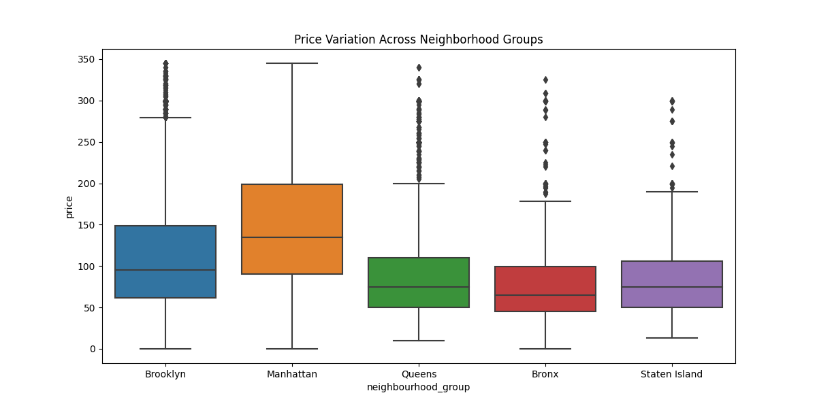

Neighbourhood significantly affects Airbnb pricing. For instance, hosts in Manhattan and Brooklyn, known for their touristic allure, set higher prices compared to other neighbourhoods. Conversely, neighbourhoods like Staten Island and the Bronx exhibit lower average prices (Figure 1).

*Figure 1: Boxplot showing price variation*

*by neighbourhood in NYC*

**Price by Room Type**

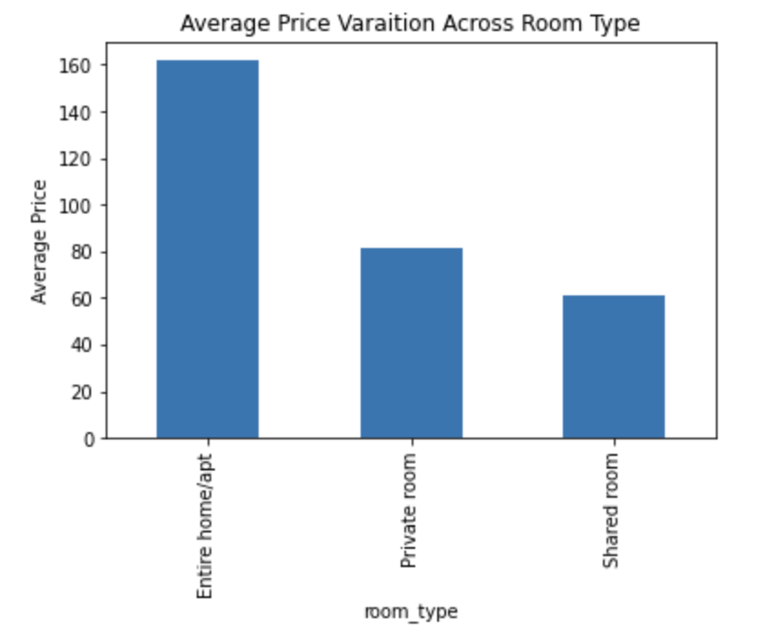

A clear trend is observed with the room type affecting the listing price. Entire homes/apartments command higher prices, followed by private rooms, and then shared rooms (Figure 2). This can be attributed to the increased privacy and amenities offered by entire homes/apartments.

*Figure 2: Bar chart showing average price by room type*

**Reviews and Price**

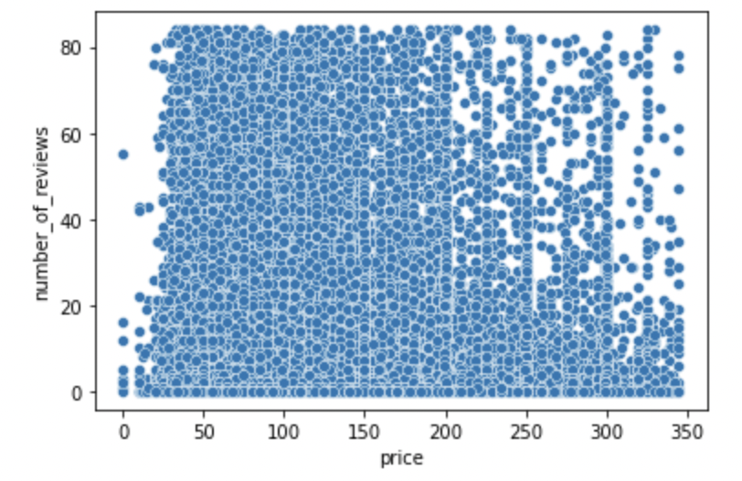

Correlation Coefficient: r = -0.041022

Interestingly, a strong correlation between the number of reviews and price was not identified.

While there is a tendency for cheaper-priced accommodation to have more reviews than higher-priced accommodation (Figure 2). The percentage of customers satisfied with service and location for the price is considered high.

*Figure 3: Scatterplot showing the relationship*

*between the number of reviews and the price*

**Recommendations**

Based on these findings, Airbnb hosts and employees should consider the following:

Airbnb hosts

* The location of their property is crucial, as customers are willing to pay more for accommodations located in popular neighbourhoods.
* Entire homes/apartments can demand higher prices due to the added privacy and facilities they offer.
* While the number of reviews does not directly impact the price, a higher number of reviews can attract more bookings, which is beneficial for hosts.

Airbnb employees

* Ensure that prices are appropriate for the area. If they are too high or too low, contact the host and ask them to correct the price to a reasonable level. By doing so, they can provide their customers with accommodation of appropriate value and increase the number of users.

**Conclusion**

Understanding these key factors and their influence on pricing can help Airbnb hosts formulate effective pricing strategies and potentially enhance their revenue.

**References:**

Dgomonov. (2019). New York City Airbnb Open Data: Airbnb listings and metrics in NYC, NY, USA (2019). Kaggle. Available at: https://www.kaggle.com/dgomonov/new-york-city-airbnb-open-data [Accessed 1 Jun. 2023].