**User Story: Pastry Shop Management System**

The Pastry Shop Management System is a role-based web application designed to streamline the operational, sales, and customer interaction processes of a pastry business. The system is intended to serve three primary user roles: Admin, Employee, and Customer each of which has distinct functionalities aligned with their respective responsibilities.

From the perspective of the admin, the system should provide full administrative control over the platform. This includes the ability to manage system users (view, add, update, or delete Admin accounts), manage the product catalog (add, view, update, and delete product listings), and monitor business performance through sales records. The admin should also be able to securely manage their own profile and log out of the system at will.

For the Employee, the system should allow the user to view and manage customer records (adding, updating or deleting customer accounts) and manage the available products, including viewing and adding new items. The employee also requires access to sales records to stay updated with transaction summaries. A profile management interface and a secure logout functionality are also necessary for proper account control.

From the Customer’s standpoint, the system must facilitate an intuitive and responsive user experience. Customers should be able to view and update their personal profiles, browse all available products, add desired items to their cart, place orders, and complete payments through an integrated payment feature. The customer must also have the ability to log out securely from the platform.

To support these functionalities, the system begins with a role-based registration process, where a user selects their role (Admin, Employee or Customer) and is subsequently directed to the appropriate registration form. After successful registration, the user may log in using their selected role, email, and password. Upon validation, the user is redirected to their respective role-based dashboard.

This user story encapsulates the overall behavior and interactions between the users and the system, establishing the functional foundation of the Pastry Shop Management System while aligning with modern software engineering principles for usability, security, and efficiency.

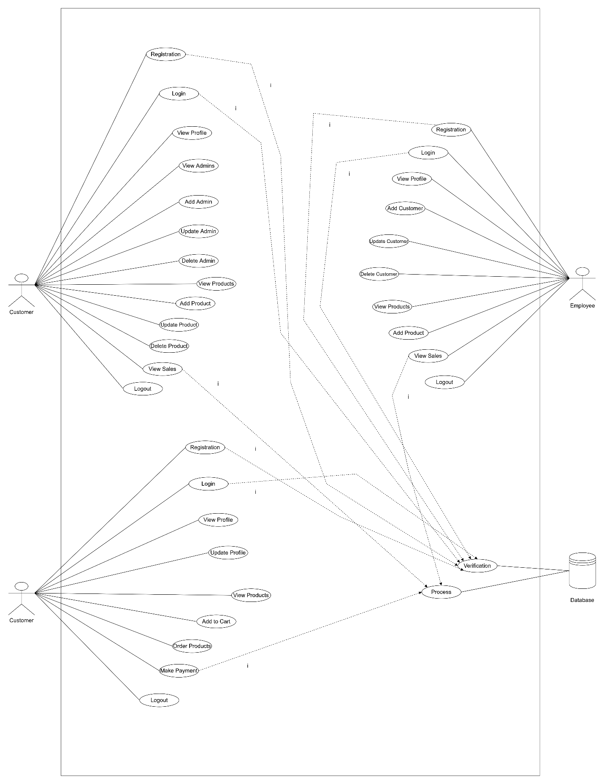

**Fig 1: Use Case Diagram for Pastry Shop Management System**

**Use Case Diagram Link:**

<https://drive.google.com/file/d/12Vain08ohjH6bA72c-BQsKmwYTLp-A-W/view?usp=sharing>