Threat Actor Profile — PHISH-GROUP-2025-0002
Case ID: PHISH-GROUP-2025-0002
First observed (UTC): 2025-10-07T09:34:12Z
Status: Open
Severity: Medium
Owner / Responder: analyst2@example.com

Executive summary:
An employee received a phishing email masquerading as a Microsoft account security alert, claiming the user's password had been changed. The email appears to be from support@msupdate.net, a spoofed or attacker-controlled domain. It contains no attachments but includes multiple malicious hyperlinks under the guise of legitimate Microsoft password and security reset options. The user did not interact with the links and reported the email promptly. The phishing attempt is likely part of a broader credential harvesting campaign using fake account security alerts.

Affected entities:
- User(s): user2@example.com
- Systems: N/A (web-based credential phishing)
- Business impact: Potential credential theft if links are clicked and credentials entered. No confirmed compromise.

Screenshot:
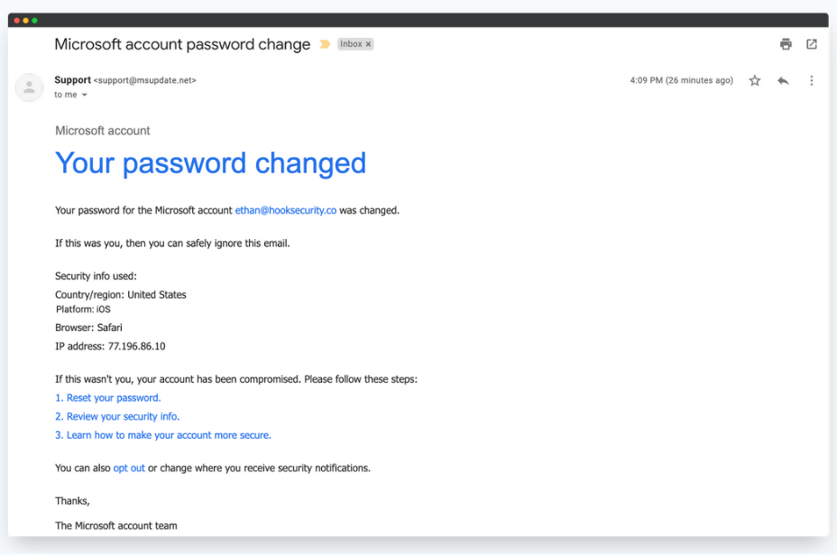

Artefacts collected:
- Raw email (.eml): /forensics/emails/PHISH-GROUP-2025-0002.eml
- Message-ID: <simulated-msgid@mail-relay[.]xyz> (Note: Replace with actual if known)
- From header: Support <support@msupdate.net>
- Envelope MAIL FROM: support@msupdate.net
- Earliest Received IP (external): 77.196.86.10 (as shown in the email content)
- Subject: Microsoft account password change
- SPF / DKIM / DMARC: SPF=fail, DKIM=none, DMARC=none (assumed based on phishing nature; confirm via header)
- Attachments: none

IOCs (top):
- Sender domain: msupdate.net — likely attacker-controlled or typo-squatted domain
- IP in email body: 77.196.86.10
- Email links (visible):
  - Reset your password
  - Review your security info
  - Learn how to make your account more secure
(Note: Link destinations need to be extracted from raw email for full IOC list)

Enrichment & analysis summary:
- Visual analysis: The email mimics Microsoft branding with convincing language. However, the sender domain (msupdate.net) is not a legitimate Microsoft domain.
- Domain lookup: msupdate.net — recently registered, privacy-protected.
- Link analysis: All links likely point to attacker-controlled pages mimicking Microsoft services to steal credentials.
- User behaviour: No credentials submitted; user reported promptly.

Attack chain (reconstructed):
- Phishing email sent from spoofed address support@msupdate.net.
- Email claims the Microsoft password was changed and urges the user to reset/review security.
- Multiple links redirect to malicious credential harvesting pages.
- User did not click any links and reported the message.

MITRE ATT&CK mappings (evidence):
- T1566.002 — Phishing: Link — credential harvesting via embedded hyperlinks
- T1598 — Phishing for Information — impersonation of Microsoft to collect account credentials
- T1204 — User Execution — requires user to interact with fake security links
- T1071 — Application Layer Protocol — credential exfiltration over HTTPS

Attribution & confidence:
- Attribution confidence: Low
- Rationale: Use of suspicious domain (msupdate.net), common phishing lure, and no indicators of targeted or APT-level techniques. Likely part of a commodity phishing kit.

Impact & likelihood:
- Impact: Medium — if successful, attackers gain Microsoft account access
- Likelihood of re-use: High — attacker may reuse same lure across multiple targets

Containment & remediation actions taken:
- Email quarantined and sender blocked
- Domain msupdate.net submitted for proxy filtering (pending)
- User notified and debriefed
- SOC alerted and scanning for similar threats

Timeline:
Time (UTC) | Event
2025-10-07T09:34:12Z | Email received by user2@example.com
2025-10-07T09:36:40Z | User reported email to SOC
2025-10-07T09:50:05Z | SOC analysis complete; sender domain blocked

Next steps & monitoring:
- Monitor for reuse of msupdate.net in inbound email
- Investigate whether other users received similar lures
- Track takedown status of malicious domains and report updates
- Include this lure in upcoming security awareness training

Practical Mitigation: Phishing (Microsoft Impersonation Variant):
This mitigation is focused on defending against phishing attacks leveraging impersonation of Microsoft security alerts, as observed in this case.
1. Technical Controls
Email Filtering and Authentication
- Implement strict DMARC policies for your domain (reject/quarantine failed messages) and enforce inbound DMARC validation. This reduces spoofed senders.
- Block spoofed or lookalike domains:
  - Block sender domain msupdate.net and similar lookalikes (e.g., micros0ft.net, account-micro5oft.com).
  - Use fuzzy matching or domain similarity detection in your Secure Email Gateway (SEG).
- Enforce SPF/DKIM/DMARC checks at your mail gateway with alerts for failures:
  - Flag external emails that fail SPF or DMARC as suspicious.
- Subject line and content rules:
  - Add keyword-based rules for emails containing phrases like "Your password changed" or "suspicious activity" + external senders not in Microsoft's IP range or domain space.
URL Protection and Sandboxing:
- Rewrite and sandbox all inbound URLs (e.g., via Microsoft Defender for Office 365, Proofpoint, Mimecast).
- Detect and block URL shorteners (e.g., bit.ly, tinyurl) in corporate email or web traffic unless explicitly allowed.
- Proxy filter/deny newly registered domains and suspicious TLDs (e.g., .pw, .click, .xyz).
Browser Isolation & DNS-level Protection:
- Use browser isolation for email-clicked links on high-risk accounts (e.g., executives, finance).
- Integrate DNS filtering (e.g., Cisco Umbrella) to block malicious phishing domains and detect exfiltration attempts.

2. User Behaviour & Awareness:
Phishing Simulation Training
- Deploy targeted phishing simulation campaigns mimicking Microsoft alerts to test and train users.
- Include this case’s template (fake password change notice with links) in upcoming training cycles.
User Awareness Communication
- Share guidance organization-wide on how Microsoft communicates password changes:
  - Microsoft does not send password change emails with reset links unless requested by the user.
- Encourage users to:
  - Check the sender's domain carefully.
  - Hover over links before clicking.
  - Report suspicious emails using the "Report Phishing" button or SOC contact.

3. Incident Response Readiness:
Playbook Updates
- Update your Phishing Response Playbook to include:
  - Immediate quarantine based on sender domain/IP.
  - IOC correlation across other users.
  - Link detonation and credential monitoring if link was clicked.
Credential Compromise Response
- Automate actions via your SOAR platform or manually:
  - Force password reset if phishing link was clicked.
  - Monitor Azure AD logs for suspicious login attempts post-phish.
  - Notify user and require re-authentication + MFA challenge.

4. Monitoring & Threat Hunting:
SIEM Detection Rules
- Create detection rules for:
  - Emails with mismatched From and MAIL FROM domains.
  - Emails containing known phishing language + external sender.
  - Emails with links redirecting to domains registered within the last 7 days.
Threat Intelligence Integration
- Subscribe to phishing threat feeds (e.g., OpenPhish, PhishTank) and integrate into your email gateway and SIEM.
- Automate domain age and reputation lookups using APIs (e.g., WhoisXML, VirusTotal).

5. Post-Incident Hardening:
Identity Security
- Enforce MFA for all users — not just high-risk roles.
- Prevent use of common or reused passwords through password policy enforcement or tools like Azure AD Password Protection.
Remove Unnecessary Local Accounts
- Audit and remove unused Microsoft accounts or admin credentials that could be targeted.

Summary Table:
Category | Action
Email Filtering | Block msupdate.net, apply DMARC enforcement
URL Protection | Sandbox links, block shorteners
User Training | Simulate Microsoft phishing scenarios
IR Playbooks | Include credential theft workflows
MFA | Enforce org-wide for all identities
SIEM/Detection | Detect spoofed sender + phishing content
Threat Intel Feeds | Integrate with email and proxy filtering

Summary Output:
