Battery Specifications

Executive Summary
Nominal Voltage | $$51.2V$$
Total Capacity | $$42Ah \left(≈2150Wh\right)$$
System Max Continuous Discharge | $$60A\left(LimitedbyBMS\right)$$
Cell-Level Max Continuous Discharge | $$126A$$
Cell Chemistry | Lithium Iron Phosphate $\left(LiFePO_{4}\right)$
Expected Life Cycle | $$>2000Cycle$$
Series/Parallel Configuration | 16S7P
Cooling Method | Passive

System Requirements
The battery pack is designed to power a BLDCM with the following key specifications:
Nominal Voltage | 48V
Rated Speed | 3000 RPM
Rated Power | 660W

The system requires two hours of continuous operation at full load. Assuming a combined electromechanical conversion efficiency (inverter and motor) of 80%, the required energy capacity is calculated as follows:
$$E_\{req\}=\frac{660W}{80\%} × 2h≈1650 Wh$$
Consequently, the required capacity in Ampere-hours (Ah) at the nominal system voltage is:
$$Ah_\{req\}=\frac{1650 Wh}{48V}≈34.38 Ah$$

Battery Design

Chemistry Selection
Lithium Iron Phosphate (LiFePO4) was selected based on the following engineering parameters:
- Thermal Stability: Inherently stable chemistry minimizes the risk of thermal runaway events.
- Cycle Life: Capable of $>2000 charge/discharge cycles$, providing a longer operational lifespan compared to alternative lithium chemistries.
- Environmental Impact: Free of toxic heavy metals.
- Environmental Tolerance: Maintains reliable performance across a wide operating temperature range.
- Total Cost of Ownership: Extended lifespan and reduced maintenance requirements yield long-term cost efficiency.

Cell Specifications
Form Factor | 32700
Nominal Voltage | 3.2V
Nominal Capacity | 6 Ah
Max Continuous Discharge Current | 18 A

Electrical Design
To size the battery pack appropriately, the required capacity must account for the safe Depth of Discharge (DoD) limit of the cells. Assuming a strict DoD limit of 90% (0.9) to preserve cell longevity:
$${Ah}_{pack}=\frac{{Ah}_{req}}{DoD_{limit}}$$
$$Ah_{pack}=\frac{34.38 Ah}{0.9}=38.2 Ah$$
Parallel Configuration ($N_{p}$):
Given each cell's capacity of 6 Ah, the required number of parallel cells is:
$$N_{p}=\frac{38.2}{6}=6.37$$
Rounding up to ensure adequate capacity, $N_{p}$ is designated as 7.
Series Configuration ($N_{s}$):
The motor's nominal voltage requirement is 48 V. Based on the 3.2 V nominal voltage of each cell:
$$N_{s (base)}=\frac{48}{3.2}=15$$
While 15S yields exactly 48V, a 16S configuration is standard for 48V-class systems. Increasing $N_{s}$ to 16 accounts for voltage sag under full load, compensates for resistive losses across system wiring and inverter switching.
Final Pack Specifications (16S7P):
Nominal Voltage | $$16×3.2\text{ V}=51.2\text{ V}$$
Nominal Capacity | $7×6\text{ Ah}=42\text{ Ah}$ (yielding $≈2150\text{ Wh}$)
Max Continuous Discharge Current | $$7×18\text{ A}=126\text{ A}$$

Implementation Details
The final physical assembly utilizes the designed 16S7P configuration using EPRO 32700 LiFePO4 cells.
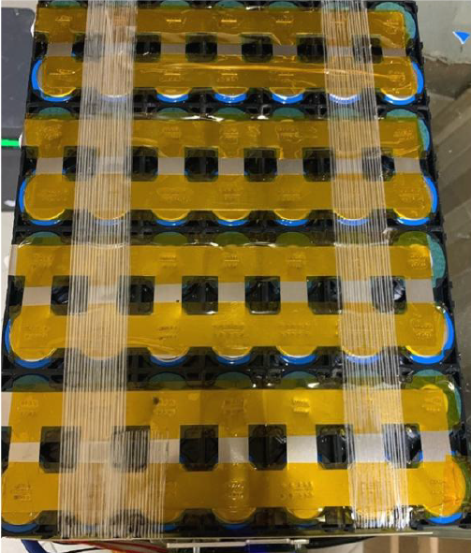 | 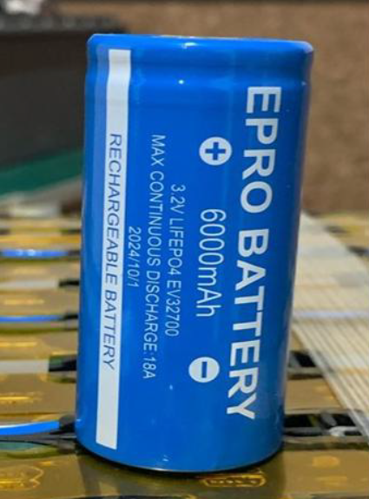
Battery Management System (BMS):
The pack is governed by a JIABAIDA DB24SA03 BMS.
- Hardware Capabilities: Supports up to 24 series strings.
- Current Limiting: Features a maximum continuous current rating of 60 A. Note: This acts as the primary system bottleneck; the pack cannot output the cell-capable 126 A without triggering over-current protection. However, 60 A is highly sufficient for the continuous $≈18\text{ A}$ draw of the target load.
- Telemetry & Communication: Features Bluetooth connectivity for mobile application monitoring and a UART port for external communication protocols.
