Predicting River Baseflow in the Republican River Basin with Multiple Linear Regression
[Team member names] | CS 5830/6830, Project 6
Presentation slides: [insert Google Slides link] GitHub: [insert repository link]

Introduction
Baseflow is the steady portion of a river that is fed by groundwater rather than by recent rain. It is what keeps streams flowing between storms and through dry summers, so it is the water that farmers, towns, and wildlife actually depend on when conditions are hard. In the Republican River basin, which spans parts of Colorado, Nebraska, and Kansas, baseflow is also a legal matter: the three states share the river under an interstate compact, and decades of disagreement over how groundwater pumping affects the river have ended up in court. Our analysis asks a practical question for the people who manage this water: can we predict monthly baseflow in a river segment from readily available information, and how much of the picture is explained by climate versus by groundwater pumping for irrigation?
We applied multiple linear regression to a dataset of 15,591 monthly observations covering 42 river segments from 1939 to 2000. Our headline findings are that the measured drivers alone (climate, pumping, and time) explain very little of baseflow when all rivers are pooled together (R² of about 0.12), that simply knowing which river segment an observation comes from raises predictive power dramatically (R² of about 0.82), and that in roughly two thirds of the segments where irrigation pumping occurs, more pumping is statistically associated with lower baseflow. For water managers, this supports a clear takeaway: local segment behavior dominates, and pumping leaves a measurable fingerprint on the river.

Dataset
The dataset comes from the Republican River Compact Administration groundwater model. Each of the 15,591 rows describes one river segment in one month and records the date, a segment identifier, the coordinates of the gaging station, evapotranspiration and precipitation in the area adjacent to the segment, the amount of groundwater pumped for irrigation nearby (stored as zero or negative values in the dataset’s own volume units, where more negative means more pumping), and the observed baseflow in cubic feet per second (cfs). The data span September 1939 through August 2000 with no missing values, which makes the set well suited for regression over a long and policy relevant period. One attribute matters above all: the 42 segments live on wildly different scales, from small tributaries averaging under 1 cfs to main stem reaches averaging almost 400 cfs, so any useful model has to account for which river it is looking at.

Analysis technique
We used multiple linear regression, evaluated on a held out test set (a random 75/25 train/test split) using R² and root mean squared error (RMSE). R² measures how much of the variation in baseflow the model explains, where 1 is a perfect fit and 0 means the model does no better than always guessing the average; RMSE is the typical size of a prediction error in cfs. Linear regression fits this problem well for three reasons. First, the target (baseflow) and the drivers (precipitation, evapotranspiration, pumping) are continuous quantities whose monthly relationships are plausibly close to linear. Second, its coefficients are directly interpretable: a stakeholder can read how many cfs of baseflow one unit of precipitation is worth, along with a p value indicating confidence. Third, it extends naturally to categorical information, so we could add segment identity through one hot encoding (turning the segment label into a set of yes or no indicator inputs) and give every river its own baseline level. We also fit a separate regression to each segment to let each river respond to climate in its own way.

Results
No single input explains baseflow on its own. Scatterplots of precipitation, evapotranspiration, and pumping against observed baseflow (Figure 1) show weak pooled relationships, and the strongest single correlation with baseflow is only 0.27 (precipitation). The reason is visible in the data: segments differ by orders of magnitude in typical flow, so river identity swamps the climate signal. The model comparison in Table 1 makes the point quantitatively. Adding segment identity to the measured drivers lifts test R² from 0.12 to 0.82 and cuts the typical prediction error from about 55 cfs to 25 cfs (Figure 2). Coordinates alone do not substitute for identity, and giving each pumped segment its own pumping slope added almost nothing, so we kept the simpler model. Even the best model struggles with the largest river, whose predictions cluster near its own average, a sign that the remaining error is concentrated where flows are biggest.
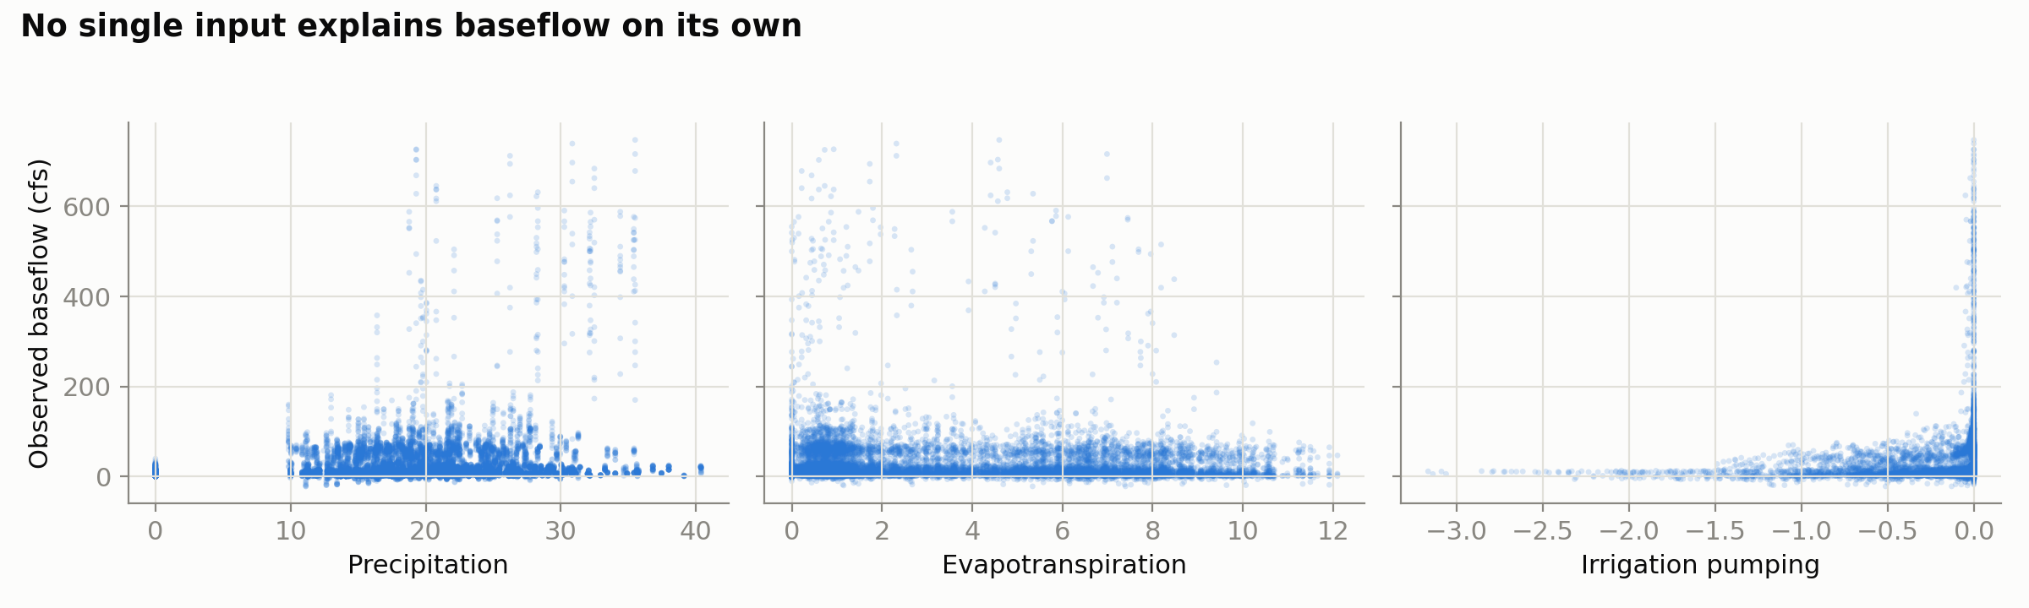
Figure 1. Observed baseflow against each predictor, all 42 segments pooled. No single variable separates the data cleanly.
Model (inputs) | Test R² | Test RMSE | What it tells us
A: date, evapotranspiration, precipitation, pumping | 0.12 | 54.6 cfs | Measured drivers alone predict poorly
B: model A plus station coordinates x, y | 0.13 | 54.3 cfs | Raw location barely helps
C: model A plus segment id (one hot encoded) | 0.82 | 25.0 cfs | Knowing the river is the key
D: model C with a pumping slope per pumped segment | 0.82 | 24.9 cfs | No meaningful gain over model C
Table 1. Model comparison on the 25 percent held out test set.
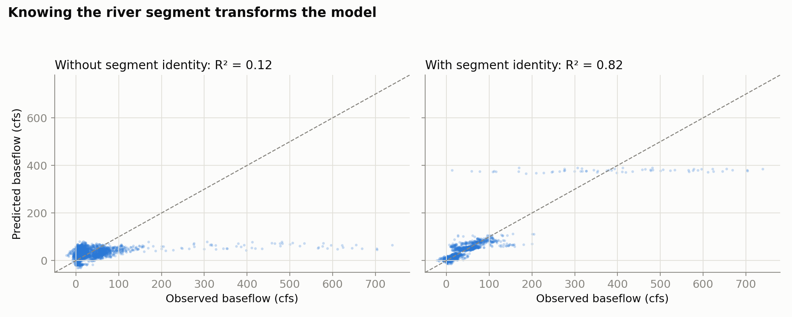
Figure 2. Predicted versus observed baseflow on the test set. Left: without segment identity. Right: with segment identity.
In the full model, every driver coefficient is statistically significant (p < 0.01) and hydrologically sensible: more precipitation predicts more baseflow (about 0.5 cfs per unit of precipitation), more evapotranspiration predicts less (about 0.9 cfs per unit), and the pumping coefficient means more pumping predicts less baseflow. Per segment regressions sharpen the picture: across the 41 segments with at least 30 months of data, the median R² is 0.38 and the best reaches 0.74 (Figure 3). Precipitation has a significant positive effect in 66 percent of those 41 segments, and among the 32 segments with any irrigation pumping, 69 percent show a significant association between more pumping and lower baseflow. The historical record tells the same story: across the ten segments with records spanning the early 1940s through 1999, average baseflow fell from about 14 cfs in the 1940s to about 8 cfs by the late 1990s, while pumping grew from essentially zero before 1950 to a sustained high level by the 1970s (Figure 4). For a water manager or compact regulator, the usefulness is concrete: a transparent regression can forecast a segment month to within about 25 cfs on average, quantify what a unit of rain or pumping is worth in streamflow, and flag which specific segments show significant pumping related decline, which is exactly where management attention and further measurement should go. The clearest limitation is the strong seasonal cycle visible in Figure 3, which a straight line model cannot capture and which accounts for much of the remaining error.
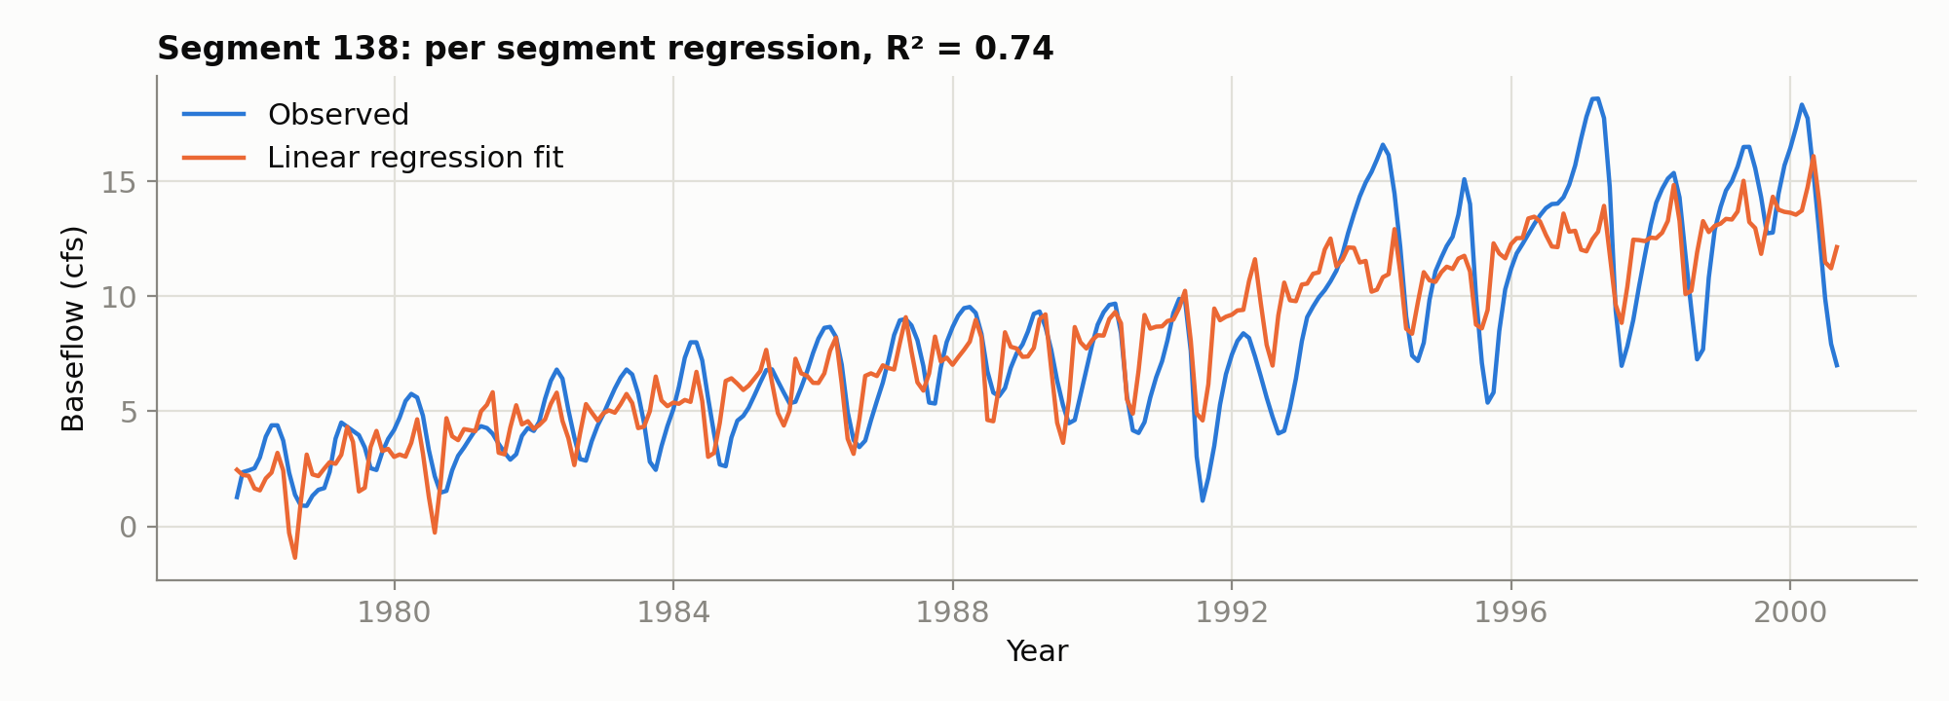
Figure 3. The best per segment model (segment 138) tracks 23 years of observed baseflow with R² of 0.74.
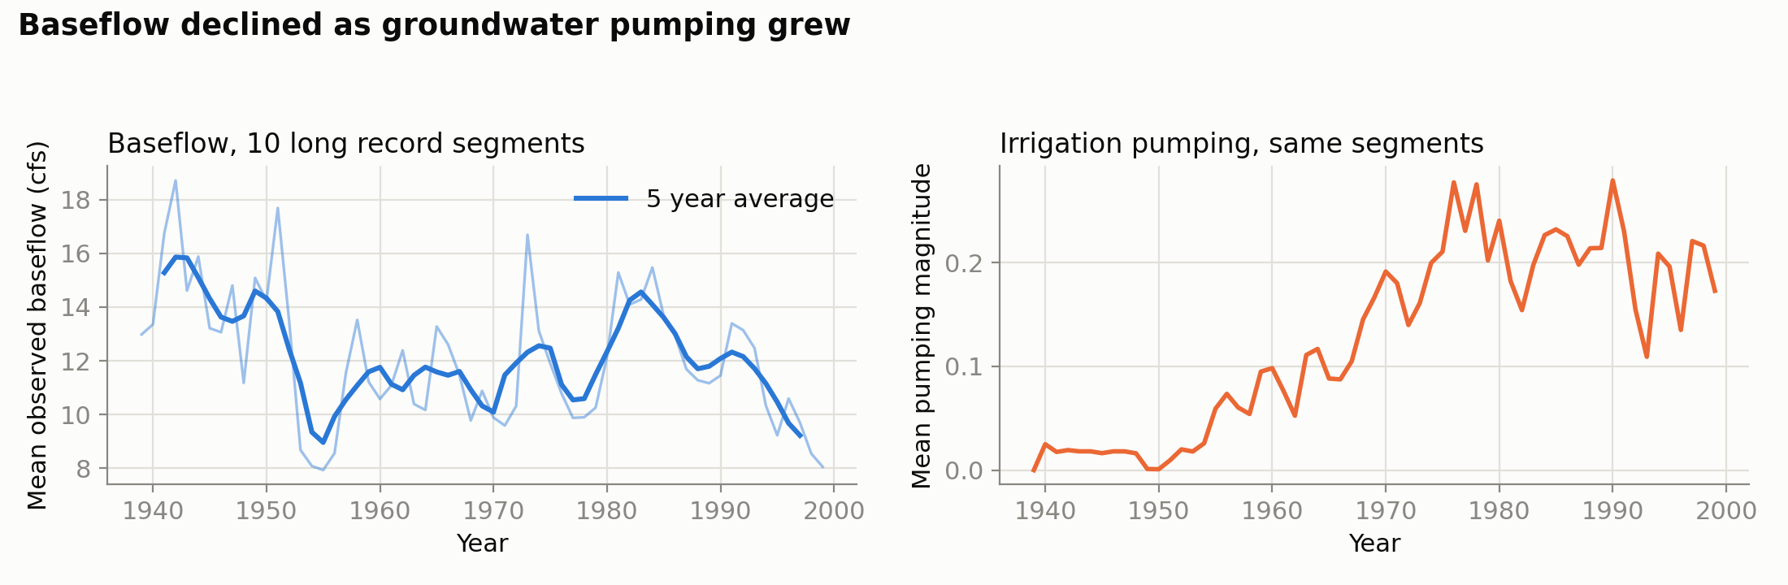
Figure 4. For the ten segments with records spanning the early 1940s through 1999, baseflow declined while irrigation pumping grew.

Technical
Data preparation. The raw Date column counts days since 01/01/0000; we subtracted 693963 to convert it to days since Jan 1, 1900 and derived a calendar date, year, and month from it. We verified there were no missing values, treated Segment_id as a categorical variable via one hot encoding (41 dummy variables with one segment dropped as the reference), and kept the pumping sign convention of the source data, where values are zero or negative and more negative means more extraction. About 1.5 percent of observed baseflow values are negative; these are physically meaningful months in which a reach loses water to the aquifer rather than gaining it, so we kept them. For the per segment regressions we required at least 30 monthly observations and dropped any predictor that was constant within a segment (pumping is identically zero for ten segments), which avoids rank deficient design matrices. For the time trend figure we discovered that the naive basin wide annual mean is misleading because the set of gaged segments changes over the decades and several very large segments appear only early in the record; we therefore restricted the trend analysis to the ten segments observed from the early 1940s through 1999, and excluded the year 2000 because the record ends in August 2000 and a partial year with no winter months biases the annual mean.
Analysis. Multiple linear regression suits this dataset because the target is continuous, the candidate drivers are a mix of continuous and categorical variables that OLS handles directly, and the stakeholder question is about direction, size, and significance of effects rather than pure predictive accuracy, which favors an interpretable model. We evaluated with a random 75/25 train/test split, scoring test R² and RMSE with scikit learn, and used statsmodels OLS on the full data to read coefficients and p values. Analysis process. We began with a pooled regression on the four measured drivers (test R² 0.121), added coordinates (0.130, a failed attempt since location as raw numbers is nearly useless), then added segment dummies (0.815, RMSE 25.0). We tried giving each pumped segment its own pumping slope in place of the shared pumping term, which changed the test score only in the third decimal (0.818 against 0.815), so we rejected that model. We then fit per segment regressions (median R² 0.383, quartiles 0.20 to 0.60) and summarized coefficient signs and significance across segments. Alternative approaches we considered and would recommend exploring are month dummies or harmonic terms for seasonality (the clear annual cycle in Figure 3 is the largest unmodeled signal), lagged precipitation to capture delayed groundwater recharge, a log transform of baseflow to handle the heavy right skew, and mixed effects models with random slopes per segment, which would formalize what our per segment fits approximate.

