**WEEK 2 – PL/SQL – 6428652**

**Exercise 1: Control Structures**

**Scenario 1:** The bank wants to apply a discount to loan interest rates for customers above 60 years old.

* + **Question:** Write a PL/SQL block that loops through all customers, checks their age, and if they are above 60, apply a 1% discount to their current loan interest rates.

**ANSWER:**

BEGIN

FOR cust IN (

SELECT c.customer_id, l.loan_id, l.interest_rate

FROM customers952 c

JOIN loans952 l ON c.customer_id = l.customer_id

WHERE c.age > 60

) LOOP

UPDATE loans952

SET interest_rate = interest_rate - 1

WHERE loan_id = cust.loan_id;

END LOOP;

COMMIT;

END;

**OUTPUT:**

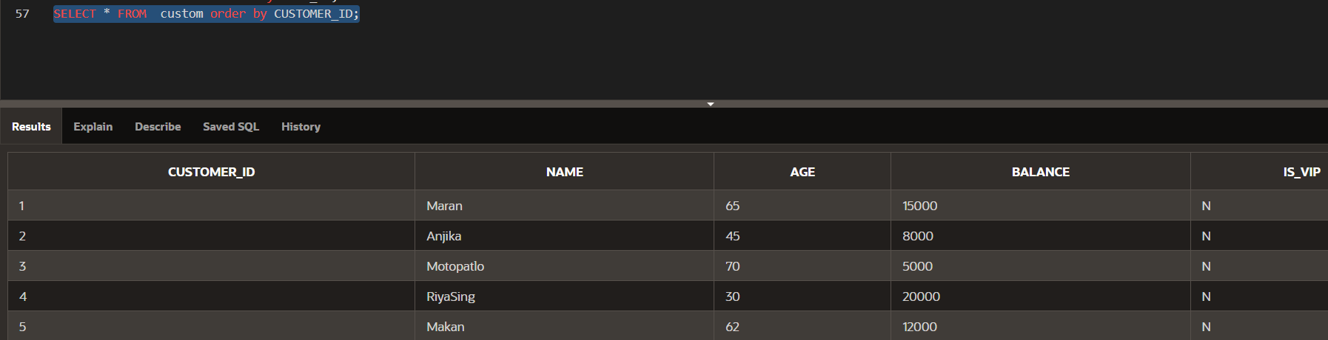

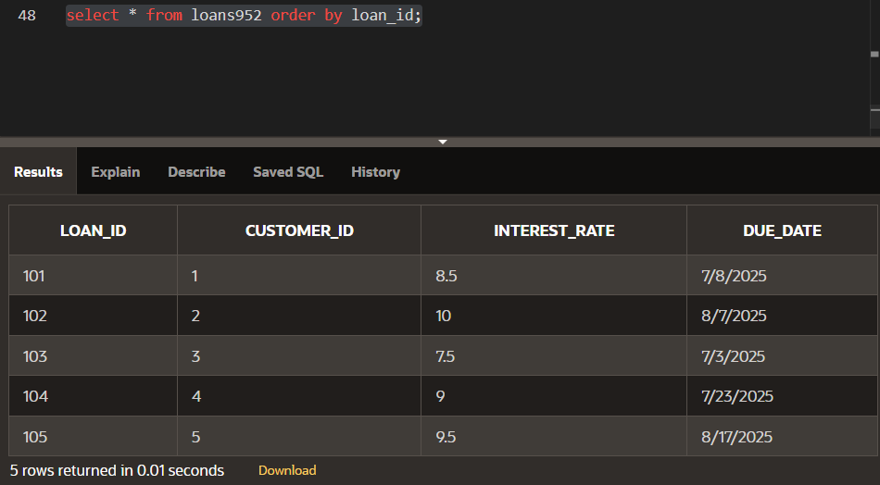

**Scenario 2:** A customer can be promoted to VIP status based on their balance.

* + **Question:** Write a PL/SQL block that iterates through all customers and sets a flag IsVIP to TRUE for those with a balance over $10,000.

BEGIN

FOR cust IN (

SELECT customer_id

FROM customers952

WHERE balance > 10000

) LOOP

UPDATE customers952

SET is_vip = 'Y'

WHERE customer_id = cust.customer_id;

END LOOP;

COMMIT;

END;

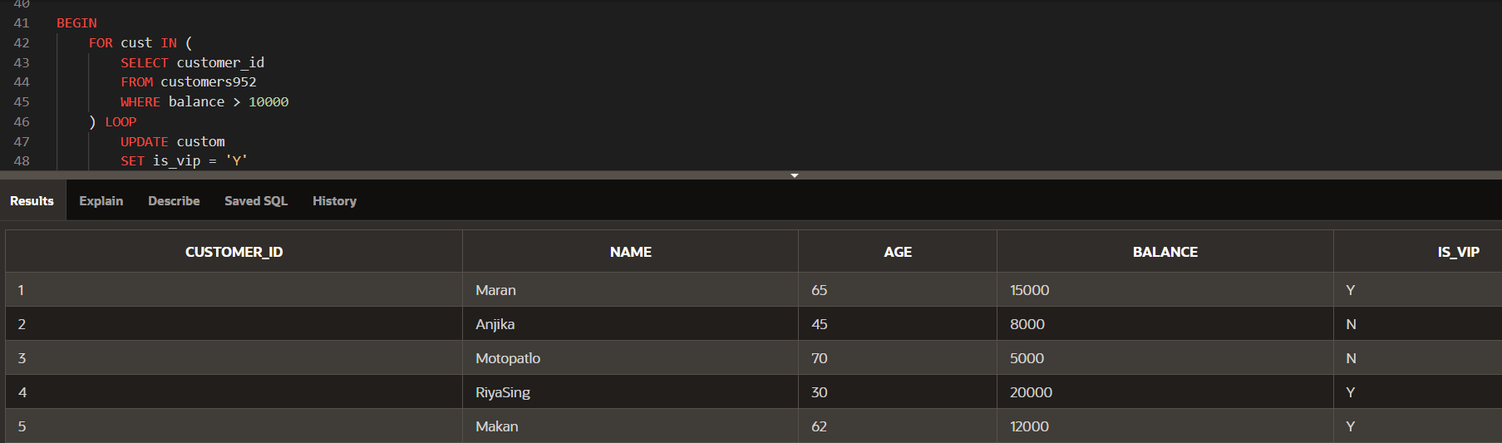

**Scenario 3:** The bank wants to send reminders to customers whose loans are due within the next 30 days.

* + **Question:** Write a PL/SQL block that fetches all loans due in the next 30 days and prints a reminder message for each customer.

**Answer:**

BEGIN

FOR loan_rec IN (

SELECT l.loan_id, c.name, l.due_date

FROM loans952 l

JOIN customers952 c ON l.customer_id = c.customer_id

WHERE l.due_date <= SYSDATE + 30

) LOOP

DBMS_OUTPUT.PUT_LINE('Reminder: Loan ID ' || loan_rec.loan_id ||

' for ' || loan_rec.name ||

' is due on ' || TO_CHAR(loan_rec.due_date, 'DD-Mon-YYYY'));

END LOOP;

END;

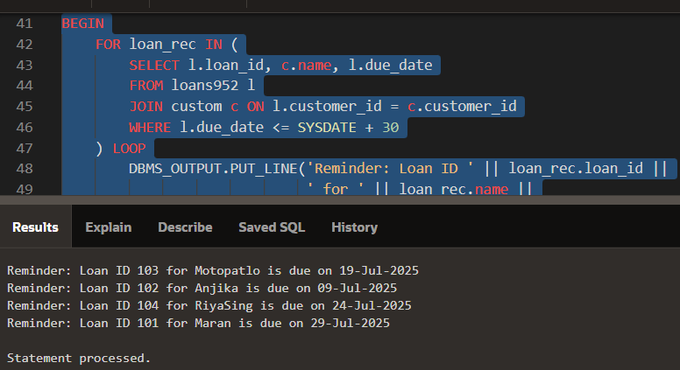

**Exercise 3: Stored Procedures**

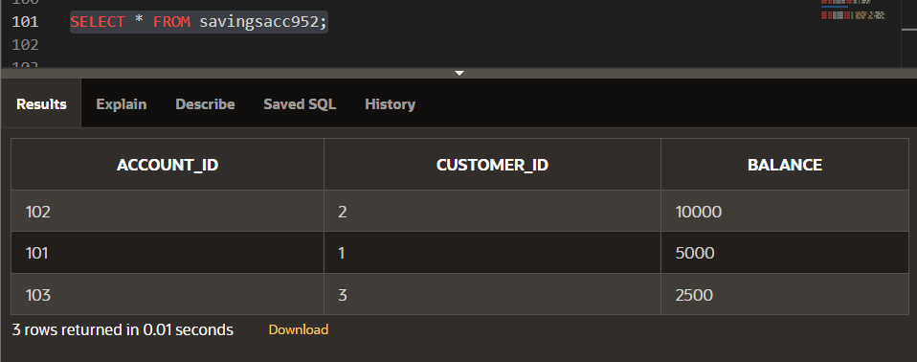

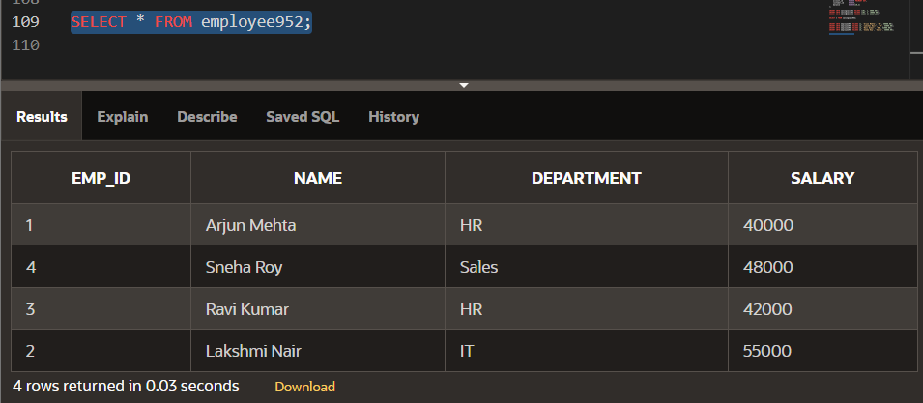

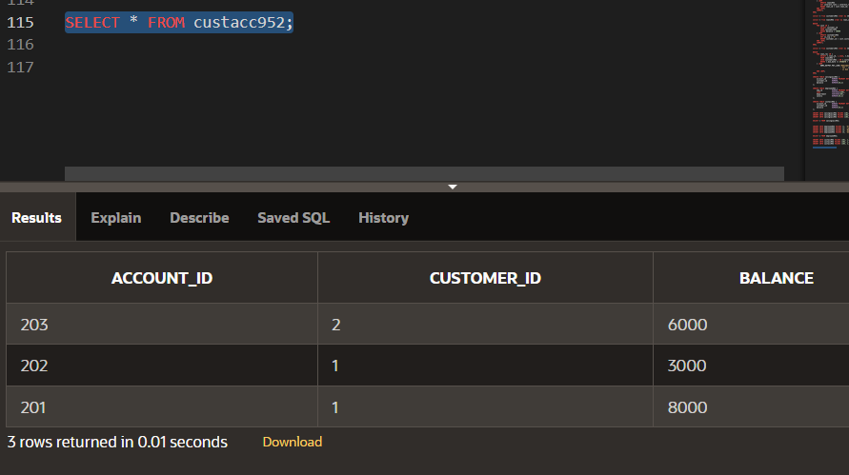

**Scenario 1:** The bank needs to process monthly interest for all savings accounts.

* + **Question:** Write a stored procedure **ProcessMonthlyInterest** that calculates and updates the balance of all savings accounts by applying an interest rate of 1% to the current balance.

CREATE OR REPLACE PROCEDURE ProcessMonthlyInterest952 AS

BEGIN

FOR acc IN (SELECT account_id, balance FROM savingsacc952) LOOP

UPDATE savingsacc952

SET balance = balance + (balance * 0.01)

WHERE account_id = acc.account_id;

END LOOP;

COMMIT;

END;

BEGIN

ProcessMonthlyInterest952;

END;

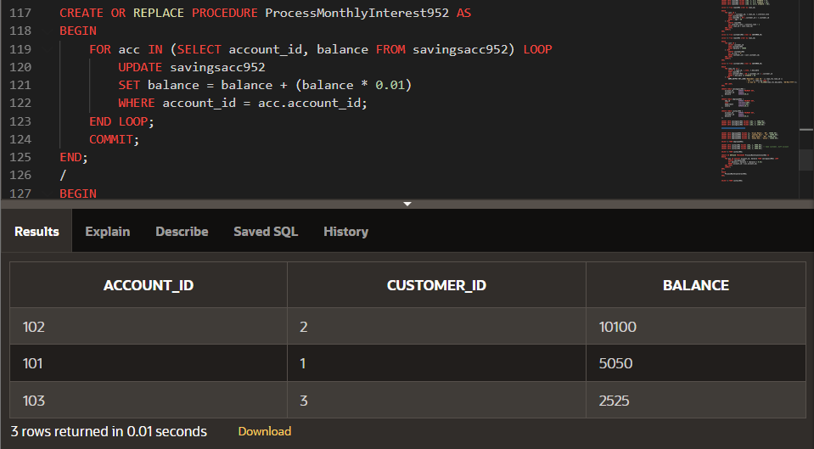

**Scenario 2:** The bank wants to implement a bonus scheme for employees based on their performance.

* + **Question:** Write a stored procedure **UpdateEmployeeBonus** that updates the salary of employees in a given department by adding a bonus percentage passed as a parameter.

CREATE OR REPLACE PROCEDURE UpdateEmployeeBonus952(

p_department IN VARCHAR2,

p_bonus_percent IN NUMBER

) AS

BEGIN

FOR emp IN (

SELECT emp_id, salary FROM employee952

WHERE department = p_department

) LOOP

UPDATE employee952

SET salary = salary + (salary * (p_bonus_percent / 100))

WHERE emp_id = emp.emp_id;

END LOOP;

COMMIT;

END;

BEGIN

UpdateEmployeeBonus952('HR', 10); -

END;

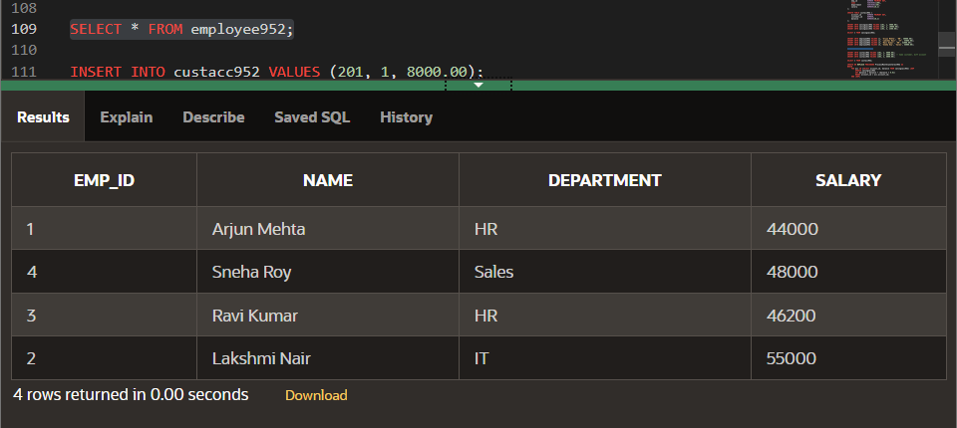

**Scenario 3:** Customers should be able to transfer funds between their accounts.

* + **Question:** Write a stored procedure **TransferFunds** that transfers a specified amount from one account to another, checking that the source account has sufficient balance before making the transfer.

CREATE OR REPLACE PROCEDURE TransferFunds952(

p_from_account_id IN NUMBER,

p_to_account_id IN NUMBER,

p_amount IN NUMBER

) AS

v_balance NUMBER;

BEGIN

SELECT balance INTO v_balance

FROM custacc952

WHERE account_id = p_from_account_id;

IF v_balance < p_amount THEN

RAISE_APPLICATION_ERROR(-20001, 'Insufficient funds in source account');

ELSE

UPDATE custacc952

SET balance = balance - p_amount

WHERE account_id = p_from_account_id;

UPDATE custacc952

SET balance = balance + p_amount

WHERE account_id = p_to_account_id;

COMMIT;

END IF;

END;

BEGIN

TransferFunds952(201, 202, 2000);

END;

