Borbon, Mark Gino G. December 2, 2019

2ECE- E

Experiment 9 Screenshots

Problem 1:

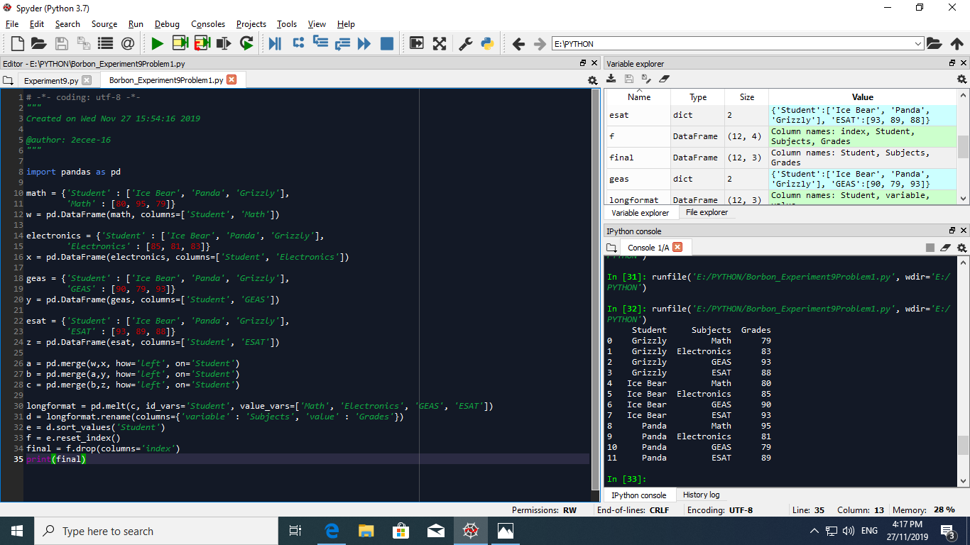

Problem 2:

