Borbon, Mark Gino G.

2ECE – E

Function 1: isWordGuessed

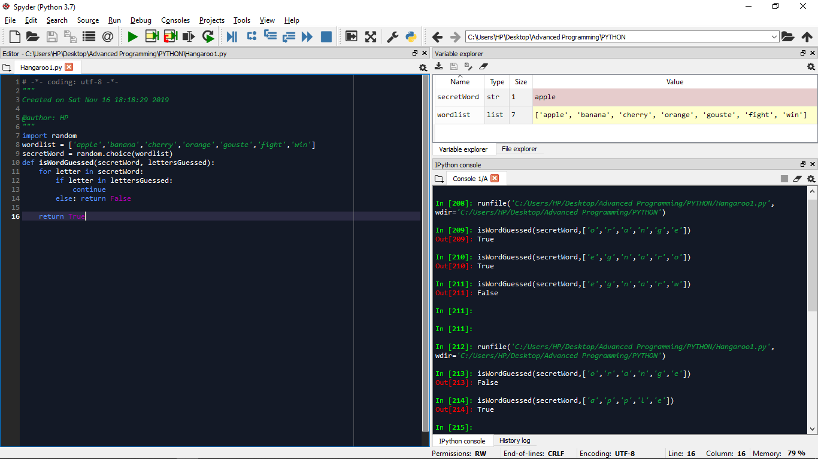

Function 2: getGuessedWord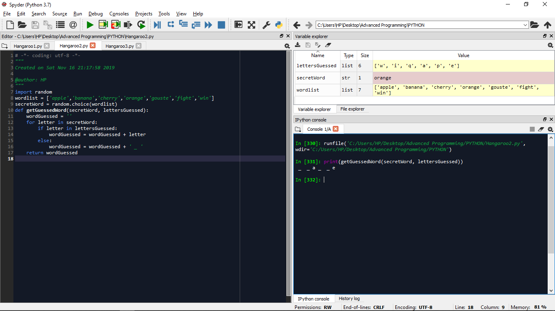

Function 3: getAvailableLetters

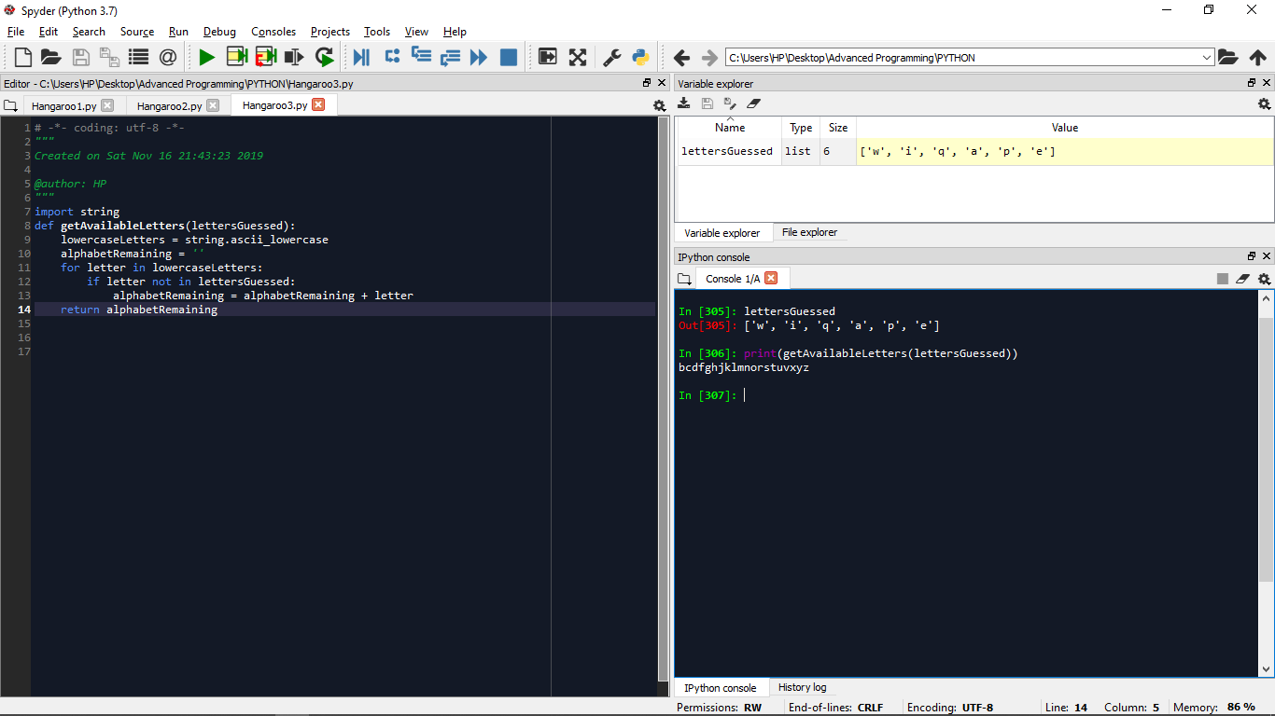

Function 4: Hangaroo (if user wins)

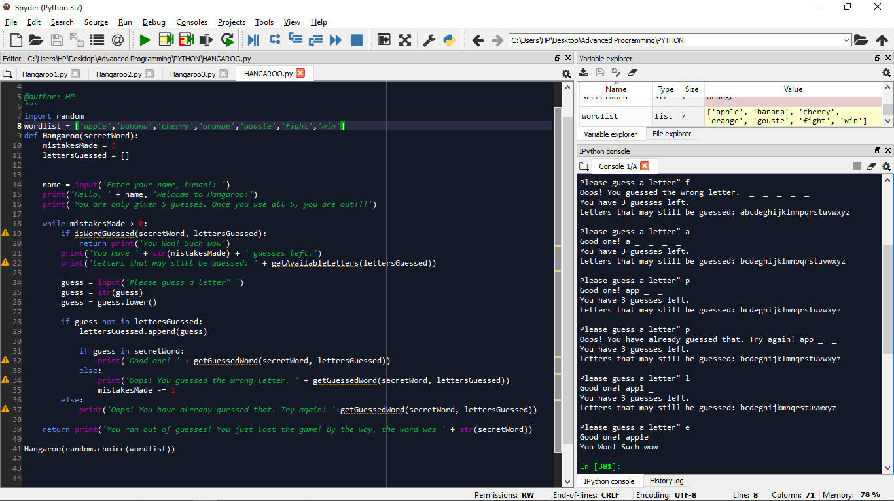

Function 4: Hangaroo (if user loses)

