Borbon, Mark Gino G. November 25, 2019

2ECE-E

Experiment 8 Screenshots

Problem 1:

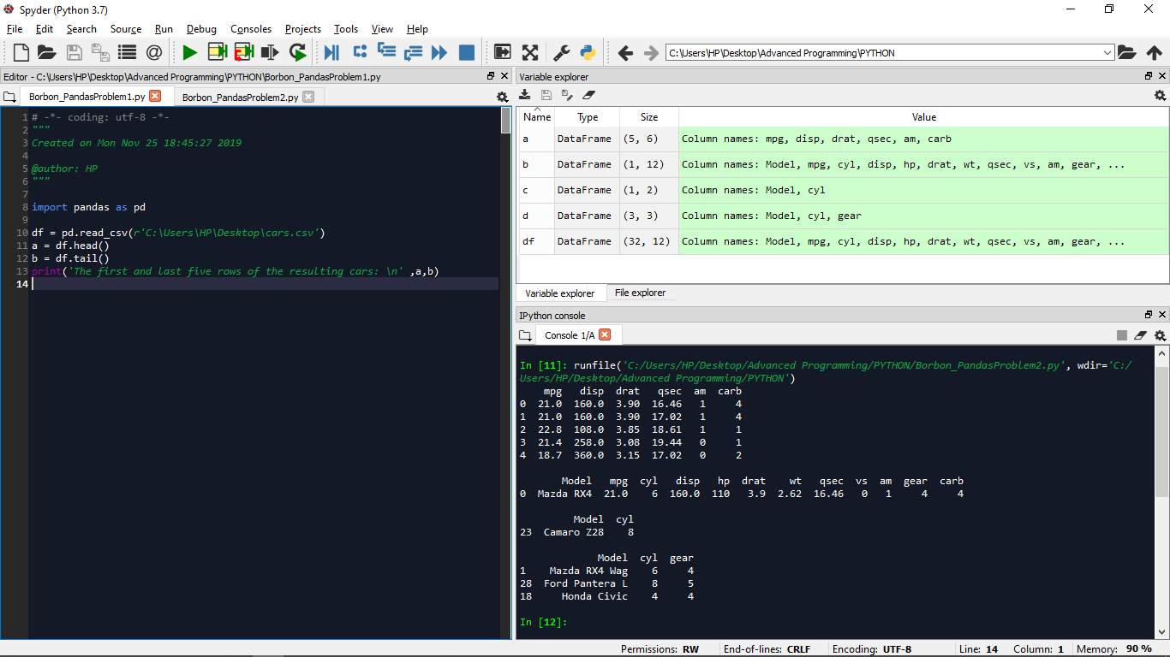

Problem 2:

