**Assignment 2: Report**

**18012619x MA Jing**

1. Environment: Windows 10, Google Chrome, Blender 2.79
2. How to run?
   1. In cmd window: python WebServer.py
   2. In Google Chrome: Enter URL <http://localhost:4422/>
   3. Operate as told by comp4422-asg-02.pdf
3. Algorithm Used to Rotate Light Source Position:
   1. Please refer to lecture 9-slide 68, slide 69
   2. Implementations: Line 350-385 med3d.js, Line 4327-4345 gl-matrix.js
   3. There are two versions of implementations in the code:
      1. the old version (the algorithm I design at first, but found not optimal later on, so I comment it out)
      2. the new version use vec3.rotate() function from gl-matrix, and the algorithm is show as Fig1 and Fig2

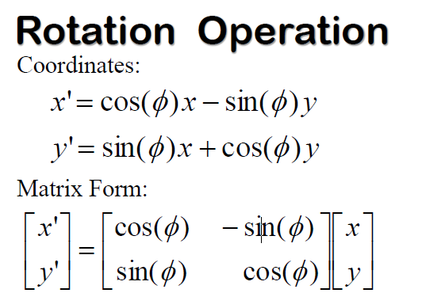

Fig 1

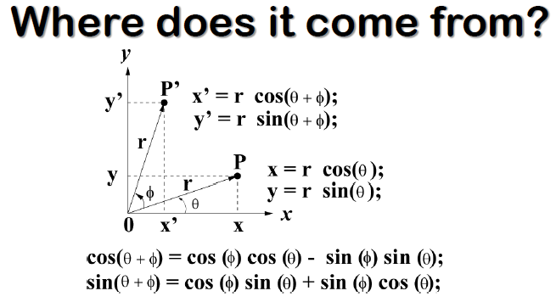

Fig 2

1. Algorithm Used to Rotate Light Source and Object Together
   1. The main idea is that when we rotate an object, we actually rotate every point in that object, thus, we could treat “light source” as a point, and rotate the light source and object together
   2. Implementations: Line 314-Line 340 med3d.js