《面向对象程序设计与训练》实验报告

信息学院 学院 计算机类 专业 2021 级

实验时间 2022 年 4 月 4 日

姓名 陈俊宏 学号 20211060245 分工

实验名称：分支与循环语句

实验成绩：

1. 实验目的

本实验的目的是让学生使用类来封装对象的属性和功能，让学生掌握对象的组合以及参数传递，让学生掌握类变量与实例变量，以及类方法与实例方法的区别，让学生掌握使用 package 和 import 语句。

二、实验仪器设备及软件

三、实验方案

1. 实验步骤

Test1:

public class test1 {

public static void main(String[] args) {

Vehicle car1, car2;

car1 = new Vehicle();

car2 = new Vehicle();

car1.setPower(128);

car2.setPower(76);

System.out.println("car1的功率是：" + car1.getPower());

System.out.println("car2的功率是：" + car2.getPower());

car1.speedUp(80);

car2.speedUp(80);

System.out.println("car1目前的速度是：" + car1.getSpeed());

System.out.println("car2目前的速度是：" + car2.getSpeed());

car1.speedDown(10);

car2.speedDown(20);

System.out.println("car1目前的速度是：" + car1.getSpeed());

System.out.println("car2目前的速度是：" + car2.getSpeed());

}

}

class Vehicle {

double speed;

int power;

void speedUp(int s) {

speed = speed + s;

}

void speedDown(int d) {

speed = speed - d;

}

void setPower(int p) {

power = p;

}

int getPower() {

return power;

}

double getSpeed() {

return speed;

}

}

==========================================================

Test2:

**MainClass.java**

public class MainClass {

public static void main(String[] args) {

TV haier = new TV();

haier.setTelevesion(1);

Family zhangsanFamily = new Family();

zhangsanFamily.setHomeTV(haier);

System.out.println("当前电视所在的频道数为" + zhangsanFamily.getHomeTvNumber());

System.out.println("当前收看的频道名称为：" + zhangsanFamily.getHomeTV());

haier.setTelevesion(2);

System.out.println("当前电视所在的频道数为" + zhangsanFamily.getHomeTvNumber());

System.out.println("当前收看的频道名称为：" + zhangsanFamily.getHomeTV());

}

}

**TV.java**

public class TV {

String televesion;

int tvnumber;

void setTelevesion(int number) {

switch (number) {

case 1:

televesion = "综合频道";

tvnumber = 1;

break;

case 2:

televesion = "经济频道";

tvnumber = 2;

break;

case 3:

televesion = "文艺频道";

tvnumber = 3;

break;

case 4:

televesion = "国际频道";

tvnumber = 4;

break;

case 5:

televesion = "体育频道";

tvnumber = 5;

break;

}

}

String getTV(String televesion) {

return televesion;

}

int getTvNumber() {

return tvnumber;

}

}

**Family.java**

public class Family {

TV homeTV;

void setHomeTV(TV tv) {

homeTV = tv;

}

String getHomeTV() {

return homeTV.televesion;

}

int getHomeTvNumber() {

return homeTV.tvnumber;

}

}

=============================================================

Test3:

import java.util.Scanner;

public class test3 {

public static void main(String[] args) {

Village v1 = new Village();

Village v2 = new Village();

Scanner s = new Scanner(System.in);

System.out.println("请输入改变的值：");

int a = s.nextInt();

v1.Drink(a);

System.out.println("村庄2查看后还剩：" + v2.SeeWater(a) + "升水");

}

}

class Village {

static int waterAmount = 1000;

public void Drink(int a) {

System.out.println("村庄1喝了：" + a + "升水");

}

public int SeeWater(int change) {

return waterAmount = waterAmount - change;

}

}

=============================================================

Test4:

**SunRise.java**

import tom.jiafei.SquareEquation;

public class SunRise {

public static void main(String args[]) {

SquareEquation gen = new SquareEquation();

gen.Getgen();

}

}

**SquareEquation.java**

package tom.jiafei;

import java.util.Scanner;

public class SquareEquation {

Scanner sc = new Scanner(System.in);

double a = sc.nextDouble();

double b = sc.nextDouble();

double c = sc.nextDouble();

double x1, x2, result;

public Double[] Getgen() {

double t = (b * b) - (4 * a * c);

if (a == 0 && b == 0 && c == 0)

System.out.println("有无穷个解");

else if (a == 0 && b == 0 && c != 0)

System.out.println("方程没有解");

else if (a == 0 && b != 0 && c != 0) {

x1 = -c / b;

System.out.printf("方程有一个实数解：\n");

System.out.printf("x1 = %.4f", x1);

} else if (t > 0) {

x1 = (-b + Math.sqrt(t)) / (2 * a);

x2 = (-b - Math.sqrt(t)) / (2 * a);

System.out.printf(" 方程有实数解：\n");

System.out.printf("x1 = %.4f\n", x1);

System.out.printf("x2 = %.4f\n", x2);

} else if (t == 0) {

result = -b / (2 * a);

System.out.printf("方程有实数解：\n");

System.out.printf("x1 = %.4f\n", result);

System.out.printf("x2 = %.4f\n", result);

} else if (t < 0) {

double realPart = -b / (2 * a);

double imgPart = Math.sqrt(4 * a * c - b * b) / (2 * a);

// System.out.printf("x1 =" + realPart + "+" + imgPart + "i, x2 = " + realPart +

// "-" + imgPart + "i");

System.out.printf(" 方程有复数解：\n ");

System.out.printf("x1 = " + "%.4f", realPart);

System.out.printf(" + " + "%.4f", imgPart);

System.out.printf("i\n");

System.out.printf(" x2 = " + "%.4f", realPart);

System.out.printf(" - " + "%.4f", imgPart);

System.out.printf("i\n");

}

Double[] num = { x1, x2 };

return num;

}

}

1. 实验结果及分析

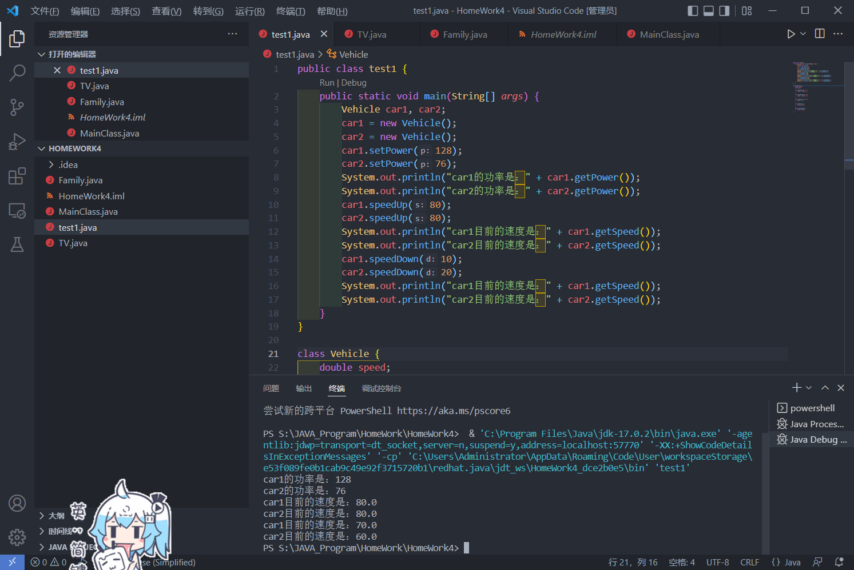

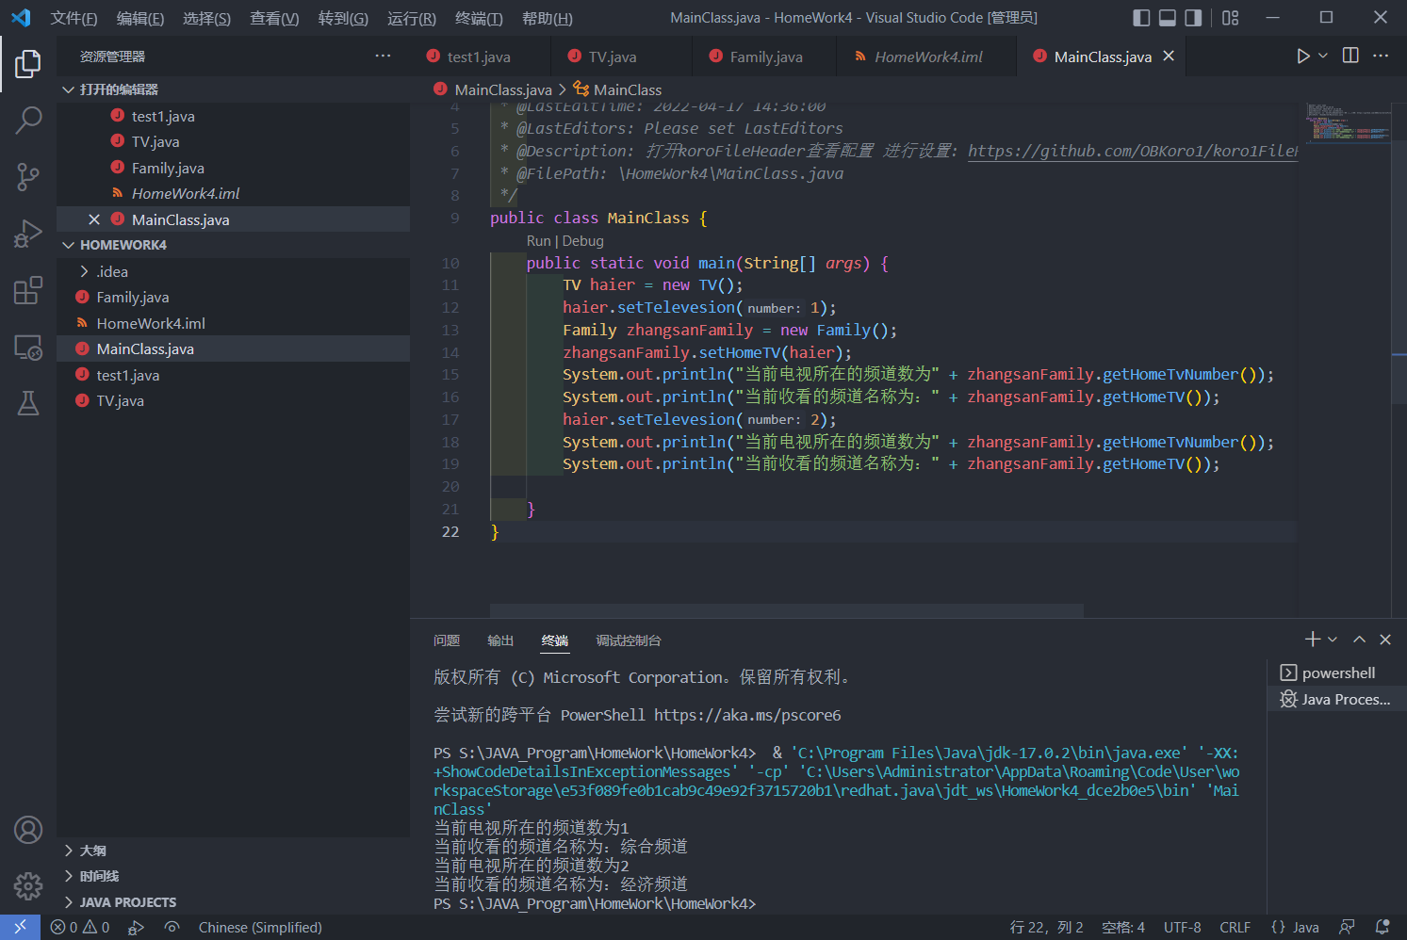

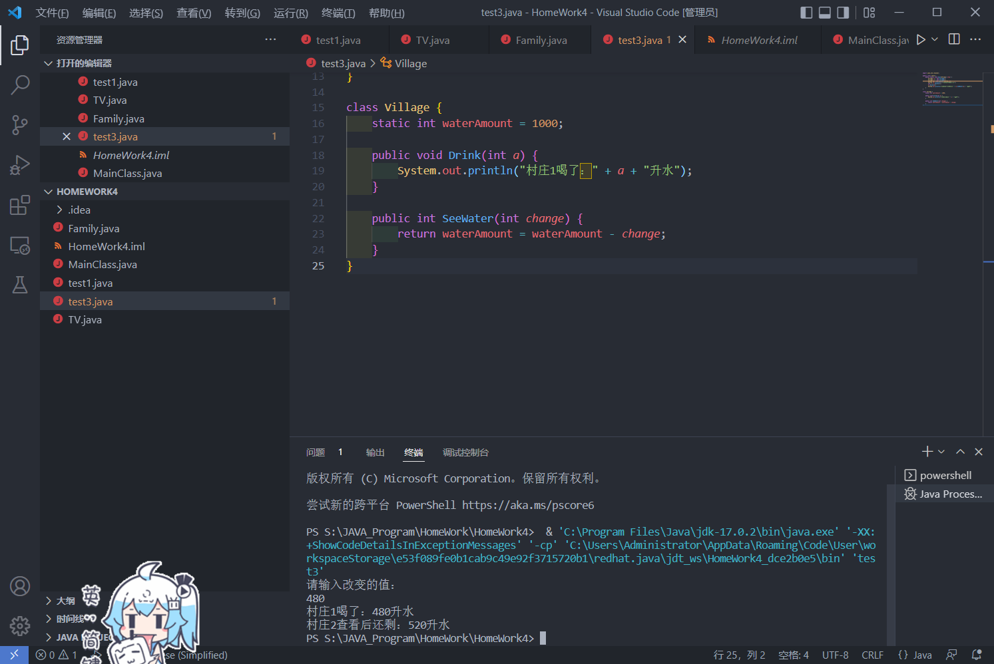

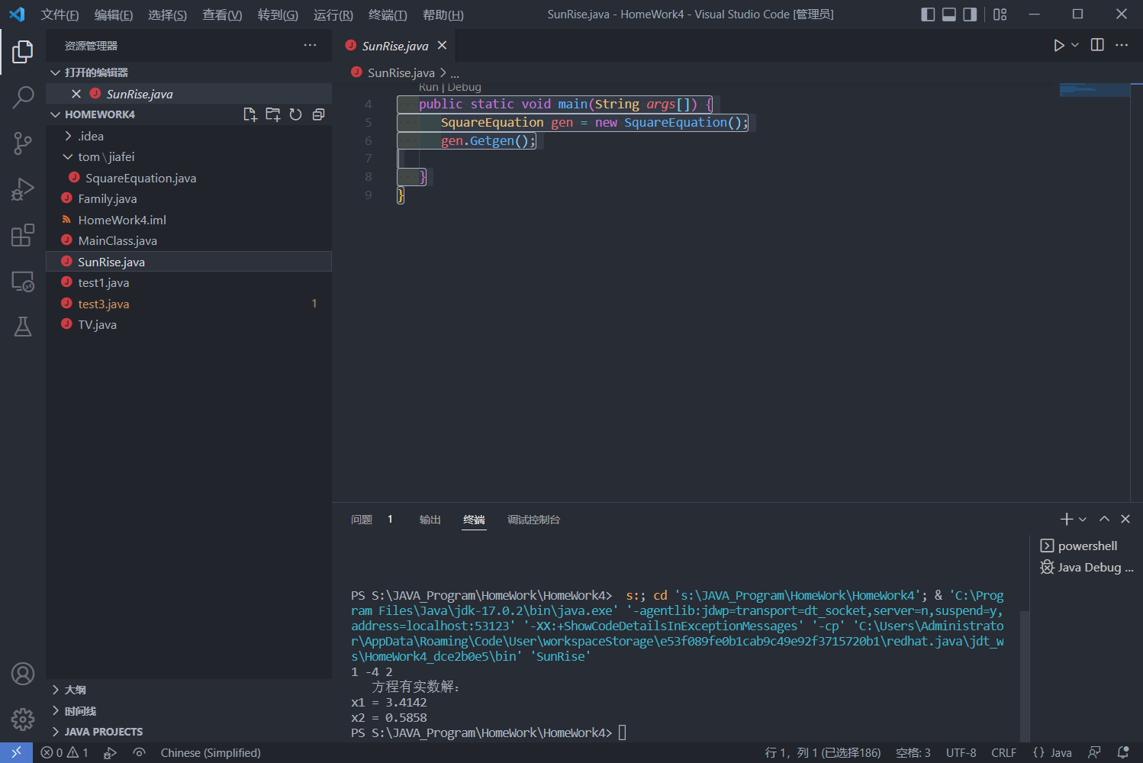

六、实验总结及体会