《面向对象程序设计与训练》实验报告

信息学院 学院 计算机类 专业 2021 级

实验时间 2022 年 4 月 11 日

姓名 陈俊宏 学号 20211060245 分工

实验名称：子类与继承

实验成绩：

1. 实验目的

本实验的目的是让学生巩固下列知识点：子类的继承性、子类对象的创建过程、

成员变量的继承与隐藏、方法的继承与重写，让学生掌握重写的目的以及怎样使用 super 关键字，让学生掌握上转型对象的使用，在讲述继承与多态时，我们通过子类对象的上转型体现了继承的多态性，即把子类创建的对象的引用放到一个父类的对象中时，得到该对象的一个上转型对象，那么这个上转型对象在调用方法时就可能具有多种形态，不同对象的上转型对象调用同一方法可能产生不同的行为。

二、实验仪器设备及软件

三、实验方案

1. 实验步骤

Test1:

class People {

protected double height;

protected double weight;

public void speakHello() {

System.out.printf("people say hello" + "\n");

}

public void averageHeight() {

System.out.printf("普通人平均身高:" + this.height + "\n");

}

public void averageWeight() {

System.out.printf("普通人平均体重:" + this.weight + "\n");

}

}

class ChinaPeople extends People {

public void chinaGongfu() {

System.out.printf("chinaGongfu yyds！" + "\n");

}

public void speakHello() {

System.out.printf("chinese people say ‘你好’." + "\n");

}

public void averageHeight() {

System.out.printf("中国人平均身高：" + this.height + "\n");

}

public void averageWeight() {

System.out.printf("中国人平均体重:" + this.weight + "\n");

}

}

class AmericanPeople extends People {

public void americanBoxing() {

System.out.printf("American Boxing" + "\n");

}

public void speakHello() {

System.out.printf("American people say 'hello'." + "\n");

}

public void averageHeight() {

System.out.printf("美国人平均身高:" + this.height + "\n");

}

public void averageWeight() {

System.out.printf("美国人平均体重:" + this.weight + "\n");

}

}

class BeijingPeople extends ChinaPeople {

public void beijingOpera() {

System.out.printf("Beijing Opera" + "\n");

}

public void speakHello() {

System.out.printf("北京人打招呼说：‘吃了吗您呐’" + "\n");

}

public void averageHeight() {

System.out.printf("北京人平均身高：" + this.height + "\n");

}

public void averageWeight() {

System.out.printf("北京人平均体重:" + this.weight + "\n");

}

}

public class test1 {

public static void main(String args[]) {

People people1 = new People();

people1.height = 170;

people1.weight = 60;

people1.speakHello();

people1.averageHeight();

people1.averageWeight();

ChinaPeople chinapeople1 = new ChinaPeople();

chinapeople1.height = 165;

chinapeople1.weight = 55;

chinapeople1.speakHello();

chinapeople1.chinaGongfu();

chinapeople1.averageHeight();

chinapeople1.averageWeight();

BeijingPeople beijingpeople1 = new BeijingPeople();

beijingpeople1.height = 165;

beijingpeople1.weight = 55;

beijingpeople1.speakHello();

beijingpeople1.beijingOpera();

beijingpeople1.averageHeight();

beijingpeople1.averageWeight();

AmericanPeople americanPeople1 = new AmericanPeople();

americanPeople1.height = 165;

americanPeople1.weight = 55;

americanPeople1.speakHello();

americanPeople1.americanBoxing();

americanPeople1.averageHeight();

americanPeople1.averageWeight();

}

}

=====================================================================

Test2:

**Bank.java**

package Bank;

public class Bank {

int savedMoney;

int year;

double interest;

double computerInterest(){

this.interest =this.year*0.035*this.savedMoney;

return interest;

}

}

**BankOfQingdao.java**

package Bank;

import java.lang.Math;

public class BankOfQingdao extends Bank {

double year;

public double computerInterest() {

super.year = (int) Math.floor(this.year);

double r = this.year - (int) Math.floor(this.year);

int day = (int) (r * 1000);//

double yearInterest = super.computerInterest();

double dayInterest = day * 0.00015 * savedMoney;

interest = yearInterest + dayInterest;

System.out.printf("%d元存在青岛银行%d年零%d天的利息：%f元\n", savedMoney, super.year, day, interest);

return interest;

}

}

**CommercialBank.java**

package Bank;

public class CommercialBank extends Bank {

double year;

public double computerInterest() {

super.year = (int) Math.floor(this.year);

double r = this.year - (int) Math.floor(this.year);

int day = (int) (r * 1000);//

double yearInterest = super.computerInterest();

double dayInterest = day * 0.00012 * savedMoney;

interest = yearInterest + dayInterest;

System.out.printf("%d元存在商业银行%d年零%d天的利息：%f元\n", savedMoney, super.year, day, interest);

return interest;

}

}

**ConstructionBank.java**

package Bank;

import java.lang.Math;

public class ConstructionBank extends Bank {

double year;

public double computerInterest() {

super.year = (int) Math.floor(this.year);

double r = this.year - (int) Math.floor(this.year);

int day = (int) (r * 1000);//

double yearInterest = super.computerInterest();

double dayInterest = day * 0.0001 * savedMoney;

interest = yearInterest + dayInterest;

System.out.printf("%d元存在建设银行%d年零%d天的利息：%f元\n", savedMoney, super.year, day, interest);

return interest;

}

}

**Test2.java**

package Bank;

public class Test2 {

public static void main(String args[]) {

ConstructionBank bank1 = new ConstructionBank();

bank1.year = 5.216;

bank1.savedMoney = 50000;

bank1.computerInterest();

BankOfQingdao bank2 = new BankOfQingdao();

bank2.year = 5.216;

bank2.savedMoney = 50000;

bank2.computerInterest();

CommercialBank bank3 = new CommercialBank();

bank3.year = 8.236;

bank3.savedMoney = 80000;

bank3.computerInterest();

}

}

====================================================================

Test3:

class Company {

Employee[] em;

Company(Employee[] em) {

this.em = em;

}

public static void main(String[] args) {

Employee[] em = new Employee[3];

em[0] = new YearWorker(1, 12000.0);

em[1] = new MonthWorker(11, 8000.0);

em[2] = new WeekWorker(40, 1200.0);

Company com = new Company(em);

double sum;

sum = em[0].earnings() + em[1].earnings() + em[2].earnings();

System.out.println("总工资为:" + sum);

}

}

abstract class Employee {

abstract double earnings();

}

class MonthWorker extends Employee {

int month;

double monthSalary;

MonthWorker(int m, double s) {

month = m;

monthSalary = s;

}

double earnings() {

return month * monthSalary;

}

}

class WeekWorker extends Employee {

int week;

double weekSalary;

WeekWorker(int w, double s) {

week = w;

weekSalary = s;

}

double earnings() {

return week * weekSalary;

}

}

class YearWorker extends Employee {

int year;

double yearSalary;

YearWorker(int y, double s) {

year = y;

yearSalary = s;

}

double earnings() {

return year * yearSalary;

}

}

1. 实验结果及分析

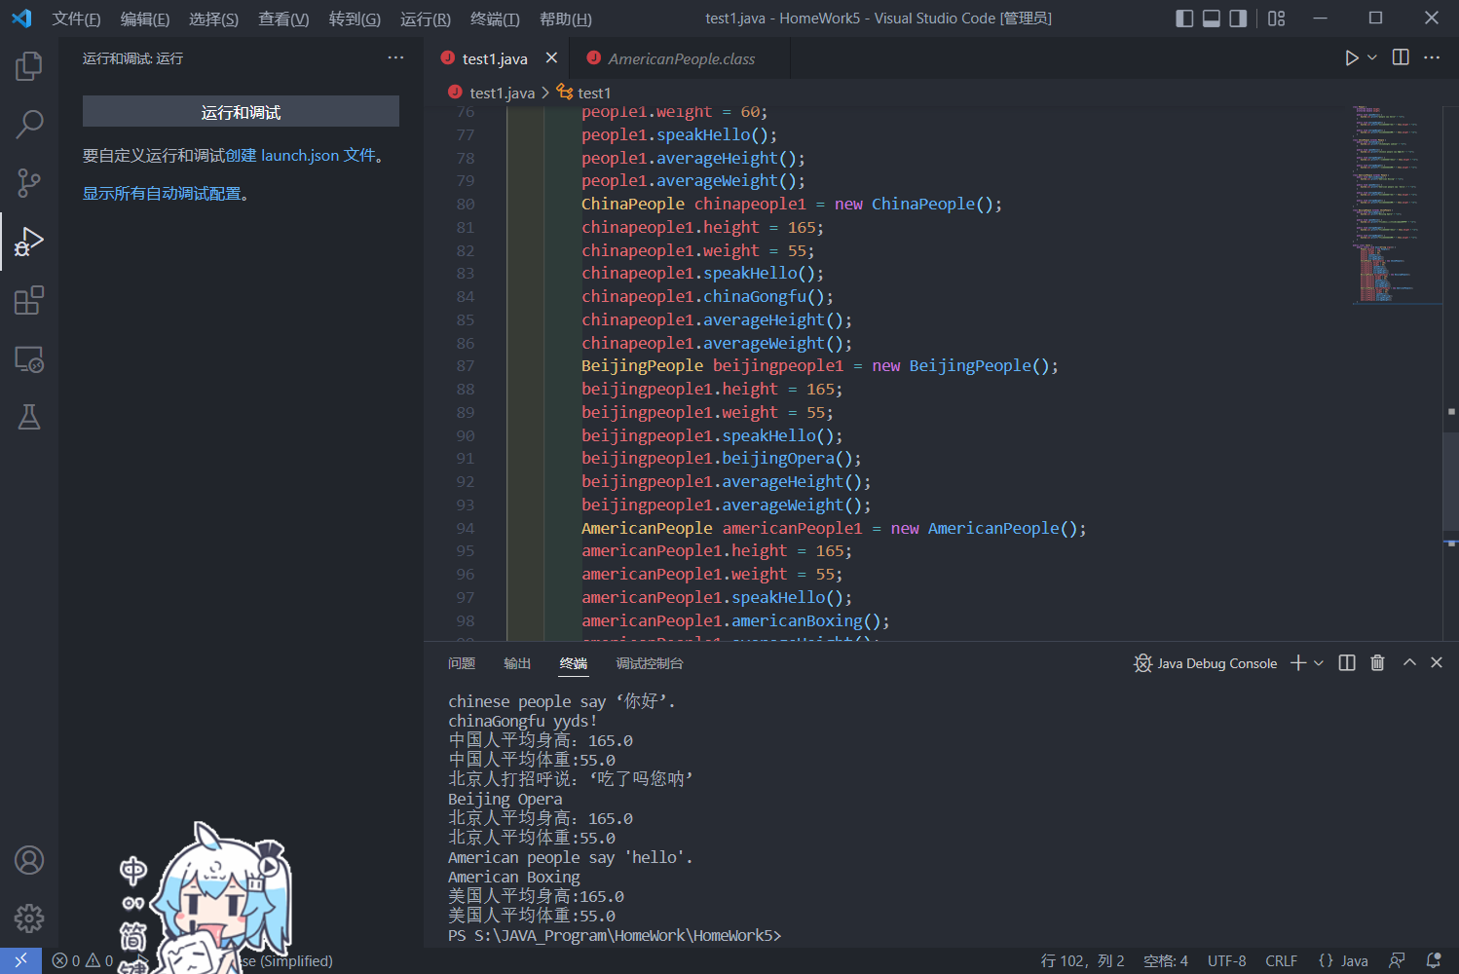

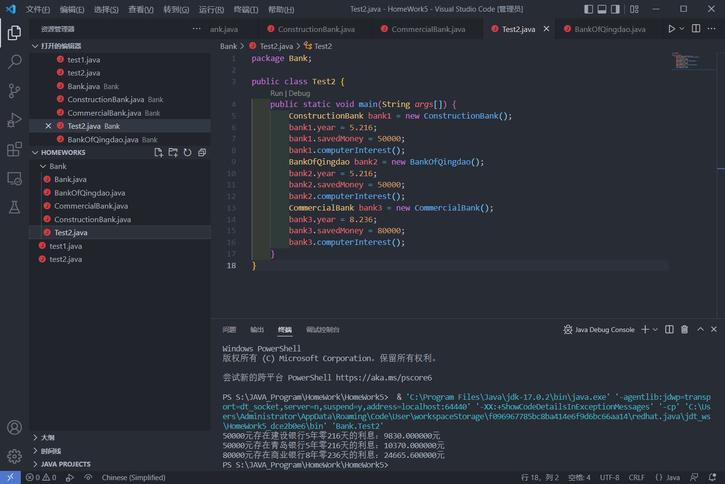

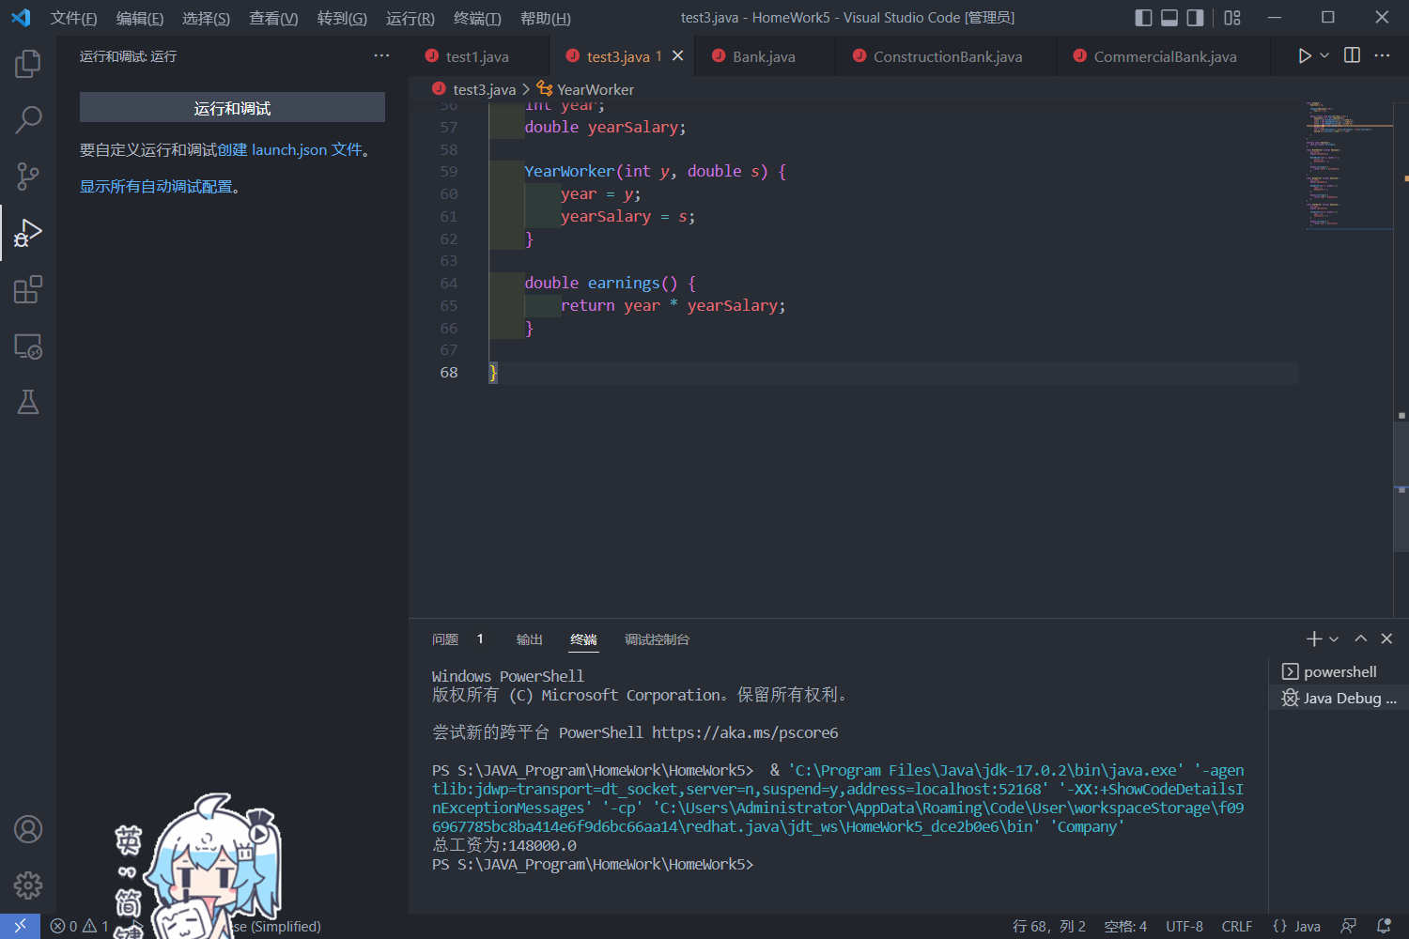

六、实验总结及体会