《面向对象程序设计与训练》实验报告

信息学院 学院 计算机类 专业 2021 级

实验时间 2022 年 5 月 16 日

姓名 陈俊宏 学号 20211060245 分工

实验名称：内部类与异常类

实验成绩：

1. 实验目的

让学生掌握内部类的用法，掌握使用 try-catch 语句。

二、实验仪器设备及软件

三、实验方案

1. 实验步骤

**Test1:**

class MobileShop {

InnerPurchaseMoney purchaseMoney1;

InnerPurchaseMoney purchaseMoney2;

private int mobileAmount;

MobileShop(){

purchaseMoney1=new InnerPurchaseMoney(20000);

purchaseMoney2=new InnerPurchaseMoney(20000);

}

void setMobileAmount(int m) {

mobileAmount = m;

}

int getMobileAmount() {

return mobileAmount;

}

class InnerPurchaseMoney {

int moneyValue;

InnerPurchaseMoney(int m) {

moneyValue = m;

}

void buyMobile() {

if(moneyValue>=20000) {

mobileAmount = mobileAmount-6;

System.out.println("用价值"+moneyValue+"的内部购物卷买了6部手机");

}else if(moneyValue<20000&&moneyValue>=10000) {

mobileAmount = mobileAmount-3;

System.out.println("用价值"+moneyValue+"的内部购物卷买了3部手机");

}

}

}

}

public class Test1

{

public static void main(String args[]) {

MobileShop shop = new MobileShop();

shop.setMobileAmount(30);

System.out.println("手机专卖店目前有"+shop.getMobileAmount()+"部手机");

shop.purchaseMoney1.buyMobile();

shop.purchaseMoney2.buyMobile();

System.out.println("手机专卖店目前有"+shop.getMobileAmount()+"部手机");

}

}

**Test2:**

**Machine.java**

public class Machine {

public void checkBag(Goods goods) throws DangerException {

if (goods.isDanger()) {

DangerException danger = new DangerException();

throw danger;

} else {

System.out.print(goods.getName() + "不是危险品! ");

}

}

}

**Goods.java**

public class Goods {

boolean isDanger;

String name;

public void setIsDanger(boolean boo) {

isDanger = boo;

}

public boolean isDanger() {

return isDanger;

}

public void setName(String s) {

name = s;

}

public String getName() {

return name;

}

}

**DangerException.java**

public class DangerException extends Exception {

public String toShow() {

return "属于危险品";

}

}

**Check.java**

public class Check {

public static void main(String args[]) {

Machine machine = new Machine();

String name[] = { "苹果", "炸药", "西服", "硫酸", "手表", "硫磺" };

Goods[] goods = new Goods[name.length];

for (int i = 0; i < name.length; i++) {

goods[i] = new Goods();

if (i % 2 == 0) {

goods[i].setIsDanger(false);

goods[i].setName(name[i]);

} else {

goods[i].setIsDanger(true);

goods[i].setName(name[i]);

}

}

for (int i = 0; i < goods.length; i++) {

try {

machine.checkBag(goods[i]);

System.out.println(goods[i].getName() + "检查通过");

} catch (DangerException e) {

e.toShow();

System.out.println(goods[i].getName() + "被禁止!");

}

}

}

}

1. 实验结果及分析

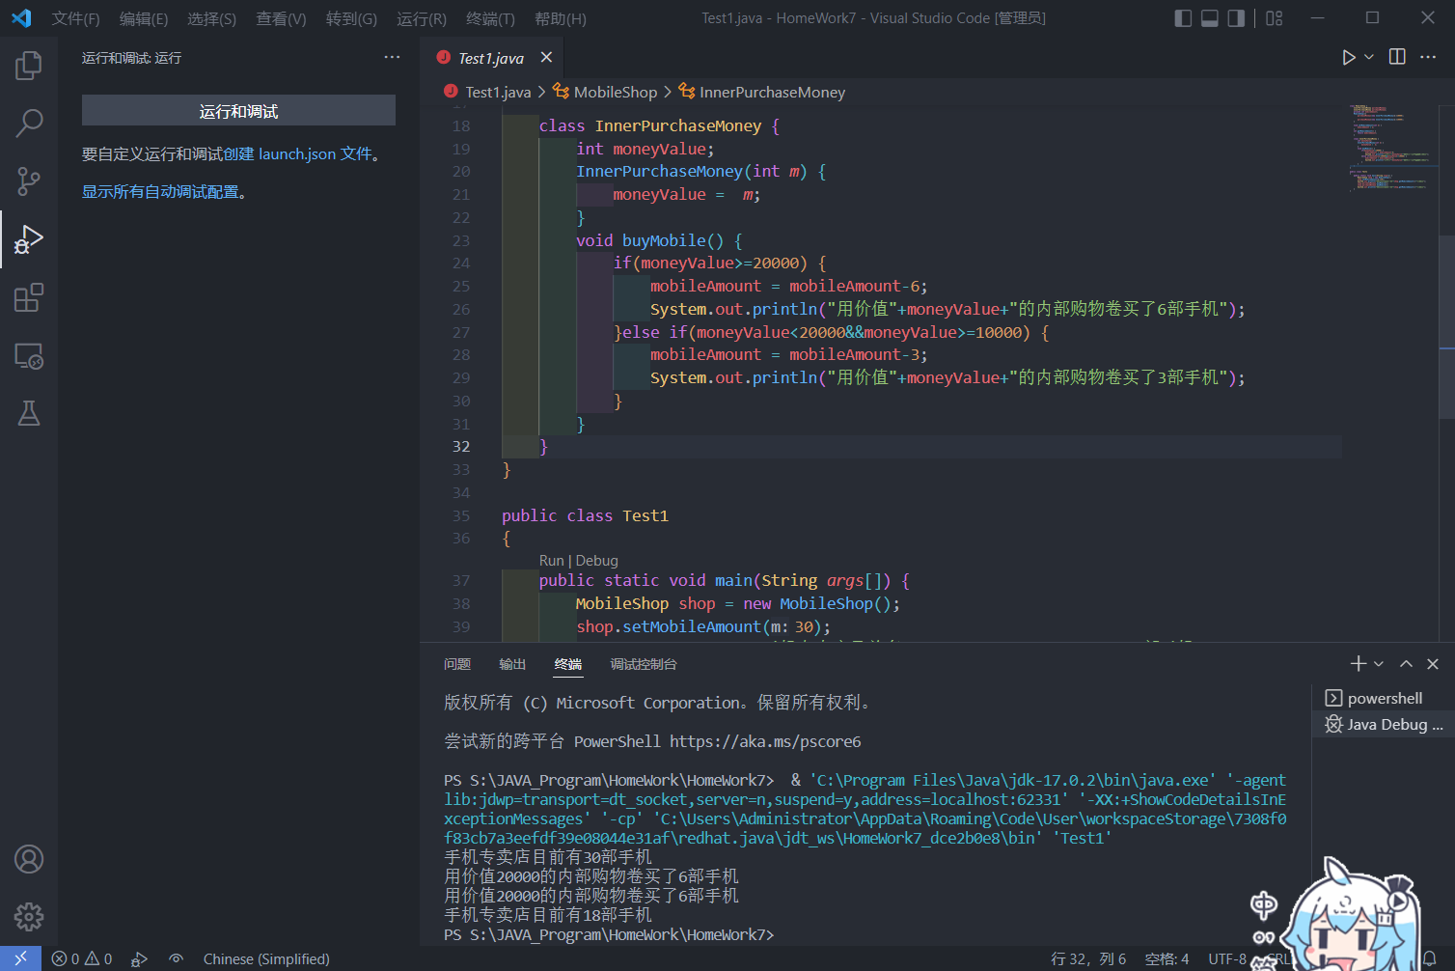

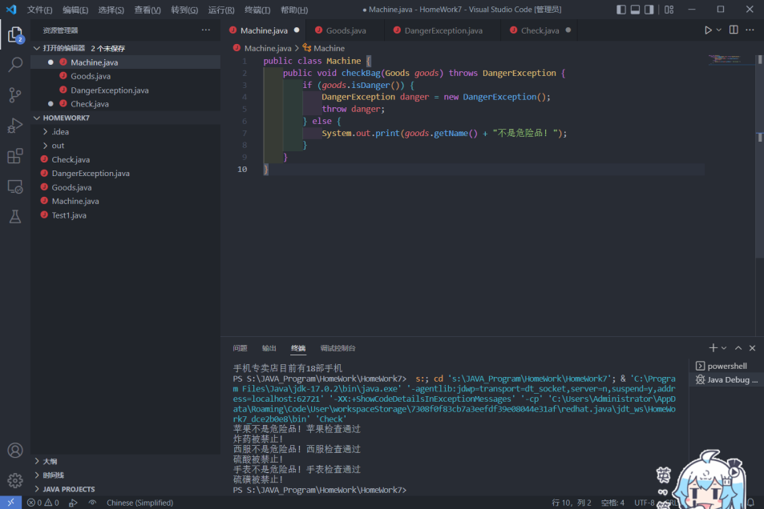

六、实验总结及体会