《面向对象程序设计与训练》实验报告

信息学院 学院 计算机类 专业 2021 级

实验时间 2022 年 5 月 23 日

姓名 陈俊宏 学号 20211060245 分工

实验名称：常用实用类

实验成绩：

1. 实验目的

本实验的目的是让学生掌握 String 类的常用方法，掌握怎样使用 Scanner 类的对象从字符串中解析程序所需要的数据，让学生掌握 Date 类以及 Calendar 类的常用方法，掌握 BigInteger 类的常用方法，掌握怎样使用 Pattern 类和 Match 类检索字符串。

二、实验仪器设备及软件

三、实验方案

1. 实验步骤

**Test1:**

public class Test1 {

public static void main(String[] args) {

String mess = "姓名：张三 出生时间：1989.10.16。个人网站：http://www.zhang.com。身高：185cm，体重：72kg";

int index = mess.indexOf("：");

String name = mess.substring(index + 1);

if (name.startsWith("张")) {

System.out.println("简历中的姓名姓\"张\" ");

}

index = mess.indexOf("：", index + 1);

String date = mess.substring(index + 1, index + 11);

System.out.println(date);

index = mess.indexOf("：", index + 1);

int heightPosition = mess.indexOf("身高");

String personNet = mess.substring(index + 1, heightPosition - 1);

System.out.println(personNet);

index = mess.indexOf("：", index + 1);

int cmposition = mess.indexOf("cm");

String height = mess.substring(index + 1, cmposition);

height = height.trim();

int h = Integer.parseInt(height);

if (h >= 180) {

System.out.println("简历中的身高" + height + "大于或等于180cm");

} else {

System.out.println("简历中的身高" + height + "小于180cm");

}

index = mess.indexOf("：", index + 1);

int kgPosition = mess.indexOf("kg");

String weight = mess.substring(index + 1, kgPosition);

weight = weight.trim();

int w = Integer.parseInt(weight);

if (w >= 75) {

System.out.println("简历中的体重" + weight + "大于或等于75kg");

} else {

System.out.println("简历中的体重" + weight + "小于75kg");

}

}

}

**Test2:**

import java.util.Scanner;

public class Test2 {

public static void main(String args[]) {

String s = "北京烤鸭：189元，西芹炒肉：12.9元，酸菜鱼：69元，铁板牛柳：32元。";

s = s.replace("：", " ");

s = s.replace("，", " ");

s = s.replace("元", "");

s = s.replace("。", "");

double price, sum = 0.0;

String name;

Scanner reader = new Scanner(s);

while (reader.hasNext()) {

name = reader.next();

price = reader.nextDouble();

System.out.println(name + "的价格为：" + price + "元");

sum += price;

}

System.out.println("菜单总价格为：" + sum + "元");

}

}

**Test3:**

import java.util.Scanner;

import java.util.Calendar;

public class Test3 {

public static void main(String args[]) {

// 输入样例为2021年12月7日

Scanner time1 = new Scanner(System.in);

Scanner time2 = new Scanner(System.in);

String regex = "\\D+", str1, str2;

str1 = time1.next().replaceAll(regex, " ");

str2 = time2.next().replaceAll(regex, " ");

String t1[] = str1.split(" ");

String t2[] = str2.split(" ");

Calendar c = Calendar.getInstance();

c.set(Integer.parseInt(t1[0]), Integer.parseInt(t1[1]) - 1, Integer.parseInt(t1[2]));

long cal1 = c.getTimeInMillis();

c.set(Integer.parseInt(t2[0]), Integer.parseInt(t2[1]) - 1, Integer.parseInt(t2[2]));

long cal2 = c.getTimeInMillis();

if (cal1 > cal2) {

System.out.println("第二个日期更早");

} else if (cal1 < cal2) {

System.out.println("第一个日期更早");

} else {

System.out.println("两个日期一样");

}

long days = Math.abs(cal1 - cal2) / (3600 * 24 * 1000);

System.out.println("两个日期相差" + days + "天");

}

}

**Test4:**

import java.math.BigInteger;

public class Test4 {

public static void main(String[] args) {

BigInteger n1 = new BigInteger("987654321987654321");

BigInteger n2 = new BigInteger("123456789123456789");

BigInteger result = null;

result = n1.add(n2);

System.out.println("和：" + result.toString());

result = n1.subtract(n2);

System.out.println("差：" + result.toString());

result = n1.multiply(n2);

System.out.println("积：" + result.toString());

result = n1.divide(n2);

System.out.println("商：" + result.toString());

BigInteger m = new BigInteger("123"),

COUNT = new BigInteger("0"),

ONE = new BigInteger("1"),

TWO = new BigInteger("2");

System.out.print(m.toString() + "的因子有：");

for (BigInteger i = TWO; i.compareTo(m) < 0; i = i.add(ONE)) {

if ((m.remainder(i).compareTo(BigInteger.ZERO)) == 0) {

COUNT = COUNT.add(ONE);

System.out.print(" " + i.toString());

}

}

System.out.println(" ");

System.out.println(m.toString() + "一共有" + COUNT.toString() + "个因子");

}

}

**Test5:**

public class Test5 {

public static void main(String args[]) {

String s = "忘记密码，不要惊慌失错，请登陆http://www.ynu.edu.cn或登陆http://computer.ynu.edu.cn，我们完美的为您解决问题。";

int wr1, wr2, wr3;

wr1 = s.indexOf("登陆");

wr2 = s.indexOf("登陆", wr1 + 1);

wr3 = s.indexOf("惊慌失错");

s = s.replace("登陆", "登录");

s = s.replace("惊慌失错", "惊慌失措");

System.out.println("“登陆”出错的位置从" + wr1 + "到" + (wr1 + 1) + "上和从" + wr2 + "到" + (wr2 + 1) + "上");

System.out.println("“惊慌失错”出错的位置从" + wr3 + "到" + (wr3 + 3) + "上");

System.out.println("正确的文字应该是：\n" + s);

}

}

1. 实验结果及分析

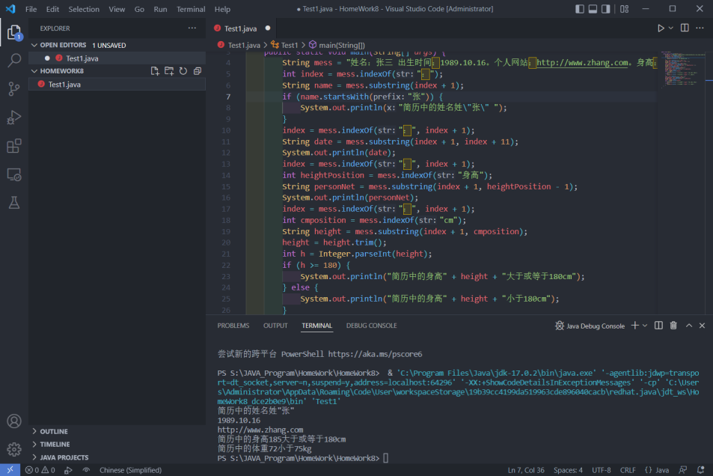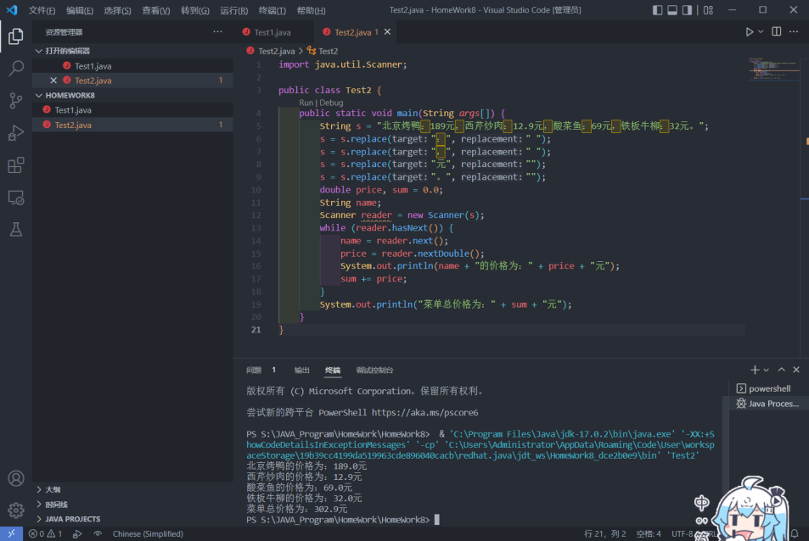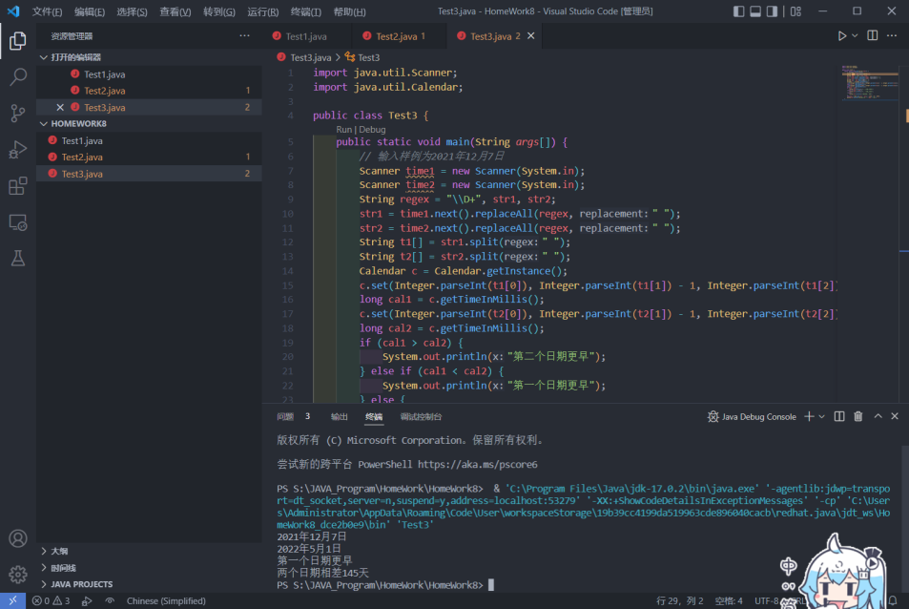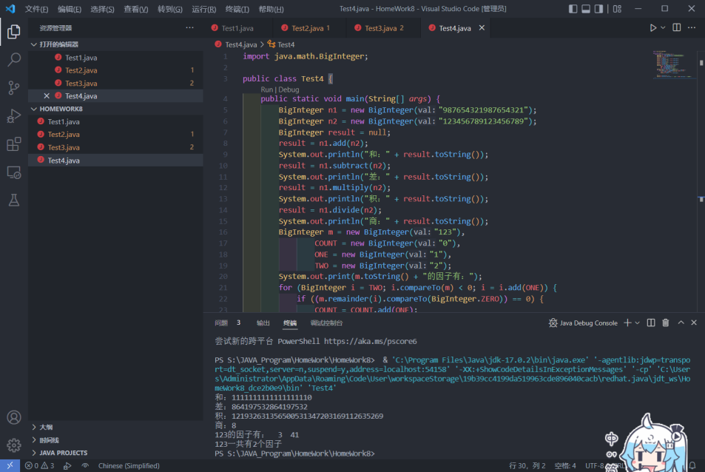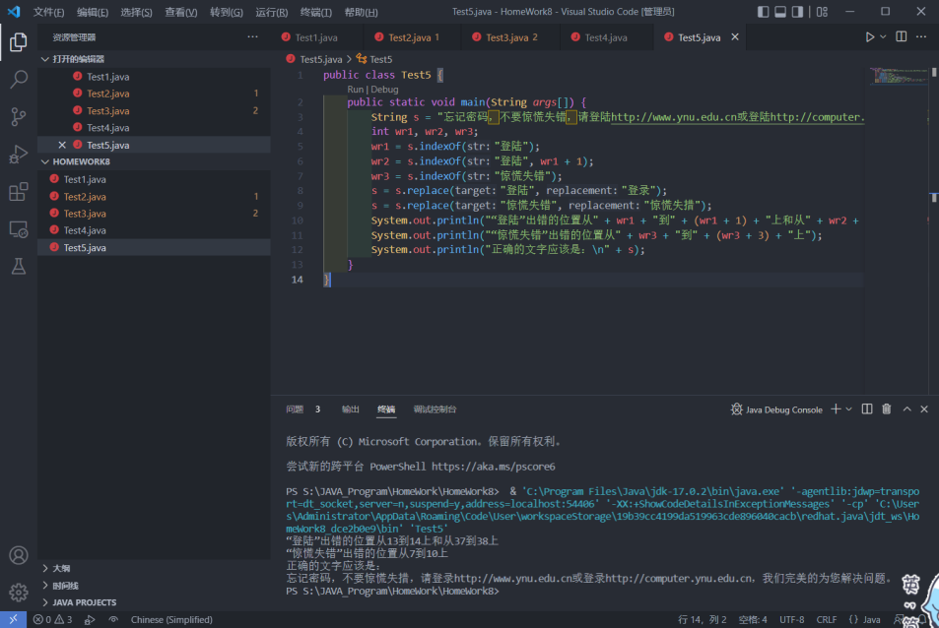

六、实验总结及体会