Chapter 5
Review Questions
R2. If all the links in the Internet were to provide reliable delivery service, would the TCP reliable delivery service be redundant? Why or why not?
答：即使网络中的单个链接是可靠的，TCP仍然有必要提供端到端的可靠性和对网络资源的有效利用。
R9. How big is the MAC address space? The IPv4 address space? The IPv6 address space?
答：MAC take 48 bits; IPv4 take 32 bits; IPv6 take 128 bits.
R10. Suppose nodes A, B, and C each attach to the same broadcast LAN (through their adapters). If A sends thousands of IP datagrams to B with each encapsulating frame addressed to the MAC address of B, will C’s adapt process these frames? If so, will C’s adapter pass the IP datagrams in these frames to the network layer C? How would your answers change if A sends frames with the MAC broadcast address?
答： C的适配器仍将处理这些帧，因为它们被发送到广播局域网。但是，C的适配器不会将这些帧中的IP数据报传到网络层，因为它们是向B而不是向C寻址的。如果A发送带有MAC广播地址的帧，那么C的适配器将处理这些帧，并将这些帧中的IP数据报传给网络层。因为广播帧被发送到局域网上的所有设备，所以C的适配器将接收这些帧并将它们传递到网络层进行处理。
R11. Why is an ARP query sent within a broadcast frame? Why is an ARP response sent within a frame with a specific destination MAC address?
答：ARP查询是通过广播帧发送的，因为在ARP查询时，发送方并不知道目标设备的MAC地址，这种广播方式确保了ARP查询能够到达网络中的所有设备，从而找到目标设备的MAC地址。
而ARP响应则是发送到具有特定目标MAC地址的帧中，在响应ARP查询时，目标设备已经知道发送方的MAC地址，因此可以直接将响应发送到发送方的MAC地址，避免ARP响应被其他设备截获并导致通信失败。
Problems:
P5. Consider the 7-bit generator, G=10011, and suppose that D has the value 1010101010. What is the value of R?
答：R的值为1010。
P14. Consider three LANs interconnected by two routers, as shown in Figure 5.33.
a. Assign IP addresses to all of the interfaces. For Subnet 1 use addresses of the form 192.168.1.xxx; for Subnet 2 uses addresses of the form
192.168.2.xxx; and for Subnet 3 use addresses of the form 192.168.3.xx
b. Assign MAC addresses to all of the adapters.
c. Consider sending an IP datagram from Host E to Host B. Suppose all of
the ARP tables are up to date. Enumerate all the steps, as done for the
single-router example in Section 6.4.1（Link-Layer Addressing and ARP）.
d. Repeat (c), now assuming that the ARP table in the sending host is empty (and the other tables are up to date).
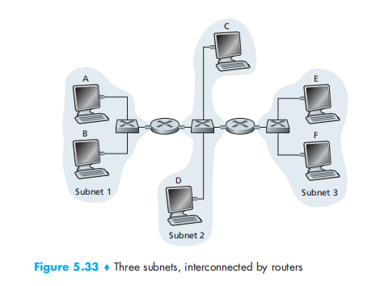
答：
a)b)
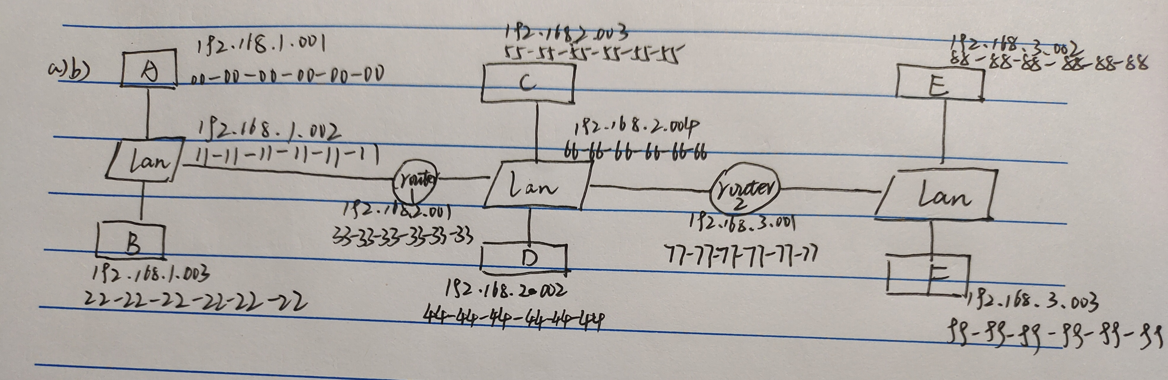
c)
1.E中的转发表确定数据报应路由到接口192.168.3.001
2 E中的适配器创建以太网目的地址为77-77-77-77-77-77的以太网数据包
3.路由器2接收数据包并提取数据报。此路由器中的转发表指示数据报将路由到198.168.2.001
4.路由器2然后通过其接口发送目的地址为33-33-33-33-33-33，源地址为66-66-66-66-66-66的以太网数据包，IP地址为198.162.2.004
5.该过程一直持续到数据包到达主机B.
d)
E中的ARP现在必须确定MAC地址198.162.3.001
主机E在广播以太网帧内发出ARP查询报文。
路由器2接收查询数据包并向主机E发送ARP响应数据包。
该ARP响应数据包由以太网帧承载，以太网目的地址为88-88-88-88-88-88

