Dear Sir,

Team Dyaus will be participating in a new competition in 2023-24, ISRO Rover Challenge – URSC (IRoC-U2024). This competition is organized by ISRO and is being held in the next year for the first time. The competition will take place in 3 stages and the registration is open till 15th December 2023. The competition will conclude on 26th August 2024 with the Awards Ceremony.

The 1st stage involves registration and submission of the proposal, which lists the basic design of our rover and the mechanisms we hope to implement. The 2nd stage involves the submission of the Design Review, which is a document listing a detailed description of our rover and all subsystems. On selection after 2nd stage, we will be proceeding for the 3rd round which includes submitting a demo of prototype of the Rover. 50 teams shortlisted for quals rounds have to build an prototype hardware for offline test demonstration in specified arena. On selection from round 3 we will move on to the 4rth Stage i.e Field Round, and we’ll be receiving 2 lakhs from the organizers for further development and construction of our rover. The 4rth stage involves the demonstration of our physical model on the given track.

**Various Stages with timeline:**

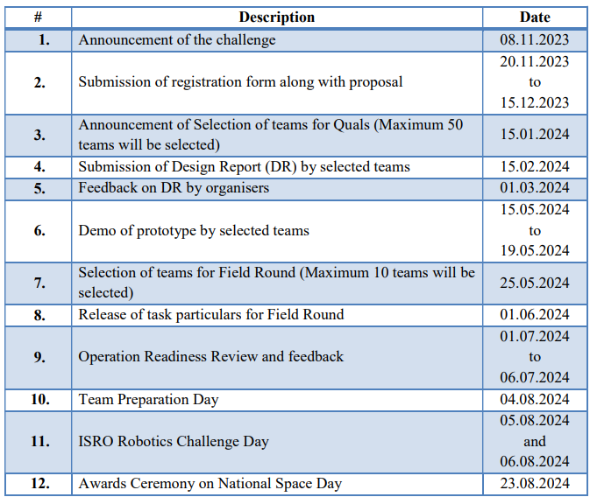

Below is given a description of the competition as present on the website <https://www.ursc.gov.in/IRoC-U2024/index.jsp>

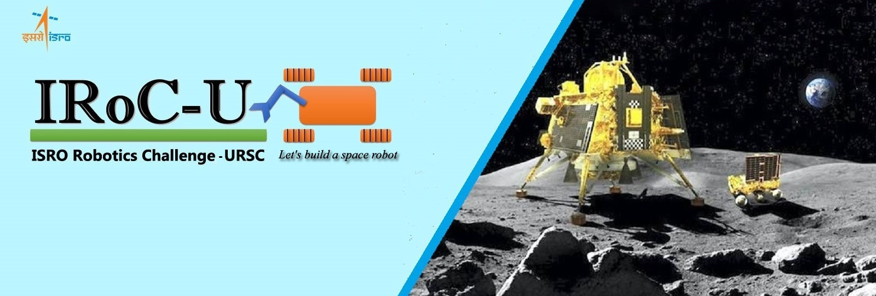

**Preamble**

Indian Space Research Organisation (ISRO) successfully landed Chandrayaan-3 Vikram on the lunar surface and Pragyan explored near to the southern pole of the Moon. Post this accomplishment, it is time to look at future robotic exploration missions to the Moon and other planetary bodies. It has been a constant endeavour at ISRO that, we create unique opportunities for academia & industry to participate in the technology developmental activities commensurate with organisational objectives. In line with these objectives, U R Rao Satellite Centre (URSC) solicits from the youth of India, innovative ideas and designs of robotic rovers for future missions through the conduct of IRoC-U 2024. This is an invitation for the student community for design and realisation of a ‘Wheeled/Legged Rover’ encompassing the development of complete hardware and software. Details of the same are provided herewith. The objective here is to provide development opportunities in space robotics to the participating entities and to leverage the creative thinking among the youth of our Nation for ISRO interplanetary missions. It is also expected to play an important role in augmenting ISRO’s activities in space exploration.  
  
All interested are encouraged to participate in this challenging competition and join hands with ISRO, towards the advancement of space science & technology in the country.

**Introduction to IRoC-U 2024**

ISRO is foraying into the development of state-of-the-art Space Robotics, Artificial Intelligence and Machine Learning technologies. The technologies are being developed to meet the futuristic mission needs of ISRO viz., ISRO In-orbit Servicer Mission, Lunar sample return mission, docking in Space (SPADEX), Mars Lander Mission etc. This is conceived as a natural next step in this direction, when ISRO’s Chandrayaan-3 mission accomplished landing and surface exploration using an indigenous Lander and Rover.

In order to provide a greater opportunity for the students of the country to provide innovative solutions in the area of space robotics, it is planned to organise “ISRO Robotics Challenge-URSC 2024 (IRoC-U 2024)” with a tagline of “Let's build a space robot”. The solutions provided by the students in IRoC-U 2024 have the greater chances of getting incorporated into ISRO’s future interplanetary robotics missions.

IRoC-U 2024 consists of an engineering project where the Institutional teams build robots to compete on an extra-terrestrial inspired arena, performing tasks based on the real-life challenges faced by space robotics. IRoC-U is being planned as a platform for co-development of technologies in the area of space robotics through organising challenges.

**Objectives of the Challenge**

* To provide a standardised platform for exploring the area of space robotics
* To develop a deeper understanding of space robotics and its applications among the student community. It enhances their communication, collaboration, inquiry, problem solving and flexibility skills that will benefit them in their academic and professional lives.
* To co-develop (students and ISRO) future technologies needed in the area of space robotics.

**Outcome for Student Community**

* Identify, formulate, and solve complex engineering problems by applying principles of mathematics, science and engineering
* Apply engineering design to produce solutions that meet specified needs
* Communicate effectively
* Collaborate with a team, provide inclusive leadership, establish goals, plan tasks, and meet objectives
* Formulate and conduct appropriate experiments, analyse and interpret test and analytical data and use engineering judgment to draw conclusions

**Venue**

The final onsite competition to perform the required tasks is planned to be conducted in URSC Bengaluru Campus in the Month of August 2024. For information about the IRoC-U 2024 competition venue, please follow our updates on the website.