As-Built
Technical Design Document

platform-identity
Profile: platform-identity · Environment: prod

Field | Value
Subscription | platform-identity
Subscription ID | 27f84456-9d87-4d58-8c73-4350c450220e
Location | southcentralus
IaC Framework | Bicep
Deployment ID | alz-platform-identity-20260428152453
Generated | 2026-04-28 15:27 UTC
Document Version | 1.0 (auto-generated)

Table of Contents

(Right-click → Update Field to populate in Word)

1. Executive Summary
This Technical Design Document (TDD) describes the as-built state of the 'platform-identity' landing zone deployed to subscription 'platform-identity' in southcentralus. This landing zone provides Active Directory Domain Services, Entra ID PIM, and privileged access workstations.
The deployment was executed using Bicep via the GitHub Actions CI/CD pipeline with OIDC authentication and environment approval gates. All resources comply with the CAF enterprise-scale baseline policies.

Key Facts
Attribute | Value
Landing Zone | platform-identity
Profile | platform-identity
Subscription | platform-identity (27f84456-9d87-4d58-8c73-4350c450220e)
Region | southcentralus
Environment | prod
IaC Framework | Bicep
Deployment ID | alz-platform-identity-20260428152453

2. Architecture Diagram
The following diagram illustrates the as-built architecture of this landing zone, including all deployed resources, networking topology, and security controls. Icons follow the official Microsoft Azure Architecture Icon set.
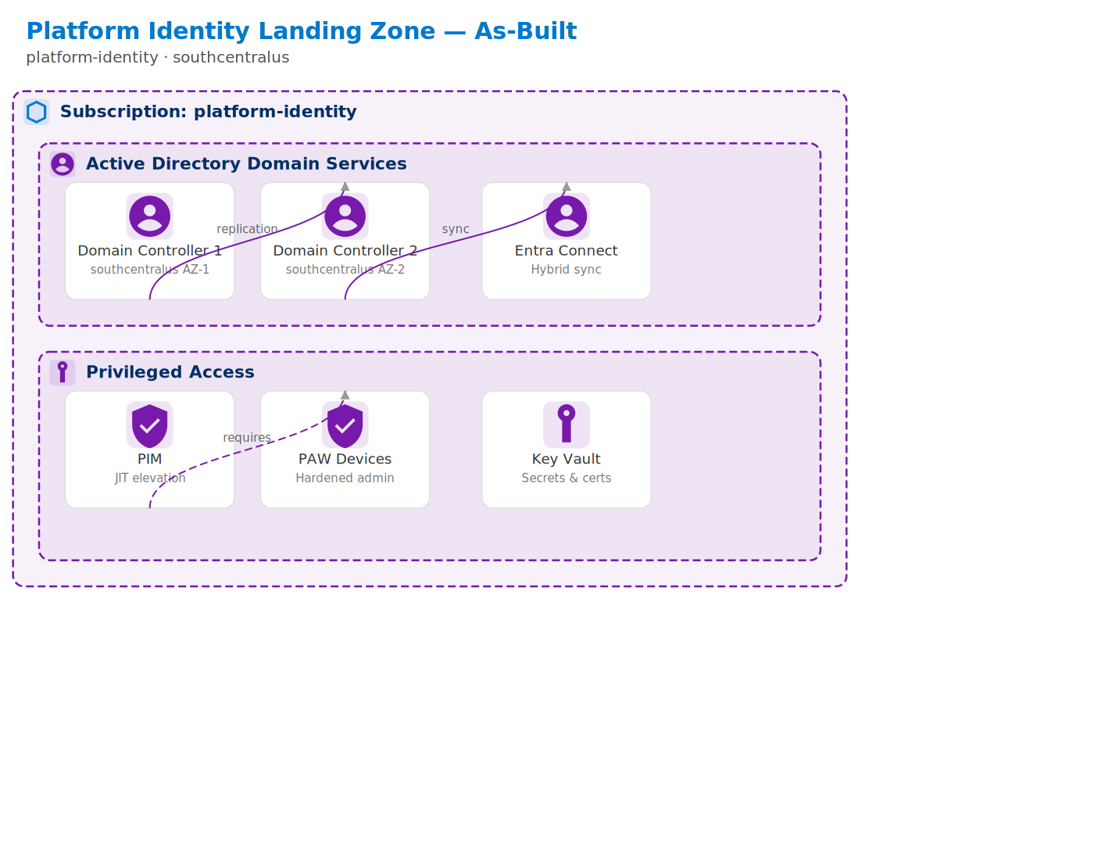
Figure 1: platform-identity Architecture — As-Built

3. Resource Inventory
Complete inventory of Azure resources deployed in this landing zone, queried from Azure Resource Graph at generation time.

3.1 Resource Summary by Type
Resource Type | Count
networksecuritygroups | 12
networkwatchers | 6
virtualnetworks | 6
userassignedidentities | 2
networkinterfaces | 2
disks | 1
virtualnetworklinks | 1
actiongroups | 1
privatednszones | 1
bastionhosts | 1
movecollections | 1
systemtopics | 1
virtualmachines | 1
storageaccounts | 1
extensions | 1
publicipaddresses | 1
Total resources: 39

4. Network Topology
This landing zone uses a spoke virtual network peered to the central hub in the Connectivity subscription. All egress traffic routes through Azure Firewall. DNS resolution uses the hub's Private DNS Zones.
Network Component | Configuration
VNet CIDR | Peered to Hub
DC Subnet | Dedicated for domain controllers
DNS | Custom DNS pointing to DCs

5. Security Posture
Security controls applied to this landing zone as part of the CAF enterprise-scale baseline. All controls are enforced via Azure Policy and validated during deployment.

5.1 Non-Negotiable Security Rules
# | Rule | Description | Status
1 | Diagnostic Settings | All resources ship logs to central Log Analytics workspace | Enforced
2 | HTTPS Only | All web endpoints require TLS 1.2+ | Enforced
3 | No Public IPs | Disallowed on compute (except for allowed profiles) | Enforced
4 | Encryption at Rest | All storage & databases use platform-managed or CMK encryption | Enforced
5 | NSG on Every Subnet | Network Security Groups required on all subnets | Enforced
6 | Defender for Cloud | Enabled on all resource types (per profile plan count) | Enforced

5.2 Defender for Cloud Plans
Defender Plan | Status
Servers | Enabled
Key Vaults | Enabled
ARM | Enabled
DNS | Enabled

5.3 Azure Policy Assignments
The following policy initiatives are assigned at the management group level and inherited by this subscription:
Initiative | Scope
CAF Foundation | Core governance (tagging, allowed locations, allowed SKUs)
CAF Security Baseline | CIS benchmark controls, encryption, network rules
Defender for Cloud | Auto-enable Defender plans and security configurations
Monitoring | Diagnostic settings, Log Analytics agent, dependency agent
Network | NSG rules, flow logs, VNet service endpoints

6. Compliance Status
Post-deployment compliance scan results. The CI/CD pipeline validates compliance after every deployment and fails the pipeline if compliance falls below 80%.

6.1 Compliance Summary
Metric | Value
Compliance Percentage | Populated at deployment time
Total Policies Evaluated | Populated at deployment time
Compliant Resources | Populated at deployment time
Non-Compliant Resources | Populated at deployment time
Exempt Resources | Populated at deployment time
Note: This section is auto-populated with live data when the TDD is generated as part of the CI/CD pipeline (post-deployment verify stage). For pre-deployment TDDs, values show 'Populated at deployment time'.

7. Cost Governance
Control | Configuration
Monthly Budget | $5,000
Alert Thresholds | 80/100/120%
Alert Recipients | Platform team + subscription owner
Cost Anomaly Detection | Enabled
Tag Requirements | Environment, Owner, CostCenter, Project

8. Operational Model

8.1 Monitoring & Alerting
Scan Type | Frequency | Source
Compliance Scan | Every 30 minutes | 4-monitor.yml
Drift Detection | Every hour | 4-monitor.yml
Full Audit Report | Daily 6 AM UTC | 4-monitor.yml
Cost Alerts | Real-time | Azure Cost Management
Security Alerts | Real-time | Defender for Cloud → Sentinel

8.2 Change Management
All infrastructure changes follow the GitOps workflow:
Step | Action | Responsible
1 | Create feature branch | Developer
2 | Push changes & open PR | Developer
3 | Automated PR validation (lint, security, cost, what-if) | 5-pr-validate.yml
4 | Peer review & approval | Platform team
5 | Merge to main | Developer
6 | Trigger deploy workflow | Platform team
7 | Environment approval gate | Required reviewers
8 | Deployment + post-deploy verification | Reusable pipeline
9 | TDD auto-generated | tdd_generator.py

8.3 Disaster Recovery
Component | Protection | Recovery Time
IaC Templates | Git repository | Minutes
Configuration | subscriptions.json | Minutes

9. Appendix

9.1 Full Estate Architecture
Overview of the complete Azure Landing Zone estate showing all platform and application landing zones.
[Estate diagram unavailable: failed to execute PosixPath('dot'), make sure the Graphviz executables are on your systems' PATH]

9.2 Document Revision History
Version | Date | Author | Changes
1.0 | 2026-04-28 | Auto-generated by CI/CD pipeline | Initial as-built TDD

9.3 References
Document | Location
CAF Enterprise-Scale | https://aka.ms/caf/enterprise-scale
Azure Landing Zone Accelerator | https://aka.ms/alz/accelerator
Landing Zone Profiles | src/config/landing_zone_profiles.yaml
Subscription Config | environments/subscriptions.json
CI/CD Workflows | .github/workflows/

