As-Built
Technical Design Document

identity
Profile: platform-identity · Environment: prod

Field | Value
Subscription | alz-platform-identity
Subscription ID | <SUB-3-ID>
Location | eastus2
IaC Framework | Bicep
Deployment ID | (manual)
Generated | 2026-04-13 16:40 UTC
Document Version | 1.0 (auto-generated)

Table of Contents

(Right-click → Update Field to populate in Word)

1. Executive Summary
This Technical Design Document (TDD) describes the as-built state of the 'identity' landing zone deployed to subscription 'alz-platform-identity' in eastus2. This landing zone provides Active Directory Domain Services, Entra ID PIM, and privileged access workstations.
The deployment was executed using Bicep via the GitHub Actions CI/CD pipeline with OIDC authentication and environment approval gates. All resources comply with the CAF enterprise-scale baseline policies.

Key Facts
Attribute | Value
Landing Zone | identity
Profile | platform-identity
Subscription | alz-platform-identity (<SUB-3-ID>)
Region | eastus2
Environment | prod
IaC Framework | Bicep
Deployment ID | (manual/CLI)

2. Architecture Diagram
The following diagram illustrates the as-built architecture of this landing zone, including all deployed resources, networking topology, and security controls. Icons follow the official Microsoft Azure Architecture Icon set.
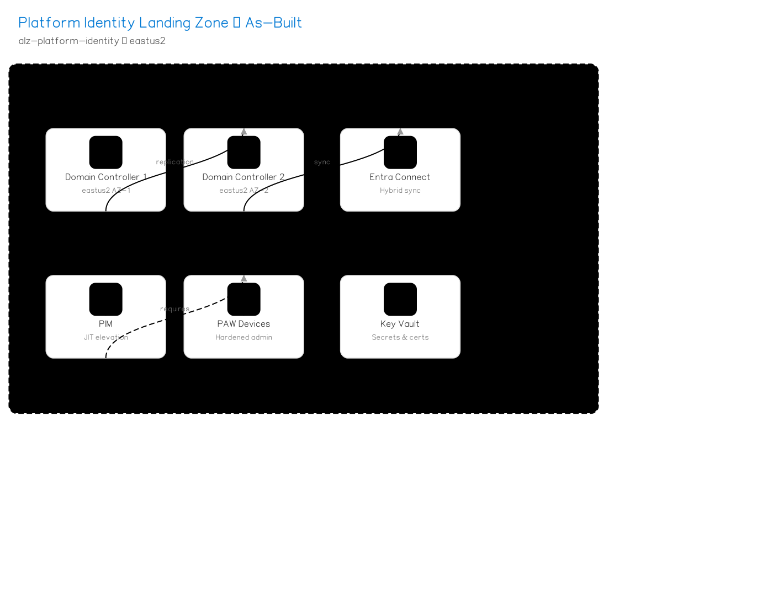
Figure 1: identity Architecture — As-Built

3. Resource Inventory
Complete inventory of Azure resources deployed in this landing zone, queried from Azure Resource Graph at generation time.

3.1 Resource Summary by Type
Resource inventory will be populated from Azure Resource Graph at deployment time.
Resource | Count | Configuration
Virtual Network (Identity) | 1 | Identity CIDR
Domain Controllers (VMs) | 2 | Zone-redundant (AZ-1, AZ-2)
Entra Connect (VM) | 1 | Hybrid sync to Entra ID
Key Vault | 1 | Domain admin credentials
NSGs | 2+ | DC and management subnets
Total resources: 0

4. Network Topology
This landing zone uses a spoke virtual network peered to the central hub in the Connectivity subscription. All egress traffic routes through Azure Firewall. DNS resolution uses the hub's Private DNS Zones.
Network Component | Configuration
VNet CIDR | Peered to Hub
DC Subnet | Dedicated for domain controllers
DNS | Custom DNS pointing to DCs

5. Security Posture
Security controls applied to this landing zone as part of the CAF enterprise-scale baseline. All controls are enforced via Azure Policy and validated during deployment.

5.1 Non-Negotiable Security Rules
# | Rule | Description | Status
1 | Diagnostic Settings | All resources ship logs to central Log Analytics workspace | Enforced
2 | HTTPS Only | All web endpoints require TLS 1.2+ | Enforced
3 | No Public IPs | Disallowed on compute (except for allowed profiles) | Enforced
4 | Encryption at Rest | All storage & databases use platform-managed or CMK encryption | Enforced
5 | NSG on Every Subnet | Network Security Groups required on all subnets | Enforced
6 | Defender for Cloud | Enabled on all resource types (per profile plan count) | Enforced

5.2 Defender for Cloud Plans
Defender Plan | Status
Servers | Enabled
Key Vaults | Enabled
ARM | Enabled
DNS | Enabled

5.3 Azure Policy Assignments
The following policy initiatives are assigned at the management group level and inherited by this subscription:
Initiative | Scope
CAF Foundation | Core governance (tagging, allowed locations, allowed SKUs)
CAF Security Baseline | CIS benchmark controls, encryption, network rules
Defender for Cloud | Auto-enable Defender plans and security configurations
Monitoring | Diagnostic settings, Log Analytics agent, dependency agent
Network | NSG rules, flow logs, VNet service endpoints

6. Compliance Status
Post-deployment compliance scan results. The CI/CD pipeline validates compliance after every deployment and fails the pipeline if compliance falls below 80%.

6.1 Compliance Summary
Metric | Value
Compliance Percentage | Populated at deployment time
Total Policies Evaluated | Populated at deployment time
Compliant Resources | Populated at deployment time
Non-Compliant Resources | Populated at deployment time
Exempt Resources | Populated at deployment time
Note: This section is auto-populated with live data when the TDD is generated as part of the CI/CD pipeline (post-deployment verify stage). For pre-deployment TDDs, values show 'Populated at deployment time'.

7. Cost Governance
Control | Configuration
Monthly Budget | $5,000
Alert Thresholds | 80/100/120%
Alert Recipients | Platform team + subscription owner
Cost Anomaly Detection | Enabled
Tag Requirements | Environment, Owner, CostCenter, Project

8. Operational Model

8.1 Monitoring & Alerting
Scan Type | Frequency | Source
Compliance Scan | Every 30 minutes | 4-monitor.yml
Drift Detection | Every hour | 4-monitor.yml
Full Audit Report | Daily 6 AM UTC | 4-monitor.yml
Cost Alerts | Real-time | Azure Cost Management
Security Alerts | Real-time | Defender for Cloud → Sentinel

8.2 Change Management
All infrastructure changes follow the GitOps workflow:
Step | Action | Responsible
1 | Create feature branch | Developer
2 | Push changes & open PR | Developer
3 | Automated PR validation (lint, security, cost, what-if) | 5-pr-validate.yml
4 | Peer review & approval | Platform team
5 | Merge to main | Developer
6 | Trigger deploy workflow | Platform team
7 | Environment approval gate | Required reviewers
8 | Deployment + post-deploy verification | Reusable pipeline
9 | TDD auto-generated | tdd_generator.py

8.3 Disaster Recovery
Component | Protection | Recovery Time
IaC Templates | Git repository | Minutes
Configuration | subscriptions.json | Minutes

9. Appendix

9.1 Full Estate Architecture
Overview of the complete Azure Landing Zone estate showing all platform and application landing zones.
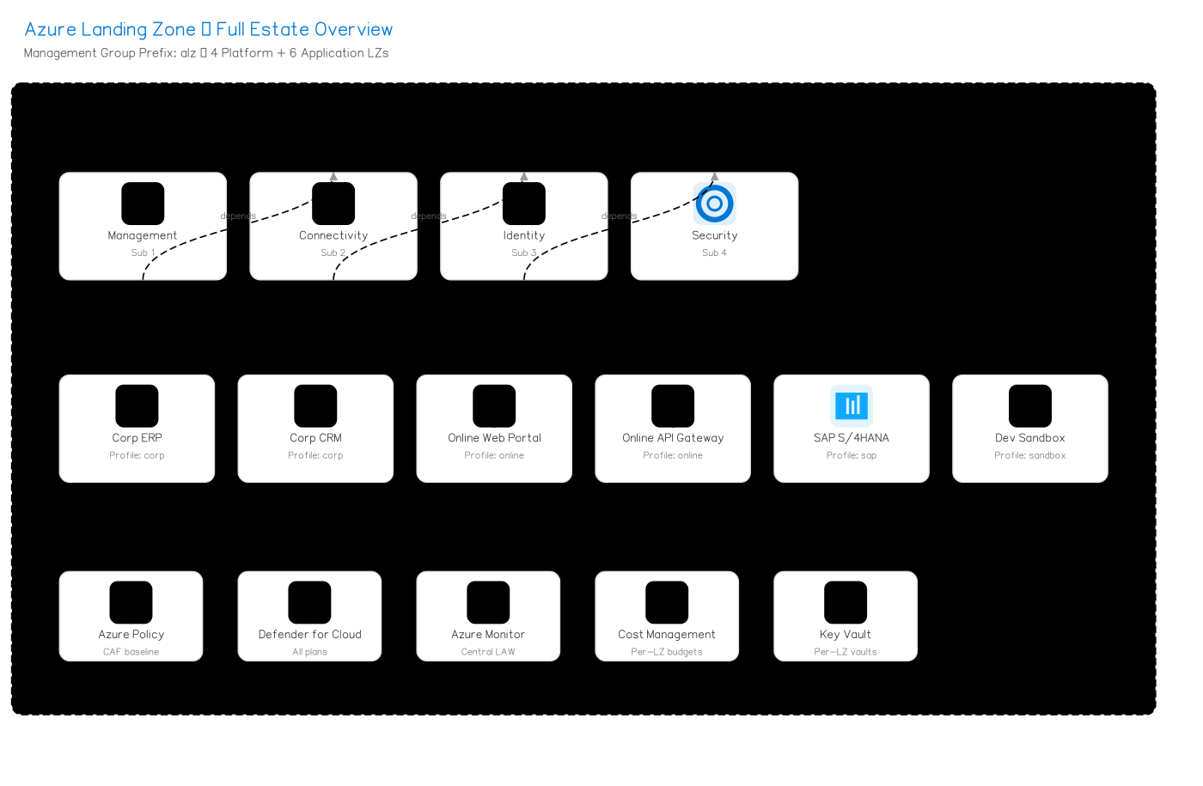
Figure 2: Full Azure Landing Zone Estate

9.2 Document Revision History
Version | Date | Author | Changes
1.0 | 2026-04-13 | Auto-generated by CI/CD pipeline | Initial as-built TDD

9.3 References
Document | Location
CAF Enterprise-Scale | https://aka.ms/caf/enterprise-scale
Azure Landing Zone Accelerator | https://aka.ms/alz/accelerator
Landing Zone Profiles | src/config/landing_zone_profiles.yaml
Subscription Config | environments/subscriptions.json
CI/CD Workflows | .github/workflows/

