**Assignment No 2**

1. Write a shell script to display your permanent address.

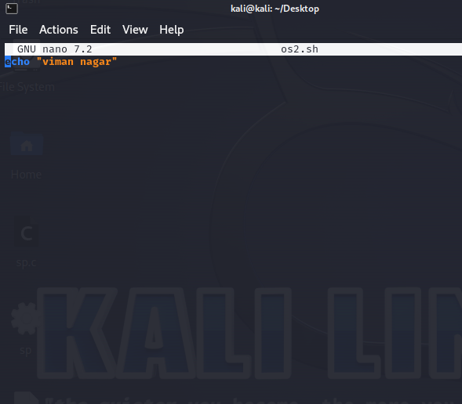



1. Write a shell script to take input from the user and display it.

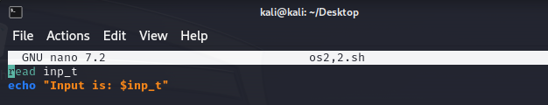

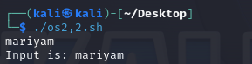

1. Write a shell script to demonstrate use of command line arguments.

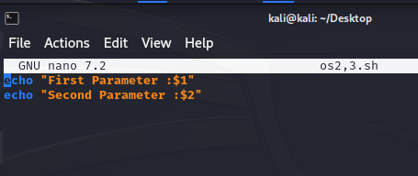

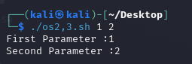

1. Write a shell scrpit to add two numbers where both the numbers are user inputs.

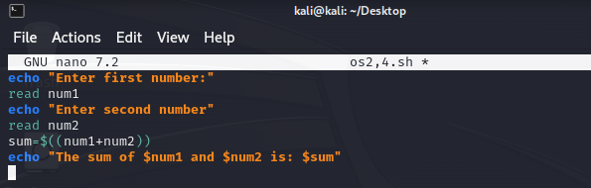



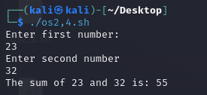

1. Write a shell script to check whether a number n is even or odd, where n is user input.

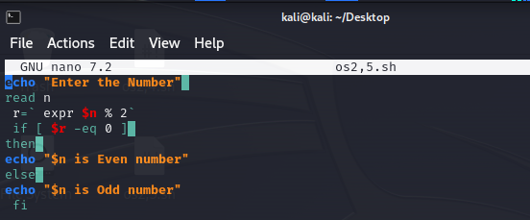

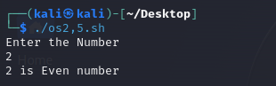

1. Write a shell script to input 10 numbers in array and find second largest number in it.

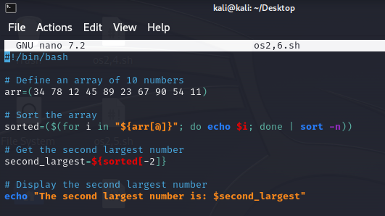

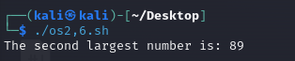

7.Write a shell script to check whether a number n is palindrome or not, where n is user input.

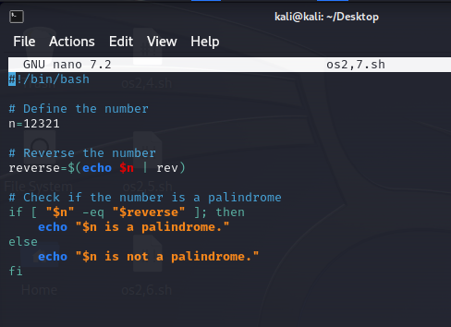



#!/bin/bash

# Define the string

str="madam"

# Reverse the string

reverse=$(echo "$str" | rev)

# Check if the string is a palindrome

if [ "$str" = "$reverse" ]; then

echo "\"$str\" is a palindrome."

else

echo "\"$str\" is not a palindrome."

Fi

8.Write a shell script to check grade of a student as follows:

Total marks of the student=100

If student ‘s mark>= 90,grade is O .

If student ‘s mark>=80 and marks<90, grade is A.

If student ‘s mark>=70 and marks<80, grade is B.

If student ‘s mark>= 60 and marks<70, grade is C.

If student ‘s mark>= 50 and marks<60, grade is E.

If student ‘s mark < 50, grade is F.

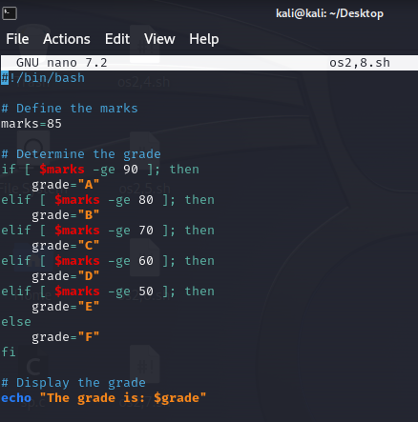

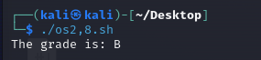

9.Write a shell script to check if input character is vowel or not using case control statement.

echo "enter character(a-z):"

read char

case $char in

a|e|i|o|u|A|E|I|O|U)

echo" $char is a vowel"

;;

*)

echo" $char is not a vowel"

;;

esac

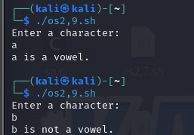

10.Write a shell script to sort an a;rray of n element using bubble sort, where n is user input.

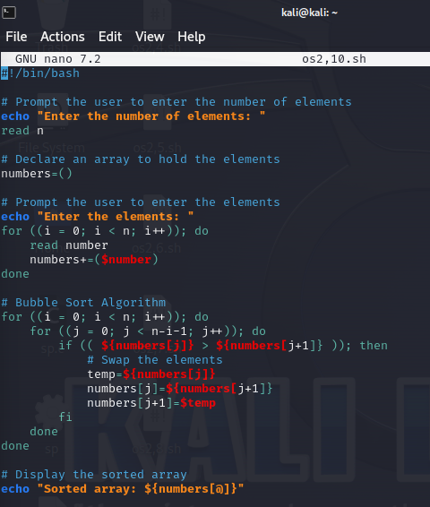

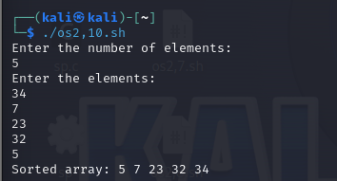

11.Write a shell script to search an element from an array of n elements where n is user input.

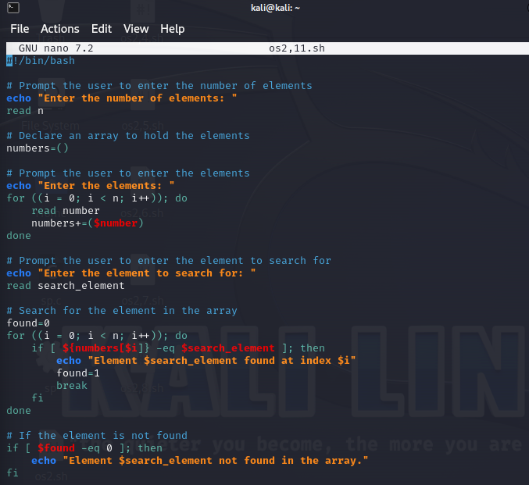

#!/bin/bash

echo "Enter no of elements:"

read n

numbers=()

echo "Enter the elements:"

for ((i = 0; i < n; i++)); do

read number

numbers+=($number)

done

echo "Enter the search element:"

read sele

found=0

for ((i = 0; i < n; i++)); do

if [ ${numbers[$i]} -eq $sele ]; then

echo "Element found at index $i"

found=1

break

fi

done

if [ $found -eq 0 ]; then

echo "Element not found"

fi

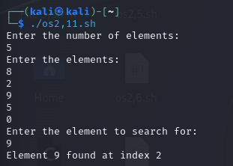

12.Write a shell script to create a file and count number of lines, number of words and number of characters from the file.

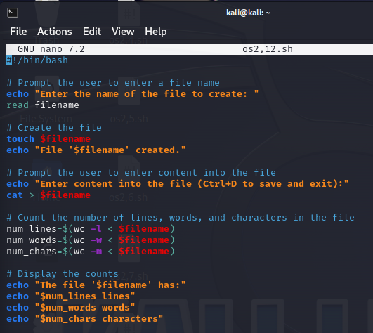

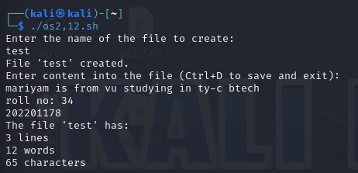

13.Write a shell script to search a pattern from a file, where filename is user input.

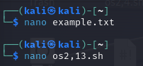

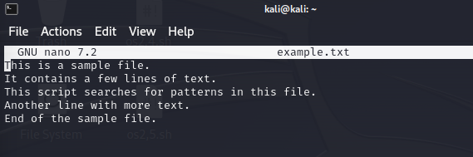

echo "enter filename"

read fn

echo "enter pattern to search:"

read pat

grep "$pat" "$fn"

if [ $? -eq 0]; then

echo "no pattern matches"

fi

