**Assignment 3**

**Input.txt -**

This is the first line.

Here is the second line.

The third line contains some text.

Another line for testing.

The last line in the file.

**Marks.txt -**

StudentID,StudentName,Telugu,English,Maths,Science,Social

1,John Doe,45,78,65,88,75

2,Jane Smith,30,45,50,60,40

3,Alice Johnson,75,80,90,88,70

4,Bob Wilson,25,40,35,55,60

5,Charlie Brown,60,70,75,80,85

1. **Write an awk command to print the lines and line number in the given input file.**

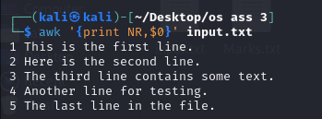

• NR: Holds the current line number.

• $0: Refers to the entire line.

1. **Write an awk command to print first field and second field only if third field value is >=50 in the given input file. (Input field separator is “,” and output field separator is “,”)**

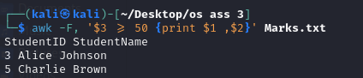

• -F,: Sets the field separator to a comma.

• $3: Refers to the third field.

**3.Consider the marks.txt is a file that contains one record per line( comma separate fields) of the student data in the form of studentid, student name, Telugu marks, English marks, Maths Marks, Science marks, Social Marks. Write an awk script to generate result for every students in the form of studentid, studentname, Total Marks and result. Result is PASS if marks is >=30 in TELUGU and English, and if marks>=40 in other subjects. Result is fail otherwise.**

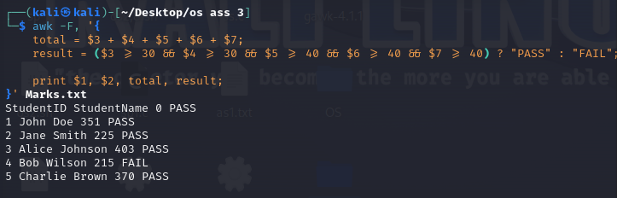

**4. Write an awk program to print the fields 1 and 4 of a file that is passed as command line argument. The file contains lines of information that is separated by “,” as delimeter. The awk program must print at the end the average of all 4th field data.**

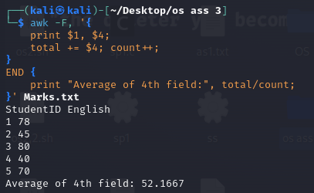

**5. Write an awk program to demonstrate user defined functions and system command.**

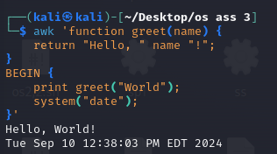

• greet(): A user-defined function.

• system(): Executes a system command (here, printing the current date).

**6. Write an awk script to count the number of lines in a file that do not contain vowels.**





**7. Write an awk script to find the number of characters, words and lines in a file.**

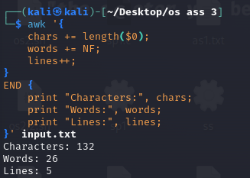

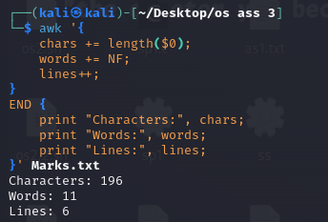

**Q.Write an awk script to prepare a report in the following format:**

**Roll No. Name BS DA HRA GS**

**The data file contains the Record in the following form:**

**Empno:Name:Basic salary:DA:HRA**

**Use the formula GS = BS + DA + HRA**

**where DA = 0.5*BS and HRA = 0.2*BS**

**Calculate the gross salary of employee and display the result.**

**CODE-**

**Example.txt-**

Empno:Name:Basic salary

101:John:40000

102:Jane:35000

103:Alice:45000

**generate_report.awk-**

BEGIN {

# Print the report header

printf "%-10s %-10s %-10s %-10s %-10s %-10s\n", "Roll No.", "Name", "BS", "DA", "HRA", "GS";

}

{

# Split the input line into fields using ":" as a delimiter

split($0, fields, ":");

# Extract fields

empno = fields[1];

name = fields[2];

bs = fields[3];

# Calculate DA, HRA, and GS

da = 0.5 * bs;

hra = 0.2 * bs;

gs = bs + da + hra;

# Print the calculated values in the report format

printf "%-10s %-10s %-10.2f %-10.2f %-10.2f %-10.2f\n", empno, name, bs, da, hra, gs;

}

To run: awk -f generate_report.awk employee_data.txt

---------------------------------------------------------------------------------------------------

Run the script using awk -f script.awk filename(textfile).

chmod +x script.awk