**NAME : MARIYAM PATEL**

**SRN:202201178**

**ROLL NO:34**

**ASSIGNMENT-7**

Q.Simulate the following CPU scheduling algorithms:  
a. First come First serve b. Shortest Job First (Non-preemptive) c. Shortest Job First (Preemptive) d. Round Robin e. Priority (Non-preemptive) f. Priority (Non-preemptive)

(l)

CODE-

import matplotlib.pyplot as plt

import numpy as np

from collections import deque

class Process:

def __init__(self, pid, arrival_time, burst_time, priority=0):

self.pid = pid

self.arrival_time = arrival_time

self.burst_time = burst_time

self.remaining_time = burst_time

self.priority = priority

self.start_time = 0

self.completion_time = 0

self.waiting_time = 0

self.turnaround_time = 0

class CPUScheduler:

def __init__(self):

self.processes = []

self.gantt_chart = []

def add_process(self, pid, arrival_time, burst_time, priority=0):

self.processes.append(Process(pid, arrival_time, burst_time, priority))

def calculate_times(self):

avg_waiting_time = sum(p.waiting_time for p in self.processes) / len(self.processes)

avg_turnaround_time = sum(p.turnaround_time for p in self.processes) / len(self.processes)

return avg_waiting_time, avg_turnaround_time

def plot_gantt_chart(self, title):

fig, ax = plt.subplots(figsize=(12, 4))

for i, (pid, start, end) in enumerate(self.gantt_chart):

ax.barh(0, end - start, left=start, height=0.3,

align='center', color=f'C{pid}', alpha=0.8)

ax.text((start + end)/2, 0, f'P{pid}',

ha='center', va='center')

ax.set_ylim(-0.5, 0.5)

ax.set_xlabel('Time')

ax.set_yticks([])

ax.set_title(title)

plt.grid(True)

plt.show()

def fcfs(self):

self.gantt_chart = []

processes = sorted(self.processes, key=lambda x: (x.arrival_time, x.pid))

current_time = 0

for process in processes:

if current_time < process.arrival_time:

current_time = process.arrival_time

process.start_time = current_time

process.completion_time = current_time + process.burst_time

process.turnaround_time = process.completion_time - process.arrival_time

process.waiting_time = process.turnaround_time - process.burst_time

self.gantt_chart.append((process.pid, current_time, process.completion_time))

current_time = process.completion_time

return self.calculate_times()

def sjf_non_preemptive(self):

self.gantt_chart = []

remaining_processes = self.processes.copy()

current_time = 0

while remaining_processes:

available_processes = [p for p in remaining_processes

if p.arrival_time <= current_time]

if not available_processes:

current_time += 1

continue

process = min(available_processes, key=lambda x: (x.burst_time, x.arrival_time))

process.start_time = current_time

process.completion_time = current_time + process.burst_time

process.turnaround_time = process.completion_time - process.arrival_time

process.waiting_time = process.turnaround_time - process.burst_time

self.gantt_chart.append((process.pid, current_time, process.completion_time))

current_time = process.completion_time

remaining_processes.remove(process)

return self.calculate_times()

def sjf_preemptive(self):

self.gantt_chart = []

remaining_processes = self.processes.copy()

current_time = 0

current_process = None

for p in remaining_processes:

p.remaining_time = p.burst_time

while remaining_processes:

available_processes = [p for p in remaining_processes

if p.arrival_time <= current_time]

if not available_processes:

current_time += 1

continue

process = min(available_processes, key=lambda x: (x.remaining_time, x.arrival_time))

if current_process != process.pid:

if current_process is not None:

self.gantt_chart.append((current_process, start_time, current_time))

current_process = process.pid

start_time = current_time

process.remaining_time -= 1

current_time += 1

if process.remaining_time == 0:

process.completion_time = current_time

process.turnaround_time = process.completion_time - process.arrival_time

process.waiting_time = process.turnaround_time - process.burst_time

remaining_processes.remove(process)

self.gantt_chart.append((current_process, start_time, current_time))

current_process = None

return self.calculate_times()

def round_robin(self, quantum):

self.gantt_chart = []

remaining_processes = deque(sorted(self.processes, key=lambda x: x.arrival_time))

current_time = 0

for p in remaining_processes:

p.remaining_time = p.burst_time

while remaining_processes:

if not remaining_processes:

break

process = remaining_processes.popleft()

if process.arrival_time > current_time:

current_time = process.arrival_time

execution_time = min(quantum, process.remaining_time)

self.gantt_chart.append((process.pid, current_time,

current_time + execution_time))

current_time += execution_time

process.remaining_time -= execution_time

if process.remaining_time > 0:

# Find the position to insert the process back

insert_pos = 0

for i, p in enumerate(remaining_processes):

if p.arrival_time > current_time:

insert_pos = i

break

insert_pos = i + 1

remaining_processes.insert(insert_pos, process)

else:

process.completion_time = current_time

process.turnaround_time = process.completion_time - process.arrival_time

process.waiting_time = process.turnaround_time - process.burst_time

return self.calculate_times()

def priority_non_preemptive(self):

self.gantt_chart = []

remaining_processes = self.processes.copy()

current_time = 0

while remaining_processes:

available_processes = [p for p in remaining_processes

if p.arrival_time <= current_time]

if not available_processes:

current_time += 1

continue

process = min(available_processes, key=lambda x: (x.priority, x.arrival_time))

process.start_time = current_time

process.completion_time = current_time + process.burst_time

process.turnaround_time = process.completion_time - process.arrival_time

process.waiting_time = process.turnaround_time - process.burst_time

self.gantt_chart.append((process.pid, current_time, process.completion_time))

current_time = process.completion_time

remaining_processes.remove(process)

return self.calculate_times()

def priority_preemptive(self):

self.gantt_chart = []

remaining_processes = self.processes.copy()

current_time = 0

current_process = None

for p in remaining_processes:

p.remaining_time = p.burst_time

while remaining_processes:

available_processes = [p for p in remaining_processes

if p.arrival_time <= current_time]

if not available_processes:

current_time += 1

continue

process = min(available_processes, key=lambda x: (x.priority, x.arrival_time))

if current_process != process.pid:

if current_process is not None:

self.gantt_chart.append((current_process, start_time, current_time))

current_process = process.pid

start_time = current_time

process.remaining_time -= 1

current_time += 1

if process.remaining_time == 0:

process.completion_time = current_time

process.turnaround_time = process.completion_time - process.arrival_time

process.waiting_time = process.turnaround_time - process.burst_time

remaining_processes.remove(process)

self.gantt_chart.append((current_process, start_time, current_time))

current_process = None

return self.calculate_times()

# Example usage and testing

if __name__ == "__main__":

# Test data

processes_data = [

(1, 0, 6, 2), # (pid, arrival_time, burst_time, priority)

(2, 1, 4, 4),

(3, 2, 2, 1),

(4, 3, 3, 3)

]

algorithms = [

("FCFS", lambda s: s.fcfs()),

("SJF (Non-preemptive)", lambda s: s.sjf_non_preemptive()),

("SJF (Preemptive)", lambda s: s.sjf_preemptive()),

("Round Robin (Q=2)", lambda s: s.round_robin(2)),

("Priority (Non-preemptive)", lambda s: s.priority_non_preemptive()),

("Priority (Preemptive)", lambda s: s.priority_preemptive())

]

for algo_name, algo_func in algorithms:

scheduler = CPUScheduler()

# Add processes

for pid, arrival_time, burst_time, priority in processes_data:

scheduler.add_process(pid, arrival_time, burst_time, priority)

# Run algorithm

avg_waiting_time, avg_turnaround_time = algo_func(scheduler)

# Print results

print(f"\n{algo_name} Results:")

print(f"Average Waiting Time: {avg_waiting_time:.2f}")

print(f"Average Turnaround Time: {avg_turnaround_time:.2f}")

# Plot Gantt chart

scheduler.plot_gantt_chart(f"{algo_name} - Gantt Chart")

**OUTPUT-**

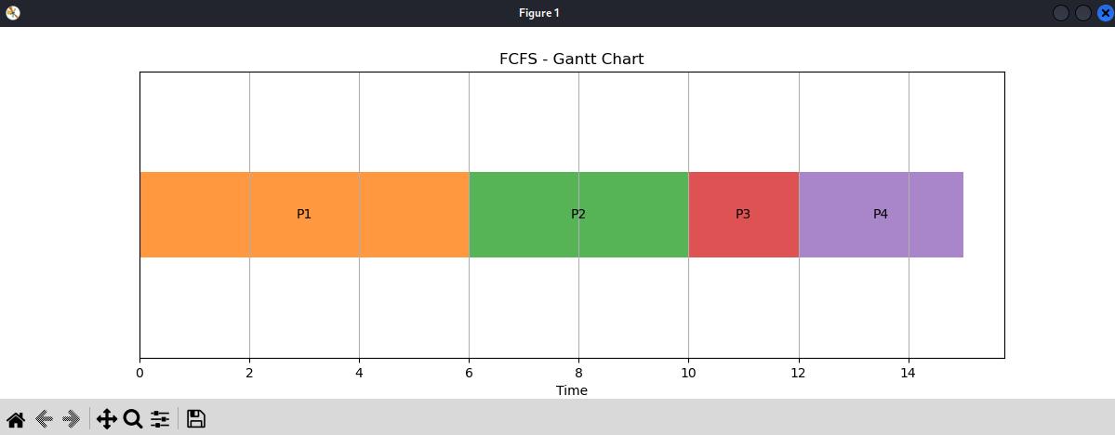

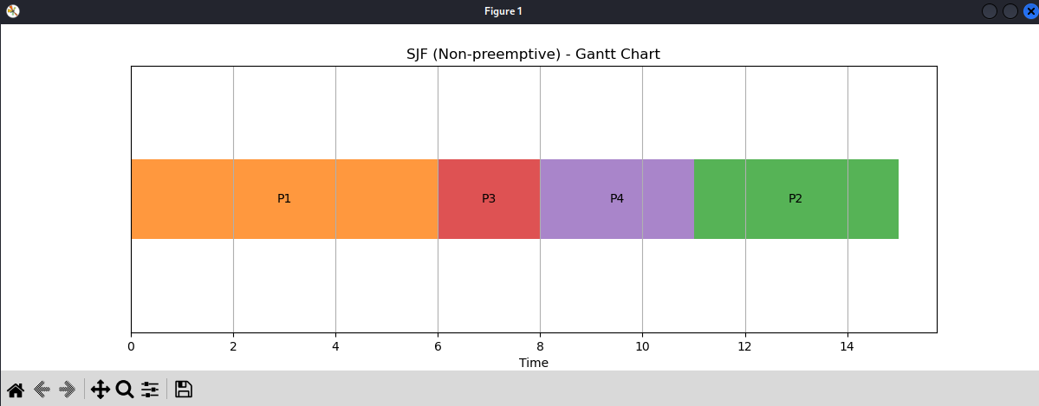

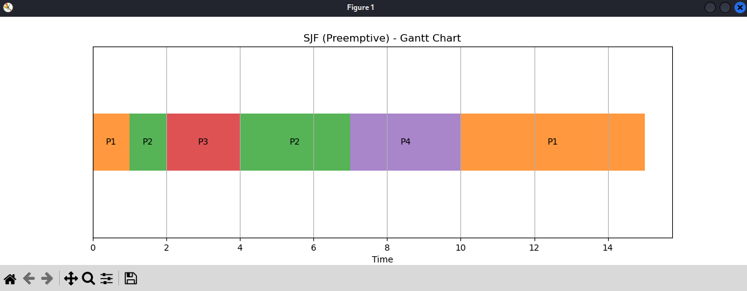

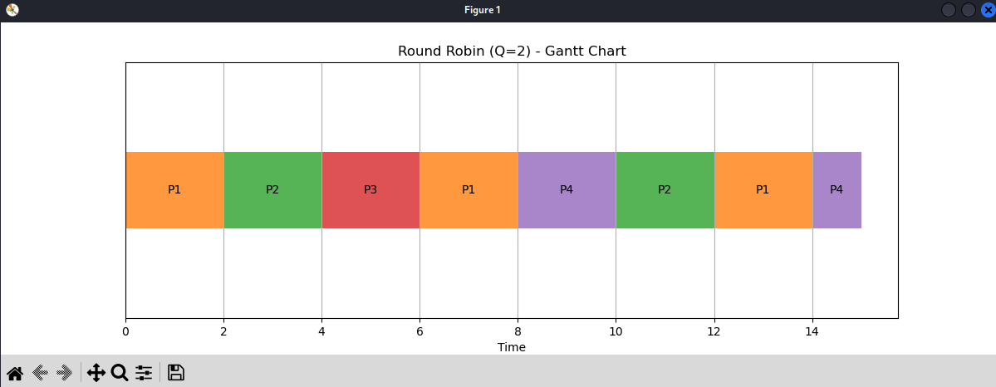

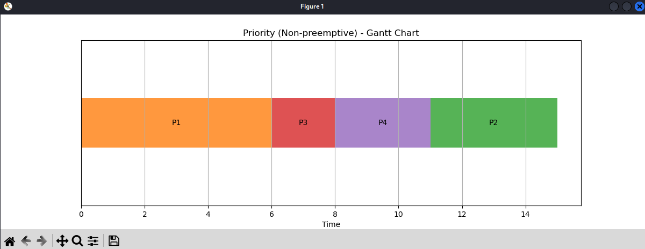

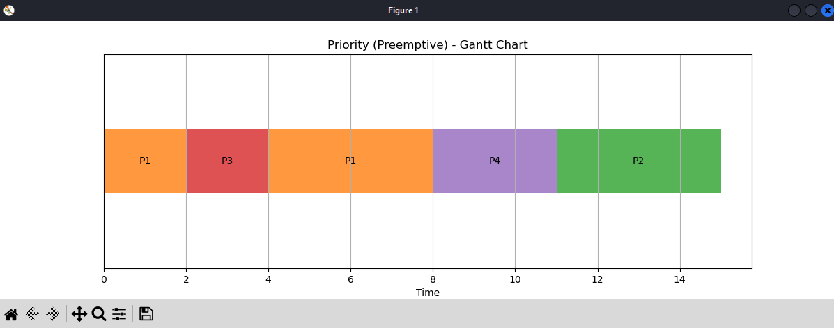

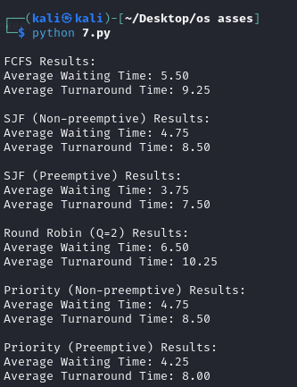

1. **First come First serve**

import matplotlib.pyplot as plt

class Process:

def __init__(self, pid, arrival_time, burst_time):

self.pid = pid

self.arrival_time = arrival_time

self.burst_time = burst_time

self.start_time = 0

self.completion_time = 0

self.waiting_time = 0

self.turnaround_time = 0

class CPUSchedulerFCFS:

def __init__(self):

self.processes = []

self.gantt_chart = []

def add_process(self, pid, arrival_time, burst_time):

self.processes.append(Process(pid, arrival_time, burst_time))

def fcfs(self):

self.gantt_chart = []

processes = sorted(self.processes, key=lambda x: (x.arrival_time, x.pid))

current_time = 0

for process in processes:

if current_time < process.arrival_time:

current_time = process.arrival_time

process.start_time = current_time

process.completion_time = current_time + process.burst_time

process.turnaround_time = process.completion_time - process.arrival_time

process.waiting_time = process.turnaround_time - process.burst_time

self.gantt_chart.append((process.pid, current_time, process.completion_time))

current_time = process.completion_time

return self.calculate_times()

def calculate_times(self):

avg_waiting_time = sum(p.waiting_time for p in self.processes) / len(self.processes)

avg_turnaround_time = sum(p.turnaround_time for p in self.processes) / len(self.processes)

return avg_waiting_time, avg_turnaround_time

def plot_gantt_chart(self, title):

fig, ax = plt.subplots(figsize=(12, 4))

for i, (pid, start, end) in enumerate(self.gantt_chart):

ax.barh(0, end - start, left=start, height=0.3, color=f'C{pid}', alpha=0.8)

ax.text((start + end) / 2, 0, f'P{pid}', ha='center', va='center')

ax.set_ylim(-0.5, 0.5)

ax.set_xlabel('Time')

ax.set_yticks([])

ax.set_title(title)

plt.grid(True)

plt.show()

# Example usage

scheduler = CPUSchedulerFCFS()

scheduler.add_process(1, 0, 6)

scheduler.add_process(2, 1, 4)

scheduler.add_process(3, 2, 2)

scheduler.add_process(4, 3, 3)

avg_waiting_time, avg_turnaround_time = scheduler.fcfs()

print(f"Average Waiting Time: {avg_waiting_time:.2f}")

print(f"Average Turnaround Time: {avg_turnaround_time:.2f}")

scheduler.plot_gantt_chart("FCFS - Gantt Chart")

IN C:

#include<stdio.h>

int main() {

int i, j, temp;

int bt[10] = {0}, at[10] = {0}, tat[10] = {0}, wt[10] = {0}, ct[10] = {0};

int n;

float totalTAT = 0, totalWT = 0;

printf("Enter number of processes: ");

scanf("%d", &n);

int p[n];

for (i = 0; i < n; i++) {

p[i] = i + 1;

}

printf("Enter arrival time and burst time for each process\n\n");

for (i = 0; i < n; i++) {

printf("Arrival time of process[%d]: ", i + 1);

scanf("%d", &at[i]);

printf("Burst time of process[%d]: ", i + 1);

scanf("%d", &bt[i]);

printf("\n");

}

for (i = 0; i < n - 1; i++) {

for (j = i + 1; j < n; j++) {

if (at[i] > at[j]) {

temp = at[i];

at[i] = at[j];

at[j] = temp;

temp = bt[i];

bt[i] = bt[j];

bt[j] = temp;

temp = p[i];

p[i] = p[j];

p[j] = temp;

}

}

}

int currentTime = 0;

for (i = 0; i < n; i++) {

if (currentTime < at[i]) {

currentTime = at[i];

}

ct[i] = currentTime + bt[i];

currentTime = ct[i];

tat[i] = ct[i] - at[i];

wt[i] = tat[i] - bt[i];

totalTAT += tat[i];

totalWT += wt[i];

}

printf("\nGantt Chart:\n");

printf(" |");

for (i = 0; i < n; i++) {

printf(" P%d |", p[i]);

}

printf("\n");

printf("0");

for (i = 0; i < n; i++) {

printf(" %d", ct[i]);

}

printf("\n\n");

printf("Solution: \n\n");

printf("P#\t AT\t BT\t CT\t TAT\t WT\n");

for (i = 0; i < n; i++) {

printf("P%d\t %d\t %d\t %d\t %d\t %d\n", p[i], at[i], bt[i], ct[i], tat[i], wt[i]);

}

printf("\nAverage Turnaround Time = %.2f\n", totalTAT / n);

printf("Average Waiting Time = %.2f\n\n", totalWT / n);

return 0;

}

1. **Shortest Job First (Non-preemptive)**

import matplotlib.pyplot as plt

class Process:

def __init__(self, pid, arrival_time, burst_time):

self.pid = pid

self.arrival_time = arrival_time

self.burst_time = burst_time

self.completion_time = 0

self.turnaround_time = 0

self.waiting_time = 0

class SJFScheduler:

def __init__(self, processes):

self.processes = processes

self.gantt_chart = []

def schedule(self):

# Sort processes by arrival time, then by burst time

self.processes.sort(key=lambda p: (p.arrival_time, p.burst_time))

time = 0

completed_processes = 0

while completed_processes < len(self.processes):

# Filter processes that have arrived and are not completed

available_processes = [p for p in self.processes if p.arrival_time <= time and p.completion_time == 0]

if not available_processes:

time += 1

continue

# Select the process with the shortest burst time

shortest_job = min(available_processes, key=lambda p: p.burst_time)

start_time = time

time += shortest_job.burst_time

shortest_job.completion_time = time

shortest_job.turnaround_time = shortest_job.completion_time - shortest_job.arrival_time

shortest_job.waiting_time = shortest_job.turnaround_time - shortest_job.burst_time

# Add to Gantt chart

self.gantt_chart.append((shortest_job.pid, start_time, time))

completed_processes += 1

def calculate_averages(self):

total_waiting_time = sum(p.waiting_time for p in self.processes)

total_turnaround_time = sum(p.turnaround_time for p in self.processes)

avg_waiting_time = total_waiting_time / len(self.processes)

avg_turnaround_time = total_turnaround_time / len(self.processes)

return avg_waiting_time, avg_turnaround_time

def plot_gantt_chart(self, title):

fig, ax = plt.subplots(figsize=(12, 4))

for pid, start, end in self.gantt_chart:

ax.barh(0, end - start, left=start, height=0.3, label=f'P{pid}', edgecolor='black', alpha=0.8)

ax.text(start + (end - start) / 2, 0, f'P{pid}', ha='center', va='center', color='white')

ax.set_title(title)

ax.set_xlabel("Time")

ax.set_yticks([])

ax.legend()

plt.show()

# Example Usage

if __name__ == "__main__":

# Input process data

processes = [

Process(pid=1, arrival_time=0, burst_time=7),

Process(pid=2, arrival_time=2, burst_time=4),

Process(pid=3, arrival_time=4, burst_time=1),

Process(pid=4, arrival_time=5, burst_time=4)

]

scheduler = SJFScheduler(processes)

scheduler.schedule()

avg_waiting_time, avg_turnaround_time = scheduler.calculate_averages()

print("PID\tAT\tBT\tCT\tTAT\tWT")

for p in scheduler.processes:

print(f"{p.pid}\t{p.arrival_time}\t{p.burst_time}\t{p.completion_time}\t{p.turnaround_time}\t{p.waiting_time}")

print(f"\nAverage Waiting Time: {avg_waiting_time:.2f}")

print(f"Average Turnaround Time: {avg_turnaround_time:.2f}")

scheduler.plot_gantt_chart("SJF Non-preemptive - Gantt Chart")

IN C:

#include <stdio.h>

int main()

{

int A[100][4];

int i, j, n, total = 0, index, temp;

float avg_wt, avg_tat;

printf("Enter number of processes: ");

scanf("%d", &n);

printf("Enter Burst Time:\n");

for (i = 0; i < n; i++) {

printf("P%d: ", i + 1);

scanf("%d", &A[i][1]);

A[i][0] = i + 1;

}

for (i = 0; i < n; i++) {

index = i;

for (j = i + 1; j < n; j++) {

if (A[j][1] < A[index][1]) {

index = j;

}

}

temp = A[i][1];

A[i][1] = A[index][1];

A[index][1] = temp;

temp = A[i][0];

A[i][0] = A[index][0];

A[index][0] = temp;

}

A[0][2] = 0;

for (i = 1; i < n; i++) {

A[i][2] = 0;

for (j = 0; j < i; j++) {

A[i][2] += A[j][1];

}

total += A[i][2];

}

avg_wt = (float)total / n;

total = 0;

printf("\nP\tBT\tWT\tTAT\n");

for (i = 0; i < n; i++) {

A[i][3] = A[i][1] + A[i][2]; // TAT = BT + WT

total += A[i][3];

printf("P%d\t%d\t%d\t%d\n", A[i][0], A[i][1], A[i][2], A[i][3]);

}

avg_tat = (float)total / n;

printf("\nGantt Chart:\n");

printf("|");

for (i = 0; i < n; i++) {

printf(" P%d |", A[i][0]);

}

printf("\n");

int completion_time = 0;

printf("0");

for (i = 0; i < n; i++) {

completion_time += A[i][1];

printf(" %d", completion_time);

}

printf("\n\nAverage Waiting Time = %.2f", avg_wt);

printf("\nAverage Turnaround Time = %.2f\n", avg_tat);

return 0;

}

1. **Shortest Job First (Preemptive)**

import matplotlib.pyplot as plt

class Process:

def __init__(self, pid, arrival_time, burst_time):

self.pid = pid

self.arrival_time = arrival_time

self.burst_time = burst_time

self.remaining_time = burst_time

self.completion_time = 0

self.turnaround_time = 0

self.waiting_time = 0

self.start_time = -1 # To track when the process started execution

class SJFPreemptiveScheduler:

def __init__(self, processes):

self.processes = processes

self.gantt_chart = []

def schedule(self):

time = 0

completed_processes = 0

processes = sorted(self.processes, key=lambda x: x.arrival_time) # Sort by arrival time

ready_queue = []

current_process = None

last_time = 0

while completed_processes < len(processes):

# Add all processes that have arrived by the current time to the ready queue

for p in processes:

if p.arrival_time <= time and p not in ready_queue and p.remaining_time > 0:

ready_queue.append(p)

# If there's a process in the ready queue, choose the one with the shortest remaining time

if ready_queue:

ready_queue.sort(key=lambda p: p.remaining_time)

current_process = ready_queue[0]

# If the process has not started, set its start time

if current_process.start_time == -1:

current_process.start_time = time

current_process.remaining_time -= 1

time += 1

# If the process has finished execution

if current_process.remaining_time == 0:

current_process.completion_time = time

current_process.turnaround_time = current_process.completion_time - current_process.arrival_time

current_process.waiting_time = current_process.turnaround_time - current_process.burst_time

completed_processes += 1

ready_queue.remove(current_process)

self.gantt_chart.append((current_process.pid, last_time, time))

else:

time += 1 # If no process is in the ready queue, increment time

return time

def calculate_averages(self):

total_waiting_time = sum(p.waiting_time for p in self.processes)

total_turnaround_time = sum(p.turnaround_time for p in self.processes)

avg_waiting_time = total_waiting_time / len(self.processes)

avg_turnaround_time = total_turnaround_time / len(self.processes)

return avg_waiting_time, avg_turnaround_time

def plot_gantt_chart(self, title):

fig, ax = plt.subplots(figsize=(12, 4))

for pid, start, end in self.gantt_chart:

ax.barh(0, end - start, left=start, height=0.3, label=f'P{pid}', edgecolor='black', alpha=0.8)

ax.text(start + (end - start) / 2, 0, f'P{pid}', ha='center', va='center', color='white')

ax.set_title(title)

ax.set_xlabel("Time")

ax.set_yticks([])

ax.legend()

plt.show()

# Example Usage

if __name__ == "__main__":

# Input process data

processes = [

Process(pid=1, arrival_time=0, burst_time=7),

Process(pid=2, arrival_time=2, burst_time=4),

Process(pid=3, arrival_time=4, burst_time=1),

Process(pid=4, arrival_time=5, burst_time=4)

]

scheduler = SJFPreemptiveScheduler(processes)

scheduler.schedule()

avg_waiting_time, avg_turnaround_time = scheduler.calculate_averages()

print("PID\tAT\tBT\tCT\tTAT\tWT")

for p in scheduler.processes:

print(f"{p.pid}\t{p.arrival_time}\t{p.burst_time}\t{p.completion_time}\t{p.turnaround_time}\t{p.waiting_time}")

print(f"\nAverage Waiting Time: {avg_waiting_time:.2f}")

print(f"Average Turnaround Time: {avg_turnaround_time:.2f}")

scheduler.plot_gantt_chart("SJF Preemptive (SRTF) - Gantt Chart")

IN C:

#include <stdio.h>

#include <limits.h>

struct Process {

int pid;

int bt;

int art;

};

void findWaitingTime(struct Process proc[], int n, int wt[]) {

int rt[n];

int i,j;

for ( i = 0; i < n; i++)

rt[i] = proc[i].bt;

int complete = 0, t = 0, minm = INT_MAX;

int shortest = 0, finish_time;

int check = 0;

while (complete != n) {

for ( j = 0; j < n; j++) {

if ((proc[j].art <= t) &&

(rt[j] < minm) && rt[j] > 0) {

minm = rt[j];

shortest = j;

check = 1;

}

}

if (check == 0) {

t++;

continue;

}

rt[shortest]--;

minm = rt[shortest];

if (minm == 0)

minm = INT_MAX;

if (rt[shortest] == 0) {

complete++;

check = 0;

finish_time = t + 1;

wt[shortest] = finish_time -

proc[shortest].bt -

proc[shortest].art;

if (wt[shortest] < 0)

wt[shortest] = 0;

}

t++;

}

}

void findTurnAroundTime(struct Process proc[], int n, int wt[], int tat[]) {

int i;

for ( i = 0; i < n; i++)

tat[i] = proc[i].bt + wt[i];

}

void findavgTime(struct Process proc[], int n) {

int i;

int wt[n], tat[n], total_wt = 0,total_tat = 0;

findWaitingTime(proc, n, wt);

findTurnAroundTime(proc, n, wt, tat);

printf(" P\t\t"

"BT\t\t"

"WT\t\t"

"TAT\t\t\n");

for ( i = 0; i < n; i++) {

total_wt = total_wt + wt[i];

total_tat = total_tat + tat[i];

printf(" %d\t\t"

"%d\t\t %d"

"\t\t %d\n", proc[i].pid,

proc[i].bt, wt[i], tat[i]);

}

printf("\nAverage waiting time = "

"%f", (float)total_wt / (float)n);

printf("\nAverage turn around time = "

"%f", (float)total_tat / (float)n);

}

int main() {

struct Process proc[] = { { 1, 6, 2 }, { 2, 2, 5 },

{ 3, 8, 1 }, { 4, 3, 0}, {5, 4, 4} };

int n = sizeof(proc) / sizeof(proc[0]);

findavgTime(proc, n);

return 0;

}

1. **Round Robin**

import matplotlib.pyplot as plt

from collections import deque

class Process:

def __init__(self, pid, arrival_time, burst_time):

self.pid = pid

self.arrival_time = arrival_time

self.burst_time = burst_time

self.remaining_time = burst_time

self.completion_time = 0

self.turnaround_time = 0

self.waiting_time = 0

self.start_time = -1 # To track when the process started execution

class RoundRobinScheduler:

def __init__(self, processes, time_quantum):

self.processes = processes

self.time_quantum = time_quantum

self.gantt_chart = []

def schedule(self):

time = 0

completed_processes = 0

processes = sorted(self.processes, key=lambda x: x.arrival_time) # Sort by arrival time

ready_queue = deque()

last_time = 0

while completed_processes < len(processes):

# Add all processes that have arrived by the current time to the ready queue

for p in processes:

if p.arrival_time <= time and p not in ready_queue and p.remaining_time > 0:

ready_queue.append(p)

# If there's a process in the ready queue, select the next process to execute

if ready_queue:

current_process = ready_queue.popleft()

# If the process has not started, set its start time

if current_process.start_time == -1:

current_process.start_time = time

# Calculate the time to execute the process

exec_time = min(current_process.remaining_time, self.time_quantum)

current_process.remaining_time -= exec_time

time += exec_time

# If the process has finished execution

if current_process.remaining_time == 0:

current_process.completion_time = time

current_process.turnaround_time = current_process.completion_time - current_process.arrival_time

current_process.waiting_time = current_process.turnaround_time - current_process.burst_time

completed_processes += 1

self.gantt_chart.append((current_process.pid, last_time, time))

else:

ready_queue.append(current_process)

last_time = time

else:

time += 1 # If no process is in the ready queue, increment time

return time

def calculate_averages(self):

total_waiting_time = sum(p.waiting_time for p in self.processes)

total_turnaround_time = sum(p.turnaround_time for p in self.processes)

avg_waiting_time = total_waiting_time / len(self.processes)

avg_turnaround_time = total_turnaround_time / len(self.processes)

return avg_waiting_time, avg_turnaround_time

def plot_gantt_chart(self, title):

fig, ax = plt.subplots(figsize=(12, 4))

for pid, start, end in self.gantt_chart:

ax.barh(0, end - start, left=start, height=0.3, label=f'P{pid}', edgecolor='black', alpha=0.8)

ax.text(start + (end - start) / 2, 0, f'P{pid}', ha='center', va='center', color='white')

ax.set_title(title)

ax.set_xlabel("Time")

ax.set_yticks([])

ax.legend()

plt.show()

# Example Usage

if __name__ == "__main__":

# Input process data

processes = [

Process(pid=1, arrival_time=0, burst_time=5),

Process(pid=2, arrival_time=1, burst_time=3),

Process(pid=3, arrival_time=2, burst_time=8),

Process(pid=4, arrival_time=3, burst_time=6)

]

time_quantum = 4 # Set time quantum for Round Robin

scheduler = RoundRobinScheduler(processes, time_quantum)

scheduler.schedule()

avg_waiting_time, avg_turnaround_time = scheduler.calculate_averages()

print("PID\tAT\tBT\tCT\tTAT\tWT")

for p in scheduler.processes:

print(f"{p.pid}\t{p.arrival_time}\t{p.burst_time}\t{p.completion_time}\t{p.turnaround_time}\t{p.waiting_time}")

print(f"\nAverage Waiting Time: {avg_waiting_time:.2f}")

print(f"Average Turnaround Time: {avg_turnaround_time:.2f}")

scheduler.plot_gantt_chart("Round Robin Scheduling - Gantt Chart")

IN C:

#include<stdio.h>

#include<conio.h>

void main()

{

int i, NOP, sum = 0, count = 0, y, quant, wt = 0, tat = 0, at[10], bt[10], temp[10];

float avg_wt, avg_tat;

int gantt[100], gantt_time[100], gantt_index = 0;

printf("Total number of processes in the system: ");

scanf("%d", &NOP);

y = NOP;

for(i = 0; i < NOP; i++)

{

printf("\nEnter the Arrival and Burst time of Process[%d]\n", i + 1);

printf("Arrival time: ");

scanf("%d", &at[i]);

printf("Burst time: ");

scanf("%d", &bt[i]);

temp[i] = bt[i];

}

printf("Enter the Time Quantum for the processes: ");

scanf("%d", &quant);

printf("\nProcess No\tBurst Time\tTurnaround Time\tWaiting Time");

for(sum = 0, i = 0; y != 0;)

{

if(temp[i] <= quant && temp[i] > 0)

{

sum += temp[i];

temp[i] = 0;

count = 1;

gantt[gantt_index] = i + 1;

gantt_time[gantt_index] = sum;

gantt_index++;

}

else if(temp[i] > 0)

{

temp[i] -= quant;

sum += quant;

gantt[gantt_index] = i + 1;

gantt_time[gantt_index] = sum;

gantt_index++;

}

if(temp[i] == 0 && count == 1)

{

y--;

printf("\nProcess[%d]\t\t%d\t\t%d\t\t%d", i + 1, bt[i], sum - at[i], sum - at[i] - bt[i]);

wt += sum - at[i] - bt[i];

tat += sum - at[i];

count = 0;

}

if(i == NOP - 1)

{

i = 0;

}

else if(at[i + 1] <= sum)

{

i++;

}

else

{

i = 0;

}

}

avg_wt = (float)wt / NOP;

avg_tat = (float)tat / NOP;

printf("\nAverage Turnaround Time: %.2f", avg_tat);

printf("\nAverage Waiting Time: %.2f\n", avg_wt);

printf("\nGantt Chart:\n|");

for(i = 0; i < gantt_index; i++)

{

printf(" P%d |", gantt[i]);

}

printf("\n0");

for(i = 0; i < gantt_index; i++)

{

printf(" %d", gantt_time[i]);

}

getch();

}

1. **Priority (Non-preemptive)**

import matplotlib.pyplot as plt

class Process:

def __init__(self, pid, arrival_time, burst_time, priority):

self.pid = pid

self.arrival_time = arrival_time

self.burst_time = burst_time

self.priority = priority

self.completion_time = 0

self.turnaround_time = 0

self.waiting_time = 0

self.start_time = -1 # To track when the process started execution

class PriorityScheduler:

def __init__(self, processes):

self.processes = processes

self.gantt_chart = []

def schedule(self):

time = 0

completed_processes = 0

processes = sorted(self.processes, key=lambda x: (x.arrival_time, x.priority)) # Sort by arrival time and priority

ready_queue = []

last_time = 0

while completed_processes < len(processes):

# Add processes that have arrived by the current time to the ready queue

for p in processes:

if p.arrival_time <= time and p not in ready_queue:

ready_queue.append(p)

# If there's a process in the ready queue, select the one with the highest priority

if ready_queue:

ready_queue.sort(key=lambda p: p.priority) # Sort by priority

current_process = ready_queue.pop(0) # Process with highest priority

# If the process has not started, set its start time

if current_process.start_time == -1:

current_process.start_time = time

# Process executes to completion

current_process.completion_time = time + current_process.burst_time

current_process.turnaround_time = current_process.completion_time - current_process.arrival_time

current_process.waiting_time = current_process.turnaround_time - current_process.burst_time

time = current_process.completion_time # Update time to when the current process finishes

completed_processes += 1

self.gantt_chart.append((current_process.pid, last_time, time))

else:

time += 1 # If no process is in the ready queue, increment time

last_time = time

return time

def calculate_averages(self):

total_waiting_time = sum(p.waiting_time for p in self.processes)

total_turnaround_time = sum(p.turnaround_time for p in self.processes)

avg_waiting_time = total_waiting_time / len(self.processes)

avg_turnaround_time = total_turnaround_time / len(self.processes)

return avg_waiting_time, avg_turnaround_time

def plot_gantt_chart(self, title):

fig, ax = plt.subplots(figsize=(12, 4))

for pid, start, end in self.gantt_chart:

ax.barh(0, end - start, left=start, height=0.3, label=f'P{pid}', edgecolor='black', alpha=0.8)

ax.text(start + (end - start) / 2, 0, f'P{pid}', ha='center', va='center', color='white')

ax.set_title(title)

ax.set_xlabel("Time")

ax.set_yticks([])

ax.legend()

plt.show()

# Example Usage

if __name__ == "__main__":

# Input process data: (PID, Arrival Time, Burst Time, Priority)

processes = [

Process(pid=1, arrival_time=0, burst_time=5, priority=2),

Process(pid=2, arrival_time=1, burst_time=3, priority=1),

Process(pid=3, arrival_time=2, burst_time=8, priority=4),

Process(pid=4, arrival_time=3, burst_time=6, priority=3)

]

scheduler = PriorityScheduler(processes)

scheduler.schedule()

avg_waiting_time, avg_turnaround_time = scheduler.calculate_averages()

print("PID\tAT\tBT\tPriority\tCT\tTAT\tWT")

for p in scheduler.processes:

print(f"{p.pid}\t{p.arrival_time}\t{p.burst_time}\t{p.priority}\t\t{p.completion_time}\t{p.turnaround_time}\t{p.waiting_time}")

print(f"\nAverage Waiting Time: {avg_waiting_time:.2f}")

print(f"Average Turnaround Time: {avg_turnaround_time:.2f}")

scheduler.plot_gantt_chart("Priority Scheduling (Non-preemptive) - Gantt Chart")

1. **Priority (preemptive)**

def priority_scheduling(processes):

n = len(processes)

processes.sort(key=lambda x: (x['arrival_time'], x['priority'], x['pid']))

time = 0

completed = 0

gantt_chart = []

ready_queue = []

current_process = None

while completed < n:

# Debugging: Display the time and process states

print(f"Time: {time}, Completed: {completed}, Ready Queue: {[p['pid'] for p in ready_queue]}")

# Add processes to the ready queue based on arrival time

for process in processes:

if process['arrival_time'] <= time and not process['is_completed']:

if process not in ready_queue:

ready_queue.append(process)

# Check if the current process is completed

if current_process and current_process['burst_time'] == 0:

current_process['is_completed'] = True

current_process['finish_time'] = time

current_process['turnaround_time'] = current_process['finish_time'] - current_process['arrival_time']

current_process['waiting_time'] = current_process['turnaround_time'] - current_process['original_burst_time']

completed += 1

current_process = None # Reset current process

# Select the next process to execute

if current_process is None and ready_queue:

ready_queue.sort(key=lambda x: (x['priority'], x['arrival_time'], x['pid']))

current_process = ready_queue.pop(0)

# Execute the current process or mark the CPU as idle

if current_process:

gantt_chart.append(current_process['pid'])

current_process['burst_time'] -= 1

else:

gantt_chart.append("Idle")

# Increment time

time += 1

# Safeguard: Prevent infinite loop by ensuring progress

if time > 100: # Timeout for debugging

print("ERROR: Timeout reached. Check the logic for infinite loops.")

break

# Optimize Gantt chart to remove consecutive duplicates

optimized_gantt_chart = [gantt_chart[0]]

for i in range(1, len(gantt_chart)):

if gantt_chart[i] != gantt_chart[i - 1]:

optimized_gantt_chart.append(gantt_chart[i])

# Prepare the results for display

results = []

for p in processes:

results.append({

"PID": p["pid"],

"Priority": p["priority"],

"Arrival Time": p["arrival_time"],

"Burst Time": p["original_burst_time"],

"Finish Time": p["finish_time"],

"Turnaround Time": p["turnaround_time"],

"Waiting Time": p["waiting_time"],

})

return results, optimized_gantt_chart

# Input

process_list = [

{"pid": "P1", "arrival_time": 0, "burst_time": 7, "priority": 2, "is_completed": False, "finish_time": 0, "turnaround_time": 0, "waiting_time": 0},

{"pid": "P2", "arrival_time": 2, "burst_time": 4, "priority": 1, "is_completed": False, "finish_time": 0, "turnaround_time": 0, "waiting_time": 0},

{"pid": "P3", "arrival_time": 4, "burst_time": 1, "priority": 3, "is_completed": False, "finish_time": 0, "turnaround_time": 0, "waiting_time": 0},

{"pid": "P4", "arrival_time": 5, "burst_time": 4, "priority": 2, "is_completed": False, "finish_time": 0, "turnaround_time": 0, "waiting_time": 0},

]

# Store original burst time

for p in process_list:

p["original_burst_time"] = p["burst_time"]

# Run simulation

results, gantt_chart = priority_scheduling(process_list)

# Display Results

print("\nGantt Chart:", " -> ".join(gantt_chart))

print("\nResults:")

for res in results:

print(res)