Contents

Prerequisites 2

Create project 3

Add XR support 3

Add head tracking to camera 3

Add XR interaction toolkit 4

Setup XR Rig 4

Play on Oculus Quest 2 6

# Prerequisites

The start of this document is written on 05/09/2022

# Create project

Editor version: 2021.3.8f1

Project template: 3D (URP)

# Add XR support

Go to Edit -> Project settings -> XR Plug-in Management and enable OpenXR for Desktop and Android

# Add head tracking to camera

# Add XR interaction toolkit

Go to Window -> Package Manager and Add package by name.

# Setup XR Rig

1. Remove Main Camera from scene
2. Add new Object to the scene: XR -> XR Origin (VR)

1. Set the Tracking Origin Mode to Floor Graphical user interface, text, application

   Description automatically generated
2. Install the package to configure the controller actions. Under XR Interaction Toolkit install the Starter Assets.

This creates the following directory

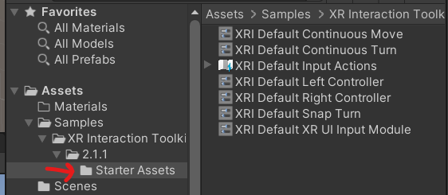

1. Use the XRI Default Left Controller preset for the Left Hand Controller under the XR Origin. (Do this for the left and right controller)

1. Add the Input Action Manager to the XR Origin

1. The controllers are now set up and to visualize this you can add small cubes to the hands.

# Play on Oculus Quest 2

Open SteamVR via Air Link and play the scene in Unity.