S I L O R A O R I E N T

缠 花
C H Ā N H U Ā

Living Heritage in Silk and Poetry
丝线与诗意中的活态非物质文化遗产

Exhibition Proposal · 展览提案
United Nations Chinese Language Day & Mid-Autumn Cultural Events
联合国中文日 · 中秋文化活动 ·
纽约New York
April 2026

About the Artist & Studio 关于艺术家与工作室

Silora Orient was co-founded five years ago by Ma Yuetong (马玥桐) and her best friend, a master craftsperson. The studio was born from a single conviction: that Chānhuā — one of China's most exquisite intangible cultural heritages — deserves a new stage in the world.
工作室由马玥桐与最好的朋友王晨（园林设计师）共同创立，五年来以缠花非遗为核心进行设计创作，致力于将这门古老工艺带入当代世界的舞台。

M A Y U E T O N G 马玥桐

– Graduated from Peking University (北京大学)
– Geospatial Analyst & Cartographer · 地理分析师与制图师
– Trained in Botany & Garden / Landscape Arts · 植物学与园林
– Currently based in New York, United Nations · 现就职于联合国纽约总部
– Co-founder, Silora Orient Studio · 缠花工作室联合创始人

S I L O R A O R I E N T S T U D I O

– Founded 2020 · Five years of heritage craft and design
– All works conceived from the imagery of classical Chinese poetry
– Osmanthus Series featured on CCTV Spring Festival Gala 2026 · 2026年登上央视春晚
– Empowering artisan women in Sichuan Province through craft
– Fully biodegradable materials — silk, paper, wood pulp, natural gemstones

The Craft — What is Chānhuā? 缠花是什么？

Chānhuā (缠花) is a traditional Chinese craft in which colourful silk threads are wound layer by layer around frames of copper wire and stiff paper, creating vivid three-dimensional flowers, birds, and jewellery. The craft traces its origins to the Northern Song Dynasty (960–1127 AD). Today it carries the status of Chinese Intangible Cultural Heritage (非物质文化遗产), with two regional schools: Yingshan Chānhuā (英山缠花, Hubei Province) in the north, and Minnan Chānhuā (闽南缠花, Fujian Province) in the south.
缠花以铜丝为骨、卡纸为底、蚕丝为面，将多色蚕丝线逐圈缠绕在胚架上，制作出栩栩如生的立体花卉、飞鸟及装饰珠宝。起源于北宋，现已列为中国非物质文化遗产，形成「北英南闽」两大流派——湖北英山缠花与福建闽南缠花。

The Four Defining Qualities · 四大特色

小 Small Compact, wearable, intimate in scale
巧 Clever Ingenious design — every thread deliberate
精 Refined Meticulous craftsmanship, hours of skilled handwork
活 Flexible Endless forms — flowers, birds, landscapes, jewellery

Our Values 我们与联合国可持续发展理念

Silora Orient was built on three commitments that go beyond aesthetics. We believe heritage craft should leave the world better — not only more beautiful.
工作室建立于三项超越美学的承诺之上：可持续、社会公平与个人连结。

I. Sustainability 可持续
All silk threads, paper, and wood-pulp card are 100% biodegradable bio-materials. Jewel accents are responsibly sourced. Our packaging is fully compostable — from the first stitch to the final box, every element returns to nature.
所有蚕丝线、卡纸和木浆均为可降解生物材料。珠宝配饰负责任采购。包装全为可降解材料，每个环节都与自然和谐共生，从第一针到最后的包装盒。

II. Social Equity 社会公平
Over five years, we have actively partnered with unemployed women in Sichuan Province, bringing them into our design and production process. Their mastery of the craft has grown alongside the studio — giving their skills a platform and a livelihood.
五年来，我们积极与四川省的失业女性合作，让她们加入设计与制造流程，使她们的传统工艺得以绽放，为她们带来收入与尊严，赋予非遗新的传承者。

III. Personal Connection 个人连结
We create fully customised pieces that link each wearer to their own story. Using orchid (兰花) — a flower rich in classical poetic meaning — as our signature motif, we design flowers that reflect the client's personal narrative, deepening their bond with this living heritage.
我们以兰花为例，将顾客自身的故事融入定制花朵设计，增强顾客与非遗工艺之间的情感连结，让传统工艺走入个人生命。

Featured Collections 代表作品系列

All works are named and conceived from the imagery of classical Chinese poetry — each piece a wearable poem, a bridge between the written word and the hand-made object. Every title is drawn directly from a Tang or Song Dynasty verse.
所有作品均以中国古诗意境取名立意，每件皆为可佩戴的诗篇，是文字与手工之间的桥梁。每个系列名称直接源自唐宋诗词。

I. Phalaenopsis Jewellery Series 蝴蝶兰系列
The moth orchid was chosen for its naturally extraordinary form — its wing-like petals require no embellishment; the flower alone is enough. The design philosophy centres entirely on colour, with seven named colourways each evoking a distinct sensory world: Honey Peach Oolong (蜜桃乌龙), Starry Moon Night (星月夜), Frozen Wonderland (冰雪奇缘), Gilded Dreams (澛金旧梦), and more. Available as earrings (耳钉), rings (戒指), and pendants (挂坠).
蝴蝶兰花型天然优雅，翩翩展翅，本身即是最好的设计，无需多余装饰。整体设计重心落在色彩上，共七款配色，每款以一种感官体验命名，搭配贝壳珠、水晶与宝石。系列涵盖耳钉、戒指与挂坠三种形式。

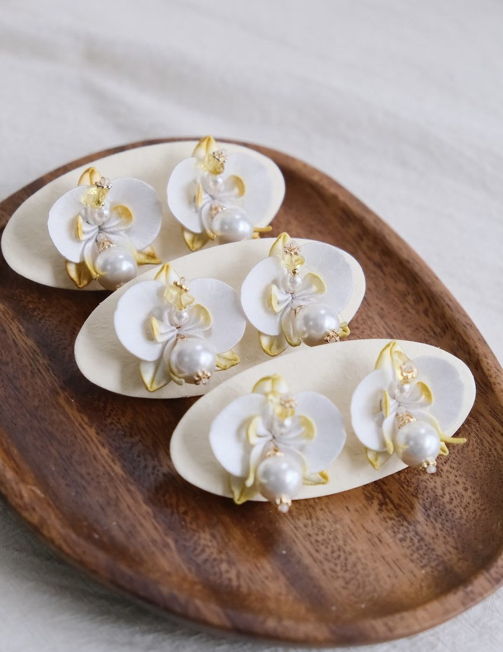 | 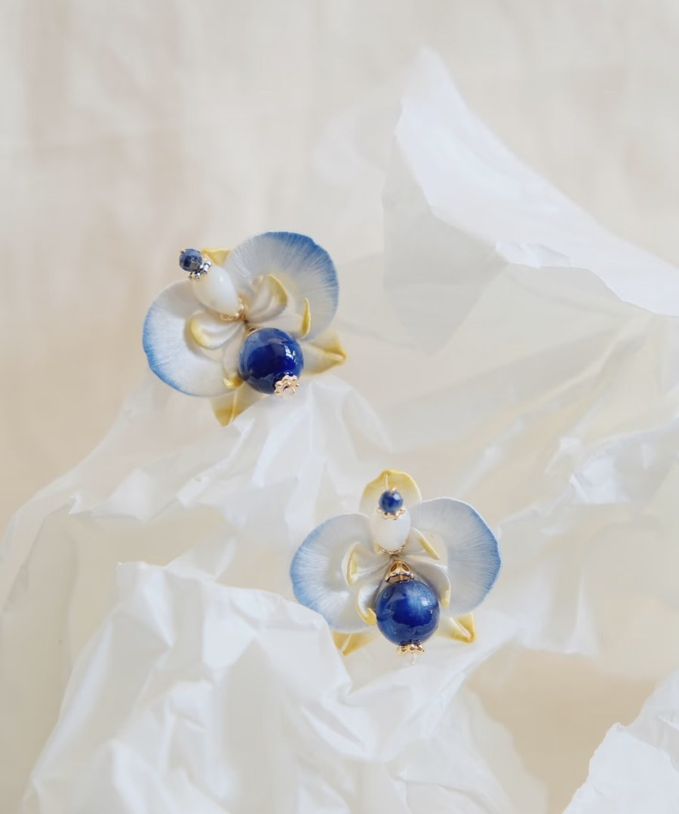
Gilded Dreams · 澛金旧梦 | Starry Moon Night · 星月夜

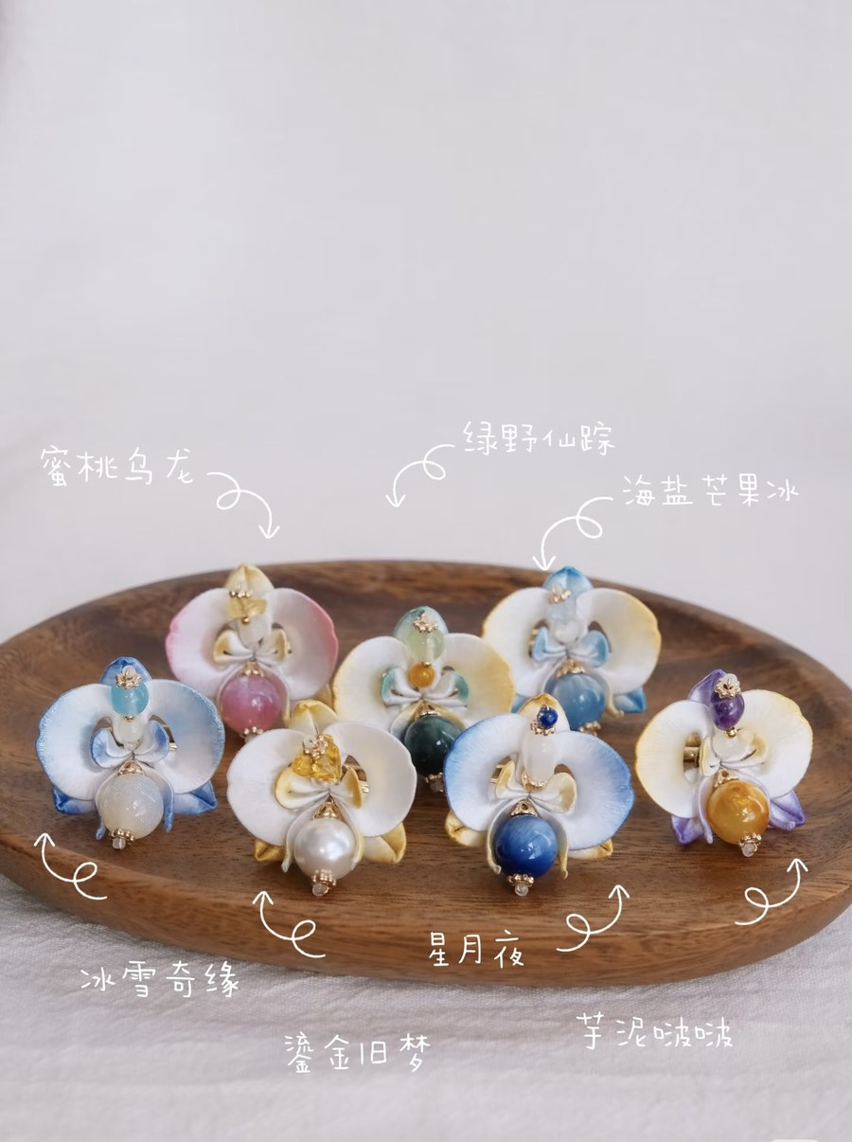
Complete Phalaenopsis series — seven colourways · 蝴蝶兰系列全七款配色
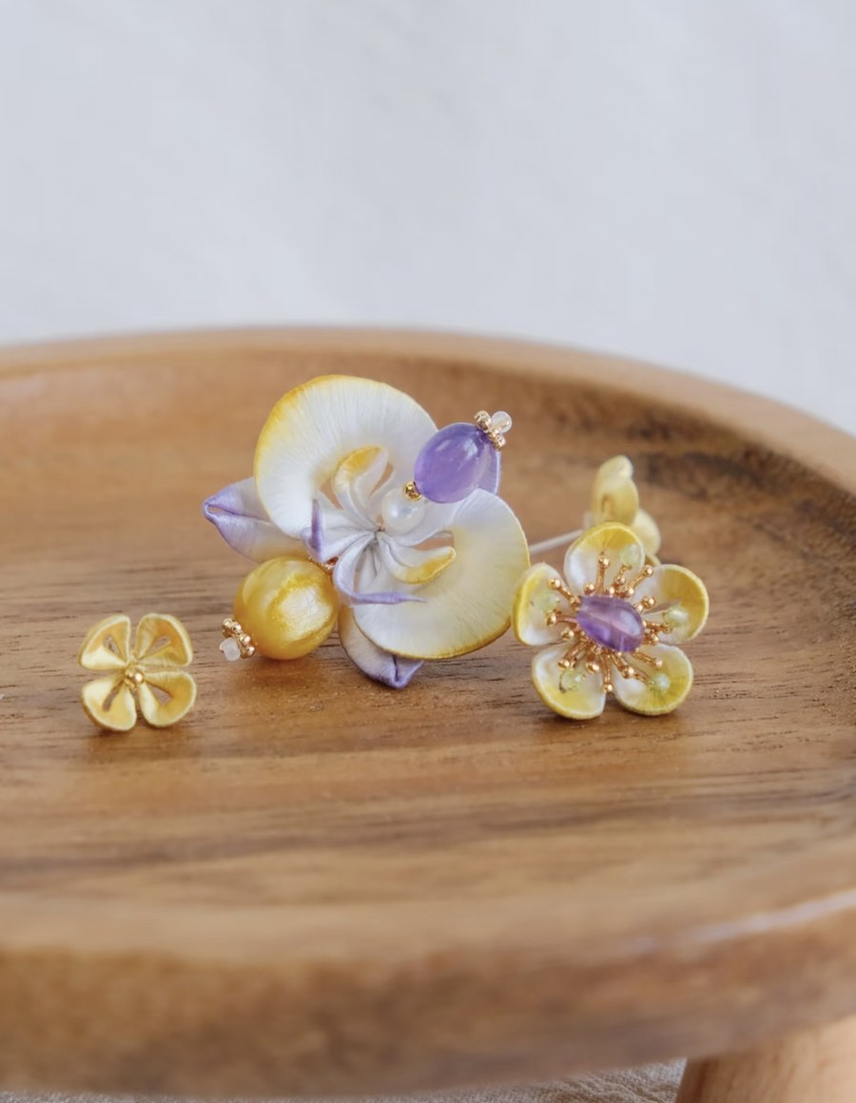 | 
Pendant & earring set · 挂坠与耳钉组合 | Blue ombré earrings · lapis lazuli · 蓝色渐变款

II. Crystal Curtain · Hairpin & Brooch Set 却下水晶帘

"She rolls back the crystal curtain, and gazes through its jade-clear folds at the autumn moon."
「却下水晶帘，玲珑望秋月。」
— Li Bai · 李白 · Tang Dynasty

Inspired by Li Bai's famous verse, this hairpin set builds from three images in the poem. At the centre: a large translucent moon disc, softly luminous. Around it: lavender and blue-white five-petal flowers shade from deep purple to white — the palette of a night sky. Below: crystal chain tassels (水晶流苏) shimmer with every movement, evoking moonbeams filtered through a crystal curtain.
作品名取自李白「却下水晶帘，玲珑望秋月」，围绕诗中三个意象展开：中央半透明圆形月片、周围薰衣草紫至蓝白渐变的五瓣小花，以及下方随风摇曳的水晶流苏。发簪与胸针套装，共同还原诗中的静秋夜色。

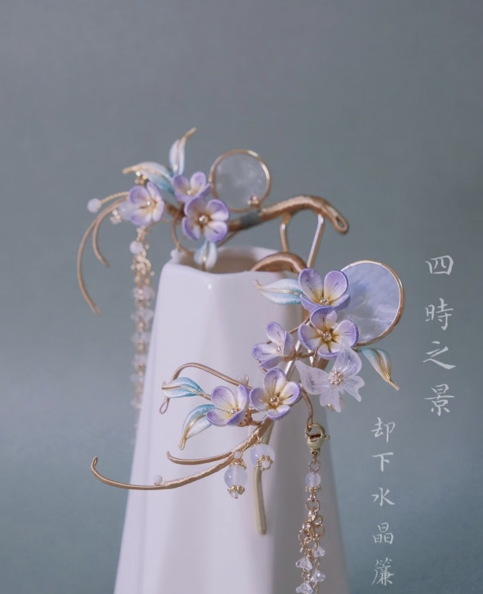
'Crystal Curtain' hairpin & brooch set · 却下水晶帘发簪套装

III. Osmanthus Series 月桂流金 · 四时之景

★ Featured on CCTV Spring Festival Gala 2026 · 桂花系列亮相2026年中央电视台春晚 ★
The Osmanthus series — 'Scenes of the Four Seasons: Moonlit Osmanthus in Flowing Gold' (四时之景·月桂流金) — embodies Chānhuā's core philosophy: understand nature deeply, then render it with vision rather than imitation. Osmanthus blossoms are tiny in nature; here they are intentionally enlarged so the four-petal form becomes the visual hero. Gold and amber blooms against deep olive-green leaves — autumn made wearable. Presented in three forms: Lattice Brooches (花窗胸针), Hairpin (发簪), and Hair Crown (发冠).
桂花系列以缠花创作核心哲学为基础：深入理解自然，以艺术眼光重新诠释，而非照搬。自然界的桂花极小，此处有意放大，使四瓣结构成为视觉焦点。金黄桂花簇与深绿秋香色叶片相搭，是可佩戴的秋天。系列以花窗胸针、发簪、发冠三种形式呈现，已亮相2026年央视春晚。

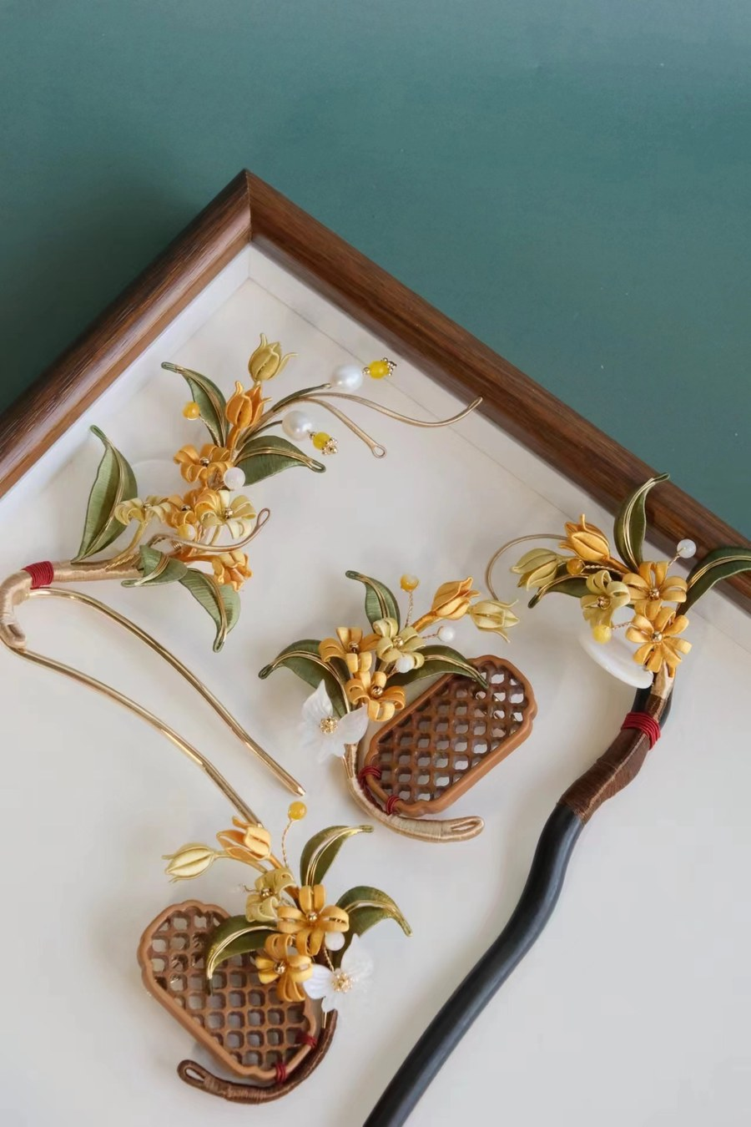 | 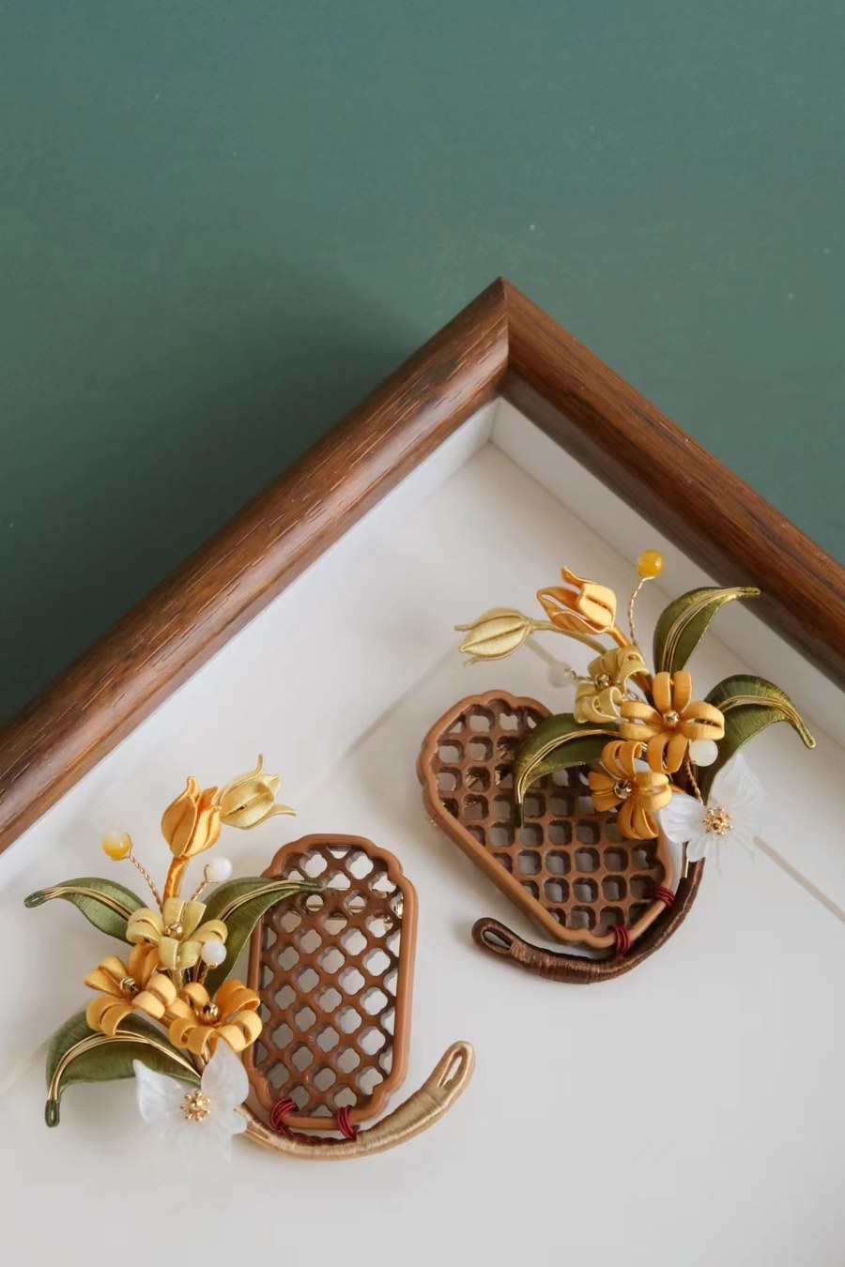
Full collection in display tray · 全套陈列 | Lattice brooches · 花窗胸针特写

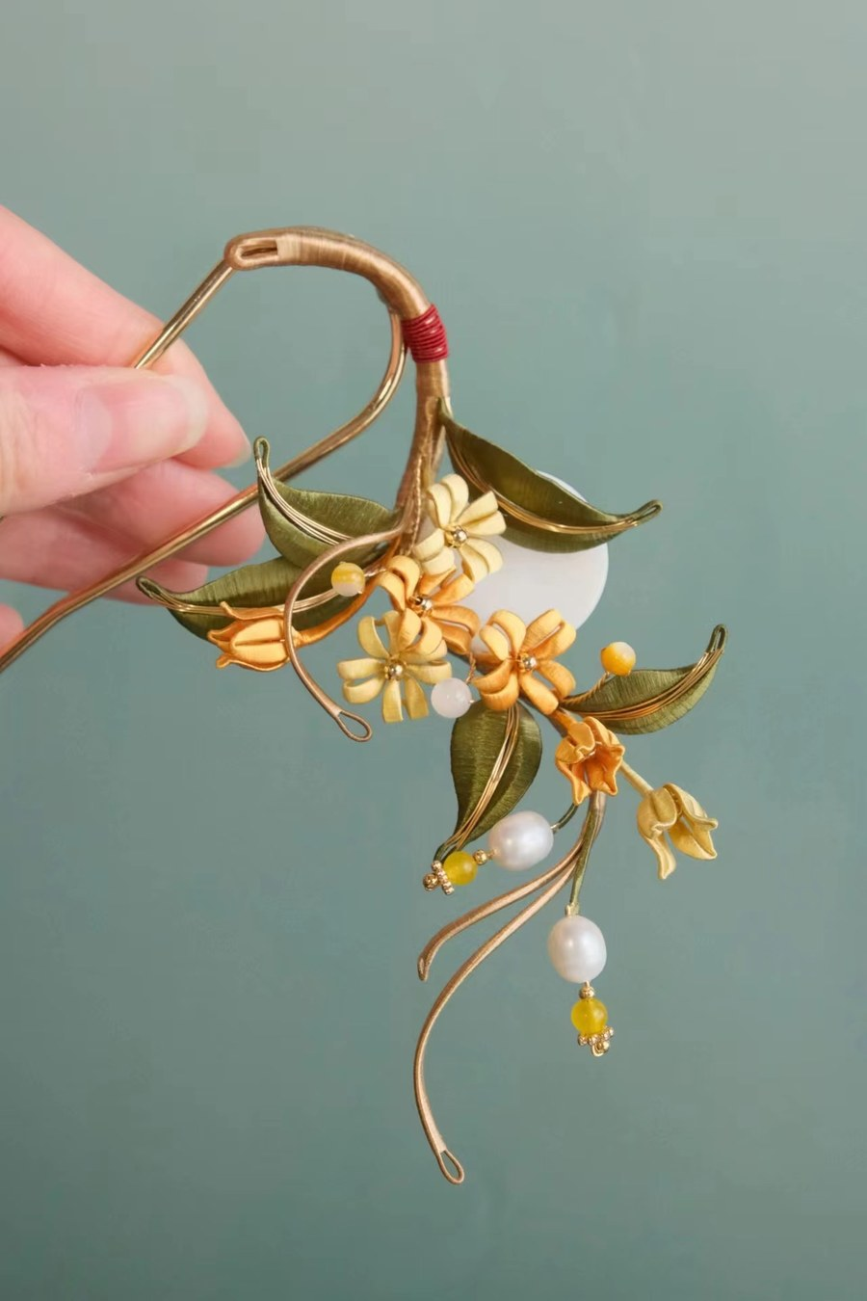 | 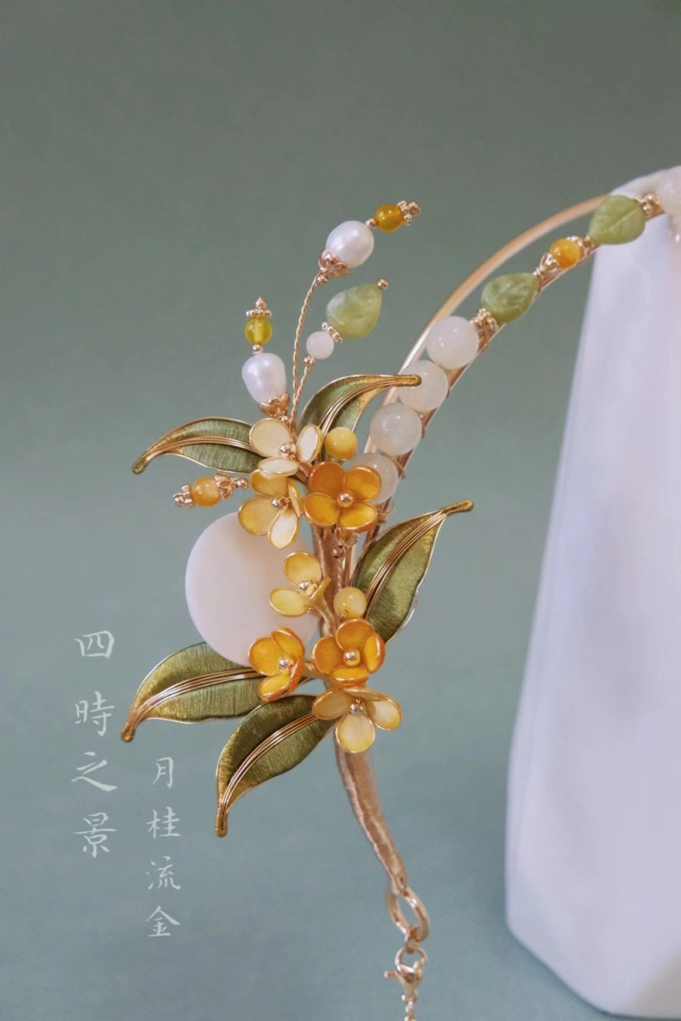
Osmanthus hairpin · 月桂发簪 | Hair crown · 发冠月桂流金

IV. Lily in Moonlight 月下逢 · 四时之景

"If not upon the summit of Jade Mountain, then we shall meet beneath the moon at Yaotai."
「若非群玉山头见，会向瑶台月下逢。」
— Du Fu · 杜甫 · Tang Dynasty

White silk petals fade from pure white at the centre to the cool blue of a night sky at the tips, held open by gold copper wire that catches light as real moonlight would. Yellow amber beads and white jade beads scattered along the wire evoke candlelight and moonlight in a classical Chinese night scene. The dyeing technique creates 'flowing luminosity' (流光感) — a shimmering, shifting quality suggesting moonlight moving gently across petals. Full set: hairpin (发簪), brooches (胸针), ring.
白色蚕丝花瓣从花心纯白过渡到花尖夜空蓝，金色铜丝延伸如藤蔓，光线下熠熠生辉。黄色琥珀珠与白色玉珠点缀其间，重现古典夜色中烛光与月光交织的意境。染色工艺着重「流光感」——蚕丝在光线下呈现流动、变幻的光泽，如同月光轻抚花瓣。全套包括发簪、胸针与戒指。

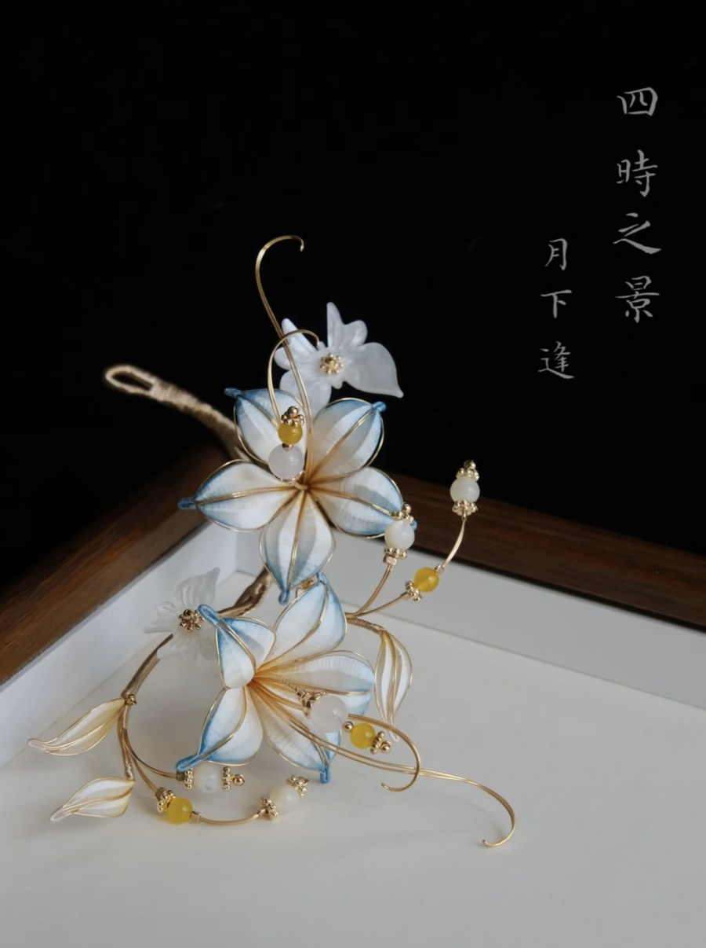 | 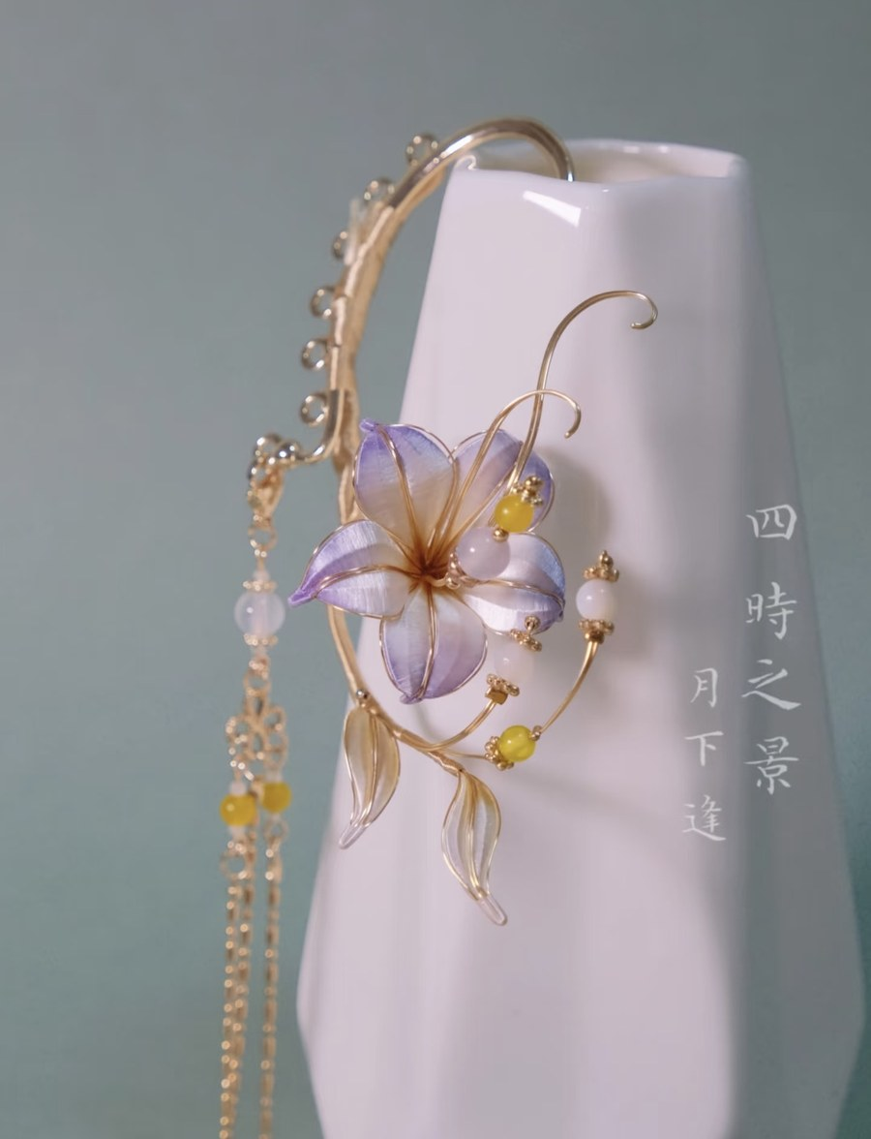
Lily hairpin close-up · 月光百合发簪特写 | 'Moon Encounter' · 月下逢发簪

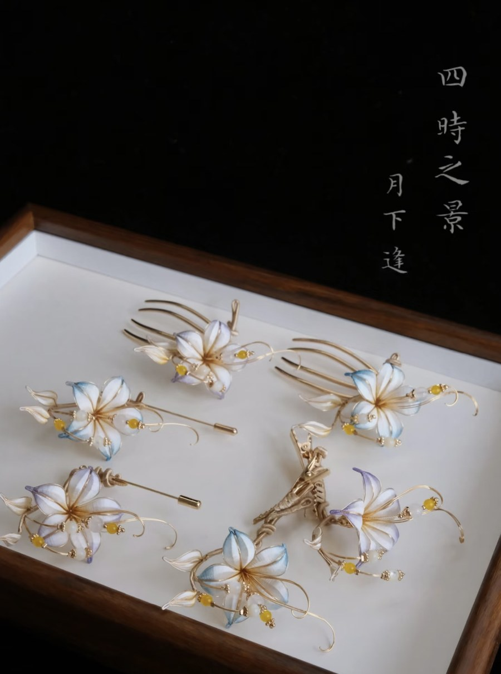
Complete 'Lily in Moonlight' collection · 月光下的小百合全套

V. Lotus in the Wind 一一风荷举 · 四时之景

"The water's surface — round and clear — lotus after lotus rising gently in the wind.."
「水面清圆，一一风荷举。」
— Zhou Bangyan · 周邦彦 · Song Dynasty · 《苏幕遮》

Titled after the graceful image of lotus rising on a summer breeze, this seasonal collection captures the moment when a lotus petal lifts and pauses in the wind. Pale green and blush-white silk petals are wound with precision around copper wire frames, their tips curved gently upward as if caught mid-breath. Freshwater pearls and delicate jade beads nestle among the petals, their cool lustre suggesting still water beneath summer heat.
以夏风中荷叶轻举的意象为题，捕捉花瓣在风中停顿的瞬间。淡绿与藕白蚕丝花瓣缠绕于铜丝骨架，花尖轻轻上翘，如同凝固于风中一息。淡水珍珠与翡翠珠点缀于花间，清凉光泽如同夏日荷下的静水。

Exhibition Proposal 联合国文化活动展览提案

Silora Orient is honoured to propose a complimentary exhibition for the United Nations Chinese Language Day (20 April, UN Headquarters, New York) and the Mid-Autumn Festival cultural celebrations hosted by the UN Chinese community. We offer this contribution freely as our personal commitment to sharing China's living intangible cultural heritage with the international community.
我们荣幸提出为联合国中文日（每年4月20日，纽约联合国总部）及联合国中秋文化活动提供免费展览，以个人之力推广中国活态非物质文化遗产。

Why Chānhuā at the UN? · 为何将缠花带入联合国？

UN Chinese Language Day celebrates the richness of Chinese language and culture through calligraphy, tea ceremony, and cultural talks. Chānhuā offers something uniquely powerful: a craft so intricate it must be seen up close, creating genuine, intimate dialogue between each visitor and a living tradition — a tradition that is also a poem. Every piece carries a classical verse, giving international visitors both a visual experience and a literary entry into Chinese culture.
缠花是中国非遗的理想使者：既古老又当代，既可触摸又可视觉欣赏，材料朴素却成就非凡。每件作品承载一首古诗，让国际访客同时获得视觉体验与进入中国文化历史的文学入口。马玥桐目前就职于联合国，以个人身份架起工艺与机构文化使命之间的桥梁。

Exhibition Format · 展览形式

– Table-top display, approximately 0.5 m² (50 cm × 100 cm) 桌面展览，约半平方米展示区域（50厘米×100厘米）
– Self-contained — no installation required, set up in under 30 minutes 自给自足，无需安装，30分钟内可完成布展与撤展
– Bilingual display cards (English / Chinese) for every work 每件作品附双语说明卡（英/中）
– Studio introduction panel and artist biography 工作室介绍展板及艺术家简介
– Optional live demonstration of silk-winding technique 可选：现场展示蚕丝缠绕技法

Availability Note · 参展说明

For the current UN Chinese Language Day event (April 2026, New York), the studio will present a curated selection of pieces currently in New York. The full collection is produced in China; a more comprehensive exhibition can be arranged for future events — particularly the Mid-Autumn Festival, for which the studio can provide a richer display including the Osmanthus series and additional seasonal works.
本次（2026年4月，纽约）展览以目前在纽约的作品为主，数量有限但精致。完整系列在中国制作，如未来中秋节活动有需要，工作室可提供更为丰富的展品，包括已亮相央视春晚的桂花系列等更多季节性作品，欢迎进一步商议。

What We Offer, Free of Charge · 我们的提供（完全免费）

– Exhibition of Chānhuā jewellery and art pieces — no cost to organisers 缠花珠宝与艺术品展览，不需活动方承担任何费用
– Bilingual display and educational materials on Chānhuā as Intangible Heritage 缠花非遗双语展示与教育材料
– Customisation showcase: heritage craft connected to personal stories 定制展示：以兰花为例，非遗工艺如何与个人故事产生连结
– Sustainability story: fully biodegradable materials as a model of eco-conscious culture 可持续故事：完全可降解材料链作为生态文化生产的典范
– CCTV Spring Gala 2026 connection: bridging tradition and contemporary Chinese media 央视春晚2026连结：在传统与当代中国媒体文化之间架起桥梁

What We Request · 我们的需求

– A tabletop area of approximately 0.5 m² 约半平方米的桌面展示区域
– Basic table, tablecloth, and a small light source if available 基本桌面、桌布及小型光源（如可提供）
– Permission for a brief studio introduction panel 允许放置一块简短的工作室介绍展板
– Opportunity to connect with cultural organisations and heritage enthusiasts 与文化机构、外交官及非遗爱好者交流的机会

Alignment with UN Sustainable Development Goals · 与联合国可持续发展目标的契合

Our work connects to SDG 5 (Gender Equity — empowering women artisans in Sichuan), SDG 8 (Decent Work — craft-based livelihoods), SDG 12 (Responsible Consumption — fully biodegradable materials), and SDG 11 (Sustainable Communities — preserving intangible cultural heritage as community resilience).
我们的工作与SDG 5（性别平等——赋能四川女性工艺家）、SDG 8（体面工作——工艺为基的生计）、SDG 12（负责任消费——完全可降解材料）以及SDG 11（可持续社区——非遗保护作为社区韧性）相契合。

Closing Words 结语

"Each piece of Chānhuā begins as a simple combination of paper, copper wire, and silk thread — but in the hands of a skilled craftsperson, it becomes something else entirely: a poem, a season, a piece of jewellery that carries centuries of Chinese artistry."
「每一件缠花，都从简单的纸板、铜丝、蚕丝线开始，却在匠人手中蜕变为一首诗、一个季节，或一件承载千年中华技艺的珠宝。」
— Silora Orient · 缠花工作室

Chānhuā is listed as an Intangible Cultural Heritage because it cannot be manufactured or replicated at scale. Every work is unique. Every thread is placed by hand. And every piece holds, in its quiet shimmer, the patience and vision of the person who made it.
缠花被列为非物质文化遗产，正是因为它无法被量产或复制。每件作品都是唯一的，每一圈丝线都由手工放置，每件作品的微光之中，都蕴藏着制作者的耐心与视野。
We invite you to bring Chānhuā to your event — and to see in the silk the stories it tells.
我们诚挚邀请您，将缠花带入您的活动——在蚕丝的光泽里，听见它所讲述的故事。

C O N T A C T & L I N K S
Ma Yuetong 马玥桐
Co-founder, Silora Orient · 缠花工作室联合创始人 · New York

Studio Website · 工作室网站 https://silora-orient.vercel.app/
Personal Portfolio · 个人网站 https://mayuetong.github.io/
Email · 联系邮箱 joannasoo@163.com

缠花 · Chānhuā · Living Heritage in Silk and Poetry
S I L O R A O R I E N T

