RABANES, Matthew Gabriel M.

2ECE-D

**isWordGuessed:** Function to determine whether all registered letters are sufficient to guess the secret word. Outputs *true* or *false*.

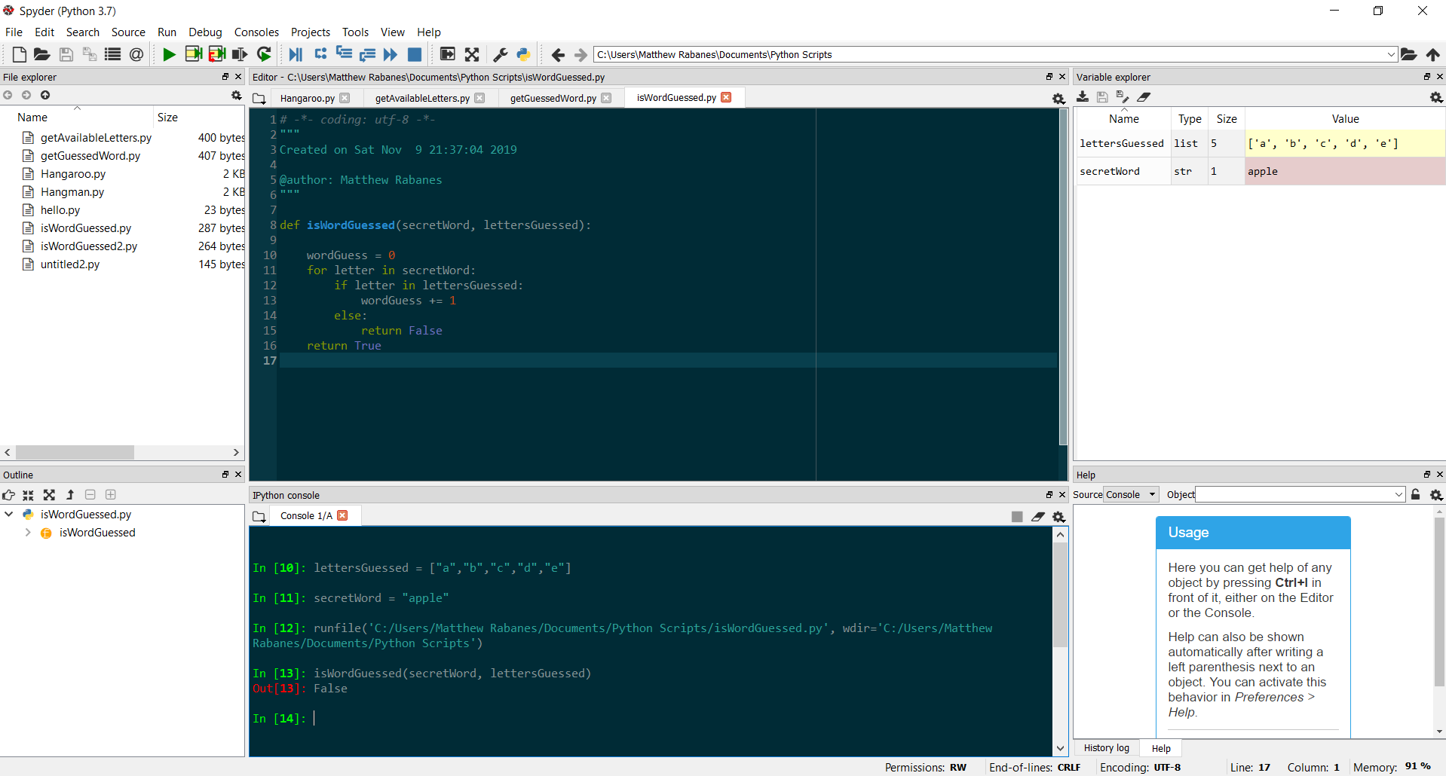

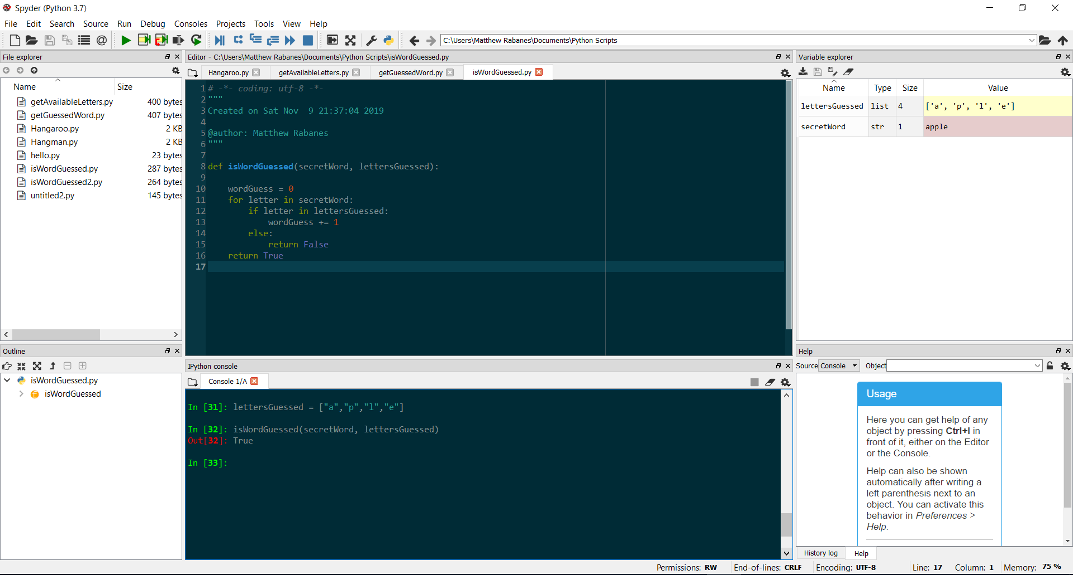

**getGuessedWord:** Function to print the letters guessed so far together with the blanks depending on the length of the word. 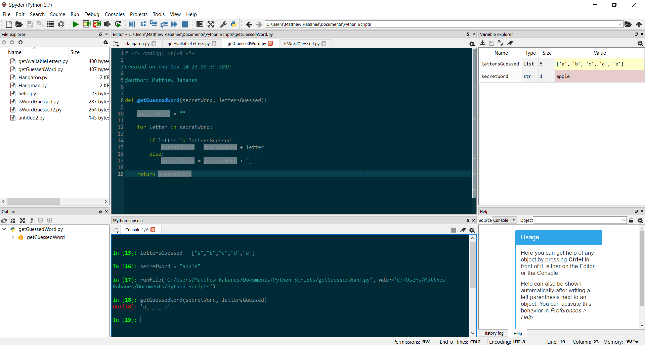

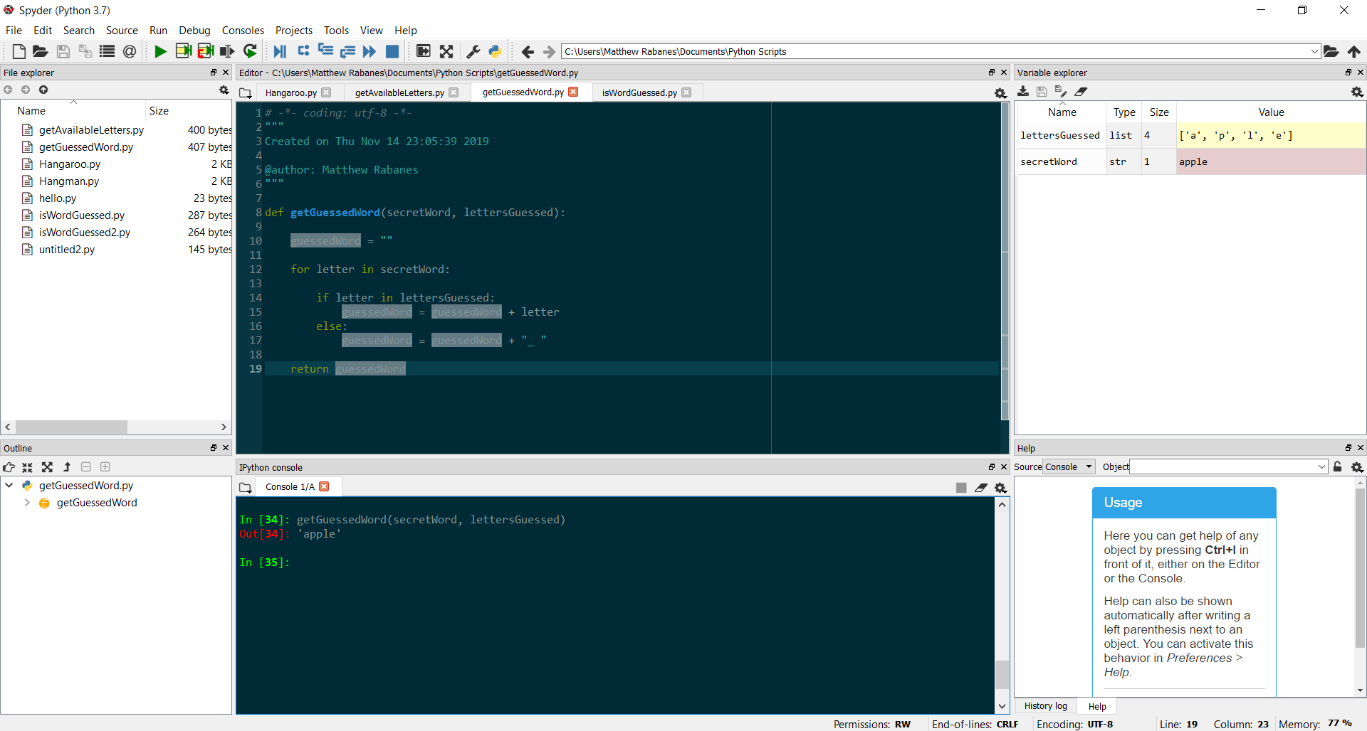

**getAvailableLetters:** Function to determine the available letters for guessing the secret word, not including the one that was already guessed.

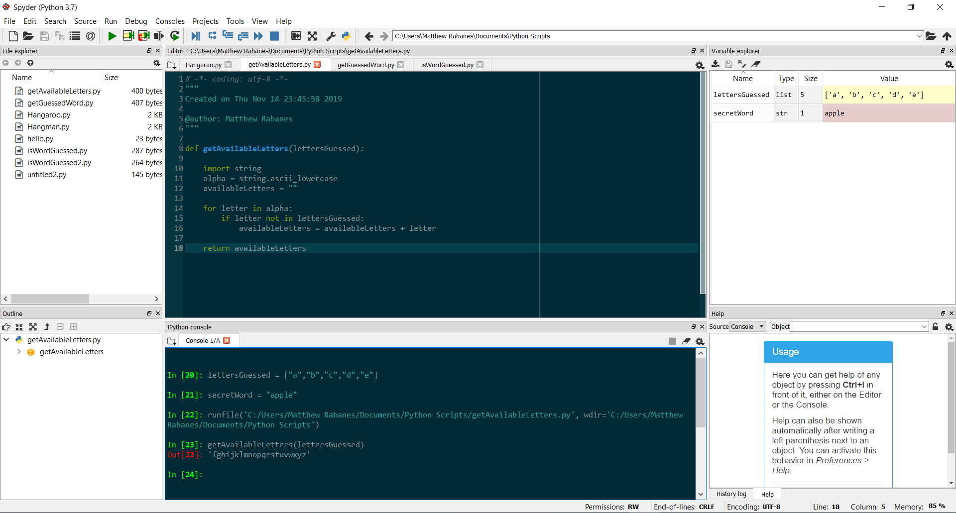

**Hangaroo:** Function that initiates the game Hangaroo.

*If the word is guessed:*

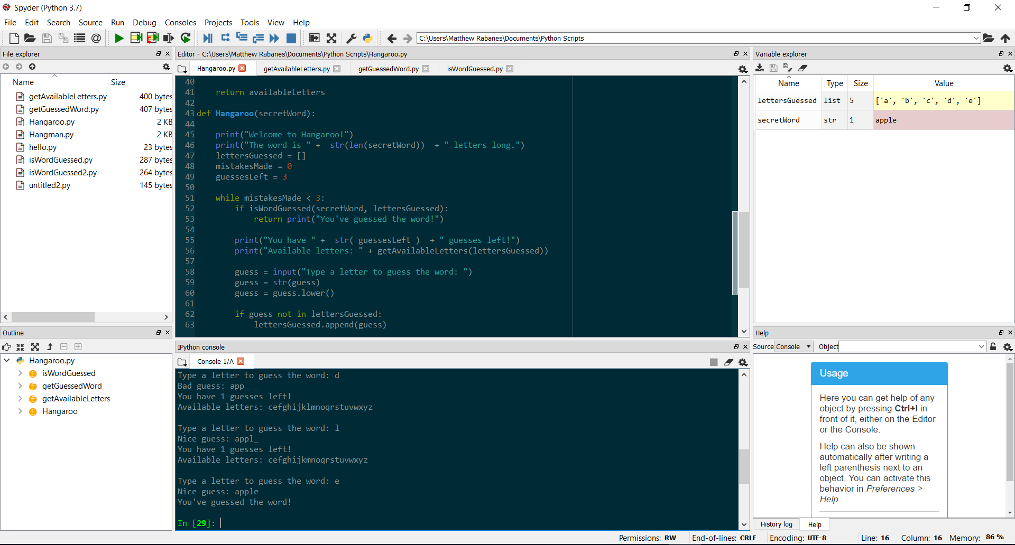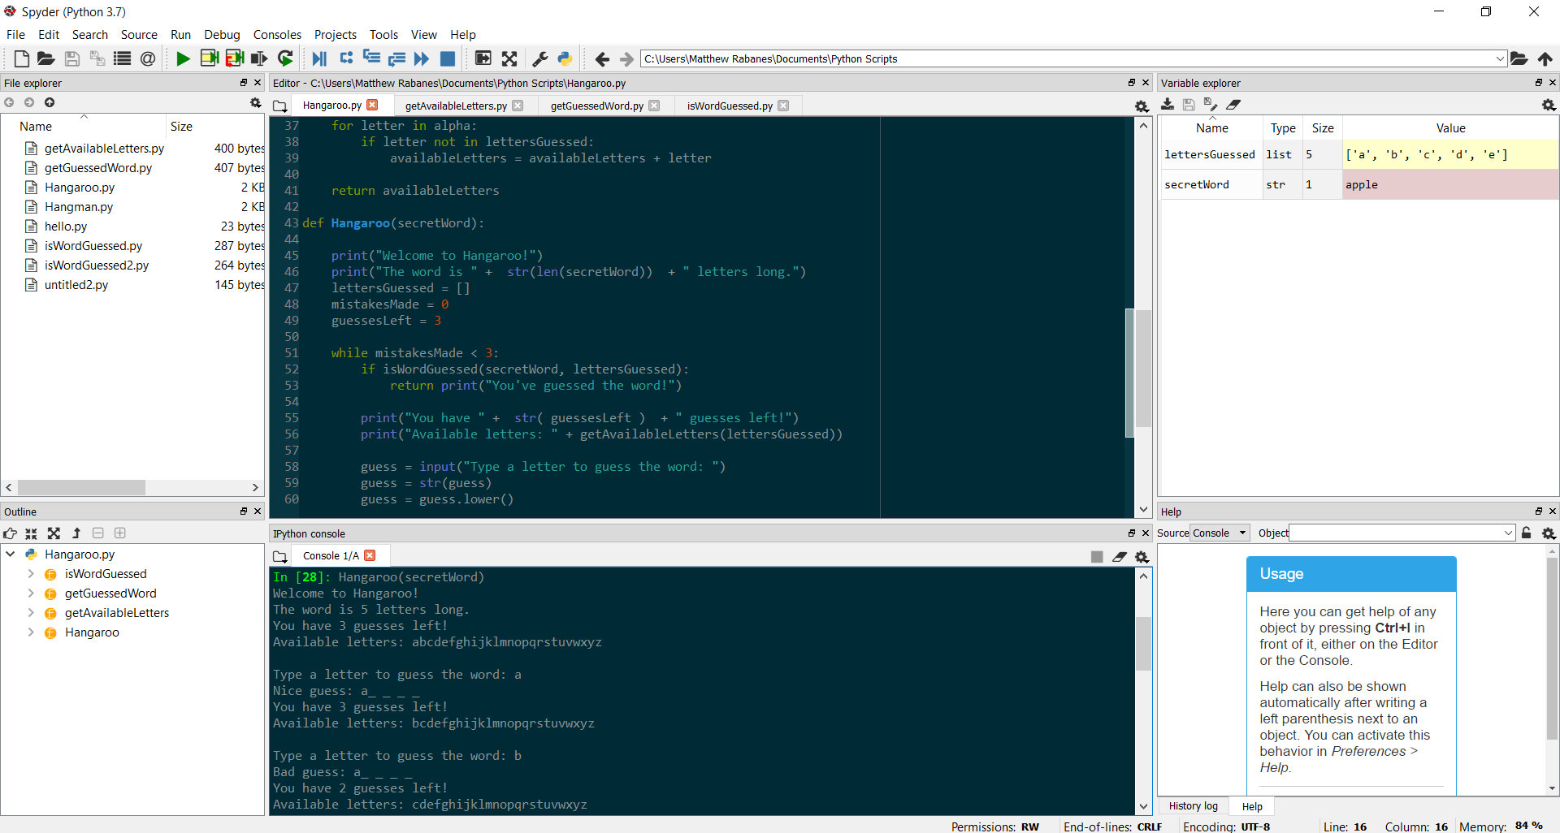

*If the word is not guessed:*

