RABANES, Matthew Gabriel M.

2ECE-D

Problem 1:

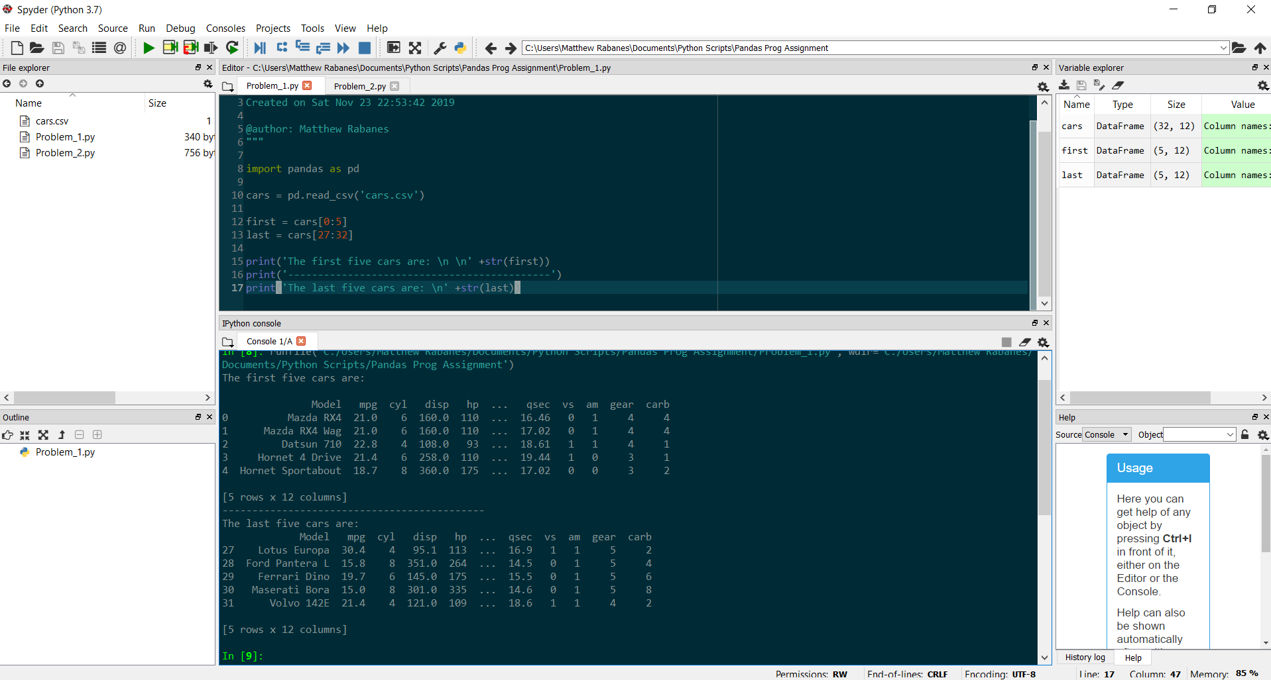

Problem 2:

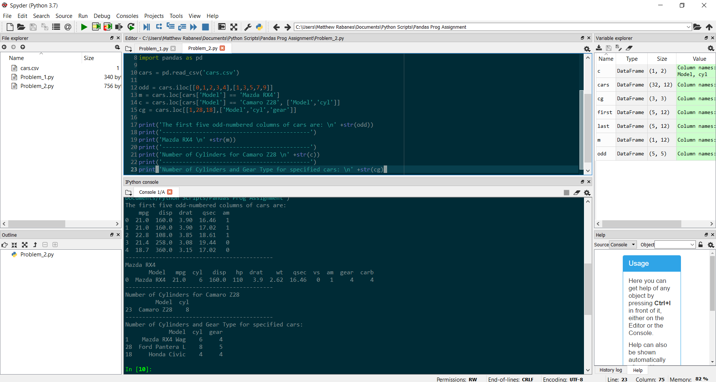

1. How many cylinders (‘cyl’) does the car model ‘Camaro Z28’ have?

The car model, *Camaro Z28,* has 8 cylinders.

1. Determine how many cylinders (‘cyl’) and what gear type do the car models ‘Mazda RX4 Wag’, ‘Ford Pantera L’, and ‘Honda Civic’ have.

*Mazda RX4 Wag* has 6 cylinders and 4 gears, *Ford Pantera L* has 8 cylinders and 5 gears, and *Honda Civic* has 4 cylinders and 4 gears.