**RABANES, Matthew Gabriel M.**

**TENEDERO, Gerard Emilson G.**

**PROBLEM 2** Write a program that accepts as input three points (𝑥, 𝑦) lying on a circle in a 2-

dimensional Cartesian plane. The program must return the following parameters of the circle on

which the three points lie:

• center (ℎ, 𝑘);

• radius 𝑟;

• vector [𝐷, 𝐸, 𝐹], where 𝐷, 𝐸, and 𝐹 are the coefficients in the general equation of a circle 𝑥2 +

𝑦2 + 𝐷𝑥 + 𝐸𝑦 + 𝐹 = 0

**CODE SCREENSHOTS**

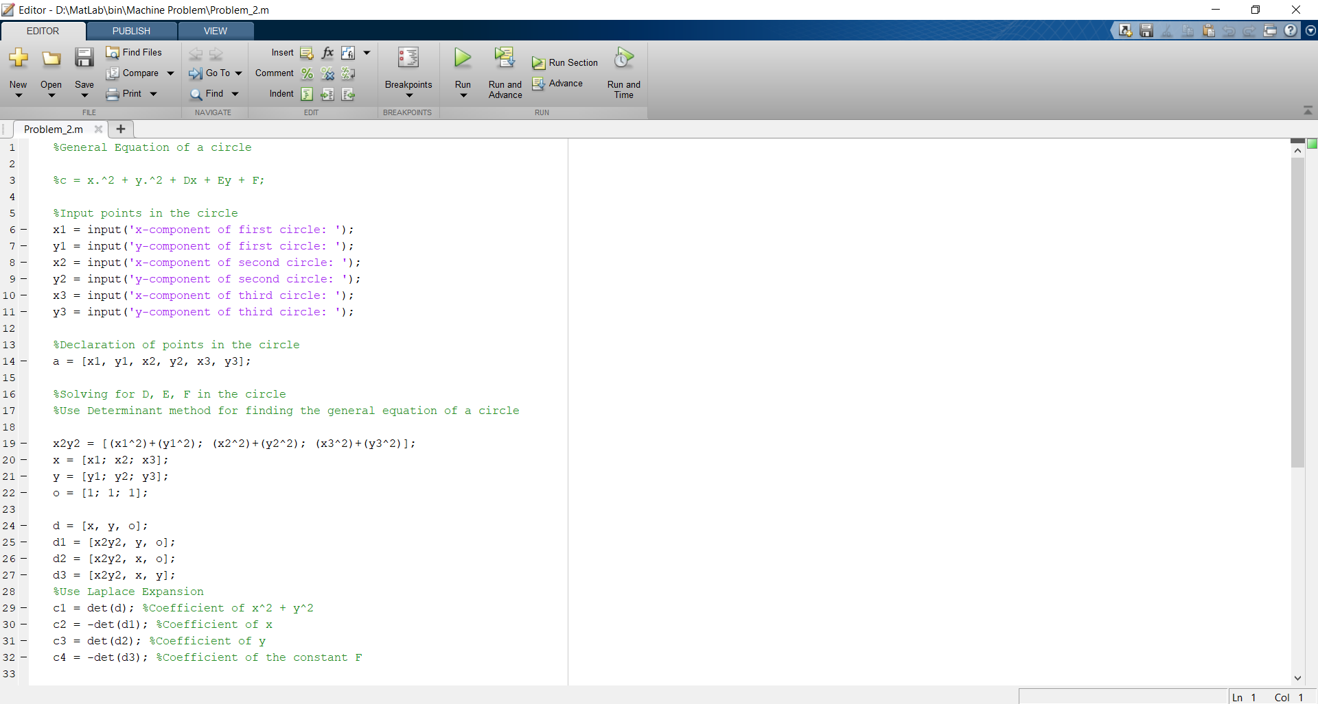

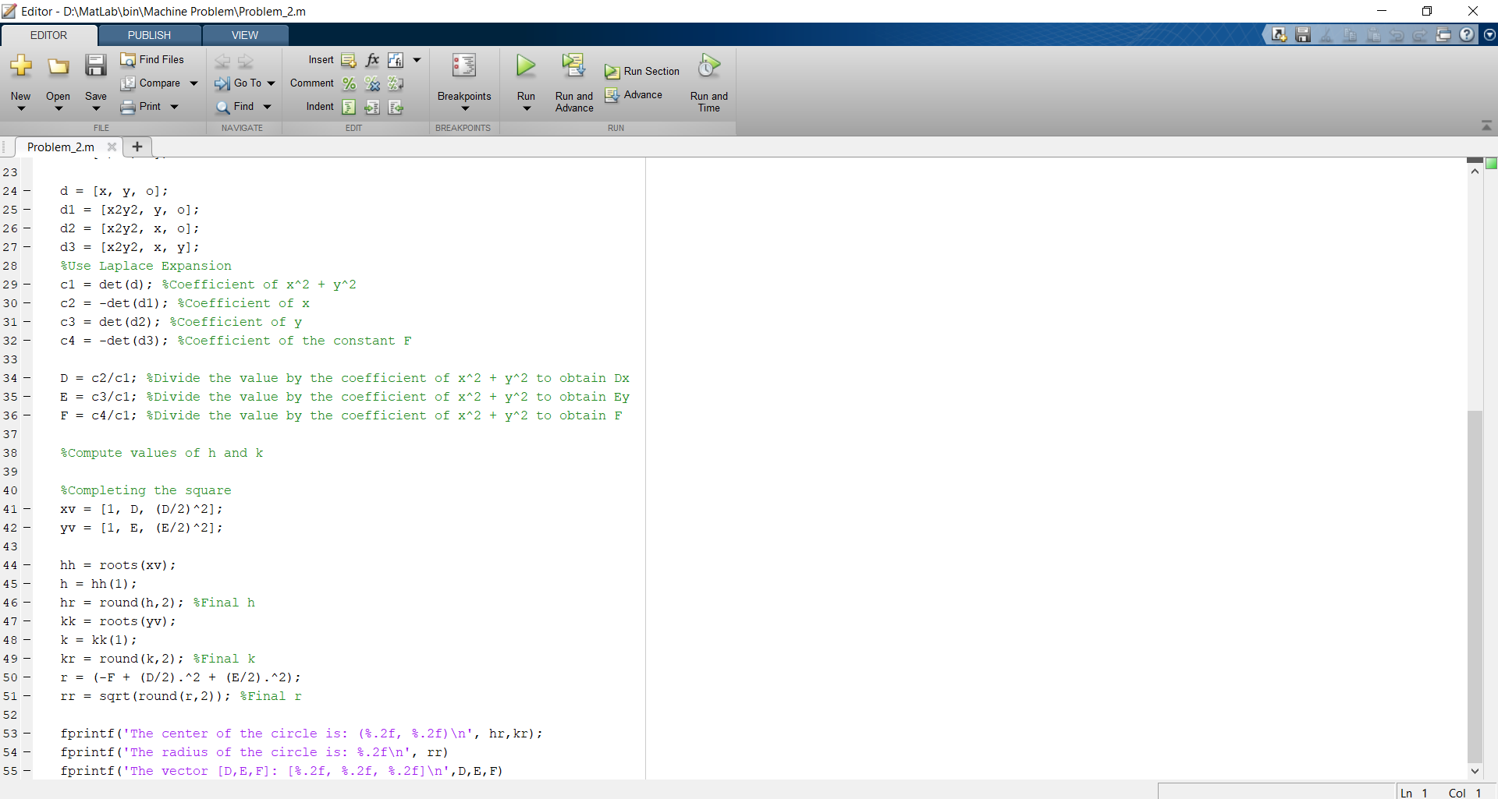

Testing of code at points (7,4), (-3,2), (8, -1)

