**RABANES, Matthew Gabriel M.**

**TENEDERO, Gerard Emilson G.**

**PROBLEM 3** Given a certain set of experimental points (𝑥𝑖, 𝑦𝑖 ), regardless of how many, the program

must be able to return the coefficients of the polynomial 𝑓(𝑥) that would best approximate the data

according to the least-norm error vector 𝑒(𝑥) in Experiment 4, i.e.

**CODE SCREENSHOTS**

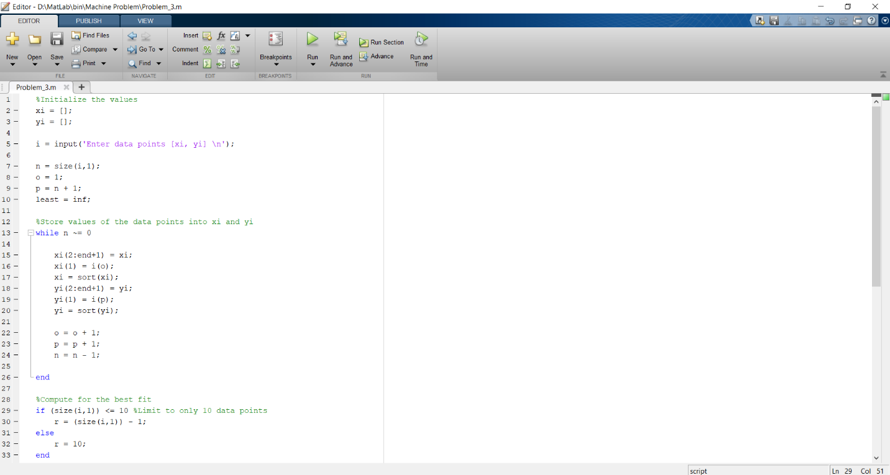

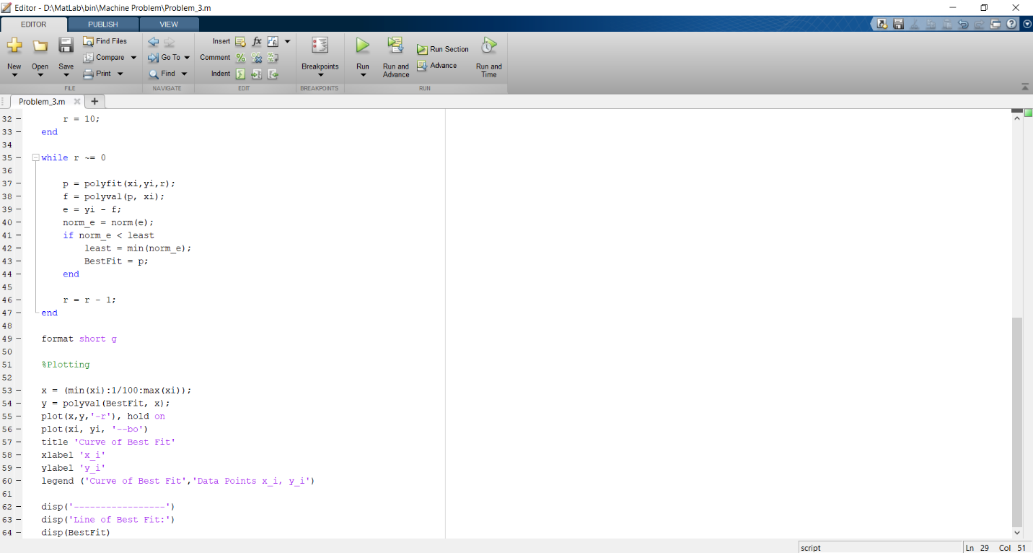

Testing the program through points [ 2 -4; 3 -6; -3 2; 1 -5; -4 -2; 6 10; -1 -4; 5 2; -2 1; 8 -7 ]