**RABANES, Matthew Gabriel M.**

**TENEDERO, Gerard Emilson G.**

**PROBLEM 4** In your physics class, projectile motion has two components: constant-velocity motion

in the horizontal direction and free-fall motion in the vertical direction. However, in reality, the

horizontal motion has acceleration due to air resistance, wind, and other factors. The goal of this

problem is to visualize the trajectory of a projectile for both ideal and non-ideal motion.

**CODE SCREENSHOTS**

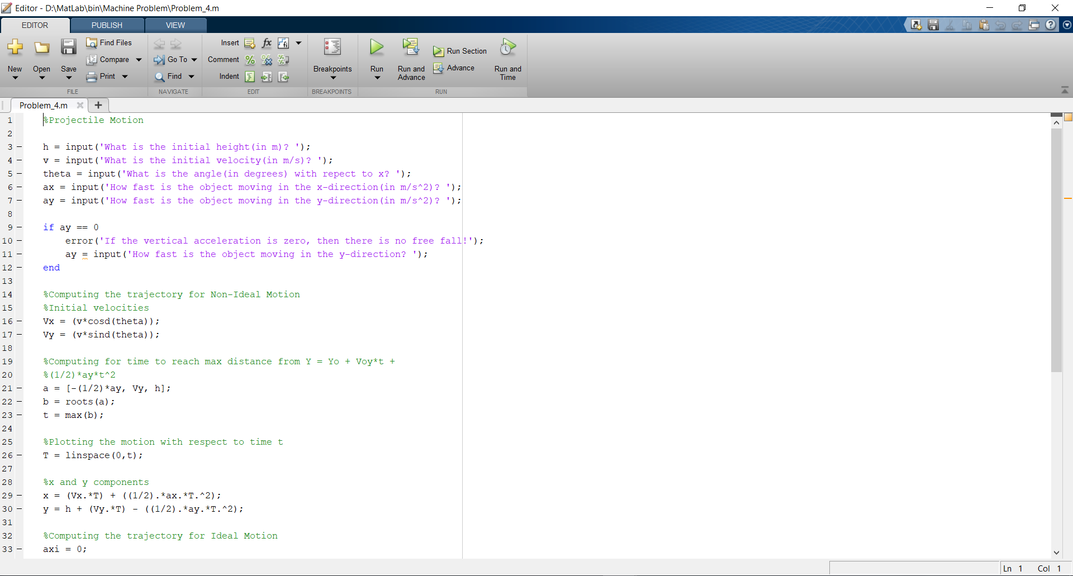

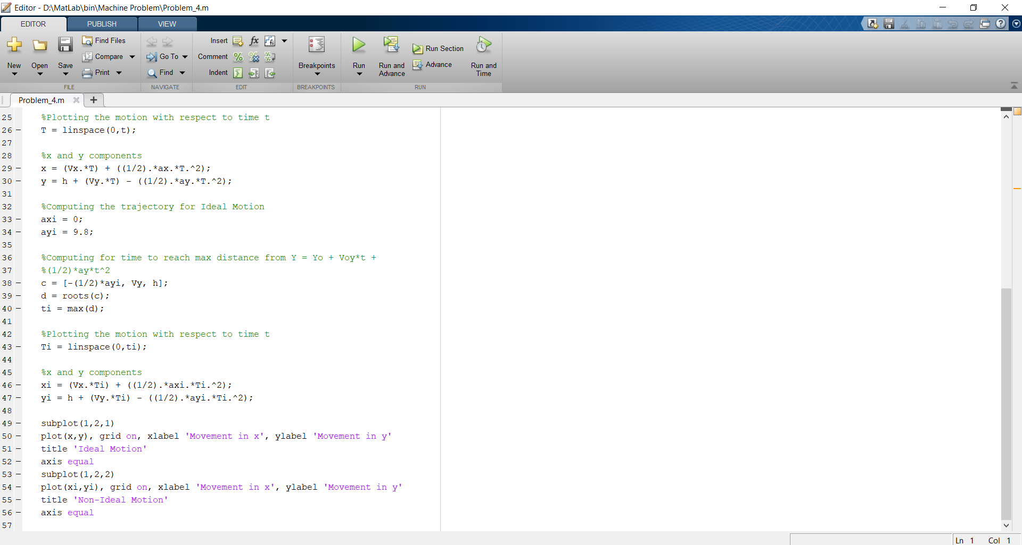

Testing of code at h = 10m , v = 10m/s, theta = 60 degrees , ax = 10m/s2, ay = 10m/s2

