**RABANES, Matthew Gabriel M.**

**TENEDERO, Gerard Emilson G.**

**PROBLEM 5** For n = 0:199, given the user-input 𝑥(𝑛), determine 𝑦(𝑛) if

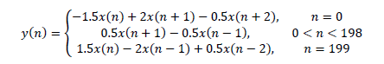

Test your program for



**CODE SCREENSHOTS**

