Capstone Project — Review 2 Report
──────────────────
Speech-Driven Drafting of First Information Reports for the Tamil Nadu Police (CCTNS IF-1):
A Bilingual, Explainable NLP Pipeline with BNS 2023 Statute Identification
Submitted by
Madhav Komanduri — «Register No.»
«Team Member 2» — «Register No.»
«Team Member 3» — «Register No.»
Under the guidance of
«Guide Name and Designation»
«Department / School»
«University / Institution»
August 2026

Abstract
The registration of a First Information Report (FIR) is the entry point to the criminal justice process in India, yet at the police-station level it remains a manual, error-prone task performed under time pressure and, in Tamil Nadu, across a bilingual Tamil–English setting. This project proposes an end-to-end, speech-driven decision-support system that converts a spoken citizen complaint into a draft FIR in the standard Tamil Nadu CCTNS Integrated Investigation Form (IF-1). The system chains five stages: multilingual automatic speech recognition robust to Tamil–English code-switching; legally-salient information extraction against a strict IF-1 JSON schema with per-field confidence and transcript provenance; applicable-statute identification under the Bharatiya Nyaya Sanhita (BNS) 2023 with element-wise (“ingredients of offence”) justification; deterministic instantiation of the fixed IF-1 form; and an officer verification workspace with an immutable audit trail. The system is explicitly decision support, not automation — the officer remains the author of record and every automated output is overridable, provenance-linked, and logged. A key research contribution is an explainable statute-identification pipeline built on the public IPC-era ILSI corpus, bridged to BNS 2023 through a verified IPC→BNS mapping layer. This Review-2 report presents the domain analysis and problem definition, a review of existing approaches and the gaps they leave, and the proposed methodology, system architecture, dataset plan, feasibility and risk analysis, ethics posture, and two-semester work plan.

Rubric Coverage Map
Each Review-2 evaluation parameter is addressed by the report sections below.
# | Evaluation Parameter | Report Section(s) | CO
1 | Domain understanding & problem definition | §1.1–1.3 | CO2
2 | Literature/patent review & existing approaches | Chapter 2 (§2.1–2.7) | CO2
3 | Objectives, scope & expected outcomes | §1.4–1.6 | CO2, CO4
4 | Proposed methodology | §3.1–3.2 | CO2, CO4
5 | System architecture / module / experimental design | §3.3–3.5 | CO2, CO4
6 | Feasibility, risks, ethics & work planning | §3.6 | CO1, CO3, CO4
7 | Report quality, presentation & responses | Whole report | CO3, CO4

Table of Contents

1. Introduction

1.1 Background and Domain
An FIR is the written document prepared by police on receipt of information about the commission of a cognizable offence; under the new procedural law it is registered under Section 173 of the Bharatiya Nagarik Suraksha Sanhita (BNSS) 2023 (formerly Section 154 CrPC). In Tamil Nadu, FIRs are recorded on the Crime and Criminal Tracking Network and Systems (CCTNS) Integrated Investigation Form IF-1, a fixed, standardised form capturing complainant and accused particulars, occurrence details, place of occurrence with direction and distance from the police station, properties involved, reasons for any delay in reporting, witnesses, and a free-text narrative of the incident. From 1 July 2024, the Indian Penal Code (IPC) 1860 was replaced by the Bharatiya Nyaya Sanhita (BNS) 2023, renumbering and reorganising the substantive criminal law that every new FIR must cite.
Two properties of the Tamil Nadu setting make the task technically demanding. First, complaints are narrated primarily in Tamil, frequently in a colloquial register with heavy Tamil–English code-switching (names, vehicle numbers, amounts, and legal terms often surface in English). Second, correctly identifying the applicable BNS sections requires reasoning over the “ingredients of offence” rather than simple keyword matching, and must be transparent enough for an officer to verify and defend.
For grounding, Table 1.1 summarises the principal IF-1 field groups the system must populate.
IF-1 field group | Representative fields
Complainant / informant | Name, parent/spouse name, age, occupation, address, contact
Accused particulars | Known/unknown, names, aliases, physical description, address
Occurrence details | Date/time or interval; information received at P.S.; GD reference
Place of occurrence | Address; direction & distance from P.S.; beat number; outside-limits P.S.
Offence & sections | Applicable BNS/special-act sections; cognizability
Properties & value | Items involved, description, estimated value; total value
Other | Reason for delay in reporting; witnesses; free-text narrative

Table 1.1 — Principal field groups of the Tamil Nadu CCTNS IF-1 form.

1.2 Motivation
Manual FIR drafting is slow and inconsistent: mandatory fields are missed, section selection varies with officer experience, and the recent IPC→BNS transition has increased the cognitive load of choosing correct sections. A system that listens to the complaint, drafts the structured form, and proposes justified BNS sections — while leaving the officer in full control — can improve completeness, consistency, and speed, and can serve as an assistive and training tool. Crucially, no such bilingual, explainable, offline-capable tool exists for the Tamil Nadu format.

1.3 Problem Definition
Given a spoken Tamil / code-switched citizen complaint, automatically produce a review-ready draft FIR in the TN IF-1 format — comprising (a) accurately transcribed and normalised text, (b) a populated IF-1 record with every value linked to its source utterance and a confidence score, (c) a ranked set of applicable BNS 2023 sections each accompanied by an element-wise justification, and (d) a cognizability decision routing the complaint to an FIR or to a Community Service Register (CSR) advisory — such that the drafting officer can inspect, override, and approve every element, with a complete audit trail. The system must never file autonomously and must not hallucinate facts into the record.

1.4 Objectives
- Build a Tamil / code-switched ASR front-end with punctuation restoration and inverse text normalisation of dates, times, phone and vehicle numbers, and currency amounts.
- Extract legally-salient information into a strict IF-1 JSON schema, comparing an encoder-NER pipeline against a schema-constrained LLM, each emitting per-field confidence and transcript-span provenance.
- Develop an explainable statute-identification module that predicts applicable offences and verifies each statutory element against the complaint, producing per-section justifications, bridged from IPC-era training data to BNS 2023 via a verified mapping layer.
- Apply a cognizability gate (BNSS First Schedule) to route cognizable complaints to an FIR draft and non-cognizable ones to a CSR advisory.
- Deterministically instantiate the fixed IF-1 form and compose a strictly-grounded, faithfulness-checked narrative in Tamil and English.
- Provide an officer verification workspace with span-level provenance, confidence heat-mapping, inline editing, accept/override logging, and immutable versioning.
- Evaluate every stage on held-out and synthetic data, and the end-to-end system on field-completeness, officer edit distance, and time-to-draft.

1.5 Scope
In scope:
- Tamil and Tamil–English speech input; the standard TN CCTNS IF-1 output (fixed form).
- BNS 2023 (and BNSS 2023 for procedure) plus commonly-invoked special acts (Motor Vehicles Act, IT Act 2000, TN Prohibition of Harassment of Woman Act).
- A local-only, offline-degradable prototype running on a single 16 GB consumer GPU.
Out of scope (this project):
- Actual electronic filing or live CCTNS integration; biometric capture.
- Case-progress tracking beyond FIR registration; languages other than Tamil/English.
- Any autonomous decision — the officer verifies and is the author of record.

1.6 Expected Outcomes
- A working five-stage prototype that drafts a bilingual IF-1 FIR from a spoken complaint within a few minutes, for officer review.
- An explainable statute-identification module with measurable faithfulness of its element-wise justifications, benchmarked against the LeSICiN baseline on ILSI (BNS-mapped).
- A verified IPC→BNS mapping resource and a reproducible synthetic-data + evaluation harness.
- A quantified evaluation: ASR word/character error rate, slot-level extraction F1, statute-ID micro/macro-F1, and end-to-end field-completeness and time-to-draft.

1.7 Organisation of the Report
Chapter 2 reviews existing work on multilingual ASR, legal information extraction, statute identification, the IPC→BNS transition, and grounded generation, and identifies the gaps this project addresses. Chapter 3 presents the proposed methodology, the system architecture and module design, the dataset and evaluation plans, and the feasibility, risk, ethics, and work-planning analysis.
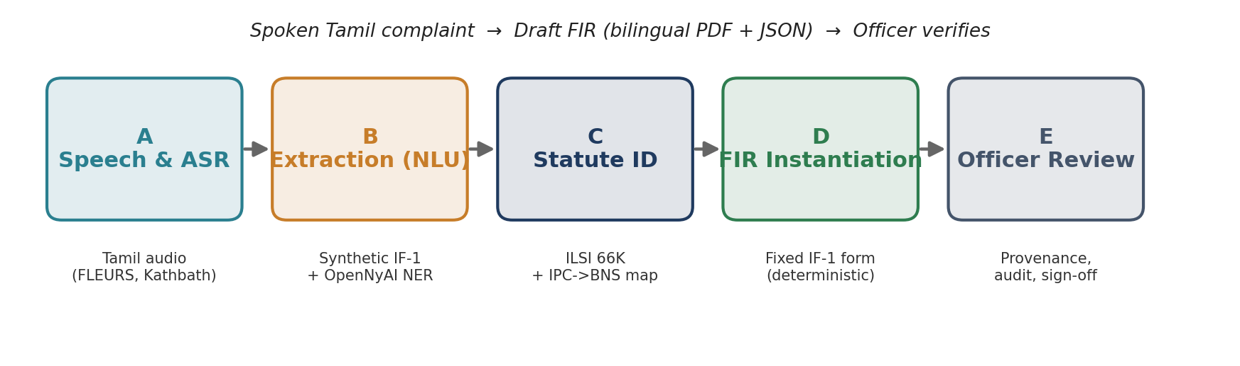
Figure 1.1 — The five-stage pipeline and the data feeding each stage.

2. Literature and Patent Review
This chapter surveys the components the system depends on, assesses credible datasets and models, and identifies the gaps that motivate the proposed work.

2.1 Multilingual and Tamil Automatic Speech Recognition
Whisper (Radford et al., 2023) established robust multilingual ASR via large-scale weak supervision and supports Tamil zero-shot, though it degrades on colloquial and code-switched speech. AI4Bharat's IndicWhisper and IndicConformer, trained on Indian-language corpora, improve Tamil accuracy; the associated IndicSUPERB benchmark and the Kathbath corpus (1,684 hours across 12 languages, CC0) provide substantial labelled Tamil speech. Public evaluation sets include FLEURS-ta and Mozilla Common Voice (ta). The open gap is code-switching: none of these corpora target Tamil–English police-complaint speech, and inverse text normalisation of India-specific entities (vehicle registrations, rupee amounts) is not handled out of the box.
In practice, code-switching is handled better by models exposed to Indian-language data during training, which motivates comparing a fine-tuned IndicWhisper against zero-shot Whisper on a code-switched development set. Because complainants routinely dictate India-specific entities (vehicle registration numbers, rupee amounts, phone numbers, dates), inverse text normalisation is treated as a first-class post-processing step rather than an afterthought.

2.2 Legal Information Extraction and Named-Entity Recognition
MuRIL (Khanuja et al., 2021) and XLM-R (Conneau et al., 2020) provide strong multilingual encoders for Indian-language token classification. For the legal domain specifically, the OpenNyAI InLegalNER corpus annotates 14 legal entity types (e.g., statute, court, provision, petitioner) over Indian judgments and supports high-F1 legal NER models. These resources target court judgments rather than spoken complaints and do not map onto the IF-1 form's fields, but they are an effective warm-start for slot extraction.

2.3 Legal Statute Identification
Automatic Legal Statute Identification (LSI) frames section prediction as multi-label classification over case facts. The ILSI dataset (~66K fact descriptions labelled with 100 IPC sections) and the LeSICiN model (Paul et al., AAAI 2022), which represents statutes and documents as a heterogeneous graph, are the standard benchmark and baseline. Domain-adapted encoders such as InLegalBERT further improve legal text classification. Two limitations are decisive here: the labels are IPC-era (pre-2024), and the inputs are English court-fact text, not Tamil colloquial complaints — both create a domain and label gap the proposed system must bridge.
A further consequence is that statute-identification models trained on ILSI learn from written, formal court language, whereas our inputs are colloquial spoken complaints. We therefore treat statute identification as reasoning over the extracted and (where necessary) translated narrative, and we measure cross-domain generalisation explicitly rather than assuming in-domain performance will transfer.

2.4 The IPC → BNS Transition
Because BNS 2023 renumbers and reorganises the IPC (e.g., murder moves from IPC 302 to BNS 103; dowry death from 304B to 80; cheating from 420 to 318), any model trained on IPC-labelled data must translate its outputs to BNS to be usable operationally. The Ministry of Home Affairs published correspondence tables, and several secondary conversion tables exist; however, the mapping is many-to-one and one-to-many in places and contains genuine ambiguities, so a verified, versioned mapping layer with human review is required rather than a naive lookup.

2.5 Grounded Generation, Faithfulness and Retrieval-Augmentation
Retrieval-augmented generation (Lewis et al., 2020) and constrained decoding allow an LLM to be anchored to source evidence, and natural-language-inference-based faithfulness checks can flag unsupported statements. For a legal document these techniques are safety-critical: any generated sentence must be entailed by the extracted facts. Parameter-efficient fine-tuning (LoRA; QLoRA, Dettmers et al., 2023) and 4-bit quantisation make it feasible to run and adapt 7–8B-parameter models on a single consumer GPU.

2.6 Existing Systems and Patents
CCTNS provides electronic FIR entry and some states offer citizen e-FIR portals, but these are manual data-entry forms without speech input, extraction, or statute reasoning. Commercial legal AI tools focus on research and drafting for practitioners, not on-desk FIR assistance in Indian languages. To the best of our review, there is no published system or patent combining Tamil speech input, IF-1 extraction with provenance, explainable BNS statute identification, and officer-in-the-loop verification.

2.7 Comparative Analysis and Research Gaps
Approach / Resource | Strength | Limitation for our problem
Whisper large-v3 | Robust multilingual ASR | Weak on Tamil–English code-switch; no ITN for Indian entities
IndicWhisper / Kathbath | Strong Tamil ASR + large corpus | Not police-complaint domain; no code-switch complaint audio
OpenNyAI InLegalNER | 14 legal entity types, high F1 | Judgment domain; not mapped to IF-1 fields
ILSI + LeSICiN | 66K facts, standard LSI benchmark | IPC-era labels; English court facts, not spoken complaints
CCTNS e-FIR portals | Official IF-1 data capture | Manual entry; no speech/extraction/statute reasoning

Identified gaps this project addresses:
- No public Tamil complaint→IF-1 corpus → addressed by a synthetic-first data pipeline with a human gold set staged later.
- Statute-ID resources are IPC-era → addressed by a verified IPC→BNS mapping layer.
- Existing tools are neither explainable nor officer-in-the-loop → addressed by element-wise justifications, provenance, and an audited verification workspace.
- No offline-capable, single-GPU, bilingual FIR-drafting system exists → the core contribution.

3. Proposed Methodology and System Design

3.1 Overview of the Proposed Approach
The system is a five-stage pipeline (Figure 1.1) orchestrated as a directed graph. Design is governed by five invariants: (i) decision support, not automation; (ii) grounded generation only — no generative model writes into structured fields; (iii) mandatory provenance and confidence on every extracted value; (iv) explicit, auditable cognizability routing; and (v) local-only, offline-degradable operation. Because the IF-1 form is fixed and standardised, Stage D is deterministic form-filling rather than document generation — the difficulty lives in Stages B (extraction) and C (statute identification).

3.2 Proposed Methodology (per stage)

3.2.1 Stage A — Speech ingestion and ASR
Audio is resampled to 16 kHz mono, segmented by voice-activity detection, and (in guided-interview mode) diarised to separate complainant from officer. Transcription uses faster-whisper (Whisper large-v3, int8) with AI4Bharat IndicConformer as a low-VRAM fallback, followed by punctuation restoration, disfluency removal, and inverse text normalisation of dates, times, phone and vehicle numbers, and currency. Zero-shot and LoRA-fine-tuned variants are compared. Original Tamil spans are preserved verbatim with character offsets and audio timestamps.

3.2.2 Stage B — Information extraction
Two approaches are built and compared head-to-head: (A) a fine-tuned encoder NER (MuRIL / XLM-R / IndicBERT) with rule-based slot assembly, warm-started on OpenNyAI; and (B) a schema-constrained LLM that emits IF-1 JSON with per-field confidence and transcript-span provenance. Bilingual handling preserves Tamil verbatim and renders English equivalents where the form requires.

3.2.3 Stage C — Statute identification (research core)
A multi-label classifier (InLegalBERT/MuRIL) trained on ILSI predicts candidate offences; the IPC→BNS mapping layer converts predictions to BNS 2023. For each candidate section a retrieval-augmented verifier retrieves the statutory elements (BGE-m3 over BNS text) and a local LLM checks each “ingredient of offence” against the complaint, emitting a per-element satisfied/unclear judgement with supporting spans — the explainability contribution. A cognizability gate (BNSS First Schedule) then routes the complaint; ambiguous cases default to officer review.

3.2.4 Stage D — FIR instantiation
A deterministic template engine fills the fixed IF-1 structured fields from the JSON record; no generative model writes structured fields. A local LLM composes only the free-text narrative under constrained decoding, and every sentence must be entailed by an extracted fact (a faithfulness/NLI gate blocks unsupported content) before the officer edits it. Outputs are a print-faithful bilingual PDF and a machine-readable JSON record.

3.2.5 Stage E — Officer verification
The React workspace shows the transcript and extracted fields side-by-side with span-level provenance links, a confidence heat-map, inline editing, suggested sections with expandable element-wise justifications, and accept/override actions. Every action is written to an immutable, versioned audit trail; the officer marks the record verified and remains the author of record.

3.2.6 Model selection
Models are chosen to co-reside on a single 16 GB GPU while meeting the latency target. Table 3.1 summarises the selection, trading accuracy against latency and VRAM. The inference path keeps one resident 4-bit 7–8B LLM serving extraction, verification, and narrative composition; the larger 14B model is used only for offline synthetic-data generation.
Stage / role | Model (precision) | VRAM | Rationale
ASR (primary) | Whisper large-v3 (int8) | ~2 GB | Best general Tamil; code-switch fine-tuning
ASR (fallback) | IndicConformer (fp16) | ~1 GB | Low-VRAM path for 12 GB machines
Extraction / verify / narrative | Qwen2.5-7B-Instruct (4-bit) | ~6 GB | Multilingual; strong JSON adherence; resident
NER (approach A) | MuRIL-base (fp16) | <1 GB | Indian-language token labelling
Statute classifier | InLegalBERT (fp16) | <1 GB | Legal-domain pre-training
RAG retriever | BGE-m3 (fp16) | ~1.5 GB | Strong multilingual retrieval
Synthetic data-gen (offline) | Qwen2.5-14B (4-bit) | ~9 GB | Best local quality; GPU-alone, batch

Table 3.1 — Model-selection matrix (accuracy vs. latency vs. VRAM) for a 16 GB budget.

3.3 System Architecture and Module Design
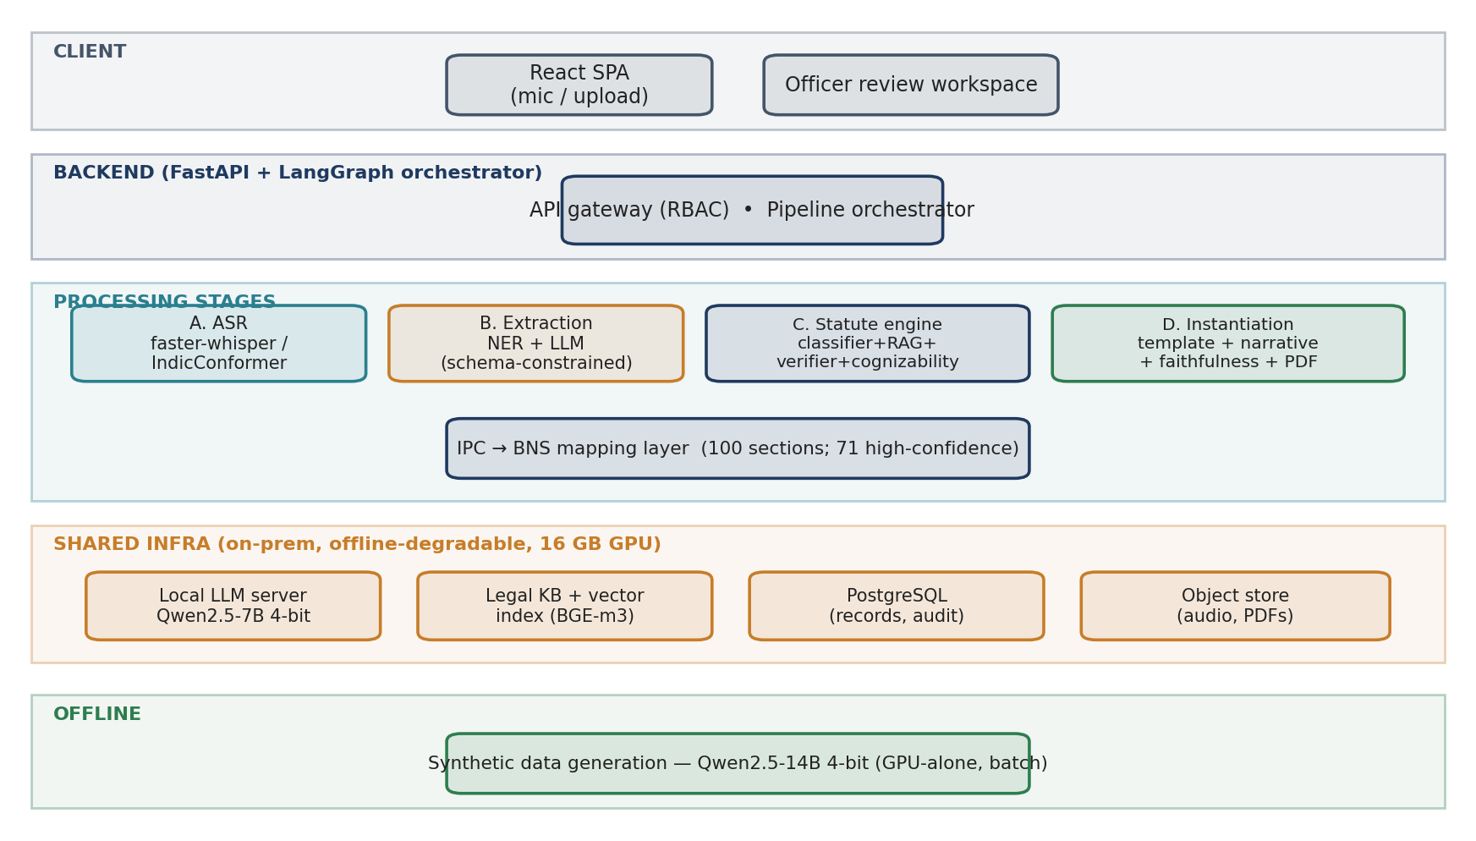
Figure 3.1 — Component architecture: client, orchestrated backend, five stages, and the shared on-prem infrastructure. Synthetic data generation runs offline.
Modules communicate only through the orchestrator via versioned contracts over a canonical IF-1 JSON schema; no module reaches into another's internals. Each extracted field is a typed wrapper carrying value, bilingual text, confidence, provenance (character offsets + audio timestamps), and an edit-status. Table 3.1 summarises the module boundaries.
Module | Responsibility | Key interface (in → out)
asr | Transcribe + normalise | AudioRef → ASRResult (tokens, timestamps, spans)
extract | Populate IF-1 record | ASRResult → ExtractionResult (FIRRecord + provenance)
statute | Sections + justification + routing | FIRRecord+narrative → StatuteAssessment
instantiate | Fill form + grounded narrative | FIRRecord+StatuteAssessment → FIRDocument (PDF+JSON)
review-api | Officer edits, audit, versioning | FIRDocument → verified record + AuditEvents

Table 3.2 — Module boundaries and interface contracts.
Figure 3.2 traces the end-to-end data flow and the artefact produced at each hop; note that only the narrative is generated, and it is gated for faithfulness before the officer sees it.
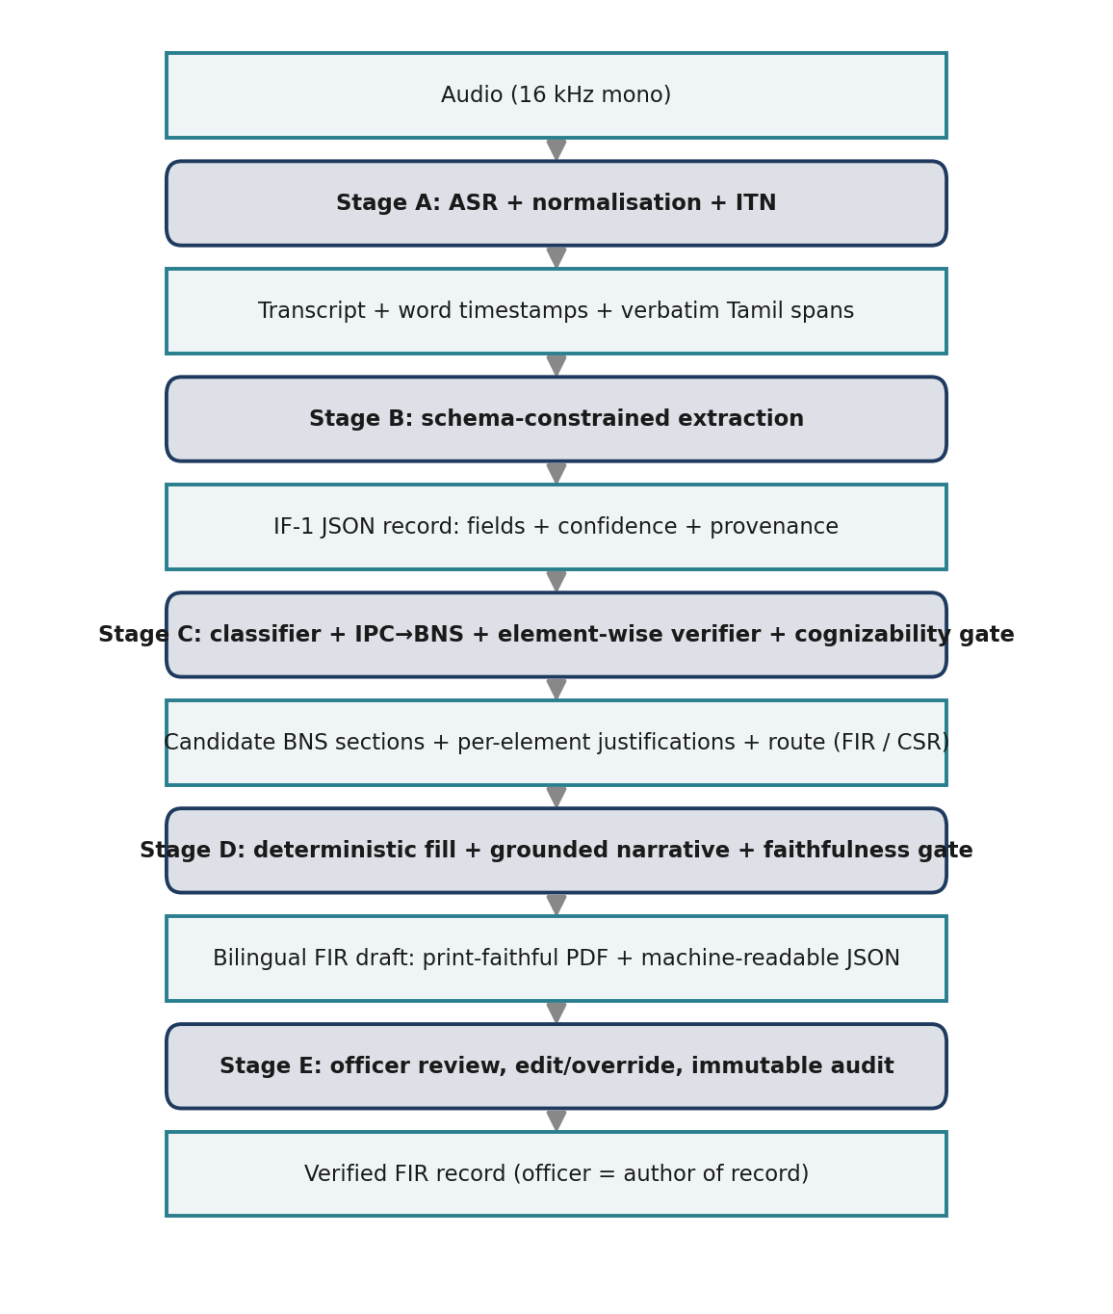
Figure 3.2 — End-to-end data flow: alternating processes (dark) and the data artefacts they emit (light).
The canonical schema is a strict JSON mirror of IF-1; Table 3.3 lists its key structures. Every field is a typed wrapper with value, bilingual text, confidence, provenance, and edit-status, so the record is self-documenting and fully auditable.
Schema element | Purpose
field wrapper | value + ta/en text + confidence + provenance[] + status(extracted/edited/…)
provenance | transcript char offsets + audio start/end (ms) + utterance id
complainant / accused | person particulars; known/unknown accused with descriptions
occurrence / place | datetime or interval; direction & distance from P.S.; beat
acts_sections | act, section, score, elements[] with per-element satisfied + justification
cognizability | decision, route (FIR / CSR_advisory / officer_review), schedule ref
narrative | ta / en text + grounding[] linking each sentence to supporting provenance

Table 3.3 — Key structures of the canonical IF-1 JSON schema.

3.3.1 Illustrative walkthrough
Consider a complainant who narrates, in Tamil, that her married sister was harassed for dowry by her husband and in-laws and was later found dead. Stage A transcribes and normalises the narration, preserving the Tamil spans and the reported dates. Stage B populates the IF-1 record — complainant and accused particulars, place and time of occurrence, and the narrative — each field carrying a confidence score and a pointer back to the spoken span. Stage C predicts the applicable offences and, after mapping the IPC-era model output to BNS 2023, proposes the sections corresponding to dowry death, cruelty by a husband or relatives, and acts done with common intention (in BNS terms, sections 80, 85 and 3(5)), with an element-wise justification for each. The cognizability gate marks the matter cognizable and routes it to an FIR draft. Stage D fills the fixed form and composes a grounded bilingual narrative, which the officer reviews, edits, and signs. This mirrors the real ILSI case structure used to train and evaluate the statute module.

3.4 Datasets and Data Plan
Dataset availability was verified against live sources. Table 3.2 lists the resources; all are openly downloadable. Because no public Tamil complaint→IF-1 corpus exists, the project is synthetic-first: a local LLM (Qwen2.5-14B, 4-bit, offline) generates Tamil / code-switched complaint narratives from structured scenario seeds — the seed doubles as the gold label — which are voiced with Indic-TTS. A self-recorded human gold set is staged as a later milestone for real evaluation.
Dataset | Role | Volume / License | Access
FLEURS (ta_in) | ASR eval/train | 3,335 clips, ~2.76 GB, CC-BY | Hugging Face
AI4Bharat Kathbath | ASR train | 1,684 h (12 langs), CC0 | Hugging Face
ILSI | Statute ID | ~66K facts, 100 IPC sections | Zenodo (open)
OpenNyAI InLegalNER | Legal NER seed | 46,545 entities, 14 types | Hugging Face / GitHub
BNS/BNSS 2023 text | Statute KB (RAG) | 358 BNS sections | India Code
IPC→BNS mapping | Bridge layer | 100 ILSI sections (built) | This project

Table 3.4 — Verified datasets underpinning the system.
The IPC→BNS mapping layer was built for the 100 IPC sections used by ILSI and verified against a published BNS–IPC directory; 71 of 100 rows are high-confidence (auto-applied) and 29 are flagged for human review, with conflicts (e.g., IPC 325→BNS 117(2), 326→118(2), 353→132) resolved (Figure 3.3). Only high-confidence rows are auto-applied; the rest route to the officer.
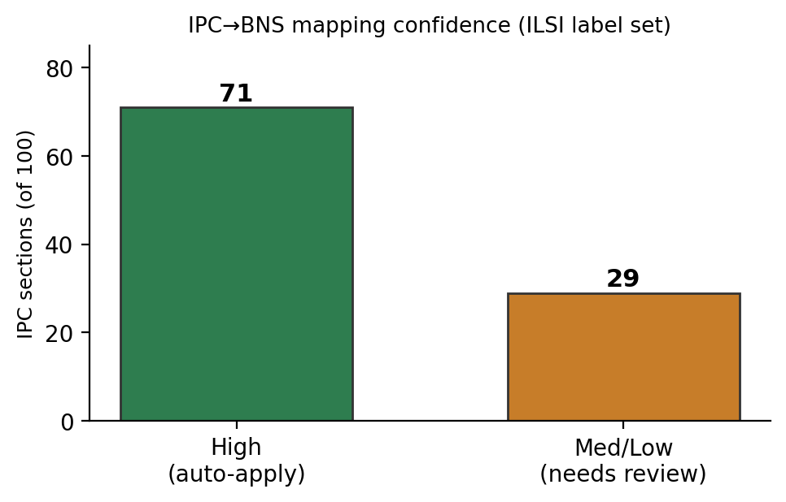
Figure 3.3 — IPC→BNS mapping confidence over the ILSI label set.

3.5 Evaluation Plan
Stage | Metric(s) | Data / baseline
ASR | WER, CER (per register/speaker) | FLEURS-ta, code-switched set
Extraction | Slot precision/recall/F1; provenance coverage | Synthetic gold; A vs B
Statute ID | Micro/macro-F1; cognizability accuracy | ILSI (BNS-mapped) vs LeSICiN
Justification | Element-support & entailment rate | Faithfulness metrics
End-to-end | Field-completeness, officer edit distance, time-to-draft | Synthetic + human gold

Table 3.5 — Per-stage evaluation metrics and baselines.

3.6 Feasibility, Risks, Ethics and Work Planning

3.6.1 Technical feasibility
The inference path fits a single 16 GB GPU: a resident 4-bit 7–8B LLM (~6 GB) co-resides with int8 Whisper (~2 GB), the BGE-m3 retriever (~1.5 GB), and small encoders/NLI (~2 GB), leaving headroom for the KV cache (~13–14 GB total). The larger 14B data-generation model runs offline, GPU-alone. Parameter-efficient fine-tuning (LoRA/QLoRA) keeps training within budget. The target latency is a review-ready draft within roughly four minutes of a three-minute complaint; a 12 GB fallback (IndicConformer ASR, serialised loading) is documented. All datasets and tooling are confirmed available, making the plan concretely buildable.
Table 3.6 gives the target latency budget assumed for a three-minute complaint; a resident LLM server avoids model-swap overhead so the stages run back-to-back.
Stage | Budget | Basis
A. ASR (large-v3 int8) | 45 s | ~4–8× real-time on 16 GB GPU
A′. Normalisation / ITN | 10 s | CPU-light
B. Extraction | 30 s | 1–few constrained LLM calls
C. Statute ID + verify | 90 s | Classifier + RAG + batched element checks
D. Narrative + faithfulness | 40 s | One generation + one entailment pass
D′. PDF + JSON render | 5 s | Deterministic
Total | ≈ 3.7 min | Resident 8B avoids model-swap overhead

Table 3.6 — Target latency budget (three-minute complaint).

3.6.2 Risk register
Risk | Impact | Mitigation
Local-only caps synthetic-data quality (no frontier teacher) | High | Largest local model (Qwen2.5-14B 4-bit) + templates + human curation
No public Tamil complaint audio | Med | Synthetic-first + self-recorded human gold set
IPC→BNS mapping ambiguity | High | Verified/versioned map; confidence flags; officer review of non-high rows
Narrative hallucination | Critical | Constrained decoding + entailment gate + mandatory officer review
Code-switching degrades ASR | Med | Code-switch fine-tuning; surface low-confidence tokens
16 GB VRAM contention | Med | Resident 8B + int8 ASR co-residence; 14B offline only
Legal-correctness liability | Critical | Decision-support framing; officer author-of-record; full audit; legal review

Table 3.7 — Principal risks and mitigations.

3.6.3 Ethics, privacy and DPDP alignment
The system handles sensitive personal data and therefore follows privacy-by-design aligned with the Digital Personal Data Protection (DPDP) Act 2023: data minimisation, local encrypted storage, retention limits, role-based access control, and an immutable audit trail. All development and evaluation use fictitious particulars — no real complainant data. The system is strictly assistive: it never files autonomously, every output is overridable, and the officer is the author of record. Statute suggestions are decision support, not legal advice, and gold-set section labels are validated by a law-qualified reviewer.

3.6.4 Timeline and allocation of responsibilities
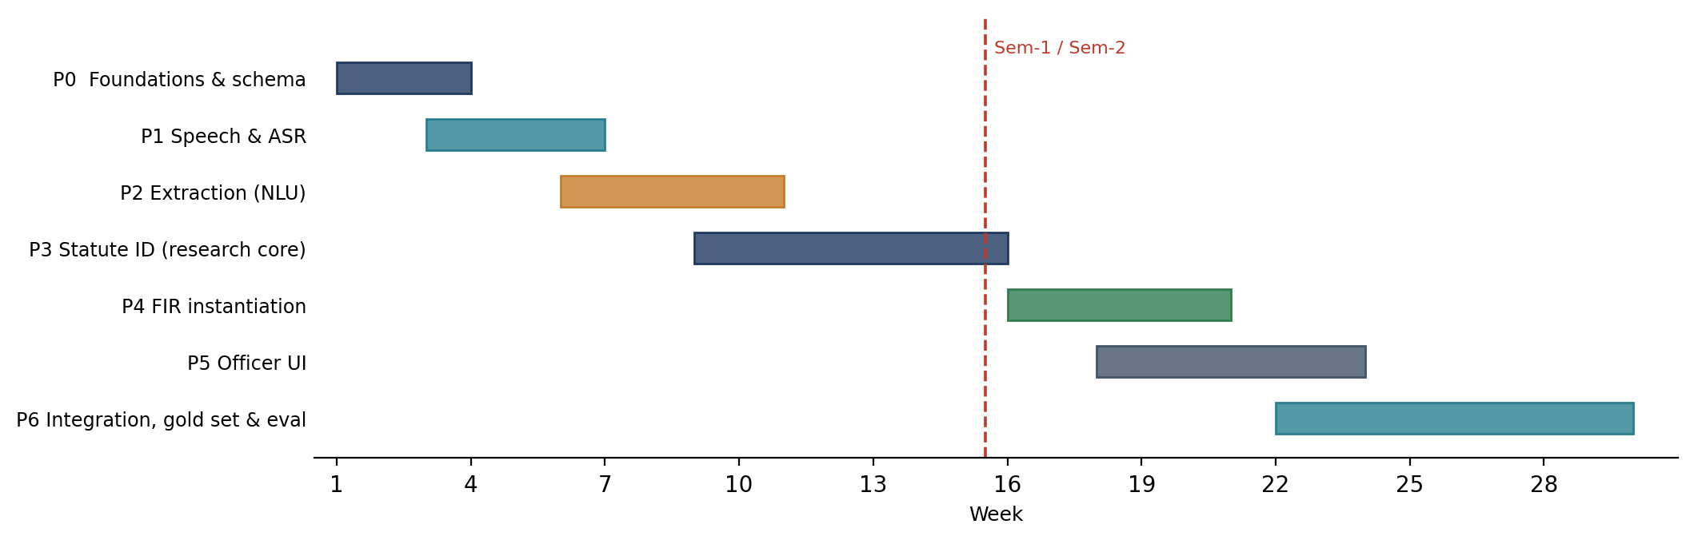
Figure 3.4 — Two-semester phase timeline (weeks). The statute research core (P3) is the critical path.
Table 3.8 lists the phase milestones and their exit criteria.
Phase | Milestone | Exit criterion
P0 | Foundations: env, FIR schema v0, legal KB, IPC→BNS map | Models co-load < 14 GB; schema validates samples
P1 | Speech front-end + ASR baseline | WER/CER measured on FLEURS-ta
P2 | Extraction A (NER) & B (LLM) | Schema-valid output with provenance; A vs B logged
P3 | Statute ID + element-wise verifier (research core) | Micro/macro-F1 vs LeSICiN; justifications emitted
P4 | Deterministic instantiation + faithfulness gate | 0 unsupported narrative sentences on gold
P5 | Officer verification UI | Span-linked review; accept/override audited
P6 | Integration, human gold set & evaluation | End-to-end draft within latency budget; full results

Table 3.8 — Two-semester milestones and exit criteria.
The three-member team divides the work along coherent subsystems, with shared responsibility for synthetic data, testing, and documentation.
Member | Primary responsibility | Stages / artefacts
Madhav Komanduri | Legal reasoning core (research contribution) | Stage C, IPC→BNS map, legal KB, faithfulness of justifications
«Team Member 2» | Speech & language front-end | Stage A (ASR/ITN), Stage B (extraction A & B), bilingual handling
«Team Member 3» | Instantiation, UI & evaluation | Stage D, Stage E officer UI, evaluation harness, integration/DevOps

Table 3.9 — Allocation of responsibilities (team of three).

3.7 Summary
This chapter has set out the proposed methodology, the component architecture and module contracts, the verified dataset foundation and synthetic-first data plan, the per-stage evaluation metrics, and the feasibility, risk, ethics, and work-planning analysis. The design is concretely buildable on a single 16 GB GPU using entirely open data, and its principal research contribution — explainable, BNS-aware statute identification bridged from IPC-era corpora — is well scoped and de-risked. Review 3 will report the first end-to-end vertical slice: a statute-identification baseline on ILSI with the IPC→BNS mapping applied, an ASR baseline on FLEURS-ta, and the initial synthetic-data pipeline, together with the reproducible evaluation harness.

References
[1] A. Radford et al., “Robust Speech Recognition via Large-Scale Weak Supervision (Whisper),” ICML, 2023.
[2] K. S. Bhogale et al., “Vistaar / IndicWhisper: Tamil and Indian-language ASR,” AI4Bharat, 2023.
[3] T. Javed et al., “IndicSUPERB: A Speech Processing Universal Performance Benchmark for Indian Languages,” AAAI, 2023.
[4] AI4Bharat, “Kathbath: A labelled ASR corpus for 12 Indian languages,” 2022.
[5] S. Khanuja et al., “MuRIL: Multilingual Representations for Indian Languages,” arXiv:2103.10730, 2021.
[6] A. Conneau et al., “Unsupervised Cross-lingual Representation Learning at Scale (XLM-R),” ACL, 2020.
[7] S. Paul et al., “LeSICiN: A Heterogeneous Graph-based Approach for Automatic Legal Statute Identification from Indian Legal Documents,” AAAI, 2022.
[8] ILSI Dataset, Zenodo, doi:10.5281/zenodo.6053791, 2022.
[9] S. Paul et al., “Pre-trained Language Models for the Indian Legal Domain (InLegalBERT),” 2023.
[10] P. Kalamkar et al., “Named Entity Recognition for Indian Legal Judgments (OpenNyAI),” 2022.
[11] The Bharatiya Nyaya Sanhita, 2023 (Act 45 of 2023), Government of India.
[12] The Bharatiya Nagarik Suraksha Sanhita, 2023 (Act 46 of 2023), Government of India.
[13] The Digital Personal Data Protection Act, 2023, Government of India.
[14] P. Lewis et al., “Retrieval-Augmented Generation for Knowledge-Intensive NLP Tasks,” NeurIPS, 2020.
[15] E. Hu et al., “LoRA: Low-Rank Adaptation of Large Language Models,” ICLR, 2022.
[16] T. Dettmers et al., “QLoRA: Efficient Finetuning of Quantized LLMs,” NeurIPS, 2023.
[17] A. Conneau et al., “FLEURS: Few-shot Learning Evaluation of Universal Representations of Speech,” 2022.
[18] R. Ardila et al., “Common Voice: A Massively-Multilingual Speech Corpus,” LREC, 2020.
[19] J. Chen et al., “BGE M3-Embedding: Multi-Lingual, Multi-Functionality, Multi-Granularity Text Embeddings,” 2024.
[20] Qwen Team, “Qwen2.5 Technical Report,” 2024.
[21] National Crime Records Bureau, “CCTNS and the Integrated Investigation Forms (IF-1),” Government of India.

