BCSE497J Project — I · Review 3 Report
──────────────────
Speech-Driven Drafting of First Information Reports for the Tamil Nadu Police (CCTNS IF-1):
A Bilingual, Explainable NLP Pipeline with BNS 2023 Statute Identification
Submitted by
Madhav K — 23BAI1088
Nischay Kuchibotla — 23BAI1245
Rohit A. S. — 23BAI1416
Under the guidance of
Dr. Shivaranjani
School of Computer Science and Engineering (SCOPE)
Vellore Institute of Technology, Chennai
September 2026

Abstract
The registration of a First Information Report (FIR) is the entry point to the criminal justice process in India, yet at the police-station level it remains a manual, error-prone task performed under time pressure and, in Tamil Nadu, across a bilingual Tamil–English setting. This project proposes an end-to-end, speech-driven decision-support system that converts a spoken citizen complaint into a draft FIR in the standard Tamil Nadu CCTNS Integrated Investigation Form (IF-1). The system chains five stages: multilingual automatic speech recognition robust to Tamil–English code-switching; legally-salient information extraction against a strict IF-1 JSON schema with per-field confidence and transcript provenance; applicable-statute identification under the Bharatiya Nyaya Sanhita (BNS) 2023 with element-wise (“ingredients of offence”) justification; deterministic instantiation of the fixed IF-1 form; and an officer verification workspace with an immutable audit trail. The system is explicitly decision support, not automation — the officer remains the author of record and every automated output is overridable, provenance-linked, and logged. A key research contribution is an explainable statute-identification pipeline built on the public IPC-era ILSI corpus, bridged to BNS 2023 through a verified IPC→BNS mapping layer. This Review-2 report presents the domain analysis and problem definition, a review of existing approaches and the gaps they leave, and the proposed methodology, system architecture, dataset plan, feasibility and risk analysis, ethics posture, and two-semester work plan.
Status at Review 3 (16 September 2026). The pipeline described in Chapter 3 now runs end to end as one LangGraph graph: ASR with hallucination guards and Tamil inverse text normalisation, rule-based extraction with provenance, a Tamil→English view for the English-only statute classifier, statute identification on the full ILSI corpus, IPC→BNS conversion under a high-confidence-only rule, cognizability routing from the BNSS First Schedule parsed from the gazette, element-wise justification, deterministic IF-1 instantiation with a grounded narrative, and a local FastAPI service with an officer verification page. Chapter 4 reports the implementation, the test suite (368 tests) and interim results: TF-IDF statute identification at micro-F1 0.700 against InLegalBERT at 0.526; Tamil ASR at WER 57.25% / CER 22.37% zero-shot, made five times faster by removing the decoder's temperature fallback; and a cognizability table in which the official Schedule corrected four entries of the hand-coded version.

Rubric Coverage Map
Each Review-3 evaluation parameter is addressed by the report sections below.
# | Evaluation Parameter | Report Section(s) | CO
1 | Follow-up on Review 2 feedback & progress vs plan | §3.8, §4.1, Fig. 4.1 | CO1, CO3, CO4
2 | Implementation & functional progress | §4.2, Table 4.1 | CO4
3 | Technical accuracy & best practices | §4.3, §4.5 | CO2
4 | Interim testing, results & analysis | §4.4 (Tables 4.3–4.8, Figs 4.2–4.4) | CO2
5 | Problem-solving & technical refinement | §4.5 | CO2, CO4
6 | Progress of the report | this document; §4.7 | CO1, CO4
7 | Presentation, individual responsibility | §4.7; Review3_Presentation | CO3, CO4

Table of Contents
Abstract 2
Rubric Coverage Map 2
Table of Contents 3
1. Introduction 6
1.1 Background and Domain 6
1.2 Motivation 6
1.3 Problem Definition 7
1.4 Objectives 7
1.5 Scope 7
1.6 Expected Outcomes 8
1.7 Organisation of the Report 8
2. Literature and Patent Review 9
2.1 Multilingual and Tamil Automatic Speech Recognition 9
2.2 Legal Information Extraction and Named-Entity Recognition 9
2.3 Legal Statute Identification 9
2.4 The IPC → BNS Transition 10
2.5 Grounded Generation, Faithfulness and Retrieval-Augmentation 10
2.6 Existing Systems and Patents 10
2.7 Comparative Analysis and Research Gaps 10
3. Proposed Methodology and System Design 12
3.1 Overview of the Proposed Approach 12
3.2 Proposed Methodology (per stage) 12
3.2.1 Stage A — Speech ingestion and ASR 12
3.2.2 Stage B — Information extraction 12
3.2.3 Stage C — Statute identification (research core) 12
3.2.4 Stage D — FIR instantiation 12
3.2.5 Stage E — Officer verification 13
3.2.6 Model selection 13
3.3 System Architecture and Module Design 14
3.3.1 Illustrative walkthrough 16
3.4 Datasets and Data Plan 16
3.5 Evaluation Plan 17
3.6 Feasibility, Risks, Ethics and Work Planning 17
3.6.1 Technical feasibility 17
3.6.2 Risk register 18
3.6.3 Ethics, privacy and DPDP alignment 18
3.6.4 Timeline and allocation of responsibilities 19
3.7 Summary 20
3.8 Revisions since Review 2 21
4. Implementation and Interim Results 21
4.1 Development environment and engineering constraints 21
4.2 Implementation by stage 22
4.3 Testing and validation 24
4.4 Interim results 24
4.4.1 Statute identification (ILSI, 100 IPC sections) 24
4.4.2 Legal knowledge base: mapping, cognizability, statute text 25
4.4.3 Automatic speech recognition (FLEURS ta_in) 26
4.4.4 Translation (Tamil → English, classifier view) 28
4.4.5 Extraction and element cues 29
4.5 Analysis, problems met and corrective action 29
4.6 Limitations at this stage 30
4.7 Individual contribution 30
5. Conclusion and Future Work (outline) 31
References 31

1. Introduction

1.1 Background and Domain
An FIR is the written document prepared by police on receipt of information about the commission of a cognizable offence; under the new procedural law it is registered under Section 173 of the Bharatiya Nagarik Suraksha Sanhita (BNSS) 2023 (formerly Section 154 CrPC). In Tamil Nadu, FIRs are recorded on the Crime and Criminal Tracking Network and Systems (CCTNS) Integrated Investigation Form IF-1, a fixed, standardised form capturing complainant and accused particulars, occurrence details, place of occurrence with direction and distance from the police station, properties involved, reasons for any delay in reporting, witnesses, and a free-text narrative of the incident. From 1 July 2024, the Indian Penal Code (IPC) 1860 was replaced by the Bharatiya Nyaya Sanhita (BNS) 2023, renumbering and reorganising the substantive criminal law that every new FIR must cite.
Two properties of the Tamil Nadu setting make the task technically demanding. First, complaints are narrated primarily in Tamil, frequently in a colloquial register with heavy Tamil–English code-switching (names, vehicle numbers, amounts, and legal terms often surface in English). Second, correctly identifying the applicable BNS sections requires reasoning over the “ingredients of offence” rather than simple keyword matching, and must be transparent enough for an officer to verify and defend.
For grounding, Table 1.1 summarises the principal IF-1 field groups the system must populate.
IF-1 field group | Representative fields
Complainant / informant | Name, parent/spouse name, age, occupation, address, contact
Accused particulars | Known/unknown, names, aliases, physical description, address
Occurrence details | Date/time or interval; information received at P.S.; GD reference
Place of occurrence | Address; direction & distance from P.S.; beat number; outside-limits P.S.
Offence & sections | Applicable BNS/special-act sections; cognizability
Properties & value | Items involved, description, estimated value; total value
Other | Reason for delay in reporting; witnesses; free-text narrative

Table 1.1 — Principal field groups of the Tamil Nadu CCTNS IF-1 form.

1.2 Motivation
Manual FIR drafting is slow and inconsistent: mandatory fields are missed, section selection varies with officer experience, and the recent IPC→BNS transition has increased the cognitive load of choosing correct sections. A system that listens to the complaint, drafts the structured form, and proposes justified BNS sections — while leaving the officer in full control — can improve completeness, consistency, and speed, and can serve as an assistive and training tool. Crucially, no such bilingual, explainable, offline-capable tool exists for the Tamil Nadu format.

1.3 Problem Definition
Given a spoken Tamil / code-switched citizen complaint, automatically produce a review-ready draft FIR in the TN IF-1 format — comprising (a) accurately transcribed and normalised text, (b) a populated IF-1 record with every value linked to its source utterance and a confidence score, (c) a ranked set of applicable BNS 2023 sections each accompanied by an element-wise justification, and (d) a cognizability decision routing the complaint to an FIR or to a Community Service Register (CSR) advisory — such that the drafting officer can inspect, override, and approve every element, with a complete audit trail. The system must never file autonomously and must not hallucinate facts into the record.

1.4 Objectives
- Build a Tamil / code-switched ASR front-end with punctuation restoration and inverse text normalisation of dates, times, phone and vehicle numbers, and currency amounts.
- Extract legally-salient information into a strict IF-1 JSON schema, comparing an encoder-NER pipeline against a schema-constrained LLM, each emitting per-field confidence and transcript-span provenance.
- Develop an explainable statute-identification module that predicts applicable offences and verifies each statutory element against the complaint, producing per-section justifications, bridged from IPC-era training data to BNS 2023 via a verified mapping layer.
- Apply a cognizability gate (BNSS First Schedule) to route cognizable complaints to an FIR draft and non-cognizable ones to a CSR advisory.
- Deterministically instantiate the fixed IF-1 form and compose a strictly-grounded, faithfulness-checked narrative in Tamil and English.
- Provide an officer verification workspace with span-level provenance, confidence heat-mapping, inline editing, accept/override logging, and immutable versioning.
- Evaluate every stage on held-out and synthetic data, and the end-to-end system on field-completeness, officer edit distance, and time-to-draft.

1.5 Scope
In scope:
- Tamil and Tamil–English speech input; the standard TN CCTNS IF-1 output (fixed form).
- BNS 2023 (and BNSS 2023 for procedure) plus commonly-invoked special acts (Motor Vehicles Act, IT Act 2000, TN Prohibition of Harassment of Woman Act).
- A local-only, offline-degradable prototype running on a single 16 GB consumer GPU.
Out of scope (this project):
- Actual electronic filing or live CCTNS integration; biometric capture.
- Case-progress tracking beyond FIR registration; languages other than Tamil/English.
- Any autonomous decision — the officer verifies and is the author of record.

1.6 Expected Outcomes
- A working five-stage prototype that drafts a bilingual IF-1 FIR from a spoken complaint within a few minutes, for officer review.
- An explainable statute-identification module with measurable faithfulness of its element-wise justifications, benchmarked against the LeSICiN baseline on ILSI (BNS-mapped).
- A verified IPC→BNS mapping resource and a reproducible synthetic-data + evaluation harness.
- A quantified evaluation: ASR word/character error rate, slot-level extraction F1, statute-ID micro/macro-F1, and end-to-end field-completeness and time-to-draft.

1.7 Organisation of the Report
Chapter 2 reviews existing work on multilingual ASR, legal information extraction, statute identification, the IPC→BNS transition, and grounded generation, and identifies the gaps this project addresses. Chapter 3 presents the proposed methodology, the system architecture and module design, the dataset and evaluation plans, and the feasibility, risk, ethics, and work-planning analysis.
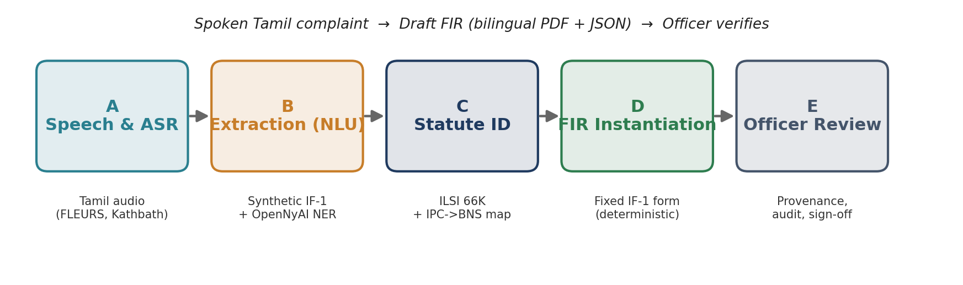
Figure 1.1 — The five-stage pipeline and the data feeding each stage.

2. Literature and Patent Review
This chapter surveys the components the system depends on, assesses credible datasets and models, and identifies the gaps that motivate the proposed work.

2.1 Multilingual and Tamil Automatic Speech Recognition
Whisper (Radford et al., 2023) established robust multilingual ASR via large-scale weak supervision and supports Tamil zero-shot, though it degrades on colloquial and code-switched speech. AI4Bharat's IndicWhisper and IndicConformer, trained on Indian-language corpora, improve Tamil accuracy; the associated IndicSUPERB benchmark and the Kathbath corpus (1,684 hours across 12 languages, CC0) provide substantial labelled Tamil speech. Public evaluation sets include FLEURS-ta and Mozilla Common Voice (ta). The open gap is code-switching: none of these corpora target Tamil–English police-complaint speech, and inverse text normalisation of India-specific entities (vehicle registrations, rupee amounts) is not handled out of the box.
In practice, code-switching is handled better by models exposed to Indian-language data during training, which motivates comparing a fine-tuned IndicWhisper against zero-shot Whisper on a code-switched development set. Because complainants routinely dictate India-specific entities (vehicle registration numbers, rupee amounts, phone numbers, dates), inverse text normalisation is treated as a first-class post-processing step rather than an afterthought.

2.2 Legal Information Extraction and Named-Entity Recognition
MuRIL (Khanuja et al., 2021) and XLM-R (Conneau et al., 2020) provide strong multilingual encoders for Indian-language token classification. For the legal domain specifically, the OpenNyAI InLegalNER corpus annotates 14 legal entity types (e.g., statute, court, provision, petitioner) over Indian judgments and supports high-F1 legal NER models. These resources target court judgments rather than spoken complaints and do not map onto the IF-1 form's fields, but they are an effective warm-start for slot extraction.

2.3 Legal Statute Identification
Automatic Legal Statute Identification (LSI) frames section prediction as multi-label classification over case facts. The ILSI dataset (~66K fact descriptions labelled with 100 IPC sections) and the LeSICiN model (Paul et al., AAAI 2022), which represents statutes and documents as a heterogeneous graph, are the standard benchmark and baseline. Domain-adapted encoders such as InLegalBERT further improve legal text classification. Two limitations are decisive here: the labels are IPC-era (pre-2024), and the inputs are English court-fact text, not Tamil colloquial complaints — both create a domain and label gap the proposed system must bridge.
A further consequence is that statute-identification models trained on ILSI learn from written, formal court language, whereas our inputs are colloquial spoken complaints. We therefore treat statute identification as reasoning over the extracted and (where necessary) translated narrative, and we measure cross-domain generalisation explicitly rather than assuming in-domain performance will transfer.

2.4 The IPC → BNS Transition
Because BNS 2023 renumbers and reorganises the IPC (e.g., murder moves from IPC 302 to BNS 103; dowry death from 304B to 80; cheating from 420 to 318), any model trained on IPC-labelled data must translate its outputs to BNS to be usable operationally. The Ministry of Home Affairs published correspondence tables, and several secondary conversion tables exist; however, the mapping is many-to-one and one-to-many in places and contains genuine ambiguities, so a verified, versioned mapping layer with human review is required rather than a naive lookup.

2.5 Grounded Generation, Faithfulness and Retrieval-Augmentation
Retrieval-augmented generation (Lewis et al., 2020) and constrained decoding allow an LLM to be anchored to source evidence, and natural-language-inference-based faithfulness checks can flag unsupported statements. For a legal document these techniques are safety-critical: any generated sentence must be entailed by the extracted facts. Parameter-efficient fine-tuning (LoRA; QLoRA, Dettmers et al., 2023) and 4-bit quantisation make it feasible to run and adapt 7–8B-parameter models on a single consumer GPU.

2.6 Existing Systems and Patents
CCTNS provides electronic FIR entry and some states offer citizen e-FIR portals, but these are manual data-entry forms without speech input, extraction, or statute reasoning. Commercial legal AI tools focus on research and drafting for practitioners, not on-desk FIR assistance in Indian languages. To the best of our review, there is no published system or patent combining Tamil speech input, IF-1 extraction with provenance, explainable BNS statute identification, and officer-in-the-loop verification.

2.7 Comparative Analysis and Research Gaps
Approach / Resource | Strength | Limitation for our problem
Whisper large-v3 | Robust multilingual ASR | Weak on Tamil–English code-switch; no ITN for Indian entities
IndicWhisper / Kathbath | Strong Tamil ASR + large corpus | Not police-complaint domain; no code-switch complaint audio
OpenNyAI InLegalNER | 14 legal entity types, high F1 | Judgment domain; not mapped to IF-1 fields
ILSI + LeSICiN | 66K facts, standard LSI benchmark | IPC-era labels; English court facts, not spoken complaints
CCTNS e-FIR portals | Official IF-1 data capture | Manual entry; no speech/extraction/statute reasoning

Identified gaps this project addresses:
- No public Tamil complaint→IF-1 corpus → addressed by a synthetic-first data pipeline with a human gold set staged later.
- Statute-ID resources are IPC-era → addressed by a verified IPC→BNS mapping layer.
- Existing tools are neither explainable nor officer-in-the-loop → addressed by element-wise justifications, provenance, and an audited verification workspace.
- No offline-capable, single-GPU, bilingual FIR-drafting system exists → the core contribution.

3. Proposed Methodology and System Design

3.1 Overview of the Proposed Approach
The system is a five-stage pipeline (Figure 1.1) orchestrated as a directed graph. Design is governed by five invariants: (i) decision support, not automation; (ii) grounded generation only — no generative model writes into structured fields; (iii) mandatory provenance and confidence on every extracted value; (iv) explicit, auditable cognizability routing; and (v) local-only, offline-degradable operation. Because the IF-1 form is fixed and standardised, Stage D is deterministic form-filling rather than document generation — the difficulty lives in Stages B (extraction) and C (statute identification).

3.2 Proposed Methodology (per stage)

3.2.1 Stage A — Speech ingestion and ASR
Audio is resampled to 16 kHz mono, segmented by voice-activity detection, and (in guided-interview mode) diarised to separate complainant from officer. Transcription uses faster-whisper (Whisper large-v3, int8) with AI4Bharat IndicConformer as a low-VRAM fallback, followed by punctuation restoration, disfluency removal, and inverse text normalisation of dates, times, phone and vehicle numbers, and currency. Zero-shot and LoRA-fine-tuned variants are compared. Original Tamil spans are preserved verbatim with character offsets and audio timestamps.

3.2.2 Stage B — Information extraction
Two approaches are built and compared head-to-head: (A) a fine-tuned encoder NER (MuRIL / XLM-R / IndicBERT) with rule-based slot assembly, warm-started on OpenNyAI; and (B) a schema-constrained LLM that emits IF-1 JSON with per-field confidence and transcript-span provenance. Bilingual handling preserves Tamil verbatim and renders English equivalents where the form requires.

3.2.3 Stage C — Statute identification (research core)
A multi-label classifier (InLegalBERT/MuRIL) trained on ILSI predicts candidate offences; the IPC→BNS mapping layer converts predictions to BNS 2023. For each candidate section a retrieval-augmented verifier retrieves the statutory elements (BGE-m3 over BNS text) and a local LLM checks each “ingredient of offence” against the complaint, emitting a per-element satisfied/unclear judgement with supporting spans — the explainability contribution. A cognizability gate (BNSS First Schedule) then routes the complaint; ambiguous cases default to officer review.

3.2.4 Stage D — FIR instantiation
A deterministic template engine fills the fixed IF-1 structured fields from the JSON record; no generative model writes structured fields. A local LLM composes only the free-text narrative under constrained decoding, and every sentence must be entailed by an extracted fact (a faithfulness/NLI gate blocks unsupported content) before the officer edits it. Outputs are a print-faithful bilingual PDF and a machine-readable JSON record.

3.2.5 Stage E — Officer verification
The React workspace shows the transcript and extracted fields side-by-side with span-level provenance links, a confidence heat-map, inline editing, suggested sections with expandable element-wise justifications, and accept/override actions. Every action is written to an immutable, versioned audit trail; the officer marks the record verified and remains the author of record.

3.2.6 Model selection
Models are chosen to co-reside on a single 16 GB GPU while meeting the latency target. Table 3.1 summarises the selection, trading accuracy against latency and VRAM. The inference path keeps one resident 4-bit 7–8B LLM serving extraction, verification, and narrative composition; the larger 14B model is used only for offline synthetic-data generation.
Stage / role | Model (precision) | VRAM | Rationale
ASR (primary) | Whisper large-v3 (int8) | ~2 GB | Best general Tamil; code-switch fine-tuning
ASR (fallback) | IndicConformer (fp16) | ~1 GB | Low-VRAM path for 12 GB machines
Extraction / verify / narrative | Qwen2.5-7B-Instruct (4-bit) | ~6 GB | Multilingual; strong JSON adherence; resident
NER (approach A) | MuRIL-base (fp16) | <1 GB | Indian-language token labelling
Statute classifier | InLegalBERT (fp16) | <1 GB | Legal-domain pre-training
RAG retriever | BGE-m3 (fp16) | ~1.5 GB | Strong multilingual retrieval
Synthetic data-gen (offline) | Qwen2.5-14B (4-bit) | ~9 GB | Best local quality; GPU-alone, batch

Table 3.1 — Model-selection matrix (accuracy vs. latency vs. VRAM) for a 16 GB budget.

3.3 System Architecture and Module Design
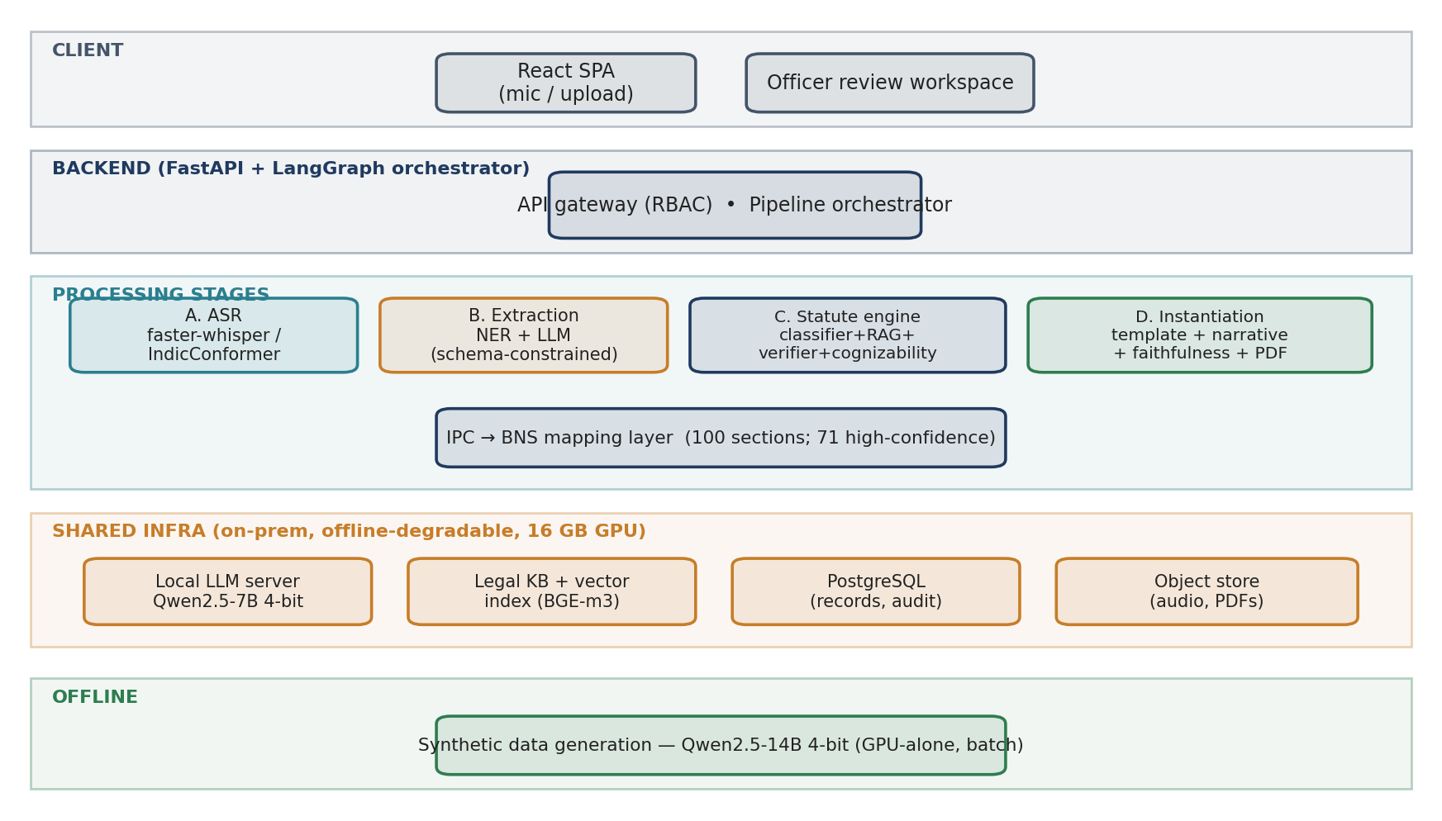
Figure 3.1 — Component architecture: client, orchestrated backend, five stages, and the shared on-prem infrastructure. Synthetic data generation runs offline.
Modules communicate only through the orchestrator via versioned contracts over a canonical IF-1 JSON schema; no module reaches into another's internals. Each extracted field is a typed wrapper carrying value, bilingual text, confidence, provenance (character offsets + audio timestamps), and an edit-status. Table 3.1 summarises the module boundaries.
Module | Responsibility | Key interface (in → out)
asr | Transcribe + normalise | AudioRef → ASRResult (tokens, timestamps, spans)
extract | Populate IF-1 record | ASRResult → ExtractionResult (FIRRecord + provenance)
statute | Sections + justification + routing | FIRRecord+narrative → StatuteAssessment
instantiate | Fill form + grounded narrative | FIRRecord+StatuteAssessment → FIRDocument (PDF+JSON)
review-api | Officer edits, audit, versioning | FIRDocument → verified record + AuditEvents

Table 3.2 — Module boundaries and interface contracts.
Figure 3.2 traces the end-to-end data flow and the artefact produced at each hop; note that only the narrative is generated, and it is gated for faithfulness before the officer sees it.
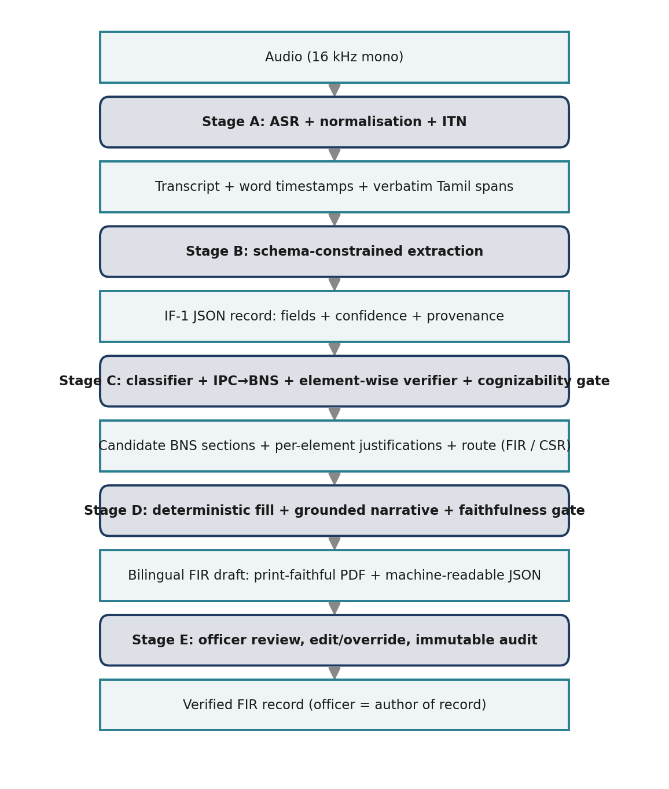
Figure 3.2 — End-to-end data flow: alternating processes (dark) and the data artefacts they emit (light).
The canonical schema is a strict JSON mirror of IF-1; Table 3.3 lists its key structures. Every field is a typed wrapper with value, bilingual text, confidence, provenance, and edit-status, so the record is self-documenting and fully auditable.
Schema element | Purpose
field wrapper | value + ta/en text + confidence + provenance[] + status(extracted/edited/…)
provenance | transcript char offsets + audio start/end (ms) + utterance id
complainant / accused | person particulars; known/unknown accused with descriptions
occurrence / place | datetime or interval; direction & distance from P.S.; beat
acts_sections | act, section, score, elements[] with per-element satisfied + justification
cognizability | decision, route (FIR / CSR_advisory / officer_review), schedule ref
narrative | ta / en text + grounding[] linking each sentence to supporting provenance

Table 3.3 — Key structures of the canonical IF-1 JSON schema.

3.3.1 Illustrative walkthrough
Consider a complainant who narrates, in Tamil, that her married sister was harassed for dowry by her husband and in-laws and was later found dead. Stage A transcribes and normalises the narration, preserving the Tamil spans and the reported dates. Stage B populates the IF-1 record — complainant and accused particulars, place and time of occurrence, and the narrative — each field carrying a confidence score and a pointer back to the spoken span. Stage C predicts the applicable offences and, after mapping the IPC-era model output to BNS 2023, proposes the sections corresponding to dowry death, cruelty by a husband or relatives, and acts done with common intention (in BNS terms, sections 80, 85 and 3(5)), with an element-wise justification for each. The cognizability gate marks the matter cognizable and routes it to an FIR draft. Stage D fills the fixed form and composes a grounded bilingual narrative, which the officer reviews, edits, and signs. This mirrors the real ILSI case structure used to train and evaluate the statute module.

3.4 Datasets and Data Plan
Dataset availability was verified against live sources. Table 3.2 lists the resources; all are openly downloadable. Because no public Tamil complaint→IF-1 corpus exists, the project is synthetic-first: a local LLM (Qwen2.5-14B, 4-bit, offline) generates Tamil / code-switched complaint narratives from structured scenario seeds — the seed doubles as the gold label — which are voiced with Indic-TTS. A self-recorded human gold set is staged as a later milestone for real evaluation.
Dataset | Role | Volume / License | Access
FLEURS (ta_in) | ASR eval/train | 3,335 clips, ~2.76 GB, CC-BY | Hugging Face
AI4Bharat Kathbath | ASR train | 1,684 h (12 langs), CC0 | Hugging Face
ILSI | Statute ID | ~66K facts, 100 IPC sections | Zenodo (open)
OpenNyAI InLegalNER | Legal NER seed | 46,545 entities, 14 types | Hugging Face / GitHub
BNS/BNSS 2023 text | Statute KB (RAG) | 358 BNS sections | India Code
IPC→BNS mapping | Bridge layer | 100 ILSI sections (built) | This project

Table 3.4 — Verified datasets underpinning the system.
The IPC→BNS mapping layer was built for the 100 IPC sections used by ILSI and verified against a published BNS–IPC directory; 71 of 100 rows are high-confidence (auto-applied) and 29 are flagged for human review, with conflicts (e.g., IPC 325→BNS 117(2), 326→118(2), 353→132) resolved (Figure 3.3). Only high-confidence rows are auto-applied; the rest route to the officer.
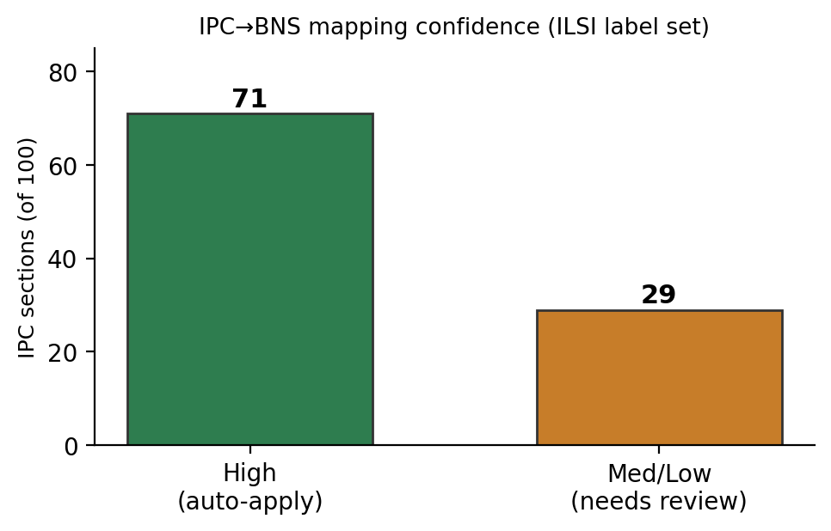
Figure 3.3 — IPC→BNS mapping confidence over the ILSI label set.

3.5 Evaluation Plan
Stage | Metric(s) | Data / baseline
ASR | WER, CER (per register/speaker) | FLEURS-ta, code-switched set
Extraction | Slot precision/recall/F1; provenance coverage | Synthetic gold; A vs B
Statute ID | Micro/macro-F1; cognizability accuracy | ILSI (BNS-mapped) vs LeSICiN
Justification | Element-support & entailment rate | Faithfulness metrics
End-to-end | Field-completeness, officer edit distance, time-to-draft | Synthetic + human gold

Table 3.5 — Per-stage evaluation metrics and baselines.

3.6 Feasibility, Risks, Ethics and Work Planning

3.6.1 Technical feasibility
The inference path fits a single 16 GB GPU: a resident 4-bit 7–8B LLM (~6 GB) co-resides with int8 Whisper (~2 GB), the BGE-m3 retriever (~1.5 GB), and small encoders/NLI (~2 GB), leaving headroom for the KV cache (~13–14 GB total). The larger 14B data-generation model runs offline, GPU-alone. Parameter-efficient fine-tuning (LoRA/QLoRA) keeps training within budget. The target latency is a review-ready draft within roughly four minutes of a three-minute complaint; a 12 GB fallback (IndicConformer ASR, serialised loading) is documented. All datasets and tooling are confirmed available, making the plan concretely buildable.
Table 3.6 gives the target latency budget assumed for a three-minute complaint; a resident LLM server avoids model-swap overhead so the stages run back-to-back.
Stage | Budget | Basis
A. ASR (large-v3 int8) | 45 s | ~4–8× real-time on 16 GB GPU
A′. Normalisation / ITN | 10 s | CPU-light
B. Extraction | 30 s | 1–few constrained LLM calls
C. Statute ID + verify | 90 s | Classifier + RAG + batched element checks
D. Narrative + faithfulness | 40 s | One generation + one entailment pass
D′. PDF + JSON render | 5 s | Deterministic
Total | ≈ 3.7 min | Resident 8B avoids model-swap overhead

Table 3.6 — Target latency budget (three-minute complaint).

3.6.2 Risk register
Risk | Impact | Mitigation
Local-only caps synthetic-data quality (no frontier teacher) | High | Largest local model (Qwen2.5-14B 4-bit) + templates + human curation
No public Tamil complaint audio | Med | Synthetic-first + self-recorded human gold set
IPC→BNS mapping ambiguity | High | Verified/versioned map; confidence flags; officer review of non-high rows
Narrative hallucination | Critical | Constrained decoding + entailment gate + mandatory officer review
Code-switching degrades ASR | Med | Code-switch fine-tuning; surface low-confidence tokens
16 GB VRAM contention | Med | Resident 8B + int8 ASR co-residence; 14B offline only
Legal-correctness liability | Critical | Decision-support framing; officer author-of-record; full audit; legal review

Table 3.7 — Principal risks and mitigations.

3.6.3 Ethics, privacy and DPDP alignment
The system handles sensitive personal data and therefore follows privacy-by-design aligned with the Digital Personal Data Protection (DPDP) Act 2023: data minimisation, local encrypted storage, retention limits, role-based access control, and an immutable audit trail. All development and evaluation use fictitious particulars — no real complainant data. The system is strictly assistive: it never files autonomously, every output is overridable, and the officer is the author of record. Statute suggestions are decision support, not legal advice, and gold-set section labels are validated by a law-qualified reviewer.

3.6.4 Timeline and allocation of responsibilities
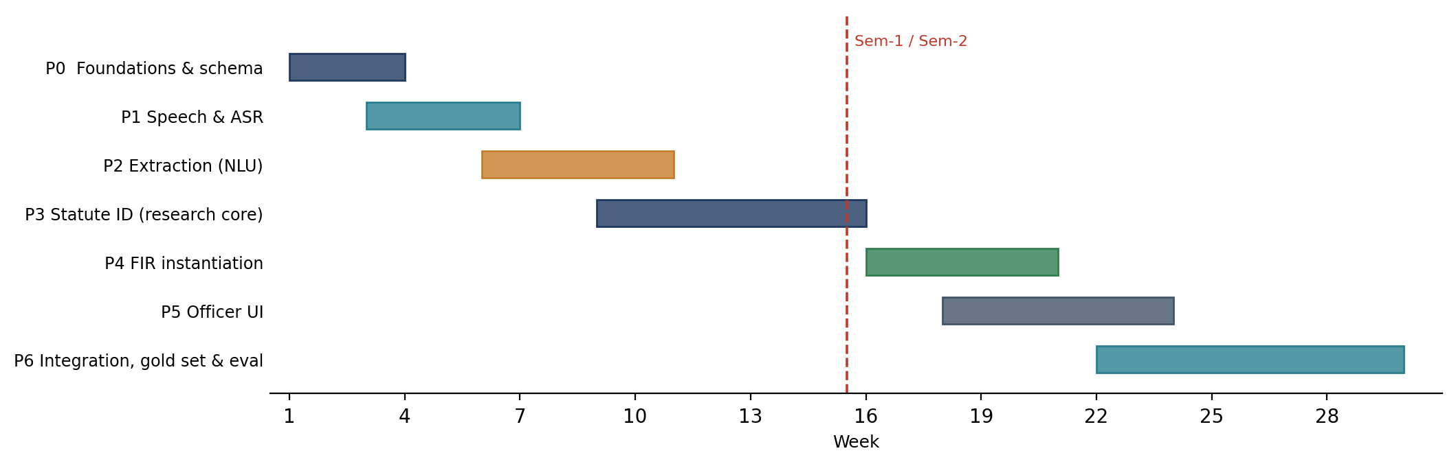
Figure 3.4 — Two-semester phase timeline (weeks). The statute research core (P3) is the critical path.
Table 3.8 lists the phase milestones and their exit criteria.
Phase | Milestone | Exit criterion
P0 | Foundations: env, FIR schema v0, legal KB, IPC→BNS map | Models co-load < 14 GB; schema validates samples
P1 | Speech front-end + ASR baseline | WER/CER measured on FLEURS-ta
P2 | Extraction A (NER) & B (LLM) | Schema-valid output with provenance; A vs B logged
P3 | Statute ID + element-wise verifier (research core) | Micro/macro-F1 vs LeSICiN; justifications emitted
P4 | Deterministic instantiation + faithfulness gate | 0 unsupported narrative sentences on gold
P5 | Officer verification UI | Span-linked review; accept/override audited
P6 | Integration, human gold set & evaluation | End-to-end draft within latency budget; full results

Table 3.8 — Two-semester milestones and exit criteria.
The three-member team divides the work along coherent subsystems, with shared responsibility for synthetic data, testing, and documentation.
Member | Primary responsibility | Stages / artefacts
Madhav Komanduri | Legal reasoning core (research contribution) | Stage C, IPC→BNS map, legal KB, faithfulness of justifications
«Team Member 2» | Speech & language front-end | Stage A (ASR/ITN), Stage B (extraction A & B), bilingual handling
«Team Member 3» | Instantiation, UI & evaluation | Stage D, Stage E officer UI, evaluation harness, integration/DevOps

Table 3.9 — Allocation of responsibilities (team of three).

3.7 Summary
This chapter has set out the proposed methodology, the component architecture and module contracts, the verified dataset foundation and synthetic-first data plan, the per-stage evaluation metrics, and the feasibility, risk, ethics, and work-planning analysis. The design is concretely buildable on a single 16 GB GPU using entirely open data, and its principal research contribution — explainable, BNS-aware statute identification bridged from IPC-era corpora — is well scoped and de-risked. Review 3 will report the first end-to-end vertical slice: a statute-identification baseline on ILSI with the IPC→BNS mapping applied, an ASR baseline on FLEURS-ta, and the initial synthetic-data pipeline, together with the reproducible evaluation harness.

3.8 Revisions since Review 2
The methodology of Chapter 3 stands, with five revisions recorded here so that the report and the implementation agree (guideline §2).
- Compute budget (§3.6.1). The development machine has an RTX 5050 Laptop GPU with 8 GB of VRAM, below the 12 GB fallback assumed at Review 2. Every model entry in configs/models.yaml now carries a fits flag against the real budget; the 14B synthetic-data generator does not fit at 4-bit (~9 GB) and the 7B-versus-14B-with-offload decision is deferred to a measured benchmark on mains power.
- Statute classifier (§3.2.3). InLegalBERT was to be the multi-label classifier. On the full ILSI corpus a TF-IDF + one-vs-rest logistic baseline reaches micro-F1 0.7000 against 0.5256 for the encoder with every lever applied, and an ensemble adds +0.0006. TF-IDF is therefore the classifier of record; the encoder's role moves to element verification (§4.4.1).
- Translation node. The classifier is English-only; a Tamil→English node (interim Helsinki-NLP/opus-mt-dra-en) feeds it. Its first real failure — “வரதட்சணை” (dowry) rendered as “relief” — motivated the bilingual element cue-scan safety net that runs on the original text (§4.4.5).
- Legal knowledge base (§3.4). The BNSS First Schedule and all 358 BNS section texts are parsed from the official gazette PDFs with page citations, replacing the hand-coded cognizability stub, which the gazette showed to be wrong on four of forty-eight entries (§4.4.2).
- Allocation of responsibilities (§3.6.4). «State here how the split described in Table 3.9 was actually followed between Review 2 and Review 3.»

4. Implementation and Interim Results
This chapter reports the state of the implementation at Review 3: the environment and its constraints, what was built for each stage, how it is tested, the interim measurements, an analysis of the technical problems met and how they were resolved, the limitations at this stage, and the individual contributions. Every number is read from a machine-written report under artifacts/reports/ and can be regenerated with make results.

4.1 Development environment and engineering constraints
All Python runs inside WSL2 Ubuntu 24.04 (Python 3.11, uv-managed virtual environment) because Windows Smart App Control blocks the pyarrow wheel that the Hugging Face datasets and bitsandbytes packages depend on; data loaders therefore read plain JSONL/TSV and parquet through DuckDB. The GPU is an RTX 5050 Laptop (Blackwell, sm_120, 8 GB); PyTorch 2.11 with CUDA 12.8 wheels is required because older wheels ship no kernels for this architecture. The WSL virtual machine has 7.7 GB of RAM and restarts itself when a single process's Python heap passes roughly 2 GB; every corpus-scale build (vectoriser, tokenizer, prediction) is therefore chunked, long jobs are launched detached with logs on the Windows file system, and one memory-heavy job runs at a time. Inference is strictly local: models load from a local Hugging Face cache with HF_HUB_OFFLINE=1, the API binds 127.0.0.1 only, and uploaded audio is deleted after transcription.
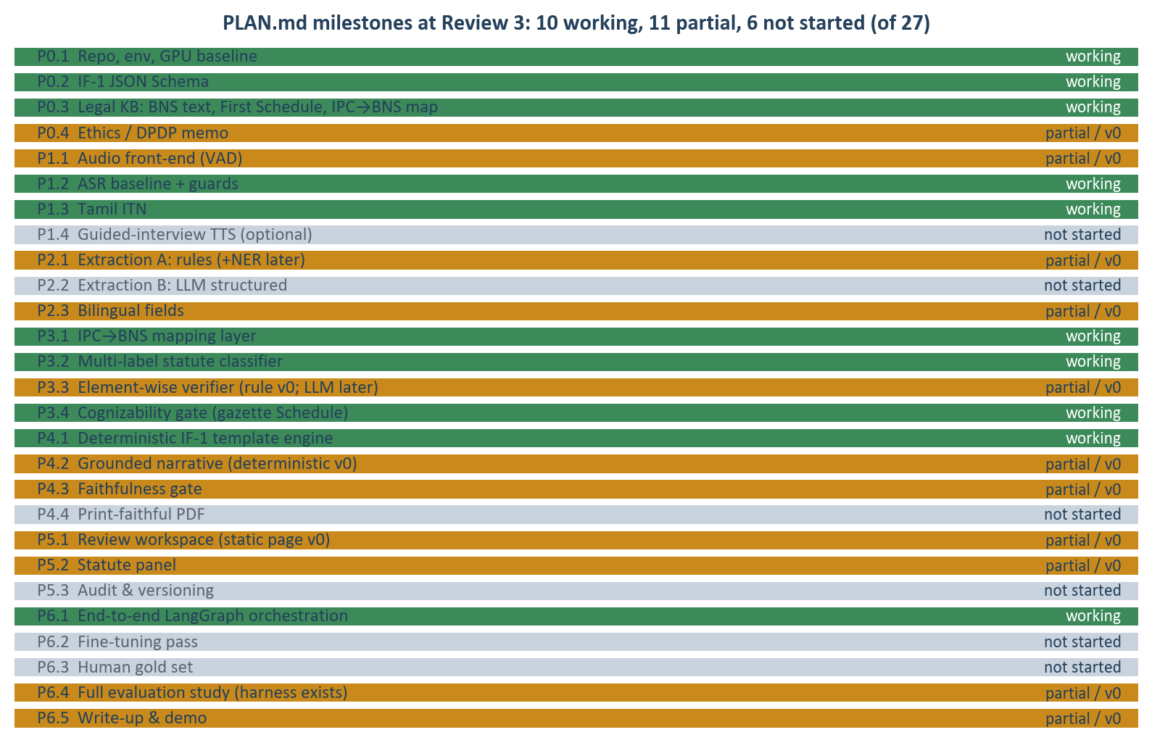
Figure 4.1 — Status of the 27 PLAN.md milestones at Review 3: 10 working, 11 partial (v0), 6 not started.

4.2 Implementation by stage
Figure 4.2 summarises the graph as built. Table 4.1 lists the modules behind each stage, the file that implements them and the tests that pin their behaviour.
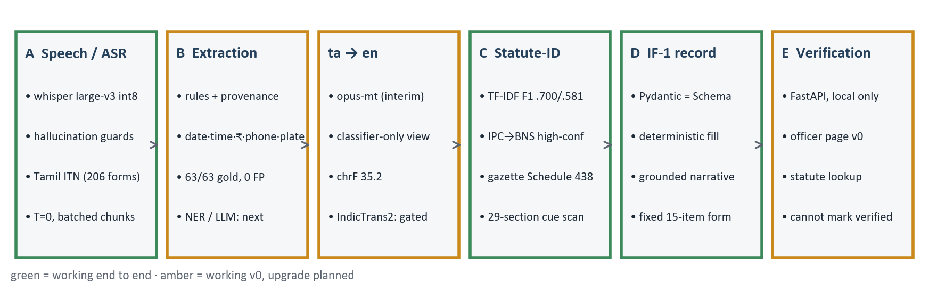
Figure 4.2 — The pipeline as built. Green: working end to end; amber: working v0 with a planned upgrade.
Stage | Module (src/fir/…) | What it does | Tests
A | asr/whisper.py | faster-whisper large-v3 (CTranslate2 int8) with device fallback; one decoding pass at temperature 0; batched VAD-chunk decoding | test_asr_quality
A | asr/quality.py | transcript guards: duplicated-trigram fraction (replay loops) and foreign-script count (language drift), calibrated on the baseline | test_asr_quality (fixtures from real clips)
A | asr/itn.py | Tamil inverse text normalisation: 206-form number lexicon with sandhi, spoken dates/times/amounts → digits, offset map to the transcript | test_itn (69)
B | extract/rules.py, extract/fill.py | dates, times, ₹ amounts, phones, vehicle plates with character offsets; fills an IF-1 slot only when unambiguous | test_extract_rules; harness gold set (28 docs)
→ | translate/indictrans.py | Tamil→English for the classifier only (marian/nllb/indictrans backends); original text kept for every other stage | test_translate
C | statute/tfidf_baseline.py, statute/inlegalbert.py, statute/registry.py | multi-label statute classifiers on ILSI; TF-IDF (hashed 1–2-grams, chunked) is the default | harness/run_statute_baseline
C | statute/ipc_bns_map.py | IPC→BNS conversion; auto-apply only when confidence = high, needs_review = N and the target is a BNS section | test_slice_golden
C | statute/cognizability.py | BNSS First Schedule lookup (438 keys from the gazette); cognizable / non-cognizable / conditional / unknown; value-resolved conditions | test_bnss_schedule (41), test_slice_golden
C | statute/elements.py | element-wise justification for 29 sections with English + Tamil cues; cue scan as recall safety net | test_elements, test_cue_scan, test_cue_battery
C | statute/statute_text.py, statute/bns_text.py | statute text lookup and lexical retrieval rank (ILSI IPC text); BNS 2023 section text from the gazette | test_statute_text, test_bns_text
D | schema/if1.py, schema/statute_decision.py | Pydantic IF-1 record in parity with the canonical JSON Schema; the decision record with provenance | test_if1_schema
D | instantiate/from_decision.py, narrative.py, render.py | decision → record bridge; grounded bilingual narrative with a faithfulness gate; the fixed 15-item form | test_narrative, test_render_if1
E | serving/app.py, serving/static/index.html, __main__.py | FastAPI (text, audio, statute lookup, health); officer verification page; CLI draft / check / mapping | test_serving, test_cli
all | orchestrator/graph.py | LangGraph state graph: (audio→asr) → extract → translate → statute_id → ipc_bns → cognizability_check → instantiate | test_slice_golden (fixture-pinned)

Table 4.1 — Modules implemented at Review 3, by pipeline stage.

4.3 Testing and validation
The suite has 368 tests across 17 files and runs in about twenty seconds without model weights, so it runs on every change. Beyond unit tests, four kinds of checks carry the legal-safety requirements of Chapter 3 as executable assertions:
- Golden end-to-end fixtures (tests/fixtures/golden_slice.json): nine complaints with the expected IPC predictions, BNS sections, review reasons and route, run through the real graph with a stub classifier so that the mapping, cognizability and instantiation logic — not the model — is under test.
- Invariants as tests: the IPC→BNS auto-apply rule; “an unknown section never defaults”; “nothing in src/ can set a record to verified”; “a threat to kill is criminal intimidation, not attempt or murder”; Pydantic ↔ JSON Schema parity that fails on any drift.
- Data integrity: the parsed First Schedule must have 438 keys in gazette order, no empty classification cells, a gazette page on every row and 25 classifications a lawyer can check; the BNS text must contain exactly sections 1–358 with headings.
- Reproduced failures: the mistranslated dowry complaint, the Whisper replay loop and the Cyrillic drift are fixtures; the tests that guard them would fail if the guard were removed.
Static checks: ruff (E, F, W, I) is clean; the repository is LF-only; every build artefact has a make target (make schedule, make bns-text, make results).

4.4 Interim results

4.4.1 Statute identification (ILSI, 100 IPC sections)
ILSI provides 42,835 training, 10,200 development and 13,039 test court documents. Decision thresholds are tuned on the development split for micro-F1 and reported on test. Table 4.3 and Figure 4.3 compare the sparse baseline with the domain-pretrained encoder on the 8k subsample used for the vertical slice and on the full corpus.
Training set | Model | micro-F1 | macro-F1 | labels used / 100
8k subsample | TF-IDF + OvR logistic | 0.5988 | 0.4278 | 99
8k subsample | InLegalBERT (2 ep) | 0.2846 | 0.1811 | 79
8k subsample | InLegalBERT, head LR ×10 | 0.3530 | 0.2398 | 89
full corpus | TF-IDF + OvR logistic | 0.7000 | 0.5805 | 100
full corpus | InLegalBERT (2 ep) | 0.4636 | 0.3984 | 97
full corpus | InLegalBERT (4 ep, head LR ×10, head+tail) | 0.5256 | 0.4594 | 100
full corpus | Ensemble α=0.8 (TF-IDF, BERT) | 0.7006 | 0.5839 | —

Table 4.3 — Statute identification on the ILSI test split. Thresholds tuned on dev.
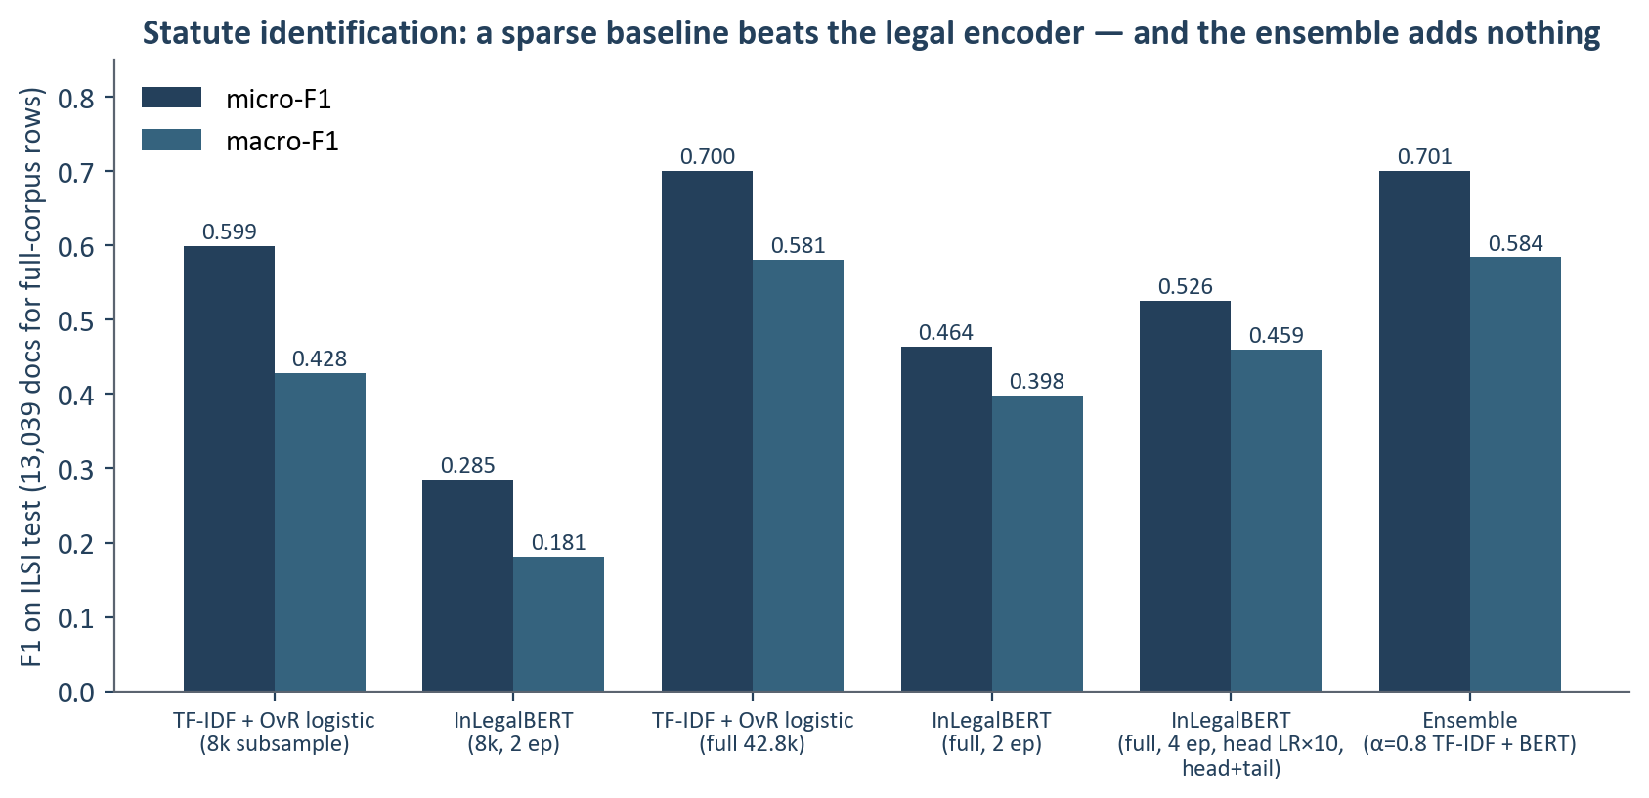
Figure 4.3 — micro- and macro-F1 by model and training set.
Two explanations for the encoder gap were tested and ruled out. Truncation to 512 wordpieces keeps 24.1% of the text and costs the TF-IDF model 0.0516 micro-F1 (8.6% relative), far less than the gap; and the first encoder run's collapse onto six labels (macro-F1 0.018) was a loss problem — plain binary cross-entropy on a hundred sparse labels — fixed with positive-class weighting, after which the encoder still loses. The conclusion for this corpus is that TF-IDF is the classifier and the encoder's contribution lies in element verification, where it reads statute text against the complaint rather than assigning labels.

4.4.2 Legal knowledge base: mapping, cognizability, statute text
The IPC→BNS mapping covers the 100 ILSI sections: 69 rows are auto-applicable, 29 are flagged for review and 7 map outside the BNS (Prevention of Corruption Act, omitted sections). The source is a third-party pocket directory rather than the official gazette, which is why the auto-apply rule is strict and why the 29 flagged rows remain a legal task.
The BNSS 2023 First Schedule, Part I (gazette pp. 158–188) was parsed into 438 section keys from 461 printed rows: 277 cognizable, 135 non-cognizable and 26 conditional. Conditional entries are those the Schedule itself makes depend on a fact — abetment and attempt follow the principal offence, section 85 (cruelty) is cognizable only when reported by the aggrieved woman or a relative, and section 303(2) (theft) is non-cognizable where the property is worth less than ₹5,000. They route to the officer with the Schedule's words quoted; the theft split is resolved automatically when the complaint states a value. Table 4.4 lists the entries on which the parsed Schedule disagreed with the hand-coded table used until this review.
BNS section | Hand-coded stub | Gazette Schedule | Direction of the error
126 wrongful restraint | non-cognizable | cognizable | would have refused an FIR
223 disobedience to public servant's order | non-cognizable | cognizable | would have refused an FIR
296 obscene acts and songs | non-cognizable | cognizable | would have refused an FIR
329 criminal trespass | non-cognizable | cognizable | would have refused an FIR
85 cruelty by husband or relatives | cognizable | conditional (who reports) | hid a condition
303(2) theft | cognizable | conditional (value ≥ ₹5,000) | hid a condition
61, 190, 238 conspiracy / common object / evidence | flat | conditional (follows the offence) | hid a condition

Table 4.4 — Disagreements between the hand-coded cognizability table and the parsed First Schedule.
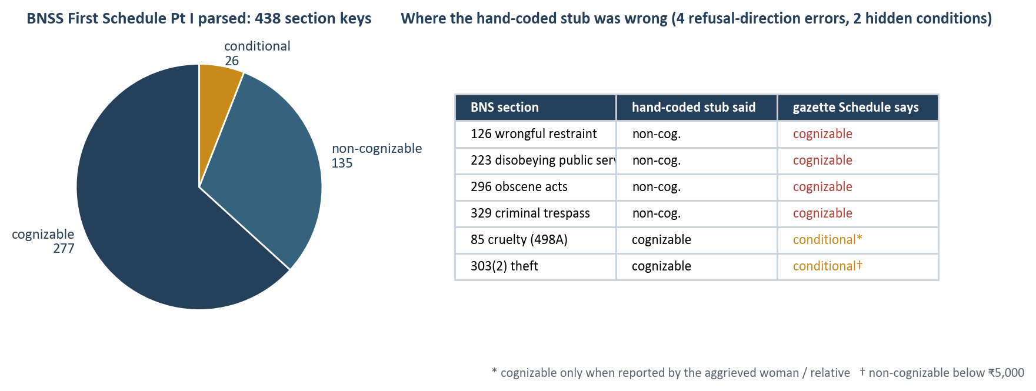
Figure 4.4 — Classification of the parsed First Schedule, and the entries the hand-coded version had wrong.
All 358 BNS sections were parsed from the BNS gazette (heading, chapter, full text and an illustration-free operative text). The officer page shows the BNS words next to every suggested section, with the IPC text from ILSI kept as lineage; the same corpus is the input the element verifier will read.

4.4.3 Automatic speech recognition (FLEURS ta_in)
Table 4.5 reports the zero-shot faster-whisper large-v3 (int8) baseline on 60 FLEURS Tamil test clips (743 s of audio). Tamil is agglutinative, so a single word-boundary decision changes the word count; character error rate is therefore reported beside WER, and per-clip WER above 100% is not by itself evidence of fabrication.
Decoding | WER | CER | median clip WER | RTF | flagged clips
temperature fallback ladder (library default), condition_on_previous_text off | 57.25% | 22.37% | 50.00% | 1.81 | 2
fallback ladder, condition_on_previous_text on | 55.37% | 20.11% | 50.00% | 1.84 | —
one pass at T = 0, sequential 30 s window | 53.49% | 15.82% | 48.15% | 0.51 | 1
one pass at T = 0, batched VAD chunks (bs = 8) — pipeline default | 51.41% | 15.05% | 45.45% | 0.46 | 2

Table 4.5 — ASR on FLEURS ta_in test, faster-whisper large-v3 int8 on CUDA.
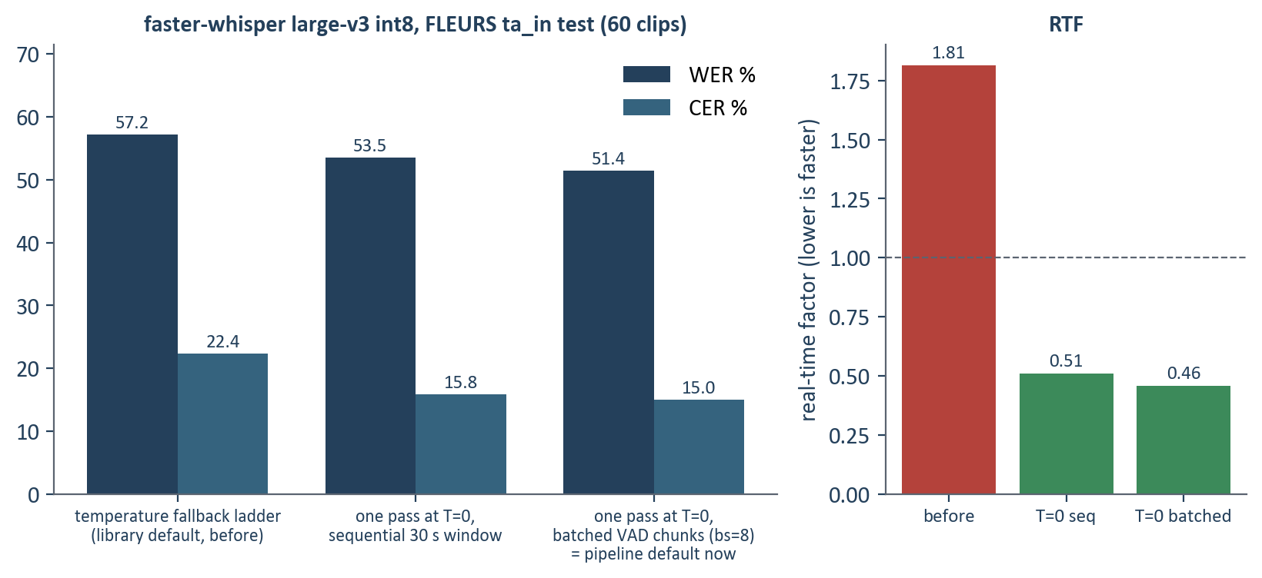
Figure 4.5a — WER, CER and real-time factor before and after the decoding change, 60 clips.
The corrected decoding is the pipeline default: WER 57.25% → 51.41%, CER 22.37% → 15.05%, RTF 1.81 → 0.46 on the same 60 clips. The transcript guard still flags 2 clips for a repetition loop (clip 1916 among them), so the temperature ladder explains the speed, not the replay failure; the guard remains the defence and the loop is the next ASR problem to solve (no-repeat-n-gram or repetition penalty in decoding, then IndicWhisper).
Profiling explained the slow real-time factor of the first baseline. faster-whisper's default decoding retries every window whose output fails a compression-ratio or average-log-probability check at up to five higher sampling temperatures; low-confidence Tamil fails that check constantly, so most clips were decoded several times, and the high-temperature passes are sampled — the path on which invented text can appear. Table 4.6 gives the measurements on eight clips and on the same clips joined into one complaint-length recording.
Setting | Beam | Temperature fallback | Batch | RTF | WER
per clip | 1 | ladder | — | 3.057 | 65.83%
per clip | 1 | none (T = 0) | — | 0.574 | 59.95%
per clip | 5 | ladder | — | 3.199 | 60.92%
per clip | 5 | none (T = 0) | — | 0.653 | 59.31%
joined 148 s recording | 5 | none (T = 0) | sequential | 0.310 | 80.81%
joined 148 s recording | 5 | none (T = 0) | 8 | 0.105 | 49.42%
joined 148 s recording | 5 | none (T = 0) | 16 | 0.104 | 49.42%

Table 4.6 — Where the decoding time goes (CTranslate2 4.8.2, NVIDIA GeForce RTX 5050 Laptop GPU).
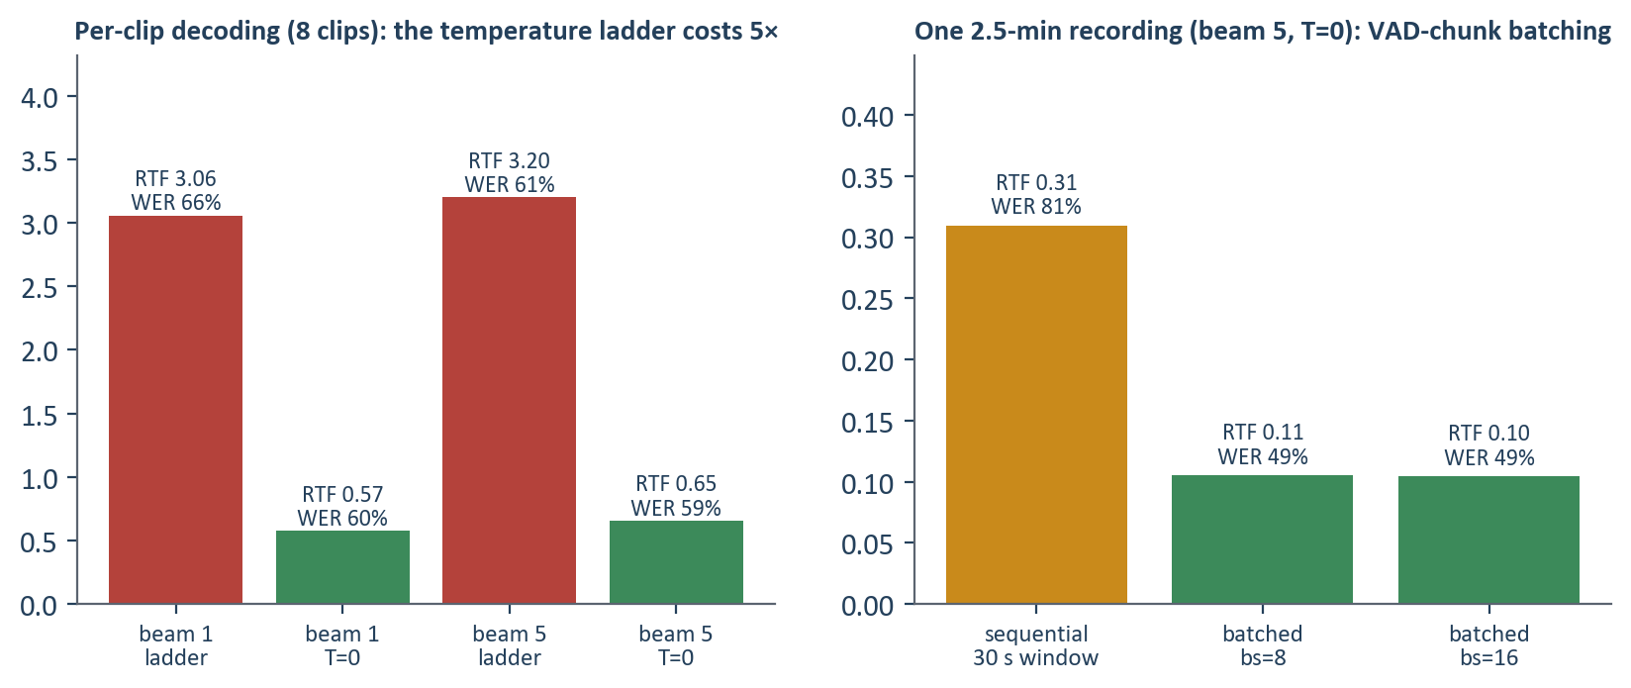
Figure 4.5 — Real-time factor and WER by decoding setting.
Removing the fallback made per-clip decoding 5.3× faster at equal or better WER; on the complaint-length recording, decoding the VAD chunks in batches was 3× faster again and markedly more accurate (WER 81% → 49%) than the fixed 30-second sliding window, because chunk boundaries follow the speaker's pauses instead of cutting sentences. Both are now the pipeline defaults. The compute-type comparison made earlier under the fallback ladder (int8 best, float16 worse) is superseded: without the ladder int8 and float16 give the same WER and float16 is faster; int8 is kept for its VRAM footprint.

4.4.4 Translation (Tamil → English, classifier view)
Model | Backend | Sentence pairs | chrF | BLEU | s / sentence
Helsinki-NLP/opus-mt-dra-en | marian | 336 | 35.2 | 10.5 | 0.30

Table 4.7 — Tamil→English translation on FLoRes devtest (FLEURS ta_in × en_us joined on sentence id). Wikipedia register, not complaints: a model-comparison signal.
The interim model trails IndicTrans2 by roughly 20 chrF in published comparisons; IndicTrans2 is gated behind a licence acceptance and is the planned upgrade. The translation is used only as the classifier's view of the complaint; extraction, element checks and the narrative keep the original text, which is what allowed the cue-scan safety net to catch the mistranslated dowry complaint.

4.4.5 Extraction and element cues
Slot | TP | FP | FN | Precision | Recall
date | 18 | 0 | 0 | 1.00 | 1.00
time | 16 | 0 | 0 | 1.00 | 1.00
amount_inr | 17 | 0 | 0 | 1.00 | 1.00
phone | 7 | 0 | 0 | 1.00 | 1.00
vehicle | 5 | 0 | 0 | 1.00 | 1.00
micro | 63 | 0 | 0 | 1.00 | 1.00

Table 4.8 — Rule extractor on the 28-document adversarial gold set (spoken and written forms, traps such as ages and account numbers).
The gold set is a smoke test, not a benchmark: it is small and hand-written. Its value is in the traps it carries (numbers that are not slots, two phone numbers in one complaint, year-less dates) and in being the harness that will score the learned extractor against the synthetic corpus. Element cues cover 29 station-house sections; a 22-complaint battery in English and Tamil pins which sections must fire for each complaint and which tempting wrong ones must not (a road death is 304A, not 302; a threat to kill is 506, not 307). Two precision defects found by the battery — a threat cue counted toward attempt to murder, and an inflected Tamil noun missing a citation-form cue — were fixed and are now tests.

4.5 Analysis, problems met and corrective action
Nine findings changed the plan or the code between Review 2 and Review 3. Each is recorded in PROGRESS.md with the measurement that established it; the summary is:
- Hardware (finding 1): 8 GB of VRAM, not 16. Consequence: model choices carry a fits flag and the synthetic-data generator decision is a measured benchmark, not an assumption.
- Infrastructure (6d, 6e): the WSL VM restarted six times under full-corpus jobs; the predictor was Python-heap size, not GPU memory. Chunked builds and detached launches fixed it.
- Encoder training (7): the InLegalBERT head collapsed onto six labels under plain BCE; positive-class weighting restored 97–100 labels — and the encoder still lost to TF-IDF (8).
- ASR fabrication (6b): two of sixty clips contained words not spoken (a replay loop, a Cyrillic drift). Guards calibrated on the baseline flag them and block auto-resolution; condition_on_previous_text=False was predicted to remove the replay and, when tested, did not.
- ASR speed (6f): profiling attributed the 3× real-time factor to the temperature-fallback ladder; one pass at T = 0 plus batched VAD chunks gives RTF 0.10 on a complaint-length recording with better WER.
- Translation loss (5c): “dowry” became “relief” and a 498A complaint routed to CSR; the cue scan on the original text now forces officer review and names the section.
- Cognizability (9): the hand-coded stub was wrong on four entries, all in the refusal direction; the First Schedule is now parsed from the gazette with page citations and conditional entries ask the officer.
- Domain shift (5): the classifier abstains on short complaints (its top-5 for a two-sentence theft has no theft section), so a lower threshold would apply wrong sections; in-domain synthetic data, not calibration, is the fix, and the cue scan carries short inputs meanwhile.

4.6 Limitations at this stage
- The classifier is trained on English court fact-statements and reads Tamil complaints through an interim translator; Tamil statute identification is therefore bounded by translation quality until IndicTrans2 or in-domain data is in place.
- Extraction covers structured slots only; names, places and accused descriptions await the NER / LLM stage and the synthetic corpus that trains and evaluates it.
- The element verifier is rule-based (keyword cues); it is a recall net and an explanation format, not yet a judgement of the ingredients of an offence.
- The legal tables are parsed from official text but not legally signed off; the IPC→BNS map's 29 flagged rows and 4 VERIFY rows remain open.
- The narrative composer and faithfulness gate are deterministic v0; the officer interface is a static page without accept/override logging; there is no print-faithful PDF.
- ASR numbers are zero-shot on read Wikipedia sentences (FLEURS), not spoken complaints; IndicWhisper / IndicConformer have not been benchmarked.

4.7 Individual contribution
«Guideline §2 requires each member's contribution to be demonstrated. Complete the table from the dated engineering log (PROGRESS.md) and the module ownership in IMPLEMENTATION.md.»
Member | Modules / deliverables | Evidence
Madhav K (23BAI1088) | «…» | «commits, PROGRESS.md entries, slides»
Nischay Kuchibotla (23BAI1245) | «…» | «…»
Rohit A. S. (23BAI1416) | «…» | «…»

Table 4.9 — Individual contribution at Review 3.
Use of AI tools (guideline §2): an AI coding assistant (Claude Code) was used for implementation support under the team's direction. Design decisions, legal tables, experiments and results were reviewed by the team and are reproducible from the repository. «Confirm the wording with the guide.»

5. Conclusion and Future Work (outline)
To be completed for Review 4. Planned content: summary of the work completed against the objectives of §1.4; major findings (the sparse-baseline result, the cost of translation, the gazette-versus-memory result for legal tables, the ASR decoding finding); limitations carried from §4.6; and future enhancements — the local LLM decision and synthetic corpus, learned extraction, the LLM element verifier over BNS text, IndicTrans2 and IndicWhisper benchmarks, the human gold set, the React verification workspace with audit logging, and the print-faithful IF-1 PDF.

References
[1] A. Radford et al., “Robust Speech Recognition via Large-Scale Weak Supervision (Whisper),” ICML, 2023.
[2] K. S. Bhogale et al., “Vistaar / IndicWhisper: Tamil and Indian-language ASR,” AI4Bharat, 2023.
[3] T. Javed et al., “IndicSUPERB: A Speech Processing Universal Performance Benchmark for Indian Languages,” AAAI, 2023.
[4] AI4Bharat, “Kathbath: A labelled ASR corpus for 12 Indian languages,” 2022.
[5] S. Khanuja et al., “MuRIL: Multilingual Representations for Indian Languages,” arXiv:2103.10730, 2021.
[6] A. Conneau et al., “Unsupervised Cross-lingual Representation Learning at Scale (XLM-R),” ACL, 2020.
[7] S. Paul et al., “LeSICiN: A Heterogeneous Graph-based Approach for Automatic Legal Statute Identification from Indian Legal Documents,” AAAI, 2022.
[8] ILSI Dataset, Zenodo, doi:10.5281/zenodo.6053791, 2022.
[9] S. Paul et al., “Pre-trained Language Models for the Indian Legal Domain (InLegalBERT),” 2023.
[10] P. Kalamkar et al., “Named Entity Recognition for Indian Legal Judgments (OpenNyAI),” 2022.
[11] The Bharatiya Nyaya Sanhita, 2023 (Act 45 of 2023), Government of India.
[12] The Bharatiya Nagarik Suraksha Sanhita, 2023 (Act 46 of 2023), Government of India.
[13] The Digital Personal Data Protection Act, 2023, Government of India.
[14] P. Lewis et al., “Retrieval-Augmented Generation for Knowledge-Intensive NLP Tasks,” NeurIPS, 2020.
[15] E. Hu et al., “LoRA: Low-Rank Adaptation of Large Language Models,” ICLR, 2022.
[16] T. Dettmers et al., “QLoRA: Efficient Finetuning of Quantized LLMs,” NeurIPS, 2023.
[17] A. Conneau et al., “FLEURS: Few-shot Learning Evaluation of Universal Representations of Speech,” 2022.
[18] R. Ardila et al., “Common Voice: A Massively-Multilingual Speech Corpus,” LREC, 2020.
[19] J. Chen et al., “BGE M3-Embedding: Multi-Lingual, Multi-Functionality, Multi-Granularity Text Embeddings,” 2024.
[20] Qwen Team, “Qwen2.5 Technical Report,” 2024.
[21] National Crime Records Bureau, “CCTNS and the Integrated Investigation Forms (IF-1),” Government of India.
[22] Ministry of Home Affairs, Government of India, “The Bharatiya Nagarik Suraksha Sanhita, 2023 (Act No. 46 of 2023),” The Gazette of India Extraordinary, Part II Sec. 1, No. 55, CG-DL-E-25122023-250884, 25 Dec. 2023 (First Schedule, pp. 158–188).
[23] Ministry of Home Affairs, Government of India, “The Bharatiya Nyaya Sanhita, 2023 (Act No. 45 of 2023),” The Gazette of India Extraordinary, Part II Sec. 1, No. 53, CG-DL-E-25122023-250883, 25 Dec. 2023.
[24] SYSTRAN, “faster-whisper: Whisper transcription with CTranslate2,” v1.1.0, 2024; OpenNMT, “CTranslate2,” v4.8.2, 2026. https://github.com/SYSTRAN/faster-whisper
[25] J. Tiedemann and S. Thottingal, “OPUS-MT — Building open translation services for the World,” Proc. EAMT, 2020 (model Helsinki-NLP/opus-mt-dra-en).
[26] M. Post, “A Call for Clarity in Reporting BLEU Scores,” Proc. WMT, 2018 (sacreBLEU; chrF after Popović, 2015).
[27] A. Conneau et al., “FLEURS: Few-shot Learning Evaluation of Universal Representations of Speech,” Proc. IEEE SLT, 2022.
[28] Paul et al., “ILSI: Indian Legal Statute Identification (LeSICiN),” Proc. AAAI, 2022 — corpus release on Zenodo, doi:10.5281/zenodo.6053791.

