Week 15

**Question 1:**

**Given an array of integers, reverse the given array in place using an index and loop rather than a built-in function.**

**Example**

**arr = [1, 3, 2, 4, 5]**

**Return the array [5, 4, 2, 3, 1] which is the reverse of the input array.**

**Function Description**

**Complete the function reverseArray in the editor below.**

**reverseArray has the following parameter(s):**

**int arr[n]: an array of integers**

**Return**

**int[n]: the array in reverse order**

**Constraints**

**1 ≤ n ≤ 100**

**0< arr[i] < 100**

**Input Format For Custom TestingProgram:**

**The first line contains an integer, n, the number of elements in arr.**

**Each line i of the n subsequent lines (where 0 < i < n) contains an integer, arr[i]**

**Sample Case 0**

**Sample Input For Custom Testing**

**5**

**1**

**3**

**2**

**4**

**5**

**Sample Output**

**5**

**4**

**3**

**2**

**1**

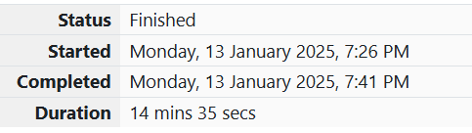

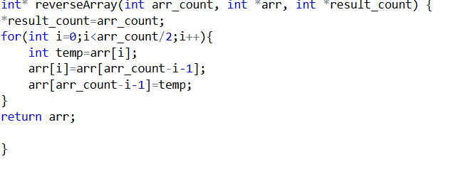

**Output:**

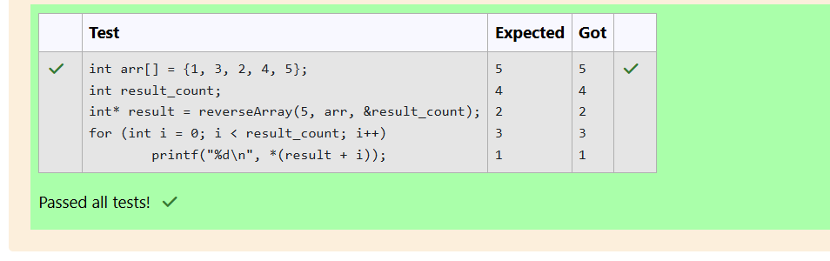

**Question 2:**

**Let’s print a chessboard!**

**Write a program that takes input: The first line contains T, the number of test cases**

**Each test case contains an integer N and also the starting character of the chessboard**

**Output Format**

**Print the chessboard as per the given examples**

**Sample Input 1:**

**2**

**2 W**

**3 B**

**Sample Output 1:**

**WB**

**BW**

**BWB**

**WBW**

**BWB**

**Program:**

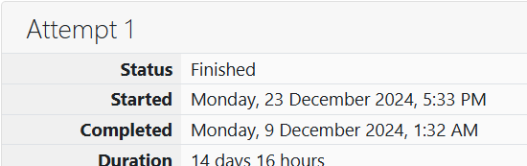

99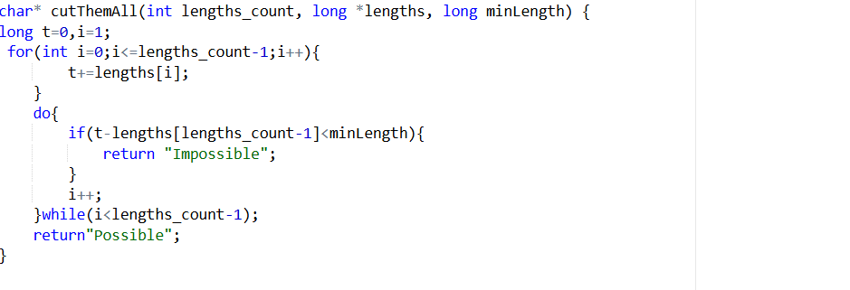

**Output:**

